Mugeeth Emergency Response System
Backend Test Cases & Sequence Diagrams
NestJS + Prisma + PostgreSQL + Socket.io
Sprint 1 + Sprint 2 + Sprint 3 Coverage
114 automated tests across 14 suites — all passing

1. Introduction
This document captures the verification plan for the Mugeeth backend, covering every endpoint and real-time event delivered during Sprint 1 (Foundation) and Sprint 2 (Core Flow + Real-Time).
For each feature we present:
- A table of test cases with ID, description, preconditions, steps, and expected result.
- A UML sequence diagram describing the actor/message flow.

1.1 Test Environment
- Framework: NestJS 11 (TypeScript)
- ORM: Prisma 6
- Database: PostgreSQL 16 (Docker)
- Realtime: Socket.io 4 via @nestjs/websockets
- Test runner: Jest 29 + Supertest 7 + socket.io-client 4
- External services: OpenStreetMap Nominatim (real, free) for geocoding; Firebase Admin SDK and Stream Chat SDK wired with graceful fallbacks when no credentials are provided.

1.2 Test Summary
All tests are executed via: npm run test:e2e
Result: 14 test suites passed, 114 tests passed, 0 failed.

2. Authentication Module
The authentication module handles user registration, login, and profile retrieval. JWT tokens are signed with HS256 and expire after 24 hours (per SRS REQ-5.3.3). Passwords are hashed with bcrypt (10 rounds).

2.1 Test Cases
ID | Description | Preconditions | Steps | Expected Result
AU-01 | Register a new user | Empty users table | POST /auth/register with valid payload | 201 + user (role=DONATOR, no password) + accessToken
AU-02 | Reject duplicate email | User exists | POST /auth/register with same email | 409 Conflict
AU-03 | Reject weak password | — | POST /auth/register with password < 8 chars | 400 Bad Request
AU-04 | Reject invalid email format | — | POST /auth/register with malformed email | 400 Bad Request
AU-05 | Login with valid credentials | User exists | POST /auth/login with correct credentials | 200 + user + accessToken
AU-06 | Login with wrong password | User exists | POST /auth/login with wrong password | 401 Unauthorized
AU-07 | Login with unknown email | No user matches | POST /auth/login with unknown email | 401 Unauthorized
AU-08 | Get current user with token | User registered | GET /auth/me with Bearer token | 200 + user (no password)
AU-09 | Reject /auth/me without token | — | GET /auth/me (no auth) | 401 Unauthorized
AU-10 | Reject /auth/me with invalid token | — | GET /auth/me with random token | 401 Unauthorized

2.2 Sequence Diagram — User Registration
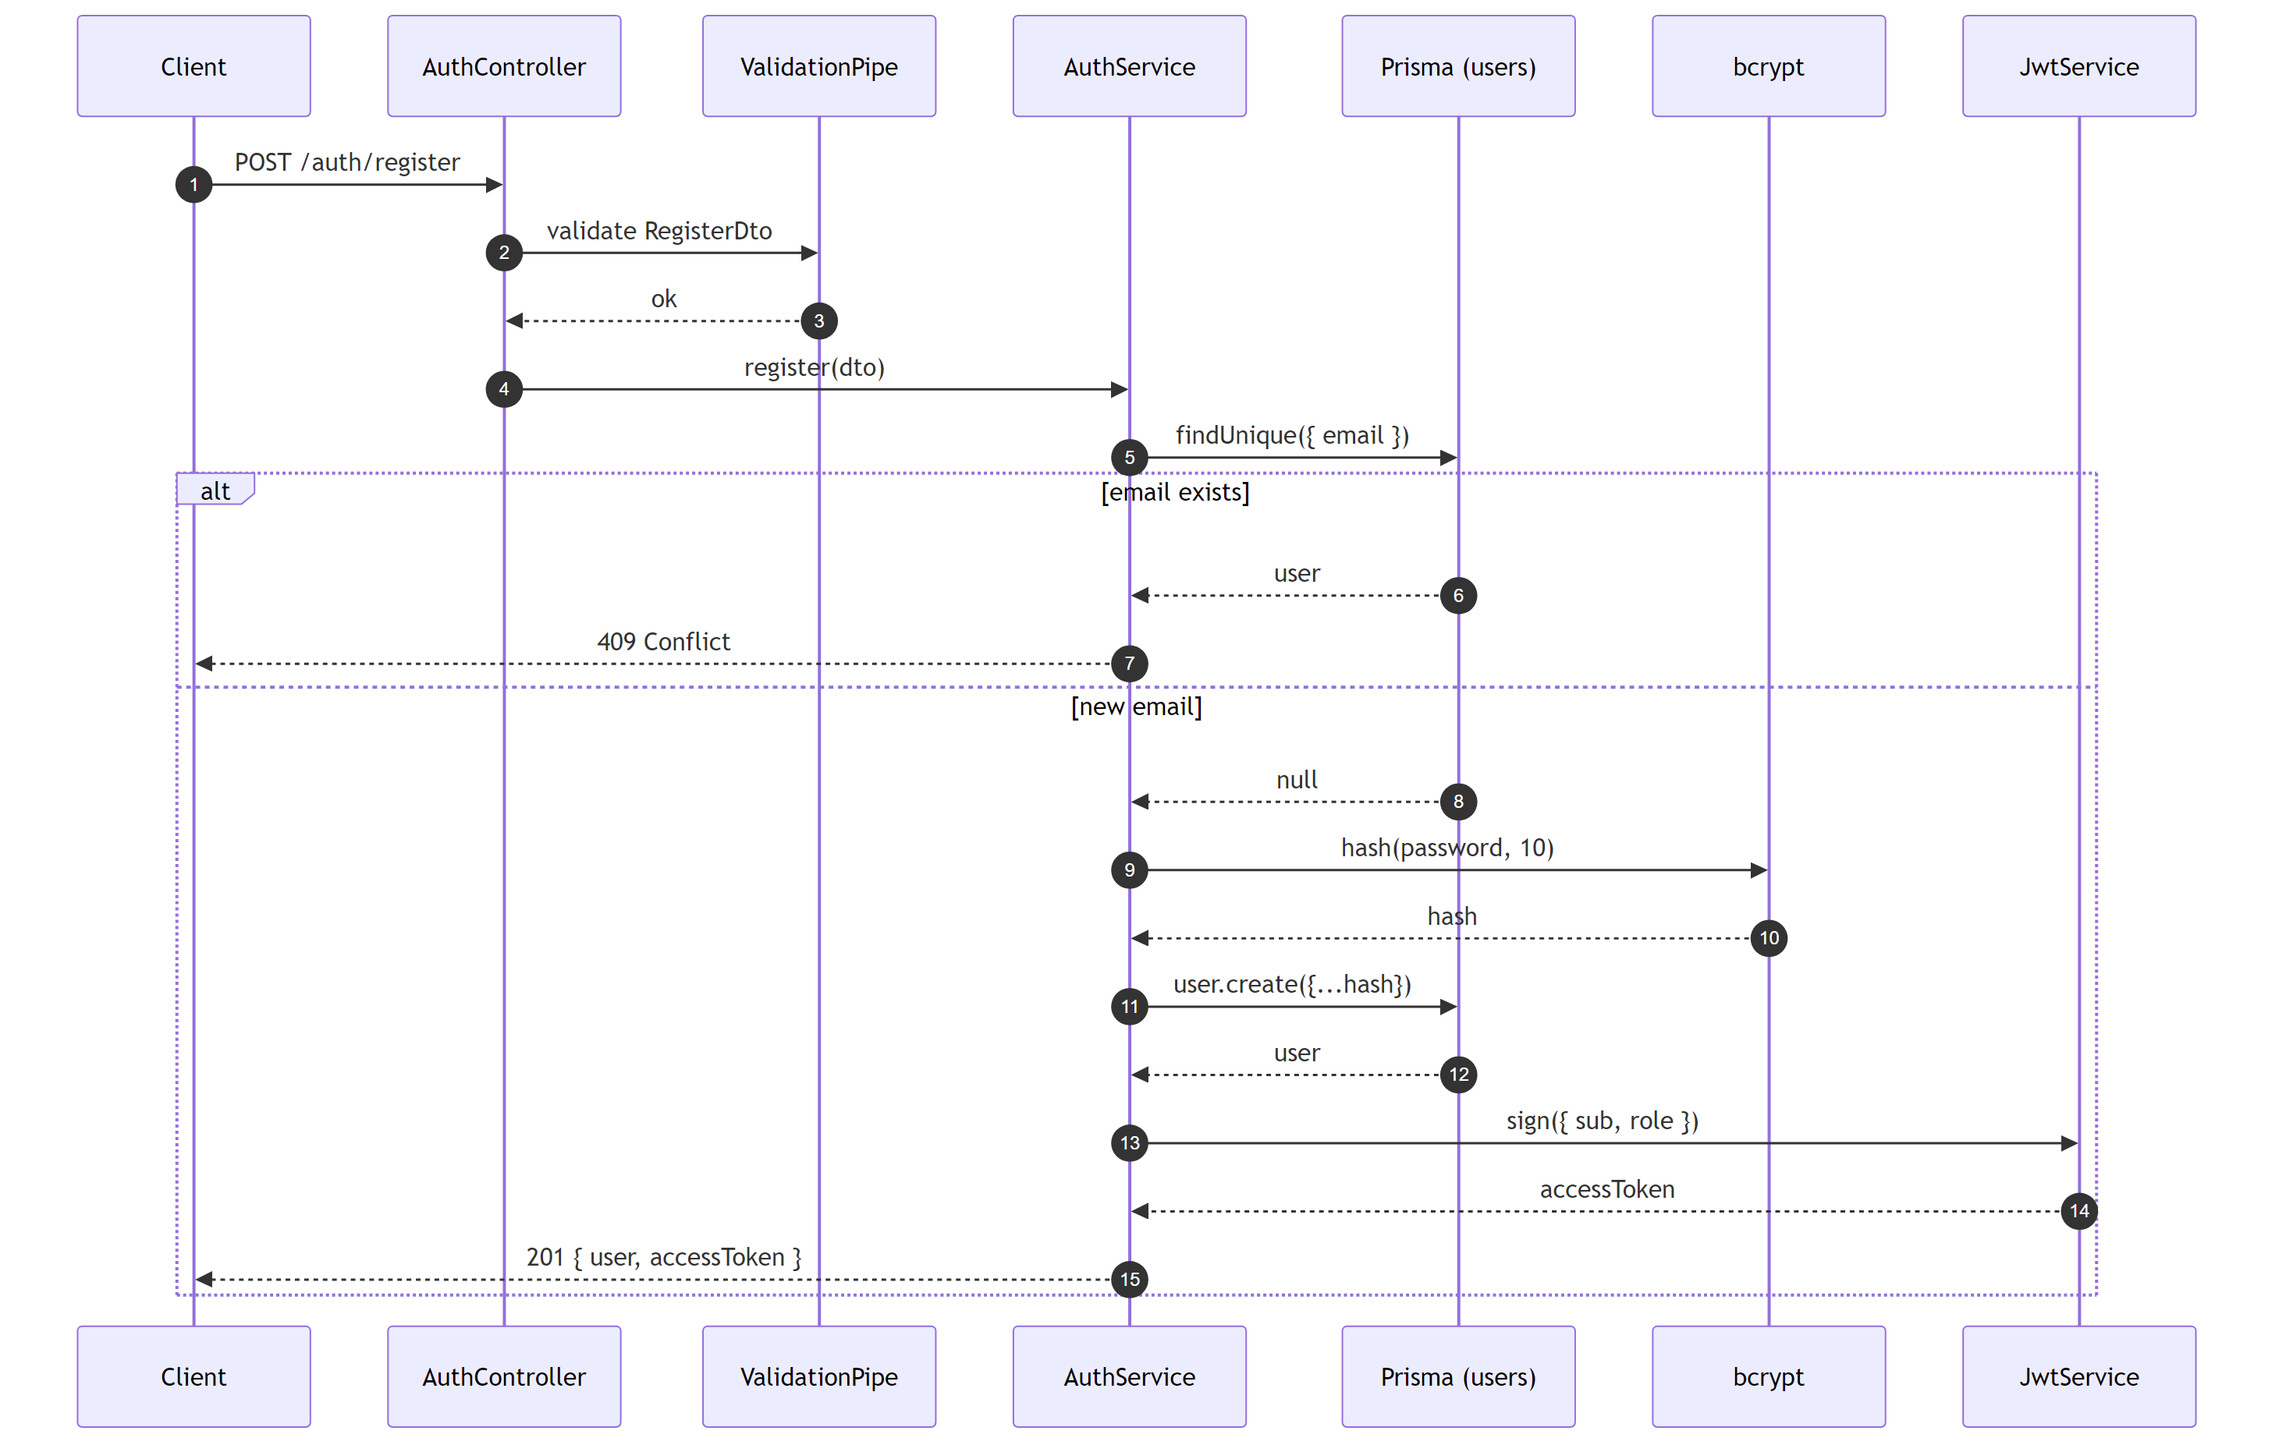
Figure 2.1 — POST /auth/register flow

2.3 Sequence Diagram — Login
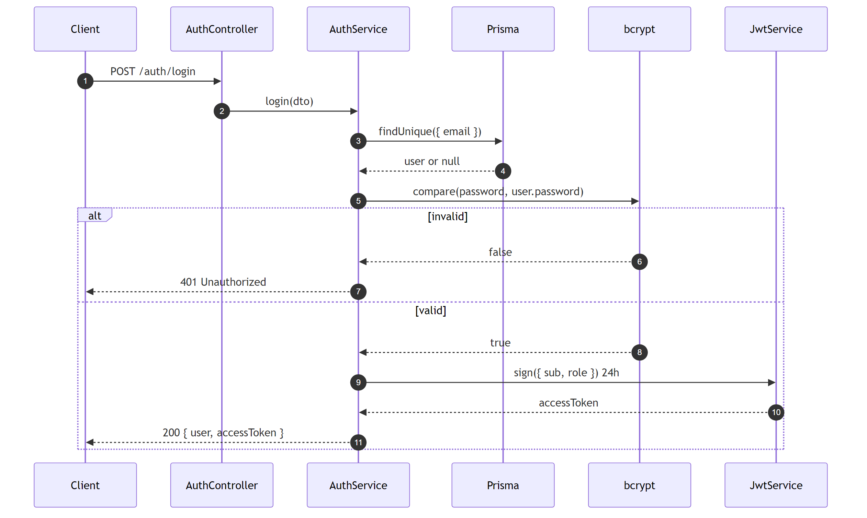
Figure 2.2 — POST /auth/login flow

2.4 Sequence Diagram — Get Current Profile
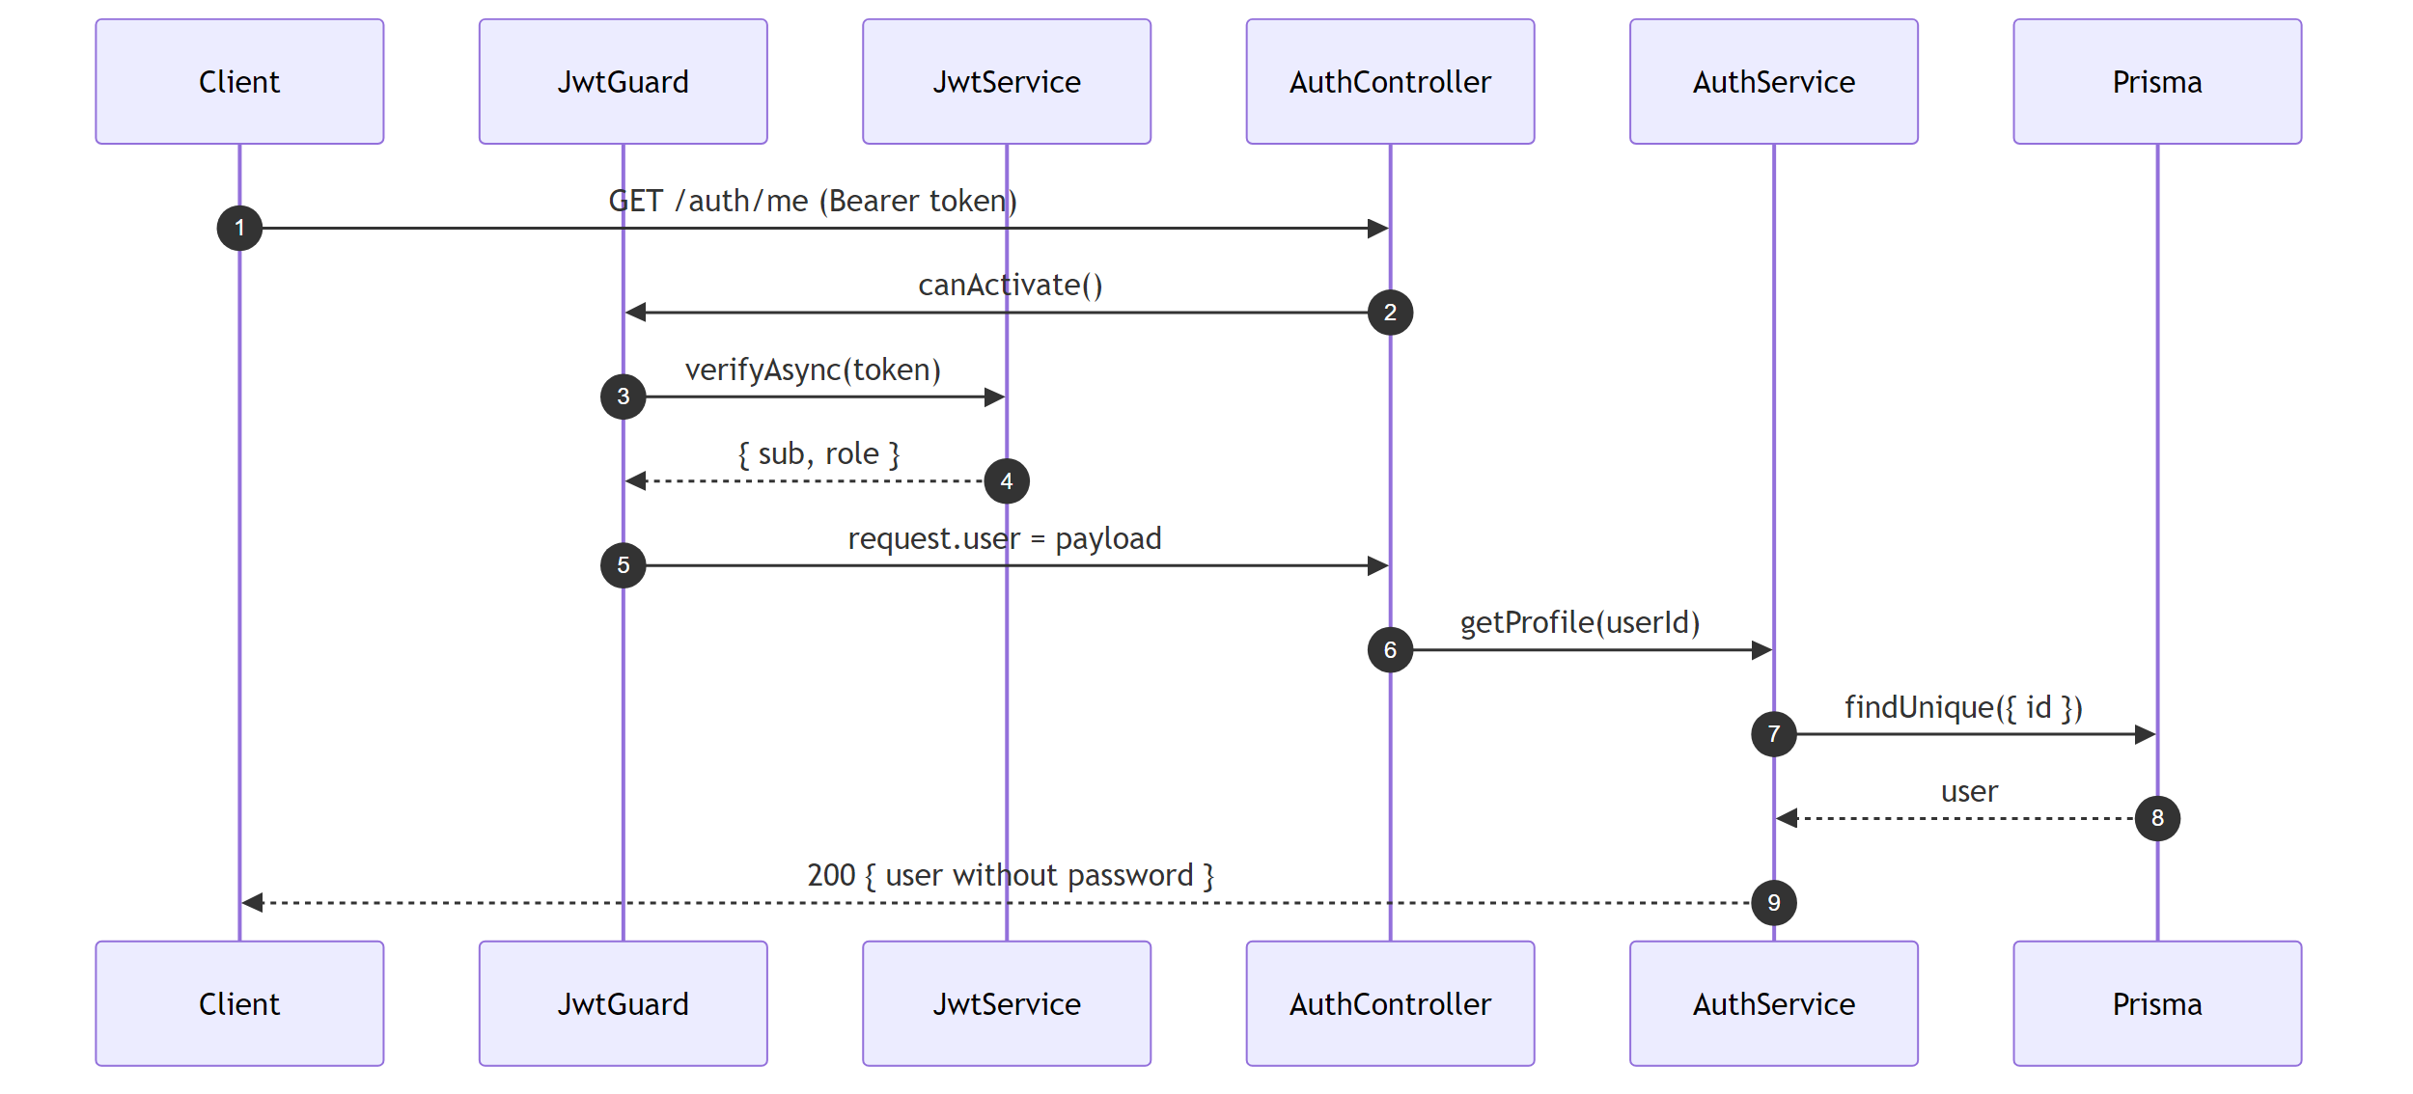
Figure 2.3 — GET /auth/me flow

3. Users Module
Manages user profiles, donator availability toggling, admin verification, and donator listings with pagination.

3.1 Test Cases
ID | Description | Preconditions | Steps | Expected Result
US-01 | Get current user profile | Authenticated user | GET /users/profile | 200 + profile
US-02 | Reject profile without token | — | GET /users/profile (no auth) | 401
US-03 | Update name/phone/certification | Authenticated donator | PATCH /users/profile with fields | 200 + fields persisted
US-04 | Update lat/lng (FLAW #2 fix) | Authenticated donator | PATCH /users/profile { latitude, longitude } | 200 + coords stored
US-05 | Reject unknown profile field | Authenticated user | PATCH with non-DTO field | 400
US-06 | Toggle availability for DONATOR | Donator authenticated | PATCH /users/availability { isAvailable: true } | 200
US-07 | Reject availability for ADMIN | Admin authenticated | PATCH /users/availability | 403
US-08 | Reject empty availability body | Donator authenticated | PATCH /users/availability {} | 400
US-09 | Admin verifies donator | Admin + donator exist | PATCH /users/:id/verify | 200 + isVerified=true
US-10 | Donator cannot verify | — | PATCH /users/:other/verify | 403
US-11 | Dispatcher lists donators | 2 donators exist | GET /users/donators | 200 + paginated response
US-12 | Filter by availability | Mix of donators | GET /users/donators?available=true | 200 + filtered
US-13 | Pagination with page & limit | 5 donators | GET /users/donators?page=1&limit=2 | 200 + 2 items, totalPages=3
US-14 | Donator cannot list donators | Donator authenticated | GET /users/donators | 403

3.2 Sequence Diagram — Update Profile with Location (FLAW #2)
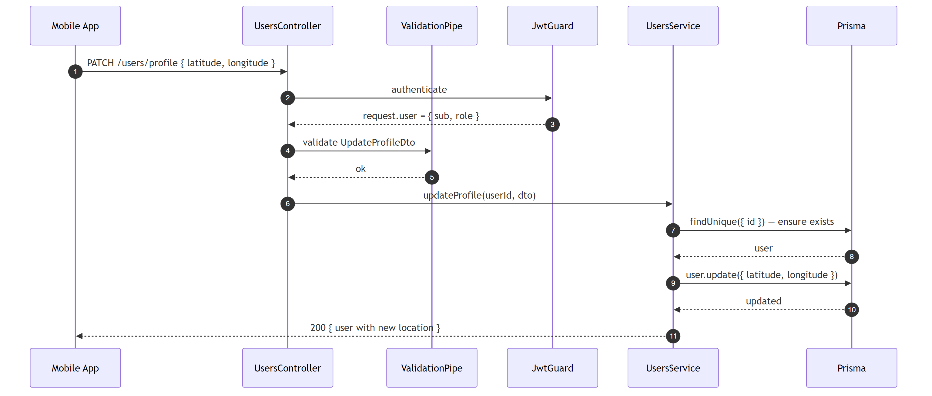
Figure 3.1 — PATCH /users/profile with coordinates

3.3 Sequence Diagram — Toggle Availability
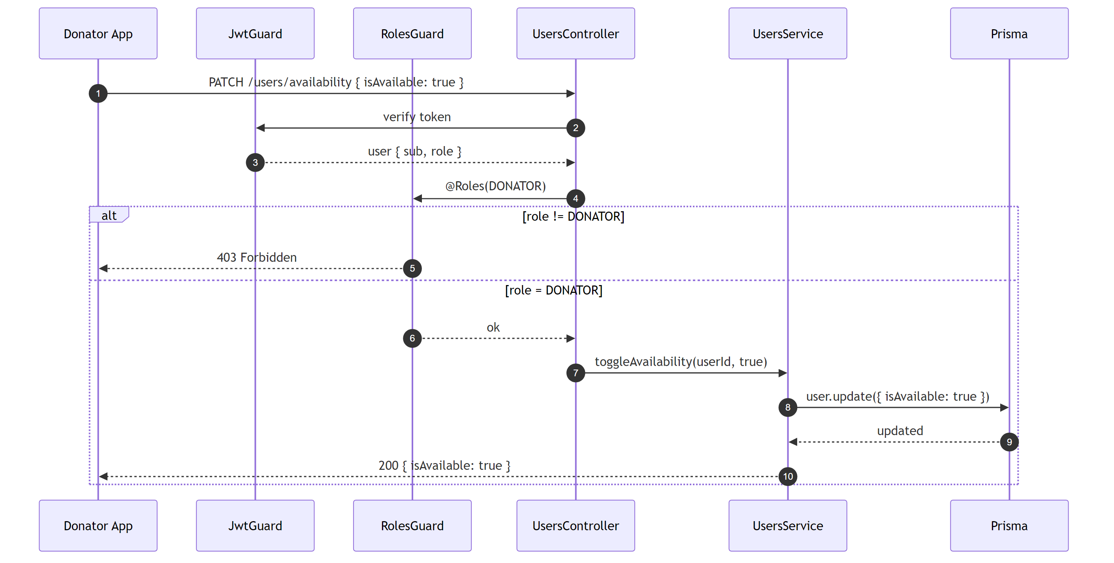
Figure 3.2 — PATCH /users/availability

3.4 Sequence Diagram — List Donators (Paginated)
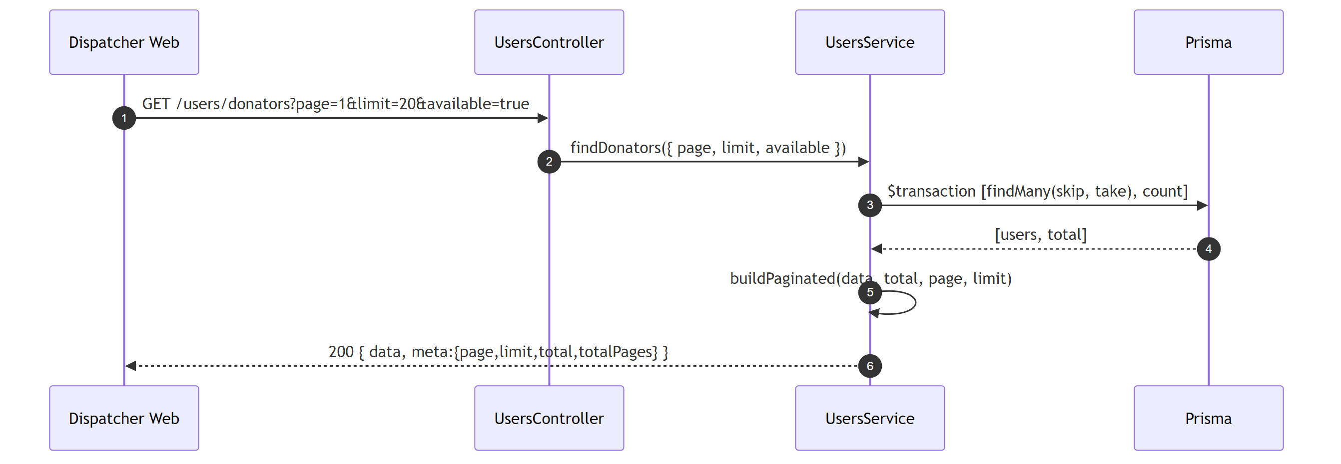
Figure 3.3 — GET /users/donators

4. Notifications Module
Stores case alerts in PostgreSQL and sends push notifications via Firebase Cloud Messaging when the user has a registered fcmToken. If Firebase credentials are not provided, sending falls back to a logged no-op (DB persistence still happens).

4.1 Test Cases
ID | Description | Preconditions | Steps | Expected Result
NO-01 | Empty list | 0 notifications | GET /notifications | 200 + []
NO-02 | List own notifications | 3 CASE_ALERT | GET /notifications | 200 + 3 items desc
NO-03 | Do not leak others | Other user has 2 | GET /notifications | 200 + []
NO-04 | Filter unread | 1 read + 1 unread | GET /notifications?unread=true | 200 + 1 item
NO-05 | Reject without token | — | GET /notifications | 401
NO-06 | Mark single as read | 1 notification | PATCH /notifications/:id/read | 200 + read=true
NO-07 | Reject others notification | Belongs to other | PATCH /notifications/:id/read | 404
NO-08 | Mark all as read | 4 unread | PATCH /notifications/read-all | 200 + {count:4}
NO-09 | Does not affect others | Other has 3 | PATCH /notifications/read-all | Other still 3 unread

4.2 Sequence Diagram — Push Notification (DB + FCM)
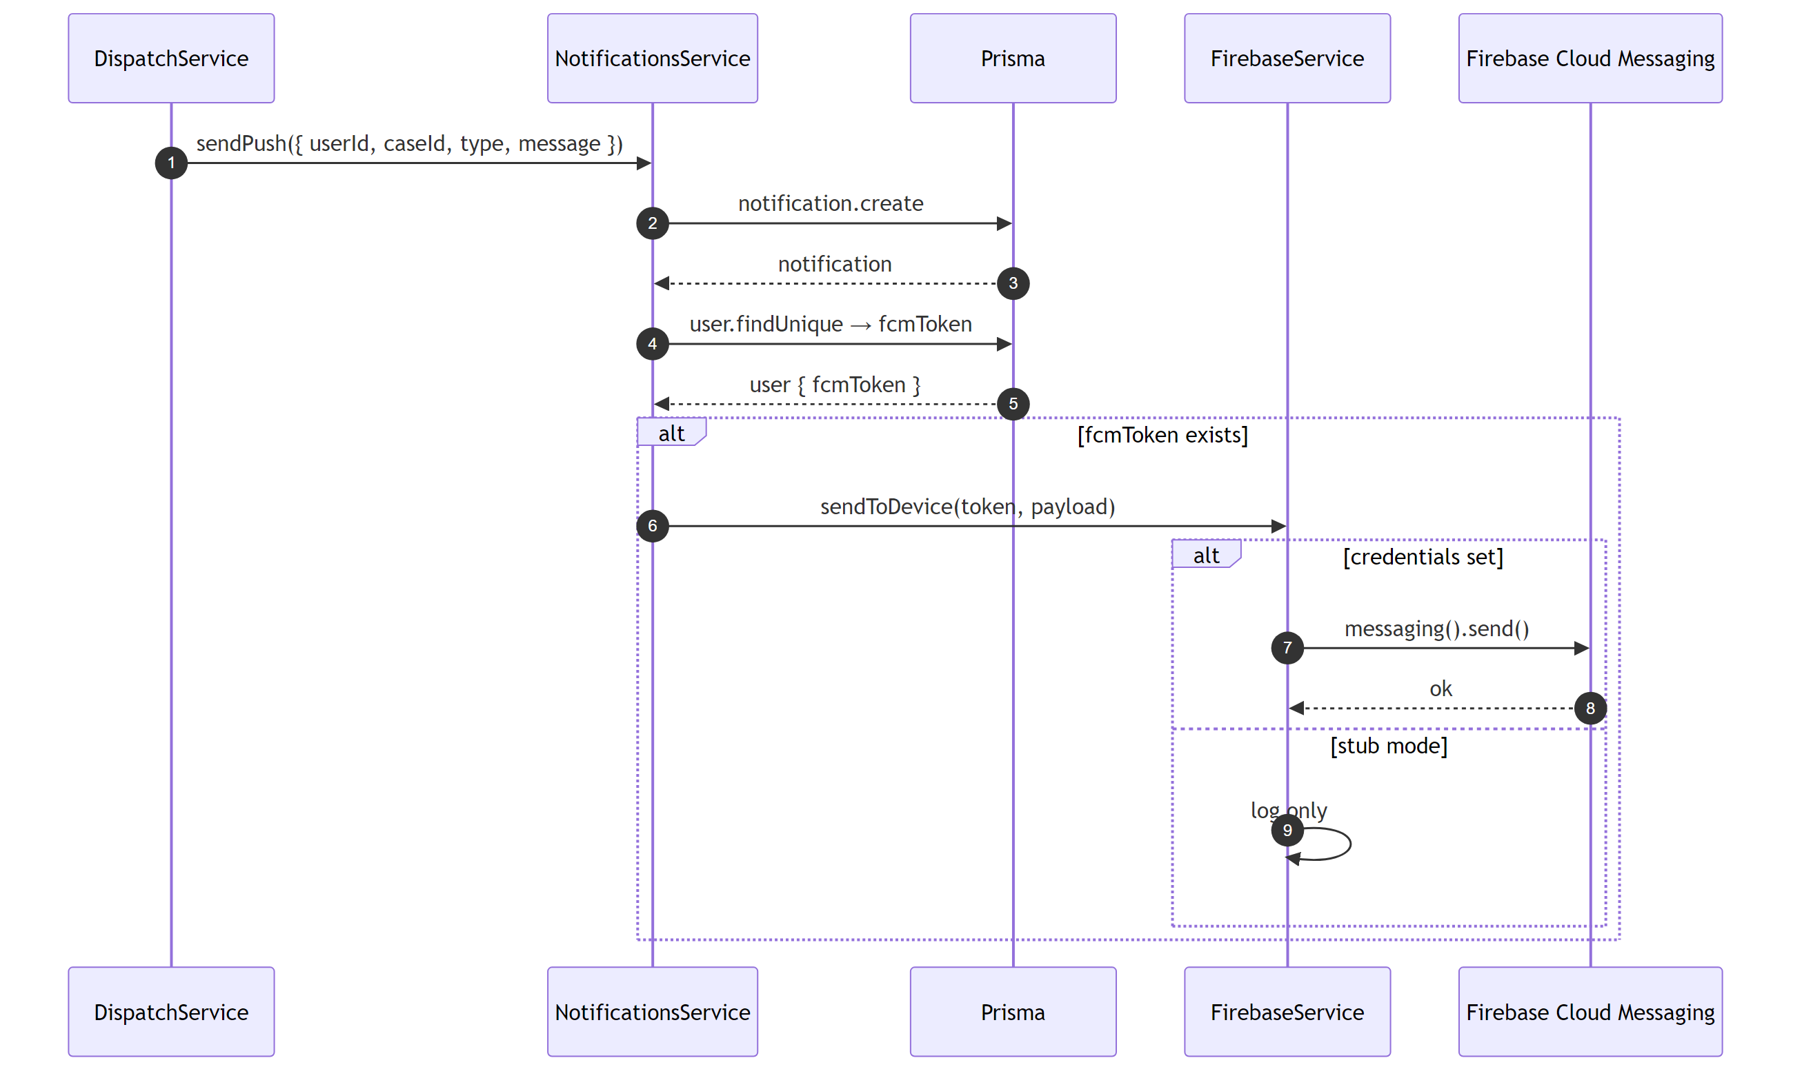
Figure 4.1 — NotificationsService.sendPush

4.3 Sequence Diagram — Mark All As Read
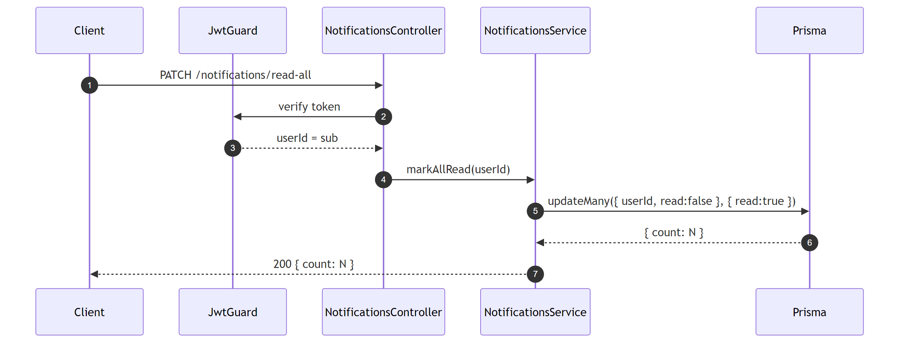
Figure 4.2 — PATCH /notifications/read-all

5. Cases Module
Models the emergency case lifecycle: OPEN → ASSIGNED → ON_SCENE → CLOSED, with OPEN → EXPIRED as a timeout path. Integrates with OpenStreetMap Nominatim, Dispatch, and Notifications.

5.1 Test Cases
ID | Description | Preconditions | Steps | Expected Result
CA-01 | Create case (DISPATCHER) | Dispatcher authenticated | POST /cases with coords | 201 + OPEN, expiresAt set
CA-02 | Reject DONATOR create | Donator auth | POST /cases | 403
CA-03 | Reject invalid severity | Dispatcher auth | POST with severity="X" | 400
CA-04 | List paginated | 2 cases | GET /cases | 200 + data length 2
CA-05 | Filter by severity | Mixed severities | GET /cases?severity=CRITICAL | 200 + matching
CA-06 | Donator cannot list | Donator auth | GET /cases | 403
CA-07 | Status ASSIGNED→ON_SCENE | Case ASSIGNED | PATCH /cases/:id/status | 200 + ON_SCENE
CA-08 | Reject CLOSED→OPEN | Case CLOSED | PATCH /status OPEN | 400
CA-09 | Close + free donator | Case ON_SCENE | PATCH /close | 200 + isBusy=false
CA-10 | Ambulance info (FLAW #3) | Case ASSIGNED | PATCH /ambulance-info | 200 + fields updated
CA-11 | Reject ambulance-info OPEN | Case OPEN | PATCH /ambulance-info | 400
CA-12 | Panic AMBULANCE_CREW (FLAW #4) | Ambulance crew auth | PATCH /panic | 200 + panicTriggered
CA-13 | Reject panic for DISPATCHER | Dispatcher auth | PATCH /panic | 403
CA-14 | Cron expires (FLAW #1) | expiresAt < now | Invoke expireOldOpenCases | status → EXPIRED
CA-15 | Cron skips future | expiresAt > now | Invoke expireOldOpenCases | still OPEN

5.2 Sequence Diagram — Create Emergency Case
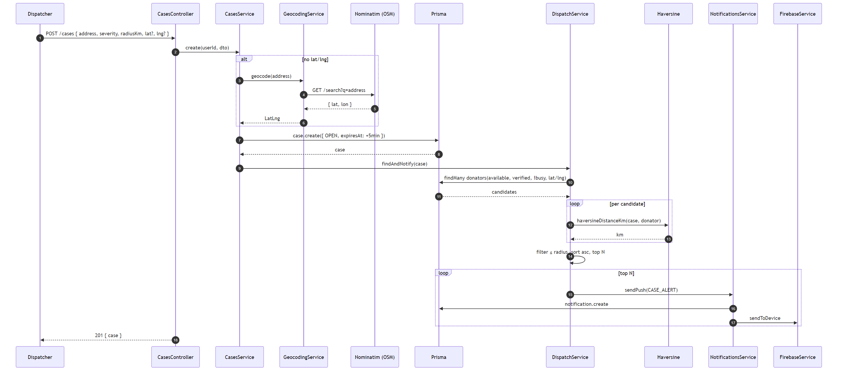
Figure 5.1 — POST /cases with geocoding + dispatch trigger

5.3 Sequence Diagram — Close Case
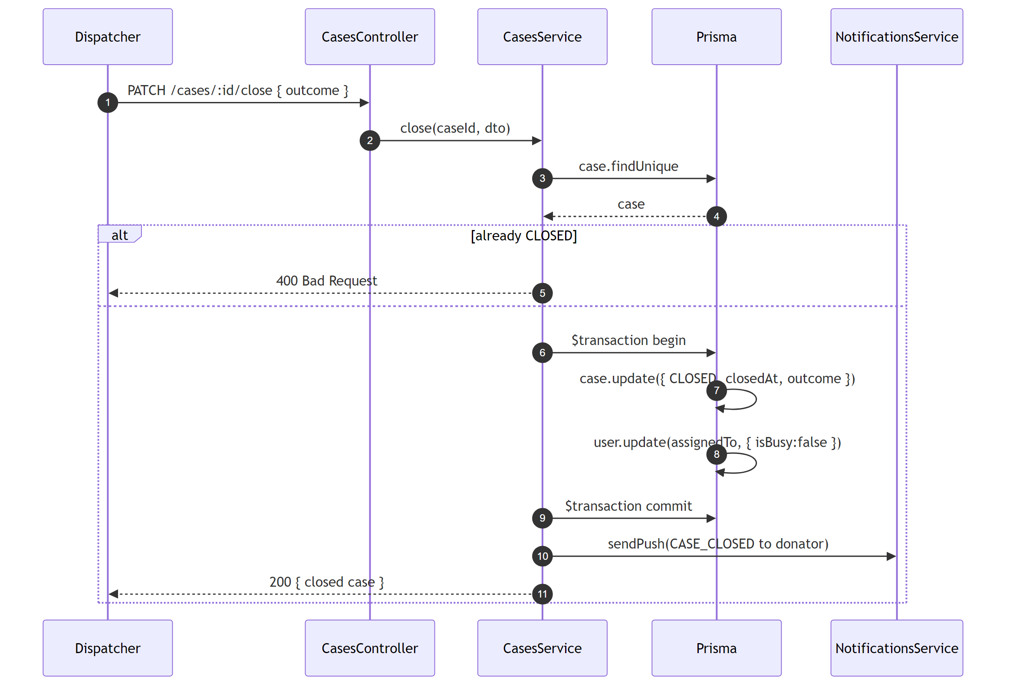
Figure 5.2 — PATCH /cases/:id/close

5.4 Sequence Diagram — Ambulance Info Update (FLAW #3)
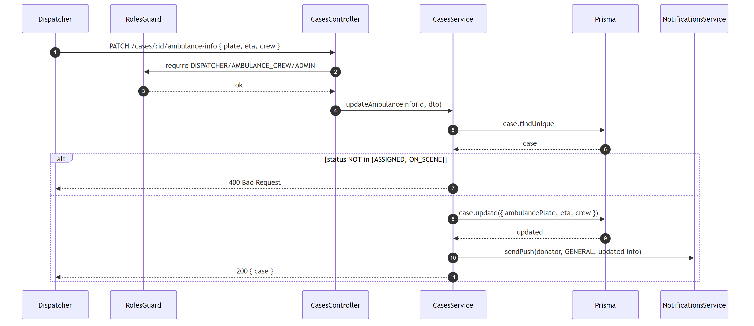
Figure 5.3 — PATCH /cases/:id/ambulance-info

5.5 Sequence Diagram — Traffic Panic Button (FLAW #4)
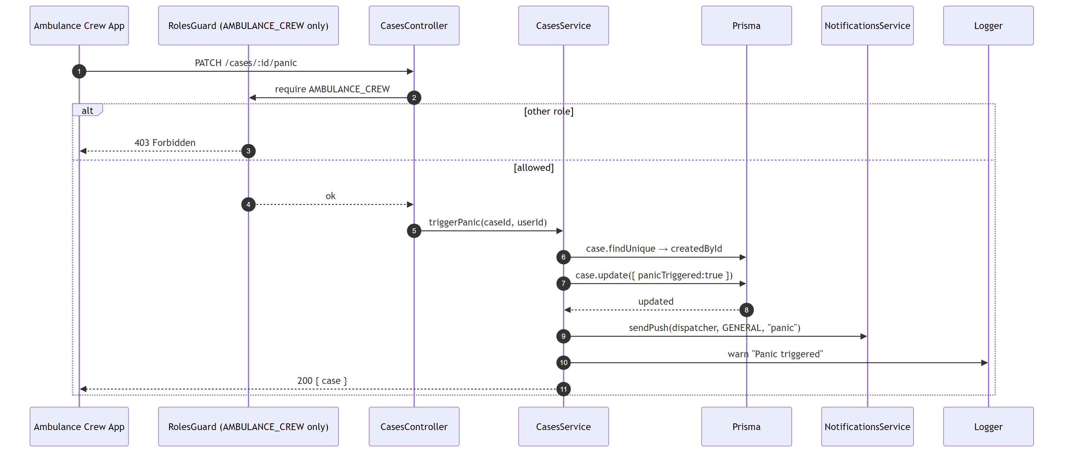
Figure 5.4 — PATCH /cases/:id/panic

5.6 Sequence Diagram — Case Expiry Cron (FLAW #1)
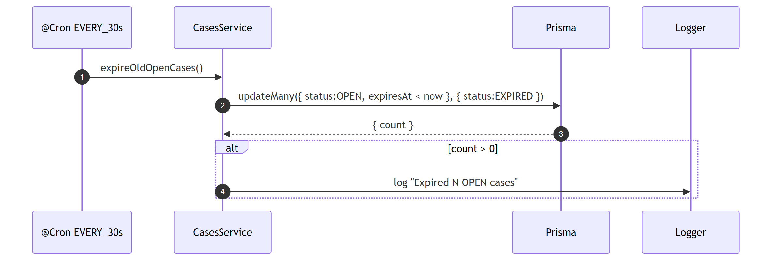
Figure 5.5 — @Cron EVERY_30_SECONDS

6. Dispatch Module
Drives donator matching using Haversine distance, atomic first-to-claim acceptance, and automatic chat-channel provisioning on accept.

6.1 Test Cases
ID | Description | Preconditions | Steps | Expected Result
DI-01 | First-to-claim wins; second 409 | 2 eligible donators | Both POST /accept | 1st 201, 2nd 409
DI-02 | Busy donator blocked | isBusy=true | POST /accept | 409
DI-03 | Non-DONATOR 403 | Dispatcher auth | POST /accept | 403
DI-04 | Cancels alerts for others | Other donator has alert | Accept case | Other gets CASE_CANCELLED
DI-05 | Reject marks read | Unread alert exists | POST /reject | alert.read=true
DI-06 | Nearby sorted by distance | 2 eligible donators | GET /nearby | sorted asc
DI-07 | Nearby excludes busy/unavailable | Busy + unavailable | GET /nearby | 200 + []

6.2 Sequence Diagram — First-to-Claim Accept
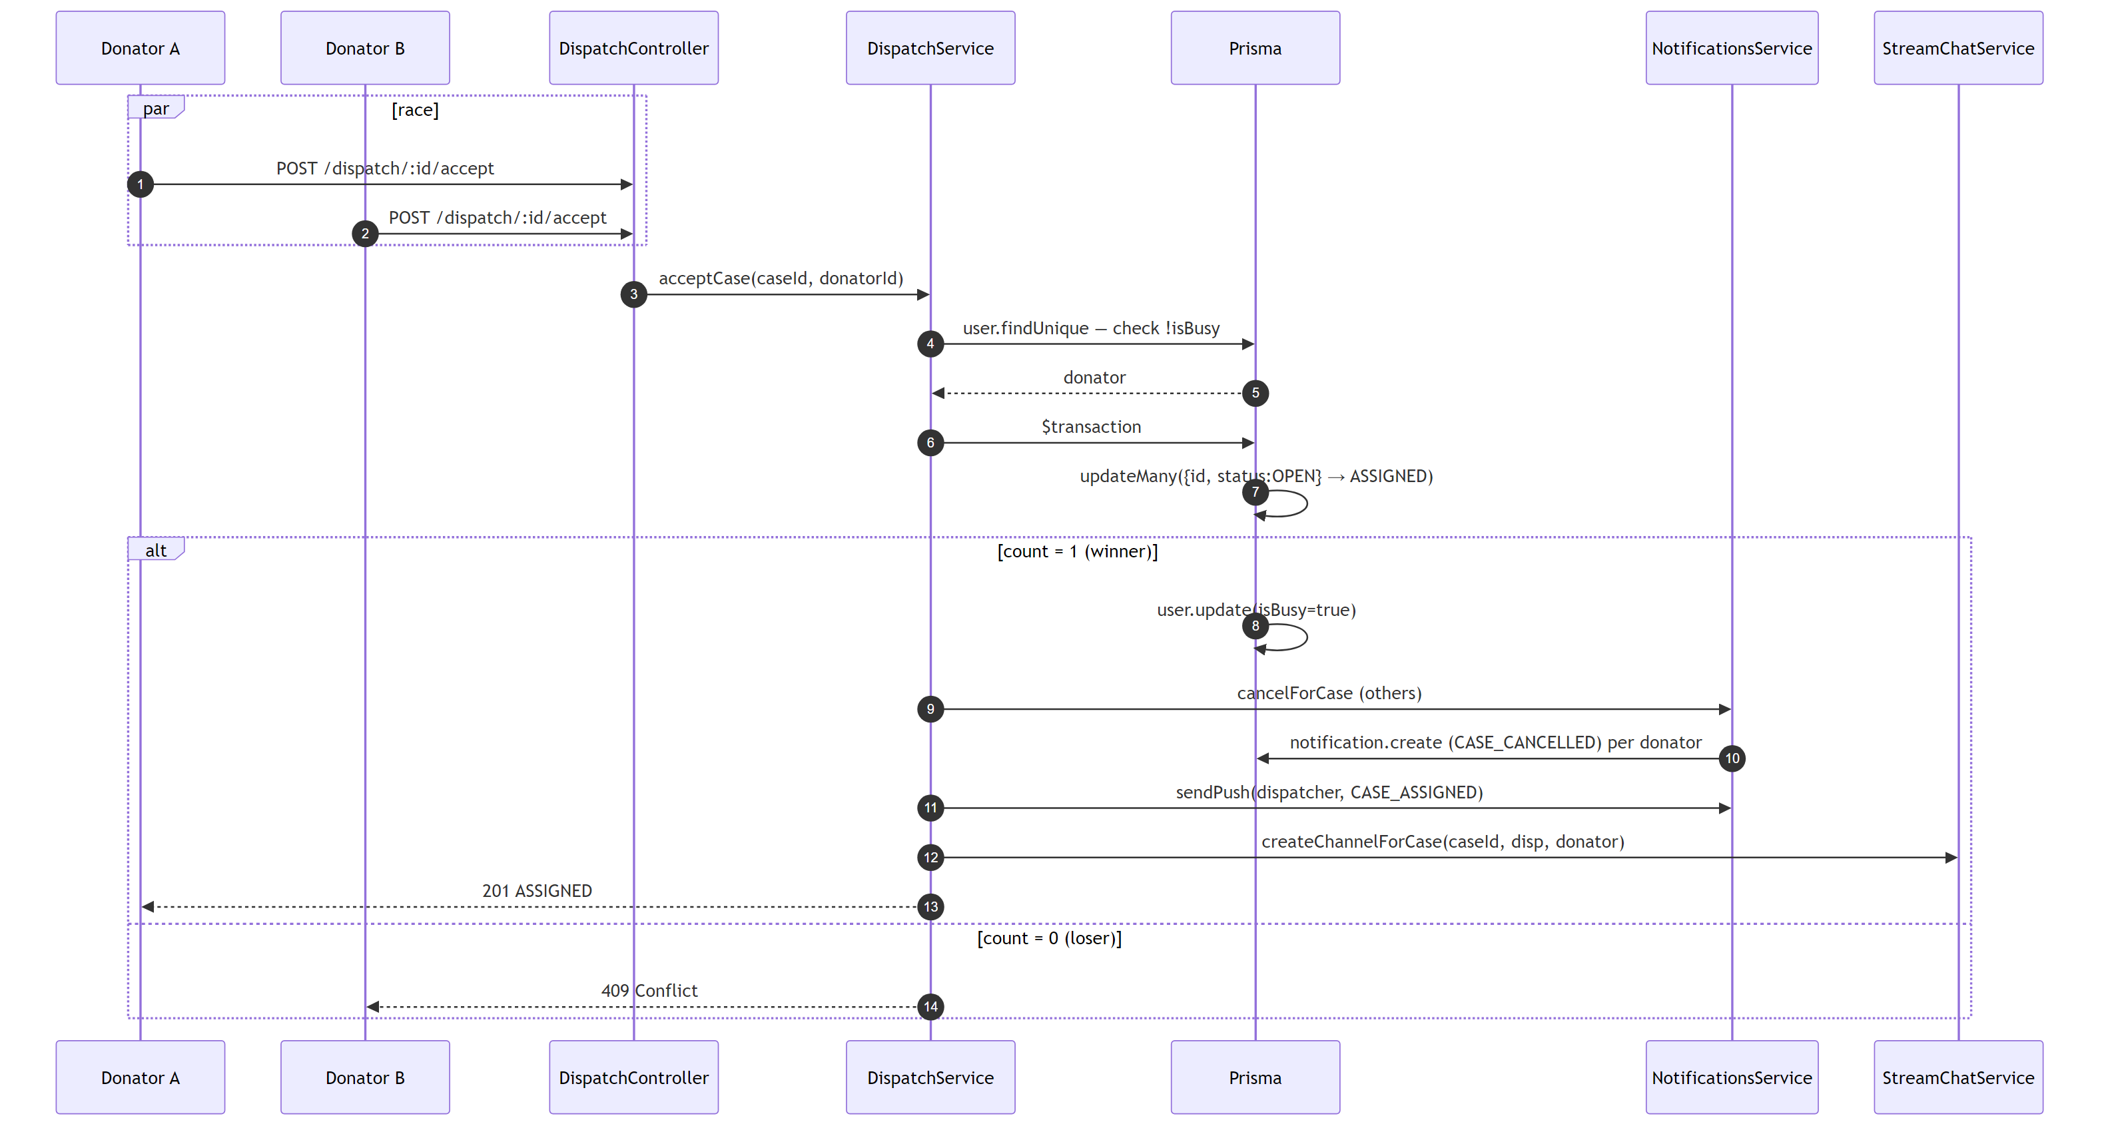
Figure 6.1 — POST /dispatch/:caseId/accept (atomic)

6.3 Sequence Diagram — Nearby Donators Query
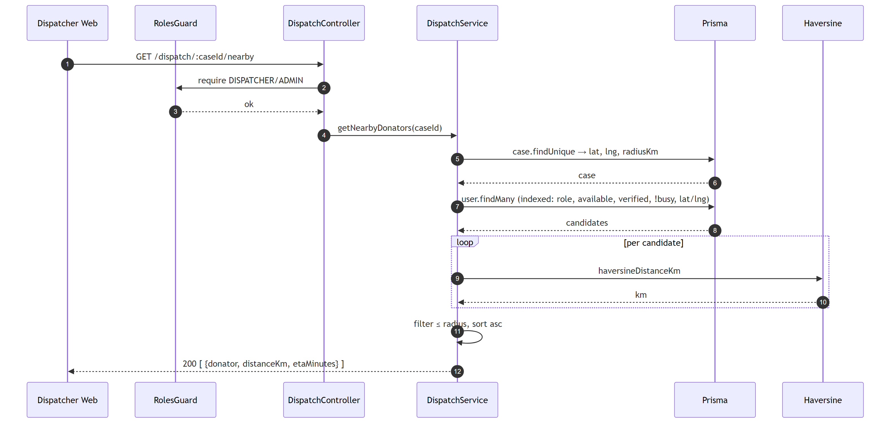
Figure 6.2 — GET /dispatch/:caseId/nearby

7. Location Module (WebSocket)
Real-time GPS streaming on the isolated /location namespace. JWT is verified from handshake.auth.token. Duplicate sockets for the same user are forcibly disconnected (FLAW #7). Events are broadcast to the per-case room case:<caseId>.

7.1 Test Cases
ID | Description | Preconditions | Steps | Expected Result
LO-01 | Reject connection without token | — | Connect /location with fake token | Disconnected
LO-02 | Broadcast to subscribed room | Dispatcher subscribed | Donator emits location:update | Dispatcher receives broadcast
LO-03 | Stale socket disconnected (FLAW #7) | Same user reconnects | Second connect | First socket disconnected
NS-01 | /location accepts authed | Valid token | io(/location, auth) | Connected
NS-02 | /location rejects missing token | No auth | io(/location) | Disconnected
NS-03 | No leak to default namespace | Both namespaces connected | Emit on /location | Not delivered to /

7.2 Sequence Diagram — WebSocket Connection & Auth
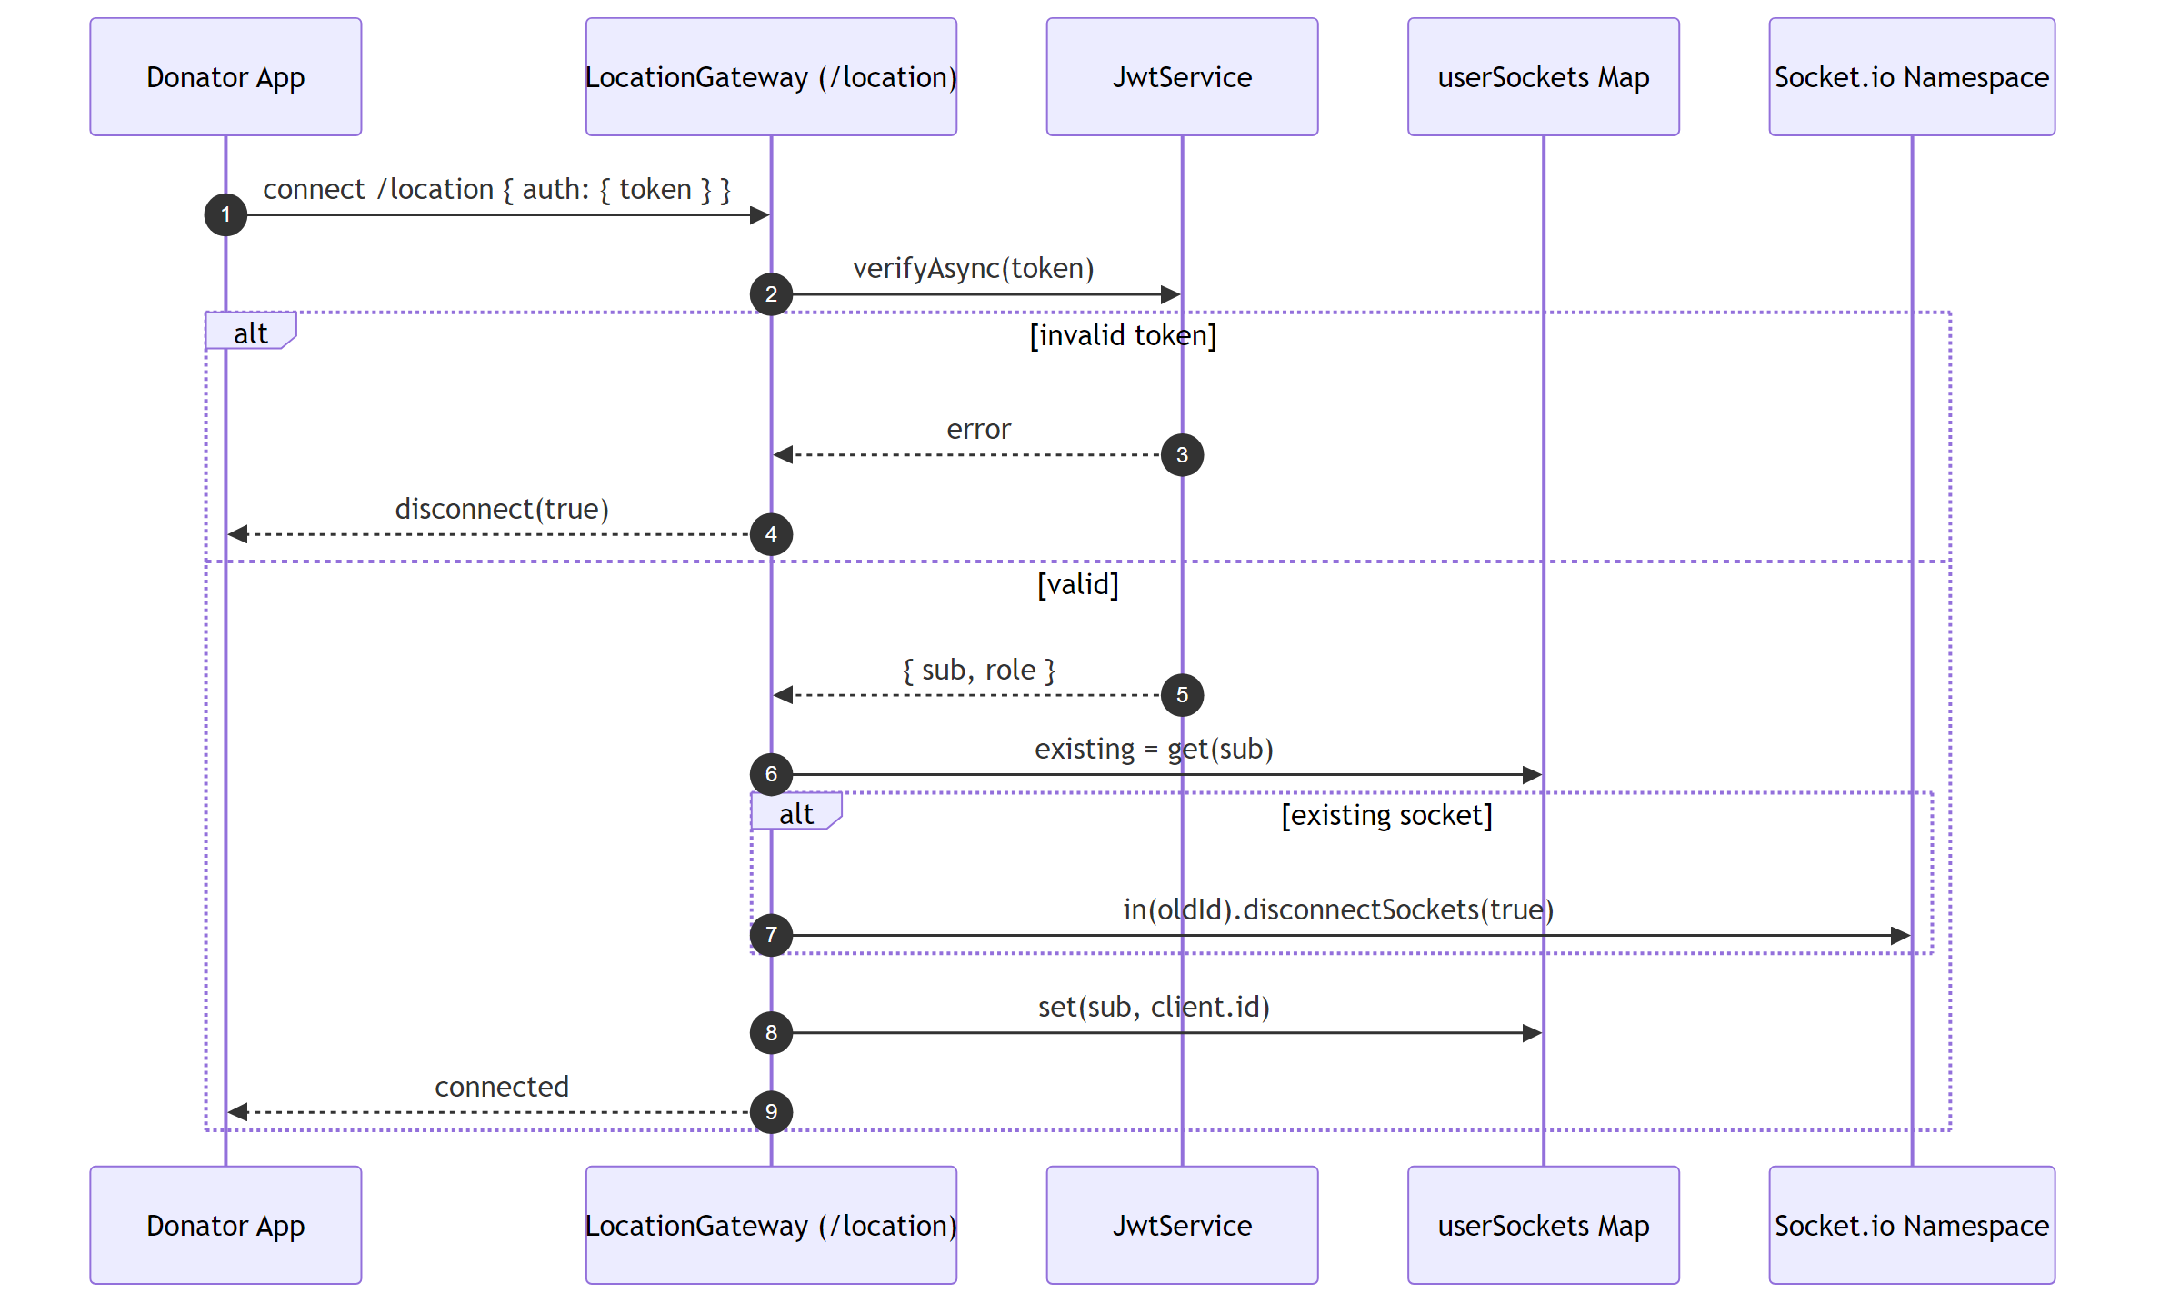
Figure 7.1 — /location handshake + JWT check + stale cleanup

7.3 Sequence Diagram — Location Update Broadcast
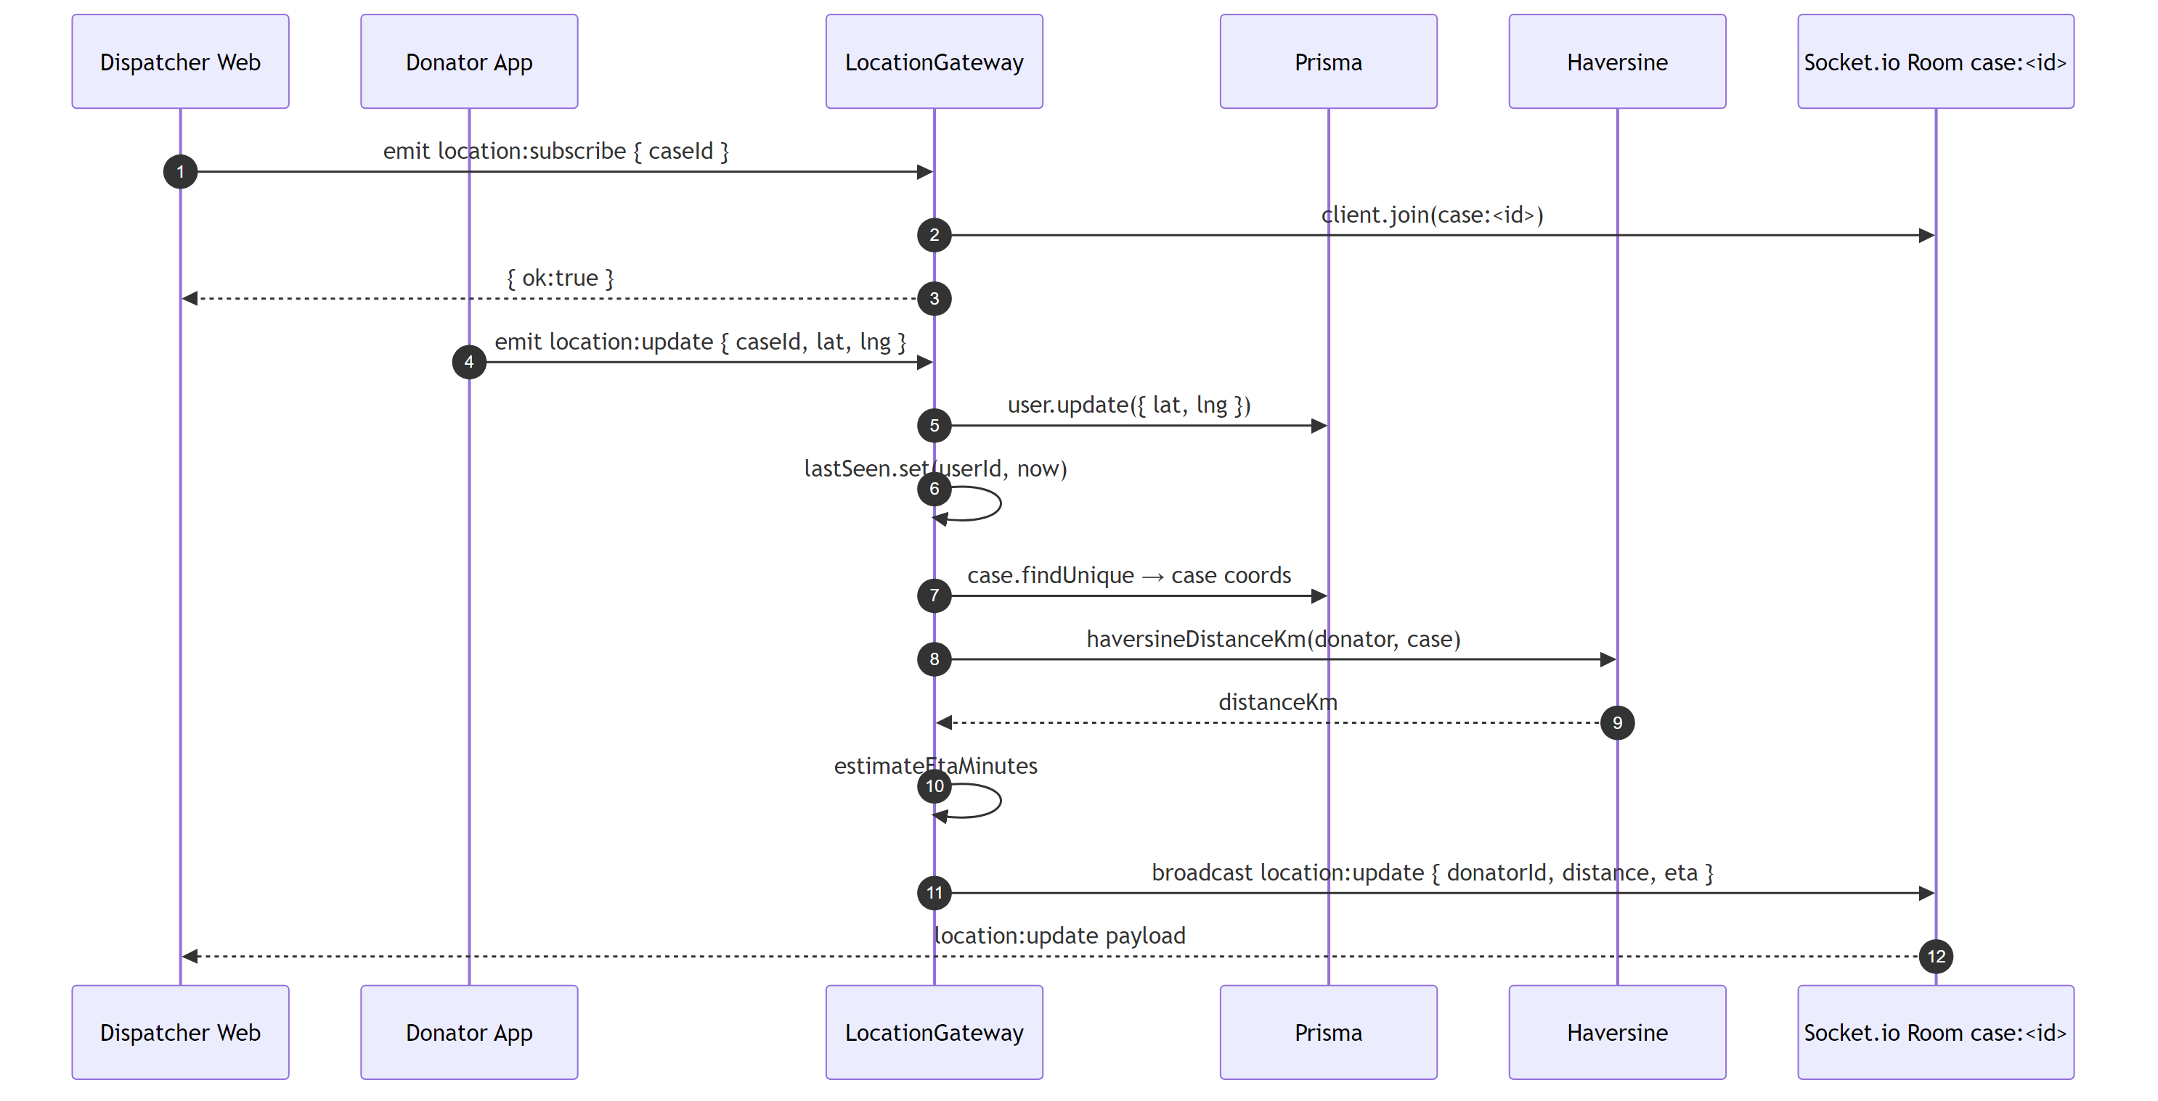
Figure 7.2 — location:update → broadcast to case room

7.4 Sequence Diagram — Signal Lost Detection
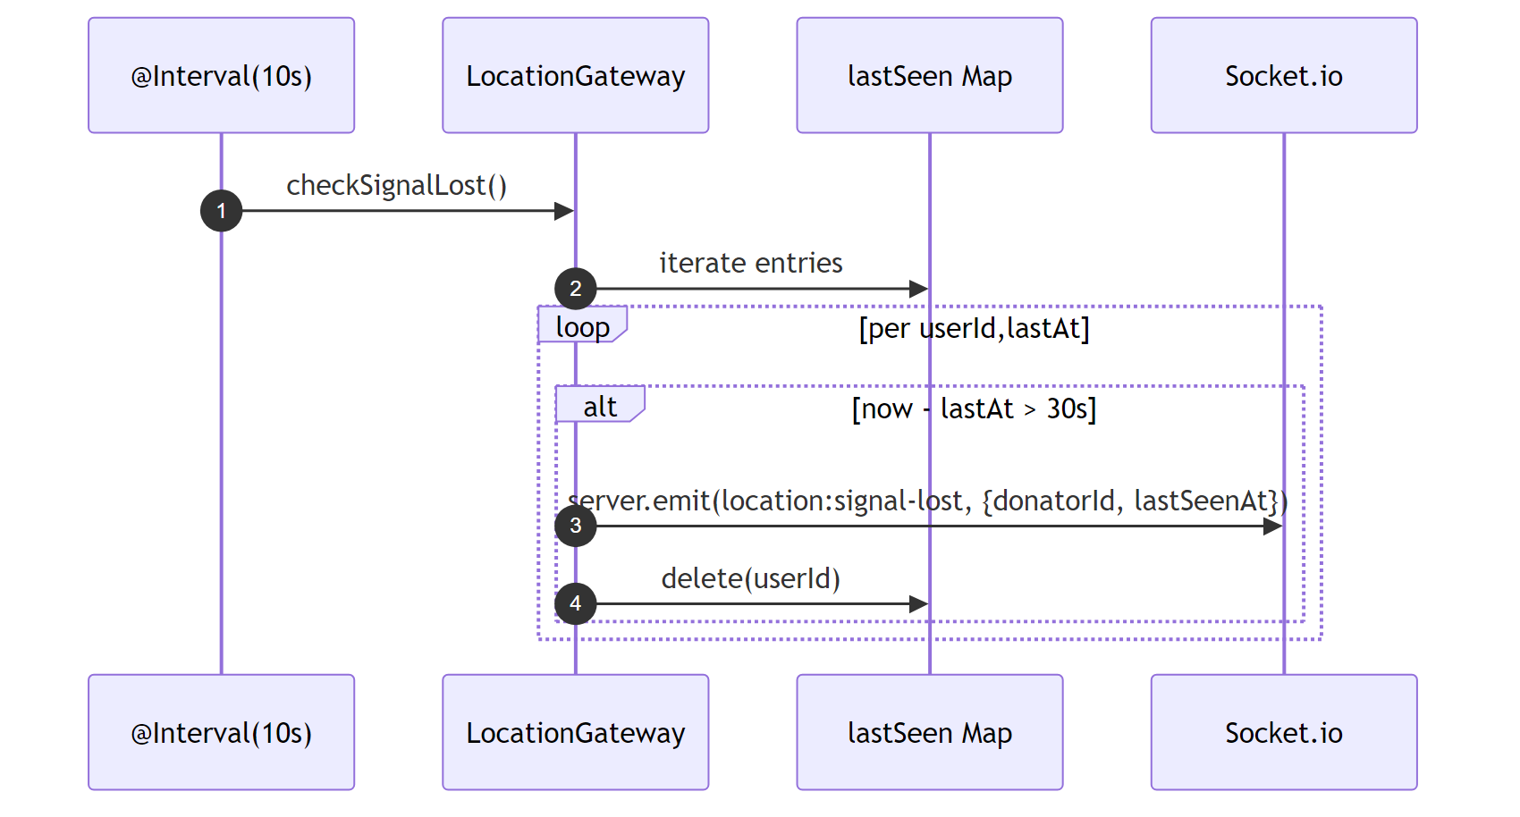
Figure 7.3 — @Interval(10s) signal-lost scan

8. Chat Module
Wraps the Stream Chat SDK for per-case messaging. If Stream credentials are present, real channels and tokens are created. Otherwise, the service returns stub values so the flow is fully exercisable end-to-end without paid credentials.

8.1 Test Cases
ID | Description | Preconditions | Steps | Expected Result
CH-01 | Create channel ASSIGNED | Case assigned | POST /chat/case/:id/channel | 201 + channelId + members
CH-02 | Reject no donator | Case OPEN | POST /chat/case/:id/channel | 400
CH-03 | Reject CLOSED case | Case CLOSED | POST /chat/case/:id/channel | 400
CH-04 | Get chat token | Authenticated user | GET /chat/token | 200 + token string
CH-05 | Reject token no auth | — | GET /chat/token | 401

8.2 Sequence Diagram — Auto-Create Channel on Accept (FLAW #5)
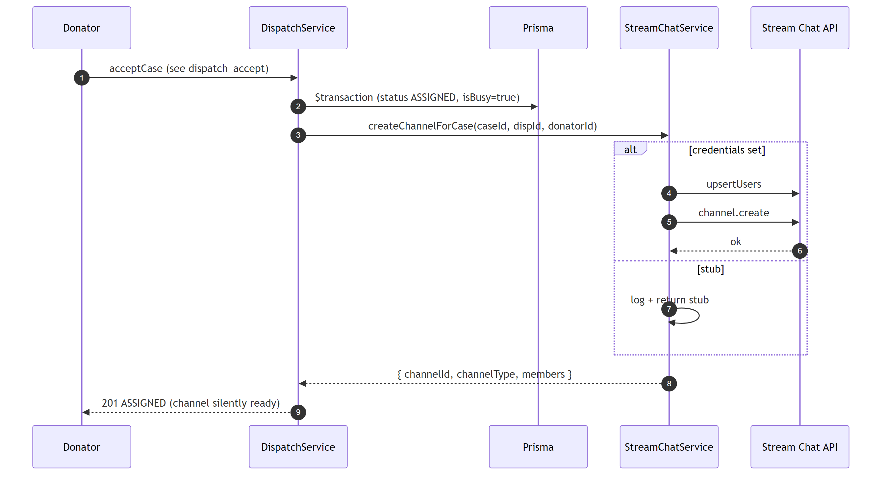
Figure 8.1 — Auto channel creation inside acceptCase

8.3 Sequence Diagram — Manual Channel Fetch
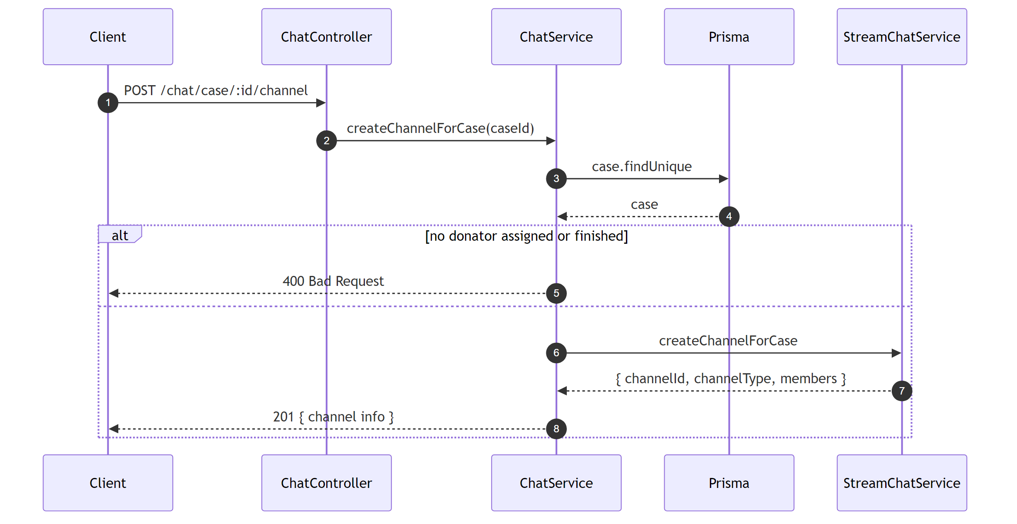
Figure 8.2 — POST /chat/case/:id/channel

8.4 Sequence Diagram — Token Generation
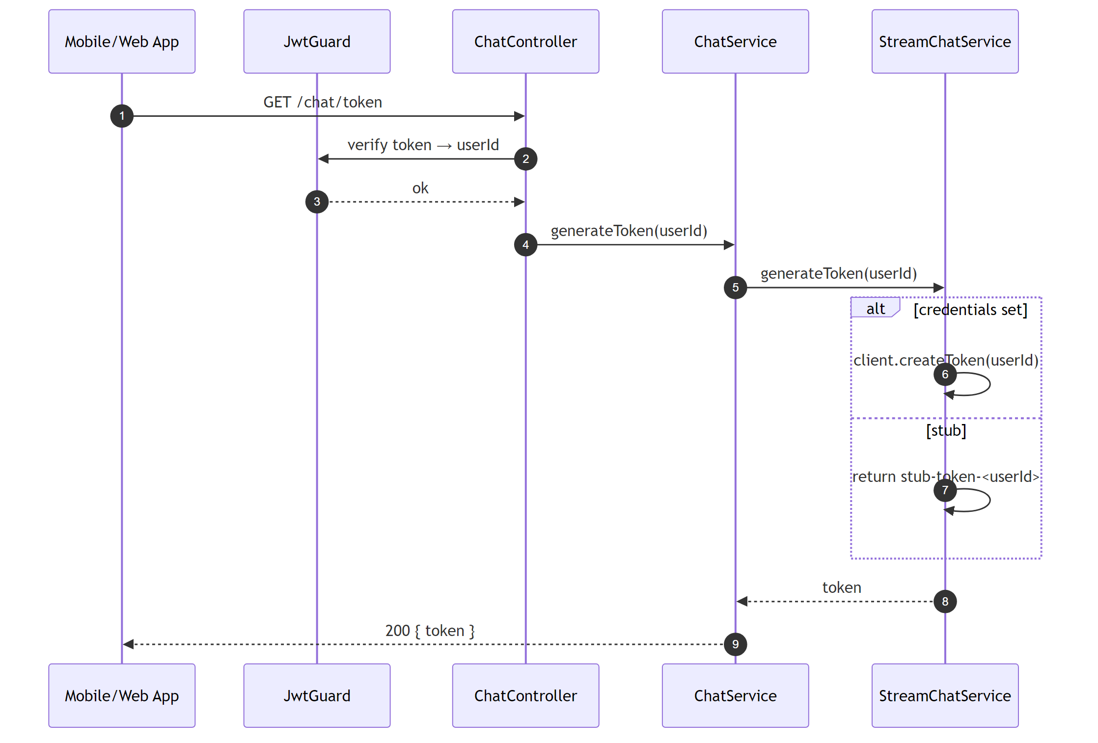
Figure 8.3 — GET /chat/token

9. VoIP Module (WebSocket)
Relays WebRTC signaling between two parties on the isolated /voip namespace. The backend only routes signaling messages (SDP offer, answer, ICE candidates); actual audio streams flow peer-to-peer. JWT is verified from handshake.auth.token and stale sockets for the same user are disconnected.

9.1 Test Cases
ID | Description | Preconditions | Steps | Expected Result
VO-01 | Reject /voip connection without valid token | — | Connect /voip with fake token | Disconnected
VO-02 | Relay call:offer to target as call:incoming | Caller + callee connected | Caller emits call:offer | Callee receives call:incoming { callerId, caseId, sdpOffer }
VO-03 | Relay call:answer as call:answered | Both connected | Callee emits call:answer | Caller receives call:answered { calleeId, sdpAnswer }
VO-04 | Relay call:ice-candidate bidirectionally | Both connected | Peer A emits candidate | Peer B receives call:ice-candidate { fromId, candidate }
VO-05 | Relay call:end as call:ended | Both connected | A emits call:end targeting B | B receives call:ended { fromId }
VO-06 | Offer to offline target returns ack error | Only caller connected | Emit call:offer to non-connected target | Ack { ok:false, error:"target offline" }

9.2 Sequence Diagram — VoIP Connection & Auth
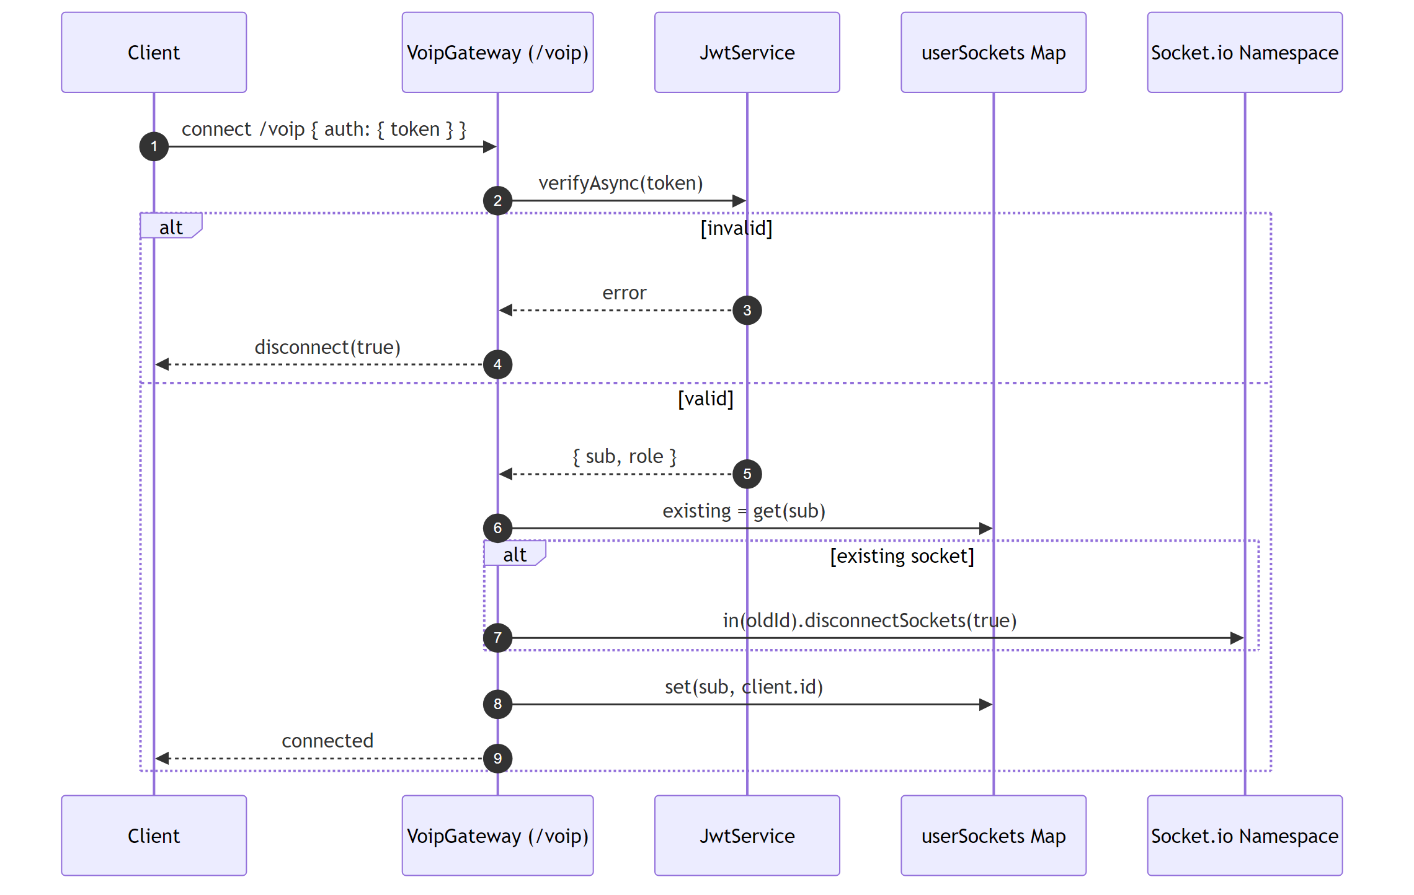
Figure 9.1 — /voip handshake + JWT check

9.3 Sequence Diagram — Call Offer
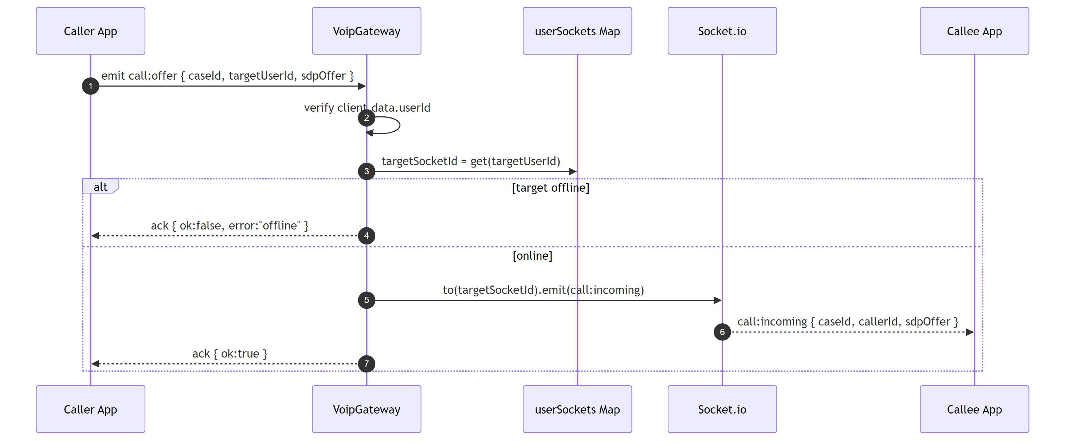
Figure 9.2 — call:offer → call:incoming

9.4 Sequence Diagram — Call Answer
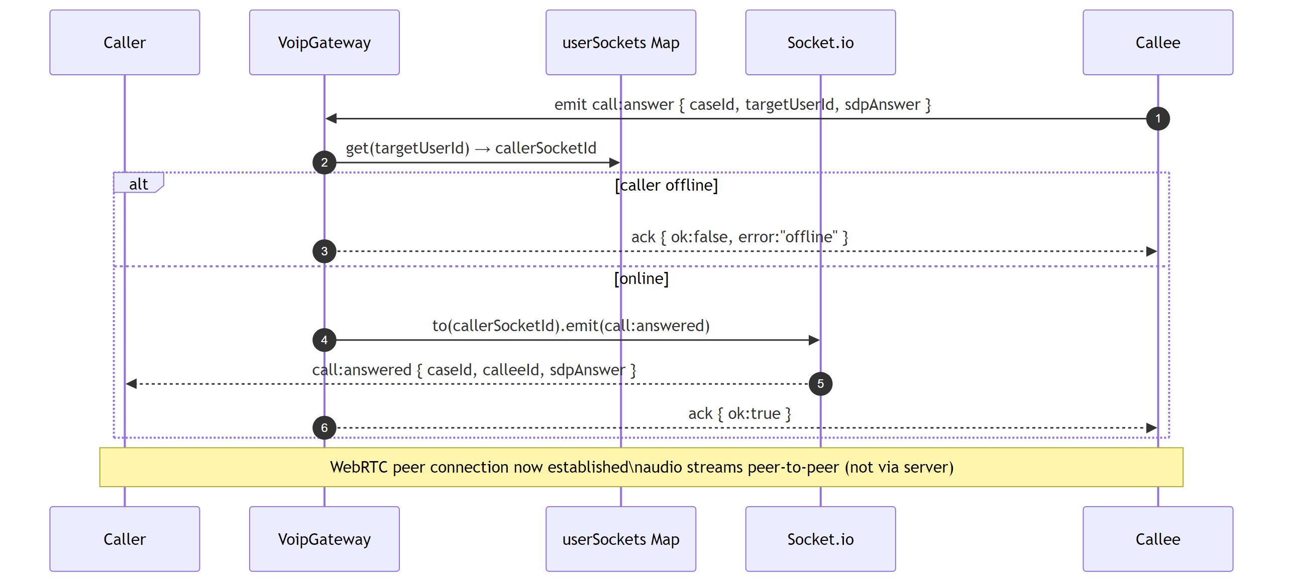
Figure 9.3 — call:answer → call:answered

9.5 Sequence Diagram — ICE Candidate Exchange
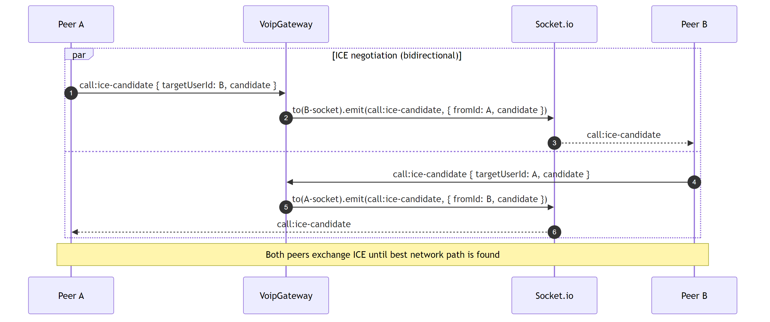
Figure 9.4 — Bidirectional call:ice-candidate relay

9.6 Sequence Diagram — Call End
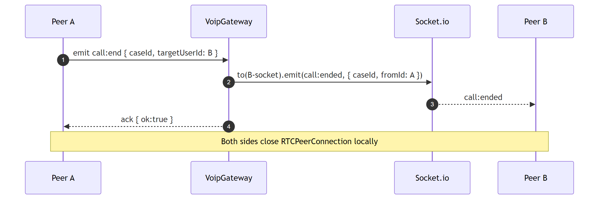
Figure 9.5 — call:end → call:ended

10. End-to-End Emergency Flow
The full life cycle, exercised by test/case-lifecycle.e2e-spec.ts.

10.1 Test Case
ID | Description | Preconditions | Steps | Expected Result
E2E-01 | Complete emergency response lifecycle | Dispatcher + Donator (available, verified, lat/lng) | POST /cases → alert → POST /accept → PATCH /ambulance-info → PATCH status ON_SCENE → PATCH /close → GET /cases/history | Case transitions OPEN→ASSIGNED→ON_SCENE→CLOSED; isBusy toggles true then false; history contains closed case.

10.2 Sequence Diagram — Full Lifecycle
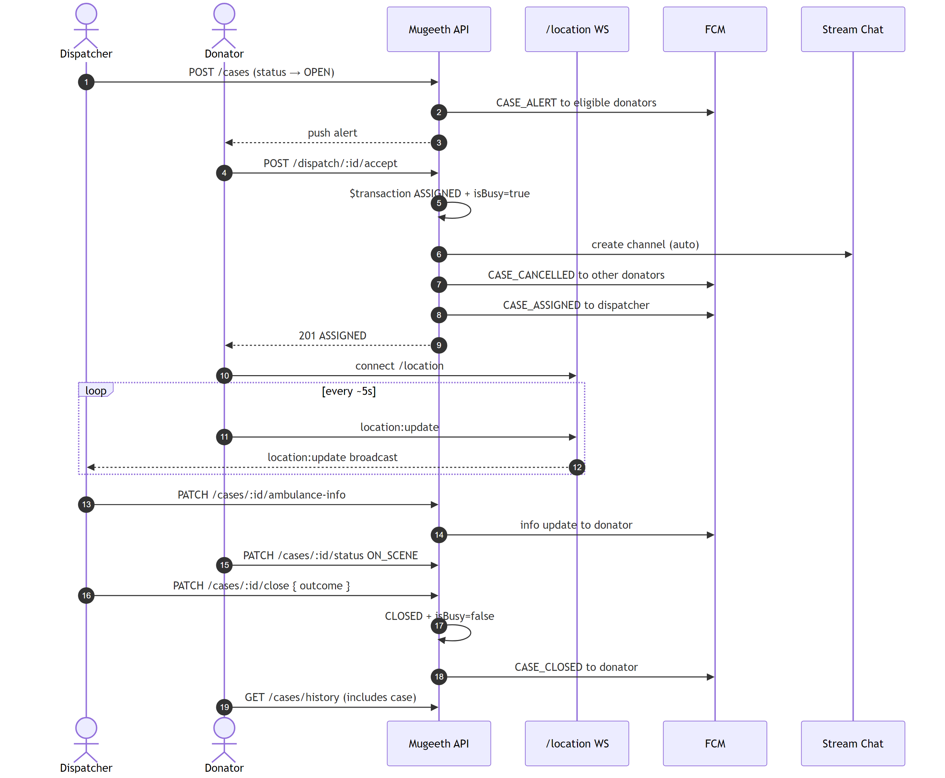
Figure 10.1 — End-to-end emergency response flow

11. Health Check
Liveness + readiness probe used by deployment platforms. Skips rate limiting via @SkipThrottle().

11.1 Test Case
ID | Description | Preconditions | Steps | Expected Result
HE-01 | Health endpoint returns DB status | PostgreSQL running | GET /health | 200 + { status: "ok", database: up }

11.2 Sequence Diagram — Health Check
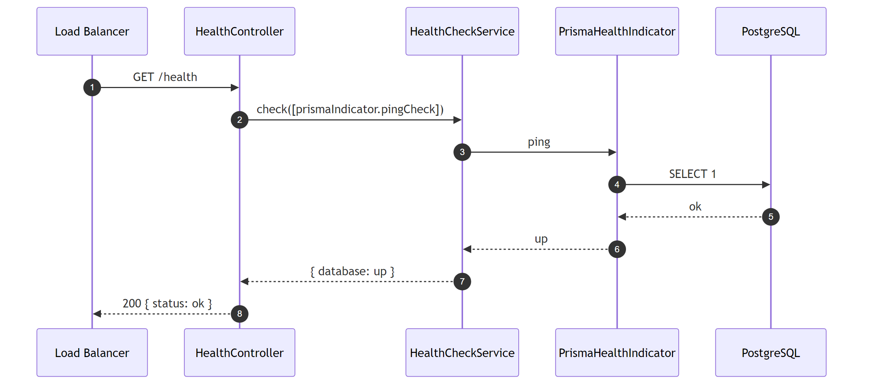
Figure 11.1 — GET /health

12. Additional Test Suites (Sprint 3)
Four additional Jest suites harden the system around guards, DTO validation, edge cases, and the pure math helpers used for distance and ETA.

12.1 Guards & Decorators Suite
File: test/guards.e2e-spec.ts — validates JwtGuard, RolesGuard, and @CurrentUser() decorator.
ID | Description | Preconditions | Steps | Expected Result
GU-01 | Valid Bearer token grants access | Registered user | GET /users/profile with Bearer | 200
GU-02 | Missing Authorization header | — | GET /users/profile | 401
GU-03 | Non-Bearer scheme (Basic) | — | GET /users/profile with Basic auth | 401
GU-04 | Malformed JWT | — | GET /users/profile with "not.a.jwt" | 401
GU-05 | Token with forged signature | — | GET /users/profile with token signed by wrong secret | 401
GU-06 | DISPATCHER can access /cases | Dispatcher auth | GET /cases | 200
GU-07 | DONATOR blocked from /cases | Donator auth | GET /cases | 403
GU-08 | ADMIN can verify donator | Admin auth | PATCH /users/:id/verify | 200
GU-09 | DISPATCHER cannot verify donator | Dispatcher auth | PATCH /users/:id/verify | 403
GU-10 | Only AMBULANCE_CREW can trigger /panic | All 4 roles tested | PATCH /cases/:id/panic | AMBULANCE_CREW 200; others 403
GU-11 | @CurrentUser extracts sub correctly | Registered user | GET /auth/me | 200 + own id

12.2 DTO Validation Suite
File: test/dto-validation.e2e-spec.ts — exercises class-validator rules across DTOs.
ID | Description | Preconditions | Steps | Expected Result
DV-01 | RegisterDto: missing name | — | POST /auth/register without name | 400
DV-02 | RegisterDto: empty password | — | POST /auth/register with password "" | 400
DV-03 | RegisterDto: forbidNonWhitelisted | — | POST /auth/register with role="ADMIN" | 400
DV-04 | UpdateProfileDto: non-numeric latitude | Authed | PATCH /users/profile with latitude="abc" | 400
DV-05 | UpdateProfileDto: invalid date | Authed | PATCH /users/profile with certExpiry="yesterday" | 400
DV-06 | CreateCaseDto: missing severity | Dispatcher | POST /cases without severity | 400
DV-07 | CreateCaseDto: short address | Dispatcher | POST /cases with address="x" | 400
DV-08 | CreateCaseDto: invalid latitude range | Dispatcher | POST /cases with latitude=500 | 400
DV-09 | CreateCaseDto: radiusKm > 50 | Dispatcher | POST /cases with radiusKm=999 | 400
DV-10 | UpdateStatusDto: invalid status | Assigned case | PATCH /cases/:id/status with status="XYZ" | 400
DV-11 | CloseCaseDto: outcome < 5 chars | ON_SCENE case | PATCH /cases/:id/close with outcome="ok" | 400
DV-12 | PaginationQuery: page=0 | Dispatcher | GET /users/donators?page=0 | 400
DV-13 | PaginationQuery: limit > 100 | Dispatcher | GET /users/donators?limit=500 | 400

12.3 Edge Cases Suite
File: test/edge-cases.e2e-spec.ts — verifies 404/409 behavior, illegal transitions, and history filtering.
ID | Description | Preconditions | Steps | Expected Result
EC-01 | GET /cases/:id returns 404 for unknown id | Dispatcher | GET /cases/<zero-uuid> | 404
EC-02 | PATCH status on unknown case | Dispatcher | PATCH /cases/<zero-uuid>/status | 404
EC-03 | Closing a CLOSED case returns 400 | Case CLOSED | PATCH /cases/:id/close | 400
EC-04 | Accepting non-OPEN case fails 409 | Case EXPIRED | POST /dispatch/:id/accept | 409
EC-05 | Geocoding failure without coords | Dispatcher | POST /cases with gibberish address + no lat/lng | Either 201 (OSM resolved) or 400
EC-06 | Donator history shows only own assigned cases | Donator + 2 closed cases (1 assigned) | GET /cases/history | 200 + 1 case only
EC-07 | Chat channel 404 for unknown case | Authed | POST /chat/case/<zero>/channel | 404
EC-08 | Accept when own user is deleted | Token issued, user deleted | POST /dispatch/:id/accept | 404

12.4 Distance & ETA Helpers Suite
File: test/location-eta.e2e-spec.ts — pure unit tests for haversineDistanceKm and estimateEtaMinutes used by the dispatch matcher and location gateway.
ID | Description | Preconditions | Steps | Expected Result
LE-01 | Zero distance for identical coords | — | haversineDistanceKm(A, A) | ≈ 0 km
LE-02 | ≈0.5 km for very close points | — | lat 21.4225 vs 21.427, same lng | 0.45 < d < 0.55 km
LE-03 | Makkah → Jeddah ≈ 70 km | — | (21.4225, 39.8262) to (21.4858, 39.1925) | 60 < d < 90 km
LE-04 | Distance is symmetric | — | dist(a,b) vs dist(b,a) | equal
LE-05 | Antipodal points ≈ 20 000 km | — | (0,0) to (0,180) | 19 000 < d < 20 100 km
LE-06 | ETA 0 minutes for zero distance | — | estimateEtaMinutes(0) | 0
LE-07 | ETA ≈ 15 min for 10 km at 40 km/h | — | estimateEtaMinutes(10) | 15
LE-08 | ETA ≈ 75 min for 50 km | — | estimateEtaMinutes(50) | 75
LE-09 | ETA rounds to integer minutes | — | estimateEtaMinutes(3.3) | integer

Appendix A — Cross-cutting Protections

A.1 Security Layers
- Helmet middleware: HSTS, X-Content-Type-Options, X-Frame-Options.
- @nestjs/throttler: 100 req/min per client.
- JwtGuard per controller; JWT expiry = 24h (SRS REQ-5.3.3).
- RolesGuard + @Roles() enforces role-based access.
- Global ValidationPipe with whitelist + forbidNonWhitelisted + transform.

A.2 Database Indexes (Performance)
- users: (role, isAvailable, isBusy) — fast dispatch matching.
- cases: (status), (status, expiresAt), (assignedToId).
- notifications: (userId, read), (userId, createdAt).

A.3 Test Execution
npm run test:e2e
Expected output: 14 test suites passed, 114 tests passed.

A.4 Test Files Inventory
- auth.e2e-spec.ts (10 tests) — Sprint 1
- users.e2e-spec.ts (14 tests) — Sprint 1
- notifications.e2e-spec.ts (9 tests) — Sprint 1
- cases.e2e-spec.ts (15 tests) — Sprint 2
- dispatch.e2e-spec.ts (7 tests) — Sprint 2
- chat.e2e-spec.ts (5 tests) — Sprint 2
- case-lifecycle.e2e-spec.ts (1 test) — Sprint 2
- location.e2e-spec.ts (3 tests) — Sprint 2
- namespace.e2e-spec.ts (3 tests) — Sprint 2
- voip.e2e-spec.ts (6 tests) — Sprint 3
- guards.e2e-spec.ts (11 tests) — Sprint 3
- dto-validation.e2e-spec.ts (13 tests) — Sprint 3
- edge-cases.e2e-spec.ts (8 tests) — Sprint 3
- location-eta.e2e-spec.ts (9 tests) — Sprint 3

A.5 FLAWS Resolved
- FLAW #1 — Case expiry cron implemented.
- FLAW #2 — Donator location REST fallback.
- FLAW #3 — Ambulance info endpoint.
- FLAW #4 — Panic button restricted to AMBULANCE_CREW.
- FLAW #5 — Chat channel auto-created on accept.
- FLAW #6 — Location gateway on isolated /location namespace.
- FLAW #7 — Stale socket cleanup on reconnect.

