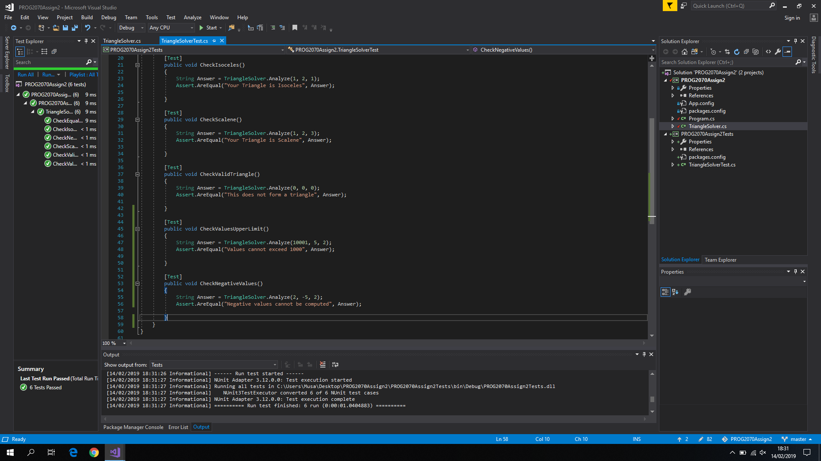

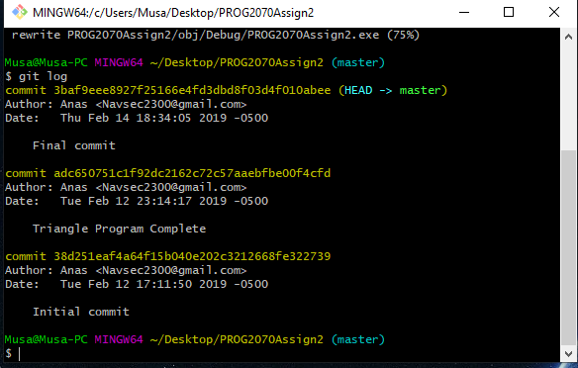

The test cases that I chose are as follows:

* Checking to see if the triangle is an Equilateral
* Checking to see if the triangle is an Isoceles
* Checking to see if the triangle is a Scalene
* Checking to see if the user inputs empty values
* Checking to see if the user inputs negative values
* Checking to see if the user exceeds the upper value limit

That last one is due to the fact that I capped the triangle calculations to 1000. I could also have made a lower limit as well to test for. Everything else is to sort of “push” the user towards an ideal triangle, that does not have negative or empty values, nor does it have ludicrous proportions or stretch to infinity.