# **Mango Leaf Disease Classification Model Documentation**

## **Introduction**

This documentation provides an overview of a Mango Leaf Disease Classification Model deployed on Streamlit. The purpose of this project is to assist mango farmers and researchers in identifying diseases in mango leaves accurately and quickly, enabling timely intervention to prevent crop damage.

## **Project Components**

**Mango Leaf Disease Dataset:** A dataset containing images of mango leaves with different disease conditions. The dataset is used to train and evaluate the classification model.

**ResNet50 Model:** A deep learning convolutional neural network (CNN) architecture known for its high accuracy in image classification tasks.

**Streamlit:** An open-source Python library for creating web applications with minimal effort. In this project, Streamlit is used to create a user-friendly interface for classifying mango leaf diseases using the trained ResNet50 model.

**Deployment Platform:** The model is deployed on a [streamlit web server](https://mango-leaf-disease-app-omdena.streamlit.app/), making it accessible via a web browser.

## **Model Training**

**Data Preprocessing**

The mango leaf dataset is preprocessed used by ResNet50 model using preprocessing function tf.keras.applications.resnet50.preprocess_input. This helps improve the model's ability to generalize to different leaf images.

**Model Architecture**

The ResNet50 architecture is used as the backbone for the classification model. It consists of 50 layers and employs residual connections, allowing the model to learn deep representations effectively.

**Training Process**

The model is trained using a portion of the dataset for several epochs, with a categorical cross-entropy loss function and the Adam optimizer. Training is performed on a GPU for faster convergence.

**Model Evaluation**

After training, the model's performance is evaluated using a separate validation dataset to ensure its accuracy and generalization capabilities. Evaluation metrics such as accuracy, precision, recall, and F1-score are calculated which are given below:

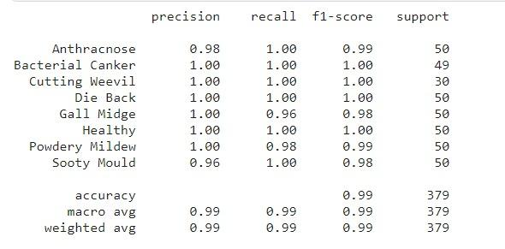

## **Model Deployment with Streamlit**

The trained ResNet50 model weights are integrated into a [Streamlit web application](https://mango-leaf-disease-app-omdena.streamlit.app/). Users can upload an image of a mango leaf, and the model will classify it into one of the following categories:

* Healthy
* Anthracnose
* Die Back
* Powdery Mildew
* Bacterial Canker
* Cutting Weevil
* Gall Midge
* Sooty Mould

**User Interface**

The Streamlit interface is designed to be user-friendly, with the following features:

* An upload button to select an image for classification.
* Display of the uploaded image along with the predicted disease class.
* A user-friendly and intuitive design.

**Model Inference**

When a user uploads an image, the model performs inference and displays the predicted disease class.

## **Running the Application Locally**

To run the Mango Leaf Disease Classification Model app deployed on Streamlit locally, follow these steps:

1. Clone the project [repository](https://github.com/waqar-ahmed91/mango-leaf-disease-omdena) to your local machine.
2. Install the required Python packages specified in the **requirements.txt** file.
3. Run the Streamlit app using the command “**streamlit run app.py**”.
4. Access the application via your web browser.

## **Conclusion**

This documentation provides an overview of the Mango Leaf Disease Classification Model deployed on Streamlit using the ResNet50 model. By making this model accessible through a web interface, it becomes a valuable tool for farmers and researchers to quickly and accurately diagnose mango leaf diseases, leading to improved crop management and yield.