***Flexibility Matters: Impact Assessment of Small and Medium Enterprises Flexibility on the German Energy Transition***

***Anas Abuzayed***1,2[1]***, Mario Liebensteiner***2***, Niklas Hartmann***1

1: Offenburg University of Applied Sciences, Badstr.22A, 77652 Offenburg, Germany

2: Friedrich-Alexander-Universität (FAU) Erlangen-Nürnberg, Lange Gasse 20, 90403 Nuremberg, Germany

**Keywords:** Demand response, Industrial energy flexibility, Energy transition, Power system modelling, Decarbonization

**Highlights:**

1. **SME offer significant system flexibility to avoid conventional thermal flexibility**
2. **Leveraging SME flexibility requires careful design to maximize their benefits**
3. **Wind FLH falls below 1500, and hydrogen storage is avoided**
4. **SME flexibility reduces 12Mt CO2 and saves 2.4B Euros in transition costs**
5. **Despite a high share of renewables, the wholesale electricity price remains high**

**Abstract**

This study analyzes the transition of the German electricity system towards climate neutrality by 2045, considering the demand-flexibility from small and medium enterprises (SMEs). Using an expansion model, a massive shift to renewable energy is required, primarily from solar and wind, with storage technologies playing a crucial role. The research uncovers the potential of flexibility from often-overlooked industrial SME sector, challenging their historical neglect in energy models and national strategies. As Germany stands at the crossroads of decarbonization, this study emphasizes the indispensable role of SMEs in shaping a resilient and flexible energy system. Despite representing only a small fraction of peak load, SME flexibility contributes to a significant reduction in carbon emissions and transition costs, as well as a decreased reliance on other flexibility measures. However, careful design and incentivization strategies are vital to reap the full benefits of SME flexibility.

Challenges in achieving a secure electricity supply during extreme weather conditions in a 100% renewable system are identified, along with how SME flexibility helps to achieve climate neutrality. By 2045, wind power becomes vital for supply security and is operated as a dispatchable ramping-up technology. Storage flexibility, especially from batteries and hydrogen, becomes essential. The transition incurs substantial costs but is economically advantageous in the long run. Overcapacities from renewables allow for a higher degree of electrification, stronger sector coupling, and suggest the possibility of a local hydrogen production. The study provides valuable insights into how SME demand response can contribute to achieving a sustainable energy system, as well as the dynamics of a sustainable energy system, emphasizing the role of renewables and flexibilities.

**Graphical abstract**

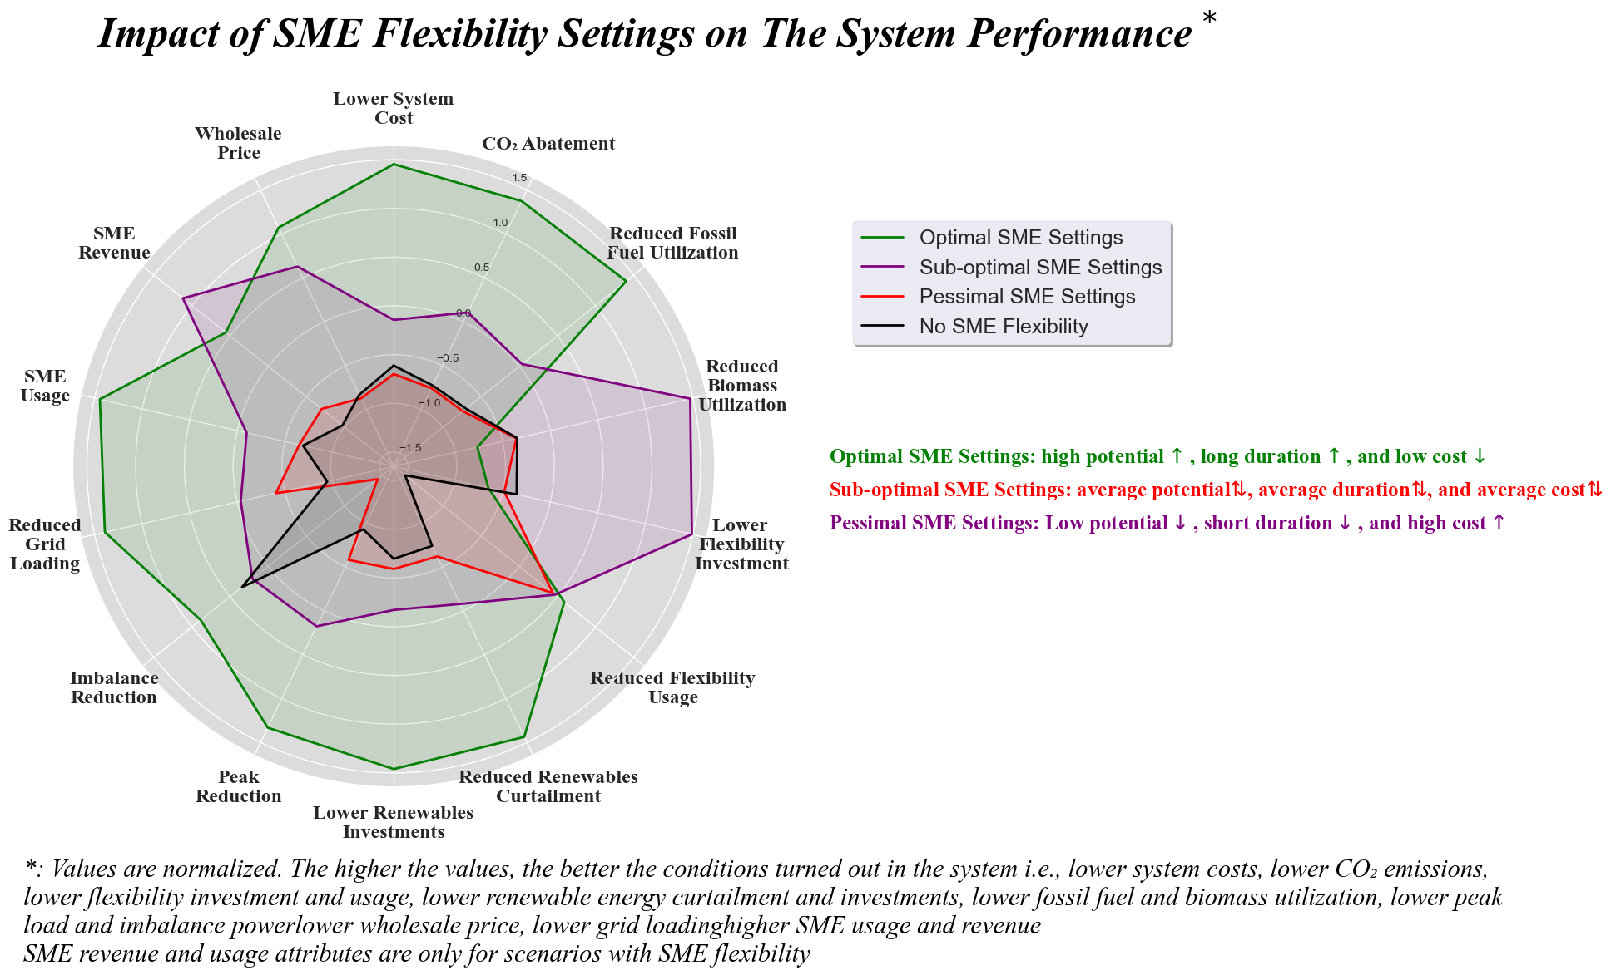

**Nomenclature**

|  |  |
| --- | --- |
| Symbol | Description |
| i | Year |
| t | Time |
| n | Network node |
| g | Generation technology (e.g. solar, onshore wind, gas, etc.) |
| s | Storage technology (e.g. battery, hydrogen, etc.) |
| D | Electrical demand |
| fd | Demand increase/decrease factor |
| Ԑ | Newly added capacity |
| Ӽ | Existing capacity |
| ӽ | Dispatch of existing generation capacity |
| ԑ | Dispatch of newly added generation capacity |
| ν | Added capacity of grid infrastructure expansion |
| Ԋ | Storage dispatch |
| Ü | Transmission technology (e.g. AC, DC, etc.) |
|  | Branch |
| κ | Annualized capital cost per unit capacity |
| o | Marginal cost per unit dispatch |
| P | Nominal power of SME flexibility |
| sc | Industrial sector |
| Δ | Power availability for SME flexibility |
| E | SME flexibility dispatch |
| M | Marginal cost for SME flexibility |
| m | Assigned marginal cost for SME flexibility |
| Fp | SME flexibility potential in percentage |
| X | Assigned SME flexibility duration in hours |

**Glossary**

|  |  |
| --- | --- |
| **Abbreviation** | **Description** |
| CCGT | Combined-cycle gas turbine |
| CCS | Carbon Capture and Storage |
| CO2 | Carbon Dioxide |
| DSM | Demand side management |
| Dunkelflaute | German for dark lulls |
| Energiewende | German for energy transition |
| ESO | Electricity system operator |
| FLH | Full load hours |
| Gt | One billion tonnes |
| GWh | Gigawatt hours |
| H2 | Hydrogen |
| Mt | One million tonnes |
| MWh | Megawatt hours |
| NUTS3 | Nomenclature of Territorial Units for Statistics, level 3 |
| OCGT | Open-cycle gas turbine |
| PtX | Power-to-X |
| RES | Renewable energy systems |
| ror | Run-of-river power plant |
| SME | Small and Medium Enterprises |
| TWh | Terawatt hours |
| V2G | Vehicle-to-Grid |
| VRE | Variable renewable energy |

1. **Introduction**

Germany is steadfast in its commitment to achieve climate neutrality by 2045 [1], through the "Energiewende," a comprehensive energy transition plan. Central to this plan is the increased utilization of renewable energy sources, the enhancement of energy efficiency, and the gradual phase-out of conventional power plants. Higher hopes of fulfilling the country’s electricity generation from renewable sources by 2035 are already being intensely discussed following the Russian-Ukrainian war [2]. The energy sector in Germany is the leading source of greenhouse gas emissions, accounting for 256 million tonnes of CO2 [3], followed by other sectors, including industry, transport, as well as buildings and agriculture [4].

Ongoing research and legislations in Germany outline a future energy system fed by a high share of renewable energies, eliminating the necessity for conventional power plants [5] [6] [7] [8] [9]. While these measures set path for a sustainable and low-carbon energy system, they also present challenges, particularly in terms of flexibility. The success of the "Energiewende" heavily relies on the availability of flexibility in the energy system, particularly with the integration of higher shares of variable renewable energy (VRE) sources and the electrification of various economic sectors, such as industry and transportation [10] [11] [12] [13]. Flexibility is crucial for mitigating the intermittent nature of renewable energy generation and ensuring grid security, thereby preventing potential disruptions in energy supply [14] [15] [16] [17]. This study investigates the benefits of utilizing flexibility from small and medium enterprises (SME) in Germany’s industrial sector, and analyzes its impact on the overall system flexibility requirements.

The price volatility of electricity markets with higher shares of renewable energy has already become a challenge for grid operators and energy traders [18] [10] [19] [20]. With sunny or windy weeks in Germany, the prices tend to become negative more frequently, and vice versa during a “Dunkelflaute” i.e., dark lull. Between December 2012 and December 2013, 97 hours with a negative price were observed [21]. This number increased to more than 300 hours in 2023 [22], and is expected to increase further with a higher share of VRE [23]. Several studies concluded that a more flexible energy system is the key to prevent such phenomena [24] [25] [26].

The electricity system operator for Great Britain, National Grid ESO, classifies flexibility into four types: electricity system flexibility, supply side flexibility, storage system flexibility and demand system flexibility [27]. The electricity system flexibility, often referred to as grid infrastructure, is characterized by relatively lower storage levels and occasional insufficiency of transmission capacity [14] [27] [28]. In the pursuit of adequate flexibility, the energy system traditionally relied on the supply side flexibility, i.e., thermal power plants [29]. However, as Germany progresses towards a low-carbon future, the contribution of these conventional sources of flexibility will diminish [30]. Carbon capture and storage technologies (CCS) as well as other carbon reduction technologies may also turn out important, whereas their potential is not yet exploited [31] [27]. Thus, a decarbonization transformation of the energy system may require the exploitation of all other flexibility measures available.

Various types of storage flexibility are currently available in the market, each with different market shares and maturity levels [32] [33] [34]. It is crucial to identify these storage needs within the system, and most importantly, understand how they will affect and interact with the other flexibility measures [35] [36] [37] [38] [39]. Different flexibility technologies exist on the demand side, such as Power-to-X (PtX) and Vehicle to Grid (V2G), but their market contribution is currently uncommercialized and undersized to be decisive [40] [41] [42] [43]. Demand side management (DSM) in several sectors and its interaction with VRE generation will play a major role in future energy systems, but their full potential is yet to be realized [44] [16] [45] [15]. The potential of demand side management at an hourly timescale is mainly determined by the availability, duration and associated cost of flexible power capacity [30] [46] [14] [47]. It is therefore essential to classify the DSM by sector [48] [49].

The German industrial sector is energy intense. In 2021, it consumed around 213 TWh of electricity and emitted 183 million tons of CO2 [3] [50]. Multiple studies have emphasized the importance of significant electrification and energy efficiency improvements for decarbonizing the industrial sector [51] [52] [53]. Moreover, other studies highlight a considerable potential of the industrial sector for providing demand-side flexibility [46] [54] [55] [56]. Göransson et al. showed that electrification reduces total system cost and enables a faster transition towards climate neutrality [57]. Ramin et al. studied the technical requirements of the metal-casting industry for participation in the day-ahead and both energy and reserve Nordic markets [58]. They concluded that demand response has the potential serving as a secondary revenue stream for the industry as well as significantly reducing their energy costs. Wang et al. identified the flexibility provision from the energy-intense ladle furnaces and steel industry in China [59], where it was shown that they can provide a substantial amount of flexibility during peak times while reducing their electricity costs. Paulus and Borggrefe investigated the technical and economic potential of energy-intense industries in Germany [46]. They projected its benefits through 2030 in the reserve market, highlighting the potential for large-scale industries to make meaningful contributions to the balancing market [46]. Golmohamadi studied the demand flexibility within the global energy-intense industries and suggested that the value of industrial flexibility can be great for the energy systems [60] [55]. However, flexibility potentials in other industries are still unexplored and need further investigation.

German SMEs, widely regarded as the backbone of the country's economy, play an irreplaceable and indispensable role in driving innovation, creating jobs, and fueling economic growth, as they form 99.6% of the German firms [61]. The SME sector is responsible for around 60% of the jobs in the German market, 37% of total corporate turnover, and 57% of value added in Germany [62]. Despite the great similarities in processes amongst the different SME sectors, their energy consumption varies greatly [63], making it even more complicated to model this heterogeneous sector. This resulted in a wide negligence of their specific differences in energy system models [64] [65]. Therefore, obtaining a much deeper understanding of electrical load is critical, especially for industry sectors [64]. Despite their importance, there is currently no study that addresses the flexibility potential in the SME sector, leaving the flexibility potential of SMEs in the industrial sector largely untapped. The novelty of this research, is that it explores the flexibility potential within the industrial SME sector. Moreover, it characterizes and maps the SME’s demand with a high spatiotemporal resolution in Germany.

The aim of this study is to investigate the flexibility potential of the SME sector in Germany with regard to greenhouse-gas abatement from the energy sector and cost savings in the decarbonization transition. First, the decarbonization path shows the huge changes that the energy system in Germany will face, and identifies the flexibility requirements that will be needed to achieve climate neutrality. Then, by investigating the flexibility potential of SMEs, this study evaluates the benefits that the SME sector can offer to the broader goals of the national energy transition, as well as unlocking novel revenue streams for the sector. A comprehensive analysis of the impact of SME flexibility on system transition goals and other flexibility measures is provided, distinguishing its role in network congestion management. By addressing these objectives, this research aims to provide valuable insights into the role of SMEs in Germany's energy transition and contribute to the development of effective policies and strategies for achieving climate neutrality.

1. **Methodology**
   1. **Energy System Model: MyPyPSA-Ger**

For our analysis, we use an open-source capacity expansion model for the German electricity system, MyPyPSA-Ger. MyPyPSA-Ger is an open-source myopic optimization model developed to represent the German energy system, particularly focusing the electricity sector [66]. The model features a highly detailed mapping, incorporating spatial and temporal dimensions with up to 317 nodes in the electrical network and a temporal resolution of up to 8760 hours per year.

The model takes into account regional differences within Germany, considering diverse characteristics and potential in various areas. Utilizing a myopic optimization approach, the model considers shorter time horizons and a sequential decision-making process on a yearly basis to account for uncertainties in the energy system. Dynamic factors, such as changing technology investment costs and electricity demand, are taken into account over the planning horizon, allowing for a more realistic and precise modeling of the energy system. The model is introduced in detail in [66] and [67] (e.g., the cost assumptions, data processing, and model validation), and is available open-source [68].

* 1. **Industrial SME Sector Mapping**

Germany is considered a leader in many industrial domains, which includes the sectors of steel, copper and aluminum industry, chemicals industry, automotive industry, electronics industry, mechanical engineering along with many other areas of activities [69]. The largest energy consumer within the industrial sector is the chemical and petrochemical sector, with a share of 43% in 2017, followed by other industries such as metal production, on-metallic minerals, paper, machinery, food, and transport [70].

As the model in this study allows a high spatial disaggregation in Germany, this comes in line with a recent study, which showed significant regional differences in the industrial energy consumption [71]. This study evaluates the most three prominent manufacturing industries in Germany with the highest numbers of companies in the year 2020 which form together around 20% of the total industrial electricity demand in Germany. These industries are 1) manufacture of food products (4932 companies), 2) manufacture of fabricated metal products (7434 companies), and 3) manufacture of machinery and equipment (5456 companies) [72].

Despite the fact that various industries share similar processes and end uses, even in the same sector, their energy consumption patterns vary greatly depending on the final product. DemandRegio is an open-source database that provides temporal, spatial and sectoral disaggregation of electricity demand of all the economic activities of the industrial sector in Germany [73]. Synthetical load profiles for the different sectors of the industry are publicly available as open-source [74]. Mapping the industrial load profiles in a high spatial, temporal and sectoral resolution will require the combination of the two open-source datasets. By doing so, the load profiles per industry sector are available in a high temporal and spatial disaggregation level, and are accordingly integrated within the model MyPyPSA-Ger [66]. The mapping procedure is described subsequently in three steps.

Step 1: Regional disaggregation of DemandRegio

In the first step, we utilize the spatial disaggregation of DemandRegio, which is available per NUTS3 region [73]. This dataset provides information about the electrical demand for different industry type in different regions. To incorporate these demand profiles into the model, the electrical demand is then aggregated in a way that aligns with the spatial attributes of the model. The Great-Circle Distance Formula is therefore used. This formula considers the geographical distances between the regions and helps to accurately distribute the industrial electricity demand. The resulting spatial distribution of the demand in the MyPyPSA-Ger mode is represented in Figure 1.

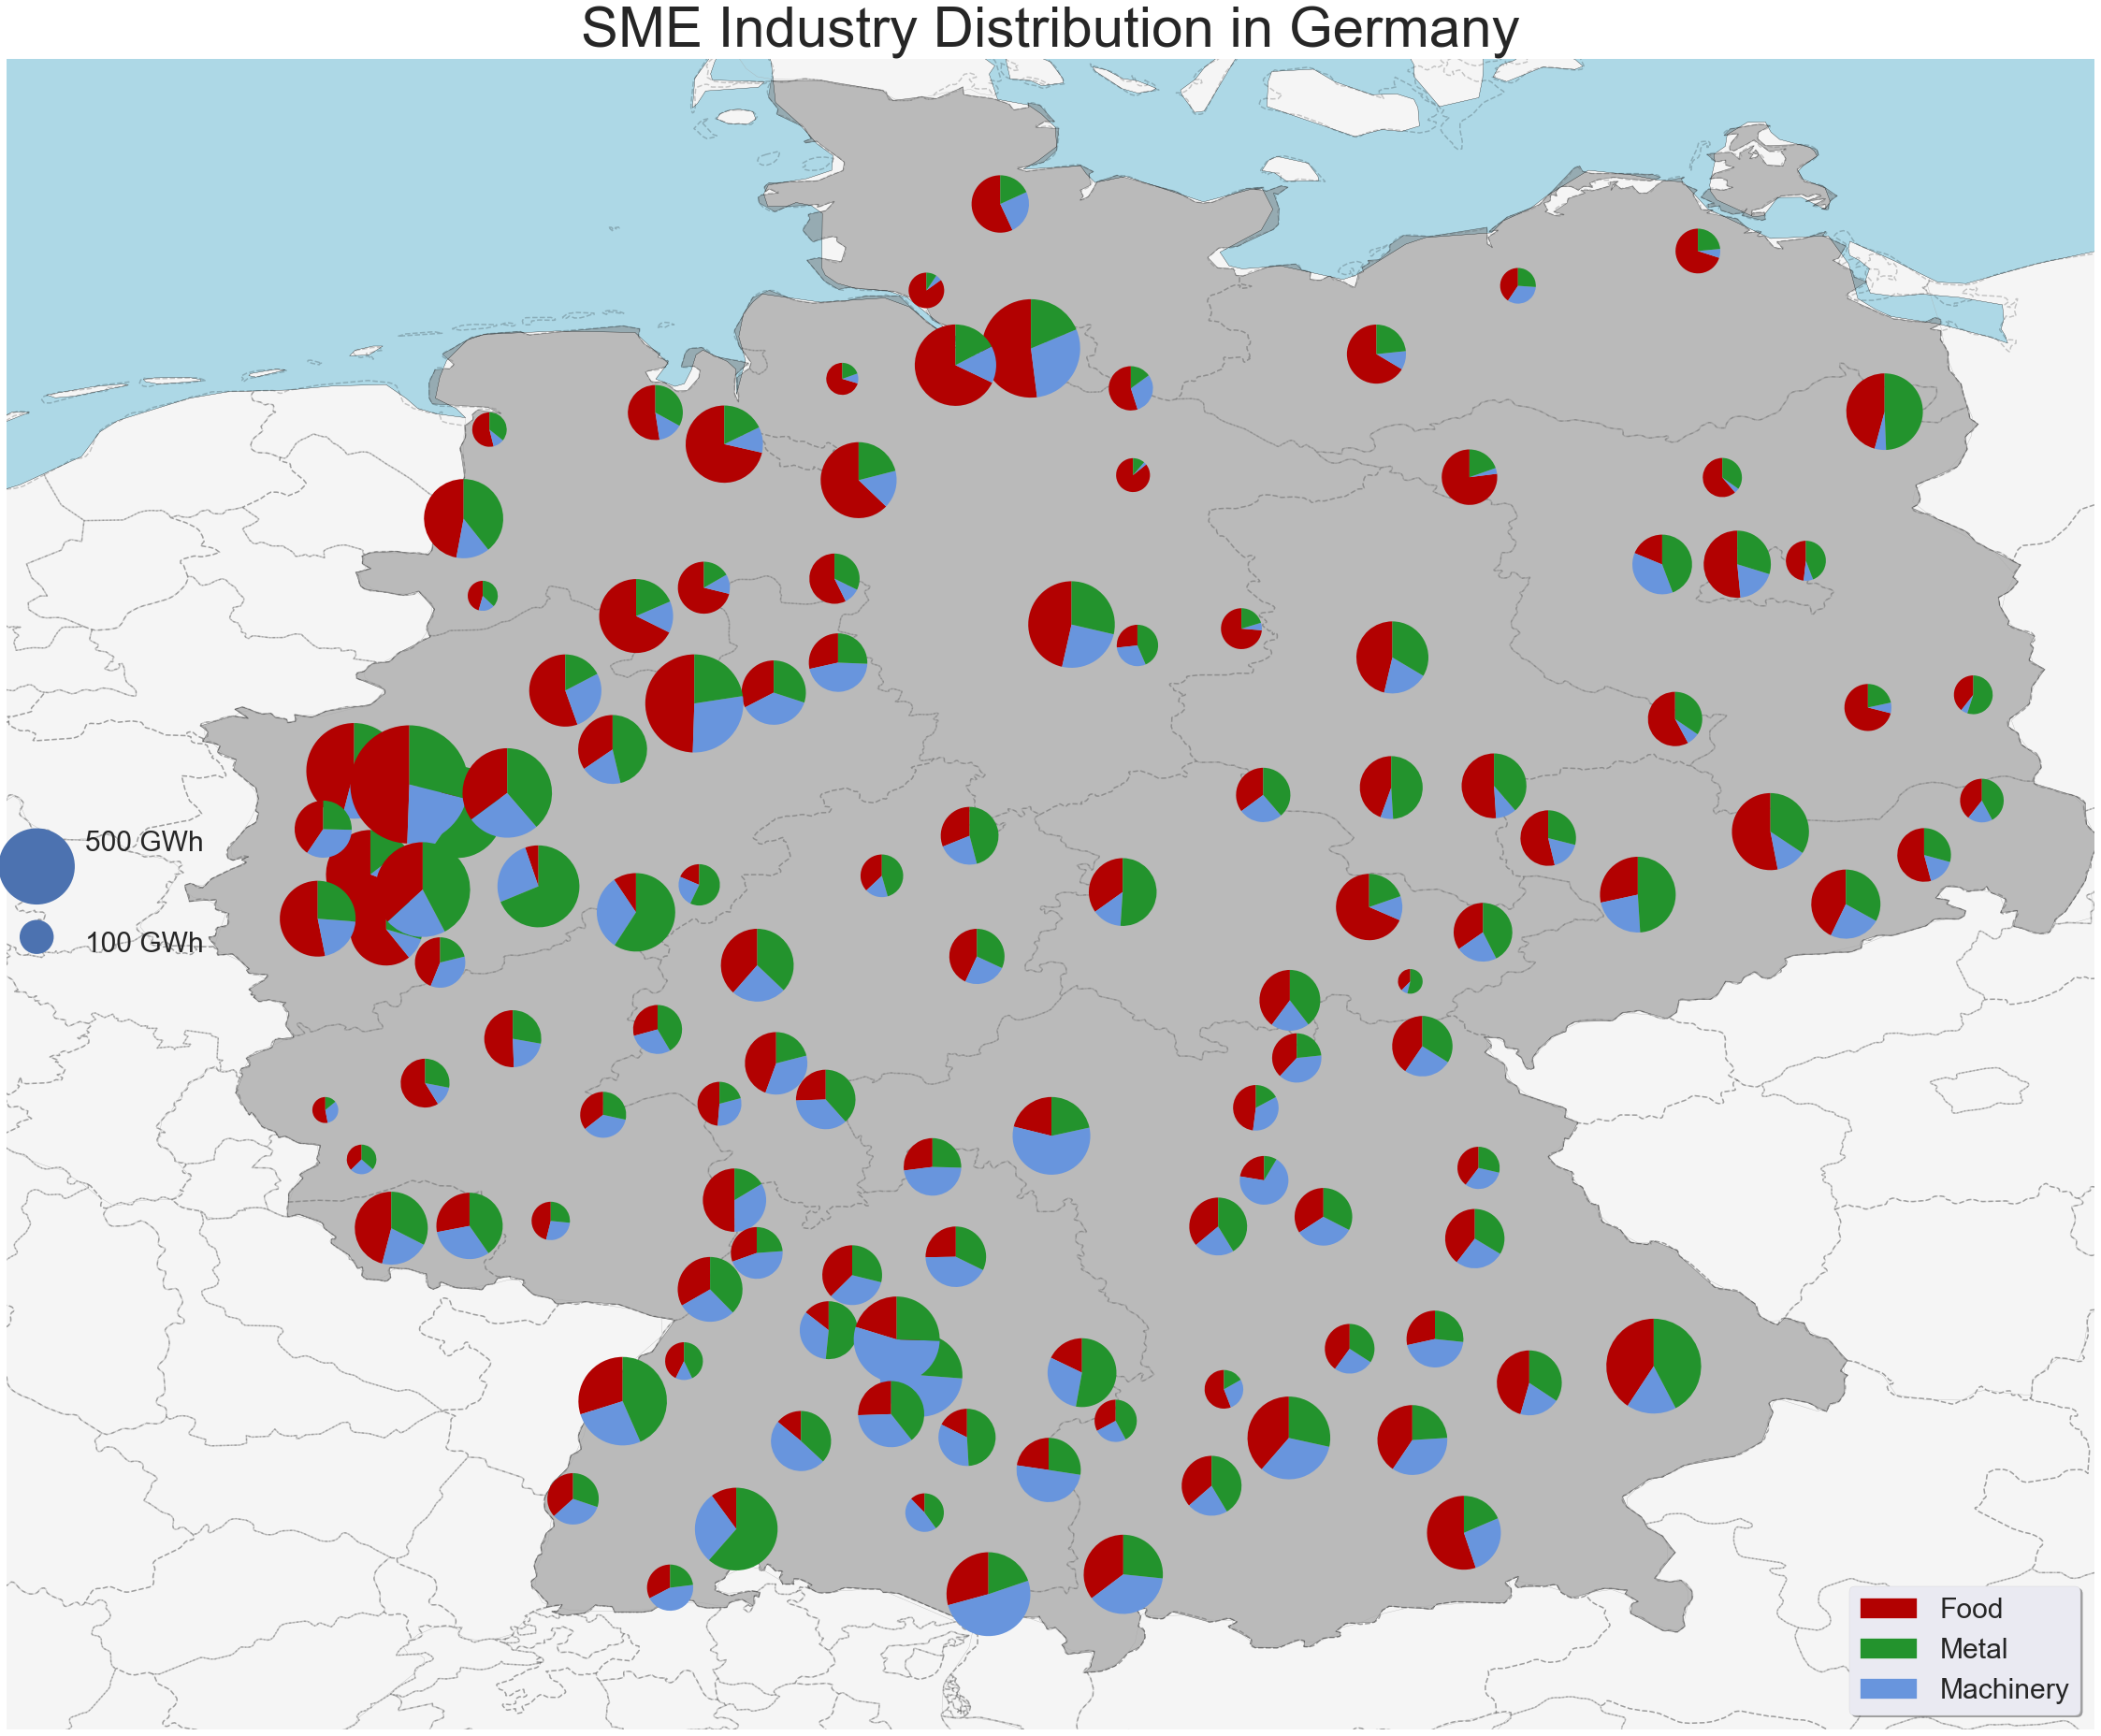

Figure 1: Industrial electricity demand in MyPyPSA-Ger model.

Step 2: Creation of industrial load profiles

In a second step, the normalized load profiles are used to generate basic load profiles specific to each industry type [74], because the load profiles serve as a representation of the electricity consumption patterns for the various industries. By combining the load profile of the industry with its corresponding manufacturing processes, a synthetic load profile is created. This profile provides a comprehensive view of the electricity consumption pattern for the industry. The result of this step, including the synthetic load profiles, is illustrated in Figure 2, demonstrating the combined information from the two open-source datasets.

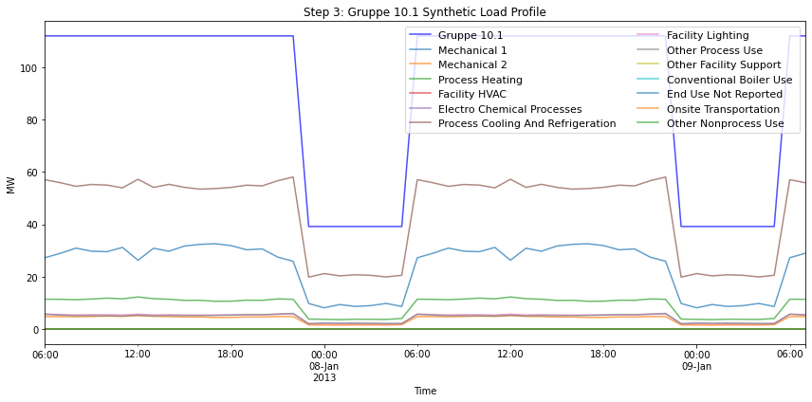

Figure 2: Synthetical Load profile after combining the two open-source datasets (SyntheticLoadProfiles and DemandRegio). The demand (Gruppe 10.1) is electrical demand from DemandRegio of the slaughtering and meat processing subsector from manufacture of food products sector. The resulting load profiles for different processes are the results of combining the Synthetical load profiles [74] and DemandRegio [73] this step.

Step 3: Mapping detailed electricity consumption within the model

As a final step, the industrial demand is available per node in the model. Figure 3 provides a visual representation of the detailed electricity consumption, enabling a deeper understanding of the electricity usage patterns within the model. Upon this, flexibility margins are defined for all parts of the industrial demand. This process is further discussed in section 2.3.

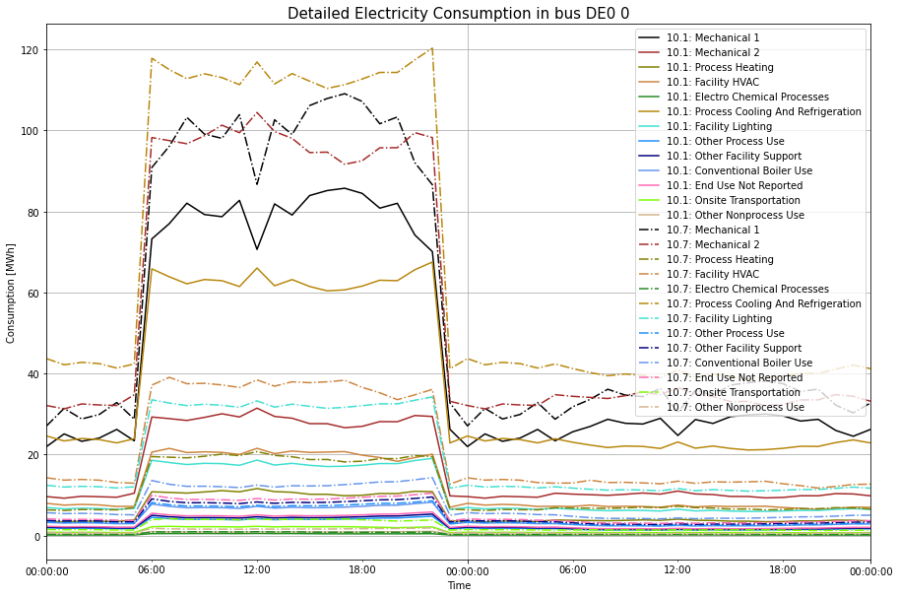

Figure 3: Detailed processes load profiles at an exemplary node (DE0 0) in the model.

* 1. **Model development**

Here, only changes to the original MyPyPSA-Ger model and the objective function are presented.

* + 1. Add flexibility

The flexibility component in the model is integrated as a storage unit, attached to each node of the model, with the ability for inter-temporal load shifting. Initially, the nominal power (P) of the SME flexibility is set to the maximum demand (*max*(D)) from each sector (sc) at each node (n) in the beginning of optimization period (year 2025), as explained in equation (1).

To represent the hourly changing industrial demand, the flexibility availability in percentage (*Δ*) for each sector (*sc*) at each time (*t*), node (*n*), and year (*i*) will be defined by the actual industrial demand (*D*) over the nominal power (*P*). This availability is defined as a fixed ratio over the optimization period, hence the constant year (i=2025):

* + 1. Define flexibility

Flexibility in the model is defined based on its three pillars: potential, duration, and cost. The three flexibility pillars are initially assigned in the model before the beginning of the optimization period (2025-2050). As further discussed in section 3, a sensitivity analysis is implemented on those three pillars with initial values at the beginning of the optimization (i.e., 20% flexibility potential, 8 hours flexibility duration, with a cost of 10 Euro/MWh). The flexibility duration is assumed to be fixed over the whole optimization horizon. However, the potential and cost will be changing dynamically each year.

The dispatch of SME flexibility (*E*) for each sector (*sc*) is constrained by a combination of the previously identified nominal power (*P*) and its availability (*Δ*), the assigned flexibility duration in hours (*Xs*), and the assigned flexibility potential in percentage (*Fp*). This is described in the following equation.

The dispatch of the storage unit can either be positive (extracting energy from the grid) or negative (discharging into the grid). Here, changes in the load are equivalent to advancing (LHS of equation 3) or postponing (RHS of equation 3) the demand to an earlier or later time, respectively.

The marginal cost of the flexibility (*M*) will be assigned as a constant cost (*m*) in the beginning of the optimization period (2025). Here, we assume that the marginal costs do not vary with output (flexibility), and that the time of use will not have an impact on the actual cost of flexibility.

For the purpose of this study, the time where flexibility can be used (*t*) is limited within a normal operation time for several industries as defined in equation (5).

* + 1. Update flexibility

As the electrical demand increases in the model due to the electrification of several sectors, the flexibility power available (*P*) from each sector (sc) will as well increase with the same demand growth rate (*fd*) on a yearly basis.

* + 1. Objective Function

The objective function of this model is constructed in [66] and [67]. However, an addition with respect to the industrial flexibility part is essential, as to construct the new objective function of the optimization problem in this study, with the goal to minimize the annual system cost:

It consist of **1)** the newly added generation capacity *(Ԑ)* at a certain year *(i)* for each technology *(g)* at each node *(n)* and their annualized capital cost *(κ)* per capacity; **2)** the dispatch of newly added generation capacity *(ԑ)* at a certain year *(i)* and time *(t)* for each technology *(g)* at each node *(n)* and their marginal cost *(**o)* per unit of generation; **3)** the dispatch of already existing added generation capacity *(ӽ)* at a certain year *(i)* and time *(t)* for each technology *(g)* at each node *(n)* and their marginal cost *(o)* per unit of generation; **4)** the newly added branch capacity (*v*) of a certain branch () of a transmission technology (Ü) at a certain year (i) along with their annualized capital cost (κ); **5)** the newly added storage capacity *(Ԑ)* at a certain year (i) for each storage technology (s) at each node (n) and their annualized capital cost (κ) per capacity; along with **6)** the positive dispatch (Ԋ+) of storage technologies (s) at a certain year *(i)* and time *(t)* at each node *(n)* with their associated marginal cost (*o*). On top of that, **7)** the positive dispatch of SME flexibility (*E*) technologies from each sector (*sc*) at a certain year *(i)* and time *(t)* at each node *(n)* with their associated marginal costs (*M*) is added to the total system cost. The optimization is implemented on a yearly basis with varying weather and demand conditions, with the goal of reducing the overall system cost on an annual basis and achieving climate neutrality by the year 2045.

1. **Scenarios Development**

The scenarios in this research aim to offer insights on the flexibility needs for enabling the climate neutrality in Germany. The model MyPyPSA-Ger allows for different scenario settings, such as, but not limited to, different CO2 allowance prices with different levels of emissions reduction, different learning rates for technologies, different fuel prices, different degrees of technologies’ innovation and flexibility measures needed to achieve climate neutrality, as well as different limits for the regional distribution of renewables technologies.

The future electricity demand will be driven by the electrification of the heat and industrial sectors, as well as a shift towards electric mobility [75]. Hence, a 1% annual increase in demand is set to reach around 730 TWh by the year 2050. This would represent a scenario of a modest level of electrification in various sectors. A Huge grid development is expected in Germany to allow for the integration of different renewable energy resources. Thus, the grid development is enabled in the model. The storage and generation technologies are constrained on a yearly basis as in Table 1.

Table 1: Summary of scenarios limits on generation and storage expansion.

|  |  |  |
| --- | --- | --- |
|  | **Value** | **Unit** |
| **Regional potential for expansion of generation technologies** | *4* | *GW/Region/a* |
| **Yearly potential for expansion of renewable generation technologies** | *50* | *GW/a* |
| **Yearly potential for expansion of conventional (Gas) generation technologies** | *6* | *GW/a* |
| **Yearly potential for expansion of storage technologies** | *22* | *GW/a* |

To focus on identifying the flexibility measures needed and the impact of SME’s flexibility on the national energy transition, a constant CO2 allowance price of 75 Euro/ton is implemented. To go in line with the national CO2 reduction plan, 65% reduction by 2030 is planned, 88% by 2040, and a completely climate neutral energy system by the year 2045[2]. The yearly reduction of CO2 emissions is implemented on a linear basis. By law, coal and lignite-fired power plants are set to be phased out by latest 2038, with an option to end it by 2035 [76]. This is adapted in the model on a linear basis. The investment and operating cost development of several technologies highly affect the results. Therefore, several studies were previously analyzed to follow the modest assumptions in [66] and [67]. The cost assumptions are summarized in Table A 1 and Table A 2. In all scenarios, a linear adaption path is applied on the cost development, demand growth, and coal phase-out.

To conduct a sensitivity analysis on the SME flexibility, different assumptions are made. Flexibility on industrial plants comes with an extra cost on the industrial plant itself. Therefore, different cost assumptions ranging between 0.01 to 0.1 Euro/kWh are assigned to SME flexibility. The flexibility cost is assumed to be constant over the optimization period as well as the flexibility duration. The flexibility cost in this study was designed around the industries electricity price cap proposed by the German federal government, in order to investigate if the flexibility cost needs to be subsidized [76].

Different potentials will be assigned from the available nominal power of SME’s demand, along with several temporal settings from 1 to 8 hours to represent load shifting within one working shift (8 hours). The three SME sectors that will provide flexibility has a total of 41.9 TWh electricity consumption (refer to Figure 1). However, following the constraints from the design parameters (potential and duration), they can provide a maximum of 6.7 TWh. These settings go in line with a recent energy audit on several SME sectors to identify the potential of SME flexibility [77]. The electrification process will be as well facing the SME sector. Therefore, the available flexibility will be increasing by an 1% annually.

By means of scenarios, 128 scenarios are conducted to investigate the impact on the SME flexibility on the system transition as well as on other flexibility measures. Moreover, the sensitivity analysis will be conducted to investigate the impact of the SME flexibility settings on their usage and benefits to the system. The scenarios, implemented and compared to a reference scenario; where no SME flexibility is available, are summarized in Table 2.

Table 2: SME flexibility scenario settings.

|  |  |
| --- | --- |
|  | **Assumptions** |
| **Cost**  (Euro/kWh) | *0.01, 0.05, 0.07, 0.1* |
| **Flex Potential**  (% of Full Load) | *5, 10, 15, 20* |
| **Maximum duration**  (Hours) | *1-8 hours* |
| **Time of Flexibility** | *Intraday*  *6AM-9PM* |

1. **Results and Discussion**
   1. **Utilization and design of Small and Medium (SME) flexibility**

This section summarizes the main results on SME flexibility. The results essentially compare a baseline scenario of reaching climate neutrality by 2050 without utilizing SME flexibility relative to a counterfactual that uses the available SME flexibility. The flexibility coming from SME represents only a small fraction of the peak load, representing at maximum less than 1% of the peak load. This makes its impact of a limited size on the system transformation. However, following the scenarios analysis, the SME’s flexibility turned out to have a huge impact on the system transformation goals as well as the usage of other flexibility measures and fuel-fired power plants.

The usage of SME flexibility heavily depends on how its settings are designed. SME costs have a high impact on the SME flexibility utilization level, but are not the sole determinant. A combination of settings between duration, cost, and potential essentially determines how much of SME’s flexibility the system utilizes. This allows for a creation of a priority matrix when designing such flexibilities for system operators.

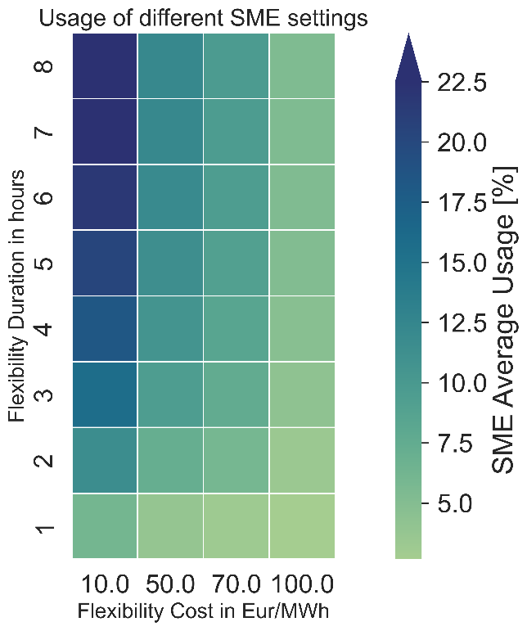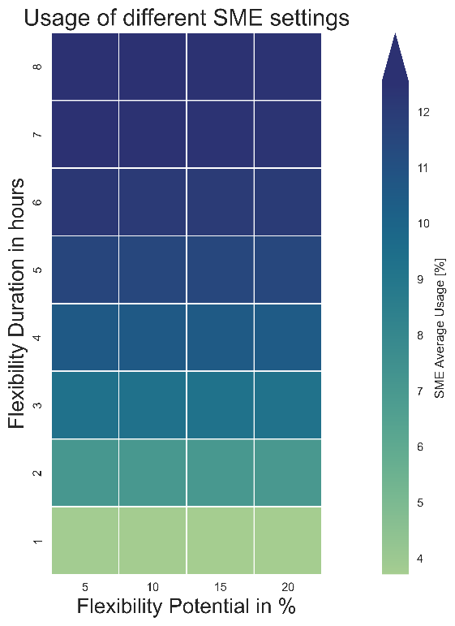

Figure 4:SME’s average usage with different settings.

Figure 4 shows the average usage rates of SME flexibility. SME cost has the highest impact on how much of the SME flexibility is actually used. The duration of SME flexibility plays an important role as well. This leaves potential in the last priority when deciding how much of SME flexibility to be used. Moreover, with the higher amounts of energy coming from nearly-zero marginal cost renewable energy and the added storage flexibilities, SME flexibility is used less and less around and after 2045 (Figure 5), making it only an option during longer dark lulls “Dunkelflaute”, or when the system has higher flexibility needs to operate. Utilization rates of SME flexibility get very low post-2045 compared to pre-2045. This raises the question whether the SME flexibility pre and post climate-neutrality should be incentivized by the state, for example through subsidy payments

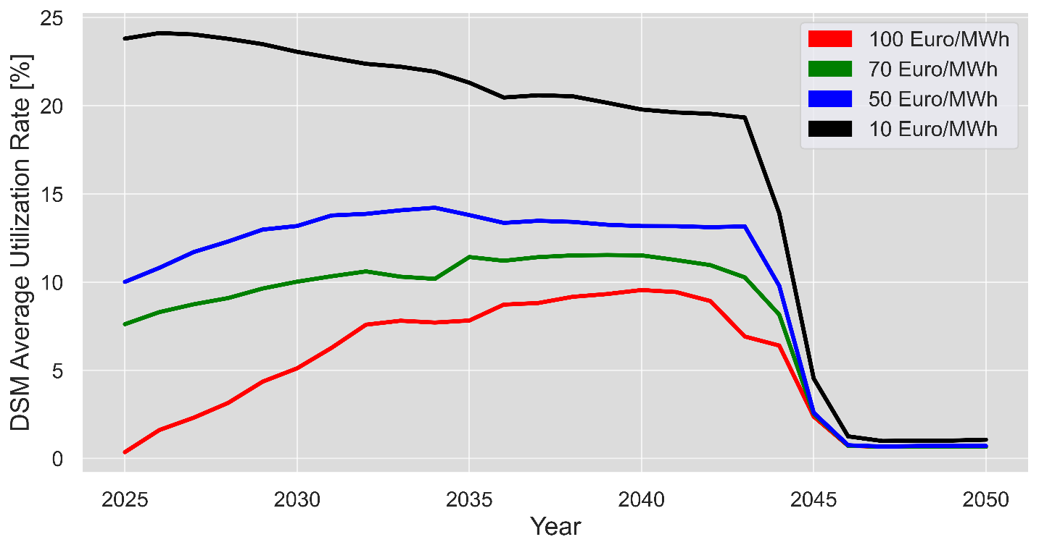

Figure 5:SME’s average usage rate over the years.

The total load shifting capability of the SME turns out to be a direct translation of which flexibility setting should be given priority. Higher potential (Figure 6a), lower cost duration (Figure 6b), and most importantly, longer duration (Figure 6a and b) are the decisive factors affecting how much SME flexibility can be used. Higher potential means higher MW ranges that can be used, with a longer duration that is translated into more MWh used, all at lower costs so that it can compete with other flexibility measures. This is critical, especially before 2045, as the system did not yet have enough storage and grid flexibility integrated to help balance the massive load-generation mismatch.

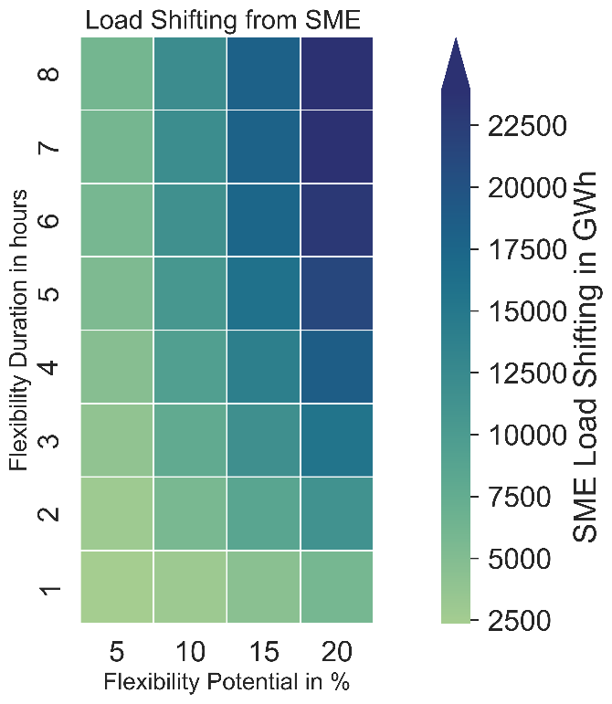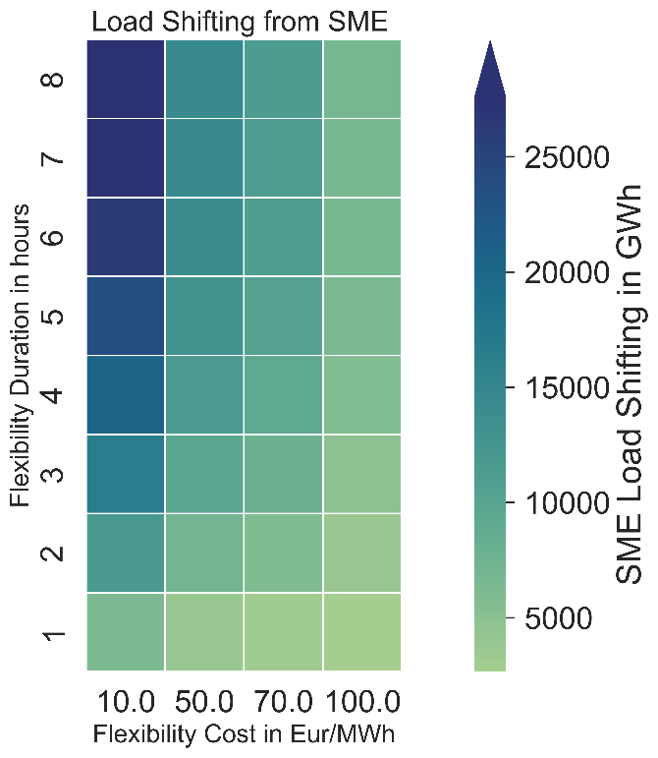

(a) (b)

Figure 6:SME’s average shifting capabilities over the years.

The total cost of the used SME flexibility (from the system operator’s point of view)[3] does not heavily depend on how much each MWh costs, while the potential and duration of the flexibility matter much more.

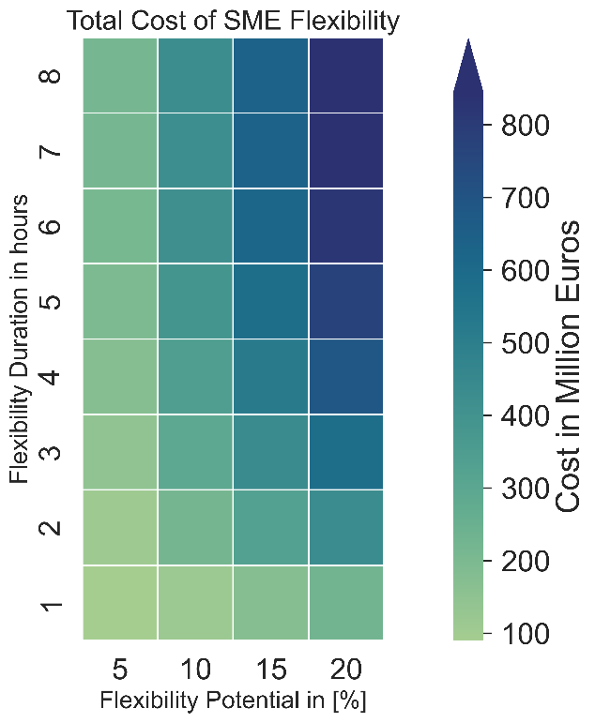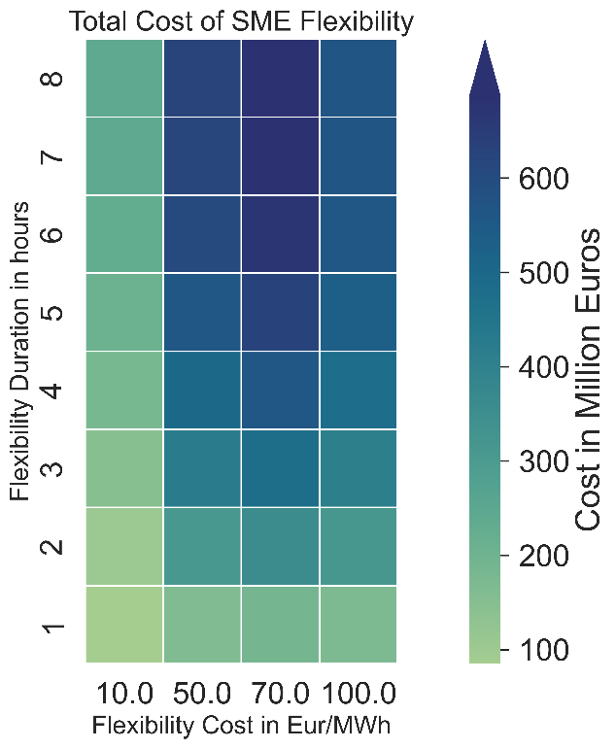

(a) (b)

Figure 7: SME’s total flexibility cost over the years.

As it can be seen from Figure 7a, higher costs of SME’s do not result in the highest total cost of load shifting capabilities, as the system can utilize other flexibility measures (i.e. biomass) to balance any mismatch, while the duration and potential play a more important role when it comes to the total costs of the SME flexibility (Figure 7b). As already explained, higher potential and longer duration result in more MWh being used, which in the end lead to higher revenues for SME operators. It is important to mention in this regard that only the revenue stream for SME operators is being explored, as the opportunity costs on their production are not considered.

* 1. **SME’s impact on different aspects of climate neutrality** 
     1. **Generation and storage expansion for the energy transition**

The results show a considerable investment in both renewable energy generation and storage capacities (Figure 8), in order to realize net-zero in the electricity sector. Combined, solar and wind technologies make up around 90% of the installed power and 98% of the generation mix by 2050. Coal and lignite-fired power plants are phased out from the system, while gas technologies remain in the energy mix up to 2045, mainly coming from combined cycle gas-fired power plants due to their higher efficiency. The run-of-river (ror) capacity remains constant, as it has a better weather profile and low marginal costs, while biomass capacity decreased nearly to the half. Despite biomass’s dispatchable generation capability, this is mainly due to the high marginal costs.

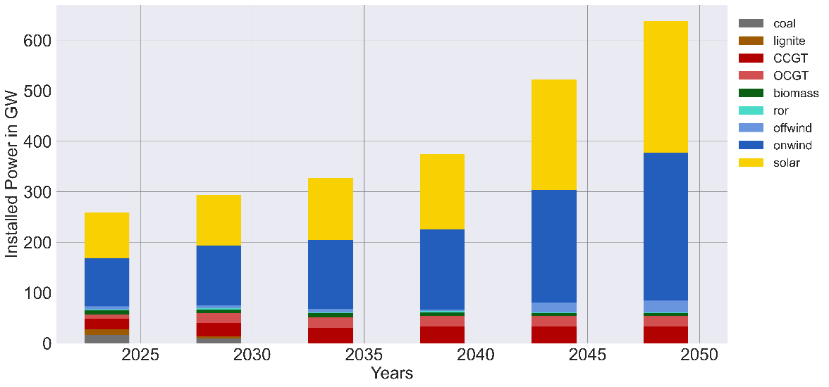

(a)

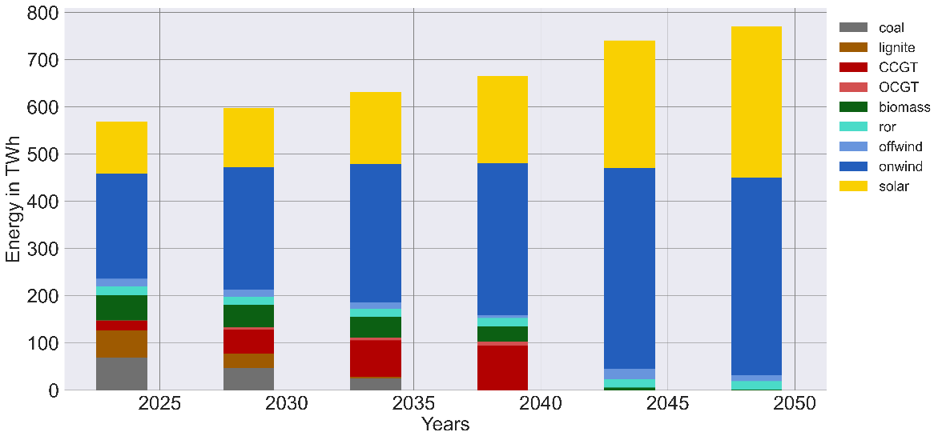

(b)

Figure 8: Installation (a) and generation mix (b) development over the years.

In terms of flexibility, the system first relies on thermal-flexibility coming from lignite and coal, with lower participation of gas-fired power plants up until around 2030. This is due to the high cost of energy coming from gas, and the higher flexible generation of coal and lignite coming in the system. However, gas-fired power plants start to see higher investments and utilization rates after 2030 due to the ongoing phase-out of coal-fired power plants.

The system starts slightly investing in temporal flexibilities around 2030, where the conventional flexibility coming from coal and lignite becomes more limited. At first, batteries come into play by 2030 as they have lower capital and marginal costs. After 2040, hydrogen is also introduced to the model, mainly because its capital cost becomes more economically efficient from learning. Moreover, both flexibility options, batteries and hydrogen, ramp up significantly around 2045, where the flexibility requirements to operate a system with 100% renewable energy becomes more pressing (Figure 9 a). Higher capacities from hydrogen storage are specifically added after 2045. However, these capacities are only used less, resulting in total in less energy dispatched (Figure 9 b).

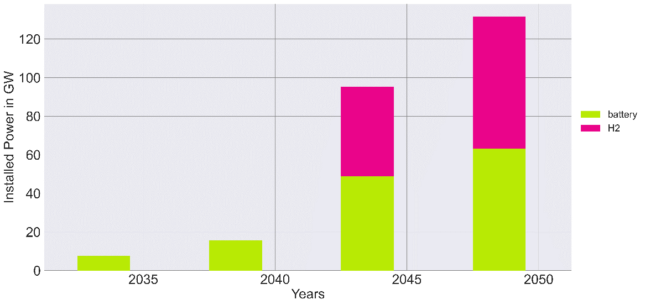

(a)

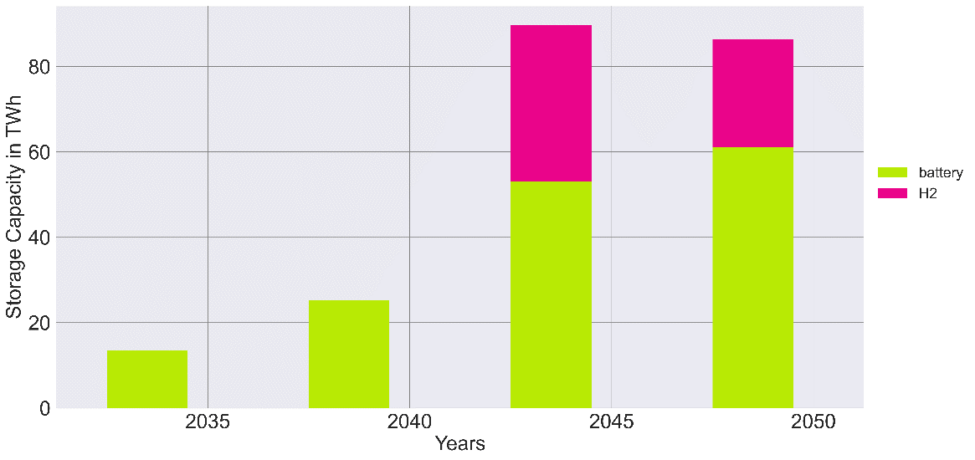

(b)

Figure 9: Storage investments (a) and dispatch (b) over the years.

For instance, hydrogen storage, along with the batteries, are used all over the year prior and up to 2045 (Figure 10 a), and not only at times of shortages or lower electricity infeed from solar and wind power (i.e., Jan or Nov). However, hydrogen usage becomes more limited after 2045 (Figure 10 b), despite the higher installed capacity.

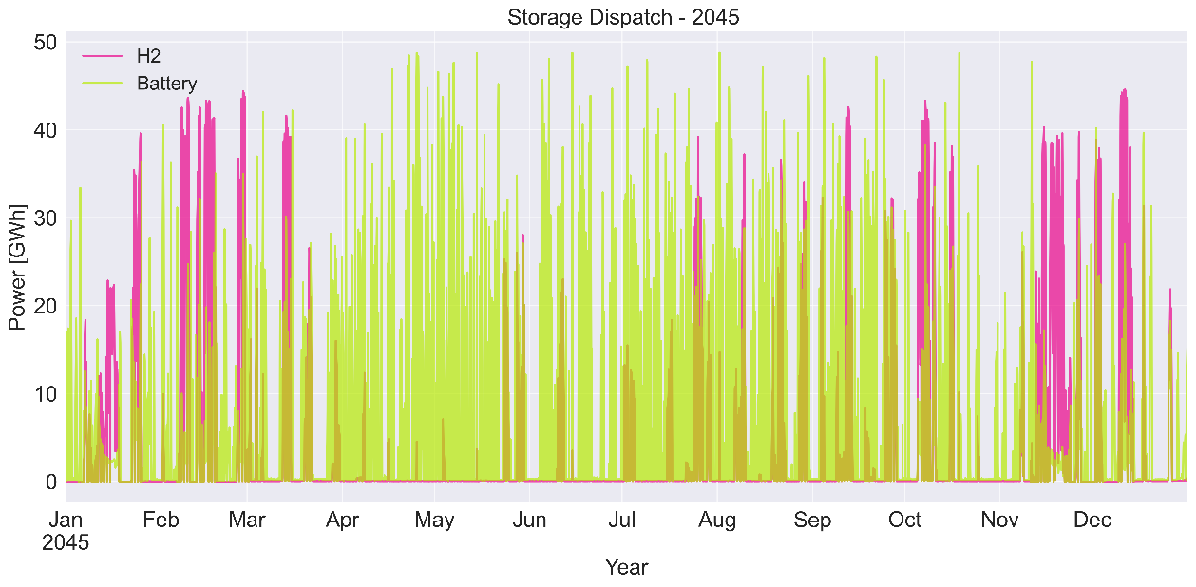

(a)

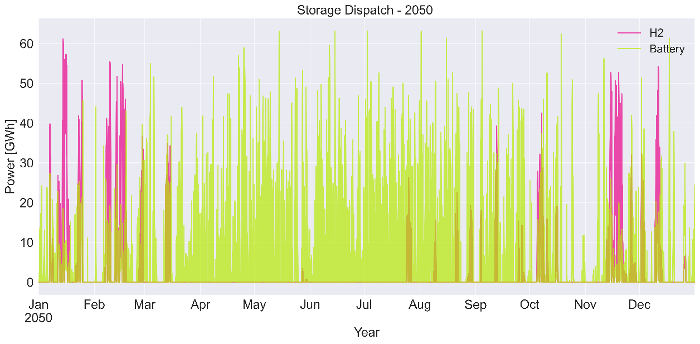

(b)

Figure 10:Storage dispatch over (a)2045, and (b) 2050.

This behaviour is due to several reasons. The investment rates set in the model limit how much can be invested in each storage technology a single year, where the system in 2045 faces an unforeseen situation of operating a 100% renewable energy system with no thermal power flexibility, so that the annual investment limit set in the model restrict higher investments in batteries, resulting in more usage of hydrogen. Moreover, the roundtrip efficiency of both technologies differs greatly. Hydrogen storage drastically reduces whatever being stored to around 46%, while batteries have higher roundtrip efficiency of around 81%. This makes batteries operation nearly twice as cost-effective compared to hydrogen, despite the latter’s longer storage capabilities. Thus, the higher hydrogen investments by 2050 was due to the system flexibility needs during the longer-duration “Dunkelflaute”, where its overall operation over the year was less and in favour of batteries. The other reason behind this behaviour is examined by observing the generation dispatch in both 2045 and 2050.

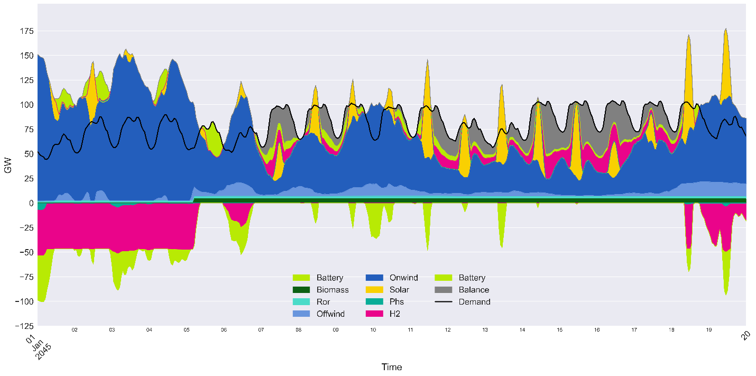

Figure 11:Generation dispatch in winter of 2045.

As illustrated in Figure 11, in 2045, huge imbalances occur multiple times over the year, even with the already-high shares of batteries (48.8 GW) and hydrogen (46.5 GW) installations in the system. These imbalances happen mostly at times with a longer-duration of low-generation infeed from solar and wind “Dunkelflaute” (7th till 18th of January in Figure 11), which happen quite frequently in the German system. In order to balance the system during such incidents, all of the biomass capacity is used, along with the little energy available from solar and wind during such times, and with the available storage capacity. Therefore, the system is left with no other option but to not meet the demand. These supply shortages can either be compensated by imports or via shedding demand. Biomass usage during “Dunkelflaute” becomes essential after reaching climate neutrality by 2045, as there is no carbon-free alternative dispatchable power plant to provide the required flexibility.

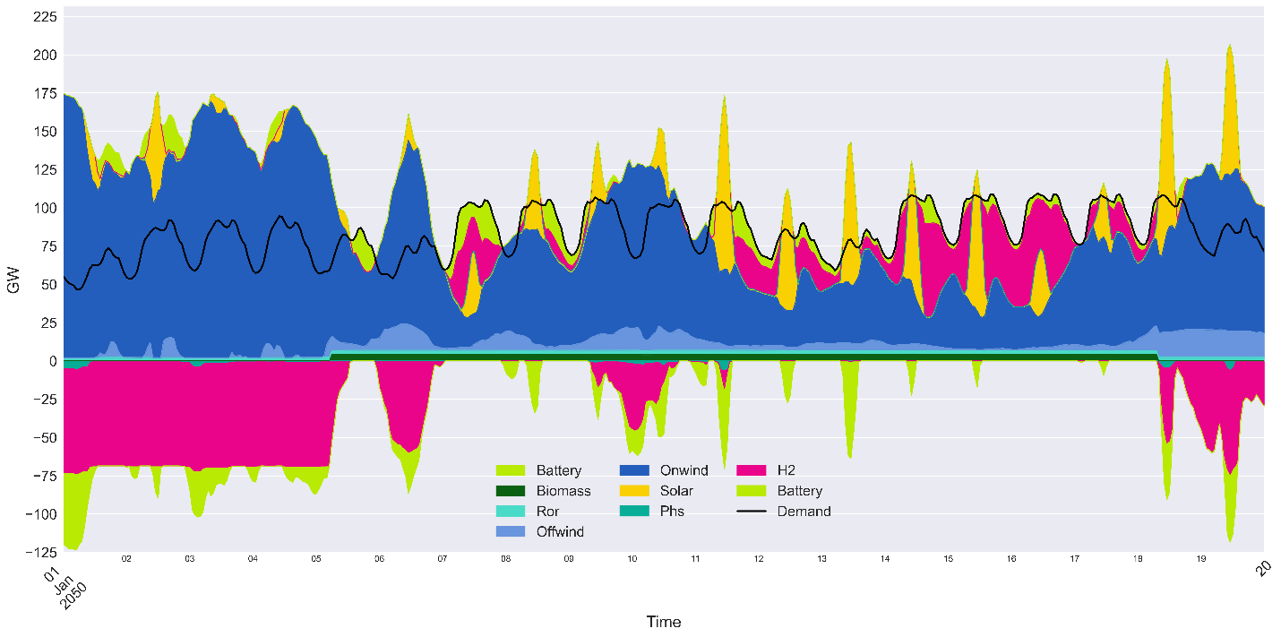

Figure 12:Generation dispatch in winter of 2050.

However, in 2050 (Figure 12), more capacity hydrogen (68.5 GW) and batteries (63.1 GW) capacity is added. This allows the system to match demand by means of storage flexibility, together with the available dispatchable capacity. None the less, hydrogen usage after 2045 is essential mostly only during peak or “Dunkelflaute” periods, due to its longer storage duration capabilities, as well as the investment limitation on each of the storage technologies. However, batteries storage after 2045 is preferred all over the year as it has a higher roundtrip efficiency. This makes storage flexibility the most important asset in the system to achieve a secure and reliable electricity supply.

The usage of SME flexibility shows a massive decrease in the flexibility requirements in 2045 from other flexibility measures, such as hydrogen, batteries, and thermal flexibility from biomass power plants. While the findings do not demonstrate a clear link between SME flexibility settings (potential, cost, or duration) and the necessary flexibility from other resources, the system flexibility requirements in 2045 are at least 3.3 TWh less in case of using the SME flexibility, irrespective of the quality of the SME flexibility design and settings as shown in Figure 13.

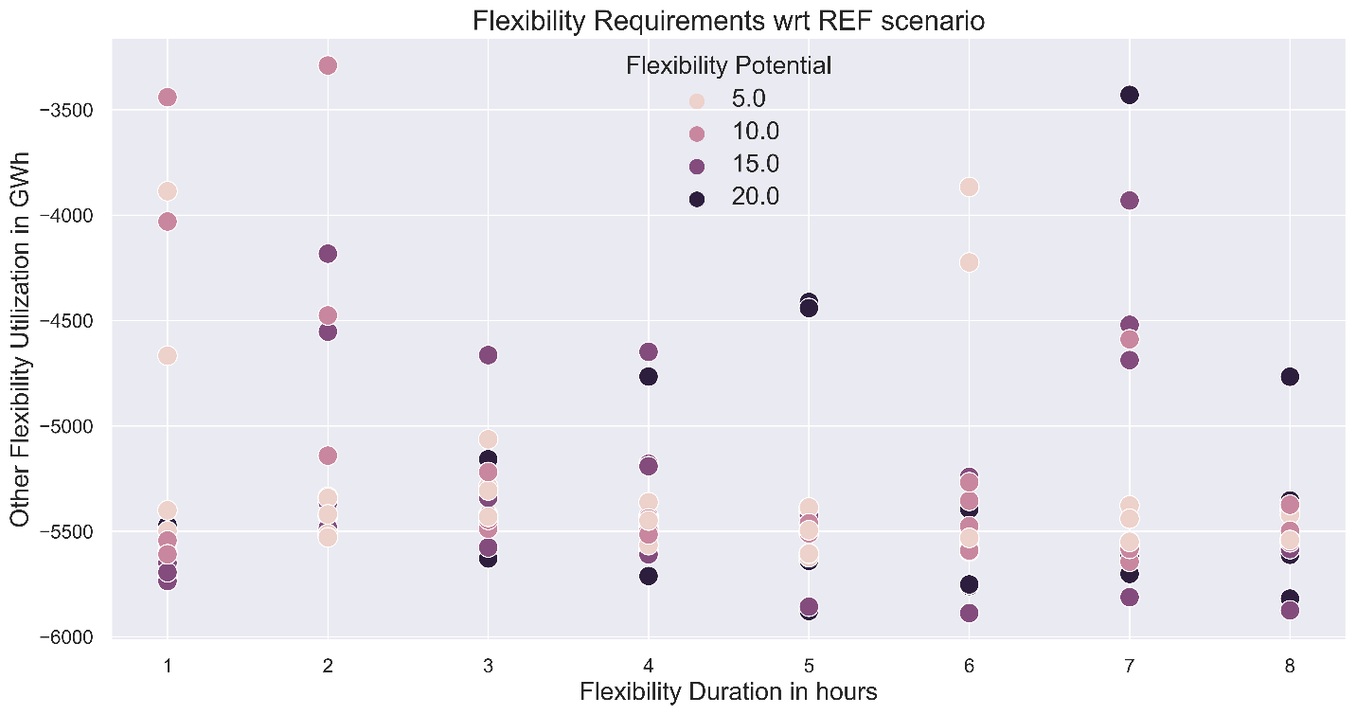

Figure 13: Flexibility requirements in 2045 in comparison with the reference scenario (negative values indicate a lower flexibility requirements).

The impact of SME flexibility extends beyond the utilization of other flexibilities. It affects also the investments needed in all other flexibility requirements (Figure 14). The usage of SME flexibility reduces the need for investment in other flexibility measures by at least 600 MW. In case of better SME flexibility design (higher potential and lower costs), investment in other flexibility measures can even be reduced by a significant amount of 1.8 GW.

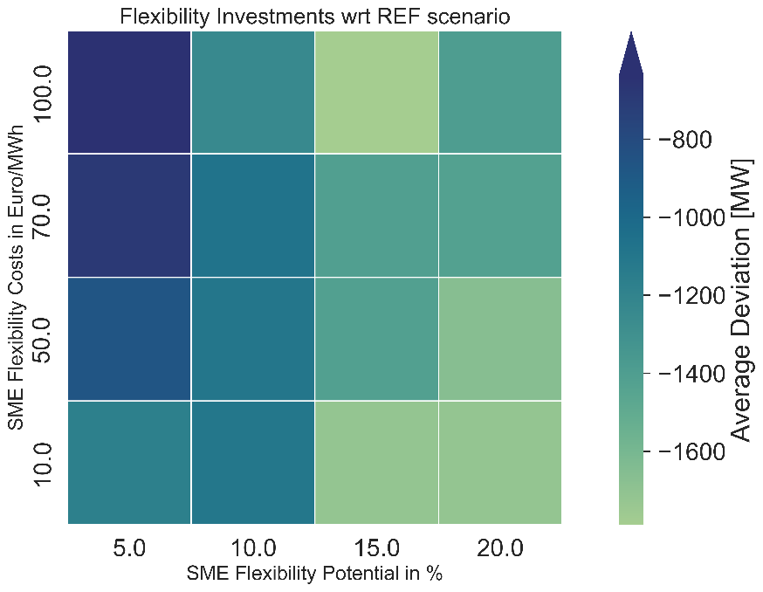

Figure 14: Impact of SME's flexibility on investments from other flexibility measures.

* + 1. **Renewable energy curtailment and full load hours**

After achieving climate neutrality by 2045, the system’s behaviour undergoes a significant change. Investments in solar and offshore wind power peak around 2045, while onshore wind keeps on expanding as shown in Figure 15.

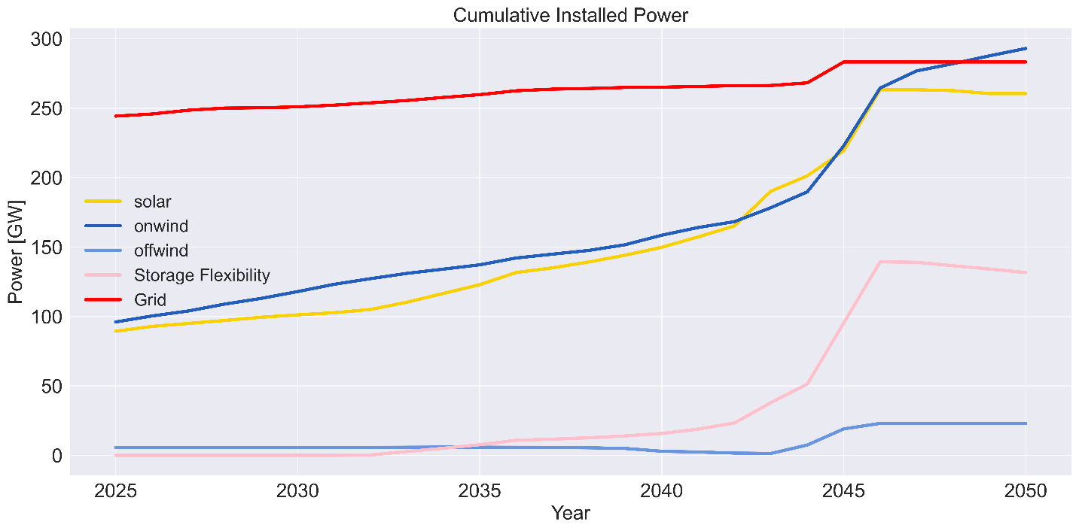

Figure 15:Cumulative installed power over the years.

This can be explained by examining the generation dispatch at 2045 and 2050 shown previously in Figure 11 and Figure 12. At extreme weather incidents such as “Dunkelflaute”, with little energy coming from solar generation, together with limited dispatchable generation from biomass and run of river, and in a system that has no conventional generation (i.e., gas or coal), and relatively-limited storage capabilities, wind becomes vital to keep the system operating. Thus, it keeps expanding after 2045. In 2045, wind generation peaks around 150 GWh infeed (Figure 11), where during the same week in 2050 wind reaches a peak of around 173 GWh (Figure 12), with very limited solar supply in both cases.

In terms of load full load hours (FLH), solar and ror are given priority due to their extremely low marginal costs (which are even lower than other renewable resources such as wind and biomass). This results in solar and ror being able to operate constantly at full capacity as shown in Figure 16. However, biomass usage is drastically decreased from around 7000 hours in 2025 to less than 500 hours in 2050. This goes in line the announced plans of the Federal Ministry for Economic Affairs and Climate Action of Germany [78], where biomass must be used in other sectors which are more difficult to decarbonize than the electricity sector, such as transport and industry.

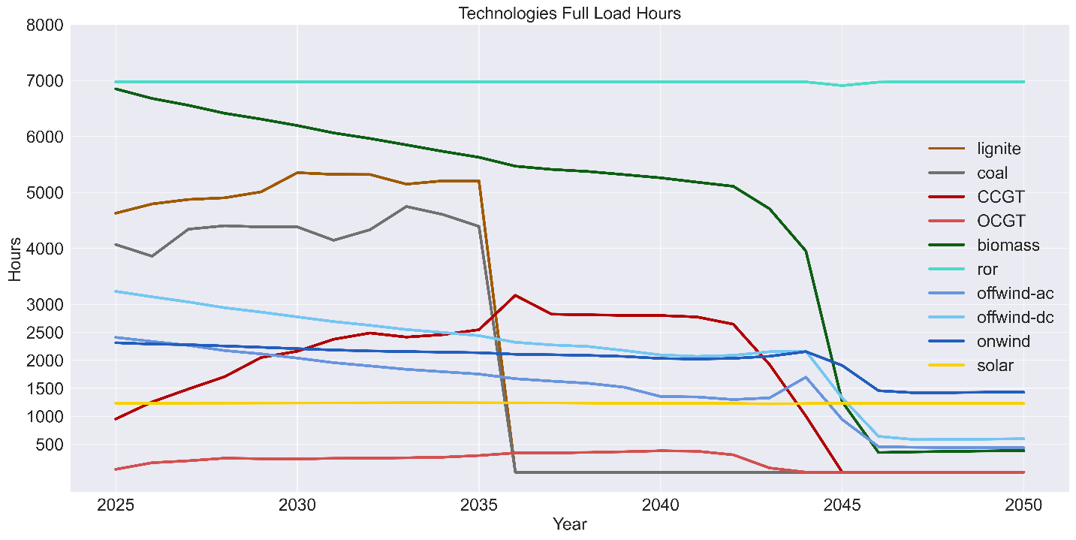

Figure 16: Technologies full load hours over the years.

Moreover, the wind technologies, especially onshore wind, undergo a dramatic shift in their operation, due to the high capacity of solar that is already added to the system, and which is given priority over wind due to its lower marginal costs. Hence, wind technologies are used less at times of high solar availability. Yet, many weeks with near-zero infeed coming from solar generation make wind generation the only possible generation technology able to cover the massive imbalance in the system, hence the continuous expansion of onshore wind power after 2045 (Figure 15), despite having lower utilization rates (Figure 16), making onshore wind an essential supply technology.

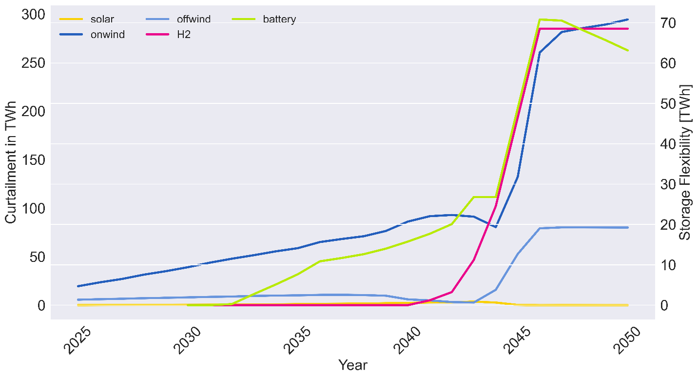

Figure 17:Renewable energy curtailment and storage flexibility over the years.

This can be clearly seen when examining the curtailment of those technologies, as shown in Figure 17. Before 2045, the curtailment of onshore wind is significant, but its FLH are still high (Figure 16). However, after 2045, wind curtailment reaches extreme levels, accompanied with lower utilization rates for hydrogen storage. The reason behind the pronounced curtailment of wind, as explained previously, is the continuous capacity expansion of wind to the system to cover extreme weather events. Yet during non-extreme conditions, wind technologies are curtailed due to the higher marginal costs compared to solar power, which already has a capacity more than 150 GW in the system (Figure 15). This makes wind plants behave more or less like a peaking technology, that operates fully when solar generation cannot cover the demand. However, this massive wind curtailment greatly encourages stronger electrification and sector-coupling degrees. Moreover, the excess energy could be used for the local production of green hydrogen which can be used in other sectors.

* + 1. **The path towards climate neutrality**

Lignite and coal are used at high utilization rates until their planned phase-out (Figure 16) due to their lower marginal costs compared with other thermal power plants. Combined cycle gas-fired power plants (CCGT) are preferred in the energy mix in comparison with the less efficient open-cycle gas turbines plants (OCGT). This results in having OCGT operate as a “super ramping-up technology”, where CCGT is utilized more frequently in the energy mix.

The utilization of thermal power plants, in turn, results in huge total system emissions over the transition period. Up until their planned phase-out, coal and lignite make up the largest part of the CO2 emissions, where gas fired-power plants emit significantly less. Over the transition period, gas-fired power plants generate more than 1446 TWh of electricity, which is equivalent to around 485 million tonnes of CO2, where on the other side, coal-fired power plants generate around 885 TWh of electricity, that equates around 680 million tonnes of CO2. This makes a total of 1.16 Gt CO2, during 2025-2045 as summarized in Figure 18.

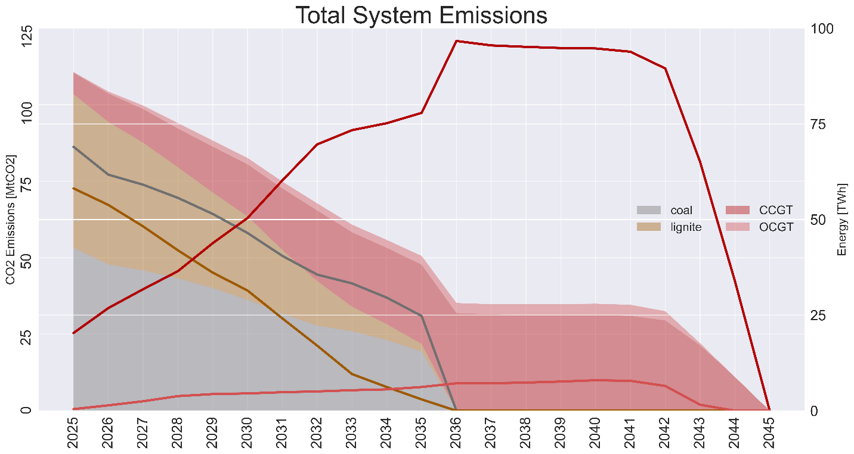

Figure 18: Total System Emissions (area) and fossil fuel generation (line) over the transition era.

Out of the total global carbon budget, Germany has, as of 2022, a remaining carbon budget of 7.5 gigatons of CO2 to stay within the 2-degree Celsius target, 6.1 gigatons for the 1.75-degree target, and 3.1 gigatons for the 1.5-degree target [79]. Germany emitted 746 Mt CO2 in 2022 [3], with projected 734 million tons and 722 million tons in 2023 and 2024, respectively[4]. Consequently, the remaining carbon budgets stand at 5.3 gigatons of CO2 for the 2-degree target, 3.9 gigatons for the 1.75-degree target, and 0.9 gigatons for the 1.5-degree target. Assuming that the energy system contributes to 30% of the total emissions, the resulting allocated budget for the energy system is 1590 million tonnes of CO2 for the 2-degree target, 1170 million tonnes of CO2 for the 1.75-degree target, and 270 million tonnes of CO2 for the 1.5-degree target. In this case, even though the system reaches climate neutrality by 2045, the total budget for Germany will not be enough to achieve 1.5-degree-target and nearly achieve the 1.75-degree-target. This sheds light on the current debate whether the existing policy interventions are appropriate to guarantee or accelerate the energy transition towards a climate neutral energy system. This study’s results show that using SME flexibility helps the system to decrease its dependence on flexibility coming from thermal power plants, as shown in Figure 19. Hence, the utilization of SME flexibility supports the decarbonization transition by limiting Germany’s dependency on fuels.

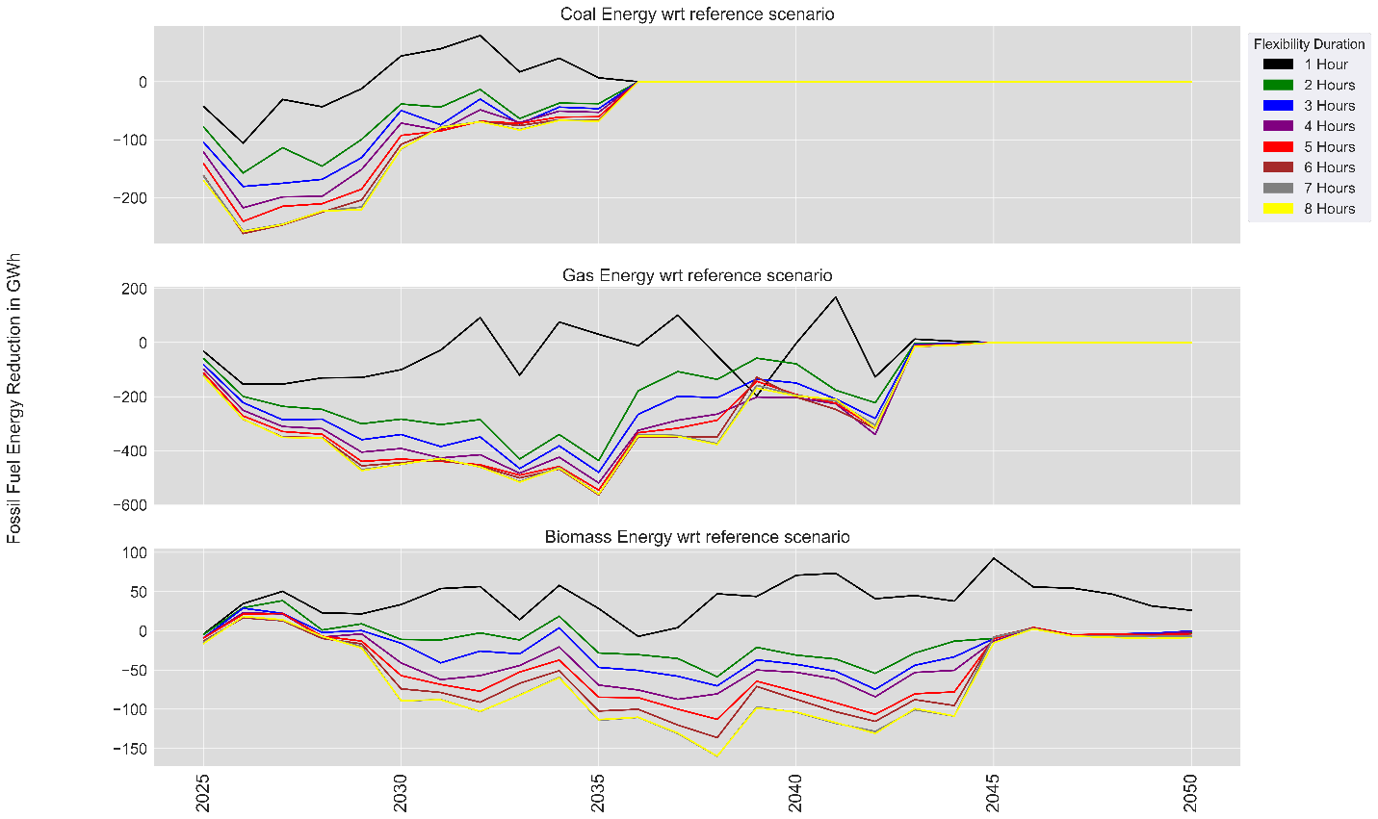

Figure 19: Average thermal energy requirements reduction with respect to the reference scenario.

This reduction in the flexibility from thermal power plants is on average less than the reference scenario (Figure 19). This means, that using flexibility coming from SME reduces the need for thermal flexibility coming from coal or gas. Gas usage on average is less in all scenarios, while coal and biomass usage with very short SME flexibility duration is higher than the reference scenario without SME flexibility. This shows the importance of a longer duration of SME flexibility, especially flexibility from thermal power plants. Biomass utilization reduction is beneficial, especially because the Federal Ministry for Economic Affairs and Climate Action of Germany plans to use biomass mostly to decarbonize other sectors, and limit its usage in the energy system [78]. Moreover, as it can be seen from the model’s costs assumptions, biomass and gas are the most expensive energy carriers (Table A 2). Thus, the utilization of SME flexibility saves costs and results in lower wholesale electricity prices.

The reduced reliance on conventional energy carriers (coal and gas) due to SME’s flexibility is not only beneficial for the system from an economic point of view, but even more importantly, from an ecological point of view. The results showed that utilizing flexibility from SME reduces the total carbon emissions over the transition years, thus maintaining better conditions for the CO2 budget.

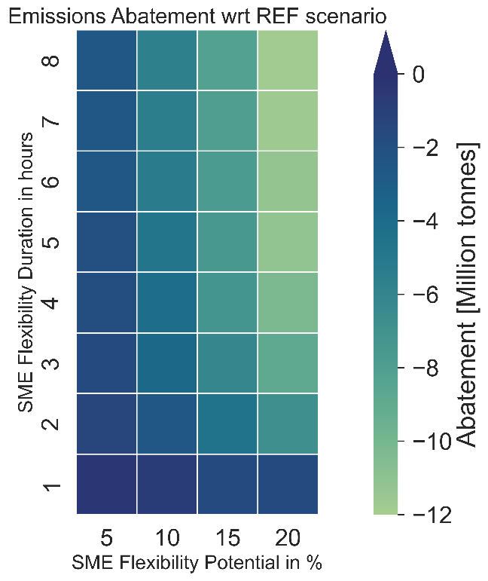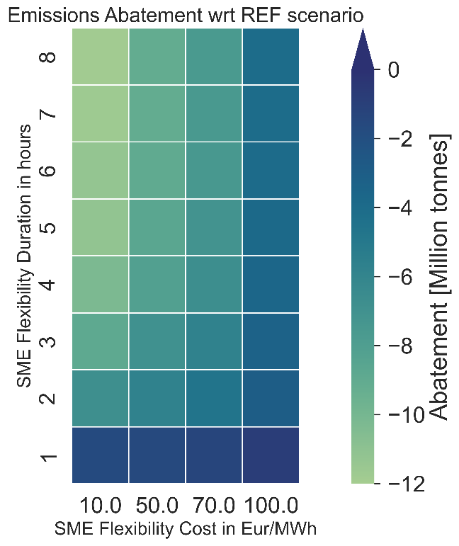

(a) (b)

Figure 20: Total system emissions with respect to reference scenario.

Figure 20 shows the system emissions with different SME settings (potential (a), cost (b), and duration (a and b)). Evidently, the three SME flexibility pillars play an important role in reducing both the fossil-fuel usage and the overall system emissions. This shows the importance of a careful design of demand-responsive flexibility, because it heavily impacts the system’s overall performance. On average, a higher CO2 reduction is achieved with better SME flexibility settings (longer duration, higher potential, and lower costs).

* + 1. **Market dynamics of a 100% renewable energy system**

This massive addition of renewable energy poses a challenge on the electricity spot market, because the mismatch between generation profiles and demand profiles becomes more pronounced. Thus, the number of hours with zero or negative prices increases significantly with higher renewables penetration levels, reaching around 6000 hours a year by 2045 (Figure 21). Moreover, the hours were the available generation and storage units cannot fully cover the demand peaks occur at 2045, exactly when the system is required to stop its reliance on conventional generation (gas-fired power plants in this case), making it bigger of a challenge to operate the system securely. However, with the continuing expansion in generation (mainly wind) and storage technologies beyond 2045, the system becomes able again to match the demand, reduce the imbalance, and operate a 100% renewable system completely.

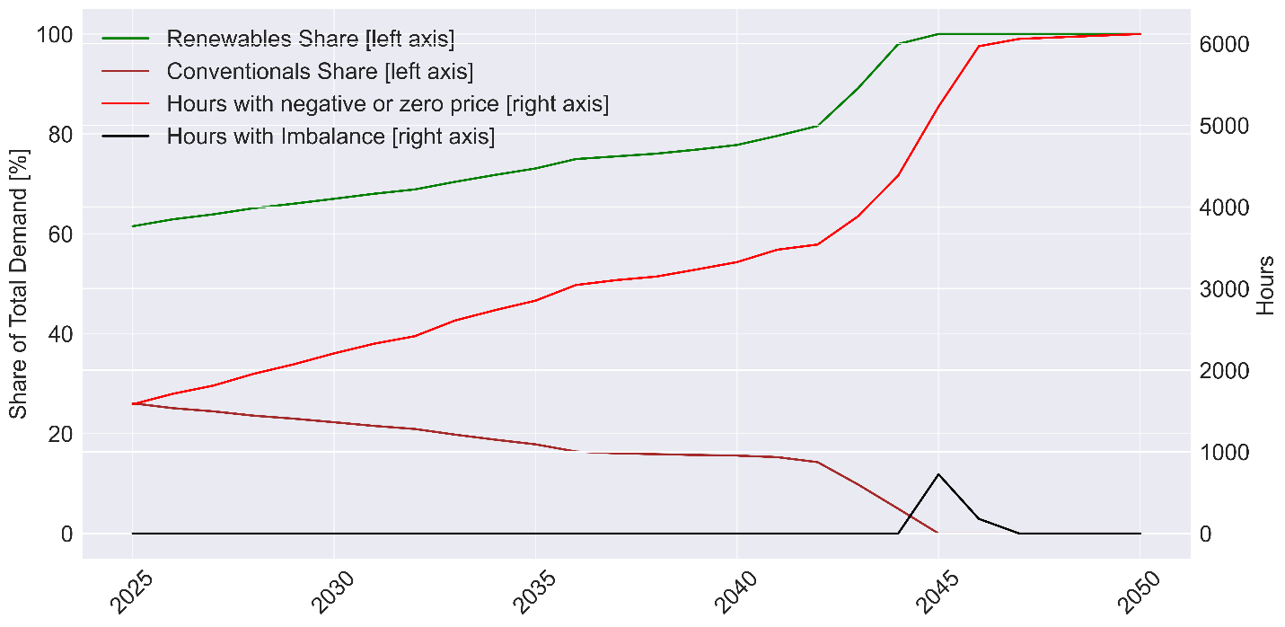

Figure 21:Renewable and conventional energy shares and its impact on the market dynamics.

However, despite the hours with zero prices increase, the average wholesale electricity price stays at a positive level, ranging between 35 and 45 Euro per MWh until 2045 (Figure 22). This is due to several reasons. The high share of fossil fuel energy in the system (Figure 18), with hard coal and lignite contributing until 2036, and gas until 2045, as well as high biomass utilization rates before 2045 (Figure 16), which are technologies with considerably higher marginal costs (Table A 2), contribute to a relatively high wholesale electricity price until about 2045. Moreover, at 2045, despite the system being fed by 100% renewable energy, an imbalance “import” cost, which is assumed to be 250 Eur/MWh, contributes to a relatively high wholesale electricity price of around 22 Euro per MWh. After 2045, the lower energy utilization from biomass (Figure 16), together with huge near-zero imbalance hours let the average wholesale electricity price drop to around 4 Euro per MWh.

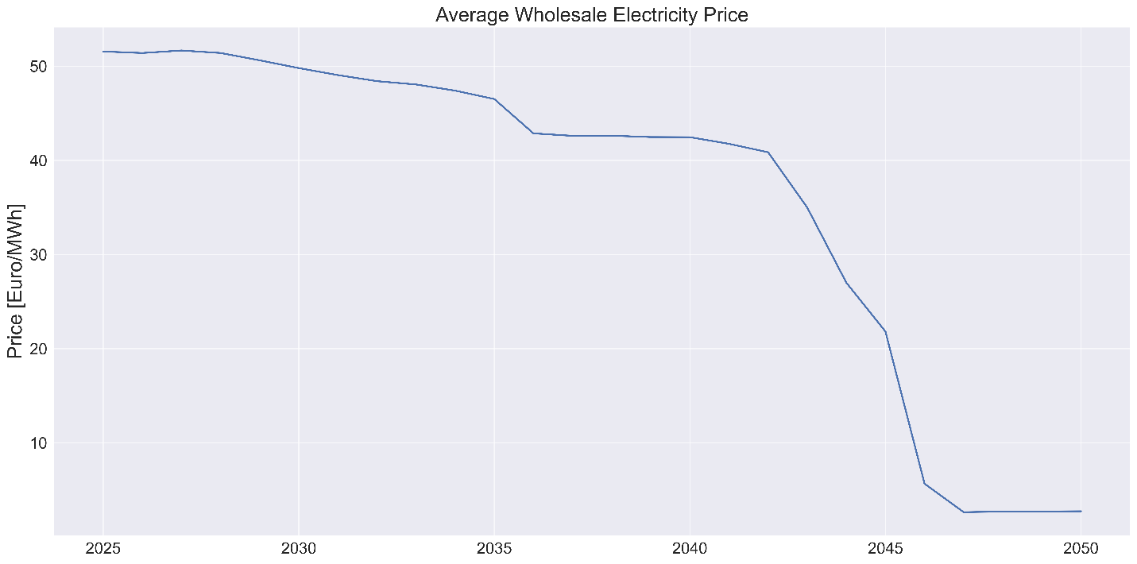

Figure 22:Average wholesale electricity price over the years.

The transition to a 100% renewable energy system comes at relatively high costs, when comparing the status quo with how the future energy system looks like. Maintaining the status quo of high shares of expensive fossil-fuel power plants is more expensive than the massive transition towards a climate-neutral energy system. From an investor point of view, investigating at the annual system cost in Figure 23, the total system costs in the beginning of the transition highly consist of an expensive conventional generation cost (in yellow) along with a high generation cost for renewable energy (in lime green), mainly from biomass. This is accompanied by relatively smaller investments in green energy power plants (in sea green), and conventional gas-fired power plants (in brown).

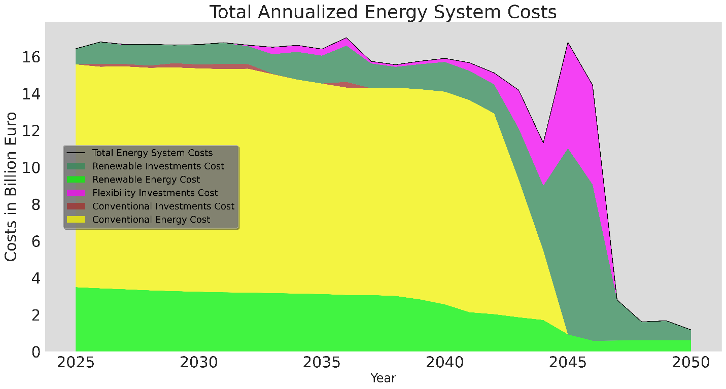

Figure 23:Total annual energy system costs.

However, to achieve the energy transition, the high costs are shifted towards investments in renewable energy power plants mainly from solar and wind (in sea green), with flexibility investments in storage and grid (in fuchsia), where the generation costs (in lime green) consist mainly of near-zero generation costs of solar and wind technologies. Hence, the high investment cost around the year 2045 lead to a system transformation that eventually leads to very low system operating costs in the longer run, making this expensive transition cost of greater value.

The usage of SME flexibility is translated directly into a reduction in the total system cost. Compared to the reference scenario (without SME), all scenarios with SME flexibility come with lower costs on average than the references scenario. As it can be clearly seen in Figure 24, SME’s flexibility, even with worse flexibility settings, resulted on average in a total system cost reduction in comparison to the reference scenario without SME flexibility. This reduction in total system costs cannot be explained by one single direct impact, but is due to various factors as discussed previously, such as a reduced usage of conventional energy carriers, a decreased flexibility need, and an avoidance of investments in flexibility measures, as well as a relatively small effect on the wholesale electricity price.

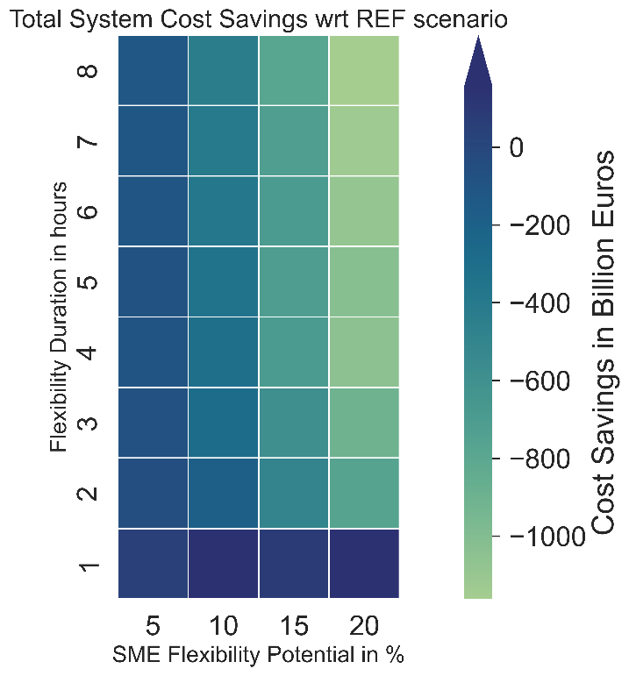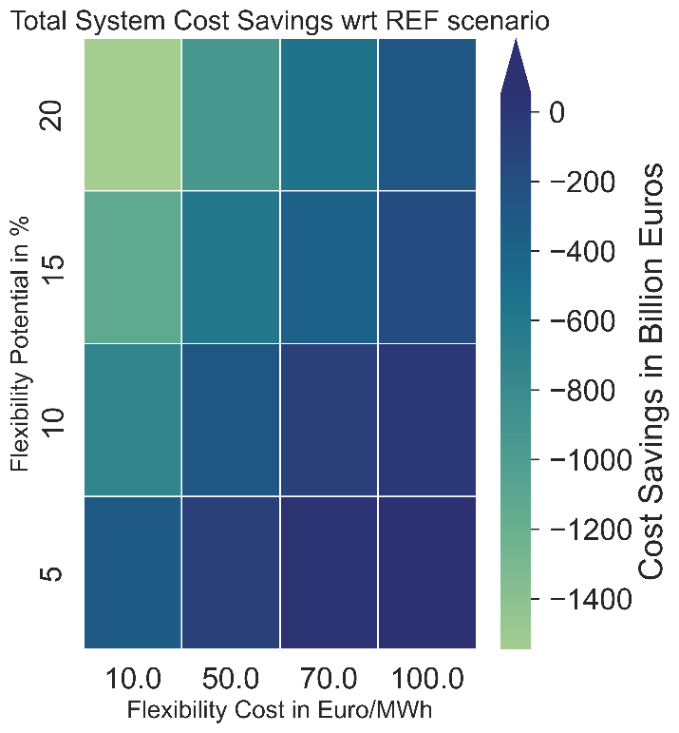

(a) (b)

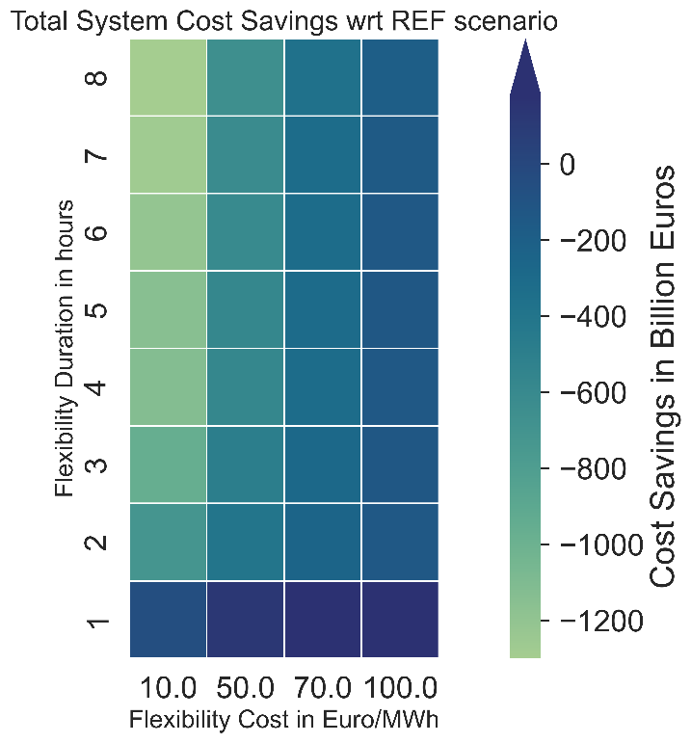

(c)

Figure 24: Total system cost with respect to reference scenario.

* 1. **Summary of SME’s flexibility impact on the system transformation**

Due to the complexity of the model, the distinct relation between each of the SME flexibility design parameters and the overall system performance cannot always be directly interpreted. However, several patterns of improvements in the system can be recognized. Therefore, several performance indicators were chosen to evaluate the impact of SME’s flexibility on the system. Figure 25 shows the normalized reduction due to SME flexibility on several factors, namely the total system cost, the total CO2 emission, flexibility usage from other resources, investments in flexibility measures and generation technologies, biomass and fossil fuel usage, peak load and imbalance, wholesale electricity price, and renewable energy curtailment. Moreover, the SME flexibility usage and revenue stream are applied to investigate which flexibility setting highly affected its usage.

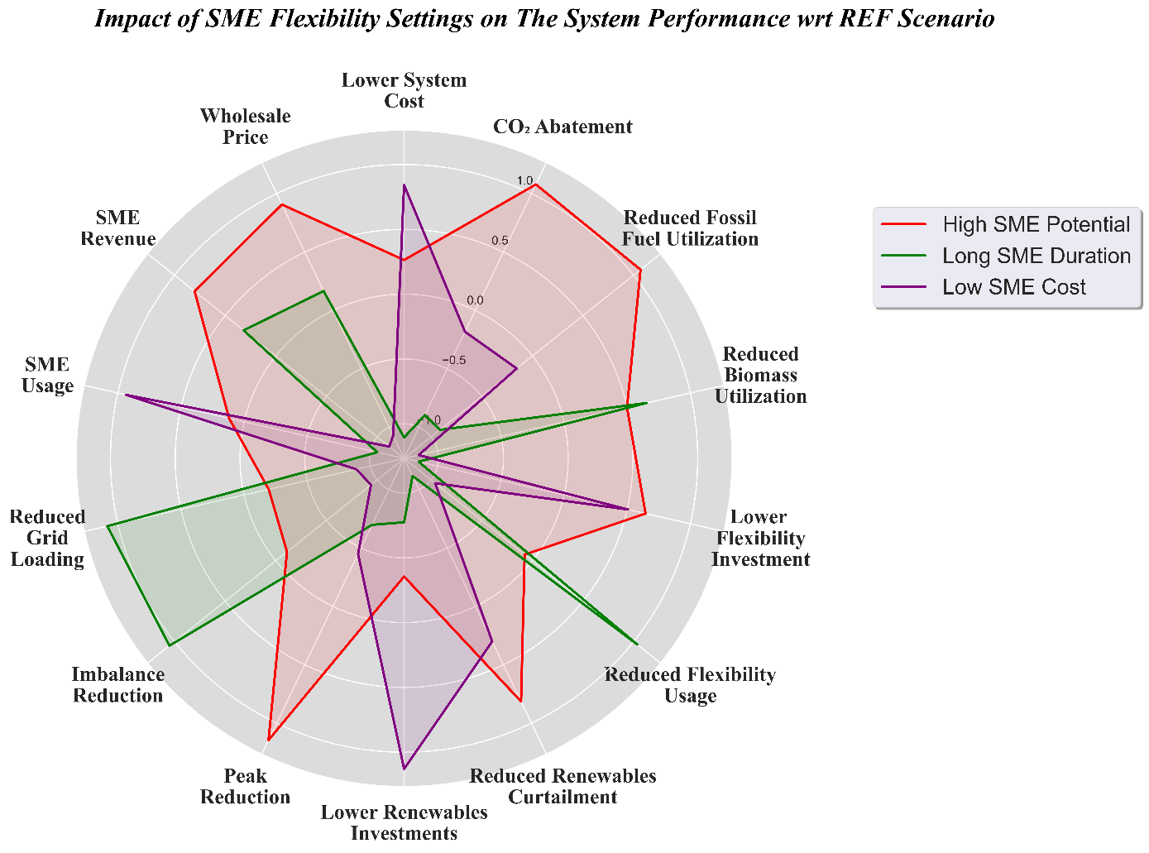

Figure 25: Impact of SME's flexibility potential, costs, and duration on the overall system, with respect to the reference scenario (without SME flexibility) except for SME Usage/Revenue attributes. Impacts are normalized to the average impact of all scenarios with the best potential/cost/duration, due to the huge difference in units between the attributes (total system cost in billion Euros), (CO2 emissions in Million tons of CO2), (flexibility and renewables investment, and imbalance in GW), (fossil-fuel utilization, biomass utilization, flexibility usage and SME usage in TWh), (peak load and grid loading in percent), and (SME Revenue in million Euros). The higher the values, the better the conditions turned out in the system, i.e., bigger reduction. The reader is referred to Table B1 in the annex for the original values.

The huge impact of potential, costs, and duration can be clearly seen in Figure 25. For instance, longer duration resulted in less utilization of flexibility and biomass, however, resulted in higher renewable energy curtailment and investments in other flexibility measures. This however does not mean that the system resulted in worse conditions than the reference scenario, rather worse conditions compared to scenarios with other SME flexibility settings (Table B1). Longer duration had the highest impact on grid loading and imbalance load, as they helped maintain a secure supply for a longer period. From Figure 25, it can be seen that higher flexibility potentials were decisive in having better system conditions, in particular less flexibility investments. A direct link between SME flexibility potential in MW and investing in other flexibilities in MW can be drawn, while on the other hand duration affected how much of those flexibilities were used in MWh. Lower SME flexibility costs yielded on average lower system costs and resulted in higher usage of SME flexibility in comparison to other scenarios.

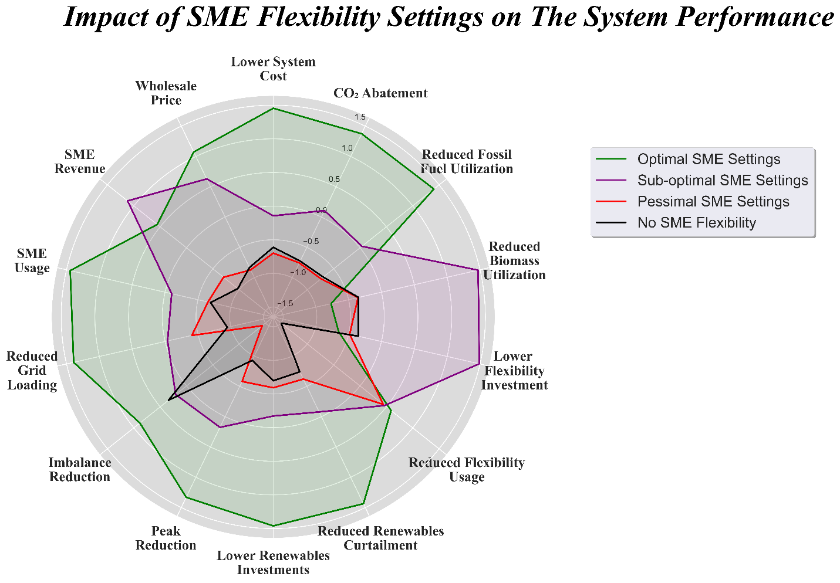

Figure 26: Impact of SME's optimal, suboptimal, and pessimal flexibility settings on the overall system. Impacts are normalized to the average impact of all scenarios, due to the huge difference in units between the attributes. The higher the values, the better the conditions turned out in the system. The reader is referred to Table B 2 in the annex for the original values.

When investigating the optimal, sub-optimal, and pessimal SME settings[5] with the reference scenario as shown in Figure 26, it becomes evident that using SME flexibility with the worst-settings eventually resulted in worse system conditions. This means that the system was better off without SME flexibility than with unfavourable SME settings (low potential, short duration, and high cost). This is true for all attributes except for usage of other flexibility measures in 2045, where the introduction of SME flexibility to the system highly reduced the system flexibility requirements from other resources by a minimum of 3.3 TWh as it was observed in Figure 13. Therefore, careful steps should be taken into consideration when designing the appropriate SME flexibility. The best-case scenario for SME flexibility with long duration, high potential, and low cost resulted in a CO2 reduction of around 12 million tonnes, a cost reduction of 2.4 billion euros, and a 5.9 TWh less flexibility requirements in comparison with the reference scenario, while only costing the system 388 million euros for the SME flexibility. However, these improvements due to the best SME flexibility settings did not result in optimal results in all of the attributes. Biomass utilization was higher in the optimal SME flexibility case, along with the investment in flexibilities, as the impact of SME cannot be interpreted directly with one attribute without impacting others.

There is a delicate balance and trade-off among the factors of potential, costs, and duration of SME flexibility, influencing the overall performance of the system, and these factors collectively influence system performance. Optimal SME flexibility settings will not always yield the best conditions in all the attributes as shown in Figure 26, where the system will not have optimal values in all system attributes, but rather find an equilibrium that aligns with specific goals and trade-offs, showcasing the intricate relationships among potential, costs, and duration of SME flexibility. Therefore, appropriate design and incentives are crucial for SME Flexibility to get the right settings for optimizing the system's performance and achieving better outcomes. This means, that utilizing even small parts of the electrical demand as a demand-responsive flexibility resulted in a great added-value for the system from an economic, environmental, and operational point of view. However, as the model complexity grows larger with adding flexibility from SME, this analysis is, therefore, designed to uncover patterns and dependencies, shedding light on how variations in SME flexibility settings can contribute to enhancing the performance and conditions to achieve climate neutrality in Germany.

1. **Conclusion and Limitations**

The impact of small and medium enterprises' (SMEs) flexibility, while evident in enhancing several aspects of the system, represents a relatively small fraction of the peak load. This encourages a deeper investigation on the potential of demand-responsive flexibility in the German system. The study recognizes the dependency of SMEs' flexibility utilization on specific settings, emphasizing the need for careful design. The decline in SMEs' flexibility usage after 2045 prompts questions about incentivization strategies in the post-climate neutrality era, warranting further investigation.

The analysis draws a path for the transition towards a climate-neutral energy system by 2045. The integration of renewable energy sources, particularly solar and wind technologies, alongside the adoption of storage solutions such as batteries and hydrogen, play a pivotal role in achieving the goal of net-zero emissions. The post-2045 period witnesses a shift in system behaviour, with wind power becoming increasingly vital for maintaining operational security.

However, during extreme weather conditions, the system will face a great a challenge maintaining a secure and reliable supply within a 100% renewable energy system, resulting in imbalances and significant mismatches between demand and generation. The study reveals the critical role of storage flexibility, particularly from batteries and hydrogen, in ensuring a secure and reliable energy supply during such conditions. The increase in renewable energy penetration also influences the electricity market, with a surge in hours with zero or negative prices, though the wholesale electricity price experiences a greater decline only post-2045.

The transition to a 100% renewable energy system involves substantial investment costs. However, considering the annual system cost perspective, the investment in renewables and flexibility proves economically advantageous in the long run due to lower operating costs compared to maintaining the status quo with higher conventional energy shares in the energy mix.

By observing how dramatically the dynamics of generation utilization pre and post 2045 changed, it can be fruitful to further investigate the potential of negative emissions technologies in combination with gas-fired power plants, which may reveal interesting aspects on how the use of thermal-conventional flexibility can affect other flexibility measures. Moreover, the results showed how the usage of thermal power plants can play an important role and affect the CO2 budget for the country. This shows how different policy interventions can be decisive in several aspects of the energy transition.

Despite the comprehensive analysis, certain limitations should be acknowledged. The model's complexity may pose challenges in directly attributing certain behaviour in the system to specific factors. The optimization model assumes a myopic foresight of future parameter values. The influence of external factors, such as policy changes or advancements in technology, could impact the accuracy of the results. Therefore, the pathways generated by the model should be viewed as conceptualized transformations of the German electricity system. Additionally, the study focuses on the electricity sector, but neglects electricity trade with neighbouring grids. A broader consideration for a holistic energy transition, including other sectors, may provide a deeper understanding.

In conclusion, while the study offers valuable insights into the potential benefits of renewable energy and flexibility integration, addressing these limitations will contribute to a more robust understanding of the dynamics involved in achieving a sustainable and cost-effective energy system.

**Acknowledgment**

The work on the model MyPyPSA-Ger was carried out as part of the project GaIN - Gewinnbringende Partizipation der mittelständischen Industrie am Energiemarkt der Zukunft; FKZ 0EI6019E, BMWK 2019 - 2022. We gratefully acknowledge the German Federal Ministry of Economics and Climate Change (BMWK) for their fund. Furthermore, we are grateful to Alejandro Tristan Jimenez (Fraunhofer IPA) for valuable feedback on the SME design parameters. We thank Miriam Silva Taylor (FAU) for proofreading.

**Data Availability**

All results analysis and plotting codes are publicly available on Zenodo [81], and is maintained on GitHub [82]. Code and data to reproduce the study’s results are publicly available by using MyPyPSA-Ger [68].

**Annex**

1. **Cost Assumptions in the model**

Table A 1: Model costs assumptions [66] [67]

|  |  |  |  |  |  |  |  |  |  |
| --- | --- | --- | --- | --- | --- | --- | --- | --- | --- |
| Technology | Investment Cost[6] [€/kW] | | | | | | | O&M  [% of CAPEX] | O&M [7] [€/MWh] |
|  | 2020 | 2025 | 2030 | 2035 | 2040 | 2045 | 2050 |  |  |
| Solar | 648 | 600 | 550 | 505 | 463 | 425 | 390 | 2 | 0.1[8] |
| Onshore wind | 1257 | 1197 | 1137 | 1062 | 987 | 955 | 923 | 3 | 1.5 |
| Offshore wind[9] | 2736 | 2419 | 2102 | 2000 | 1900 | 1800 | 1700 | 3 | 3 |
| CCGT | 800 | 800 | 800 | 800 | 800 | 800 | 800 | 3.75 | 4.4 |
| OCGT | 400 | 400 | 400 | 400 | 400 | 400 | 400 | 2.5 | 4.5 |
| Coal | - | - | - | - | - | - | - | 1.6 | 2.9 |
| Lignite | - | - | - | - | - | - | - | 1.6 | 2.9 |
| Biomass | 2350 | - | - | - | - | - | - | 3.6 | 2.1 |
| Run-of-river (ror) | 2500 | - | - | - | - | - | - | 2 | 0.1‡‡ |
| Battery inverter | 210 | 160 | 119 | 98 | 80 | 66 | 52 | 1 | - |
| Battery Storage [€/kWh] [10] | 300 | 229 | 171 | 141 | 114 | 95 | 76 | - | - |
| Electrolysis | 1100 | 875 | 650 | 537 | 425 | 312 | 200 | 4 | - |
| Fuel cell | 1320 | 1134 | 949 | 763 | 578 | 392 | 207 | 3 | - |
| Hydrogen storage [€/kWh]*** | 4 | 4 | 4 | 4 | 4 | 4 | 4 | - | - |

Table A 2: Fuel costs assumptions [66] [67]

|  |  |  |  |  |  |  |  |
| --- | --- | --- | --- | --- | --- | --- | --- |
| technology | Fuel Cost [€/MWhthermal] | | | | | | |
| 2020 | 2025 | 2030 | 2035 | 2040 | 2045 | 2050 |
| Gas | 31.5 | 35.7 | 39.8 | 42.1 | 44.4 | 46.6 | 48.9 |
| Biomass | 26.38 | 27.12 | 27.86 | 29.13 | 30.4 | 31.67 | 32.94 |
| Coal | 8.73 | 9.4 | 10.1 | 10.4 | 10.7 | 11.1 | 11.4 |
| Lignite | 3.2 | 3.4 | 3.6 | 3.7 | 3.8 | 3.9 | 4 |
| Oil | 46.4 | 59.3 | 72.3 | 76.5 | 80.7 | 84.9 | 89 |

1. **Overall average impact of the SME’s usage on the system**

Table B 1: Impact of different SME's settings on the system performance (colour scaled from highest in red to lowest in green).

|  |  |  |  |  |
| --- | --- | --- | --- | --- |
|  | **High SME Potential** | **Long SME Duration** | **Low SME Cost** | **No SME Flexibility** |
| **Total System Cost**  **[BEur]** | 444.73 | 444.96 | 444.62 | 445.60 |
| **Total CO2 Emissions**  **[Mton CO2]** | 1780.40 | 1782.08 | 1781.47 | 1786.84 |
| **Flexibility Investment**  **[MW]** | 95.72 | 96.04 | 95.75 | 96.03 |
| **Flexibility Usage**  **[TWh]** | 89.98 | 89.88 | 90.05 | 95.36 |
| **Renewables Curtailment**  **[TWh]** | 3412.35 | 3418.05 | 3413.87 | 3422.03 |
| **Fossil Fuel Utilization**  **[TWh]** | 3041.83 | 3045.65 | 3044.19 | 3055.53 |
| **Biomass Utilization**  **[TWh]** | 1115.52 | 1115.35 | 1117.35 | 1117.14 |
| **Renewables Investments**  **[GW]** | 420.87 | 421.02 | 420.32 | 421.15 |
| **Peak Load**  **[%]** | -6.89 | -6.67 | -6.70 | -6.29 |
| **SME Usage**  **[TWh]** | 17.96 | 15.04 | 19.98 | N/A |
| **SME Revenue**  **[MEur]** | 651.24 | 531.53 | 176.24 | N/A |
| **Imbalance**  **[GW]** | 52.98 | 52.82 | 53.09 | 53.05 |
| **Wholesale Price**  **[Eur/MWh]** | 36.12 | 36.14 | 36.18 | 36.22 |
| **Grid Loading**  **[%]** | 28.78 | 28.64 | 28.85 | 28.94 |

Table B 2: Performance of optimal, suboptimal, and pessimal SME's settings wrt to reference scenario (colour scaled from highest in red to lowest in green).

|  |  |  |  |
| --- | --- | --- | --- |
|  | **Optimal SME Settings** | **Sub-optimal SME Settings** | **Pessimal SME Settings** |
| **Total System Cost**  **[BEur]** | -2.36 | -0.45 | 0.30 |
| **Total CO2 Emissions**  **[Mton CO2]** | -11.84 | -3.72 | 0.22 |
| **Flexibility Investment**  **[MW]** | -694.46 | -255.25 | 205.52 |
| **Flexibility Usage**  **[TWh]** | -5.89 | -5.30 | -3.29 |
| **Renewables Curtailment**  **[TWh]** | -21.74 | -5.36 | 1.18 |
| **Fossil Fuel Utilization**  **[TWh]** | -25.75 | -7.77 | 0.59 |
| **Biomass Utilization**  **[TWh]** | -6.14 | -0.94 | 2.41 |
| **Renewables Investments**  **[GW]** | -1.69 | -0.19 | 0.82 |
| **Peak Load**  **[%]** | -0.84 | -0.36 | 0.10 |
| **SME Usage**  **[TWh]** | 44.10 | 11.26 | 0.81 |
| **SME Revenue**  **[MEur]** | 1.10 | 0.41 | 0.02 |
| **Imbalance**  **[GW]** | -1.86 | -0.09 | 1.53 |
| **Wholesale Price**  **[Eur/MWh]** | -0.18 | -0.06 | 0.04 |
| **Grid Loading**  **[%]** | -0.85 | -0.08 | 0.72 |

**References**

|  |  |
| --- | --- |
| [1] | BMWK, “Klimaschutzgesetz: Generationenvertrag für das Klima,” 2021. [Online]. Available: https://www.bundesregierung.de/breg-de/themen/klimaschutz/klimaschutzgesetz-2021-1913672. |
| [2] | CLEW, “100% green power by 2035 – high hopes for Germany's next renewables reform.,” Clean Energy Wire CLEW, Berlin, 2022. |
| [3] | German Environment Agency, “Indicator: Emission of greenhouse gases covered by the UN Framework Convention on Climate,” German Environment Agency, 2023. |
| [4] | German Environment Agency, “Emission of greenhouse gases covered by the UN Framework Convention on Climate,” German Environment Agency, Dessau-Roßlau, 2023. |
| [5] | Prognos, Öko-Institut, Wuppertal-Institut, “Klimaneutrales Deutschland 2045. Wie Deutschland seine Klimaziele schon vor 2050 erreichen kann,” 2021. |
| [6] | K. Löffler, T. Burandt, K. Hainsch, P.-Y. Oei, F. Seehaus and F. Wejda, “Chances and barriers for Germany's low carbon transition - Quantifying uncertainties in key influential factors,” *Energy,* vol. 239, p. 121901, 2022. |
| [7] | H. K. Bartholdsen et al., “Pathways for Germany’s Low-Carbon Energy Transformation Towards 2050,” *energies,* vol. 12, no. 15, p. 2988, 2019. |
| [8] | K. S. Rogge , B. Pfluger and F. W. Geels , “Transformative policy mixes in socio-technical scenarios: The case of the low-carbon transition of the German electricity system (2010–2050),” *Technological Forecasting and Social Change,* vol. 151, p. 119259, 2020. |
| [9] | T. Naegler et al., “Exploring long-term strategies for the german energy transition - A review of multi-Sector energy scenarios,” *Renewable and Sustainable Energy Transition ,* vol. 1, p. 100010, 2021. |
| [10] | T. Mai et al., “Envisioning a renewable electricity future for the United States,” *Energy,* vol. 65, no. 1, pp. 374-386, 2014. |
| [11] | P. Denholm and M. Hand, “Grid flexibility and storage required to achieve very high penetration of variable renewable electricity,” *Energy Policy,* vol. 39, pp. 1817-1830, 2011. |
| [12] | IRENA, “Adapting Market Design to High Shares of Variable Renewable Energy,” International Renewable Energy Agency, Abu Dhabi, 2017. |
| [13] | L. Söder, P. D. Lund, H. Koduvere, T. F. Bolkesjø, H. G. Rossebø, E. Rosenlund-Soysal, K. Skytte, J. Katz and D. Blumberga, “A review of demand side flexibility potential in Northern Europe,” *Renewable and Sustainable Energy Reviews,* vol. 91, pp. 654-664, 2018. |
| [14] | Bundesnetzagentur, “Flexibility in the electricity system Status quo, obstacles and approaches for a better use of flexibility,” The German Federal Network Agency , Bonn, 2017. |
| [15] | O. Babatunde et al., “Power system flexibility: A review,” *Energy Reports,* vol. 6, pp. 101-106, 2020. |
| [16] | P. D. Lund, J. Lindgren, J. Mikkola and J. Salpakari, “Review of energy system flexibility measures to enable high levels of variable renewable electricity,” *Renewable and Sustainable Energy Reviews,* vol. 45, pp. 785-807, 2015. |
| [17] | Siemens Energy AG, “Toward a new energy system: A holistic view of how we can shape the energy transition together,” Siemens Energy AG, Erlangen, 2022. |
| [18] | N. S. Malik, “Negative Power Prices? Blame the US Grid for Stranding Renewable Energy,” Bloomberg, 2022. |
| [19] | P. Atănăsoae et al., “Considerations Regarding the Negative Prices on the Electricity Market,” *Proceedings ,* vol. 63, no. 1, 2020. |
| [20] | J. Starn, “Power Worth Less Than Zero Spreads as Green Energy Floods the Grid,” Bloomberg, 2018. |
| [21] | Agora Energiewende, “Negative Electricity Prices: Causes and Effects An analysis of recent developments and a suggestion for a flexibility law,” Agora Energiewende, Berlin, 2014. |
| [22] | Energy-Charts, “Electricity production and spot prices in Germany,” Fraunhofer ISE, 2023. |
| [23] | S. Amelang and K. Appunn, “The causes and effects of negative power prices,” Clean Energy Wire CLEW, Berlin, 2018. |
| [24] | H. Höfling et al., “Negative Preise auf dem Stromgroßhandelsmarkt und Auswirkungen von § 24 EEG,” Federal Ministry for Economic Affairs and Climate Action of Germany, 2015. |
| [25] | J. Seel et al., “Plentiful electricity turns wholesale prices negative,” *Advances in Applied Energy,* vol. 4, no. 19, p. 100073, 2021. |
| [26] | P. J. Heptonstall and R. J. K. Gross , “A systematic review of the costs and impacts of integrating variable renewables into power grids,” *Nature Energy ,* vol. 6, p. 72–83 , 2021. |
| [27] | National Grid ESO, “Introduction to energy system flexibility What is flexibility and why do energy systems need it?,” National Grid ESO. |
| [28] | A. Lee, “Fewer wind curtailments and negative power prices seen in Texas after major grid expansion,” U.S. Energy Information Administration, Washington DC , 2014. |
| [29] | IEA, “Energy transitions require innovation in power system planning,” International Energy Agency, 2022. |
| [30] | Agora Energiewende, “Flexibility,” Agora Energiewende, Berlin. |
| [31] | W. Y. Hong, “A techno-economic review on carbon capture, utilisation and storage systems for achieving a net-zero CO2 emissions future,” *Carbon Capture Science & Technology,* vol. 3, p. 100044, 2022. |
| [32] | I. Staffell et al., “The role of hydrogen and fuel cells in the global energy system,” *Energy & Environmental Science,* vol. 12, no. 2, pp. 463-491, 2019. |
| [33] | S. Öberg, M. Odenberger and F. Johnsson, “The cost dynamics of hydrogen supply in future energy systems – A techno-economic study,” *Applied Energy,* vol. 328, no. 15, p. 120233, 2022. |
| [34] | European Comission, “Study on energy storage – Contribution to the security of the electricity supply in Europe,” European Union - European Comission - Directorate-General for Energy, Brussels, 2020. |
| [35] | F. Neumann, E. Zeyen, M. Victoria and T. Brown, “Benefits of a Hydrogen Network in Europe”. |
| [36] | J. A. Dowling at al., “Role of Long-Duration Energy Storage in Variable Renewable Electricity Systems,” *Joule,* vol. 4, no. 9, pp. 1907-1928, 2020. |
| [37] | M. Arbabzadeh et al., “The role of energy storage in deep decarbonization of electricity production,” *Nature Cpmmunications,* vol. 10, p. 3413, 2019. |
| [38] | B. Pckering, F. Lombardi and S. Pfenninger, “Diversity of options to eliminate fossil fuels and reach carbon neutrality across the entire European energy system,” *Joule,* vol. 6, no. 6, pp. 1253-1276, 2022. |
| [39] | E. S. Hanley, J. Deane and B. Ó. Gallachóir, “The role of hydrogen in low carbon energy futures–A review of existing perspectives,” *Renewable and Sustainable Energy Reviews,* vol. 82, no. 3, pp. 3027-3045, 2018. |
| [40] | C. Wulf, J. Linßen and P. Zapp, “Review of Power-to-Gas Projects in Europe,” *Energy Procedia,* vol. 155, pp. 367-378, 2018. |
| [41] | P. A. Gunkel, C. Bergaentzlé, I. G. Jensen and F. Scheller, “From passive to active: Flexibility from electric vehicles in the context of transmission system development,” *Applied Energy,* vol. 277, p. 115526, 2020. |
| [42] | GTAI, “Future Mobility in Germany,” Germany Trade and Invest, Berlin, 2021. |
| [43] | M. Aziz , T. Oda, T. Mitani, Y. Watanabe and T. Kashiwagi, “Utilization of Electric Vehicles and Their Used Batteries for Peak-Load Shifting,” *Energies,* vol. 8, no. 5, pp. 3720-3738, 2015. |
| [44] | J. Kiviluoma, N. Helistö, N. Putkonen, C. Smith, M. Koivisto, M. Korpås, D. Flynn, L. Söder, E. Taibi and A. Guminski, “Flexibility From the Electrification of Energy: How Heating, Transport, and Industries Can Support a 100% Sustainable Energy System,” *IEEE Power and Energy Magazine,* vol. 20, no. 4, pp. 55-65, 2022. |
| [45] | H. C. Gils, “Assessment of the theoretical demand response potential in Europe,” *Energy,* vol. 67, pp. 1-18, 2014. |
| [46] | M. Paulus and F. Borggrefe, “The potential of demand-side management in energy-intensive industries for electricity markets in Germany,” *Applied Energy,* vol. 88, no. 2, pp. 432-441, 2011. |
| [47] | EURELECTRIC, “Flexibility and Aggregation Requirements for their interaction in the market,” EURELECTRIC, 2014. |
| [48] | dena, “Targeted control of electricity demand: Demand Side Management,” German Energy Agency GmbH (dena), Berlin. |
| [49] | M. S. Bakare et al., “A comprehensive overview on demand side energy management towards smart grids: challenges, solutions, and future direction,” *Energy Informatics,* vol. 6, 2023. |
| [50] | K. Appunn, Y. Haas and J. Wettengel, “Germany’s energy consumption and power mix in charts,” Clean Energy Wire CLEW, Berlin, 2023. |
| [51] | H. Hecking , M. Hintermayer , D. Lencz and J. Wagner , “The energy market in 2030 and 2050 – The contribution of gas and heat infrastructure to efficient carbon emission reductions,” ewi Energy Research & Scenarios, Cologne, 2018. |
| [52] | Federal Environment Agency, “Energy target 2050: 100% renewable electricity supply,” Federal Environment Agency, Dessau-Roßlau, 2010. |
| [53] | S. Lechtenböhmer et al., “Decarbonising the energy intensive basic materials industry through electrification – Implications for future EU electricity demand,” *Energy,* vol. 115, no. 3, pp. 1623-1631, 2016. |
| [54] | R. Heffron, M.-F. Körner, J. Wagner, M. Weibelzahl and G. Fridgen, “Industrial demand-side flexibility: A key element of a just energy transition and industrial development,” *Applied Energy,* vol. 269, p. 115026, 2020. |
| [55] | H. Golmohamadi, “Demand-side management in industrial sector: A review of heavy industries,” *Renewable and Sustainable Energy Reviews,* vol. 156, p. 111963, 2022. |
| [56] | D. Bogdanov et al., “Full energy sector transition towards 100% renewable energy supply: Integrating power, heat, transport and industry sectors including desalination,” *Applied Energy,* vol. 283, p. 116273, 2021. |
| [57] | L. Göransson et al., “The Benefit of Collaboration in the North European Electricity System Transition—System and Sector Perspectives,” *Energies,* vol. 12, no. 24, p. 4648, 2019. |
| [58] | D. Ramin, S. Spinelli and A. Brusaferri, “Demand-side management via optimal production scheduling in power-intensive industries: The case of metal casting process,” *Applied Energy,* vol. 225, no. 1, pp. 622-636, 2018. |
| [59] | J. Wang, Q. Wang and W. Sun, “Quantifying flexibility provisions of the ladle furnace refining process as cuttable loads in the iron and steel industry,” *Applied Energy,* vol. 342, p. 121178, 2023. |
| [60] | H. Golmohamadi, “Demand-Side Flexibility in Power Systems: A Survey of Residential, Industrial, Commercial, and Agricultural Sectors,” *Sustainability,* vol. 14, no. 13, p. 7916, 2022. |
| [61] | BMWi, “The German Mittelstand: Facts and figures about German SMEs,” Federal Ministry for Economic Affairs and Energy (BMWi), Berlin. |
| [62] | BMWi, “The German Mittelstand as a model for success,” Federal Ministry for Economic Affairs and Energy (BMWi), Berlin, 2019. |
| [63] | K. Arnold and T. Janßen, “Demand side management in industry : necessary for a sustainable energy system or a backward step in terms of improving efficiency?,” in *ECEEE Industrial Summer Study proceedings*, Berlin, 2016. |
| [64] | E. Hale, H. Horsey, B. Johnson, M. Muratori and E. Wilson, et al., “The Demand-side Grid (dsgrid) Model Documentation,” National Renewable Energy Laboratory, 2018. |
| [65] | D. Hostick, D. Belzer, S. Hadley, T. Markel, C. Marnay and M. Kintner-Meyer, “Projecting Electricity Demand in 2050,” Pacific Northwest National Laboratory "PNNL", Washington, 2014. |
| [66] | A. Abuzayed and . N. Hartmann, “MyPyPSA-Ger: Introducing CO2 taxes on a multi-regional myopic roadmap of the German energy system towards achieving the 1.5 °C target by 2050,” *Applied Energy,* 2022. |
| [67] | A. Abuzayed and N. Hartmann, “Achieving 100% renewable power system in Germany,” in *International Conference on Applied Energy 2021*, Thailand/Virtual, 2021. |
| [68] | A. Abuzayed, “MyPyPSA-Ger,” Github Repository, 2022. [Online]. Available: https://github.com/AnasAbuzayed/MyPyPSA-Ger. |
| [69] | “National Industrial Strategy 2030,” Federal Ministry for Economic Affairs and Energy, Berlin, 2019. |
| [70] | “Germany 2020: Energy Policy Review,” International Energy Agency, 2020. |
| [71] | Destatis, “New interactive map shows energy consumption in industrial areas,” The Federal Statistical Office (Destatis), Wiesbaden, 2020. |
| [72] | Destatis, “Beschäftigte, Umsatz und Investitionen des Verarbeitenden Gewerbes sowie des Bergbaus und der Gewinnung von Steinen und Erden,” Federal Statistical Office (Destatis), Wiesbaden, 2020. |
| [73] | F. Gotzens et al, “DemandRegio – Harmonisierung und Entwicklung von Verfahren zur regionalen und zeitlichen Auflösung von Energienachfragen – Abschlussbericht,” Forschungsstelle für Energiewirtschaft e. V., Jülich, Berlin, München, 2020. |
| [74] | A. Sandhaas, H. Kim and N. Hartmann, “Methodology for Generating Synthetic Load Profiles for Different Industry Types,” *Energies,* vol. 15, no. 10, p. 3683, 2022. |
| [75] | Agora Energiewende, “12 Insights on Germany’s Energiewende,” Agora Energiewende, Berlin, 2013. |
| [76] | Federal Network Agency, “Coal phase-out under KVBG Act,” Federal Network Agency, Bonn, 2021. |
| [77] | Deutsche Welle, “Germany considers electricity price cap to support industry,” Deutsche Welle, 2023. |
| [78] | B. Pascal , N. Hartmann, F. Martin, H. Sebastian, B. Lukas, M. Michael, S. Michael, G. Rainer and A. Abuzayed, “GaIN - Gewinnbringende Partizipation der mittelständischen Industrie am Energiemarkt der Zukunft : Schlussbericht,” The German National Library of Science and Technology, Hannover, 2023. |
| [79] | BMWK, “Overview of the Easter Package,” Federal Ministry of Economics Affairs and Climate Action, Berlin, 2022. |
| [80] | The German Council on the Environment, “Wie viel CO₂ darf Deutschland maximal noch ausstoßen? Fragen und Antworten zum CO₂-Budget. "What is the maximum amount of CO₂ Germany can still emit? Questions and answers on the CO₂ budget",” The German Council on the Environment, Berlin, 2022. |
| [81] | A. Abuzayed, “Flexibility Matters: Impact Assessment of Small and Medium Enterprises Flexibility on the German Energy Transition: Dataset for Reference Scenario [Data set],” Zenodo, 2023. |
| [82] | A. Abuzayed, “Code for the paper "Flexibility Matters: Impact assessment of Small and Medium Enterprises Flexibility on the German Energy Transition",” GitHub, 2023. |

1. Corresponding author

   Email address: [anas.abuzayed@hs-offenburg.de](mailto:anas.abuzayed@hs-offenburg.de)
2. Reduction percentages are with respect to 1990 values.
3. Costs are defined here as how much the system operator has to pay to use flexibility. This can also be understood as how much an SME operator is getting paid for its flexibility.
4. The calculation method followed here was proposed by the German Council on the Environment [78], assuming a linear reduction of 1.6% based on recorded data from 1990 [3].
5. Optimal is defined as favourable SME flexibility settings (high potential, long duration, and low cost), suboptimal means moderate settings (average potential, average duration, and average cost), where pessimal means unfavourable settings (low potential, short duration, and high cost).
6. Only for extendable technologies
7. Variable and fixed operation costs are assumed to be constant over the years
8. To compensate and reduce RES curtailment
9. Connection cost accounts for 18% of the total investment cost [81]
10. Total Cost for Storage (€/kWh) = Energy Cost (€/kWh) * Duration (h) + Power Cost (€/kWh)