ESP Live Monitor
Dashboard Guide: every part of the screen, and everything that happens during the simulation
Samsung Innovation Campus · AI Capstone · Group-3 · Data Drillers
File: 6_dashboard/ESP_Live_Dashboard.html
30 September 2026

What this guide is for
This guide explains the live dashboard well enough to present it to the instructor with confidence. It covers what the dashboard is, what every part of the screen means, what happens at each stage of the six-month simulation, how every number on the screen is calculated, what to say while it runs, and the questions it is likely to raise.

The dashboard in one paragraph
The dashboard is a control-room screen for well 17, a well that was created after the models were trained and saved. Its six months of sensor data are replayed as if they were arriving live, minute by minute, at any speed. The frozen models watch the data: the detector gives a trip-risk score every minute, an alarm fires when the risk stays high, the root-cause model names the developing cause, and for underload the screen advises a safer pump frequency. The real cause of each shutdown is revealed only when the pump actually trips, so the audience can see the prediction come first and the truth arrive later.
To open it. Open 6_dashboard/ESP_Live_Dashboard.html in any browser (double-click it). It needs no internet and no code. Press F11 for full screen, then press Guided demo.

1 · Why the dashboard is a fair test
An examiner's first question about any demo is whether the model has already seen the answer. Four rules make this demo fair, and each one is worth saying out loud:
Rule | What it means | Why it matters
The well is new | Well 17 does not exist in the training data. It is simulated only when the dashboard is built. | The model cannot have memorised it.
The models are frozen | The trained models are loaded from data/model_store/ and only predict. Nothing is re-trained. | What you see is the model we built, not a new one fitted to this well.
Days 1–30 are calibration | The well's normal levels, its alarm threshold (0.409) and its drawdown coefficient (k = 9.93) come from its first 30 days only. No failure labels are used. | A real new well would also have only its first weeks of data. Nothing from the future is used.
The truth comes last | The actual cause of a shutdown appears in the event log only at the moment the pump trips. | The audience sees the warning and the named cause before the answer is known.

Every feature the model uses looks only backwards in time (rolling averages of the past 15, 60 and 240 minutes, and the time since the last shutdown). So each minute's risk score uses only what had already happened by that minute, exactly as it would on a live SCADA feed.

2 · The screen, part by part
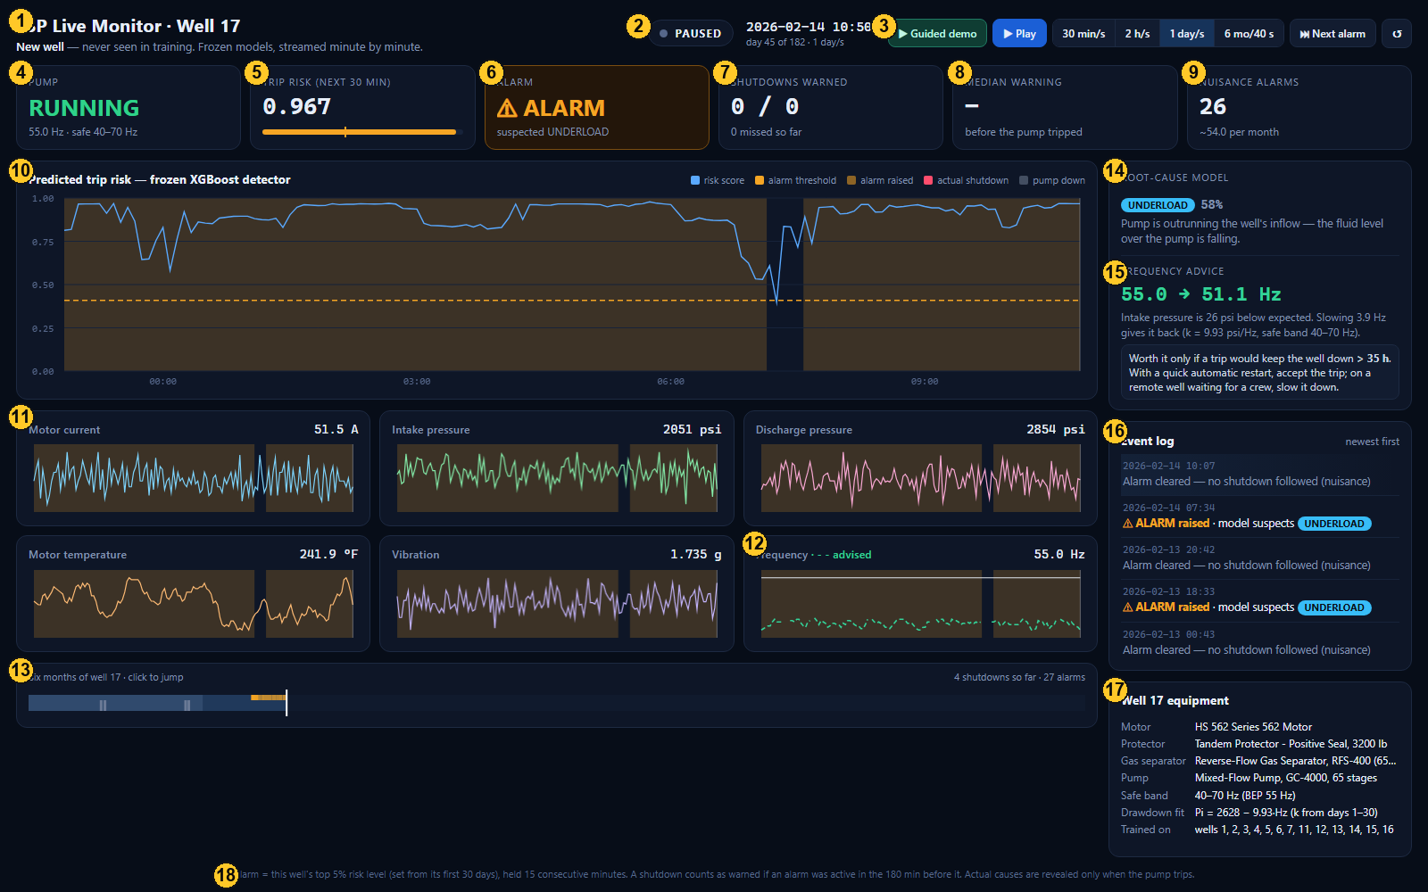
The dashboard during the underload alarm on 14 February. Each number is explained in the table below.
# | Part | What it shows and how to read it
1 | Title | ESP Live Monitor · Well 17. The line below says it is a new well, never seen in training, and that the models are frozen.
2 | Status and clock | PAUSED, CALIBRATING (amber, first 30 days), or LIVE (red dot). Next to it: the simulated date and time, the day number (out of 182) and the current speed.
3 | Controls | Guided demo, Play / Pause, four speeds, Next alarm, and Restart (↺). See Part 3.
4 | Pump | RUNNING (green) or TRIPPED (red). Shows the current frequency and the well's safe band (40–70 Hz).
5 | Trip risk (next 30 min) | The detector's score from 0 to 1: how likely the pump is to trip in the next 30 minutes. The bar fills with the score; the small amber tick is the alarm threshold. Shows “—” while the pump is down, because nothing is predicted then.
6 | Alarm | CALIBRATING, NORMAL, or ⚠ ALARM with the suspected cause. The card glows amber while an alarm is on.
7 | Shutdowns warned | Warned trips / all trips so far (after calibration), and how many were missed.
8 | Median warning | The typical number of minutes between the start of the warning and the trip, over the warned trips so far.
9 | Nuisance alarms | Alarms that were not followed by a trip, with the rate per month so far.
10 | Risk chart | The risk score over time (blue), the threshold (dashed amber), alarm periods (amber shading), real shutdowns (red lines), pump-down periods (grey). After a warned trip, a white arrow shows the minutes of warning.
11 | Sensor charts | The six raw sensors: motor current, intake pressure, discharge pressure, motor temperature, vibration and frequency, with the current value top right.
12 | Frequency chart | The actual frequency (white line) and, during an underload alarm, the advised frequency (dashed green line).
13 | Six-month strip | The whole replay. Amber marks are alarms; green ticks are warned trips; red ticks are missed trips; grey ticks are trips during calibration. Click anywhere to jump.
14 | Root-cause model | During an alarm: the suspected cause, the model's confidence (for example 58%), and a one-line explanation of what that cause means.
15 | Frequency advice | Only for underload: the advised frequency (55.0 → 51.1 Hz), why (intake pressure 26 psi below expected), and when acting on it pays (a trip must cost more than 35 hours).
16 | Event log | Newest first: calibration complete, alarms raised (with the suspected cause), alarms cleared with no trip (nuisance), and shutdowns with the actual cause and whether they were warned.
17 | Equipment | Well 17's motor, protector, gas separator and pump, its safe band and best-efficiency speed, the fitted drawdown line (Pi = 2628 − 9.93·Hz), and the wells the model was trained on.
18 | Rules line | The alarm rule and the catch rule in one sentence, always visible at the bottom.

3 · The controls
Control | Key | What it does
▶ Guided demo | D | Plays the whole six months automatically in about 50 seconds: calibration fast, then fast until shortly before the first warned trip, slow for that trip, then fast to the end and the summary. This is what the demo video shows.
▶ Play / ❚❚ Pause | Space | Start or stop the replay at the selected speed.
30 min/s |  | 30 simulated minutes per real second. Best for watching one alarm and trip in detail.
2 h/s |  | Two hours per second. One day passes in 12 seconds.
1 day/s |  | One day per second. One month in 30 seconds.
6 mo/40 s |  | The whole six months in 40 seconds.
⏭ Next alarm | N | Jumps to 8 hours before the next alarm, so you can watch it build up.
↺ Restart | R | Back to day 1, paused, with the event log cleared.
Six-month strip | click | Jumps to any day.

The page opens paused on 14 February at 13:26, fifty minutes after the first warned trip, with the alarm period, the trip line, the 180-minute arrow and the log entry all visible. It is a good screenshot as it is.
Shortcuts. Adding #demo to the end of the file's address starts the guided demo straight away; #summary opens the final summary; #t= followed by a minute number (for example #t=64010) opens that exact moment.

4 · The simulation, step by step
The replay covers 1 January to 1 July 2026: 182 days, 262,080 minutes. It happens in five stages.

Stage 1 · Calibration (1–30 January)
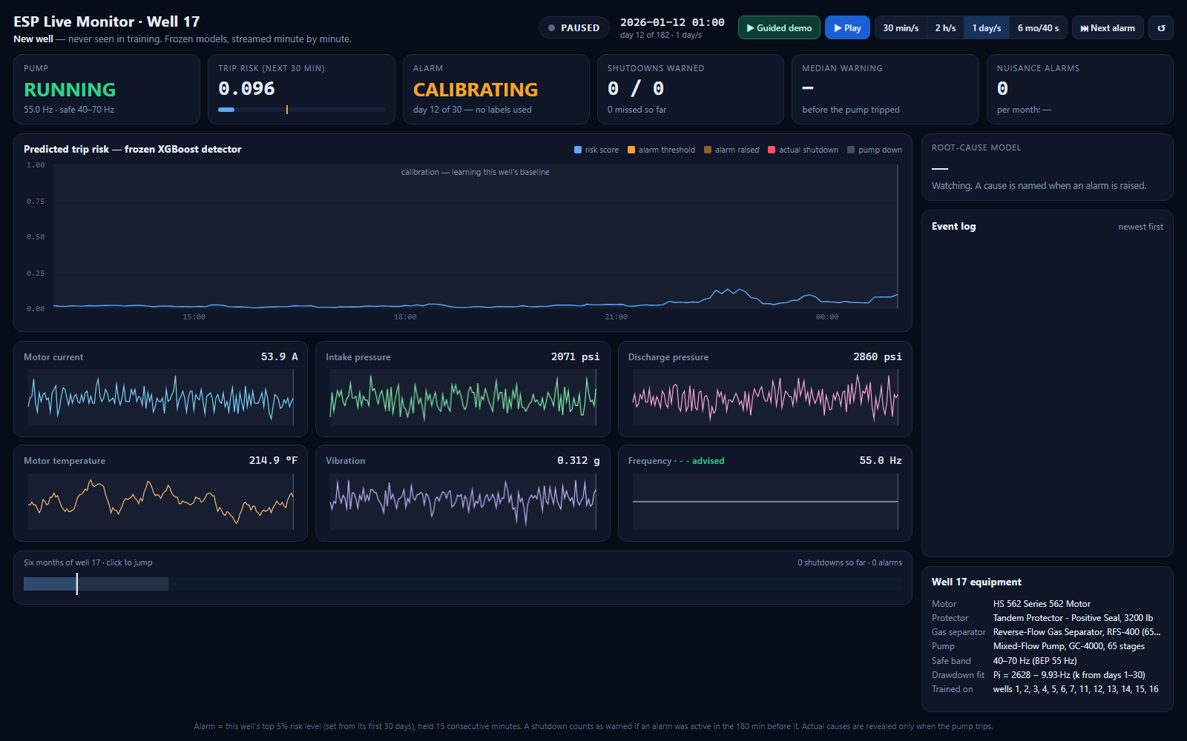
Day 11: CALIBRATING. The risk line is flat and no alarm can fire yet.
- The status shows CALIBRATING and the Alarm card counts the days (“day 11 of 30 — no labels used”).
- The detector already scores every minute, but there is no alarm threshold yet, so no alarm can fire.
- In the background the dashboard learns the well: its normal sensor levels (for the root-cause model), its alarm threshold, and its drawdown coefficient k.
- Four shutdowns happen during calibration (13 Jan high discharge, 14 Jan underload, 27 Jan underload, 28 Jan high discharge). They appear in the log as “during calibration, not scored” and are not counted in the results.

Stage 2 · Going live (31 January)
- The status turns LIVE and the log says: “Calibration complete. Alarm threshold set at 0.409 — this well's own top 5%.”
- 0.409 means: during the first 30 days, only 5% of minutes had a risk score higher than 0.409. From now on, a minute above that line is unusual for this well.
- The dashed amber threshold line appears on the risk chart.

Stage 3 · The first alarm (8 February)
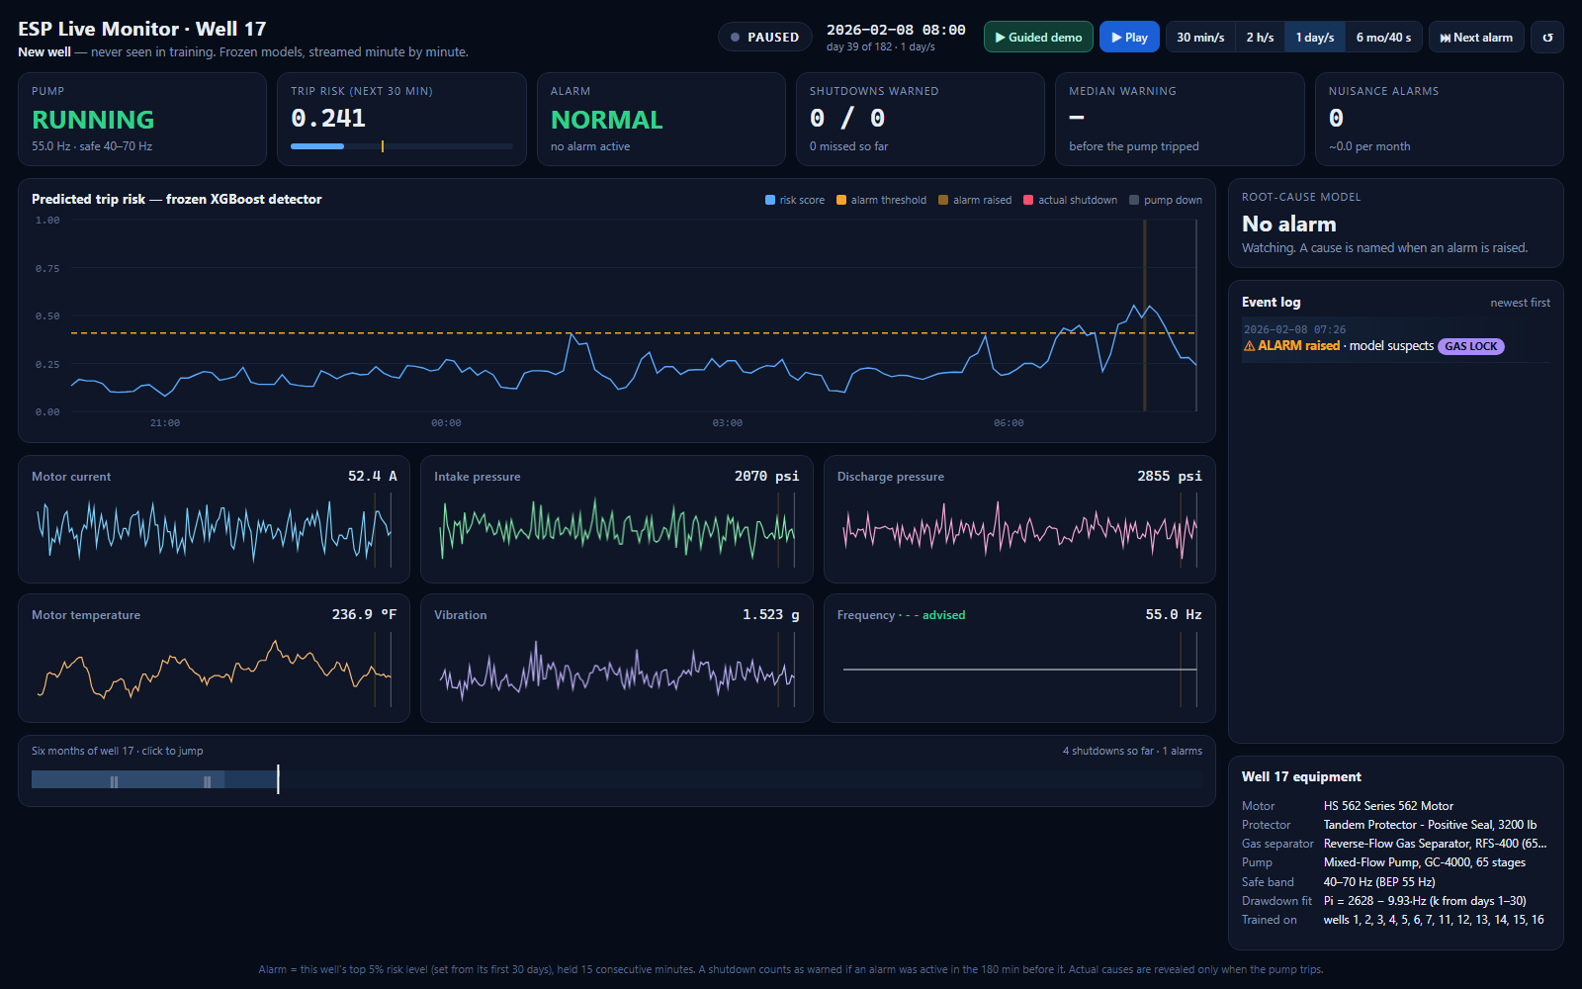
8 February: the risk crosses the threshold and the first alarm is raised. It turns out to be a false alarm.
- For the first week of live operation the risk stays below the threshold.
- On 8 February at 07:26 the risk stays above 0.409 for 15 minutes in a row, so the first ⚠ ALARM is raised. The root-cause model suspects gas lock.
- No trip follows, so three hours after it ends the log adds “Alarm cleared — no shutdown followed (nuisance)” and the Nuisance alarms card goes up by one. This is how every false alarm is counted.

Stage 4 · The warned trip (14 February): the heart of the demo
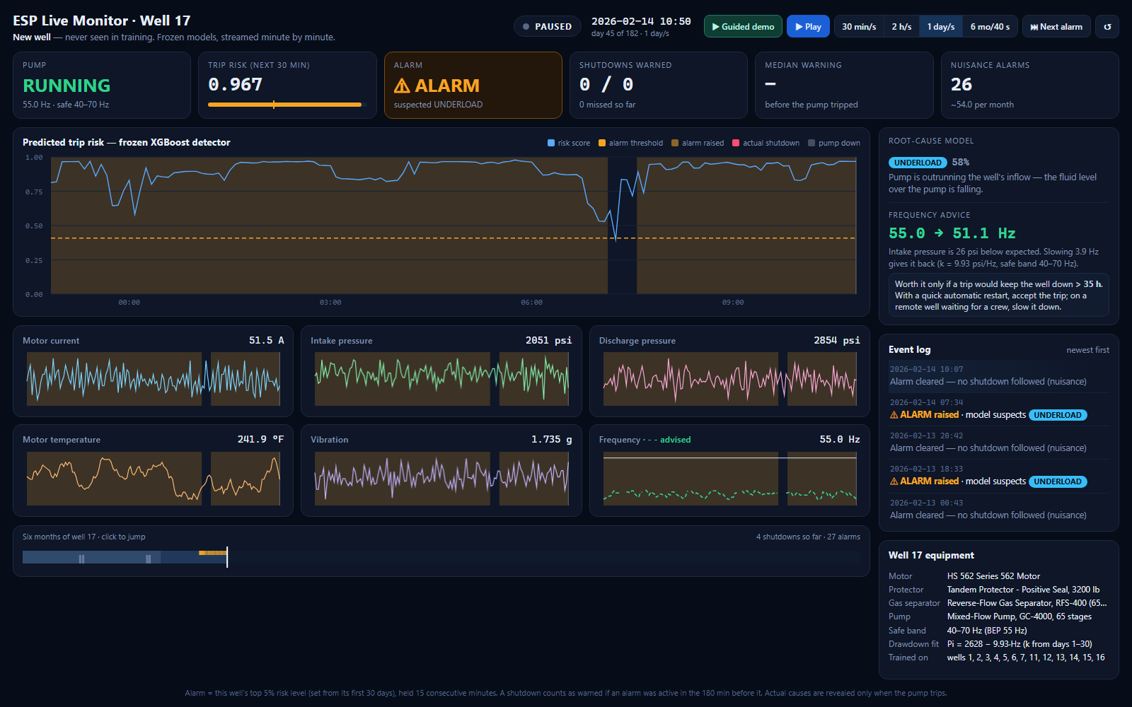
14 February, 10:56: ALARM, suspected underload, frequency advice 55.0 → 51.1 Hz.
This is the moment the guided demo slows down for. In order:
Time | What happens on screen | What it means
12–14 Feb | The risk climbs and several short alarms come and go, all suspecting underload | The fluid level over the pump is slowly falling. The model sees it in intake pressure and current.
14 Feb 07:34 | ⚠ ALARM raised · model suspects UNDERLOAD. The alarm stays on. | The warning starts about 5 hours before the trip.
During the alarm | Frequency advice appears: 55.0 → 51.1 Hz. The dashed green line appears on the frequency chart. | Intake pressure is 26 psi below what 55 Hz should give; slowing about 3.9 Hz would give it back. Worth it only if a trip would cost more than 35 hours.
14 Feb 12:36 | Pump: TRIPPED. Red line. The log: “SHUTDOWN · actual UNDERLOAD · ✓ warned 180 min ahead · cause ✓ correct” | The prediction was right about both the trip and the cause. Shutdowns warned becomes 1 / 1.
After the trip | The pump is down (grey band, current near 0 A), then restarts and ramps back up to 55 Hz over several hours. | The simulated well ignored the advice and stayed at 55 Hz, as if the operator did nothing.

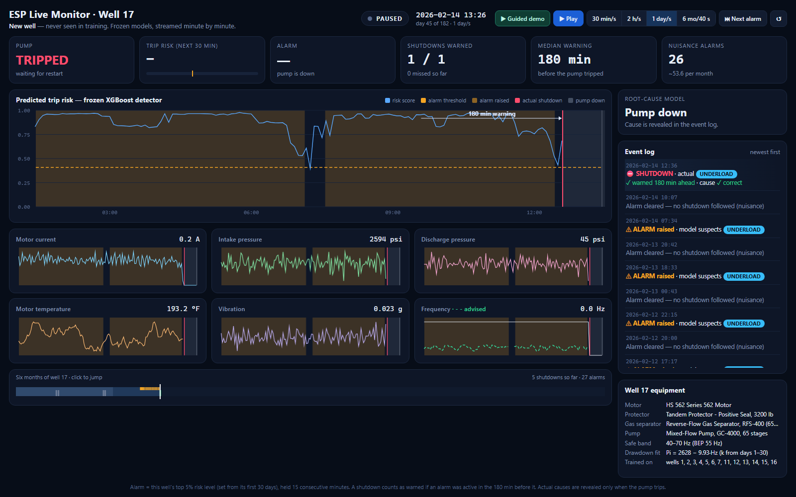
Fifty minutes after the trip: the alarm period, the trip line and the 180-minute warning arrow.
Why 180 and not 5 hours. The alarm started about 5 hours before the trip, but the dashboard reports 180 minutes. A warning is measured inside a 180-minute window before each trip, so 180 is the most any single trip can score. The same rule is used in the report.

Stage 5 · The missed trip (15 February) and the pattern for the rest of the replay
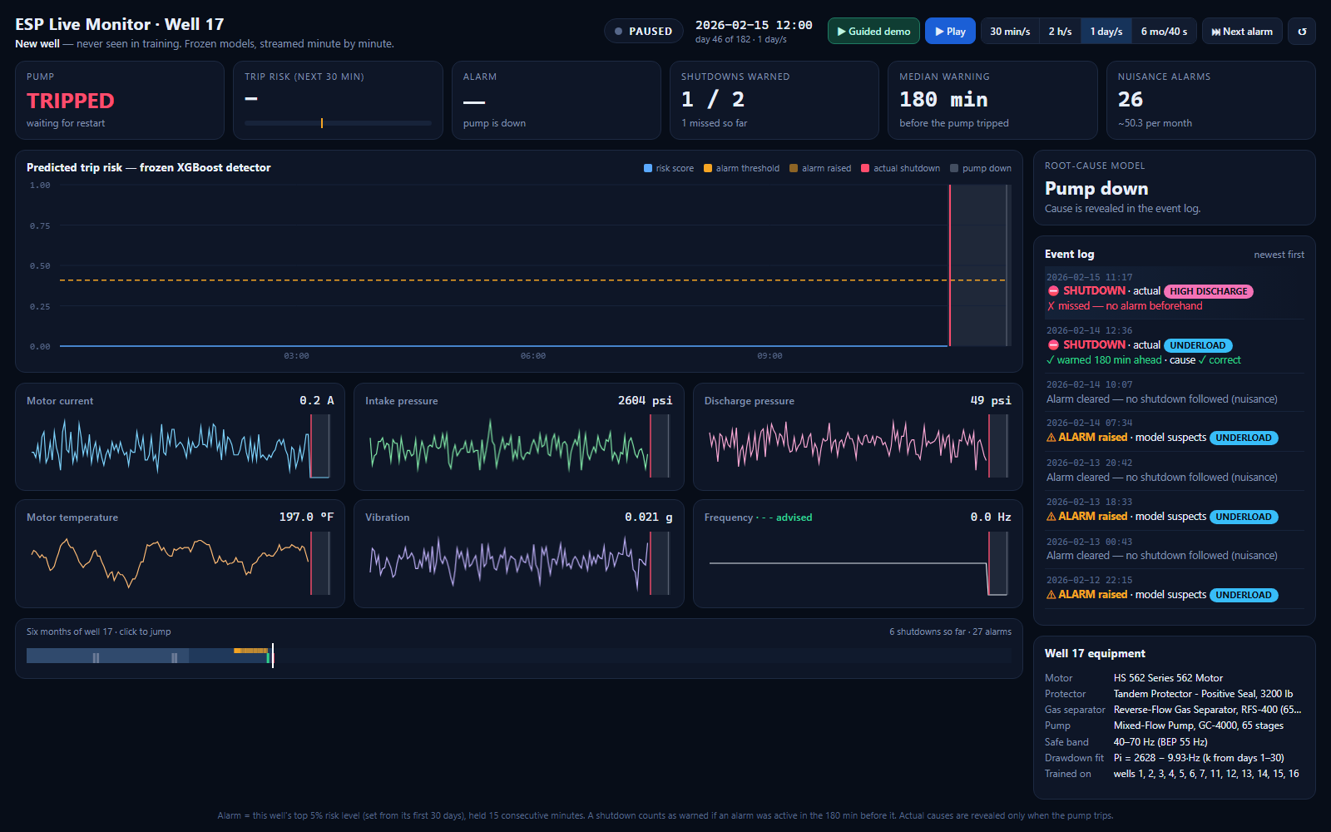
15 February: a high-discharge trip 23 hours after the underload trip, with no warning. The risk stayed near zero.
- At 11:17 the next day the pump trips again, this time from high discharge, and there was no alarm. The log says “✗ missed — no alarm beforehand”.
- Look at the risk chart: the score stayed near zero. The pump had restarted less than a day earlier. The model's most important input is time since the last shutdown, and a freshly restarted pump looks healthy to it.
- This repeats for the rest of the six months: every underload trip is warned, and every high-discharge trip, which always comes 1 to 4 days after an underload trip, is missed. This is the most useful weakness to explain.

The end · The summary
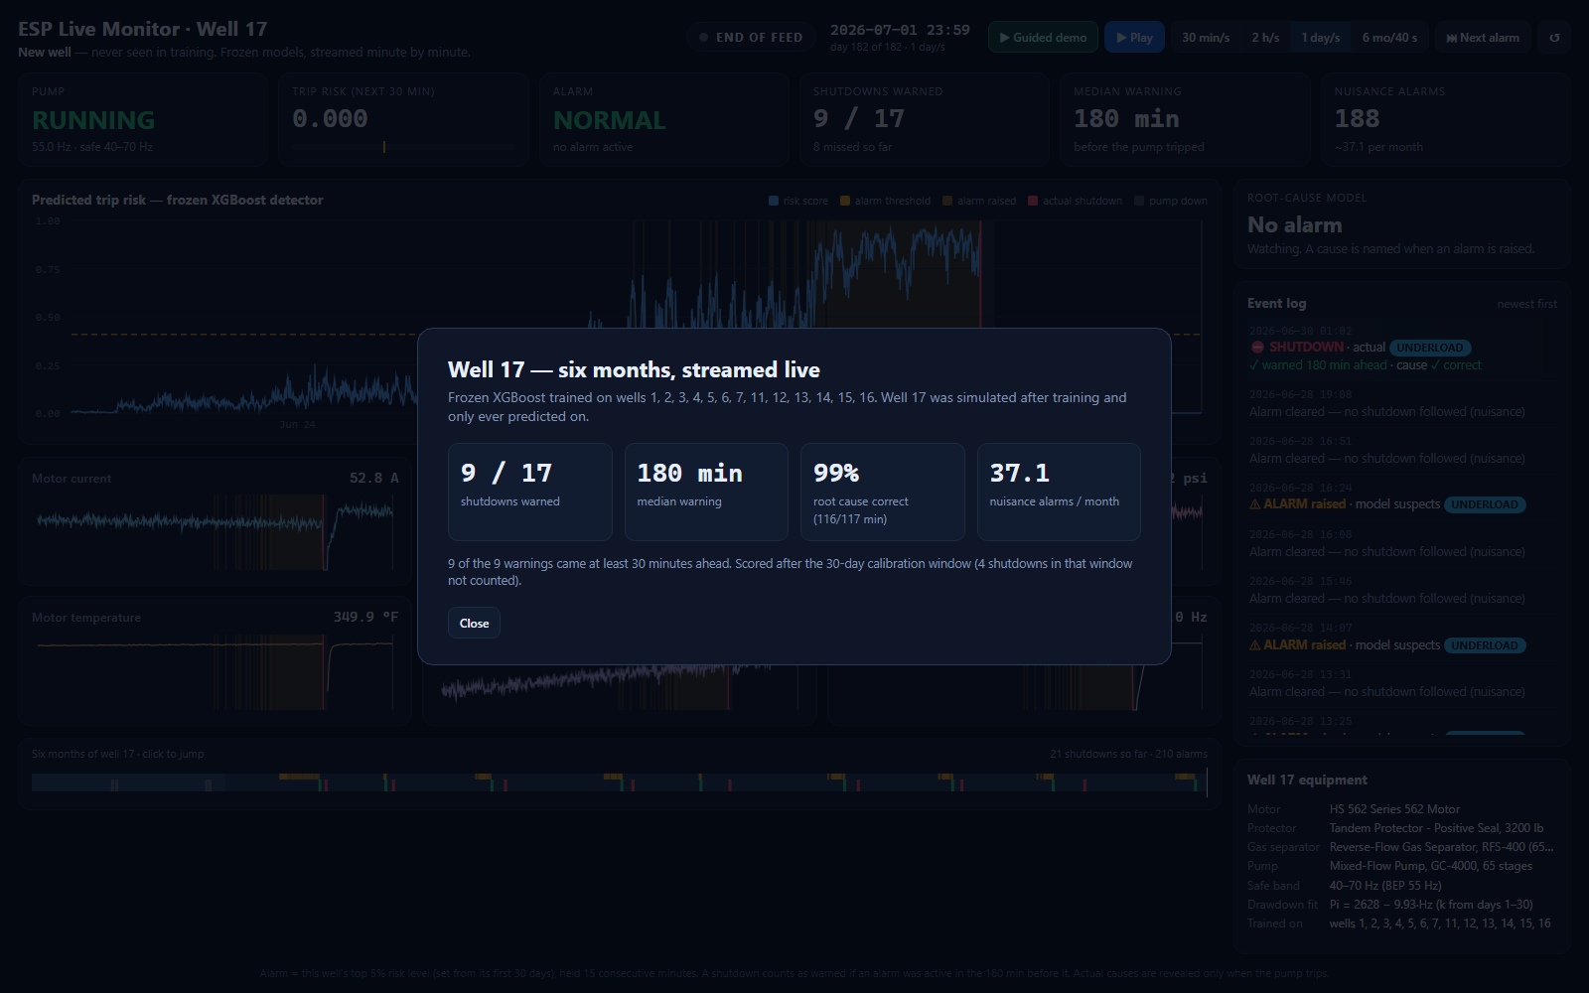
The summary that appears when the replay reaches 1 July.
- 9 / 17 shutdowns warned, all 9 at least 30 minutes ahead.
- 180 min median warning.
- 99% root cause correct on the minutes when a fault was building (116 of 117).
- 37.1 nuisance alarms per month.
- The note underneath: the 4 shutdowns during calibration were not counted.

5 · The six months, trip by trip
Date | Day | Actual cause | Result | Warning
13 Jan | 13 | High discharge | Calibration, not scored | —
14 Jan | 14 | Underload | Calibration, not scored | —
27 Jan | 27 | Underload | Calibration, not scored | —
28 Jan | 28 | High discharge | Calibration, not scored | —
14 Feb | 45 | Underload | Warned, cause correct | 180 min
15 Feb | 46 | High discharge | Missed | —
24 Feb | 55 | Underload | Warned, cause correct | 163 min
25 Feb | 56 | High discharge | Missed | —
13 Mar | 72 | Underload | Warned, cause correct | 180 min
15 Mar | 74 | High discharge | Missed | —
2 Apr | 92 | Underload | Warned, cause correct | 170 min
3 Apr | 93 | High discharge | Missed | —
14 Apr | 104 | Underload | Warned, cause correct | 179 min
18 Apr | 108 | High discharge | Missed | —
6 May | 126 | Underload | Warned, cause correct | 180 min
8 May | 128 | High discharge | Missed | —
23 May | 143 | Underload | Warned, cause correct | 180 min
24 May | 144 | High discharge | Missed | —
8 Jun | 159 | Underload | Warned, cause correct | 163 min
12 Jun | 163 | High discharge | Missed | —
30 Jun | 181 | Underload | Warned, cause correct | 180 min

210 alarms were raised after calibration. 22 of them overlapped the 180 minutes before a real trip; the other 188 were nuisance alarms. The model named underload on 172 alarms and gas lock on 38. Well 17 has no gas lock, so those 38 were always wrong, but none of the real trips was called gas lock.

6 · How every number is calculated
Number | How it is calculated
Trip risk | The XGBoost detector's probability that the pump trips within 30 minutes, from 44 features of the last 4 hours of sensor data. The chart shows the highest score in each 5-minute step.
Alarm threshold (0.409) | The level that only the top 5% of this well's risk scores reached during its first 30 days.
Alarm | Raised when the risk stays at or above the threshold for 15 minutes in a row. Consecutive minutes above the line count as one alarm, however long it lasts.
Suspected cause and % | The Random Forest root-cause model's top class and its probability, using the well's sensors normalised against its first 30 days plus three equipment numbers.
Warned trip | A trip is warned if an alarm was active at any time in the 180 minutes before it.
Warning (minutes) | From when the alarm was already active inside that 180-minute window to the trip. At most 180.
Useful warning | A warning of at least 30 minutes. All 9 warnings on well 17 were useful.
Nuisance alarm | An alarm with no trip in the 180 minutes after it ends. It is counted 180 minutes after it ends, when it can be known that no trip followed.
Cause correct at the trip | The most frequent cause the model named during the alarm minutes before the trip, compared with the actual cause. 9 of 9.
Root cause 116 / 117 | On the minutes where a fault was actually building, how often the model named the right cause.
Drawdown fit | A straight-line regression of intake pressure on frequency over days 1–30: Pi = 2628 − 9.93 × Hz. k = 9.93 psi per Hz (the simulator's true value is 9.0).
Frequency advice | deficit = expected intake pressure − measured (15-minute average). If the deficit is at least 18 psi: cut = (deficit + 12) ÷ k, new frequency = current − cut, kept inside 40–70 Hz. Example: (26 + 12) ÷ 9.93 ≈ 3.9 Hz, so 55.0 → 51.1 Hz.
Break-even (35 h) | From Step 5 of the notebook: slowing a well to 90% of its best-efficiency speed pays only if each avoided trip would have kept it down for more than about 35 hours.

7 · Reading the results honestly

7.1 What the dashboard shows well
- A new well, never seen in training, warned about three hours ahead on every underload trip.
- The cause named correctly every time a trip was warned (9 of 9), and on 116 of 117 fault minutes.
- A physical property of the well (k) recovered from routine data, close to its true value.
- A frequency advice that comes with its own condition for when it is worth following.

7.2 What it shows is still weak
- High-discharge trips are all missed on this well, most likely because each one comes soon after an underload restart, when the model's time-since-last-shutdown input says the pump is healthy.
- 37 nuisance alarms per month. Risk hovering around the threshold during the days-long underload build-up switches the alarm on and off, and each switch counts as a new alarm.
- The model sometimes names gas lock, a cause this well does not have.

7.3 Why these numbers differ from the report
 | Report (wells 8, 9, 10) | Dashboard (well 17) | Why
Trips warned | 48% | 53% (9 of 17) | Different well and cause mix
Median warning | 180 min | 180 min | Same rule
Root cause | 68.6% | 99% (116 / 117) | Well 17 has no high temperature, the cause the model fails on
Nuisance alarms / month | 18.7 | 37.1 | A live threshold can only use the first 30 days; the report's uses all six months
Trips counted | 69 | 17 | The 4 trips during calibration are not counted

The line to use. The dashboard deliberately does not copy the report's method of setting the threshold from the whole six months, because a live system cannot see the future. That honesty costs extra false alarms, and it is the right trade to defend.

8 · What to say

8.1 With the video (about one minute)
Time | On screen | Say
0–5 s | CALIBRATING | “This is well 17. The model has never seen it. For its first 30 days the system only learns what normal looks like for this well.”
5–10 s | LIVE, fast | “Now the data streams in minute by minute, and the frozen model scores every minute.”
10–25 s | Alarm, UNDERLOAD, advice | “The risk rises, an alarm fires, and the model names the cause: underload. It also advises slowing the pump from 55 to about 51 hertz.”
about 24 s | TRIPPED, log entry | “The pump trips. The warning came three hours earlier, and the cause was right.”
25–50 s | Fast to the end | “Over six months it warned about every underload trip.”
End | Summary | “Nine of seventeen shutdowns warned, three hours ahead, cause correct 99% of the time. The price is false alarms, which is what we would work on next.”

8.2 Live, with more time (about three minutes)
- Open the page. It is paused just after the first warned trip. Point at the red line, the amber alarm period and the 180-minute arrow, then at the log entry: warned 180 minutes ahead, cause correct.
- Press ↺, then 1 day/s. Let calibration run and point out CALIBRATING and the four trips that are not counted.
- Pause when it says LIVE and read the log line: threshold 0.409, this well's own top 5%.
- Press N (Next alarm) and 30 min/s. Show the alarm, the named cause and, for underload, the frequency advice with the 35-hour condition.
- Let the pump trip. Show the cause being revealed only now, and the counters changing.
- Continue to 15 February. Show the missed high-discharge trip and explain why the risk stayed low.
- Press 6 mo/40 s to finish, and read the summary.

9 · Questions the dashboard will raise

Is this really live?
It is a replay of a simulated well at high speed. The model's work is the same as it would be live: every score uses only past minutes, and the threshold uses only the first 30 days. Pointed at a real SCADA feed, the same code would score each new minute as it arrives.

Were the predictions calculated before the replay?
Yes. When the page is built, the frozen models score all six months, which takes about 20 seconds. Because no feature looks forward in time and the threshold comes only from the first 30 days, the result is exactly what minute-by-minute live scoring would give.

Why is the threshold 0.41 here but 0.003 for well 8?
Every well has its own scale. The rule is the same for all wells (the top 5% of that well's own scores), so the number is different for each.

Why so many false alarms?
Two reasons. The threshold can only use the first 30 days, when the well is young and scores are low. And the underload build-up lasts days, so the risk hovers around the threshold and the alarm switches on and off many times.

Why are all the high-discharge trips missed?
Each one comes 1 to 4 days after an underload trip. Just after a restart, the time-since-last-shutdown input is small and the pump looks healthy to the model, so the risk stays low.

Is the frequency advice applied?
No, it is advice for the engineer. The simulated well stays at 55 Hz, as if nobody acted. The effect of acting on it was measured separately: underload trips went from 22 to 0, at a cost of 18.9% of production.

What does the percentage next to the cause mean?
The root-cause model's confidence in the cause it names.

Why does it sometimes say gas lock?
The model knows four causes and sometimes names gas lock on a false alarm. None of the real trips was called gas lock.

Why does the warning always say about 180 minutes?
Warnings are measured inside a 180-minute window before each trip, so 180 is the maximum. The first warned alarm actually started 5 hours before its trip.

Can you show another well?
Yes. The dashboard is built by one script, 6_dashboard/build_dashboard.py, which can simulate any new well number with any mix of causes and score it with the same frozen models.

10 · How the dashboard is built
File | What it is
6_dashboard/ESP_Live_Dashboard.html | The dashboard itself: one self-contained page (5.5 MB) with the data inside it
6_dashboard/build_dashboard.py | The script that builds the page
6_dashboard/dashboard_template.html | The page design; the build script fills it with data
data/model_store/esp_models.joblib | The frozen models the dashboard uses

The build script runs four steps, and prints each one:
- Simulate the new well. It runs the project's own equipment and simulation code in a scratch folder, so well 17 gets exactly the equipment and data it would get in the notebook. The training data is never touched.
- Build the features. The same 44 backward-looking features as in training.
- Score every minute with the frozen models, set the threshold and fit k from days 1–30, and work out the alarms, the causes and the frequency advice.
- Write the page, with the data in 5-minute steps (52,416 points per series) and the actual shutdowns kept separate so they can be revealed at the right time.
It is rebuilt by Step 8 of the main notebook, or from a terminal with the same Python that trained the models:
cd 6_dashboard
python build_dashboard.py --well 17 --causes "UNDERLOAD:0.5;HIGH_DISCHARGE:0.5" --breakeven 34.7

