AI Course
Capstone Project
Final Report

For students (instructor review required)

ⓒ2025 SAMSUNG. All rights reserved.
Samsung Electronics Corporate Citizenship Office holds the copyright of this document.
This document is a literary property protected by copyright law so reprint and reproduction without permission are prohibited.
To use this document other than the curriculum of Samsung Innovation Campus, you must receive written consent from copyright holder.

AI/ML-Driven ESP Failure Prediction & Optimal Operation Frequency Selection

29/09/26

Group-3 — Data Drillers

Muhammed Elfeelali (Team Leader)
Anas Eddanfor
Moataz Fakah
Abdullah Shawesh
Dana Auzi
Babiker Yousuf Ahmed Hassan

Content
1. Introduction
1.1. Background Information
1.2. Motivation and Objective
1.3. Members and Role Assignments
1.4. Schedule and Milestones

2. Project Execution
2.1. Data Acquisition
2.2. Training Methodology
2.3. Workflow
2.4. System Diagram

3. Results
3.1. Data Preprocessing
3.2. Exploratory Data Analysis (EDA)
3.3. Modeling
3.4. User Interface
3.5. Testing and Improvements

4. Projected Impact
4.1. Accomplishments and Benefits
4.2. Future Improvements

5. Team Member Review and Comment

6. Instructor Review and Comment

1. Introduction

1.1. Background Information
Electrical Submersible Pumps (ESPs) are one of the most widely used artificial-lift methods in oil production, and one of the most failure-prone. An unplanned ESP trip stops production immediately and can require an expensive workover, so a single avoided failure carries real financial value.
In current practice, ESP failures are handled reactively: the SCADA system raises an alarm when a sensor crosses a fixed threshold, which usually happens at, or just before, the moment of failure. Field engineers therefore learn about most trips after the fact. The underlying degradation — gas accumulating at the intake, mechanical wear, scale building up downstream, thermal stress — develops gradually and is visible in the data long before the threshold is crossed.
A further complication is that ESPs do not fail for one reason. Gas lock, underload, high motor temperature, high discharge pressure, mechanical vibration and low voltage supply all produce a trip, but they require different responses. Some can be mitigated by changing the operating frequency; others cannot be fixed by frequency at all and need physical inspection. Any useful system must therefore identify not only that a failure is coming but which failure it is.

1.2. Motivation and Objective
Objective. Build an ML pipeline that predicts an impending ESP trip from 1-minute SCADA data with enough lead time to act, identifies the developing failure cause, and recommends a corrective operating frequency that stays within the well's own equipment limits — moving ESP maintenance from reactive to data-driven.
Failure horizon. The detection model answers a single question: will this well trip within the next 30 minutes? A 60-minute horizon was evaluated first and rejected on measurement — a longer window fills the training label with minutes that still look statistically normal, which dilutes the signal.
Operationally allowable frequency range. Each well has its own safe band, derived as the intersection of its Motor, Protector and Pump rated frequency ranges. Across the 16 wells modelled, these bands range from 35–63 Hz to 40–68 Hz. Every recommendation is clipped to the individual well's band; a single field-wide range is never used.
Scope: four degradation causes. The project began with six causes and was narrowed to four on field-engineering grounds. Low voltage was removed because a grid sag is an external supply event that well data cannot anticipate and the drive's own undervoltage protection already covers. Vibration was removed as a failure label because a pump does not shut down because it vibrates — it is a condition indicator. Both sensor channels are nevertheless retained as model inputs: removing them was tested and gas-lock classification collapsed from 0.68 to 0.20.
Cause-gated recommendation. Gas lock, high temperature, high discharge and underload all admit a frequency adjustment; anything outside that set raises an inspection flag. A quantified recommendation is implemented for underload, where the required cut can be computed from the well's own fitted drawdown coefficient; for the other three the cause is reported together with the well's safe band and a targeted inspection prompt. Underload was originally classified in this project as not frequency-related, which was wrong and has been corrected — inflow starvation is the textbook frequency-adjustable failure mode, and slowing the pump until its rate matches the well's inflow is exactly what a pump-off controller does.

1.3. Members and Role Assignments
Muhammed Elfeelali — Team Lead / Domain SME. Coordinates the team, sets requirements from artificial-lift field experience, defines the SCADA tags, the failure horizon and the per-well safe frequency bands.
Anas Eddanfor — Data Engineer. Sources and cleans the SCADA dataset, builds the feature pipeline (rolling windows, run-life), and enforces the well-and-time split that prevents leakage.
Moataz Fakah — ML Engineer (Unsupervised). Builds and tunes K-Means / DBSCAN to separate operating regimes and flag anomalies.
Abdullah Shawesh — ML Engineer (Supervised). Builds and tunes the Stage 1 detection and Stage 2 root-cause classifiers, and the baseline comparisons.
Dana Auzi — Validation Engineer. Owns the evaluation framework — lead time, false alarms, missed failures and production impact — and the comparison against real historical well data.
Babiker Yousuf Ahmed Hassan — Documentation & Presentation Lead. Owns the report, the visuals and the final presentation.

1.4. Schedule and Milestones
The project runs over four weeks (20 working days). This is an interim report: phases 1–5 are complete and phase 6 is in progress.
Phase 1 — Scope and first draft. Define the ESP use case, project boundaries, roles, failure horizon and success criteria. Complete.
Phase 2 — Data acquisition and preparation. Build the dataset, verify timestamps and well IDs, clean missing and invalid readings, define labels, and separate training, validation and test data. Complete.
Phase 3 — Feature engineering and operating regimes. Explore operating trends and class imbalance, build lag, rolling and change features, compare K-Means and DBSCAN clusters. Complete.
Phase 4 — Failure risk modelling. Build the baseline, train and tune the classifiers, choose the alert policy, and evaluate once on untouched test wells. Complete.
Phase 5 — Frequency recommendations and historical evaluation. Apply the per-well frequency limits, rank supported candidate frequencies, and back-test the recommendations. Complete.
Phase 6 — Integration, report and final presentation. Integrate the risk score and frequency recommendation into a single demo, write up methods and limitations, and rehearse the final presentation. In progress — the integrated live monitor is built; the demo video and final presentation remain.

2. Project Execution

2.1. Data Acquisition
No public multi-well ESP dataset with labelled failure causes exists at 1-minute resolution, so the pipeline is currently prototyped on a physics-based synthetic dataset, with real historical well data as the planned validation step.
Scale. 16 wells × 6 months × 1-minute resolution = 4.19 million rows. 13 wells are used for training; 3 wells (8, 9, 10) are held out entirely and contain 69 trips.
Schema. well_id, timestamp, operating state, frequency (Hz), motor current (A), supply voltage (V), intake and discharge pressure (psi), intake and motor temperature (°F), vibration (g), shutdown event, failure cause, and the well's safe minimum and maximum frequency.
Generation. Each well is simulated from a state machine (normal → onset → shutdown → ramp) with physics-inspired sensor relationships. Each well is assigned one to three dominant failure causes so the dataset holds a realistic mix rather than one repeated fault. Latent degradation indices — gas accumulation, thermal load, fouling, and the drawdown of the fluid level over the pump — leak gradually into the sensor readings before a fault formally begins, so the detector has genuine early-warning signal. Drawdown builds only while the pump outruns the well's inflow, so slowing the pump genuinely relieves underload in the simulation, as it does in the field.
Equipment configuration. Every well carries a full ESP string — Motor, Protector, Gas Separator and Pump — with representative ratings, from which the safe frequency band is derived. Wells prone to gas lock are deliberately given a weak or absent gas separator, so the equipment explains the failure mode. A quality check confirms that none of the 4.19 million rows operates outside its own well's rated band.
Extensibility. The well roster is held in a single configuration file. Adding a well — synthetic or real — requires one new row and no code change, and the data generator only simulates wells that are not already present. This is the mechanism by which real historical data will be introduced.

2.2. Training Methodology
Two independent branches. An unsupervised branch (K-Means, k = 6, and DBSCAN) maps operating regimes and anomalies with no failure labels. A supervised branch performs detection and root-cause classification. The two run in parallel; the unsupervised output is deliberately not fed into the supervised models.
Problem formulation. Stage 1 is binary classification (trip within 30 minutes: yes / no). Stage 2 is multi-class classification over the four in-scope causes, trained only on rows where a fault is actively developing. Regression was rejected for detection because the operational question is a yes/no alarm decision; linear regression is used only in the frequency stage, to fit each well's drawdown coefficient. Survival analysis is recorded as a planned refinement.
Models. Logistic Regression, Random Forest and XGBoost are trained for Stage 1 and compared against two baselines: a fixed-threshold rule mirroring current SCADA alarm logic, and a last-value (persistence) baseline. Stage 2 uses a Random Forest on per-well normalized features plus three equipment specifications.
Leakage prevention. Split by well — three wells never seen in training in any form — and by time, with the final six weeks of the training wells held out as validation. All tuning, threshold selection and model selection use validation only.
Class imbalance. Positive minutes are well under 1% of the data. Training uses a downsampled negative class at a fixed ratio together with class weighting; evaluation is always performed on the full, undownsampled test data.
Alarm policy. The raw probability is not used directly. Each well receives a threshold calibrated on its own score distribution, set at the top 5% of that distribution; an alarm requires 15 consecutive minutes above that threshold, and the policy is tuned on validation against an explicit cost weighting between a missed trip and a nuisance alarm.

2.3. Workflow
The pipeline runs as a short sequence of scripts — also packaged as a single notebook — which makes each stage reproducible and independently re-runnable:
1. Configuration and equipment. Read the well roster, assign each well its ESP string, and derive the safe frequency band as the intersection of the component ratings.
2. Data generation. Simulate 1-minute SCADA data per well, labelling each shutdown event with its cause and each onset minute with the developing cause. The step is incremental — only wells not already present are simulated.
3. Feature engineering. Rolling statistics per sensor (15 / 60 / 240-minute means and standard deviations, 5-minute changes) plus the run-life feature.
4. Labelling and splitting. Mark every minute within 30 minutes of a trip, then split by well and by time.
5. Modelling. Run the unsupervised branch, then Stage 1 detection and Stage 2 root-cause classification.
6. Alarm policy and evaluation. Tune the threshold and persistence on validation, apply to the held-out wells, and report event-level results with a full trade-off curve.
7. Recommendation. Gate on the predicted cause; where frequency is applicable, clip the recommendation to the well's own safe band. For underload, fit the drawdown coefficient on the well's first 30 days, compute the cut that recovers the intake-pressure deficit, and compare against the break-even downtime per trip.

2.4. System Design
The system is organised as two parallel branches feeding a single decision point.
SCADA data → preprocessing and feature engineering → [Branch A: unsupervised — K-Means / DBSCAN → operating regimes and anomalies] and [Branch B: supervised — Stage 1 detection → Stage 2 root cause] → alarm policy → cause gate → frequency advice (underload: fitted drawdown coefficient, clipped to the well's safe band, checked against break-even downtime) or inspection flag → live monitor.
Branch A is a health-monitoring map: it shows which operating regime a well currently sits in and flags anomalous minutes, without requiring labels. Branch B produces the actionable output. They are reported separately and never chained.
The decision point is the cause gate. If the predicted cause is underload, the system proposes a specific frequency cut computed from the well's own drawdown coefficient, bounded by its equipment limits, and states the break-even downtime above which acting on it pays; if even the minimum safe frequency cannot recover the deficit, it escalates to inspection. Gas lock, high temperature and high discharge are reported with the well's safe band and a targeted inspection prompt. Vibration and low voltage are outside the prediction scope and are left to the well's existing protection.
Generative AI is not used for the core prediction task. Its only intended role is an evidence-linked explanation of model output for engineers; it never issues an autonomous frequency recommendation.

3. Results

3.1. Data Preprocessing
Sensor channels are downcast to 32-bit floats and the unused intake-temperature channel is dropped, which keeps the 4.19-million-row dataset inside the available memory budget.
Feature engineering. For each of six sensors: 15- and 60-minute rolling means and standard deviations, a 240-minute rolling mean to capture slow drift, and a 5-minute change. Added to these is the run-life feature — minutes since that well's last shutdown — which mirrors a standard real-world ESP monitoring signal and proved to be one of the most useful inputs.
Per-well normalization. Each well has different baseline sensor levels, so features for the root-cause model are z-score normalized against each well's own baseline: the fit period for training wells, and the first 30 days for held-out wells, which mirrors the calibration window a new well would realistically have. Standard deviations are floored to prevent a near-constant channel from producing extreme values.
Labelling. Stage 1 marks every minute within 30 minutes of a trip. Stage 2 uses only rows where a fault is actively developing, with the true per-minute cause.

3.2. Exploratory Data Analysis (EDA)
Severe class imbalance. Minutes labelled as pre-failure are well under 1% of the dataset. This dominates every modelling decision: overall accuracy is meaningless here (a model predicting "no failure" always scores above 99%), which is why the project reports event-level metrics instead.
Wells are not interchangeable. Each well has its own reservoir pressure, productivity index, supply voltage and best-efficiency frequency, so absolute sensor levels differ substantially between wells. This observation later explained why a single global alarm threshold does not transfer.
Trip distribution. The three held-out wells contain 69 trips in total — 22, 18 and 29 for wells 8, 9 and 10 — split between underload (22), high discharge (22), gas lock (14) and high temperature (11).
Unsupervised branch. K-Means (k = 6) reaches a silhouette score of 0.185, and two of the six clusters carry essentially all of the failure-adjacent minutes. DBSCAN separates outliers carrying roughly double the failure rate of clustered-normal points. Both are useful today as an operating-regime map rather than as a standalone failure signal.
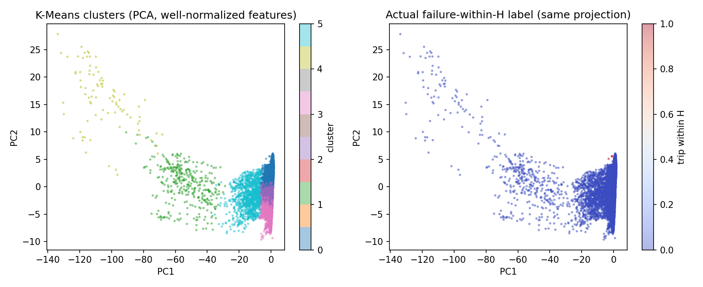
Figure 1 — K-Means clusters projected onto the first two principal components (left), with the actual failure labels on the same projection (right).

3.3. Modeling
All figures below are measured on the three wells the models never saw in training.
Stage 1 — detection. Each model was given its own alarm policy, tuned on validation using the same cost criterion, and then measured at the event level:
• Logistic Regression — 13 of 69 trips caught (19%), 20.1 nuisance alarms per well per month, 180 minutes median lead time.
• Random Forest — 21 caught (30%), 20.4 alarms per well per month, 180 minutes median lead time.
• XGBoost — 33 caught (48%), 18.7 alarms per well per month, 180 minutes median lead time. Selected.
XGBoost catches more than twice what Logistic Regression does while raising slightly fewer nuisance alarms. That combination — more catches and fewer alarms at once — is what distinguishes a genuinely better score from a threshold moved to trade one against the other. Of the 33 caught, 31 arrive at least 30 minutes ahead, which is the minimum the team treats as an actionable warning: an alarm four minutes before a trip is detection, not prediction.
The model is selected on validation event-level cost with a miss weighted 200:1, never on test performance and never on minute-level ROC-AUC, which is close to meaningless when positives are under 1% of rows.
Both baselines are beaten on the metric that matters. The fixed-threshold SCADA rule catches almost nothing (recall 0.017). The last-value persistence baseline appears to score very highly, but this is a labelling artefact — it requires knowing the near-future label, so it cannot function as an early-warning baseline.
Model performance, side by side. Table 1 is the comparison the project is judged on: each model at its own validation-tuned alarm policy, counted in shutdowns and interruptions on the three held-out wells. XGBoost is ahead on every column at once — the most trips caught, the most caught with usable warning, the fewest nuisance alarms and the highest ROC-AUC on both validation and test. It was selected on its validation cost; the test columns confirm that choice but played no part in it.
Table 1 — Stage 1 detection, event level, on held-out wells 8, 9 and 10.
Model | Alarm policy | Trips caught (of 69) | With ≥30 min warning | Nuisance alarms / well / month | Lead time median (mean) | ROC-AUC val / test | Val. cost
Logistic Regression | top 5%, 15 min | 13 (19%) | 12 (17%) | 20.1 | 180 (158) min | 0.796 / 0.676 | 5,721
Random Forest | top 5%, 10 min | 21 (30%) | 20 (29%) | 20.4 | 180 (171) min | 0.937 / 0.736 | 2,547
XGBoost — selected | top 5%, 15 min | 33 (48%) | 31 (45%) | 18.7 | 180 (159) min | 0.951 / 0.768 | 2,011
Alarm policy = the top share of each well's own risk scores that triggers, and how many consecutive minutes it must hold; each model's policy was tuned on validation. Validation cost = missed useful trips × 200 + nuisance alarms, on validation data only; lowest wins.
Why minute-level metrics are not used to choose. Table 2 gives the standard metrics at a fixed 0.5 probability cut-off. With pre-failure minutes at 0.27% of the data they mislead in both directions: every model, and even the fixed-threshold SCADA rule, scores above 94% accuracy while catching almost nothing, and the model with the best recall here (Logistic Regression, 0.204) is the weakest at the event level. No model is operated at 0.5; the per-well alarm policy in Table 1 replaces it.
Table 2 — Stage 1 detection, minute level at a 0.5 cut-off, with both baselines.
Model | Accuracy | Precision | Recall | F1 | ROC-AUC
Logistic Regression | 0.944 | 0.010 | 0.204 | 0.019 | 0.676
Random Forest | 0.981 | 0.020 | 0.125 | 0.034 | 0.736
XGBoost | 0.993 | 0.019 | 0.036 | 0.025 | 0.768
Baseline: fixed-threshold SCADA rule | 0.965 | 0.001 | 0.017 | 0.003 | —
Baseline: persistence (last value)* | 0.9998 | 0.967 | 0.967 | 0.967 | —
* Persistence copies the previous minute's label, which is only known once the trip is under 30 minutes away; it cannot give an early warning and is shown only to calibrate the minute-level numbers.
Stage 2 — root cause. A Random Forest classifies the developing cause on the minutes where a fault is actively building. Gas lock and high discharge are never named wrongly; underload catches every case but half of what it names is something else, because high temperature is never identified and its minutes are absorbed into underload.
Table 3 — Stage 2 root-cause classification (Random Forest) on the held-out wells' onset minutes.
Failure cause | Precision | Recall | F1 | Onset minutes
Gas lock | 1.00 | 0.55 | 0.71 | 110
High discharge | 1.00 | 0.79 | 0.88 | 150
High temperature | 0.00 | 0.00 | 0.00 | 91
Underload | 0.55 | 1.00 | 0.71 | 196
Overall — accuracy 0.686 | macro 0.64 | macro 0.59 | macro 0.58 | 547
Macro averages weight the four causes equally; the 0.686 accuracy weights them by onset minutes, so the large underload class lifts it.
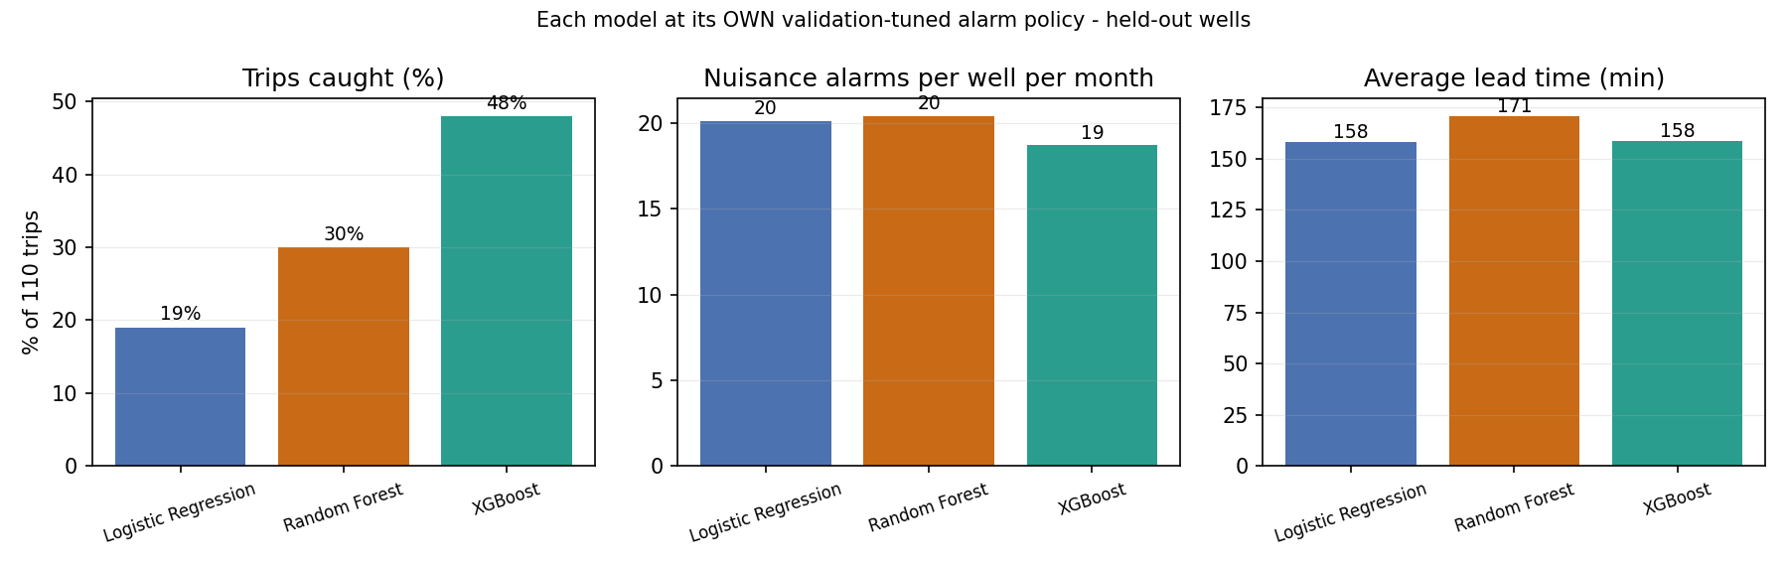
Figure 2 — Each model at its own validation-tuned alarm policy, on the held-out wells.
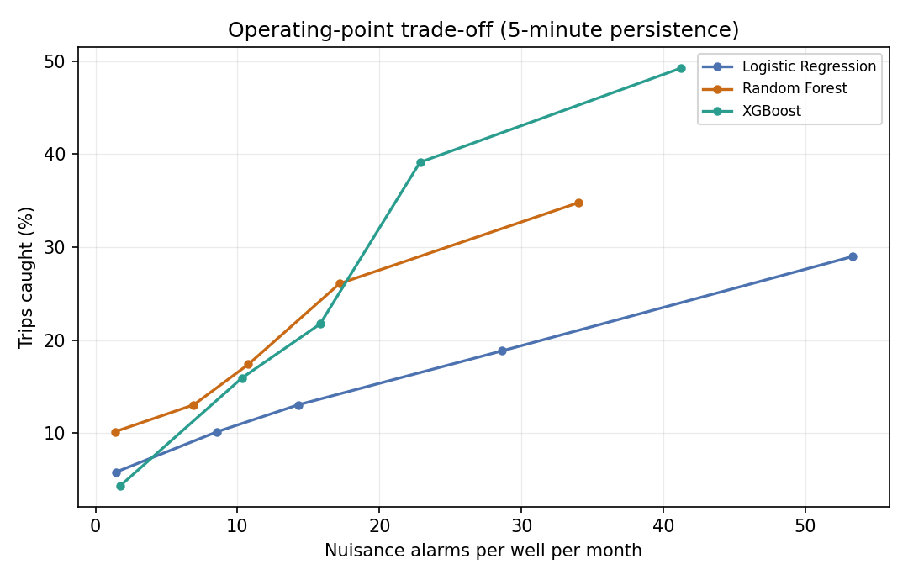
Figure 3 — The operating-point trade-off on the held-out wells (5-minute persistence); each point is a different alarm setting. Random Forest is marginally ahead at very low alarm loads; above roughly 20 alarms per well per month, XGBoost catches the most trips.
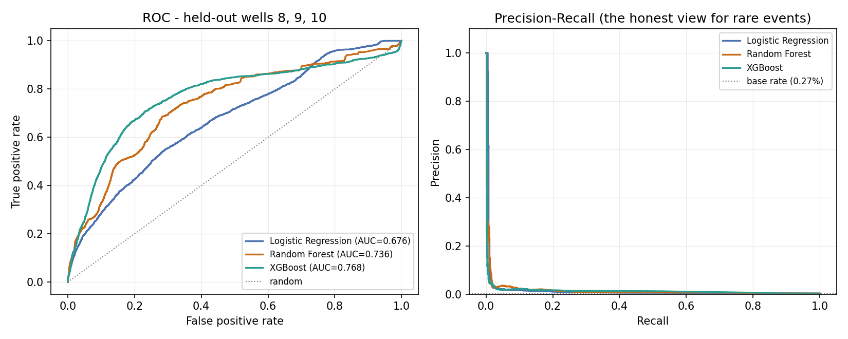
Figure 4 — ROC (left) and precision–recall (right) on the held-out wells. XGBoost has the highest ROC-AUC (0.768, against 0.736 and 0.676), but with positives at 0.27% of minutes, precision stays near the base rate — which is why the project judges models on events, not minutes.
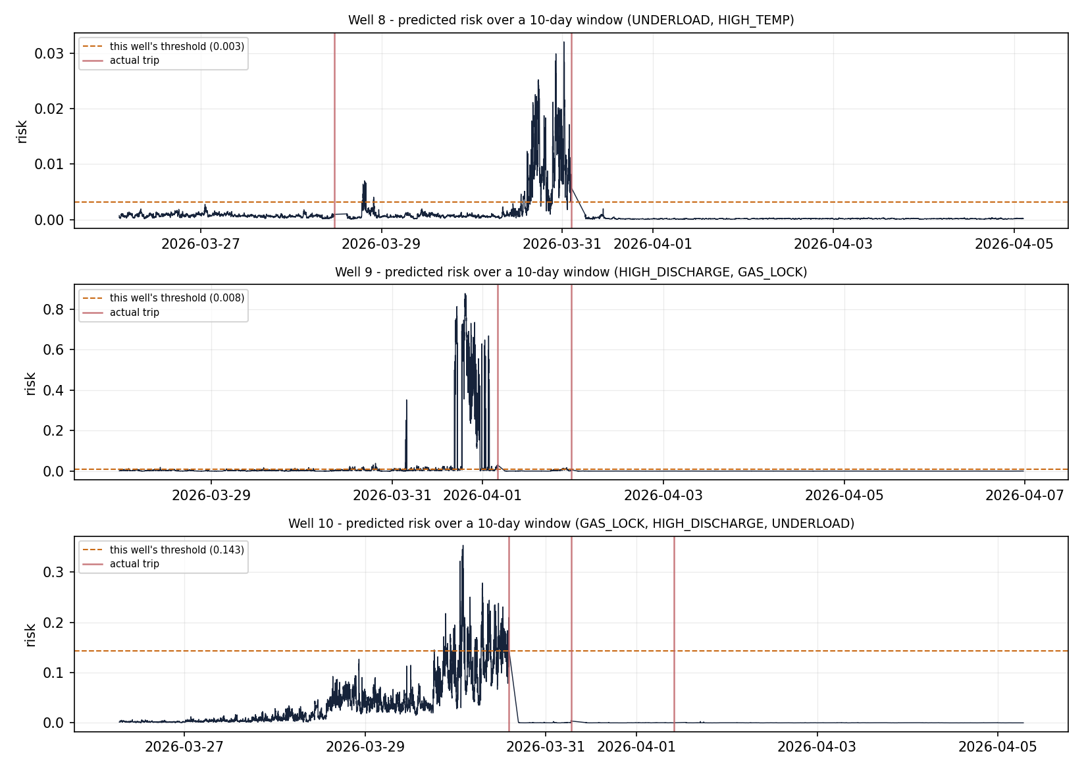
Figure 5 — Predicted risk across a 10-day window on each held-out well, with that well's own alert threshold. Wells 8 and 9 show a sharp risk climb above their thresholds before a trip; well 10 builds for two days but crosses its much higher threshold only late, which matches its 21% catch rate.
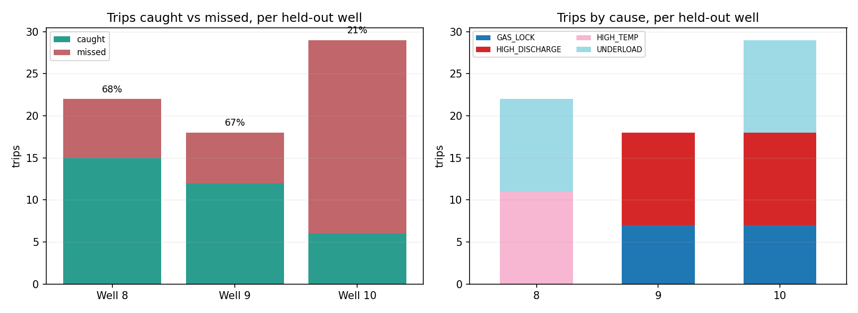
Figure 6 — Trips caught versus missed on each held-out well (left) and the causes behind them (right). Wells 8 and 9 reach 68% and 67%; well 10, with three interleaved failure modes, reaches 21%.
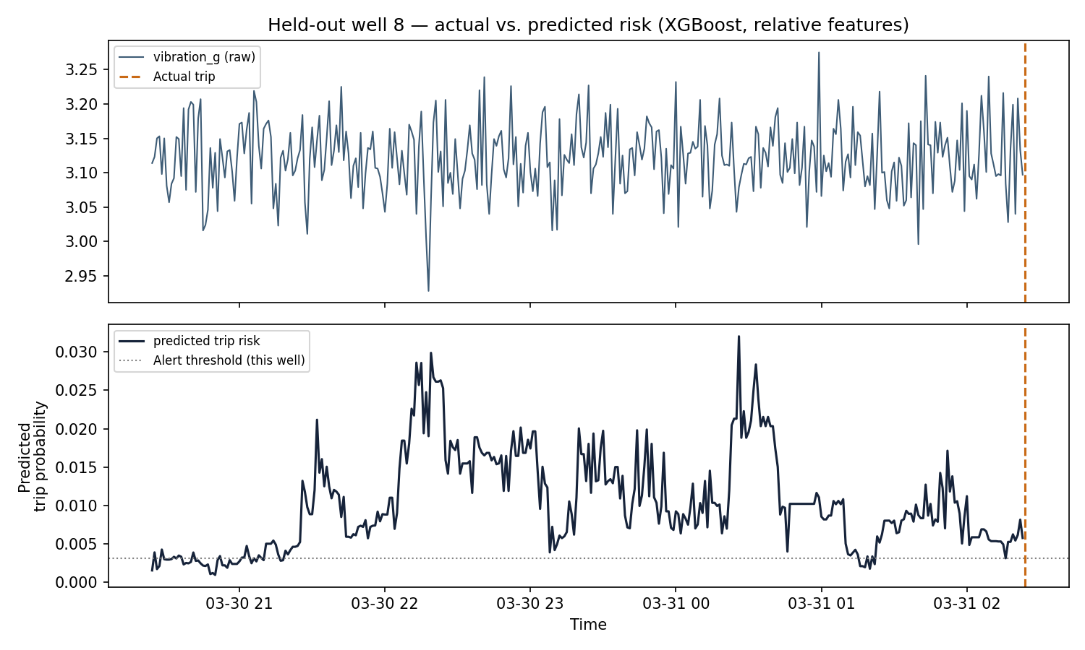
Figure 7 — Held-out well 8 in the six hours before a trip: raw vibration (top) and predicted risk against the well's alert threshold (bottom). Risk sits above the threshold for most of the final five hours. (The “relative features” label in the chart title is left over from a rejected experiment; the shipped model uses raw and rolling features.)
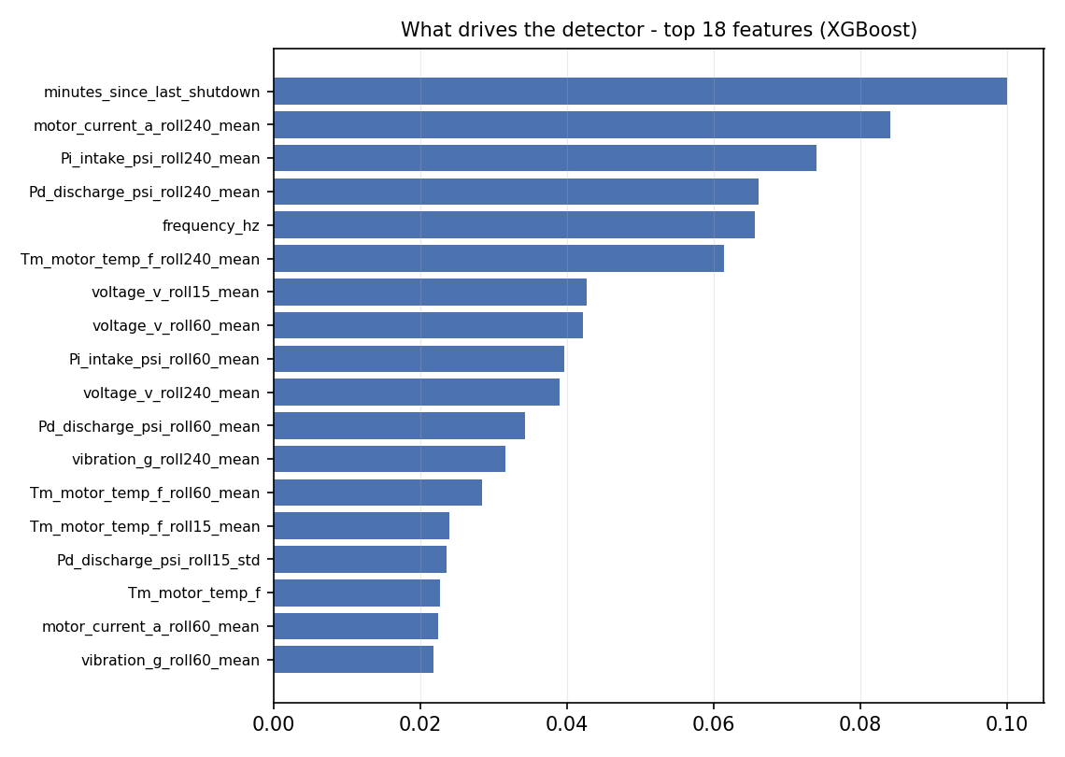
Figure 8 — What drives the detector: the 18 most important XGBoost features. The run-life feature (minutes since the last shutdown) ranks first, followed by the 240-minute rolling means of current, intake pressure, discharge pressure and motor temperature — the slow-drift features that carry the precursors.
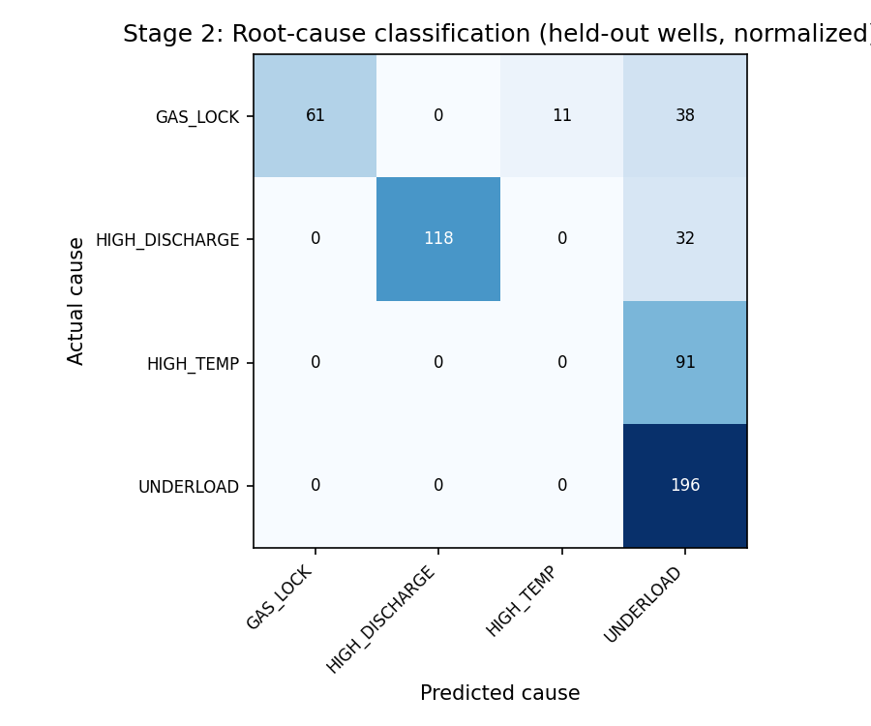
Figure 9 — Stage 2 root-cause confusion matrix on the held-out wells. Whenever the model names gas lock or high discharge it is right (1.00 precision); high temperature is never identified, and all 91 of its onset minutes are absorbed into underload.

3.4. User Interface
The operator-facing view now exists as a working prototype, alongside two earlier front-ends. Three are available today.
Interactive results dashboard. A self-contained web page organised into tabs — overview, wells and equipment, unsupervised branch, model comparison, detection, root cause, and the frequency plan. It renders the per-well safe frequency bands, the full model comparison, the trade-off curve and every chart, and works on both desktop and mobile.
Reproducible notebook. A Google Colab notebook that runs the entire pipeline end to end in about 12 minutes on a free CPU runtime, plus 4 for the frequency study, with no data download, so any team member or reviewer can reproduce every number in this report from scratch. Its final steps save the trained models and build the live monitor described next.
Live monitor. The single well view is now built: a self-contained control-room page that replays a brand-new well — well 17, created after training — minute by minute through the frozen models. It shows the current risk score against that well's own threshold, the alarm and predicted cause, a recommended frequency with its break-even condition on underload alarms, the six sensor traces, and an event log in which the true cause is revealed only when the pump trips. The threshold comes from the well's first 30 days alone, so the replay uses no future data. On well 17 it warned of 9 of 17 shutdowns after calibration, all at least 30 minutes ahead (median 180 minutes), named the cause correctly on 116 of 117 onset minutes, and fitted a drawdown coefficient of 9.93 psi/Hz against a true 9.0 — at a higher alarm load of about 37 per month, because a live threshold cannot be tuned on the full six months.
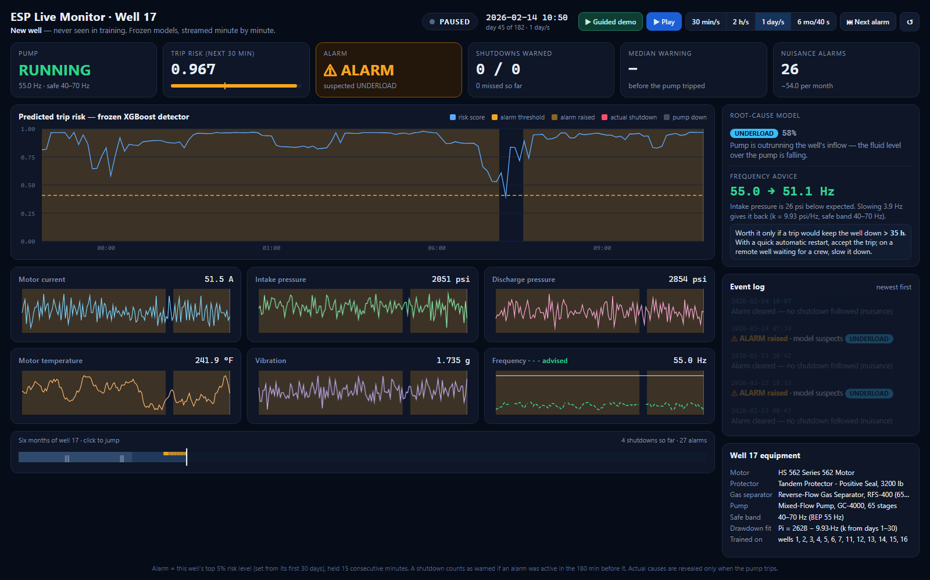
Figure 10 — The live monitor replaying well 17, which the models never saw, during an underload alarm: risk far above the well's own threshold, the cause named as underload, and frequency advice of 55.0 → 51.1 Hz from the fitted drawdown coefficient (k = 9.93 psi/Hz), with the break-even condition beside it.
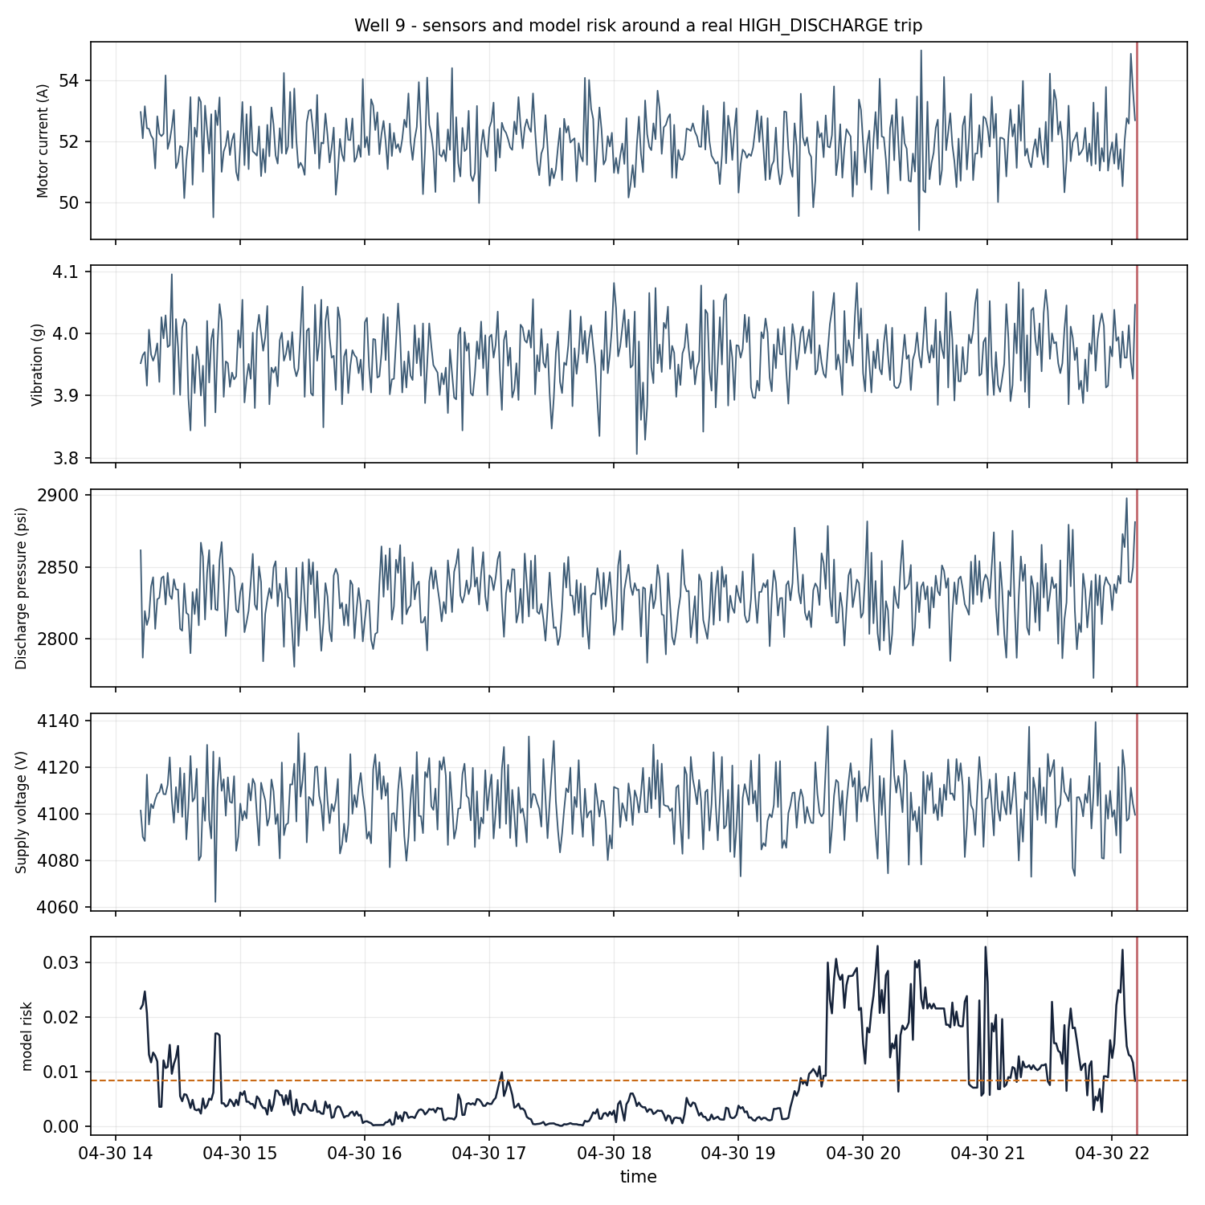
Figure 11 — The evidence behind an alarm: raw SCADA channels and the model's risk score around a real high-discharge trip on well 9, in the units an operator already reads. Risk crosses the well's threshold about two and a half hours before the pump stops.

3.5. Testing and Improvements
Nine experiments were run, five of them as complete configurations with saved results on the same held-out wells. Several promising ideas made results worse and were reverted; they are recorded here because knowing what does not work is part of the result.
Kept. Shortening the horizon from 60 to 30 minutes (measured during development; that result file was not kept); the run-life feature; alarm persistence; per-well adaptive thresholds; equipment specifications as root-cause features; and cost-weighted threshold and model selection with a 30-minute usefulness rule, which lengthened median warning from 14 to 157 minutes.
Rejected after measurement. Frequency-detrended residual features — detection fell from 49% to 28% while the root-cause model moved only from 60.5% to 61.9%. Relative-only features, which replaced every absolute sensor level with a self-referenced deviation: this did close the validation-to-test gap from 0.16 to 0.06, but from the wrong end — validation fell while test barely moved, and the catch rate dropped to 14%. The absolute levels were carrying genuine signal, not merely well identity, so the original hypothesis was wrong. F1-maximised thresholds were also rejected, because with positives under 1% of rows the criterion degenerates onto a near-zero-recall operating point.
Two corrections worth recording. First, the root-cause model initially reported 39% accuracy, which turned out to be exactly the majority-class rate — it was predicting one cause for every row and discriminating nothing. The cause was a labelling flaw: training rows carried the eventual cause across the whole pre-trip window, most of which still looks normal. Training only on true onset rows fixed it, lifting accuracy to 68.6%.
Second, an earlier configuration was reported as catching 49% of trips with a "5.4% false alarm rate". Counting false alarms as minutes concealed the real alarm load; counted as events — how often an engineer is actually interrupted — that same operating point raises roughly 208 alarms per well per month, about seven per day. No control room would run it. The current headline figure is lower but honest, at an alarm load that is operable.
The finding that moved the project furthest. Detection sat at 19% for a long stretch and no amount of feature work, model substitution or threshold tuning moved it. The diagnosis that broke the deadlock was not a modelling idea: for each cause, the team measured how large its precursor was compared with the sensor noise it had to be seen through. Catch rate tracked that ratio almost exactly — gas lock at 6σ caught 45%, high temperature at 3.1σ caught 43%, high discharge at 0.8σ caught 10%, and underload, which had no precursor at all, caught 6%. The bottleneck was the data, not the model.
Two errors in the simulator's physics were the cause. Underload was firing as an instantaneous random event when inflow starvation in fact develops gradually as the fluid level over the pump falls, and high discharge carried a 12 psi precursor against 15 psi of noise, which is mathematically undetectable. Correcting both lifted underload from 6% to 59% and high discharge from 10% to 55%, and the overall catch rate from 19% to 48%. Nothing was paid for it elsewhere — nuisance alarms fell and median warning time lengthened at the same time, which is the evidence that this was a genuine data fix rather than a threshold moved to flatter one metric at another's expense.
Known limitations. 52% of trips are still missed, so the system is a supplement to existing protection and not a replacement for it. Performance drops between validation and fully unseen wells (ROC-AUC 0.951 vs. 0.768), which remains the main open problem and shows most clearly on well 10, which carries three interleaved failure modes and reaches only 21%. High temperature collapses to zero recall in Stage 2, its cases absorbed into underload. And all results remain on synthetic data pending validation against real wells. Finally, Stage 1 figures move slightly with library versions — a local re-run with newer XGBoost and scikit-learn releases caught 29 of 69 trips (42%) at 18.0 alarms per well per month — while the data, Stage 2 and every frequency result reproduced exactly.
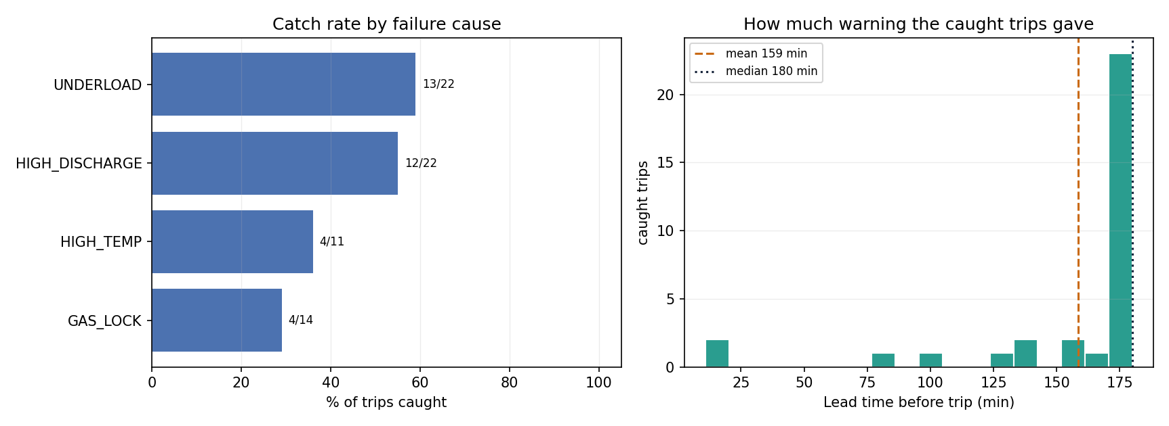
Figure 12 — Catch rate by failure cause, and the distribution of warning time on caught trips.

4. Projected Impact

4.1. Accomplishments and Benefits
A working end-to-end pipeline. From raw 1-minute SCADA data through to a cause-gated, equipment-bounded frequency recommendation, reproducible from scratch in about sixteen minutes, plus a live monitor that replays a brand-new well through the frozen models.
Genuine early warning on unseen wells. At the current operating point the system catches 33 of 69 trips (48%), 31 of them with at least 30 minutes of usable warning, at a median lead time of 180 minutes and 18.7 nuisance alarms per well per month. That is roughly 99 hours of downtime the alarms could have avoided across three wells in six months. Every figure is measured on wells never used in training.
Evidence that the model learns physics, not noise. Catch rate by cause follows the physical build-up of each fault: underload 59%, high discharge 55%, high temperature 36%, gas lock 29%. More tellingly, when two causes were given physically realistic precursors their catch rates rose to match — the model's performance moves with the physics of the signal rather than with tuning. This is the strongest validity check in the project.
Root-cause identification where the signature is distinct. Gas lock and high discharge are both classified at 1.00 precision on wells the model has never seen: when the system names one of those causes, it is right. That demonstrates the features can discriminate causes wherever the signature is separable.
A decision framework rather than a single number. The full trade-off curve lets the team choose an operating point explicitly — from 3% of trips caught at 0.7 alarms per well per month, up to 51% at 129 — instead of inheriting a hidden default. The shipped point sits where pushing from 48% to 51% would cost three to seven times the alarms, which is a bad trade for a control room that has to keep trusting them.
A frequency recommendation for underload, and the rule that says when to use it. Each well's drawdown coefficient k (psi per Hz) is fitted from its own routine SCADA history — recovered as 9.27, 8.38 and 10.36 against a true 9.0, with no step-rate test needed. Back-tested closed-loop on the same wells and seeds, the control eliminated all 22 underload trips. It also cost 18.9% of production to recover 0.8% of uptime, so the honest deliverable is not the setpoint but the break-even: slowing a well down only pays if each avoided trip would otherwise keep it down longer than roughly 33 to 36 hours. With automatic restart the arithmetic says accept the trips; with a remote well waiting on a crew it says slow it down. Same well, opposite answer, decided by restart time — a field fact rather than a modelling choice. The same method now runs on the live monitor: on well 17 it fitted k = 9.93 psi/Hz and advised cutting from 55 to about 51 Hz during underload alarms, shown next to the break-even condition.
Operational benefit. Each caught trip avoids several hours of deferred production and reduces the risk of secondary equipment damage, while the cause gate prevents the costly error of changing frequency on a well whose problem is electrical or mechanical.

4.2. Future Improvements
1. Cause-specific features for high temperature. It is the one class still failing outright in Stage 2 — zero recall, its cases absorbed into underload. Thermal build-up has a distinct signature that the shared rolling statistics are not capturing, and a dedicated thermal-trend index is the concrete fix.
2. Per-cause alarm thresholds. Gas lock sits at 29% while underload reaches 59%. A single alarm policy applied across causes whose precursors have very different shapes is leaving catches on the table.
3. Close the generalisation gap. The gap between validation (0.951) and fully unseen wells (0.768) is the main factor limiting detection. More training wells is the simplest lever; domain-adaptation methods are the more sophisticated one.
4. Reformulate as survival analysis. A continuous time-to-event risk rather than a fixed-horizon binary label would let an engineer choose their own warning time without retraining the model.
5. Validate against real historical well data. This is the decisive step. The pipeline reads its well roster from a single configuration file, so real wells matching the same schema can be added and evaluated without code changes.
6. Add submergence and pump-curve limits to the simulator. Without them the frequency sweep claims production keeps rising past the best-efficiency point — an answer nobody should act on — so recommendations stay capped at BEP until they are modelled.

5. Team Member Review and Comment

<ATTACH A TEAM PICTURE HERE>

NAME | REVIEW and COMMENT
Muhammed Elfeelali
Anas Eddanfor
Moataz Fakah
Abdullah Shawesh
Dana Auzi
Babiker Yousuf Ahmed Hassan

6. Instructor Review and Comment

CATEGORY | SCORE | REVIEW and COMMENT
IDEA | __/10
APPLICATION | __/30
RESULT | __/30
PROJECT  MANAGEMENT | __/10
PRESENTATION & REPORT | __/20
TOTAL | __/100

