AI Course
Capstone Project
Action Plan

For students (instructor’s review required)

ⓒ2025 SAMSUNG. All rights reserved.
Samsung Electronics Corporate Citizenship Office holds the copyright of this document.
This document is a literary property protected by copyright law so reprint and reproduction without permission are prohibited.
To use this document other than the curriculum of Samsung Innovation Campus, you must receive written consent from copyright holder.

Course | AI Course
Team Name | Group-3 (Data Drillers)
Team Leader/  Members | Muhammed Elfeelali (Team leader)  Anas Eddanfor, Moataz Fakah, Abdullah Shawesh, Dana Auzi, Babiker Yousuf Ahmed Hassan
Project Title | AI/ML-Driven ESP Failure Prediction & Optimal Operation Frequency Selection
Goal
Predict an impending ESP (Electric Submersible Pump) trip from 1-minute SCADA data with enough warning to act, identify which failure mode is developing, and recommend a corrective operating frequency — shifting ESP maintenance from reactive to data-driven.
Failure horizon: the model will predict whether a trip occurs within a fixed 30-minute horizon (H = 30 min). A longer horizon of H = 60 min will also be evaluated, so the choice is justified by measurement rather than assumption.
Operationally allowable frequency range: every recommendation will be restricted to the individual well’s safe band, derived as the intersection of its Motor, Protector and Pump rated frequency ranges. A single field-wide range will not be used, because the allowable band depends on the equipment installed in each well.
Abstract
ESPs are a critical but failure-prone artificial lift method, and failures are usually caught only after the fact. This project will build an ML pipeline covering six distinct failure causes — gas lock, underload, high temperature, high discharge, vibration and low voltage supply — so that the system reflects a realistic field where different wells fail for different reasons.
The pipeline will run two independent branches. An unsupervised branch (K-Means / DBSCAN) will map operating regimes and anomalies without using labels. A supervised two-stage branch will predict whether a trip is coming within the failure horizon (Stage 1) and, separately, which failure cause is developing (Stage 2). The two branches will remain independent — the unsupervised output will not be fed into the supervised models.
Because three of the six causes cannot be corrected by changing frequency, the predicted cause will gate the recommendation: gas lock, high temperature and high discharge will produce a frequency change clipped to the well’s equipment limits, while underload, vibration and low voltage will raise an inspection flag instead. The pipeline will be prototyped on a physics-based synthetic dataset and then validated against real historical well data.
Method
1. Data preparation and equipment configuration. Build a 1-minute SCADA dataset per well from a physics-based state machine (normal → onset → shutdown → ramp). Each well will be assigned one to three dominant failure causes so the dataset holds a realistic mix. Each well will also carry a full ESP string (Motor, Protector, Gas Separator, Pump), from which its safe frequency band is derived as the intersection of the component ratings.
2. Problem formulation — classification, not regression. Stage 1 will be framed as binary classification (will this well trip within the horizon: yes / no). Stage 2 will be multi-class classification over the six causes, trained only on rows where a fault is actively developing. Regression is not appropriate here because the operational question is a yes/no alarm decision rather than a continuous quantity. Survival analysis is recorded as a possible later refinement, since it would express risk as a continuous time-to-event and let an engineer choose their own warning time without retraining.
3. Feature engineering. Compute rolling statistics per sensor (15 / 60 / 240-minute means and standard deviations, and short-term rates of change), together with a run-life feature — minutes since the well’s last shutdown — which mirrors a standard real-world ESP monitoring signal.
4. Leakage prevention — split by well and by time. A subset of wells will be held out entirely and never used in training in any form. Within the training wells, the final period will be held out as a time-based validation window. All tuning, threshold selection and model selection will use validation data only — never the held-out wells.
5. Unsupervised branch. Apply K-Means and DBSCAN to normalized features, without failure labels, to surface operating regimes and anomalous behaviour. This branch will run in parallel with the supervised branch and will be reported separately.
6. Supervised modelling and baseline comparison. Train and compare Logistic Regression, Random Forest and Gradient Boosted Trees (XGBoost). Each will be compared against the two baselines requested: a fixed-threshold rule that mirrors current SCADA alarm logic, and a last-value (persistence) baseline.
7. Alarm policy — turning a risk score into an alarm. The raw model probability will not be used directly as an alarm. The policy will apply a per-well threshold calibrated on each well’s own score distribution, require the risk to stay above threshold for several consecutive minutes so that isolated noise does not raise an alarm, and be tuned with an explicit cost weighting between a missed trip and a nuisance alarm.
8. Operational evaluation. Alongside standard model metrics, the four measures requested will be reported: lead time, false alarms, missed failures and production impact. False alarms will be counted as alarm events rather than flagged minutes, since what matters operationally is how often an engineer is interrupted. Results will be broken down per model, per well and per failure cause, and presented as a trade-off curve so that the chosen operating point is an explicit engineering decision.
9. Frequency recommendation gate. The predicted cause will decide the action. Gas lock, high temperature and high discharge → adjust frequency, clipped to that well’s safe band. Underload, vibration and low voltage → flag for inspection, because they are not frequency-related faults.
10. Use of Generative AI. In line with the instructor’s decision, GenAI will not be used for the core SCADA prediction task. If used at all, it will be limited to an evidence-linked explanation of model output for engineers, and will never issue an autonomous frequency recommendation.

Data
Schema: well_id, timestamp, operating state, frequency (Hz), motor current (A), supply voltage (V), intake and discharge pressure (psi), intake and motor temperature (°F), vibration (g), shutdown event, failure cause, and the well’s safe minimum and maximum frequency.
Planned scope: multiple wells at 1-minute resolution over roughly six months each, split so that some wells are used for training and others are reserved entirely for testing.
Synthetic first, then real. A physics-based synthetic dataset will be used to prototype and validate the pipeline, because no public multi-well ESP dataset with labelled failure causes exists at this resolution. The well roster will be held in a single configuration file so that adding a well — synthetic or real — requires no code change. Real historical well data matching the same schema will then be appended and evaluated directly, which is the planned validation step.
Quality control: the dataset will be checked to confirm that no record operates outside its own well’s equipment-rated frequency band.
Expected
Outcome
An early-warning system that flags ESP failure risk with enough lead time to act, names the likely cause, and either recommends a safe operating frequency or routes the well to inspection — reducing unplanned downtime, extending pump run life, and supporting data-driven artificial-lift decisions.
Specifically, the project aims to deliver:
• A detection model that gives useful warning before a trip, evaluated on wells it has never seen, and compared against the simple-rule and last-value baselines.
• A root-cause model that distinguishes between the six failure modes well enough to decide whether a frequency change is the correct response.
• A frequency recommendation that always respects the individual well’s equipment limits.
• An honest operational report — lead time, false alarms, missed failures and production impact — including the limitations found, rather than model accuracy alone.
Role by
Member
Muhammed Elfeelali — Team Lead / Domain SME: coordinates the team, sets requirements from artificial-lift field experience, and defines the SCADA tags, the failure horizon and the per-well safe frequency bands.
Anas Eddanfor — Data Engineer: sources and cleans the SCADA dataset, builds the feature pipeline (rolling windows, run-life), and enforces the well-and-time split that prevents leakage.
Moataz Fakah — ML Engineer (Unsupervised): builds and tunes K-Means / DBSCAN to separate operating regimes and flag anomalies.
Abdullah Shawesh — ML Engineer (Supervised): builds and tunes the Stage 1 detection and Stage 2 root-cause classifiers, and the baseline comparisons.
Dana Auzi — Validation Engineer: owns the evaluation framework — lead time, false alarms, missed failures and production impact — and the comparison against real historical well data.
Babiker Yousuf Ahmed Hassan — Documentation & Presentation Lead: owns the report, the visuals and the 5-minute final presentation.

Schedule
Summary
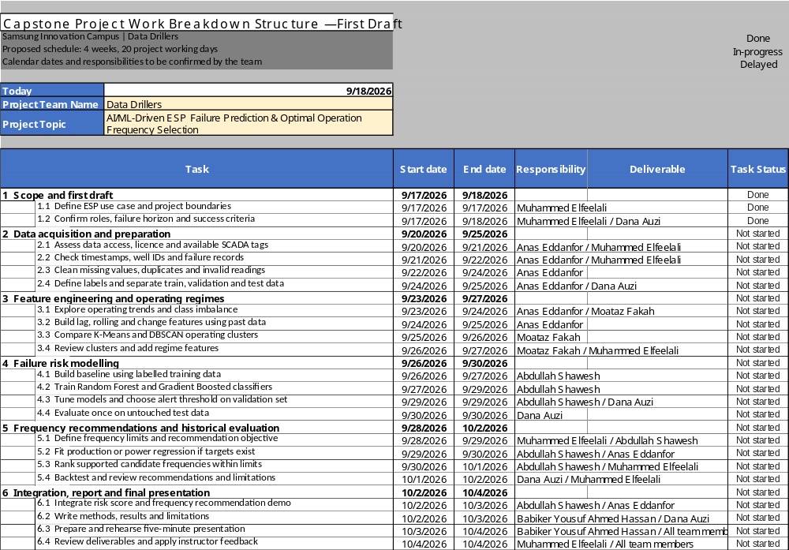
Comment &
Assessment
The maintenance objective is clear and the synthetic-to-real-data progression is sensible. Add the missing schedule, define the failure horizon and the operationally allowable frequency range, and clarify whether failure risk is classification, survival analysis, or regression.
Prevent leakage by splitting by well and by time, preserving a final held-out period; compare against a simple rule or last-value baseline and report lead time, false alarms, missed failures, and production impact alongside model metrics.
GenAI decision: it is not required for the core SCADA prediction task. If added, limit it to an evidence-linked explanation of model outputs for engineers, never an autonomous frequency recommendation.

