

**Faculty of Engineering and Technology**

**Department of Electrical and Computer Engineering**

**ENCS 2110**

**EXP 2 Post-Lab: Comparators, Adders, and Subtractors**

**Student’s name:** Anas Al Sayed

**Student’s No.:** 1221020

**Section:** 10

**Instructor:** Hanya Radwan

* **Design 8-bit BCD adder.**

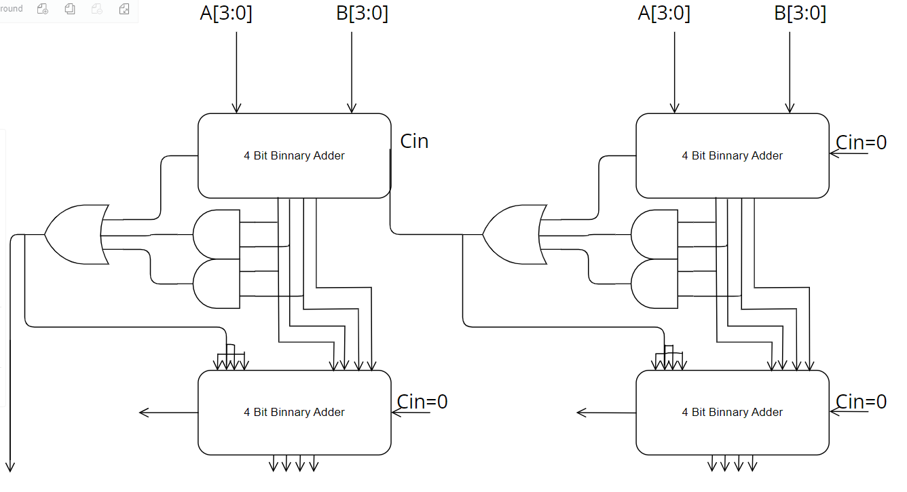

* **Design 8-bit comparator using 2 of 4-bit comparator.**

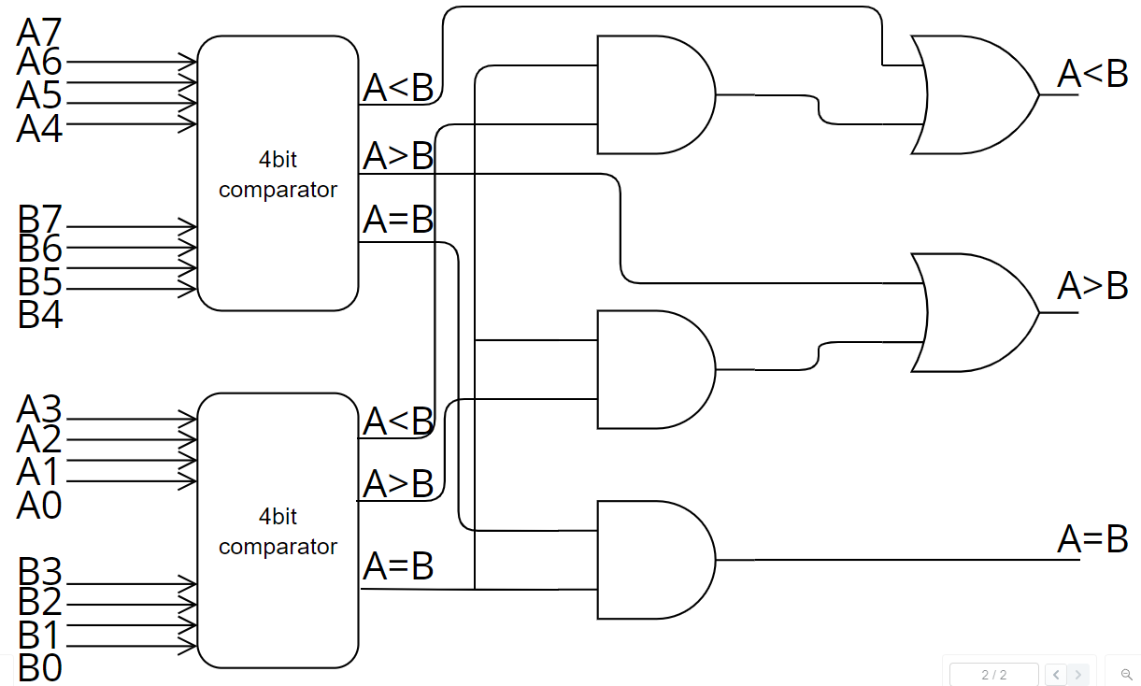

* **A 4-inputs, 3-outputs circuit that compares 2-bit unsigned numbers and outputs a ‘1’ on one of three output lines according to whether the first number is greater than, equal to, or less than the other number. You can only use two 4×1 multiplexer.**

