

**Faculty of Engineering and Technology**

**Department of Electrical and Computer Engineering**

**ENCS 2110**

**EXP 2 Pre-Lab: Comparators, Adders, and Subtractors**

**Student’s name:** Anas Al Sayed

**Student’s No.:** 1221020

**Section:** 10

**Instructor:** Hanya Radwan

* **Build half adder using basic gates.**

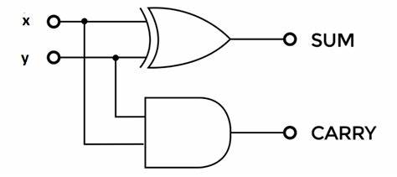

* **Build the above circuit using universal gates.**
* 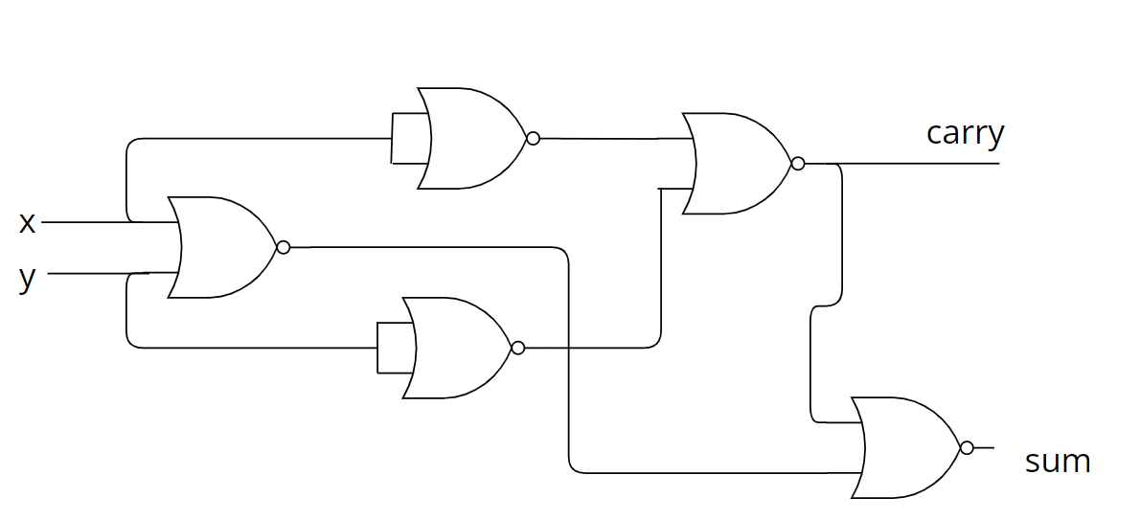**Build a full adder using basic gates.**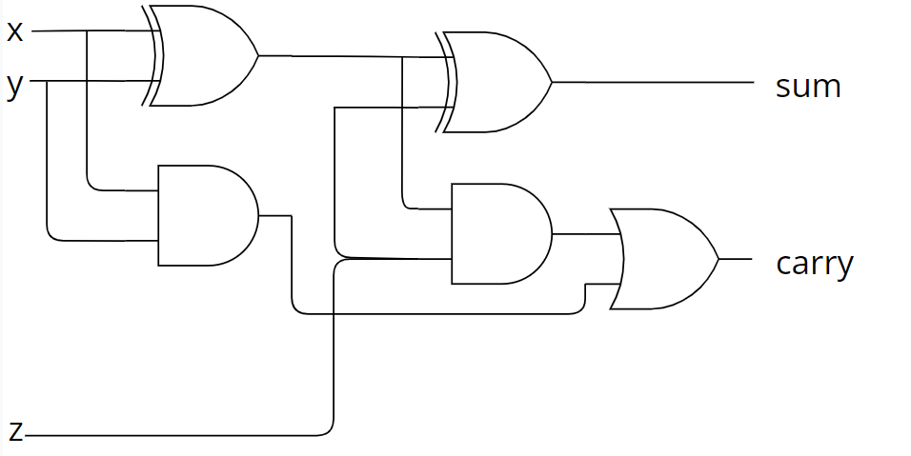

* **Build a full adder using half adder and another gate.**

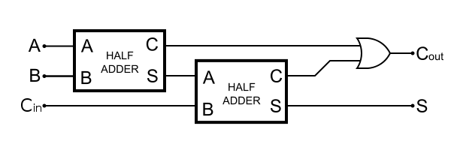

* **Build a 4-bit adder using a full adder.**

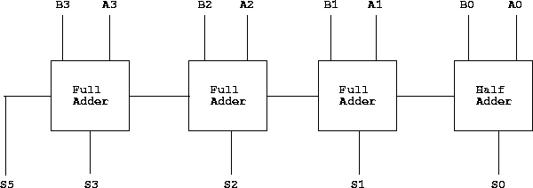

* **Build a 4-bit subtractor using basic gates.**

