

**Faculty of Engineering and Technology**

**Department of Electrical and Computer Engineering**

**ENCS 2110**

**EXP 3 Post-Lab: Encoders, Decoders, Multiplexers, and Demultiplexers**

**Student’s name:** Anas Al Sayed

**Student’s No.:** 1221020

**Section:** 10

**Instructor:** Hanya Radwan

* ***Implement 8x1 Multiplexer using lower order Multiplexers Show how to solve it.***

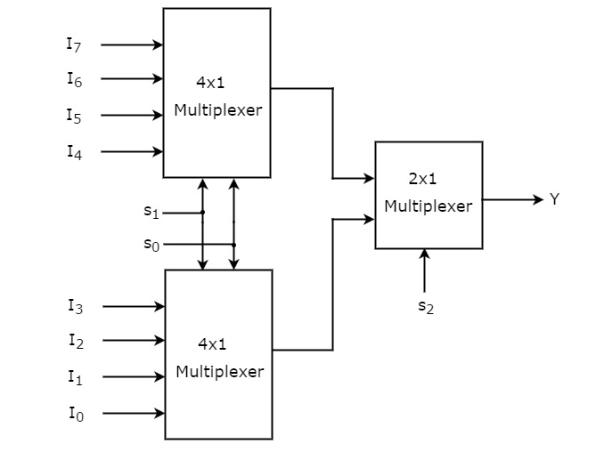

* ***Design a Majority Circuit; a circuit that takes 4 inputs A, B, C, D and 1 output Y. Its output equals 1 when 3 or 4 of the inputs are 1. You can only use two 4×1 multiplexers.***

