

**Faculty of Engineering and Technology**

**Department of Electrical and Computer Engineering**

**ENCS 2110**

**EXP 3 Pre-Lab: Encoders, Decoders, Multiplexers, and Demultiplexers**

**Student’s name:** Anas Al Sayed

**Student’s No.:** 1221020

**Section:** 10

**Instructor:** Hanya Radwan

* **Design a circuit which uses an SN74151 to implement a sum-of-products expression, as follows:.**

***a)*** *Convert the following expression into summation form (i.e., F (A, B, C) =∑ (…))****:***

F(A,B,C)=AB′+B′C  
  
identify the minterms (cases where F = 1):

|  |  |  |  |
| --- | --- | --- | --- |
| A | B | C | F(A,B,C)=AB′+B′C |
| 0 | 0 | 0 | 0 |
| 0 | 0 | 1 | 1(m1) |
| 0 | 1 | 0 | 0 |
| 0 | 1 | 1 | 0 |
| 1 | 0 | 0 | 1(m4) |
| 1 | 0 | 1 | 1(m5) |
| 1 | 1 | 0 | 0 |
| 1 | 1 | 1 | 0 |

the summation form (Sum of Products) is:

* **F(A,B,C) = ∑( 1,4,5) .**

***b)*** *Sketch on Figure 3.1 the input connections necessary to implement the function in part (a). Observe that the inputs are connected to 0 or 1 depending on the value of the function for that min term****.***

Implement using an 8-to-1 MUX (SN74151)

|  |  |  |
| --- | --- | --- |
| *Select (A B C)* | |  | | --- | |  |   *MUX Input In* |
| |  |  | | --- | --- | | **000** (m0) |  | | |  |  | | --- | --- | |  | 1 | |
| |  | | --- | | **001** (m1) | | |  |  | | --- | --- | |  | 1 | |
| |  | | --- | | **010** (m2) | | |  |  | | --- | --- | |  | 0 | |
| |  | | --- | | **011** (m3) | | |  |  | | --- | --- | |  | 0 | |
| |  |  | | --- | --- | | **100** (m4) |  | | |  |  | | --- | --- | |  | 1 | |
| |  |  | | --- | --- | | **101** (m5) |  | | |  |  | | --- | --- | |  | 1 | |
| |  |  | | --- | --- | | **110** (m6) | 0 | | |  |  | | --- | --- | | **110** (m6) | 0 | |
| |  |  | | --- | --- | | **111** (m7) | 0 | | |  |  | | --- | --- | | **111** (m7) | 0 | |

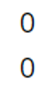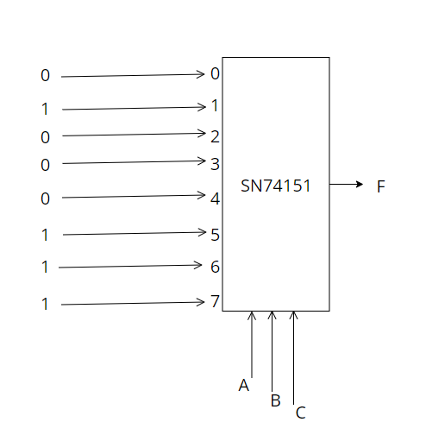

* **Design a circuit which uses an SN74138 Demultiplexer to implement a sum- of-products expression, as follows: a) Convert the following expression into summation (Sum of Products –SOP-) form (i.e. F(A,B,C)=∑(…)):**

**F(A,B,C)= A′B𝐶+B′C**  
  
identify the minterms (cases where F = 1):

|  |  |  |  |
| --- | --- | --- | --- |
| A | B | C | F(A,B,C)= A′B𝐶+B′C |
| 0 | 0 | 0 | 0 |
| 0 | 0 | 1 | 0 |
| 0 | 1 | 0 | 1(m2) |
| 0 | 1 | 1 | 1(m3) |
| 1 | 0 | 0 | 0 |
| 1 | 0 | 1 | 0 |
| 1 | 1 | 0 | 1(m6) |
| 1 | 1 | 1 | 0 |

the summation form (Sum of Products) is:

* **F(A,B,C) = ∑( 2,3,6) .**

