

**Faculty of Engineering and Technology**

**Department of Electrical and Computer Engineering**

**ENCS 2110**

**EXP 4 Pre-Lab: Digital Circuits Implementation using Breadboard**

**Student’s name:** Anas Al Sayed

**Student’s No.:** 1221020

**Section:** 10

**Instructor:** Hanya Radwan

* **Build Full Adder using basic gates.**

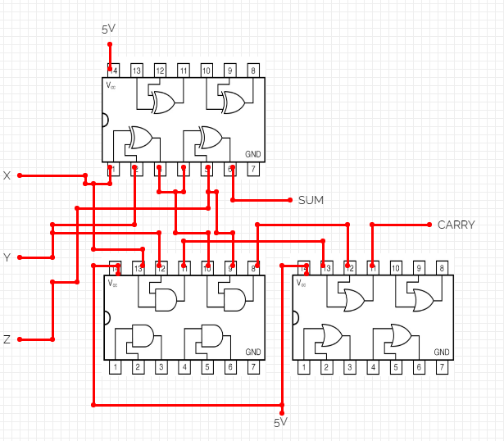

Figure :Full Adder

* **Build the bellow circuit using universal gates.**  
  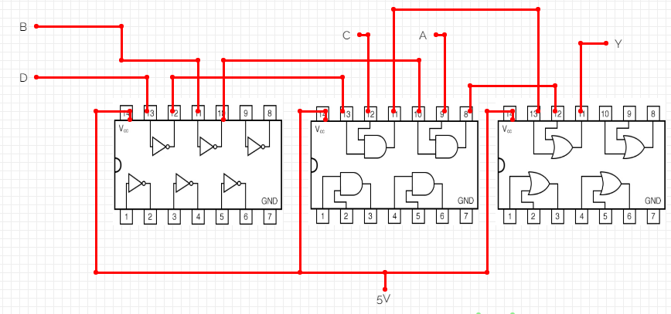
* **Build a 3x8 Decoder (active low) using basic gates.**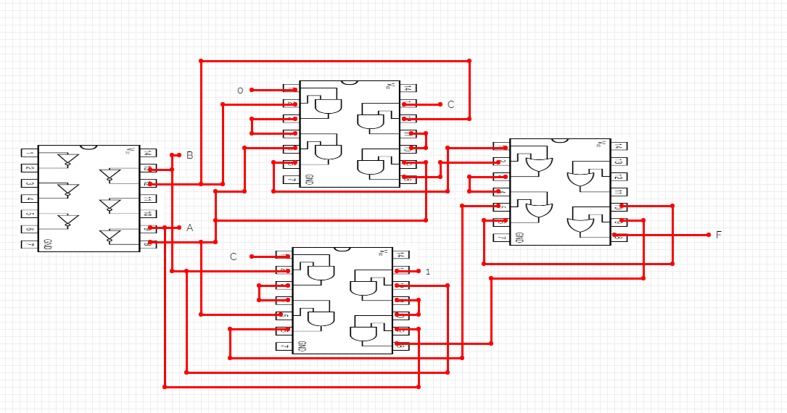

Figure : 3x8 Decoder

* **Build an 8x1 Multiplexer using basic gates.**

Figure :8x1 Multiplexer

* **Use the just constructed 4x1 multiplexer to design a three-input network that   
  gives 1 if the majority of its inputs are 1 and outputs a zero otherwise.**

Figure :4x1 multiplexer

* **Use the 2x4 decoder to implement a 2-input function that acts like an equivalence   
  gate (XNOR): gives 1 on the output if both inputs are equal.**



Figure :2x4 decoder