

**Faculty of Engineering and Technology Electrical and Computer Engineering Department DIGITAL ELECTRONICS AND COMPUTER ORGANIZATION LABORATORY ENCS2110   
Experiment No. 4   
Digital Circuits Implementation using Breadboard**

**Prepared by:  
Name**: Anas Al Sayed **Number**: 1221020

**Partners:**

**Name**: Ahmad Toffaha **Number**: 1220476

**Name**: Layan Ayyash **Number**: 1210859

**Instructor**: Dr. Hanya Radwan

**Assistant**: Ms. Katy Sadi

**Section: 10**

**Date: 15/5/2025**

# 

# **Abstract:**

This experiment aims to implement and verify logic circuits using a breadboard and basic gates, including **NAND** and **NOR** gates, to create other gates. We will connect circuits such as decoders and full adders using chips from the **74xx ICs family**, powered by a **+5V** supply. Key steps include turning off power before building, correctly inserting chips, and making connections according to the schematic, followed by verification before powering on. Common issues such as incorrect power connections and wiring errors will be addressed. The experiment also involves testing and verifying the functionality of basic logic gates, ensuring accurate outputs compared to expected truth tables. This process enhances understanding of circuit design, troubleshooting, and the practical application of logic gates in digital electronics.

1. **Table of Contents**

**Abstract:** I

**II.** **Table of Figures** III

**III.** **List of Tables** III

**1.Theory** 4

**1.1 Breadboards:** 4

**1.1.1 Advantages:** 4

**1.1.2 Disadvantages:** 4

**1.2 74xx ICs Family:** 4

**1.2.2 Logic Gates** 6

**1.3 IT-3000:** 6

**2.Procedure** **&** **Discussion** 8

**2.1 Verification of basics logical gates:** 8

**2.2 Equipment** 8

**2.3 Implementation of Circuit 2:** 8

**2.3.2 Logic Diagram:** 9

**2.3.3 Results and Output Table:** 9

**2.3.4 Discussion:** 10

**3.Conclusion** 10

**4.References** 10

**5.** **Appendices** 11

# **Table of Figures**

Figure 1:BREAD BOARDER 1 4

Figure 2:BREAD BOARDER 2 5

Figure 3:DIGITAL GATES IN IC PACKAGES 1 6

Figure 4:IT-3000 1 7

Figure 5:connect the ICs on the Breadboard 1 7

Figure 6: Logic Diagram for Circuit 2 9

Figure 7:wiring connection of Circuit 2 11

# **List of Tables**

Table 1:DIGITAL GATES IN IC PACKAGES 1 **Error! Bookmark not defined.**

Table 2: Results Truth Table for Circuit 2 **Error! Bookmark not defined.**

# **1.Theory**

we will talk about the main components of our experiment:

## **1.1 Breadboards:**

A breadboard is a tool for quickly building and testing circuits without soldering. It has holes where you can insert components and wires. Power rails, marked with red and blue lines, provide power and ground. Terminal strips have rows of holes to connect parts of the circuit. The middle gap allows for placing ICs, ensuring each pin connects separately. Always turn off the power before building circuits to avoid damaging parts or the breadboard.

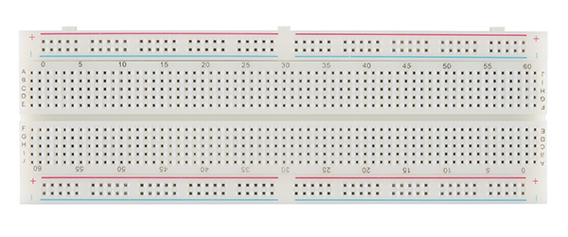

Figure 1:BREAD BOARDER 1

## **1.1.1 Advantages:**

* Easy to use, modify, and reuse components, ideal for prototyping, don’t need to use the soldering.

## **1.1.2 Disadvantages:**

* Unsuitable for high-frequency circuits; can become messy and connections may loosen over time.

## **1.2 74xx ICs Family:**

The 74xx series represents a family of TTL logic integrated circuits. Each chip in this family performs a specific logic function, such as AND, OR, NOT, NAND, NOR, XOR, or XNOR. These ICs are known for their reliability and ease of use, making them ideal for constructing and verifying digital circuits in this experiment.

Figure 2:BREAD BOARDER 2

Each chip contains a special code, each code refers to the type of the logical gates as shown on in this table:

Table 1:DIGITAL GATES IN IC PACKAGES 1

|  |  |
| --- | --- |
| **Gate** | **code** |
| AND | 5408/7408 |
| OR | 5432/7432 |
| NAND | 5400/7400 |
| NOR | 5402/7402 |
| XOR | 5486/7486 |
| Invertor | 5404/7404 |

Each gate has 2 codes as shown on the figures, there was a different company’s that industry this chip, all chips have the main features and different in the manufacturing methods or manufactured materials, but stile had the main features.

1**🡪** on

0**🡪** off



Figure 3:DIGITAL GATES IN IC PACKAGES 1

As shown in the above figure we connect the input wires with the inputs types, and the outputs in the outputs layers, take exp on 7408 Gate in pins number 1 and 2 we put the inputs and in number 3 we put the output, the same thing in all gats in all ICs nether the inverter one because its take one input and one output.

**1.2.2 Logic Gates:**  
Digital logic gates are the fundamental building blocks of digital systems. These gates perform logical operations on binary inputs to produce a binary output. In Circuit 2, we focus on combining AND, OR, and NOT gates to build composite logic functions. Each gate's behavior is defined by a specific truth table, and these can be interconnected to implement more complex Boolean expressions.

## **1.3 IT-3000:**

Using this device we will connect the Ground (GND) and the voltage in +5V to operate the circuit using a voltage source, this is making a small Electric current move inside the circuit. This makes our circuit work.

Figure 4:IT-3000 1

For more: [link](https://infinit-technologies.com/product/it-3000-digital-logic-lab/)

The other things that provided for us using the IT-300, is connect the inputs on switches SW0, SW1…. SW4 or using the high and the law inputs the other inputs and the outputs to the Led (L0, L1, L2…… L8). Of course, we will connect the circuits using the little wires to enable it to enter the holes of the Breadboard as shown on the figure:

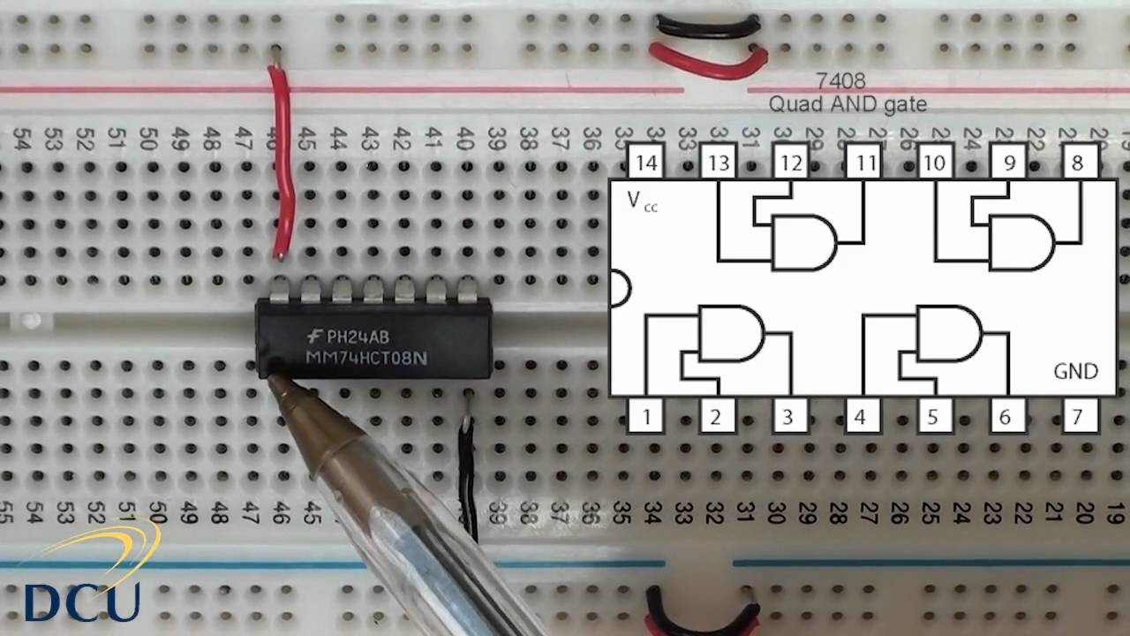

Figure 5:connect the ICs on the Breadboard 1

# **2.Procedure** **&** **Discussion**

There was a common step we that using it when we connect the circuits, and those steps are very important to have professional connection in our experiment. I will short those steps as:

## **2.1 Verification of basics logical gates:**

* Turn off the power before starting.
* Connect power and ground to the breadboard.
* Insert chips, pin 1 in the upper-left.
* Wire **+5V** and **GND** to each chip.
* Make connections as per the schematic, starting short.
* Check connections before powering on.
* Take measures and note.
* Turn off power if errors occur before rewiring.
* Return **equipment** and clean the area after the session.

**2.2 Equipment:**

* ICs chips
* Breadboards
* Connecting wires

Now there our is circuits 2 that we did in the lab, we will describe it and show its results.

**2.3 Implementation of Circuit 2:**  
  
**2.3.1 Setup and Connections:**

The circuit was assembled on a breadboard using discrete components and logic **ICs**.

Inputs were connected to toggle switches and outputs to LEDs for visual indication.

**Vcc** and **GND** were connected properly across all **ICs** to ensure functionality.

### **2.3.2 Logic Diagram:**

The logic circuit diagram for Circuit 2 is shown in Figure 1.1.  
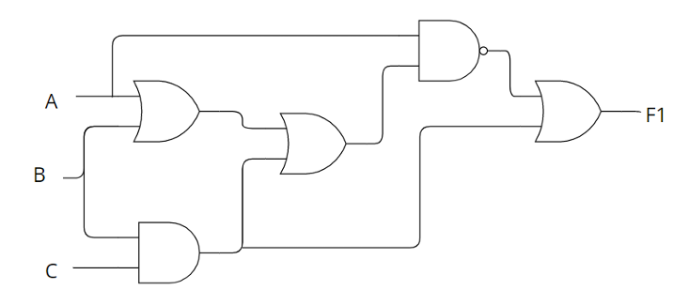

Figure 6: Logic Diagram for Circuit 2

**2.3.3 Results and Output Table:**The following combinations of input values were tested. The output matched results values from the designed truth table.

Table 2: Results Truth Table for Circuit 2

|  |  |  |  |
| --- | --- | --- | --- |
| Input A | Input B | Input C | Output |
| 0 | 0 | 0 | 1 |
| 0 | 0 | 1 | 1 |
| 0 | 1 | 0 | 1 |
| 0 | 1 | 1 | 1 |
| 1 | 0 | 0 | 0 |
| 1 | 0 | 1 | 0 |
| 1 | 1 | 0 | 0 |
| 1 | 1 | 1 | 1 |

**2.3.4 Discussion:**Throughout this experiment, each input combination was tested using toggle switches. The outputs were recorded and compared to the theoretical truth table. In most cases, the observed outputs aligned perfectly with the expected results.

Any unexpected outputs were typically traced back to either loose connections on the breadboard or incorrect wire placements. These issues were promptly identified and corrected during the testing phase. Once resolved, the output consistently reflected the correct Boolean logic.

The implementation demonstrated the practical use of AND, OR, and NAND gates, and emphasized how physical limitations—such as connection stability and IC pin configuration—can influence results. This reinforces the importance of precise wiring, clear circuit layout, and post-connection verification.

Photographic evidence of the assembled circuit and LED results was captured during the experiment and can be found in the appendices.

This hands-on experience was essential in bridging theoretical concepts with real-world circuit behavior, validating the accuracy of logic gate implementations using the 7400 series IC family.

**3.Conclusion**  
From this experiment, I gained a deeper understanding of how theoretical digital logic is applied in a practical setting using physical components. By implementing Circuit 2 on a breadboard with basic logic gates, I observed how AND, OR, and NAND gates function together to realize a specific Boolean expression.

The output behavior matched the expected truth table in nearly all cases, and any minor issues were resolved through inspection and correcting connections. This not only helped me confirm the logic function but also improved my skills in troubleshooting real circuits.

I now understand the importance of proper wiring, clean layout, and thorough verification in circuit implementation. Overall, this experiment enhanced my confidence in designing and building digital circuits using IC components.

# **4.References**

[1] ENCS2110 Lab Manual, Birzeit University, 2024.  
[2] Wikipedia. Logic Gates. <https://en.wikipedia.org/wiki/Logic_gate>

# **5.** **Appendices**

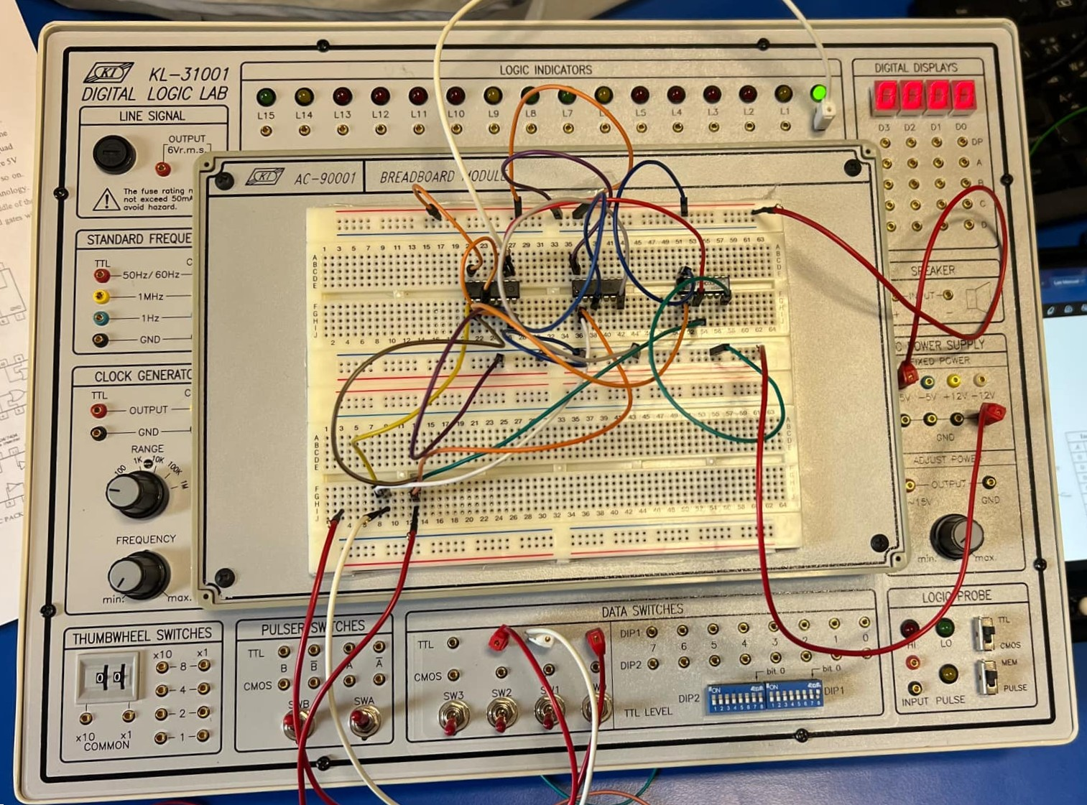

Figure 7:wiring connection of Circuit 2