

**Faculty of Engineering and Technology Electrical and Computer Engineering Department DIGITAL ELECTRONICS AND COMPUTER ORGANIZATION LABORATORY ENCS2110   
Experiment No. 6   
Sequential Logic Circuits using Breadboard and IC’s**

**Prepared by:  
Name**: Anas Al Sayed **Number**: 1221020

**Partners:**

**Name**: Ahmad Toffaha **Number**: 1220476

**Name**: Layan Ayyash **Number**: 1210859

**Instructor**: Dr. Hanya Radwan

**Assistant**: Ms. Katy Sadi

**Section: 10**

**Date: 15/4/2025**

# 

# **Abstract:**

Seven-segment displays are used to display decimal numbers and are composed of seven individual LEDs labeled A through G, which can be lit in different combinations to represent digits from 0 to 9. The IC7447 is a common BCD to seven-segment decoder/driver that translates binary input into the appropriate LED configuration for numeric output.

The IC7490 is a decade counter capable of counting from 0 to 9 in binary. It has four output pins (Q0–Q3) representing a 4-bit binary number. When connected to the decoder/driver, the output from the counter is translated to drive the display. Counters are used in many applications such as clocks, timers, and event counters.

1. **Table of Contents**

**Abstract:** I

**II.** **Table of Figures** III

**III.** **List of Tables** III

**1.Theory** 4

**1.1 Seven-Segment Display:** 4

**1.2 BCD-to-seven-segment Decoder:** 5

**1.3 Counter:** 6

6

**2.Procedure** **&** **Discussion** 7

**2.1 Procedure:** 7

**2.2 Implementation of** 7

**Part A: Testing lamps in the display:** 7

**Part B: Blanking all segments:** 8

**Part C: Implementing a decade counter** 8

**2.1.1Discussion:** 8

**3.Conclusion** 9

**4.References** 10

**5.** **Appendices** 10

# **Table of Figures**

Figure 1:Seven-segment Display 4

Figure 2:Common Cathode 4

Figure 3:Common Anode 4

Figure 4:7-Segment Display Decoder Block Diagram 5

Figure 5:7490 counter pin Block Diagram 6

Figure 6:BCD Counter Wiring Diagram 7

Figure 7:first Pulse on Connection 10

Figure 8:third Pulse on Connection 11

Figure 9:second Pulse on Connection 11

# **List of Tables**

Table 1: 7447 pin descriptions 5

Table 2: Reset/Count function table 6

Table 3: Correct Output of all Segments 9

# **1.Theory**

we will talk about the main components of our experiment:

## **1.1 Seven-Segment Display:**

The seven-segment LED display is a common device in consumer electronics, from calculators to clocks to microwave ovens. The display has seven separate bar-shaped LEDs, arranged as shown below. In addition, many seven-segment displays have one (or two) circular LEDs used as a decimal point.

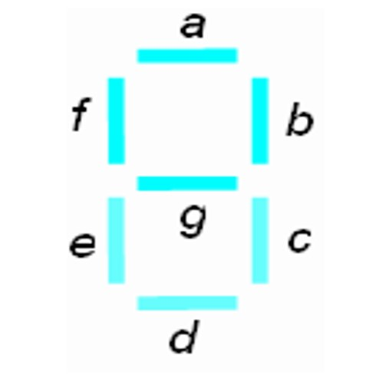

Figure 1:Seven-segment Display

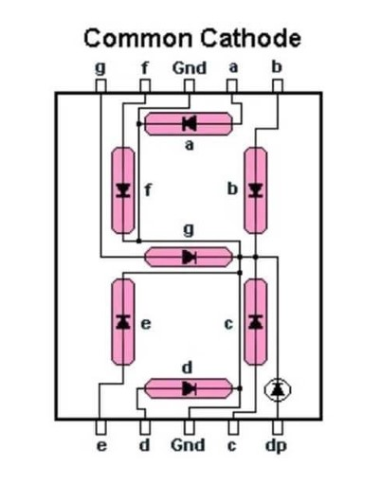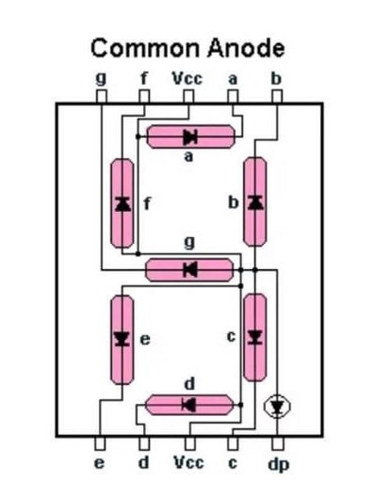

Figure 2:Common Cathode

Figure 3:Common Anode

Inside the Seven-Segment Display, one end of each LED is connected to a point, which is tied either to the ground or to the positive supply, depending on the device. If the Seven-Segment Display is designed to have the common connection tied to the positive supply (+5V), as shown in Figure 2.2 (left-hand side), it is called a **common anode configuration**. To turn on these LED segments, the inputs logic must be set to low. If the Seven-Segment Display is designed to have a common connection tied to the ground (0V), as shown in Figure 2.3 (right-hand side), it is called a **common cathode configuration**. To turn on these LED segments, the inputs logic must be set high.

## **1.2 BCD-to-seven-segment Decoder:**

A **BCD-to-seven-segment** decoder is a logic circuit used to convert the input BCD into a form suitable for the seven-segment display.

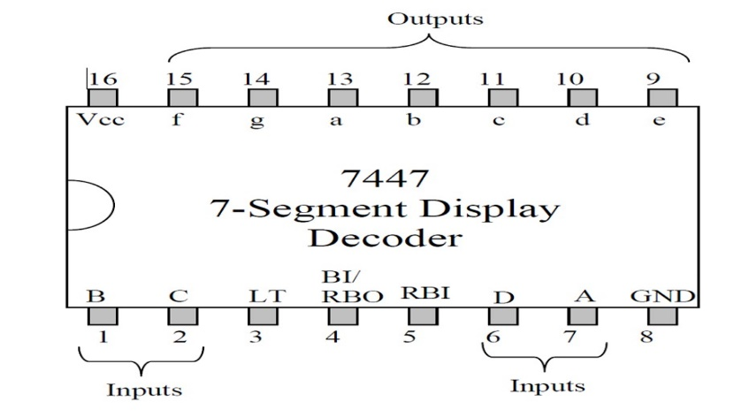

Figure 4:7-Segment Display Decoder Block Diagram

|  |  |
| --- | --- |
| Pin name | Description |
| A, B, C, D | BCD inputs: D is the most significant input **(DCBA)** |
| a, b, c, d, e, f, g | Decoder output **(Active Low)** |
| RBI | Ripple Blanking Input **(Active Low)** |
| BI/RBO | Blanking Input **(Active Low)**  Ripple Blanking Output **(Active Low)** |
| LT | Lamp Test input **(Active Low)** |

Table 1: 7447 pin descriptions

**LT** should be high for normal operation and when pulled low, all seven segments will

be turned on.

**RBI** must be high if blanking of a decimal zero is not desired.

**BI/RBO** can be used as input or output. If **BI** is high, and **LT** is low, all **7 segments**

are on. This function can be used to see if all the **LED** segments are working. BI is

used to turn off all these segments when pulled low. If A, B, C, D, and RBI are all

low, and LT is high, then all 7 segments are off. In this situation, the RBO goes low

For normal operation without blanking, the three inputs: LT, RBI, and BI/RBO should

be connected to **+5V** (if active low).

## **1.3 Counter:**

In this lab the IC type **7490 counter** will be used. The **7490-pin** assignment is shown in **Figure 5** and reset/count function table is shown in **Table 2**.

## 

Figure 5:7490 counter pin Block Diagram

|  |  |  |  |  |  |  |  |
| --- | --- | --- | --- | --- | --- | --- | --- |
| RESET INPUT | | | | OUTPUT | | | |
| R0(1) | R0(2) | R9(1) | R9(2) | QD | QC | QB | QA |
| H | H | L | X | L | L | L | L |
| H | H | X | L | L | L | L | L |
| X | X | H | H | H | L | L | H |
| X | L | X | L | COUNT  COUNT  COUNT  COUNT | | | |
| L | X | L | X |
| L | X | X | L |
| X | L | L | X |

Table 2: Reset/Count function table

# **2.Procedure** **&** **Discussion**

Before Constructing any Circuit, we have to make sure that voltage source is off to not cause any damage to the devices and check that the Modules are connected with wires to **5V+** and **GND**.

## **2.1 Procedure:**

* Insert the **7490-decade** counter and **7447-decoder** **ICs** on the breadboard.
* Connect the output pins of the **7490 (Q0–Q3)** to the corresponding input pins of the **7447**.
* Connect the output of the **7447** to the seven-segment display according to its datasheet.
* Connect power (**Vcc** and **GND**) to all ICs.
* Add a debounced clock signal using a switch or a clock generator to the clock input of the **7490**.
* Observe the display and compare the digit shown with the binary count after each clock pulse.

**2.2 Implementation of BCD counter:**

### **Part A: Testing lamps in the display:**

We placed the seven-segment display and the **7447** decoder chips on the breadboard. The circuit was implemented as shown in Figure 3.1, ensuring proper connections. Pins **4** and **5** of the **7447** decoders were connected to a **+5V** power supply, while pin 3 **(LT)** was grounded (see Figure 2.4 for pins). This setup correctly lit up all seven segments of the display, This ensured the display was ready for further use in the circuit.  
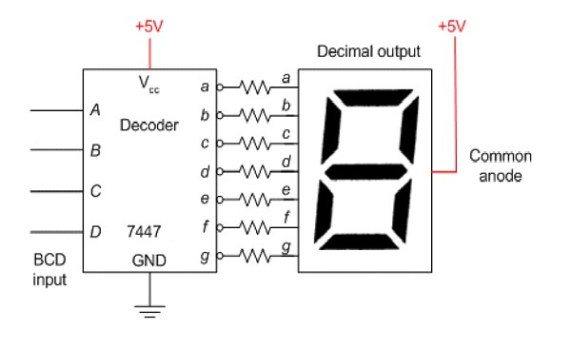

Figure 6:BCD Counter Wiring Diagram

### **Part B: Blanking all segments:**

Now we Connected pin 4 (BI) of the decoder to the ground. All 7 segments must be turned off.

(No Figure for this part)

### **Part C: Implementing a decade counter**

In this section, we will construct a counter that counts from **(0 to 9).** We connected the circuit designed and the connected circuit. Next, we applied clock pulses to pin **14** of the **7490-counter** using Pulser Switch **(SWA)**, and observe the counting sequence on display we kept applying pulses to pin 14 and observe the count sequence.

**2.1.1Discussion:**During the experiment, we successfully connected a 7490 counter to a 7447 decoder and then to a seven-segment display. The output of the counter advanced with each clock pulse, and the correct digit was shown on the display. We encountered some initial wiring issues due to confusion with common anode vs. cathode configuration of the seven-segment display, which we resolved after consulting the datasheet.

Some digits did not light properly until the power connections were secured and resistors were added to limit current through the display. Once resolved, the counter correctly looped from 0 to 9 and reset. This demonstrated the sequential operation of the 7490 and the translation of binary output to a readable display format using the 7447.

We also tested chaining two counters to form a two-digit counter, confirming that the carry-out and reset features function as described in the datasheet.

Photos of the breadboard circuit and the working display output are attached in the appendices.

|  |
| --- |
| D1 |
| 0 |
| 1 |
| 2 |
| 3 |
| 4 |
| 5 |
| 6 |
| 7 |

Table 3: Correct Output of all Segments

**3.Conclusion**  
This Experiment improved our understanding on how decoders and **BCD counters** work, and it showed us the essential role of Resistors in everyday device and circuit, and how it can be used to generate more advanced helpful circuits.

During the experiment we took notes on each part of the Experiment:

1. Seven-Segment Display: The experiment emphasized the significance of common anode and cathode configurations and the importance of them. Testing the LEDs in the display verified the proper functioning of all segments.
2. BCD-to-Seven-Segment Decoder: The 7447 decoders the converted BCD inputs to the appropriate signals for displaying decimal digits 0-9 on the seven-segment display (we ran into an issue here where one of the Decoders was Faulty and had to use another one).
3. Counter: The 7490 counter was configured to count from 0 to 9. By applying clock pulses through a pulser switch and a pulse generator, the counting sequence was observed and verified on the display. (We encountered no issue here)

# **4.References**

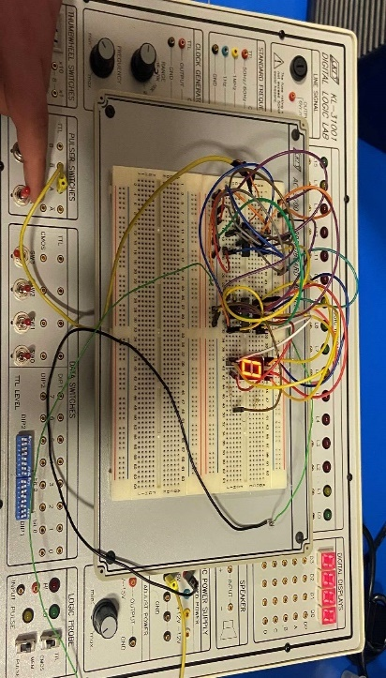[1] ENCS2110 Lab Manual, Birzeit University, 2024.  
[2] Datasheets for IC7447 and IC7490.  
[3] All About Circuits. Seven-Segment Display Basics.   
<https://www.allaboutcircuits.com/textbook/digital/chpt-5/seven-segment-displays/>

Figure 7:first Pulse on Connection

### **5.** **Appendices**

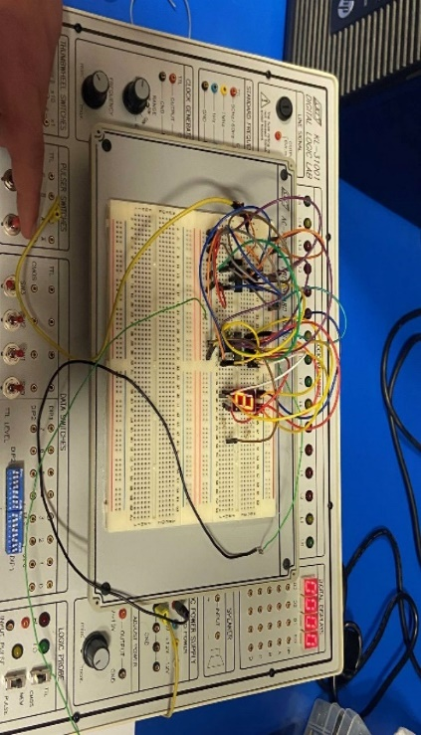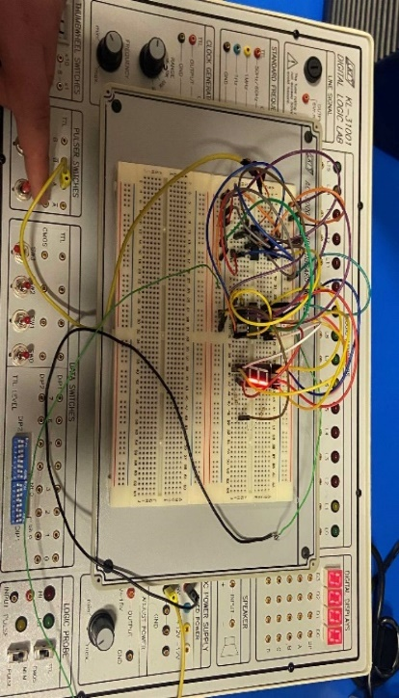

Figure 8:third Pulse on Connection

Figure 9:second Pulse on Connection