

**Faculty of Engineering and Technology**

**Department of Electrical and Computer Engineering**

**ENCS 2110**

**EXP 8 Pre-Lab: Introduction to QUARTUSII Software**

**Student’s name:** Anas Al Sayed

**Student’s No.:** 1221020

**Section:** 10

**Instructor:** Hanya Radwan

* 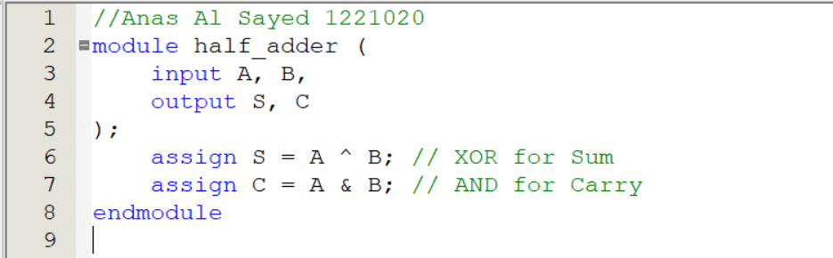 **Half Adder (Data Flow)**

A **Half Adder** adds two bits and produces a **Sum (S)** and **Carry (C)**.

* **Full Adder using Half Adder (Structural)**

**A Full Adder consists of two Half Adders and an OR gate.**

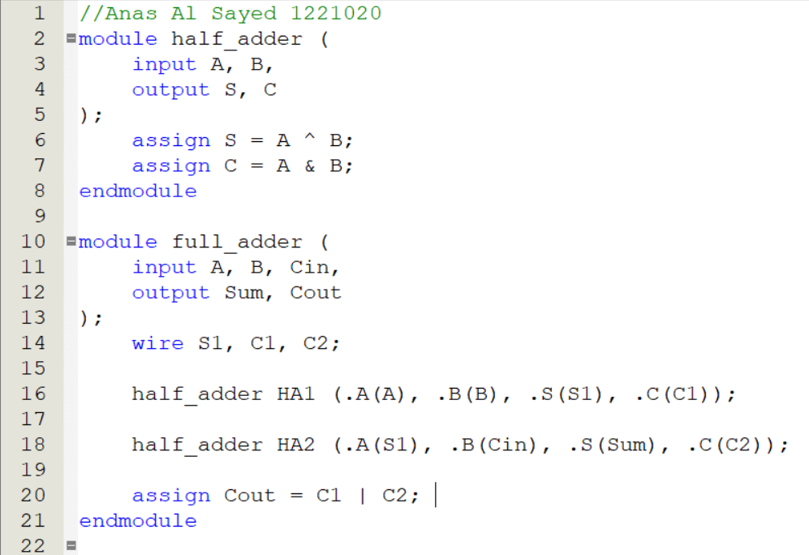

* **2-bit Counter (Behavioral)**

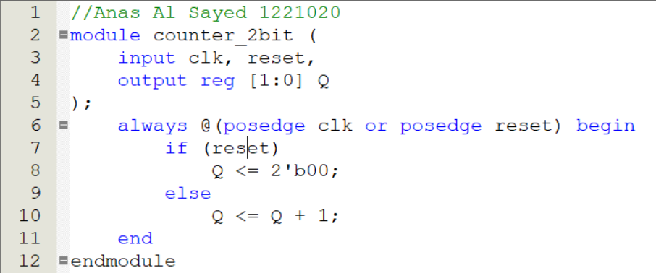**A 2-bit counter counts from 00 to 11 (0 to 3 in decimal).**

* **8-to-1 Multiplexer (Behavioral)**

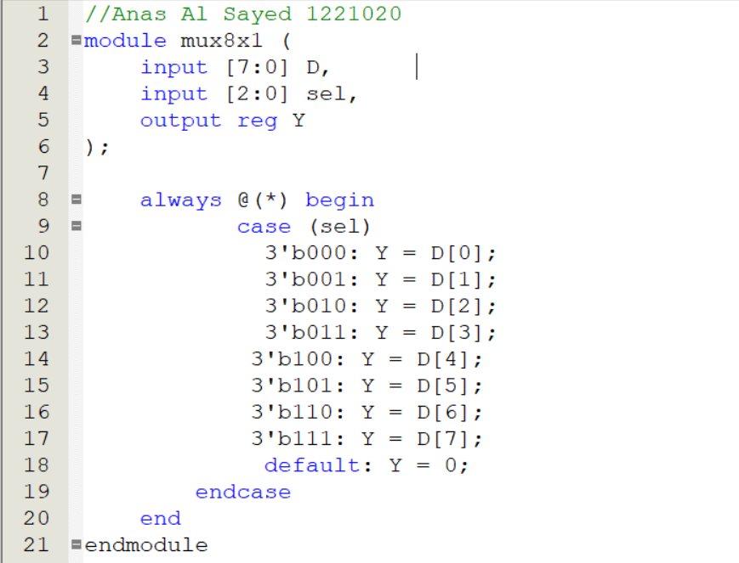**An 8x1 MUX selects one of 8 inputs based on a 3-bit select line.**

* **2x4 Decoder using Basic Gates (Structural)**

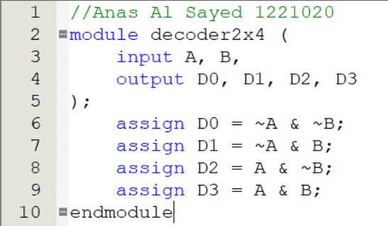**A 2x4 decoder takes 2 inputs and produces 4 outputs.**

* 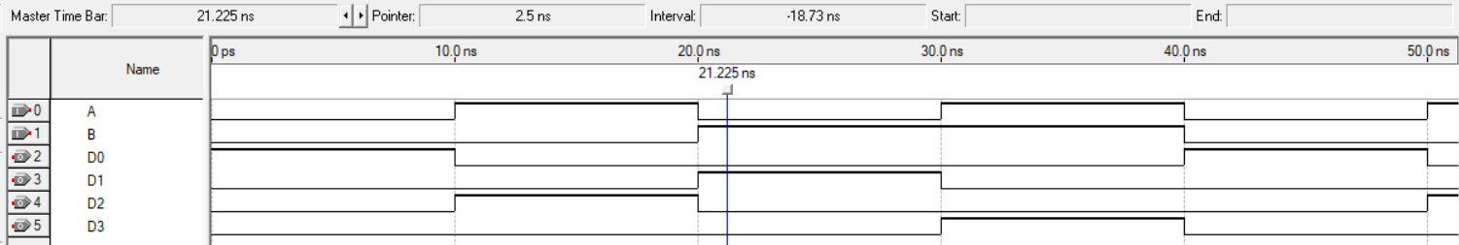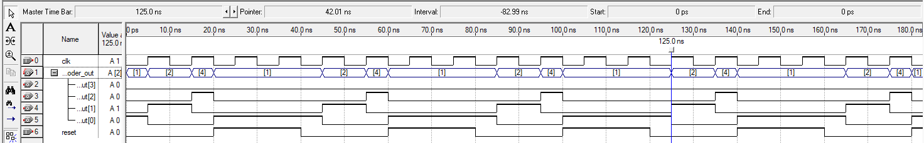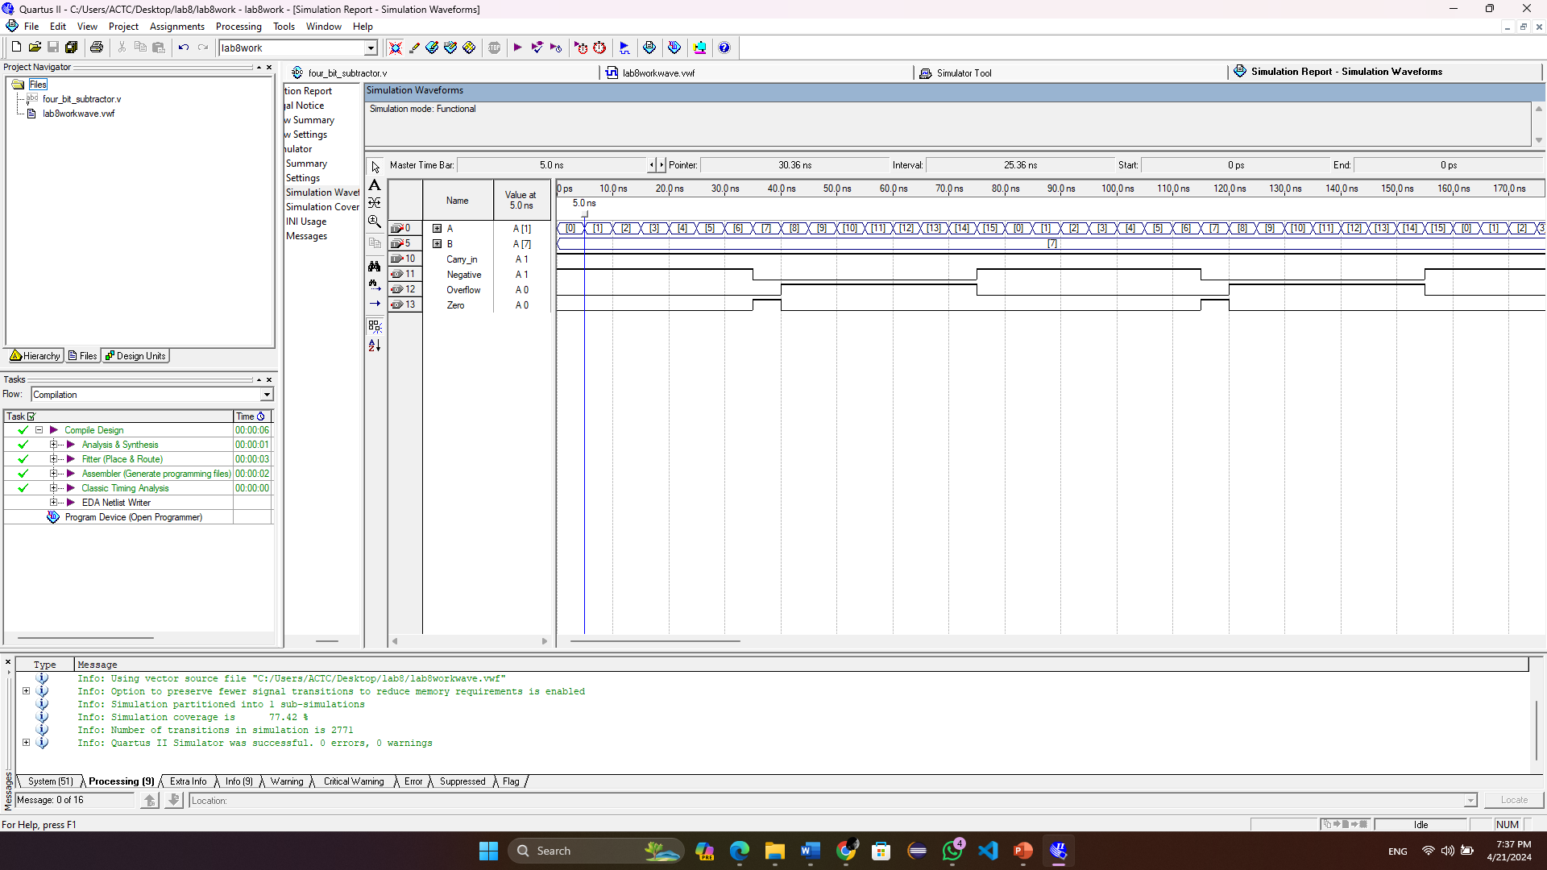**The waveform for the above parts.**