Functional Data Processing Pipeline Documentation
Functional Data Processing Pipeline

- Handle missing data (fill with defaults or remove).
- Fill missing numeric values with the median.
- Replace missing categorical values with the mode.

- Standardize formats ( dates, numerical precision).
  - (Price Per Unit, Total Spent) to all as float
  - Error OR Unknown
    - replace with Mode or median
- Data Transformation:
  - Filter rows based on conditions (eg. Item == Coffee).
  - Compute New Columns: Create a new column called Corrected Total by calculating Quantity * Price Per Unit to see if the original Total Spent matches (data validation).
  - Aggregate Data: Group by eg (Item = “Coffee") to calculate Total Spent for Coffee.
- Data Analysis Perform operations such as:
  - Statistical summaries (mean, median, variance). ⬅
- Output Results:
- Save processed data to files a clean CSV and display summaries to the console.
Data Visualization (Optional): Produce charts such as bar graphs or line charts

Cafe Sales - Dirty Data for Cleaning Training
https://www.kaggle.com/datasets/ahmedmohamed2003/cafe-sales-dirty-data-for-cleaning-training

Concepts we used in code

Higher Order Functions

Functional Example:
map, filter, and reduce are used extensively.

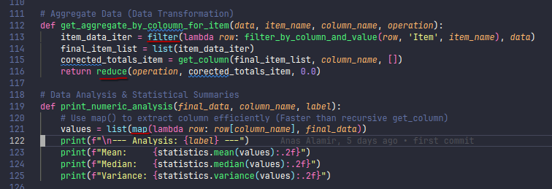Imperative Example:
Uses explicit loops instead of higher order functions.

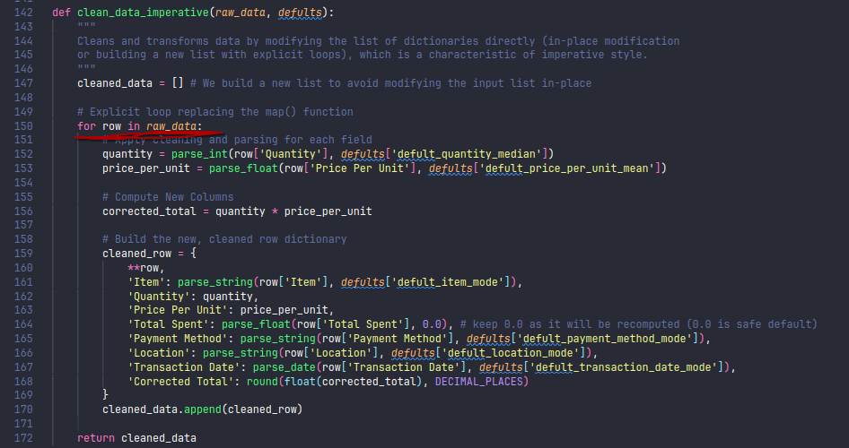

Comparison:
- - Functional code is more concise and expressive for data transformations.
- - Imperative code is more explicit and easier to debug for beginners.

Tail Recursion

Functional Example:
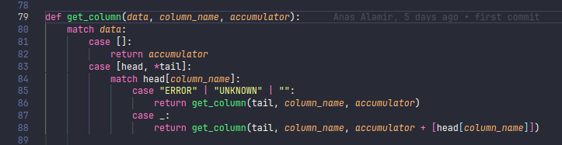

Imperative Example:
Uses loops instead Tail Recursion.

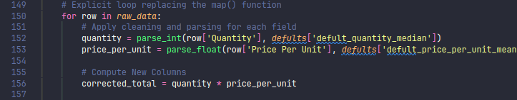

Comparison:
- Functional code can leverage recursion for list processing, but may hit recursion limits in Python.
- Imperative code avoids recursion, using loops for better performance in Python.

Single Assignment (Pure Functions)

Functional Example:
Functions like clean_row do not modify input data, but return new data
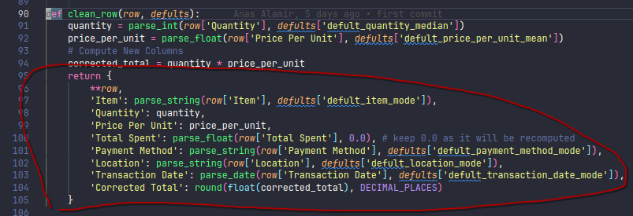

Imperative Example:
May modify or build new lists, but often uses in-place updates.

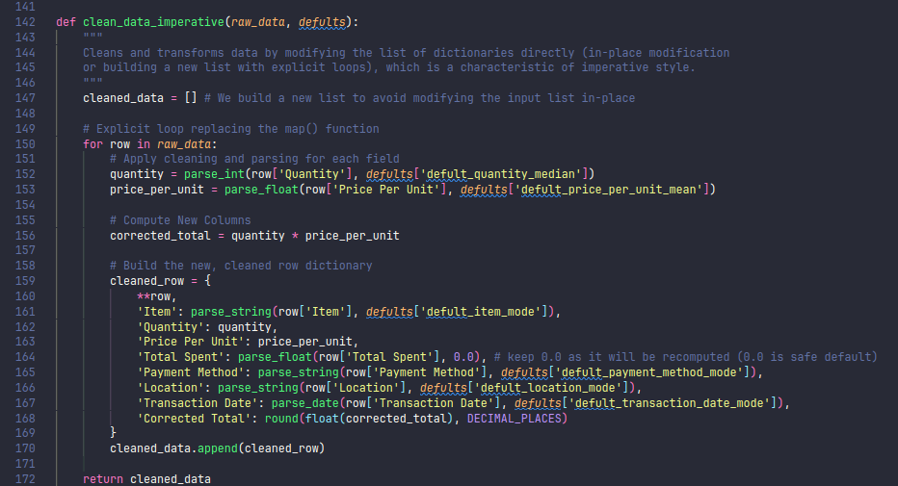

Comparison:
- Functional code encourages immutability and pure functions.
- Imperative code may use mutable data structures and side effects.

Lists

Functional Example:
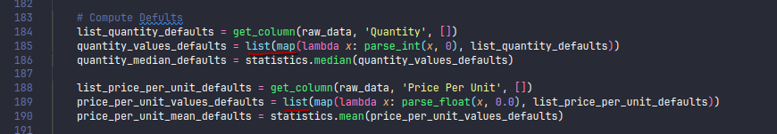

Imperative Example:
Uses explicit loops to build lists:

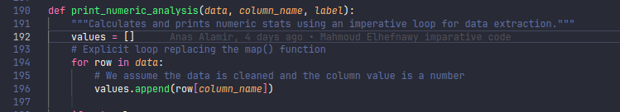

Comparison:
- Both paradigms use lists, but functional code prefers declarative transformations, while imperative code uses explicit iteration.

Mutability Vs Immutability

Functional Example:
immutability ideas accumulator, returning new data
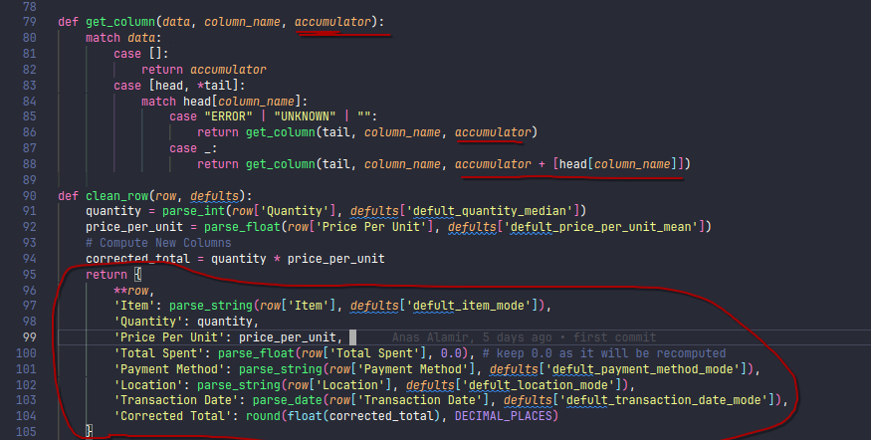

Imperative Example:
Mutability: quantities, prices_per_unit are mutated in loops
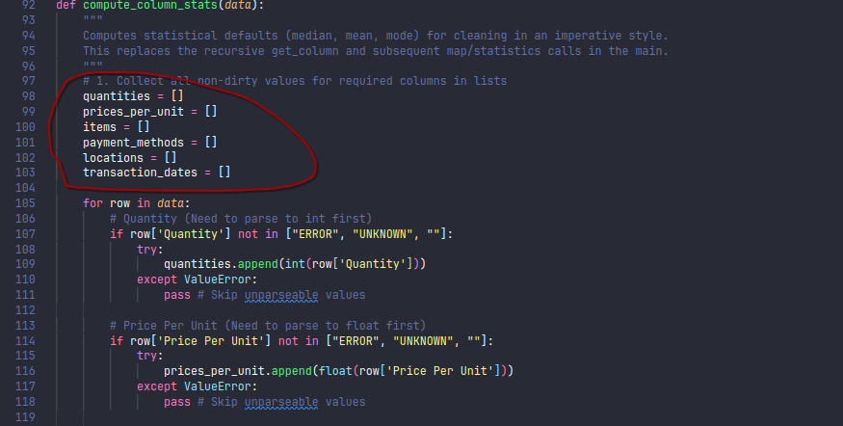

Comparison:
- Mutable objects can be changed in place; immutable objects cannot be changed after creation (a new object is created on “change”).

Conclusion
- Functional programming offers concise, expressive code with a focus on immutability and pure functions, but may be less familiar to Python programmers and can hit recursion limits.
- Imperative programming is more explicit, easier to debug, and better suited for Python's performance characteristics, but can be more verbose and prone to side effects.

Choosing a paradigm depends on the problem, team familiarity, and language features. Both styles are valuable and can be mixed for practical software development.

