Functional Data Processing Pipeline Documentation

Higher Order Functions

Functional Example:
map, filter, and reduce are used extensively.

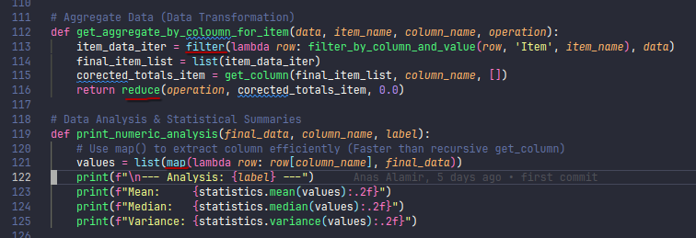
Imperative Example:
Uses explicit loops instead of higher order functions.

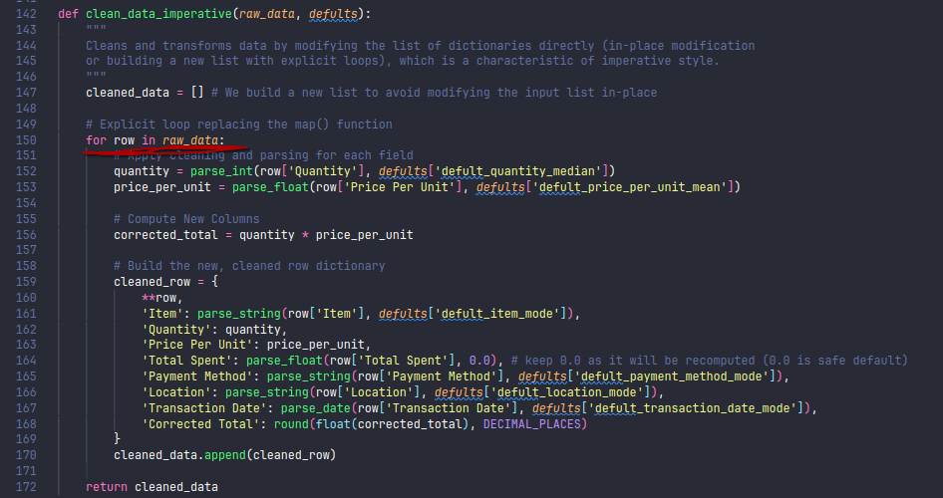

Comparison:
- - Functional code is more concise and expressive for data transformations.
- - Imperative code is more explicit and easier to debug for beginners.

Tail Recursion

Functional Example:
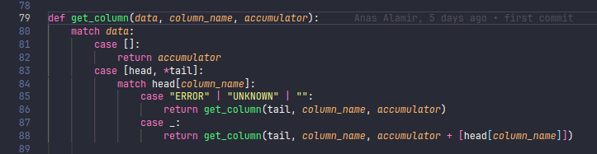

Imperative Example:
Uses loops instead Tail Recursion.

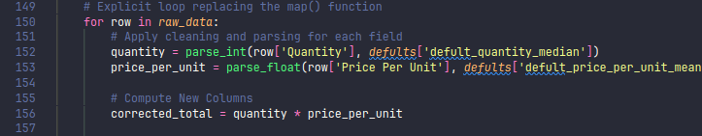

Comparison:
- Functional code can leverage recursion for list processing, but may hit recursion limits in Python.
- Imperative code avoids recursion, using loops for better performance in Python.

Single Assignment (Pure Functions)

Functional Example:
Functions like clean_row do not modify input data, but return new data
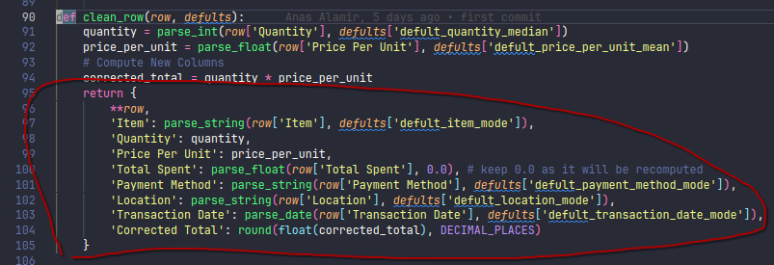

Imperative Example:
May modify or build new lists, but often uses in-place updates.

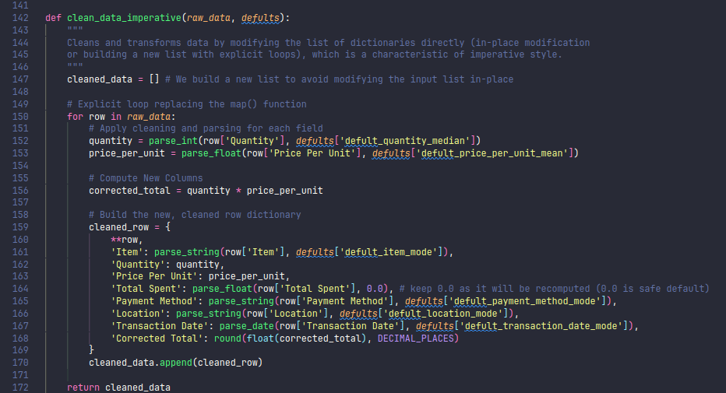

Comparison:
- Functional code encourages immutability and pure functions.
- Imperative code may use mutable data structures and side effects.

Lists

Functional Example:
Uses list comprehensions, map, and recursion
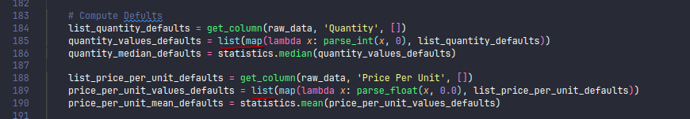

Imperative Example:
Uses explicit loops to build lists:

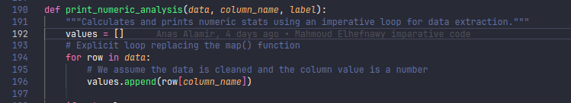

Comparison:
- Both paradigms use lists, but functional code prefers declarative transformations, while imperative code uses explicit iteration.

Conclusion
- Functional programming offers concise, expressive code with a focus on immutability and pure functions, but may be less familiar to Python programmers and can hit recursion limits.
- Imperative programming is more explicit, easier to debug, and better suited for Python's performance characteristics, but can be more verbose and prone to side effects.

Choosing a paradigm depends on the problem, team familiarity, and language features. Both styles are valuable and can be mixed for practical software development.

