SRS Document – Android Application

**Introduction:**

1. Purpose: The purpose of the android application is to help people with Amblyopia (also called lazy eye) is a type of poor vision that usually happens in just 1 eye but less commonly in both eyes.
2. Intended Audience: Our intended audience will be young age kids from the range of five to eight years.
3. Product Scope: the scope of the application will be to help patients with daily eye exercises. This data will then be stored in the database and sent to the doctor for further analysis. This is done as eye treatment takes a long time and patients are required to visit the doctor at least one a week. This application will help the doctor to monitor the patient’s condition and the patient can do eye exercise daily at convenience.

**Overall Description:**

1. User Needs:
2. Patient: Will be the primary user and will fulfil the need for a platform for eye exercises
3. Doctor: Will be the secondary user and will fulfil the need of remotely monitoring the patients condition
4. System Environment:

**System Features and Requirements:**

1. Functional Requirements: (Use Case)
2. User🡪Start Game: The user is able to start playing the game or view their previous scores.
3. User🡪Select Difficulty: The user upon clicking the start game button is navigated over here. In this page, the user will be able to select a difficulty to play on.
4. User🡪Play: The main function of the application is shown over here. The game will feature different size and colour circles that the user has to click. Upon clicking the score will increase and it will be a timed game.
5. User🡪Results: When the time is over the user will be taken to another page where his final score will be displayed.
6. User🡪Quit: The user can quit/start over.
7. Healthcare Provider🡪Results: The results provided to the healthcare provider will be how fast the patient clicked the circles once they appeared on the screen (in milliseconds).
8. External Interface Requirements

* Android Device with minimum API level of 24
* Front-end software: Android Studio
* Back-end software: SQLite

Database for Healthcare provider:

|  |  |
| --- | --- |
| Sr no | Int, PK |
| Date | date |
| Time | Time |
| Response time 1 | Time |
| Response time 2 | Time |
| Response time 3 | Time |
| Response time 4 | Time |
| Response time 5 | Time |
| Response time 6 | Time |
| Response time 7 | Time |
| Response time 8 | Time |
| Response time 9 | Time |
| Response time 10 | Time |
| Response time Avg | float |

1. System Sequence:

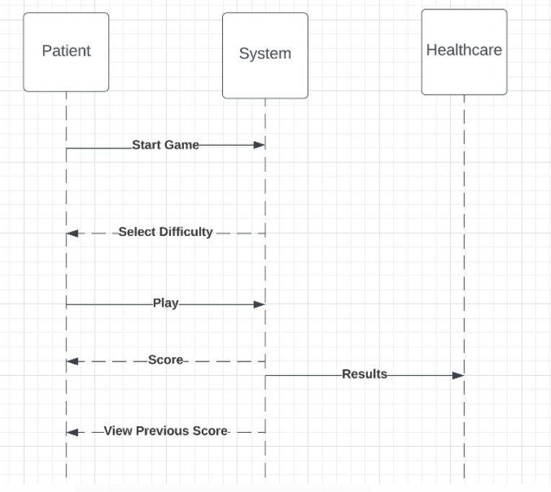

1. Non-functional Requirements

* Performance: The application should run on a variety of API levels
* Usability: Ease of use and clarity of the program.
* Scalability: The program is scalable.
* Reliability: The program is reliable during use.
* Maintainability: The program is maintenance able when there is any problem.
* Security: The program is secured from hacking and viruses.
* Regulatory: Working within the program is regular and easy to use.

**Layout:** <https://www.figma.com/file/RBt8Axje81fybYu9T3uTS4/TechHack-2023?node-id=0%3A1&t=GuvK1sm6W4uyTbLu-1>

