**Software Requirements Engineering**

**Task-01**

***الاسم : جمال داهش العامودي***

***الرقم الجامعي : 20210219***

___________________________________________________________________

***Donation Website***

***Introduction:***

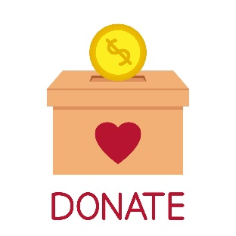The purpose of this report is to present a software project for a donation website. The project aims to help non-profit organizations collect donations from individuals and corporates easily and securely. The report outlines the problem statement, possible stakeholders, and sources of requirements gathering for the proposed software.

***Problem Statement:***

Non-profit organizations depend heavily on donations from individuals and corporates to sustain their operations. However, collecting donations can be a cumbersome and time-consuming process. The traditional methods of collecting donations involve sending donation requests through mail, making phone calls, or conducting fundraising events. These methods are not only time-consuming but also ineffective as they require a significant amount of resources and do not guarantee a high response rate.

To overcome these challenges, there is a need for a donation website that allows non-profit organizations to collect donations securely and efficiently. The proposed software project aims to address this problem by providing a platform that allows individuals and corporates to donate quickly and easily to their favorite non-profit organizations. The solution should provide a user-friendly interface that allows users to make donations securely using their credit or debit cards.

***Proposed Solutions:***

The proposed solution is a donation website that allows non-profit organizations to create their profiles and share their stories with potential donors. The website will allow donors to search for non-profit organizations based on different categories such as location, cause, and popularity. Donors will be able to view the profile of non-profit organizations and their financial reports. The website will also enable donors to make one-time or recurring donations using their credit or debit cards.

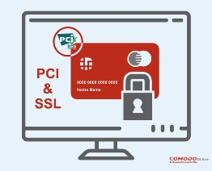The website will be built using a responsive web design approach to ensure that it works seamlessly on different devices such as desktop computers, tablets, and smartphones. The website will also incorporate the latest security measures such as SSL certificates, PCI compliance, and two-factor authentication to ensure that donor's sensitive information is protected from cyber threats.

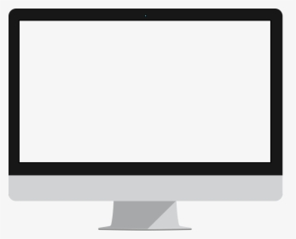

Tablets

Desktop

computers

Smart-phones

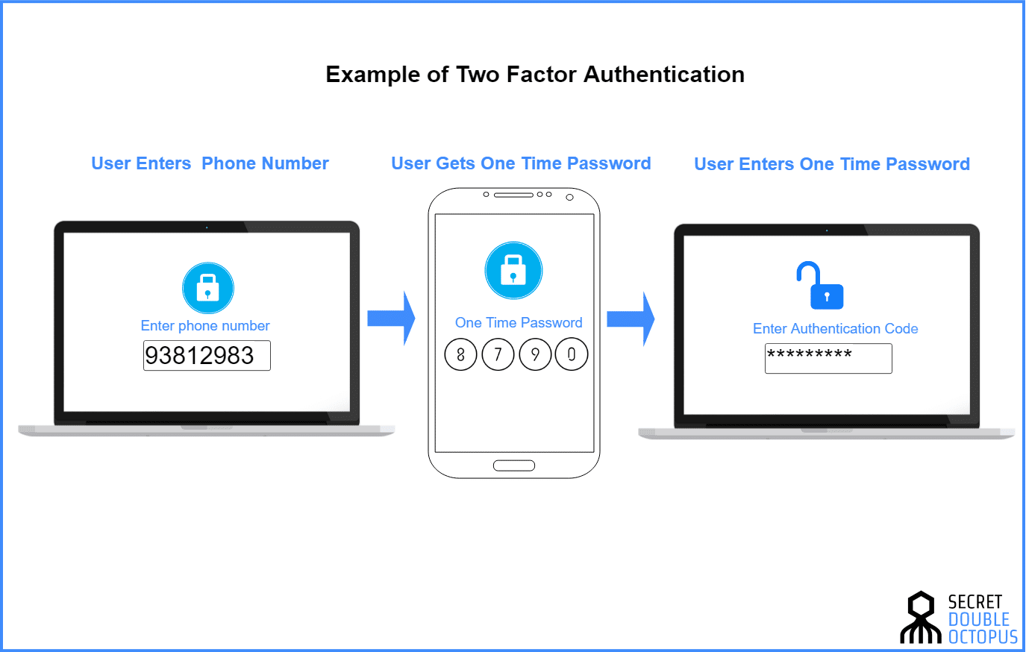

***Possible Stakeholders:***

**1. Non-profit organizations:** These are the primary stakeholders who will use the website to collect donations from donors.

**2. Donors:** These are the individuals and corporates who will use the website to donate to non-profit organizations.

**3. Website developers:** These are the stakeholders who will be responsible for developing, maintaining, and updating the website.

**4. Payment gateways:** These are the stakeholders who will provide payment processing services to the website.

**5. Regulators:** These are the stakeholders who will ensure that the website complies with the relevant laws and regulations.

***Sources of Requirements Gathering:***

**1. Non-profit organizations:** The requirements for the website can be gathered by interviewing non-profit organizations to understand their needs and pain points when it comes to collecting donations. This information can be used to design a website that meets their needs.

**2. Donors:** The requirements for the website can be gathered by conducting surveys to understand the preferences of donors when it comes to making donations. This information can be used to design a website that is user-friendly and meets the needs of donors.

**3. Website developers:** The requirements for the website can be gathered by working closely with website developers to understand the technical requirements of the website.

**4. Payment gateways:** The requirements for the website can be gathered by working closely with payment gateway providers to understand the payment processing requirements of the website.

**5. Regulators:** The requirements for the website can be gathered by reviewing the relevant laws and regulations to ensure that the website complies with them.

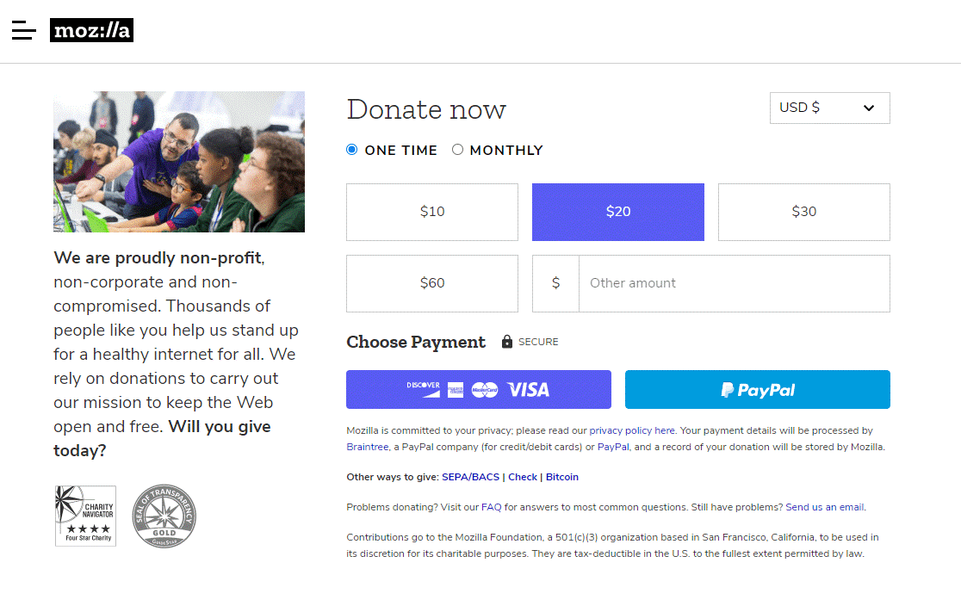

***Conclusion:***

The proposed software project aims to solve the problem of collecting donations for non-profit organizations by providing a user-friendly, secure, and efficient donation website.

The website will provide a platform that allows non-profit organizations to create their profiles and share their stories with potential donors. Donors will be able to make one-time or recurring donations using their credit or debit cards. The project stakeholders include non-profit organization.