Two-step verifications:

Relying on just usernames and passwords to secure your online accounts is no longer considered safe. Data breaches occur daily and hackers are always inventing new ways to take over your accounts.



Authy is simple to use and free. Android users can download it from Google Play, while iPhone and iPad users can get it from Apple’s App Store.



Once you’ve installed the app, enter your mobile phone number and email address. You’ll be sent a PIN, which you’ll enter to confirm you have access to the phone number.

Authy API for Java

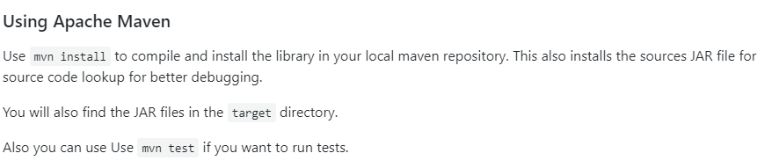Usage:

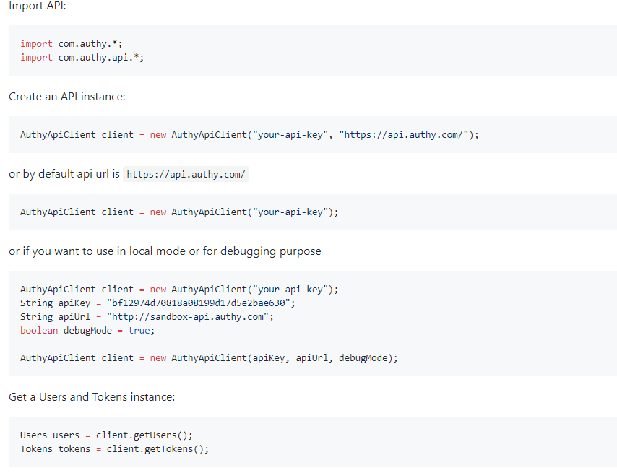

1. Registering a user:

The user is matched based on cellphone and country code, not email.

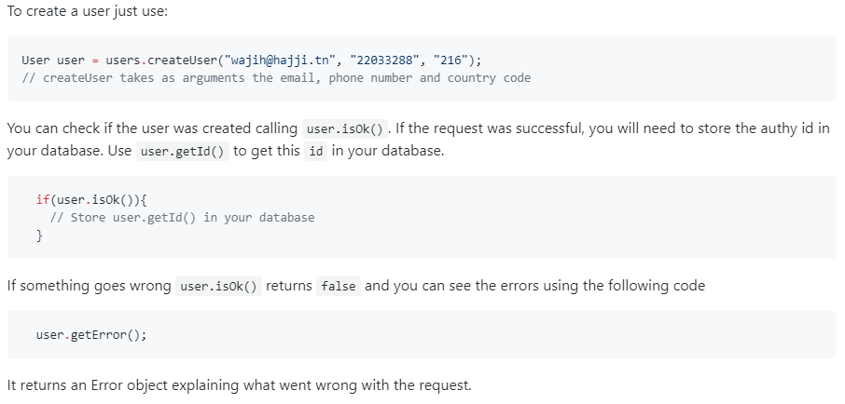

1. Verifying user

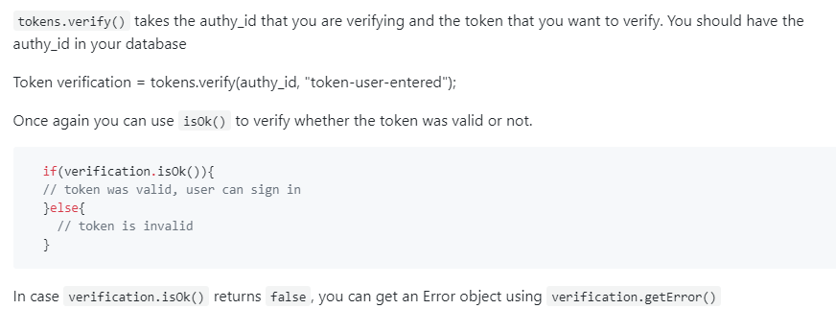

1. Requesting a call token

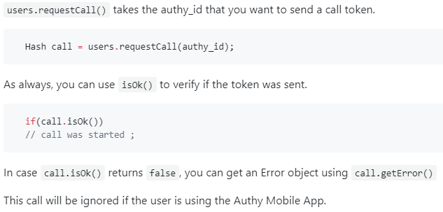

1. Requesting an SMS token

