CivicSense – Screenshot Guide
What each screen in the app shows, grouped by who uses it. File names match the folders in the GitHub repo.
Residents (the public)
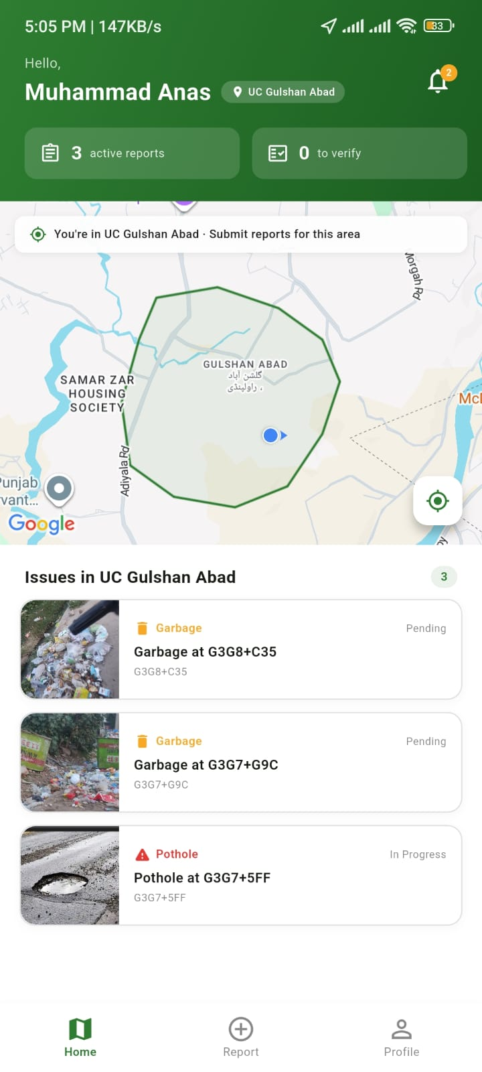 | Home & area map  Shows the resident’s Union Council boundary on the map and a list of open issues in their area, with counts of active reports and reports waiting for them to verify.  File: 01-home-map.jpg
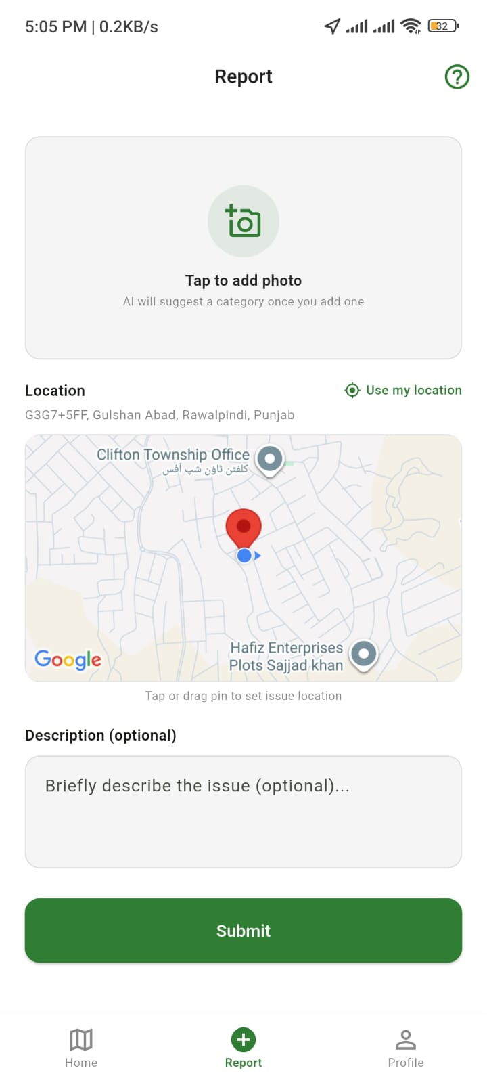 | New report  The resident adds a photo, sets the location (or uses their current location) and can add an optional description.  File: 02-new-report.jpg
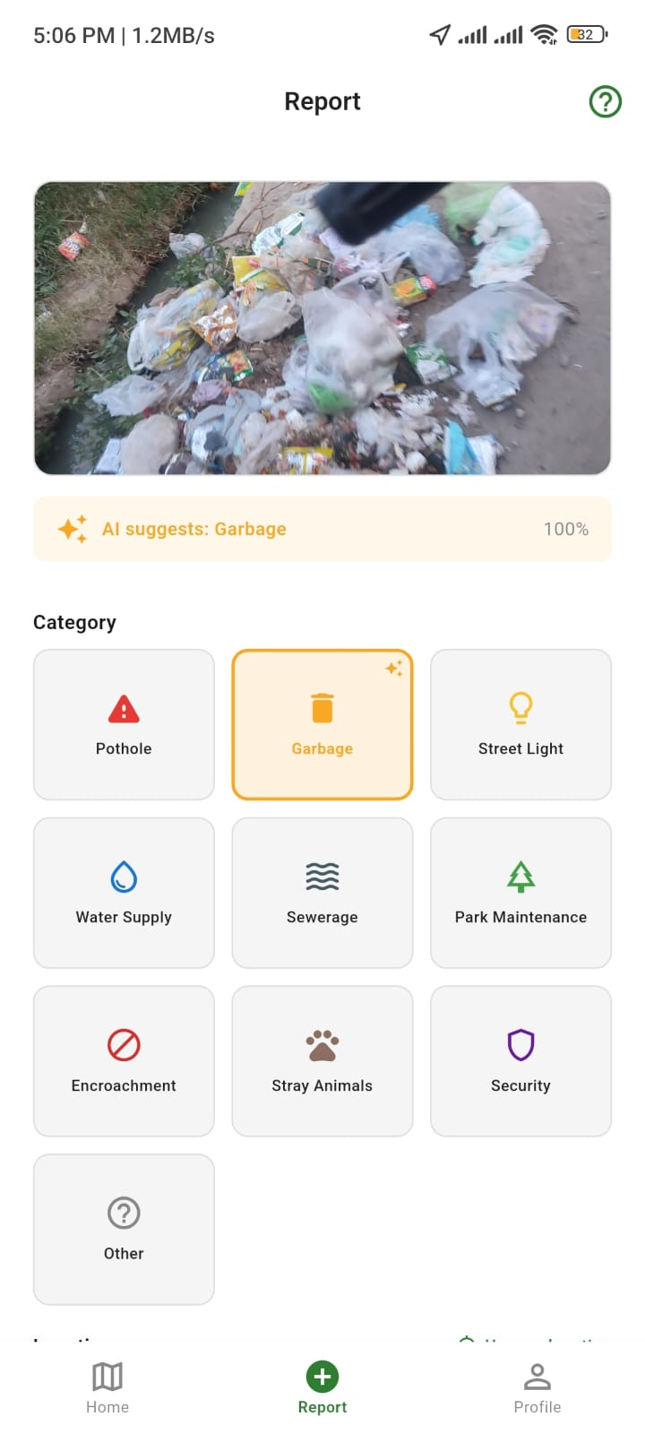 | AI category suggestion  After a photo is added, the on-device AI model suggests the category (here “Garbage”, 100% confidence). The resident can accept it or pick from 10 categories.  File: 03-ai-category-suggestion.jpg
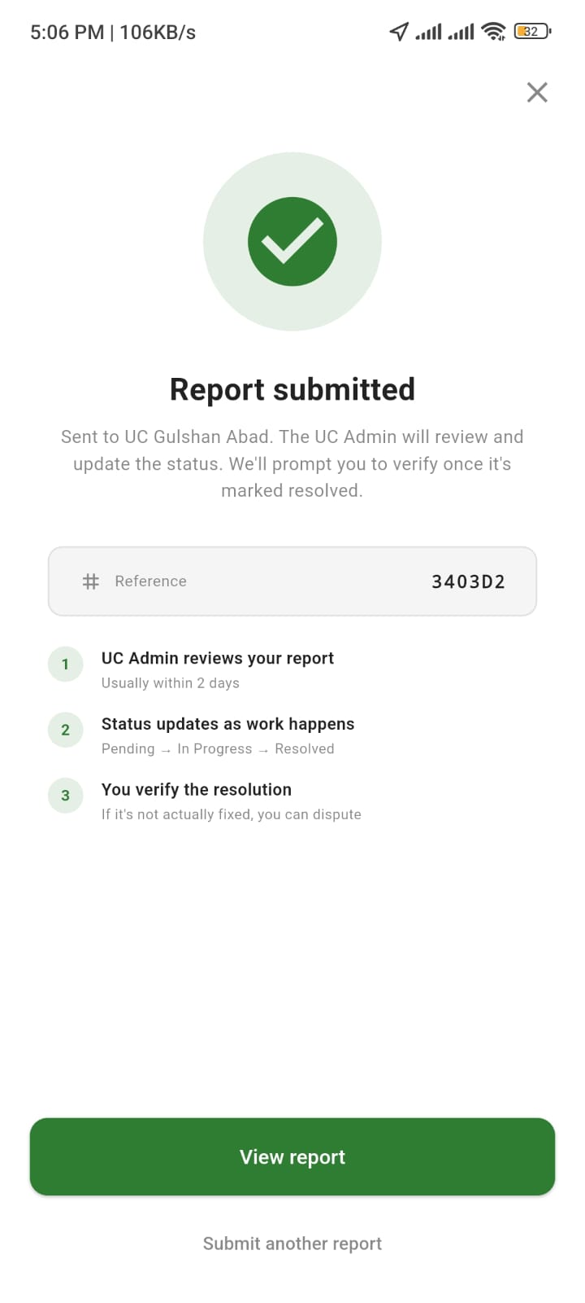 | Report submitted  Confirms which UC the report was sent to, gives a reference number, and explains the next steps: UC review, status updates, then resident verification.  File: 04-report-submitted.jpg
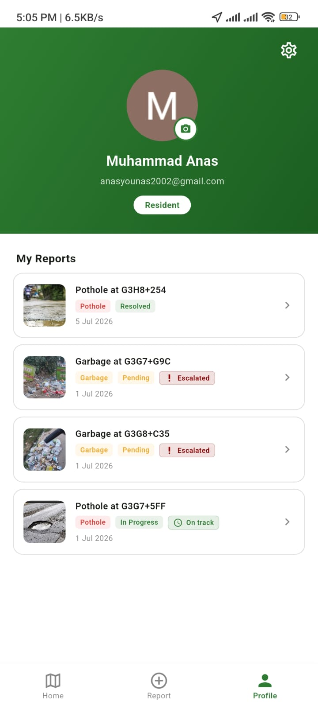 | Profile – my reports  All reports the resident has made, each with its category, status (Pending, In Progress, Resolved) and whether it’s on track or escalated.  File: 05-my-reports.jpg
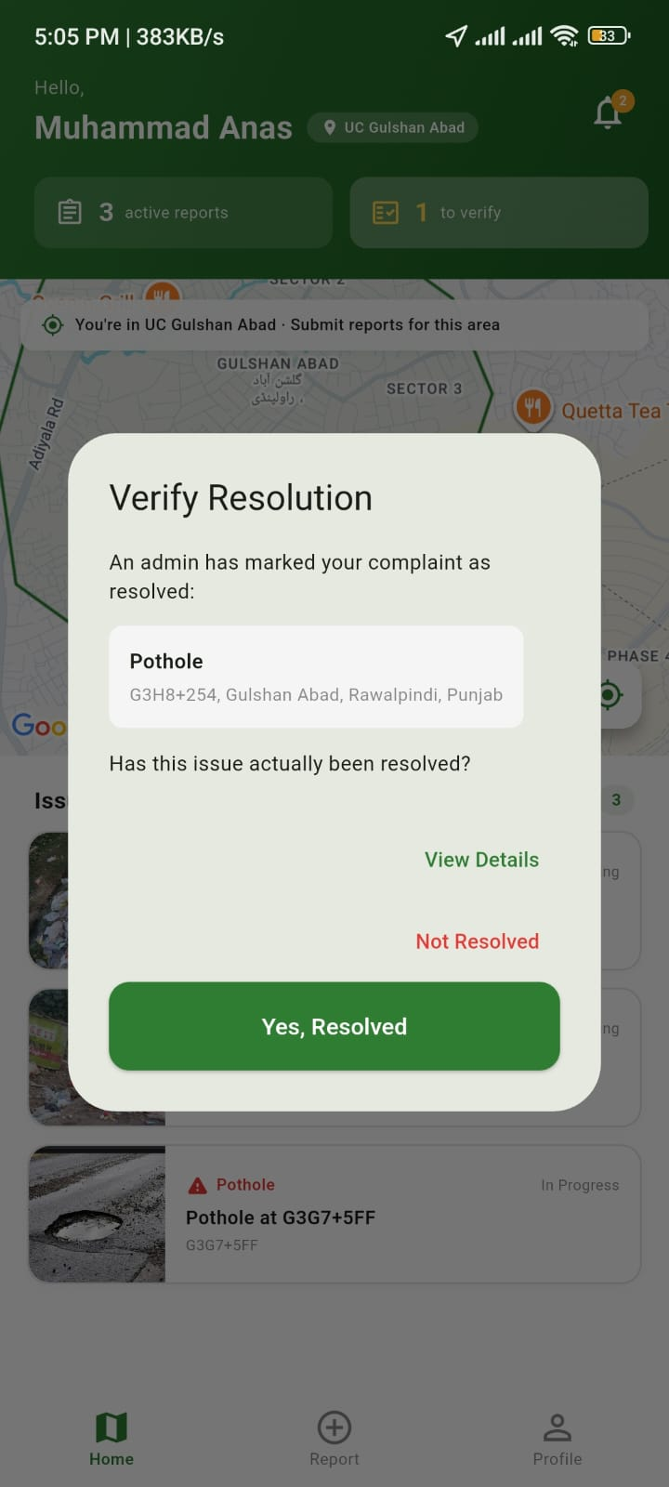 | Verify resolution  When an admin marks a complaint as resolved, the resident is asked whether it’s really fixed. They can confirm or say “Not Resolved”.  File: 06-verify-resolution.jpg
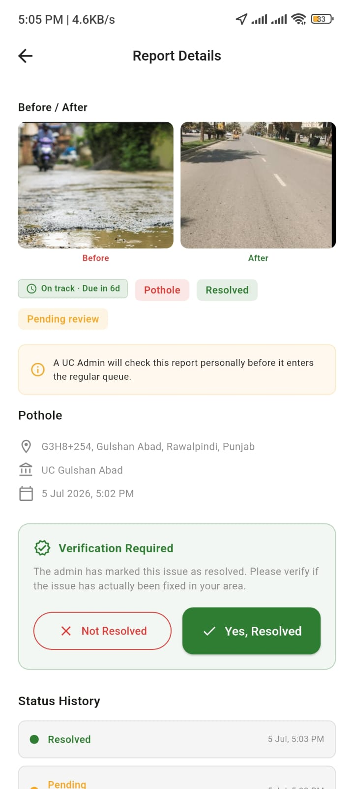 | Report details  Before and after photos, deadline status (“On track – due in 6d”), location, date, the verification step and the full status history.  File: 07-report-details-before-after.jpg
UC Admin (local Union Council office)
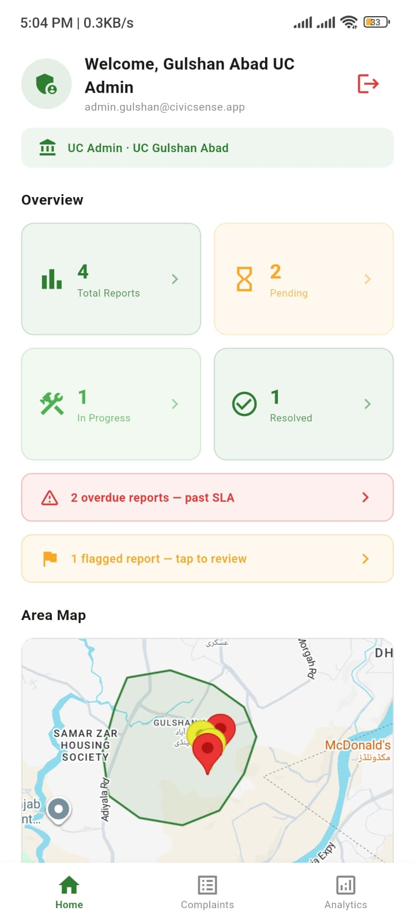 | Dashboard  Overview of total, pending, in-progress and resolved reports for this UC, with alerts for overdue reports (past SLA) and flagged reports, plus a map of where complaints are.  File: 01-dashboard.jpg
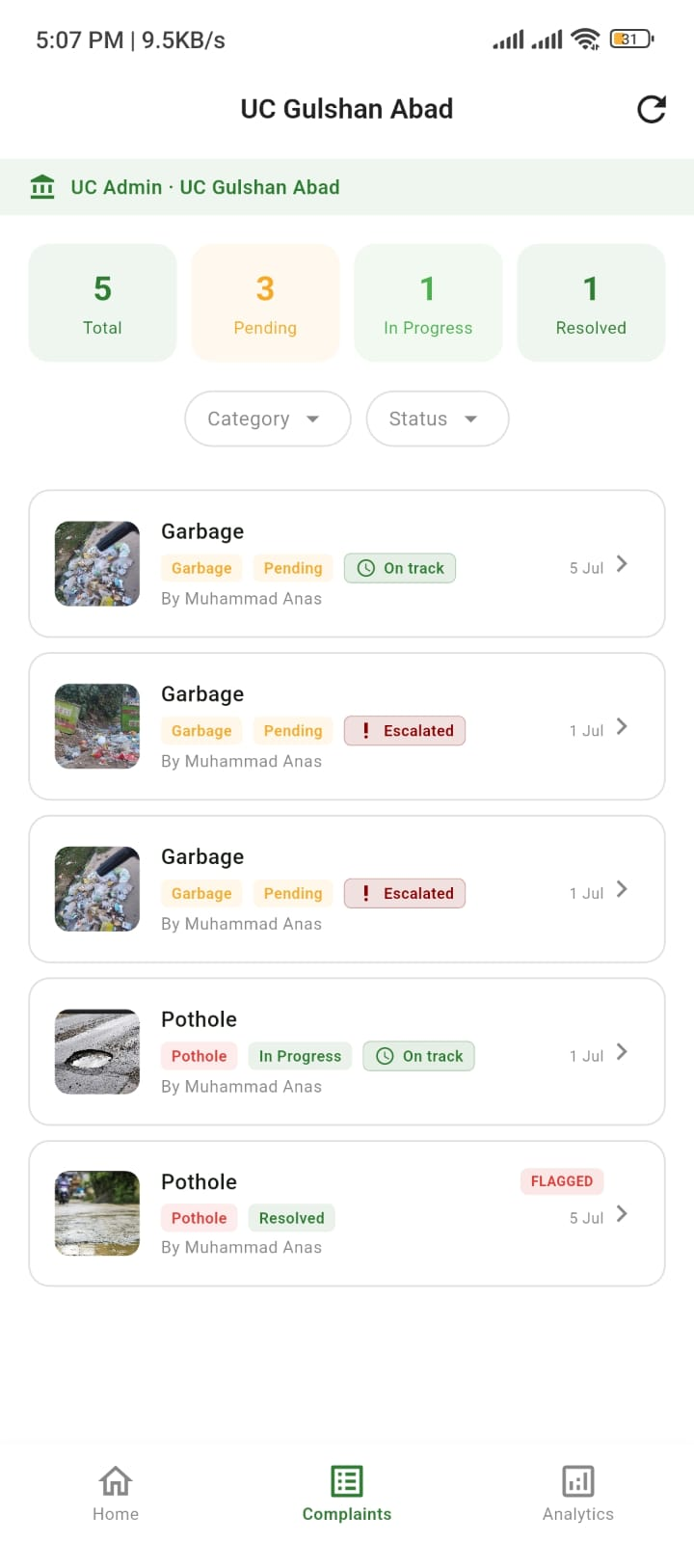 | Complaints list  All complaints for this UC, with filters by category and status, and tags for Pending, In Progress, Resolved, On track, Escalated and Flagged.  File: 02-complaints-list.jpg
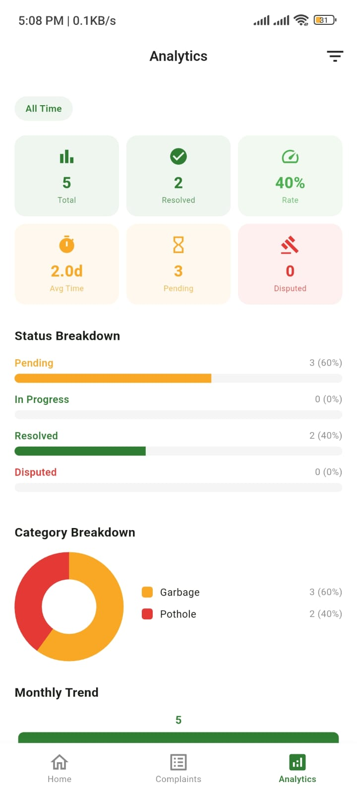 | Analytics  Resolution rate, average time to resolve, pending and disputed counts, and breakdowns by status and by category.  File: 03-analytics.jpg
Head Office (oversees all UCs)
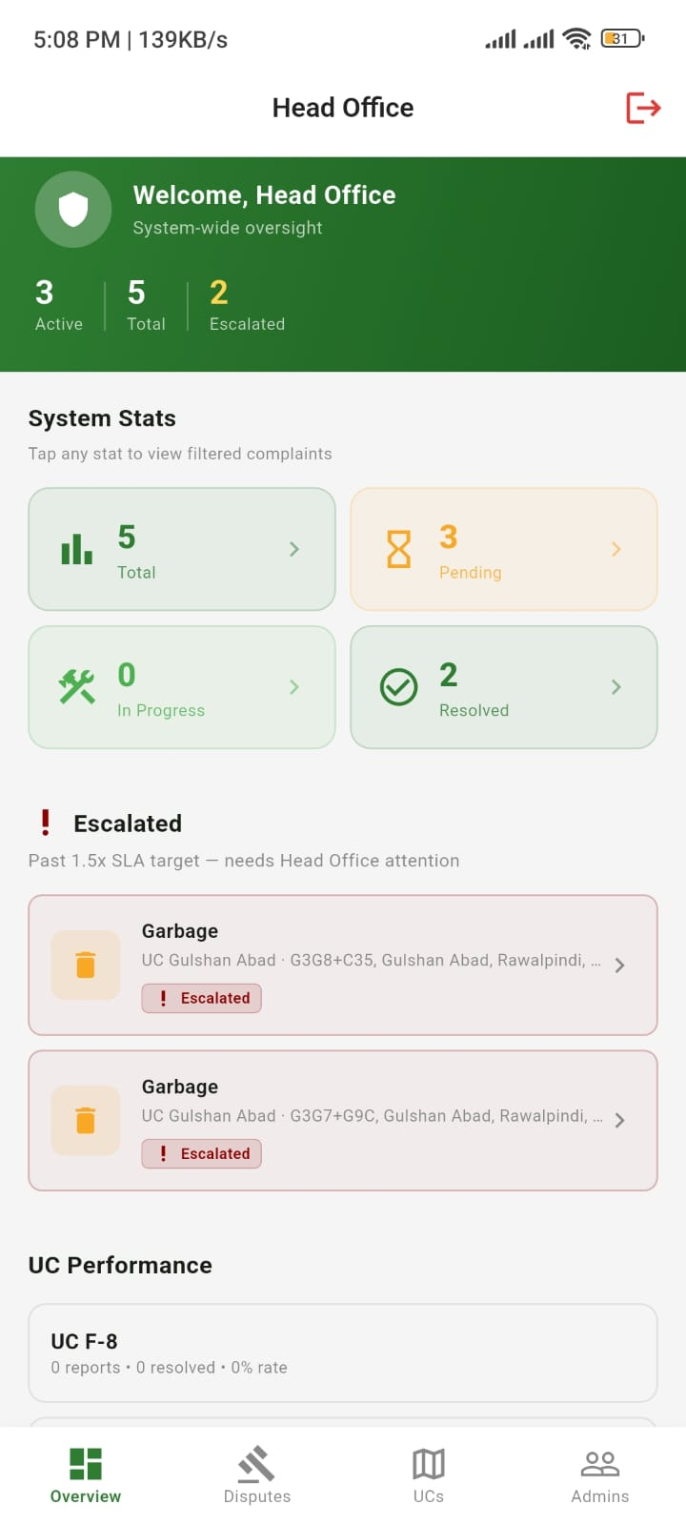 | Overview & escalations  System-wide numbers across all UCs, the list of escalated complaints (past 1.5× the target time), and each UC’s performance.  File: 01-overview-escalations.jpg
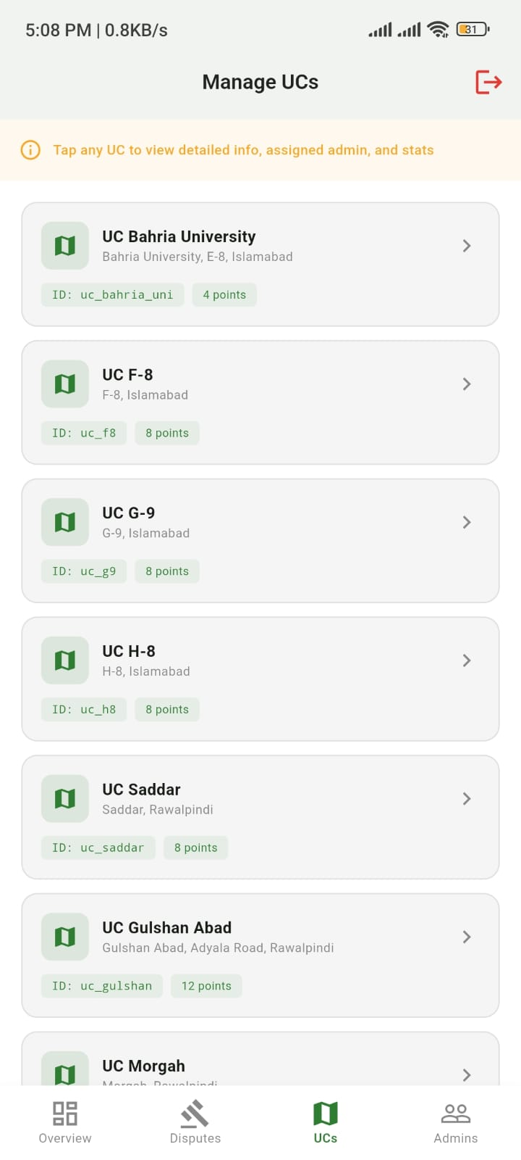 | Manage UCs  List of all Union Councils with their IDs and map boundary points. Tap a UC to see its details, assigned admin and stats.  File: 02-manage-ucs.jpg
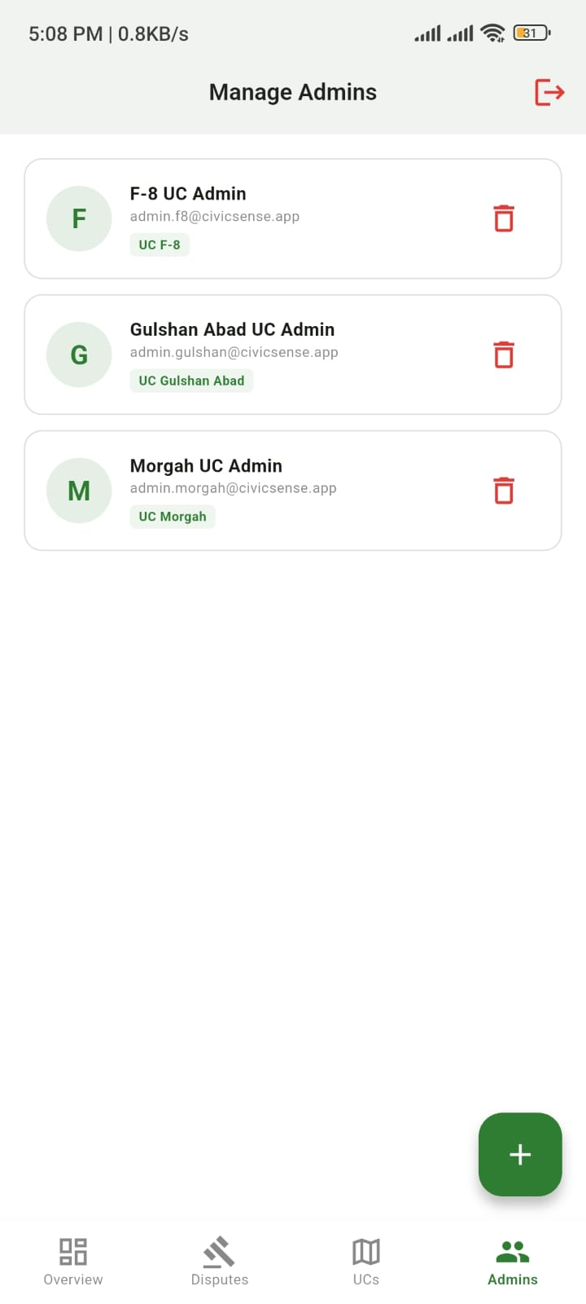 | Manage admins  Add or remove the admin account for each UC.  File: 03-manage-admins.jpg

