***Mobile Application Development Lab***

***CSL-341***

***Lab Journal***



**Student Name**

**Enrollment No.**

**Class and Section**

**Department of Computer Science**

**BAHRIA UNIVERSITY ISLAMABAD**

# Lab 1 – Flutter Introduction

## Objectives:

Installation of Flutter and setting up the environment

## Tools Used:

VS Code

### Submission Date:

## Evaluation Signatures of Lab Instructor

# Tasks

1. Write the main steps involved in Flutter installation.
2. How you connect your mobile phone in replacement of Virtual Device? Write step by step procedure.
3. In VS Code, which extension you install for flutter and Dart?
4. How can we create a flutter project?
5. What is the advantage of setting path in environment variables?

# **Flutter Installation and Setup Guide**

## **1. Main Steps Involved in Flutter Installation**

Flutter is an open-source UI toolkit used for building natively compiled applications for mobile, web, and desktop. To install Flutter, follow these steps:

### **Step 1: Download Flutter SDK**

* Visit the official Flutter website: [https://flutter.dev](https://flutter.dev/)
* Download the latest stable version of the Flutter SDK for your operating system.

### **Step 2: Extract the Flutter SDK**

* Extract the downloaded file to a suitable location on your system (e.g., C:\flutter on Windows).

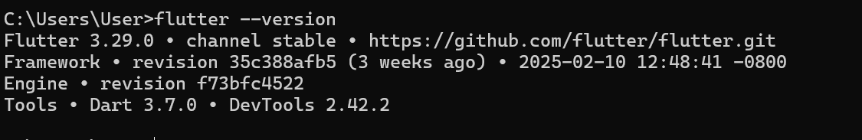

### **Step 3: Set Up Environment Variables**

* Add the Flutter bin directory (C:\flutter\bin) to the system’s environment variable PATH.

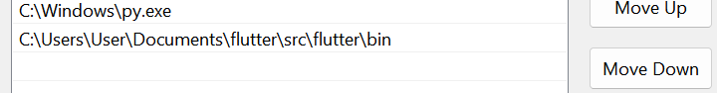

### **Step 4: Verify Installation**

* Open Command Prompt or Terminal and run:

**flutter doctor**

* This command checks for missing dependencies and provides installation recommendations.

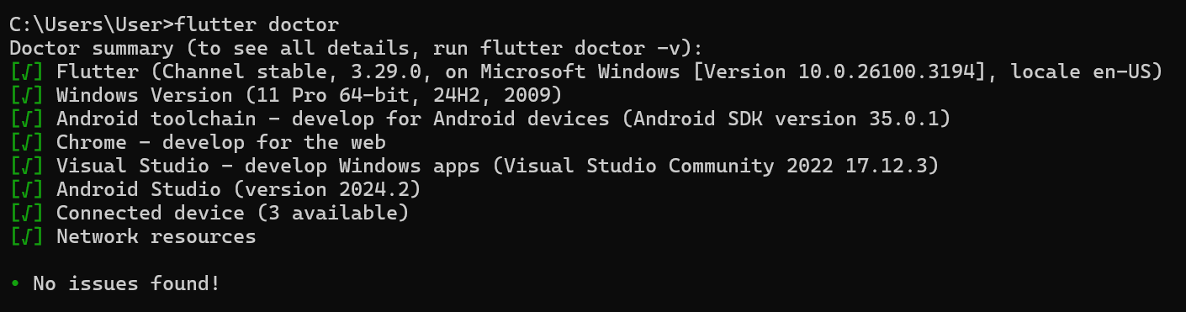

### **Step 5: Install Required Dependencies**

* Install Android Studio (for Android development).
* Install Xcode (for iOS development, macOS only).

### **Step 6: Set Up an Emulator (Optional)**

* Open Android Studio → AVD Manager → Create a Virtual Device.

## **2. Connecting a Mobile Phone Instead of a Virtual Device**

To use a physical mobile device for Flutter development, follow these steps:

### **Step 1: Enable Developer Mode on Your Mobile Device**

* Go to **Settings** → **About Phone** → Tap on **Build Number** seven times.
* Enable **USB Debugging** from Developer Options.

### **Step 2: Connect the Mobile Device to Your PC**

* Use a USB cable to connect the device.
* Ensure you have installed the required USB drivers (for Windows).

### **Step 3: Verify Device Connectivity**

* Open Command Prompt or Terminal and run:

flutter devices

* This should list your connected device.

### **Step 4: Run the Flutter Application on the Device**

* Run the command:

flutter run

* This launches the Flutter app on the connected mobile device.

## **3. Extensions Required for Flutter in VS Code**

To develop Flutter applications in **VS Code**, install the following extensions:

### **1. Flutter Extension**

* Provides Flutter support, debugging, and project management features.

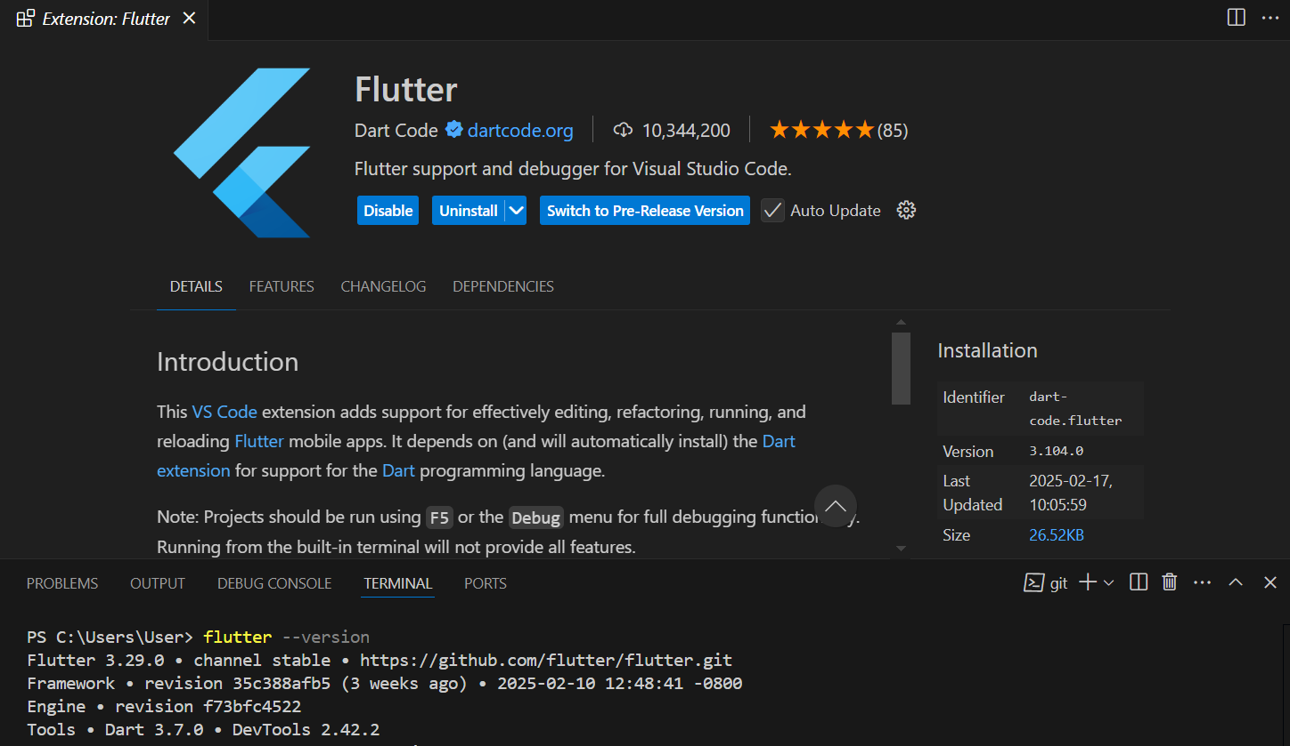

### **2. Dart Extension**

* Enables Dart language support, syntax highlighting, and debugging.

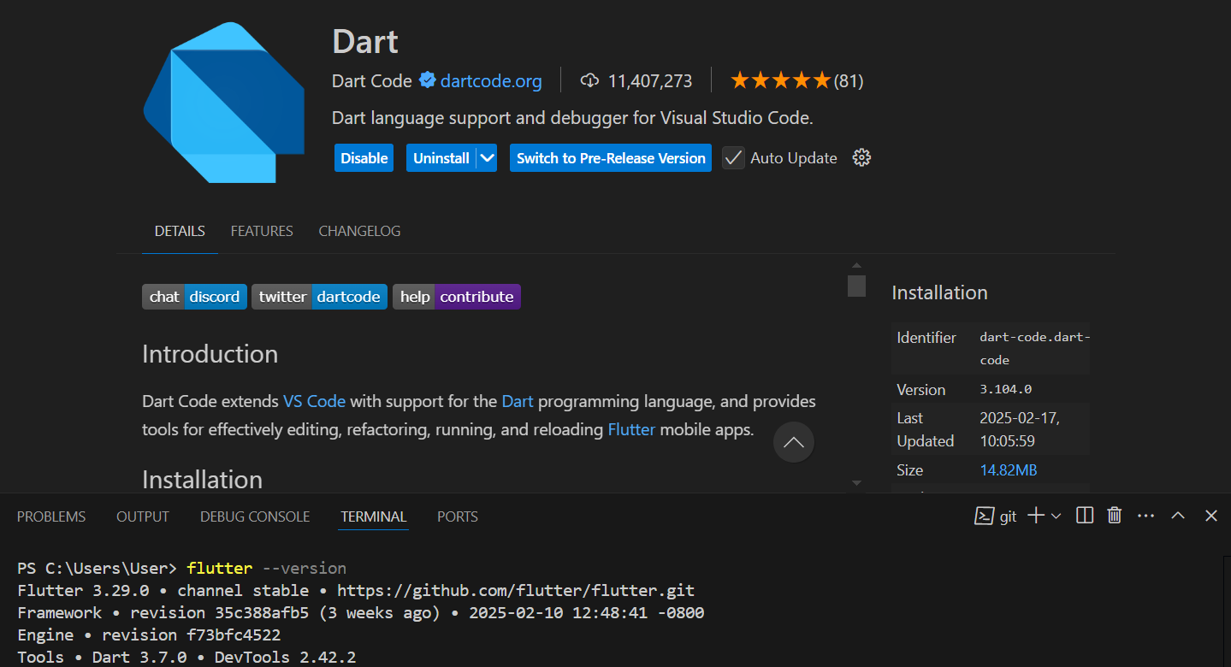

To install these extensions:

* Open **VS Code** → Go to **Extensions (Ctrl + Shift + X)** → Search for **Flutter** and **Dart** → Click **Install**.

## **4. Creating a Flutter Project**

To create a new Flutter project, follow these steps:

### **Step 1: Open VS Code or Terminal**

* Open **VS Code** and launch the terminal (**Ctrl + `**).

### **Step 2: Run the Flutter Create Command**

* Execute the following command:

flutter create my_project

* Replace my_project with your desired project name.

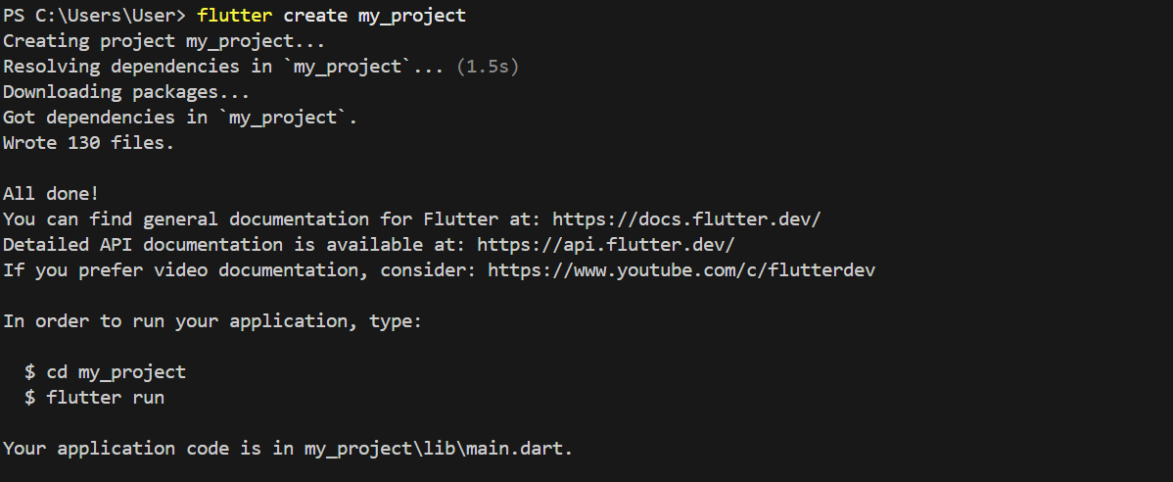

### **Step 3: Open the Project**

* Navigate to the project folder:

cd my_project

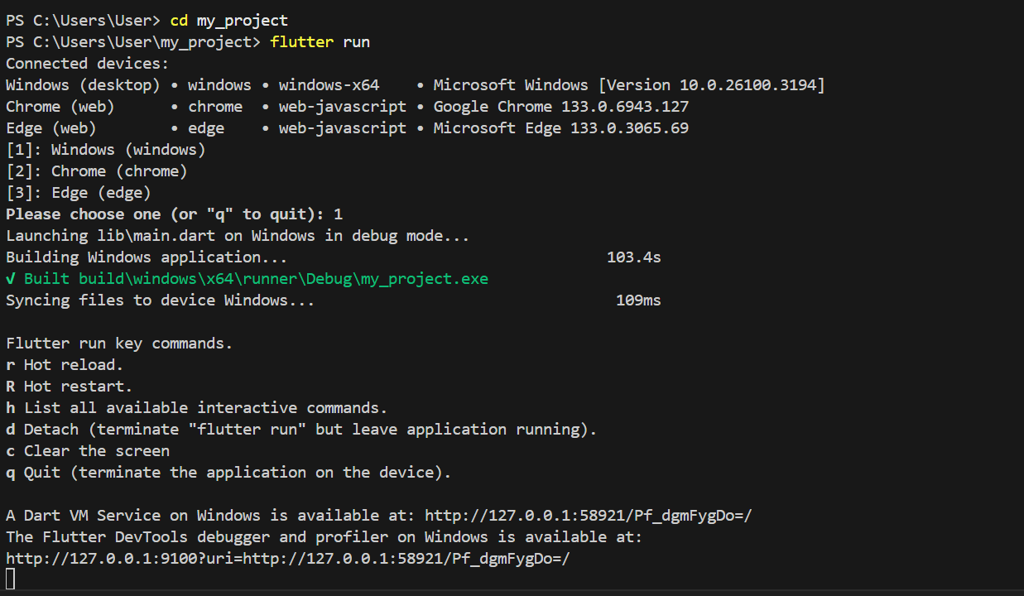

### **Step 4: Run the Application**

* To launch the Flutter app, use:

flutter run

* This will run the project on the connected device or emulator.

## **5. Advantage of Setting Path in Environment Variables**

Setting the **Flutter path** in environment variables provides the following advantages:

### ✅ **Global Access to Flutter Commands**

* You can run flutter commands from any location in the terminal without navigating to the Flutter installation folder.

### ✅ **Simplifies Development Workflow**

* Saves time by avoiding the need to specify the full Flutter SDK path each time.

### ✅ **Enables Integration with Development Tools**

* IDEs like VS Code and Android Studio can easily detect Flutter without manual configuration.

### ✅ **Consistency Across Different Terminals**

* Whether using **Command Prompt, PowerShell, or Git Bash**, the flutter command remains accessible.

## **Conclusion**

By following these steps, you can successfully install and configure Flutter, connect a physical device, install the necessary VS Code extensions, create a new project, and optimize your setup using environment variables.