Where Does the Pollution Go?
The grid penalty and the pollution swap in Jordan’s transport sector
A Well-to-Wheel Life Cycle Assessment of the 2022 Jordanian fleet, with the matrix calculations and the Monte Carlo simulation carried out in Python
A. O. H. Ghawanmeh
Jordan University of Science and Technology

Summary
Most countries that want to decarbonize transport follow the same plan: more electric vehicles, more public buses and stricter engine standards. This plan was developed in countries where electricity is already fairly clean. Jordan is different. It imports most of its energy, and most of its electricity still comes from natural gas and oil shale. This study asks whether the usual plan still works under these conditions.
The whole 2022 fleet (about 1.85 million vehicles) was assessed from the well to the wheel. The calculation is a matrix problem: a technology matrix A links fuels, electricity and vehicles, the system is solved as s = A⁻¹f, and characterization factors convert the emissions into climate and health damage. The original assessment was done in SimaPro. Here the same structure was rebuilt in Python, checked against the SimaPro results, and then tested with 10,000 Monte Carlo runs.
The main findings are:
- Grid penalty. An electric car on the Jordanian grid emits about 86 g CO₂-eq per km, compared with about 215 g for a gasoline car. It is clearly better, but part of the saving does not disappear. It moves from the exhaust pipe to the power station.
- Pollution swap. A conventional diesel bus with fewer than about 28 passengers releases more fine particles per passenger than the private cars it replaces.
- Incremental trap. 20% EVs, diesel buses and Euro 6 standards each reduce emissions by only 9 to 11%. None of them brings the sector below about 2,400 Gg CO₂-eq.
- Full electrification. Converting the whole road fleet reduces emissions by about 84% (to 448 Gg) and health damage from 2,790 to 449 DALYs. With a solar and wind grid, the same fleet would emit about 272 Gg, and most of what remains would come from aviation.
The practical message for Jordan and similar countries is that electric transport and renewable electricity have to be planned together.

1. A morning in Amman
At seven in the morning the main roads of Amman are already busy. Every car on these roads burns fuel, and together, in 2022, Jordan’s vehicles and domestic flights released about 2,800 thousand tonnes of CO₂-equivalent. The fine particles from their engines are breathed by the people who walk and wait beside the road.
If all of these cars were replaced by electric cars, the street would become quieter and the air at the bus stop would improve. However, the electricity for these cars has to be generated somewhere. In Jordan it comes mostly from power stations that burn imported natural gas or domestic oil shale. Part of the pollution would therefore move from the street to the power station instead of disappearing.
This document follows that pollution through the whole system, using the numbers from the life cycle assessment, to find out which options really reduce it.

2. Background and research question
Transport supports economic activity and gives people access to work, education and health care. It is also one of the fastest growing sources of greenhouse gas emissions (UNFCCC, 2022). According to the IPCC, efficiency improvements alone are not enough, and every transport mode needs a structural change (IPCC, 2022). The common international approach is the Avoid-Shift-Improve framework (Jarre et al., 2024): avoid unnecessary trips, shift passengers to public transport, and improve vehicles, mainly through electrification (IEA, 2024).
This approach assumes that the electricity used by EVs is low-carbon. That is true in many high-income countries, but in the Middle East and North Africa it has rarely been checked (Evensen et al., 2025; Al-Alawi and Al-Alawi, 2022).
Jordan is a good case for checking it. The country has almost no domestic oil and imports most of its fuel (MEMR, 2022). Transport is responsible for about 16% of national greenhouse gas emissions and 49% of final energy consumption (MoEnv, 2022; Jelti et al., 2021). Solar and wind made up about 27% of grid capacity in 2022 (NEPCO, 2022), but the electricity actually supplied is still mostly fossil, at about 391 g CO₂-eq per kWh (Low Carbon Power, 2022). Jordan has also committed to a 31% reduction in greenhouse gas emissions by 2030 (Ministry of Environment, 2021).
The research question is therefore: if a fossil-dependent country follows the usual clean transport plan, do its emissions and health impacts actually fall?
To answer it, the assessment must go beyond the exhaust pipe. Conventional inventories count only Tank-to-Wheel emissions. They leave out the Well-to-Tank chain: crude extraction, shipping to Aqaba, refining, distribution by tanker trucks, and electricity generation. Emissions that are not counted are not removed; they are moved to another place or turned into another type of damage (Requia et al., 2018). This study uses two terms for these effects:
- Grid penalty: emissions that leave the street with the EV but appear again at the power station (Qiao et al., 2019; Buberger et al., 2022).
- Pollution swap: a measure that lowers total CO₂ but raises local toxic pollution, for example when buses with low occupancy replace cars (Brewer, 2019; Grutter, 2014).

3. Method: the matrix model
The transport system is a network. Cars need gasoline, gasoline needs a refinery, the refinery needs crude oil and electricity, and electric cars need the grid. Life Cycle Assessment describes this network with linear algebra, following ISO 14040 and 14044 (ISO, 2006a; ISO, 2006b).

3.1 The technology matrix A
Each column of the technology matrix A is one process, for example the gasoline car fleet for one year or one GWh of Jordanian electricity. Each row is one product. The value 1 on the diagonal is the output of the process, and negative values are its inputs. The final demand vector f contains the annual transport of each fleet. The scaling vector s, which gives how much each process must operate, is:
s = A⁻¹ f (1)
The emissions of each process are stored in the intervention matrix B, so the total emissions are g = B s. The characterization factors Q then convert the emissions into impact indicators:
hᵢ = Σⱼ Qᵢⱼ × gⱼ (2)
In the original study this system was solved in SimaPro with the Ecoinvent 3 database and the ReCiPe 2016 Endpoint (H) method (Huijbregts et al., 2017; Weidema et al., 2013). For this document the main part of the system was rebuilt in Python with NumPy as a 12 × 12 technology matrix, with five fuel and electricity supply processes and seven fleets. The core calculation is:
A, B = build_system(params) # technology matrix and emissions matrix
s = np.linalg.solve(A, f) # Eq. (1): how much each process must run
g = B @ s # flows: [tailpipe CO2-eq, upstream CO2-eq]

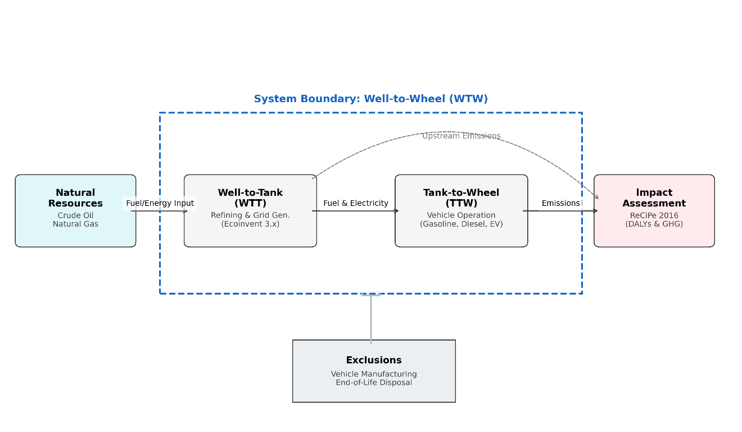
Figure 1. Well-to-Wheel system boundary: fuel and electricity supply (Well-to-Tank) and vehicle operation (Tank-to-Wheel).

3.2 The baseline matrix
Table 1 shows the supply rows of the baseline 2022 matrix. Each column shows what a process uses; for example, the gasoline car fleet uses about 14,900 TJ of gasoline per year. The fuel quantities were obtained by calibrating the matrix to the SimaPro baseline, using IPCC default combustion factors and an upstream share of about 20%.
Product ↓ / Process → | Gasoline | Diesel | Jet fuel | Premium | Electricity | Gasoline cars | Diesel veh. | Aviation | Hybrids | EVs | Diesel buses
Gasoline | 1 | · | · | · | · | -14,941 | · | · | -2,153 | · | ·
Diesel | · | 1 | · | · | · | · | -12,000 | · | · | · | ·
Jet fuel | · | · | 1 | · | · | · | · | -3,024 | · | · | ·
Premium | · | · | · | 1 | · | · | · | · | · | · | ·
Electricity | · | · | · | · | 1 | · | · | · | · | -0.21 | ·

Table 1. Supply rows of the technology matrix A (units TJ or GWh). The diagonal entries of the fleet rows are 1 and are not shown. Negative entries are inputs.

3.3 Scenarios
Four scenarios were defined based on the Avoid-Shift-Improve framework and Jordan’s climate policy (MoEnv, 2022). Each one changes the vector f or the columns of A:
Scenario | Change in the matrix | Question
Baseline 2022 | Fleet and grid as in 2022 | Reference case
S1 Promoting EVs | 20% of gasoline car demand moved to an EV column supplied by the JO grid | How large is the grid penalty?
S2 Public transport | 30% of gasoline car demand moved to a diesel bus column | Is there a pollution swap?
S3 Euro 6 standards | More efficient engines; half of the gasoline replaced by premium low-sulphur fuel | Is cleaner combustion enough?
S4 Full transformation | All road fleets electric; aviation unchanged | What is the maximum reduction?

For S2, S3 and S4, one parameter each was adjusted so that the Python result matches SimaPro. S1 was not adjusted. It was calculated with the EV energy ratio taken from S4, which makes it a check on the model. The Python result for S1 is 2,559 Gg, compared with 2,550 Gg in SimaPro (a difference of 0.3%).

3.4 Monte Carlo simulation
Real conditions differ from average values. Traffic congestion, air-conditioning in summer (which can raise EV consumption by 20 to 50%; Alarrouqi et al., 2024), changes in grid intensity and changes in bus occupancy all affect the results. Following Henriksson et al. (2015), a probability distribution was assigned to each uncertain input, and the matrix was solved 10,000 times for each scenario. The analysis was done at three levels: single vehicles (grid penalty), single buses (pollution swap) and the whole sector (incremental trap).

4. The baseline in 2022
The baseline carbon footprint of the sector is about 2,800 Gg CO₂-eq per year. Gasoline vehicles emit 1,270 Gg, almost half of the total, which matches their share of about 60% of the fleet. Diesel vehicles emit 1,080 Gg, domestic aviation 257 Gg and hybrids 183 Gg. Electric vehicles, which were still few in 2022, emit only 0.08 Gg.
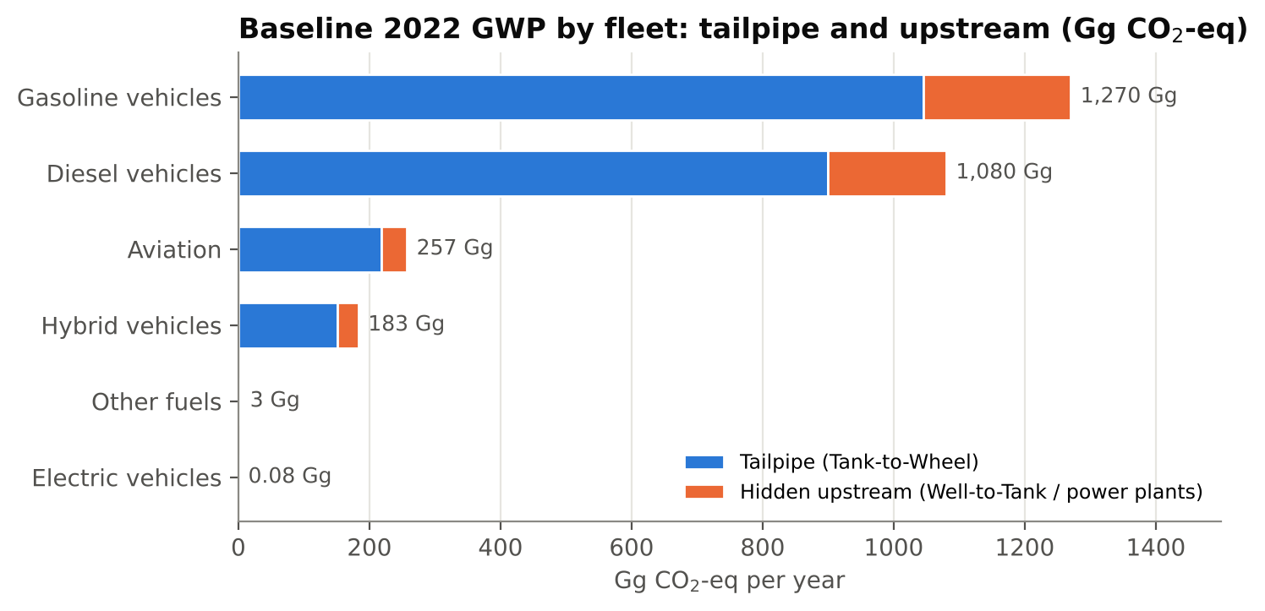
Figure 2. Baseline 2022 Well-to-Wheel emissions by fleet, split into tailpipe (TTW) and upstream (WTT) emissions.
The orange part of each bar is not visible in a tailpipe-only inventory. About 476 Gg (17%) of the sector’s emissions occur before the fuel reaches the vehicle, during extraction, shipping, refining and distribution.
The impacts are not limited to climate change. The SimaPro endpoint results give a human health burden of 2,790 DALYs, meaning 2,790 years of healthy life lost each year. Diesel causes a large part of the local damage: 497 DALYs through carcinogenic toxicity and 55.4 DALYs through non-carcinogenic toxicity, which reflects the black carbon and particles from heavy-duty diesel engines (Brewer, 2019). Fuel combustion also causes terrestrial acidification (2.05 species·yr) and ozone damage to ecosystems (1.23 species·yr).
Fossil resource scarcity for the base year is valued at about US$1.62 billion, of which US$703 million comes from gasoline vehicles and US$658 million from diesel vehicles. This is a large cost for a country that imports most of its fuel.

5. Comparing the scenarios
Figure 3 shows the results of the four scenarios. The bars are the Python model and the black diamonds are the SimaPro results.
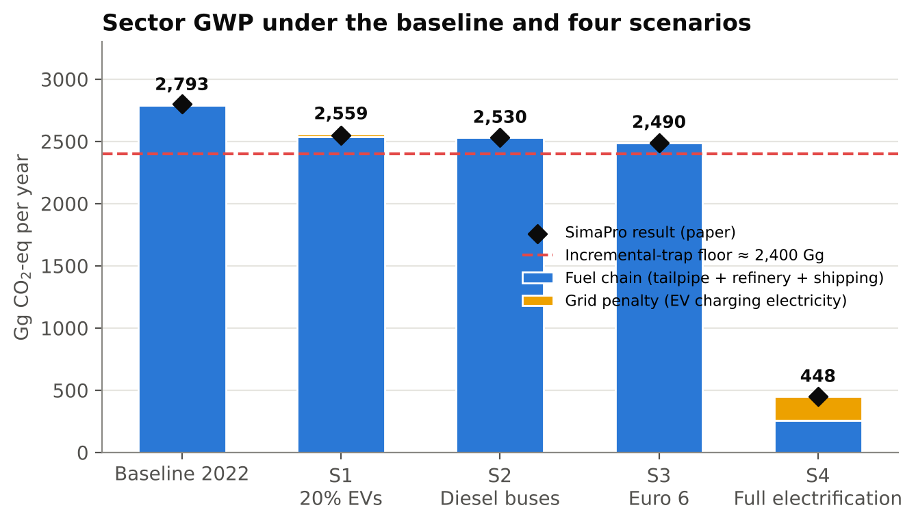
Figure 3. Sector GWP for each scenario. Bars: Python model (blue = fuel chain, yellow = electricity for EV charging). Diamonds: SimaPro results.
Scenario | Python (Gg CO₂-eq) | SimaPro (Gg CO₂-eq) | Change vs 2022 | Health (DALYs)*
Baseline 2022 | 2,793 | 2,800 | - | 2,790
S1 20% EVs | 2,559 | 2,550 | -9% | 2,540
S2 Diesel buses | 2,530 | 2,530 | -10% | 2,520
S3 Euro 6 | 2,490 | 2,490 | -11% | 2,760
S4 Full electrification | 448 | 448 | -84% | 449

*Human health endpoint from SimaPro (ReCiPe 2016 H). The Python baseline (2,793 Gg) is the sum of the fleet results; 2,800 Gg is the rounded value.
The first three scenarios give almost the same result, between 2,490 and 2,550 Gg, which is a reduction of only 9 to 11%. Health damage changes very little. Under Euro 6 it stays at 2,760 DALYs, close to the baseline, because the premium low-sulphur fuel still has to be extracted, shipped and refined. Only full electrification gives a large change: emissions fall to 448 Gg (-84%) and health damage to 449 DALYs (-84%). The remaining emissions come mainly from aviation, which was not electrified, and from the electricity used to charge the fleet.
The single score results of the original study show the same pattern. The baseline, S1, S2 and S3 are all between about 110 and 125 MPt, while S4 is about 20 MPt. The partial measures mostly move the damage from one category to another. S1 replaces part of the climate damage with mineral resource scarcity (lithium and cobalt), and S2 replaces part of it with local health damage.

6. The grid penalty
The reason S1 gives only a small reduction is that the electricity for the EVs is mostly generated from fossil fuels. In the matrix, the EV column uses the electricity row, and the electricity row is linked to gas and oil shale.
In S1 the model removes about 254 Gg of gasoline emissions and adds about 20 Gg at the power stations, using the EV energy assumption of the original study. With a stricter assumption based on vehicle physics (an EV using about 30% of the energy of the gasoline car it replaces), the power stations add about 97 Gg, which is about 38% of the saving. In both cases part of the benefit is lost at the power station.
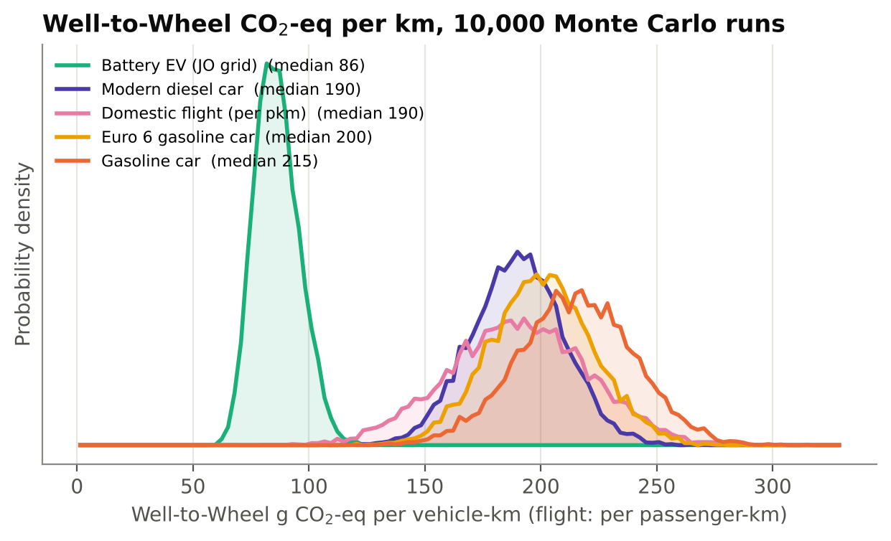
Figure 4. Monte Carlo results (10,000 runs) for Well-to-Wheel emissions per km. EV electricity from the Jordanian grid (370 to 450 g/kWh) with an air-conditioning load of 0 to 50%.
Even so, the EV remains the best option per kilometre. With air-conditioning and the current grid, its median value is about 86 g CO₂-eq/km, compared with about 215 for a gasoline car, 200 for a Euro 6 car and 190 for a modern diesel car. The EV was lower than all combustion options in 99.95% of the runs. The Euro 6 and modern diesel curves overlap strongly with the gasoline car, so better combustion gives only a small improvement. Short domestic flights are at about the same level as a modern diesel car per passenger-km.
The grid penalty therefore does not mean that EVs should be avoided. It means that the benefit of an EV depends on the electricity grid that charges it.

7. The pollution swap
CO₂ has the same effect on the climate wherever it is emitted, but fine particles affect mainly the people close to the source. PM2.5 reaches deep into the lungs and the blood and increases the risk of heart disease, stroke and lung cancer (Haines et al., 2009; WHO, 2023). Diesel engines produce about 90% of the black carbon from transport (Brewer, 2019).
The question here is how many passengers a bus needs before it releases less local PM2.5 per passenger than the cars it replaces.
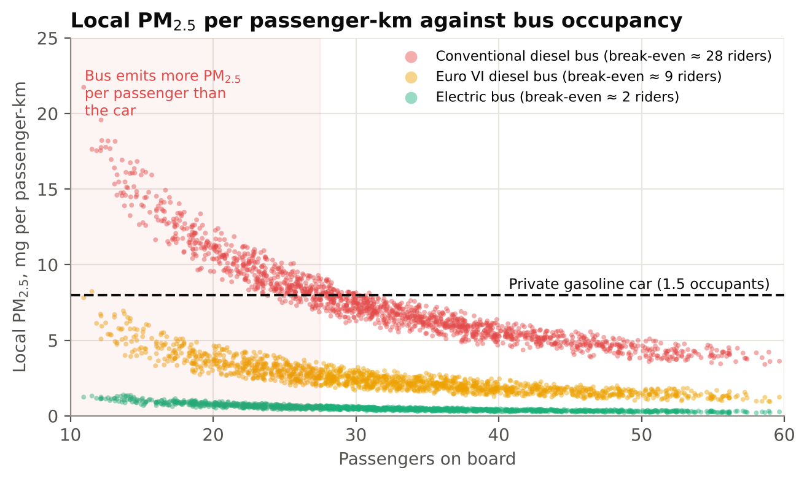
Figure 5. Local PM2.5 per passenger-km against bus occupancy (10,000 runs, 10 to 60 passengers). The emission factors are illustrative values set to match the 25 to 30 passenger threshold of the original study.
Below about 28 passengers, a conventional diesel bus releases more PM2.5 per passenger-km than a private gasoline car. With occupancy varying during the day, this was the case in 32% of the simulated trips. A Euro VI diesel bus lowers the threshold to about 9 passengers, which is better but can still be exceeded in off-peak hours. An electric bus, whose only particles come from brakes and tyres, is cleaner than the car at almost any occupancy.
This is the pollution swap. At the national level a diesel bus programme lowers CO₂, but at street level, especially in the narrow streets of Amman where exhaust is trapped (Morales Betancourt et al., 2017; Fantke et al., 2017), it can make the air worse for the people it is meant to serve. Public transport projects should therefore be assessed on occupancy and local PM2.5, and not on CO₂ alone.

8. The incremental trap
At the sector level, the matrix was solved 10,000 times for each scenario, with traffic, grid intensity, air-conditioning, bus fuel use and the real-world performance of Euro 6 allowed to vary.
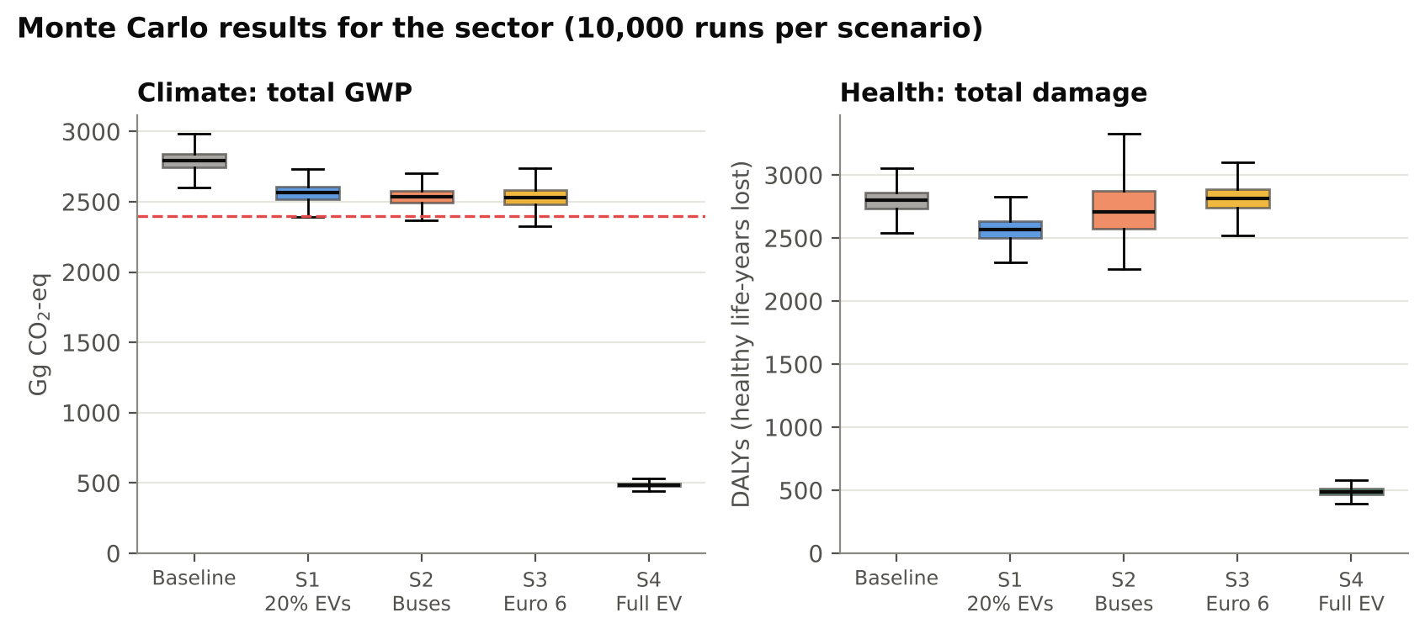
Figure 6. Sector-level Monte Carlo results (10,000 runs per scenario). Left: GWP from the Python model. Right: SimaPro health damage scaled in each run; S2 includes a wider occupancy uncertainty.
The three incremental scenarios form one group. The sector stayed above 2,400 Gg in 99.3% of the runs for S1, 98.5% for S2 and 96.0% for S3. Their ranges overlap so much that there is little statistical difference between them. This study calls this the incremental trap.
The health results show a further risk. Under S2 the middle 50% of the results lies between 2,575 and 2,876 DALYs, more than twice the width of the baseline range (2,735 to 2,864), and the upper end reaches 3,179 DALYs, which is higher than any baseline result. Expanding diesel buses without making sure they are well occupied could increase the national health burden.
Scenario 4 is clearly separate. Its 95% range is 456 to 522 Gg and 423 to 555 DALYs, far below the other scenarios in every run. (The median is slightly above the deterministic value of 448 Gg because extra air-conditioning load was added in the simulation.) Only a structural change of the fleet gets out of the incremental trap.

9. Cleaning the grid
Since the benefit of EVs depends on the grid, a cleaner grid improves every EV at the same time. In the matrix model this can be tested by changing one value, the carbon intensity of the electricity.
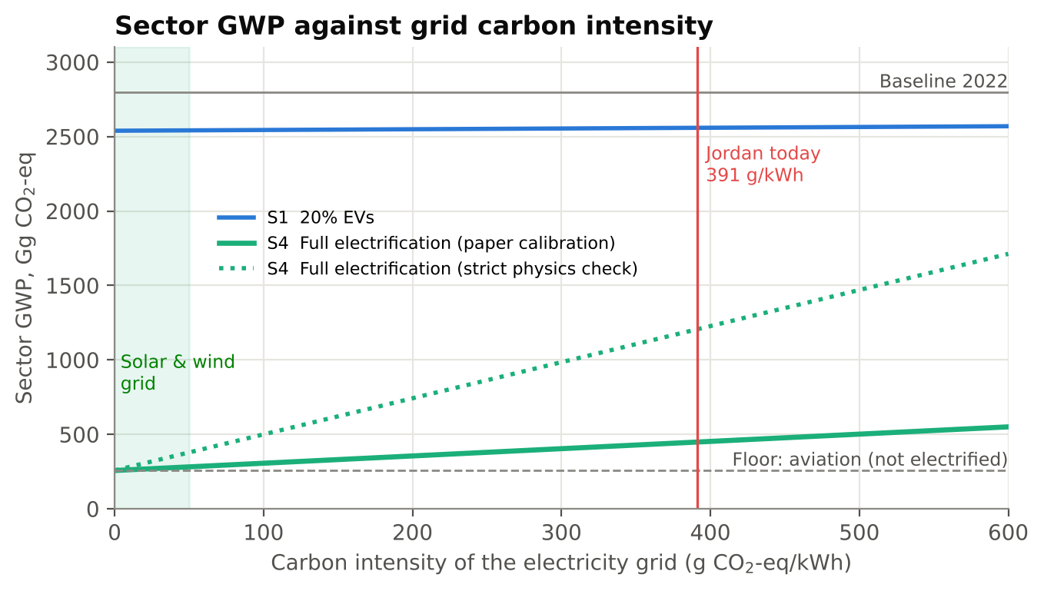
Figure 7. Sector GWP against grid carbon intensity. Solid line: EV energy as calibrated to the original study. Dotted line: stricter physics-based EV energy use.
With the current grid, full electrification gives 448 Gg. With a solar and wind grid (about 30 g/kWh over the life cycle), the same fleet would emit about 272 Gg, about 90% less than in 2022, and almost all of the remaining emissions would come from aviation. With the stricter physics-based assumption the current value is higher (1,205 Gg), but a clean grid still brings it down to about 330 Gg. The conclusion is the same under both assumptions.
The S1 line stays almost flat at about 2,550 Gg for any grid. A cleaner grid has little effect if only a small part of the fleet is electric, and a fully electric fleet gives only part of its benefit if the grid stays fossil-based. The two changes need to happen together.

10. Recommendations
Based on these results, the following actions are recommended for Jordan and for other countries with fossil-based electricity:
- Link EV targets to grid targets. National EV targets should be tied to the retirement of fossil power plants and the addition of new renewable capacity (Al-Shetwi et al., 2020).
- Solar charging depots. New charging depots for buses, taxis and government fleets should be supplied by local solar microgrids, so that these vehicles avoid the grid penalty from the start (Evensen et al., 2025).
- Daytime charging. Charging during the day can use solar output instead of adding to the evening peak, which reduces the stress on distribution networks in hot climates (Al-Owaifeer et al., 2020; Al-Shetwi et al., 2022).
- Avoid diesel as a transition technology. New bus investment should go directly to battery electric or hydrogen fuel cell buses instead of CNG or Euro 5/6 diesel, which would keep cities dependent on fossil fuel and PM2.5 for decades (Grutter, 2014; Jelti et al., 2021; Ahmadi et al., 2022). Feasibility studies should include the avoided health costs.
- Plan for battery minerals. Electrification replaces dependence on imported oil with dependence on battery minerals (IEA, 2021a; Lai et al., 2022). Battery reuse and recycling should be required to keep this dependence low (Harper et al., 2019; Ahmadi et al., 2017).
These results are also relevant outside Jordan. Many countries in the Gulf, North Africa and Asia have similar fossil-based grids, and comparative studies show that the climate benefit of EVs follows the national electricity mix closely (Aryan et al., 2025; Alghamdi, 2026).

11. Conclusion
Partial measures such as 20% EVs, diesel buses or Euro 6 standards reduce emissions by about 10% and mostly move the damage to the power station, to mineral supply chains or to the street. Full electrification reduces both emissions and health damage by more than 80%, and combined with a renewable grid it could reduce sector emissions by about 90%.
If Jordan plans its vehicles and its electricity grid together, a morning in Amman could look very different in ten years: electric buses charged from solar depots, quieter streets and cleaner air at the bus stops. The results of this study show that this is technically achievable, provided the transport and energy sectors are developed as one system.

Appendix A. The Python model
The code consists of two scripts: lca_matrix_model.py (model, Monte Carlo simulation and figures) and build_story_docx.py (this document). The first script writes all figures and a results.json file, and every number in the text is read from that file.

A.1 Structure
- Products and processes (12 × 12): gasoline, diesel, jet fuel, premium low-sulphur gasoline and electricity [JO]; and the fleets: gasoline cars, diesel vehicles, aviation, hybrids, other fuels, EVs and diesel buses.
- Emissions matrix B (2 rows): tailpipe CO₂-eq (TTW) and upstream CO₂-eq (WTT and power plants). TTW factors: 70, 75 and 72 t CO₂-eq per TJ for gasoline, diesel and jet fuel (IPCC 2006 defaults including CH₄ and N₂O). WTT factors: 15, 15, 13 and 17 t per TJ (premium fuel needs more refining). Electricity: 391 t per GWh.
- Calibration: baseline fuel use is calculated from the SimaPro fleet totals. One parameter is fitted for each of S2 (bus energy = 0.293 × shifted car energy), S3 (Euro 6 fuel saving = 12.5%) and S4 (EV electricity = 0.060 × displaced fuel energy). S1 is calculated, not fitted.

A.2 Monte Carlo distributions (10,000 iterations)
Parameter | Distribution | Used in
Grid intensity (g CO₂-eq/kWh) | Triangular 370 / 391 / 450 | Micro EV, macro
EV consumption (kWh/km) | Triangular 0.15 / 0.17 / 0.20 | Micro EV
Air-conditioning load factor | Triangular 1.0 / 1.2 / 1.5 (micro); 1.0 / 1.15 / 1.35 (macro) | EVs
ICE WTW (g/km) | Normal: gasoline 215±25, Euro 6 200±22, diesel 190±20, flight 190±30 | Micro
Traffic / driving cycle | Normal 1.00 ± 0.04 on fuel use | Macro
Bus fuel use | Triangular 0.90 / 1.00 / 1.25 | S2
Real-world Euro 6 gain | Triangular 0.5 / 1.0 / 1.1 × calibrated | S3
Bus occupancy (riders) | Triangular 10 / 30 / 60 (Grutter, 2014) | Pollution swap
Bus PM2.5 (g/km) | Diesel 0.18-0.26; Euro VI 0.05-0.10; electric 0.010-0.020 | Pollution swap

A.3 Limitations
- The Python model is a simplified reconstruction of the SimaPro/Ecoinvent system and covers climate impacts. Health, ecosystem and resource endpoints are taken from the SimaPro results.
- The PM2.5 emission factors in Section 7 are illustrative values chosen to match the 25 to 30 passenger threshold of the original study. They are not measured Jordanian values.
- The EV electricity implied by the original S4 result (about 0.5 TWh per year) is low compared with a physics-based estimate (about 2.4 TWh per year). Figure 7 shows that the main conclusions hold in both cases.
- As in the original study, vehicle and battery manufacturing and end-of-life are outside the system boundary.

A.4 Running the code
pip install numpy matplotlib python-docx
python lca_matrix_model.py # matrix LCA + 50,000 Monte Carlo solves + figures
python build_story_docx.py # writes output/Jordan_Transport_LCA_Story.docx

References
Ahmadi, L., Young, S.B., Fowler, M., Fraser, R.A. and Achachlouei, M.A. (2017) A cascaded life cycle: reuse of electric vehicle lithium-ion battery packs in energy storage systems. The International Journal of Life Cycle Assessment, 22(1), pp. 111-124.
Ahmadi, P., Raeesi, M., Changizian, S., Teimouri, A. and Khoshnevisan, A. (2022) Lifecycle assessment of diesel, diesel-electric and hydrogen fuel cell transit buses with fuel cell degradation and battery aging using machine learning techniques. Energy, 259, 125003.
Al-Alawi, B.M. and Al-Alawi, A. (2022) Electric vehicle adoption in the MENA region: A review of status, challenges, and opportunities. Journal of Cleaner Production, 330, 129929.
Alarrouqi, R.A., Al-Mulla, A. and Al-Kuwari, S. (2024) Electric buses in hot climates: Challenges, technologies, and the road ahead. IEEE Access, 12, pp. 55543-55560.
Alghamdi, A.S. (2026) Comparative life cycle assessment of battery electric and internal combustion engine passenger cars under a fossil-dominated electricity grid: The case of Saudi Arabia. World Electric Vehicle Journal, 17(8), 415.
Alotaibi, S., Omer, S. and Su, Y. (2022) Identification of potential barriers to electric vehicle adoption in oil-producing nations — The case of Saudi Arabia. Electricity, 3(3), pp. 365-395.
Al-Owaifeer, M., Al-Ghamdi, S.G. and Koç, M. (2020) Impact of electric vehicle charging on distribution networks: A case study in Qatar. Energies, 13(20), 5473.
Al-Saryrah, N., Al-Ghandoor, A. and Jaber, J.O. (2021) Assessment of energy and environmental performance of the transport sector in Jordan. Energy Policy, 156, 112456.
Al-Shetwi, A.Q., Hannan, M.A., Jern, K.P., Mansur, M. and Mahlia, T.M.I. (2020) Grid-connected renewable energy sources: Review of the recent integration requirements and control methods. Journal of Cleaner Production, 253, 119831.
Al-Shetwi, A.Q., Hannan, M.A., Jern, K.P., Mansur, M. and Mahlia, T.M.I. (2022) Grid-connected renewable energy sources: Power quality issues and outlook. Energy, 241, 122811.
Anenberg, S.C., Schwartz, J., Shindell, D., Amann, M., Faluvegi, G., Klimont, Z., Janssens-Maenhout, G., Pozzoli, L., Van Dingenen, R., Vignati, E., Emberson, L., Muller, N.Z., West, J.J., Williams, M., Demkine, V., Hicks, W.K., Kuylenstierna, J., Raes, F. and Ramanathan, V. (2012) Global air quality and health co-benefits of mitigating near-term climate change through methane and black carbon emission controls. Environmental Health Perspectives, 120(6), pp. 831-839.
Aryan, Y., C K, A., Dikshit, A.K. and Shinde, A.M. (2025) Comparative life cycle assessment of battery electric vehicles in developing countries under current and future electricity mix scenarios. Discover Sustainability, 6, 675.
Ashraf, F., Equbal, A., Khan, O., Yahya, Z., Alhodaib, A., Parvez, M. and Ahmad, S. (2025) Green Technologies and Sustainability. Green Technologies and Sustainability, 3, 100128.
Bare, J.C., Norris, G.A., Pennington, D.W. and McKone, T.E. (2002) TRACI: The tool for the reduction and assessment of chemical and other environmental impacts. Journal of Industrial Ecology, 6(3-4), pp. 49-78.
Bastos, J., Marques, P., Batterman, S.A. and Freire, F. (2019) Environmental impacts of commuting modes in Lisbon: A life-cycle assessment addressing particulate matter impacts on health. International Journal of Sustainable Transportation, 13(9), pp. 652-663.
Bisinella, V., Christensen, T.H. and Astrup, T.F. (2021) Future scenarios and life cycle assessment: systematic review and recommendations. The International Journal of Life Cycle Assessment, 26, pp. 2143-2170.
Bond, T.C., Doherty, S.J., Fahey, D.W., Forster, P.M., Berntsen, T.K., DeAngelo, B.J., Flanner, M.G., Ghan, S.J., Kärcher, B., Koch, D.M., Kinne, S., Kondo, Y., Quinn, P.K., Sarofim, M.C., Schultz, M.G., Schulz, M., Venkataraman, C., Zhang, H., Zhang, S., Bellouin, N., Guttikunda, S.K., Hopke, P.K., Jacobson, M.Z., Kaiser, J.W., Klimont, Z., Lohmann, U., Schwarz, J.P., Shindell, D.T., Storelvmo, T., Warren, S.G. and Zender, C.S. (2013) Bounding the role of black carbon in the climate system: A scientific assessment. Journal of Geophysical Research: Atmospheres, 118(11), pp. 5380-5552.
Brewer, T.L. (2019) Black carbon emissions and regulatory policies in transportation. Energy Policy, 129, pp. 1390-1399.
Buberger, J., Kersten, A., Kuder, M., Eckerle, R., Weyh, T. and Thiringer, T. (2022) Total CO2-equivalent life-cycle emissions from commercially available passenger cars. Renewable and Sustainable Energy Reviews, 159, 112158.
Chester, M.V. and Horvath, A. (2009) Environmental assessment of passenger transportation should include infrastructure and supply chains. Environmental Research Letters, 4(2), 024008.
Cox, B., Mutel, C.L., Bauer, C., Mendoza Beltran, A. and van Vuuren, D.P. (2018) Uncertain environmental footprint of current and future battery electric vehicles. Environmental Science & Technology, 52(8), pp. 4989-4995.
Cox, B., Bauer, C., Mendoza Beltran, A., van Vuuren, D. P. and Mutel, C. L. (2020) Life cycle environmental and cost comparison of current and future passenger cars under different energy scenarios. Applied Energy, 269, 115021.
Department of Statistics (DoS) (2023) Jordan Statistical Yearbook 2022. Amman: Department of Statistics.
European Environment Agency (EEA) (2019) EMEP/EEA air pollutant emission inventory guidebook 2019: Technical guidance to prepare national emission inventories. Luxembourg: Publications Office of the European Union.
Evensen, D., Uratani, J.M., Sovacool, B.K. and Griffiths, S. (2025) A novel model for barriers to electric vehicle adoption in the Middle East. Transportation Research Part D: Transport and Environment, 142, 104714.
Fantke, P., Jolliet, O., Apte, J.S., Hodas, N., Evans, J., Weschler, C.J., Stylianou, K.S., Jantunen, M.J. and McKone, T.E. (2017) Health effects of fine particulate matter in life cycle assessment: findings from the Basel Guidance Workshop. The International Journal of Life Cycle Assessment, 22(2), pp. 272-283.
Ghawanmeh, A.O.H. (2026) Environmental and Health Impacts of Transportation Sector in Jordan Using Life Cycle Assessment. M.Sc. Thesis, Faculty of Graduate Studies, Jordan University of Science and Technology, Irbid, Jordan.
Grutter, J.M. (2014) Real World Performance of Diesel Buses in Developing Countries. Grutter Consulting.
Haines, A., McMichael, A.J., Smith, K.R., Roberts, I., Woodcock, J., Markandya, A., Armstrong, B.G., Campbell-Lendrum, D., Dangour, A.D., Davies, M., Bruce, N., Tonne, C., Barrett, M. and Wilkinson, P. (2009) Public health benefits of strategies to reduce greenhouse-gas emissions: overview and implications for policy makers. The Lancet, 374(9707), pp. 2104-2114.
Harper, G., Sommerville, R., Kendrick, E., Driscoll, L., Slater, P., Stolstrane, R. and Anderson, P. (2019) Recycling lithium-ion batteries from electric vehicles. Nature, 575(7781), pp. 75-86.
Hawkes, A.D. (2010) Estimating marginal CO2 emissions rates for national electricity systems. Energy Policy, 38(10), pp. 5977-5987.
Heaps, C.G. (n.d.) LEAP: The Low Emissions Analysis Platform. Somerville, MA: Stockholm Environment Institute.
Henriksson, P.J.G., Guinée, J.B., Heijungs, R. and de Snoo, G.R. (2015) A protocol for horizontal averaging of unit process data — including estimates for uncertainty. The International Journal of Life Cycle Assessment, 20(2), pp. 220-229.
Huijbregts, M.A.J., Steinmann, Z.J.N., Elshout, P.M.F., Stam, G., Verones, F., Vieira, M., Zijp, M., Hollander, A. and van Zelm, R. (2017) ReCiPe2016: a harmonised life cycle impact assessment method at midpoint and endpoint level. The International Journal of Life Cycle Assessment, 22(2), pp. 138-147.
IEA (International Energy Agency) (2021a) The Role of Critical Minerals in Clean Energy Transitions. Paris: IEA.
IEA (International Energy Agency) (2021b) Net Zero by 2050: A Roadmap for the Global Energy Sector. Paris: IEA.
IEA (International Energy Agency) (2024) Global EV Outlook 2024: Moving Towards Increased Affordability. Paris: IEA.
Igos, E., Benetto, E., Meyer, R., Baustert, P. and Othoniel, B. (2019) How to treat uncertainties in life cycle assessment studies?. The International Journal of Life Cycle Assessment, 24(4), pp. 794-807.
International Council on Clean Transportation (ICCT) (2023) Comparison of the life-cycle greenhouse gas emissions of combustion engine and electric passenger cars in Europe. ICCT.
International Organization for Standardization (ISO) (2006a) Environmental management — Life cycle assessment — Principles and framework (ISO 14040:2006). Geneva: ISO.
International Organization for Standardization (ISO) (2006b) Environmental management — Life cycle assessment — Requirements and guidelines (ISO 14044:2006). Geneva: ISO.
IPCC (Intergovernmental Panel on Climate Change) (2022) Climate Change 2022: Mitigation of Climate Change. Cambridge University Press.
Jarre, M., Noussan, M. and Campisi, E. (2024) Avoid-Shift-Improve: Are Demand Reduction Strategies Under-Represented in Current Energy Policies?. Energies, 17(19), 4955.
Jelti, F., Allouhi, A., Al-Ghamdi, S.G., Saadani, R., Jamil, A. and Rahmoune, M. (2021) Environmental life cycle assessment of alternative fuels for city buses: A case study in Oujda city, Morocco. International Journal of Hydrogen Energy, 46(49), pp. 25308-25319.
Koç, M., Al-Ghamdi, S.G. and Al-Kuwari, A. (2023) Energy consumption analysis of electric vehicles in hot climates: A case study of Qatar. Transportation Research Part D: Transport and Environment, 118, 103689.
Lai, X., Chen, Q., Tang, X., Zhou, Y., Gao, F., Guo, Y., Bhagat, R. and Zheng, Y. (2022) Critical review of life cycle assessment of lithium-ion batteries for electric vehicles: A lifespan perspective. eTransportation, 12, 100169.
Liu, Y., Chen, J. and Wu, J. (2019) Regional variation of the life cycle environmental benefits of the electric vehicle in China. Journal of Cleaner Production, 233, pp. 1079-1089.
Low Carbon Power (2022) Countries - Jordan. Available at: https://lowcarbonpower.org/region/Jordan.
Mashayekh, S. (2020) Life cycle assessment of electric vehicles: A comprehensive review. Journal of Sustainable Development of Energy, Water and Environment Systems, 8(4), pp. 637-651.
Mills, N.L., Törnqvist, H., Gonzalez, M.C., Vink, E., Robinson, S.D., Söderberg, S., Boon, N.A., Donaldson, K., Sandström, T., Blomberg, A. and Newby, D.E. (2007) Ischemic and thrombotic effects of dilute diesel-exhaust inhalation in men with coronary heart disease. New England Journal of Medicine, 357(11), pp. 1075-1082.
Ministry of Energy and Mineral Resources (MEMR) (2022) Annual Report 2022. Amman: MEMR.
Ministry of Environment (MoEnv) (2021) Jordan's Updated First Nationally Determined Contribution (NDC). Amman: Ministry of Environment.
Ministry of Environment (MoEnv) (2022) The National Climate Change Policy of the Hashemite Kingdom of Jordan 2022–2050. Amman: Ministry of Environment.
Ministry of Environment (MoEnv) / UNFCCC (2025) Jordan's NDC 3.0 Vision. Amman / Bonn: UNFCCC. Reports that renewable electricity generation rose from about 12% (2020) to 28.5% (2024), and EV penetration rose from 1% to 21% of the national fleet over the same period.
Ministry of Transport (MoT) (2023) Annual Report 2022. Amman: Ministry of Transport.
Morales Betancourt, R., Galvis, B., Balachandran, S., Ramos-Bonilla, J.P., Sarmiento, O.L., Gallo-Murcia, S.M. and Contreras, Y. (2017) Exposure to fine particulate, black carbon, and particle number concentration in transportation microenvironments. Atmospheric Environment, 157, pp. 135-145.
Nanaki, E.A. and Koroneos, C.J. (2016) Climate change mitigation and electric vehicles deployment: The case of Greece. Renewable Energy, 91, pp. 252-258.
National Electric Power Company (NEPCO) (2022) Annual Report 2022. Amman: NEPCO.
Nordelöf, A., Messagie, M., Tillman, A.M., Ljunggren Söderman, M. and Van Mierlo, J. (2014) Environmental impacts of hybrid, plug-in hybrid, and battery electric vehicles — what can we learn from life cycle assessment?. The International Journal of Life Cycle Assessment, 19(11), pp. 1866-1890.
Petrauskienė, K., Galinis, A., Kliaugaitė, D. and Dvarionienė, J. (2021) Comparative environmental life cycle and cost assessment of electric, hybrid, and conventional vehicles in Lithuania. Sustainability, 13(2), 957.
Qiao, Q., Zhao, F., Liu, Z., Jiang, S. and Hao, H. (2019) Cradle-to-gate greenhouse gas emissions of battery electric and internal combustion engine vehicles in China. Applied Energy, 254, 113687.
Requia, W.J., Mohamed, M., Higgins, C.D., Arain, A. and Ferguson, M. (2018) How clean are electric vehicles? Evidence-based review of the effects of electric mobility on air pollutants, greenhouse gas emissions and human health. Atmospheric Environment, 185, pp. 64-77.
Shindell, D., Kuylenstierna, J.C.I., Vignati, E., van Dingenen, R., Amann, M., Klimont, Z., Anenberg, S.C., Muller, N., Janssens-Maenhout, G., Raes, F., Schwartz, J., Faluvegi, G., Pozzoli, L., Kupiainen, K., Höglund-Isaksson, L., Emberson, L., Streets, D., Ramanathan, V., Hicks, K., Oanh, N.T.K., Milly, G., Williams, M., Demkine, V. and Fowler, D. (2012) Simultaneously mitigating near-term climate change and improving human health and food security. Science, 335(6065), pp. 183-189.
United Nations Framework Convention on Climate Change (UNFCCC) (2022) Nationally Determined Contributions Registry. UNFCCC.
Weidema, B.P., Bauer, C., Hischier, R., Mutel, C., Nemecek, T., Reinhard, J., Vadenbo, C.O. and Wernet, G. (2013) Overview and methodology: Data quality guideline for the ecoinvent database version 3. St. Gallen: The ecoinvent Centre.
World Bank (2022) Jordan - Country Transport Sector Note. Washington, DC: World Bank.
World Health Organization (WHO) (2023) Ambient (outdoor) air pollution. Geneva: WHO.

