Closing the books of a rentier energy economy: reconciled energy accounts, CO₂ drivers and the renewable dual dividend in Oman, 2015–2025

Highlights
- Plant-level checks locate a 219 kb/d crude-supply gap in Oman's refinery data.
- On a net-calorific basis, 2025 primary supply is 36.7 Mtoe (90% CI 35.8–40.2).
- Combustion CO₂ is 78 Mt (76–87 Mt); oil-field gas use dominates uncertainty.
- Population and energy intensity drove CO₂ up 14.1 Mt over 2015–2024.
- Domestic gas use carries an implicit rent of about 5% of GDP a year.

Graphical abstract
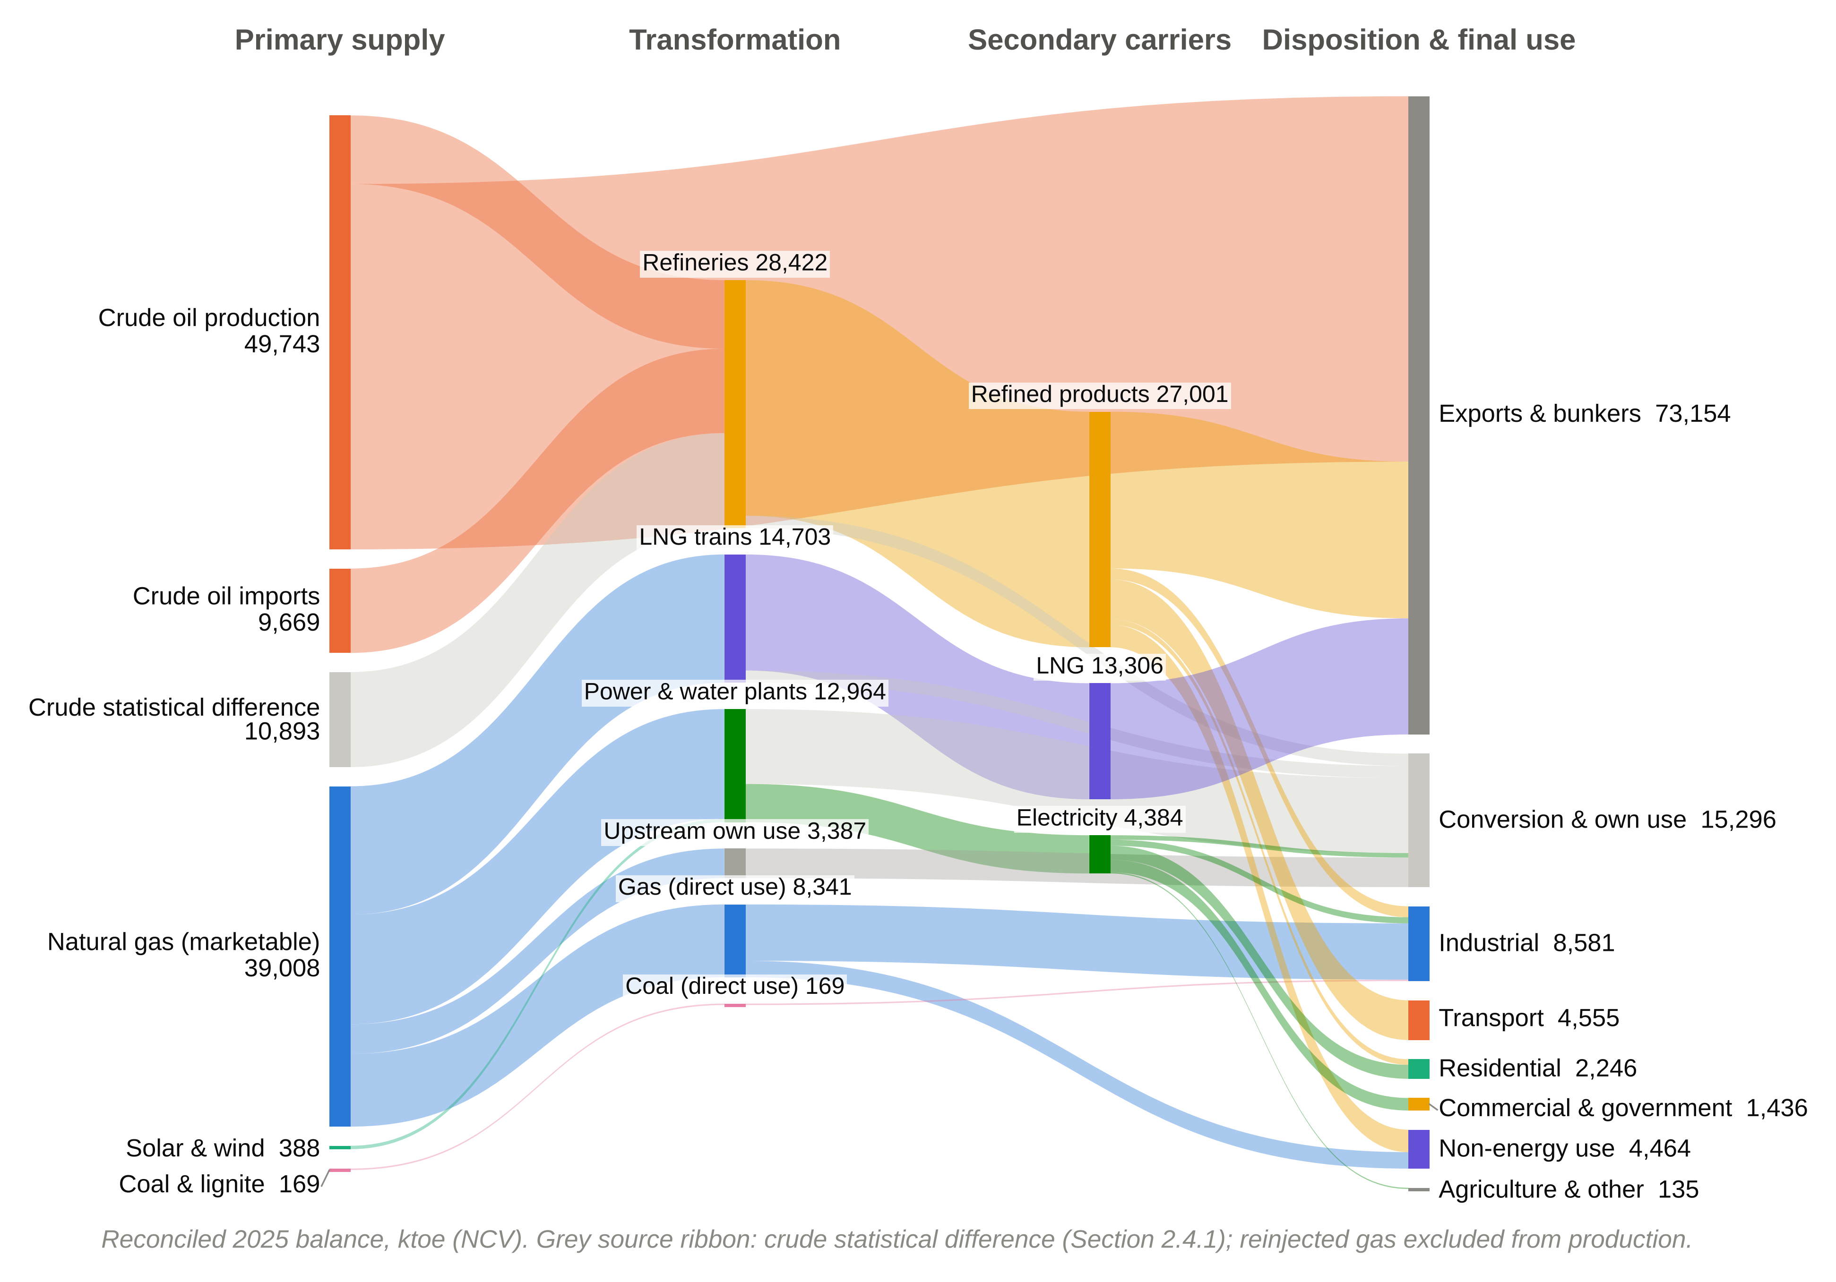

Abstract
Hydrocarbon exporters face a distinctive decarbonization problem: the fuels displaced at home are also the source of fiscal rents abroad, and the energy statistics needed to manage this trade-off are often internally inconsistent. This study applies standard compilers' checks (column closure, plant-level process closure and an explicit separation of calibration from validation) to Oman's 2025 national energy accounts and links the reconciled balance to rent incidence. The checks show that reported refinery output is consistent with plant capacities but exceeds recorded crude supply by about 219 kb/d. They also show that the reported LNG feedstock is implausible on a consistent net-calorific basis, and that reinjected gas and chemical feedstock had been counted as fuel. On a net-calorific basis, indigenous production is 89,139 ktoe and use-side Total Primary Energy Supply 36,715 ktoe (90% CI 35,830–40,250), giving a self-sufficiency ratio of 243%. Fuel-combustion CO₂ emissions are 78.4 Mt (76.0–87.2), 71% from natural gas. A logarithmic mean Divisia index decomposition of 2015–2024 attributes the rise in emissions to population growth (+16.9 Mt) and energy intensity (+11.6 Mt). Renewables supplied 8.85% of electricity in 2025, avoiding 1.8–2.4 MtCO₂ and freeing about 1 bcm of gas. Domestic gas combustion carries an implicit rent of about 5% of GDP, far larger than the rent renewables currently preserve. Transparent energy accounts are a precondition for credible decarbonization in rentier states.
Keywords: Energy balance reconciliation; Rentier state; LMDI decomposition; Monte Carlo uncertainty; Natural gas rents; Oman

Abbreviations
Abbreviation | Definition
bcm | Billion cubic metres
CI | Confidence interval (5th–95th percentile)
EF | Emission factor
EI | Energy Institute
EOR | Enhanced oil recovery
GCC | Gulf Cooperation Council
GCP | Global Carbon Project
GCV | Gross calorific value
IPCC | Intergovernmental Panel on Climate Change
IRES | International Recommendations for Energy Statistics
kbbl; kb/d | Thousand barrels; thousand barrels per day
ktoe | Thousand tonnes of oil equivalent, net calorific basis (1 toe = 41.868 GJ)
LMDI | Logarithmic mean Divisia index
LNG | Liquefied natural gas
MMBtu | Million British thermal units (gross basis)
MMscf | Million standard cubic feet
NCV | Net calorific value
NDC | Nationally Determined Contribution
OPWP | Oman Power and Water Procurement Company
SD | Statistical difference
SSR | Self-sufficiency ratio (production ÷ TPES)
TFC | Total Final Consumption
TPES | Total Primary Energy Supply
VRE | Variable renewable energy

1. Introduction

1.1. Background
The economies of the Gulf Cooperation Council (GCC) are organised around the capture and redistribution of hydrocarbon rents. In the rentier-state model, external rents accrue directly to the state, which allocates them domestically through public employment, transfers and administered energy prices rather than through taxation (Beblawi and Luciani, 1987; Krane, 2019). The fiscal architecture that sustains political stability also locks in high domestic energy demand: subsidised electricity and fuels have produced per-capita consumption and energy intensities among the highest in the world (Lahn and Stevens, 2011; Fattouh and El-Katiri, 2013; Al-Badi and AlMubarak, 2019). Climate change adds structural pressure in a region already exposed to extreme heat and water stress (Al-Maamary et al., 2017a).
The Sultanate of Oman occupies a specific position within this group. It is a mid-sized producer with modest reserves and a history of fiscal deficits, so the opportunity cost of domestic hydrocarbon use is particularly salient (Al-Sarihi and Cherni, 2023). Oman Vision 2040 formalises a pivot towards economic diversification and a low-carbon energy sector. The government has pledged net-zero emissions by 2050 and has updated its Nationally Determined Contribution (NDC) (Sultanate of Oman, 2020, 2021; Argus Media, 2023). The Oman Power and Water Procurement Company (OPWP) targets a 30% renewable share of generation by 2030, and the state-owned Hydrogen Oman (Hydrom) is mandated to develop 1.0–1.25 Mt of renewable hydrogen per year by 2030 (IEA, 2023b; OPWP, 2024).

1.2. Problem statement
Heavily subsidised, centralised petroleum economies exhibit considerable structural inertia. Incumbent institutions, administered prices and long-term export contracts tend to delay the diffusion of renewables even where resources are exceptional (Al-Sarihi and Cherni, 2023; Szalai et al., 2025). A less frequently discussed barrier is informational. Energy and climate policy rests on a national energy balance that traces energy from production and trade through transformation to final use. The balance supplies activity data for emissions inventories, denominators for efficiency indicators and the evidence base for subsidy and investment decisions (UNSD, 2018; Nagovnak et al., 2022).
Energy balances of hydrocarbon exporters are unusually difficult to compile. Large transformation sectors (refining, liquefaction and gas-fired power-and-water plants) dominate the accounts, so small errors in conversion factors, calorific bases or flow definitions propagate into large errors in primary supply. Gas reinjected for pressure maintenance must be separated from gas that is burnt, gas used as chemical feedstock from gas used as fuel, and data compiled on gross and net calorific bases must be harmonised (Neelis and Pouwelse, 2008; UNSD, 2018). Administrative data are fragmented across ministries and companies (Kuunifaa et al., 2026). A balance whose columns sum correctly can therefore still violate physical constraints.

1.3. Literature review
Four strands of literature frame this study. The first concerns the relationship between growth, energy use and emissions. The Environmental Kuznets Curve (EKC) hypothesis posits an inverted-U relationship between income and environmental pressure (Grossman and Krueger, 1995), but its empirical robustness has been widely questioned (Stern, 2004). For the GCC, panel and time-series studies generally find that energy consumption and emissions remain tightly coupled to growth (Al-Iriani, 2006; Salahuddin and Gow, 2014; Bekhet et al., 2017; Abdel-Gadir and Mohammed, 2024). Index decomposition analysis, in particular the logarithmic mean Divisia index (LMDI), is the standard tool for attributing emission changes to scale and intensity effects (Ang, 2015), yet it has rarely been applied to Oman.
The second strand addresses the political economy of transition in producer states. Self-sufficiency captures availability but not affordability, sustainability or governance (Sovacool and Mukherjee, 2011; Ang et al., 2015). For exporters, the transition both threatens rents and creates opportunities to monetise low-cost renewable electricity and hydrogen (Goldthau and Westphal, 2019; Gielen et al., 2019). Studies of Oman and the United Arab Emirates show that renewables have been rationalised partly as a means of preserving hydrocarbons for export, attracting investment and projecting a modernised image (Al-Maamary et al., 2017b; Szalai et al., 2025). Using strategic niche management, Al-Sarihi and Cherni (2023) argue that the Omani state supports renewable projects selectively, in ways that preserve the hydrocarbon regime. Regional and national reviews document targets, readiness gaps and resource potential (Al-Badi et al., 2011; Mondal et al., 2016; Praveen et al., 2020; Almasri and Narayan, 2021; Amoatey et al., 2022; Marzouk, 2024; Leal-Arcas et al., 2025).
The third strand concerns the integration of variable renewable energy (VRE) into thermal grids. As VRE penetration rises, its market value declines and flexibility requirements grow (Denholm and Hand, 2011; Hirth, 2013). In Oman, multi-criteria assessments favour pumped hydro and compressed air storage (Al-Abri et al., 2024), and distributed photovoltaics face financial, technical and awareness barriers (Mishrif and Khan, 2024; Venkatachalam et al., 2025). Transition theory locates such barriers in regimes of institutions, infrastructure and practice rather than in technology alone (Geels, 2002; Sovacool, 2016).
The fourth strand is energy statistics. Nagovnak et al. (2022) show that IRES-based balances must be adapted to capture transition-era flows. Neelis and Pouwelse (2008) document how feedstock and combustion uses are confused in industrial statistics. Liu et al. (2026) show that territorial Tier 1 accounting misattributes emissions associated with traded fuels, and studies of emerging economies document fragmented activity data and weak quality assurance in national inventories (Kuunifaa et al., 2026). Table 1 summarises the studies most relevant here.
Table 1. Synthesis of the literature most relevant to this study.
Study | Scope | Approach | Relevance to this study
Nagovnak et al. (2022) | Austria | IRES balance methodology for the energy transition | Template for matrix structure and flow diagrams
Neelis and Pouwelse (2008) | Netherlands | Reconciling feedstock and combustion in industrial statistics | Precedent for separating feedstock and non-energy use
Ang (2015) | Methodological | LMDI decomposition guide | Decomposition of CO₂ drivers, 2015–2024
Al-Sarihi and Cherni (2023) | Oman | Political economy of renewables in a rentier state | Interpretive frame for rent incidence
Szalai et al. (2025) | UAE, Oman | Political economy of renewable deployment | Renewables as rent preservation
Salahuddin and Gow (2014); Bekhet et al. (2017) | GCC | Econometric growth–energy–emissions nexus | Evidence of persistent coupling
Charabi et al. (2018) | Oman | GHG reduction pathways for a hydrocarbon economy | Policy context for NDC tracking
Liu et al. (2026) | Global | Origin of traded fuels in combustion CO₂ accounting | Limits of Tier 1 territorial accounting

1.4. Research gap and contribution
International agencies already publish energy data for Oman: the IEA and the United Nations Statistics Division compile balances from national questionnaire returns, and the Energy Institute (EI) and the Global Carbon Project (GCP) report aggregate energy and emission series (IEA, 2023a; Energy Institute, 2025; Our World in Data, 2026). These products do not document how national source data are reconciled. Oman-specific studies rely on them, and none tests the physical consistency of the underlying accounts, quantifies their uncertainty or links them to the distribution of hydrocarbon rents (Charabi et al., 2018; Abdel-Gadir and Mohammed, 2024).
The closure checks used here are routine for IEA and Eurostat compilers; the paper does not claim them as new. Its contributions are four applications. First, it applies plant-level closure checks to a producer state's national accounts, with an explicit separation between parameters calibrated to external data and tests against data not used in calibration. Second, it publishes the resulting reconciled 2025 balance for Oman, with every correction documented and the remaining uncertainty propagated by Monte Carlo simulation. Third, it places 2025 in a 2015–2024 context through an LMDI decomposition of CO₂ emissions. Fourth, it uses the reconciled accounts to quantify rent incidence: the implicit gas rent transferred to domestic users and the rent preserved by renewables, the “dual dividend”. Section 2 describes data and methods, Section 3 the results, Section 4 the political economy of the transition, Section 5 policy implications and limitations, and Section 6 concludes.

2. Data and methods
Fig. 1 summarises the research design. A failed closure test triggers re-harmonisation of the source data; gaps that cannot be resolved with available data are reported explicitly as statistical differences rather than imputed.
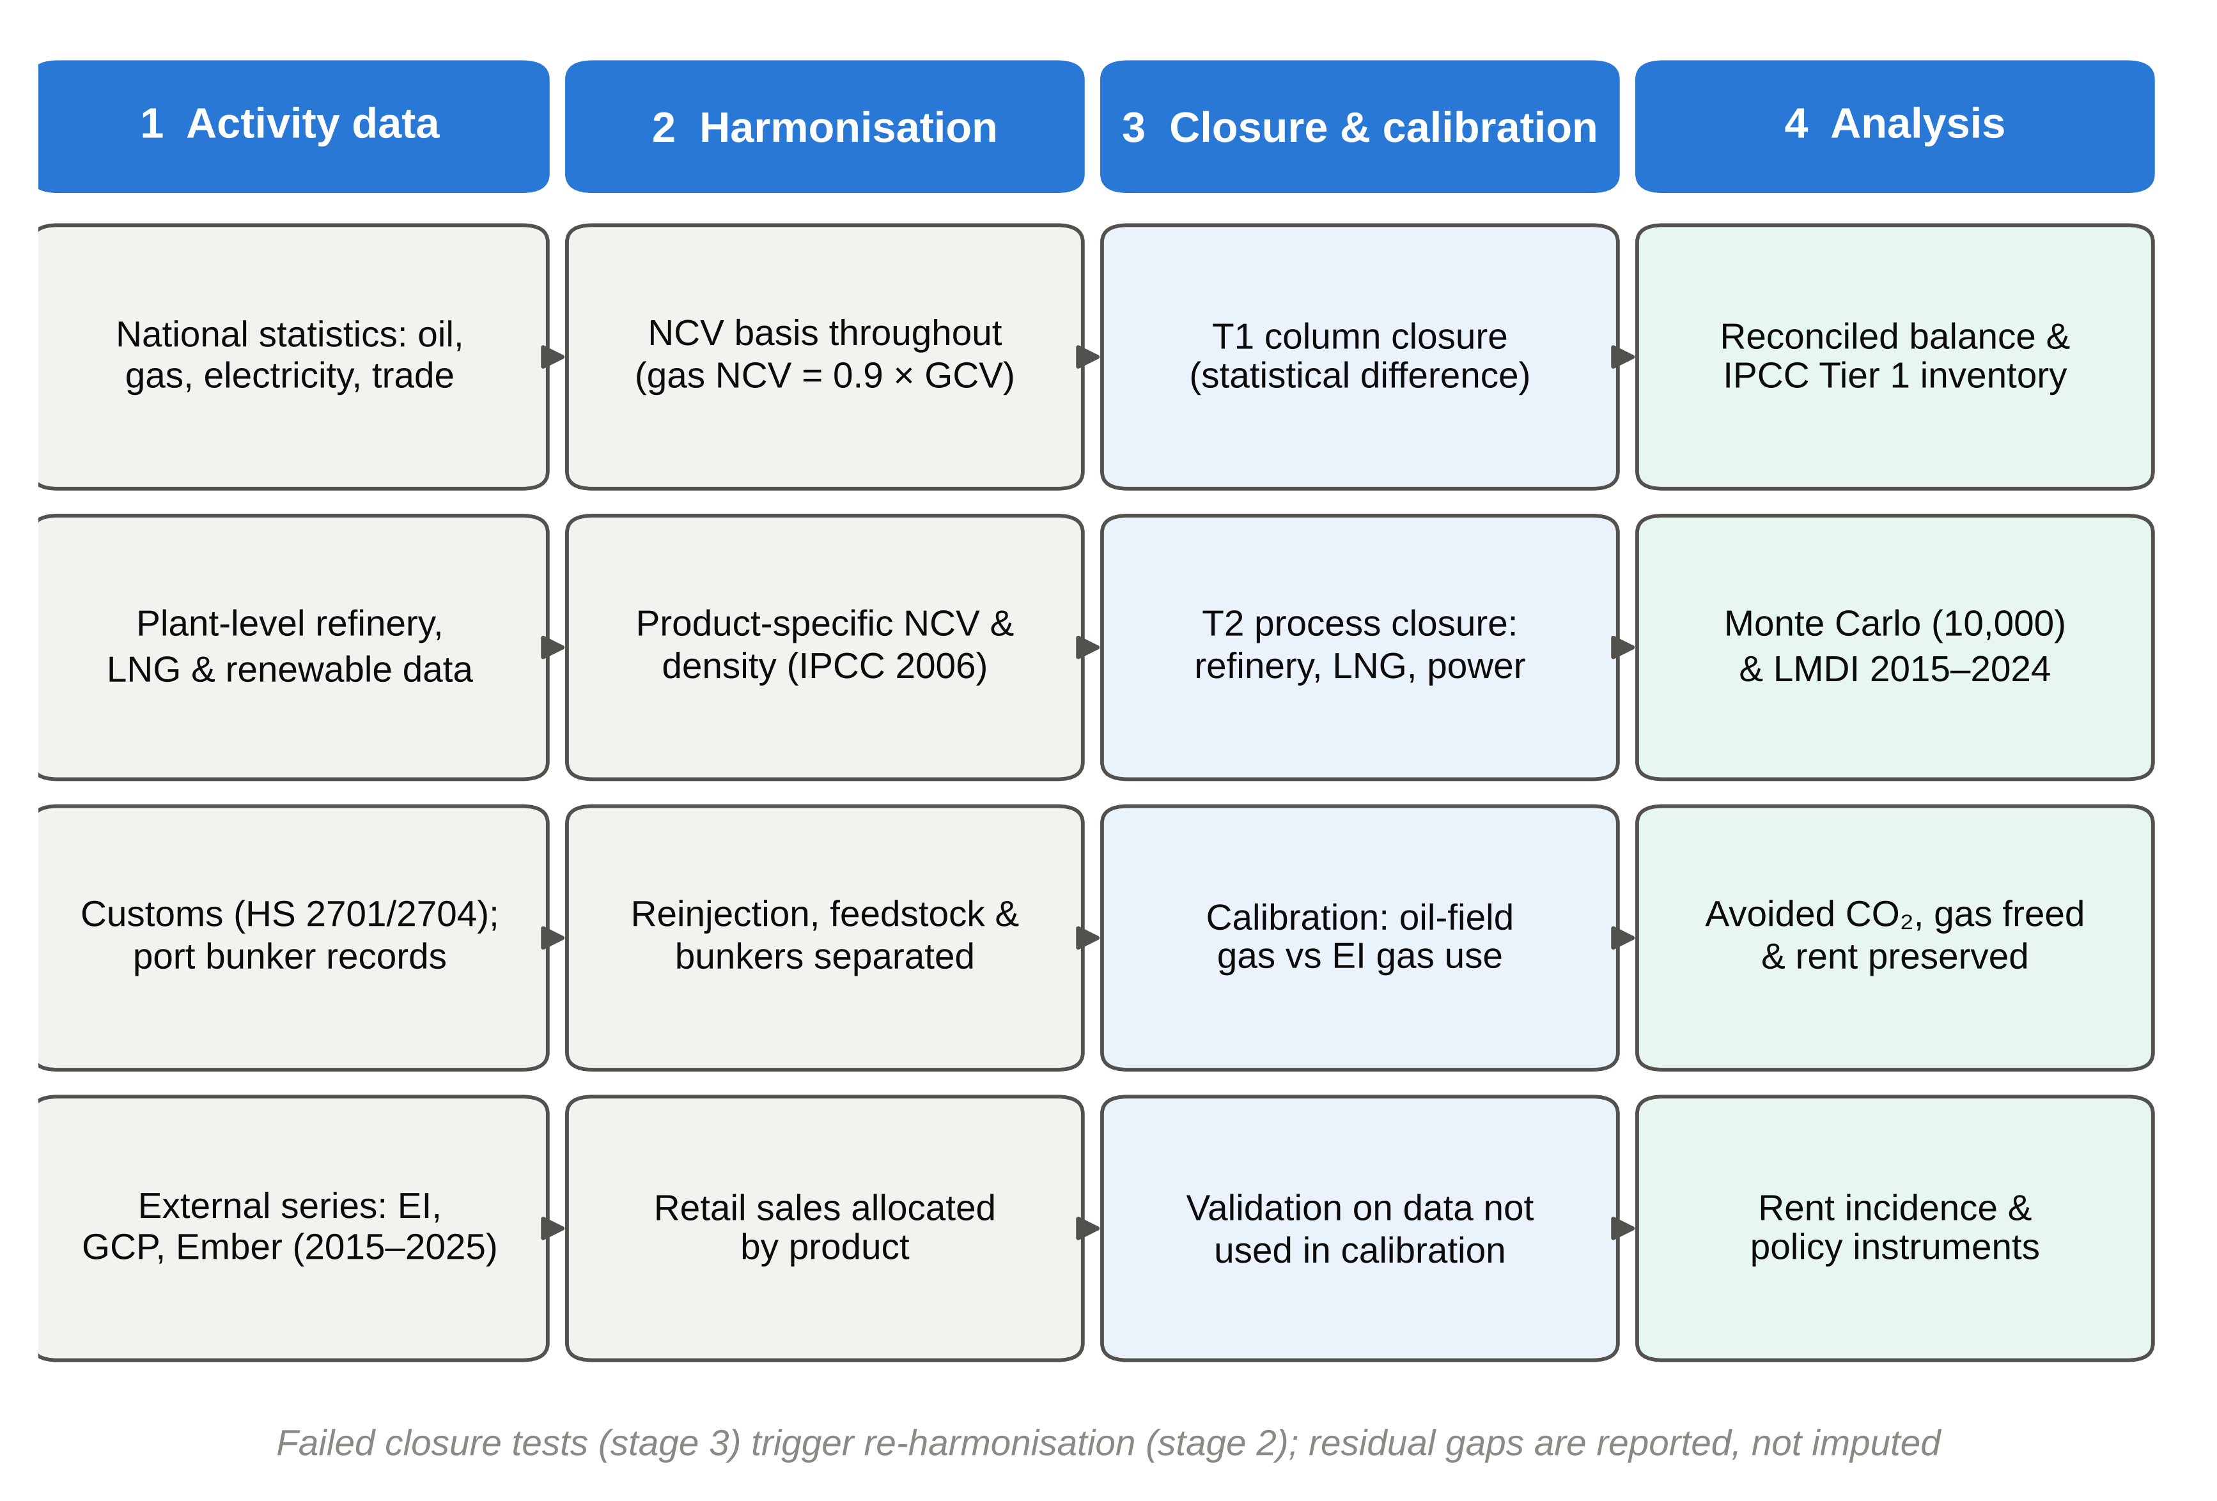
Fig. 1. Research design: activity data, harmonisation, closure, calibration and validation, and analysis.

2.1. Accounting framework, closure tests and calibration
We follow the International Recommendations for Energy Statistics (UNSD, 2018), mirrored in IEA and Eurostat practice (IEA, 2023a; Eurostat, 2021). For each commodity c, supply-side Total Primary Energy Supply is:
TPES_{c} = P_{c} + M_{c} − X_{c} − B_{c} ± ΔS_{c} (1)
where P is indigenous production, M imports, X exports, B international marine and aviation bunkers and ΔS the stock change. Final consumption follows from:
TFC_{c} = TPES_{c} − TI_{c} + TO_{c} − OU_{c} − L_{c} − SD_{c} (2)
where TI and TO are transformation inputs and outputs, OU energy-sector own use, L distribution losses and SD the statistical difference. Test T1 inspects SD_{c}. Test T2 requires the apparent efficiency of each transformation process k, evaluated plant by plant where data allow, to be physically plausible:
η_{k} = Σ_{c} TO_{c,k} / Σ_{c} TI_{c,k} , 0 < η_{k} < η_{k}^{max} (3)
Parameters that cannot be measured are either calibrated to an external dataset (C) or bounded by engineering ranges. Agreement with a dataset used for calibration is not treated as evidence of accuracy. Independent validation (V) uses only external data that do not enter the calibration: crude and condensate production, oil consumption and electricity generation. External 2024 values are extrapolated to 2025 with their 2019–2024 compound growth rates to remove the year mismatch. Following IRES, primary electricity comprises only solar and wind, reinjected gas is excluded from production, and all quantities are expressed on a net calorific value (NCV) basis (UNSD, 2018).

2.2. Data
Table 2 lists the data sources. All 2025 activity data are official national statistics or company data submitted to the national statistical system; 2015–2025 external series are from public international datasets.
Table 2. Data sources.
Source | Data | Coverage
National Centre for Statistics and Information (NCSI, 2026) | Crude and condensate production and exports; Sohar and Mina Al Fahal output by product; gas production and use by category; LNG exports; electricity; GDP; population | 2021–2025
Ministry of Energy and Minerals | Monthly production; gas use by sector | 2025
Duqm refinery operator | Refinery output; foreign crude imports; product exports | 2025
Renewable Energy Bulletin | Monthly renewable generation by plant | 2022–2025
Customs; port bunkering records | Coal (HS 2701) and lignite (HS 2704) trade; marine bunkers | 2025
EI, GCP and Ember via Our World in Data | Primary energy, gas and oil consumption, CO₂ by fuel, electricity, population, GDP | 2015–2025
Industry sources | Refinery and chemical-plant capacities; production and export estimates | 2024–2026
IPCC (2006) | Default NCVs and CO₂ emission factors | International default

2.3. Calorific basis and conversion factors
The national gas factor (0.02549 ktoe/MMscf) corresponds to about 1,012 Btu/scf, a gross calorific value (GCV). Because the IPCC emission factors are NCV-based, all gas quantities are converted to NCV with the conventional ratio NCV = 0.9 × GCV (UNSD, 2018). Crude oil is converted at 0.136 ktoe/kbbl. Refined products use product-specific factors from IPCC (2006) NCVs and typical densities (Appendix B), giving 0.1265 ktoe/kbbl for the Sohar and Mina Al Fahal slate. Duqm, which has no product breakdown, is assigned 0.130 ktoe/kbbl (range 0.125–0.135), reflecting its middle-distillate design. LNG is converted at 1.178 toe/t (NCV ≈ 49.3 GJ/t), electricity at its physical energy content and coal at 0.65 ktoe/kt (Table 3).
Table 3. Conversion factors (NCV basis).
Commodity | Unit | Factor | Basis
Crude oil and condensate | kbbl | 0.136 ktoe/kbbl | National crude assay
Products: Sohar + Mina Al Fahal | kbbl | 0.1265 ktoe/kbbl | Product-specific (Appendix B)
Products: Duqm | kbbl | 0.130 ktoe/kbbl | Middle-distillate slate; U(0.125, 0.135)
Natural gas | MMscf | 0.02549 × 0.9 = 0.02294 ktoe/MMscf | GCV ≈ 1,012 Btu/scf; NCV = 0.9 GCV
LNG | t | 1.178 toe/t | NCV ≈ 49.3 GJ/t
Coal and lignite | t | 0.00065 ktoe/t | IPCC-consistent default
Electricity | GWh | 0.086 ktoe/GWh | Physical energy content

2.4. Reconciliation procedures

2.4.1. Refinery and crude oil
National data report two refinery figures. The product-resolved output of 115,140 kbbl (14,561 ktoe) published by NCSI covers only the Sohar and Mina Al Fahal system. The total of 210,833 kbbl also includes Duqm's output of 95,693 kbbl (12,440 ktoe), reported by the operator without product detail. Each figure is consistent with its plant's capacity (Fig. 3a). Sohar and Mina Al Fahal produced 315 kb/d against a combined nameplate of 304 kb/d (198 and 106 kb/d). Duqm produced 262 kb/d against 255 kb/d after its 2025 debottlenecking (Oxford Business Group, 2019; QCIntel, 2025; Argus Media, 2025). The 2–4% excess in each case equals the volume gain expected when crude is converted into lighter products. At a net refinery energy efficiency η_{ref} of 0.95 (0.92–0.98; Szklo and Schaeffer, 2007), the implied crude intake is 28,422 ktoe, or 573 kb/d, about 102% of nameplate. This agrees with operator reports of running above nameplate.
Recorded crude supply to refineries (production − exports + imports) is only 17,529 ktoe (353 kb/d), so a gap of 10,893 ktoe (219 kb/d) remains. Three explanations were tested. (H0) Refinery output is double-counted. This is rejected because each plant group's output is consistent with its own capacity. The rejection also holds against the special case of symmetric double counting of output and exports: Duqm's product breakdown is not in the NCSI slate, so its output cannot have been counted twice in the 210,833 kbbl total. (H1) Crude exports are over-recorded. This is not supported, because the export series (844 kb/d) is consistent with IMF-sourced estimates of 830–842 kb/d and OPEC-sourced estimates of about 897 kb/d (FRED, 2025; CEIC, 2026). (H2) Crude production is under-recorded. This is also rejected: recorded production (1,002 kb/d) matches independent estimates of crude (775 kb/d) plus condensate (233 kb/d) (Energy Intelligence, 2025; CEIC, 2026). The location of the gap therefore cannot be identified with public data. Candidate explanations include crude imports for Duqm beyond those recorded, draws on the Ras Markaz strategic storage, and terminal liftings to domestic refineries that are recorded as exports.
Following IEA practice, we do not attribute the gap. Instead, we carry it as an explicit statistical difference (SD) in the crude oil column and report two TPES measures. Supply-side TPES (Eq. 1) uses recorded trade and production. Use-side TPES adds back the crude SD and is anchored on physically observed refinery throughput. Use-side TPES is the central measure because it is consistent with plant capacity, observed domestic product use and independent oil consumption data (Section 3.2).

2.4.2. Natural gas: LNG, feedstock, oil fields and power-and-water plants
Gross production is 46,313 ktoe (NCV). The reported LNG feedstock (599,187 MMscf, or 13,746 ktoe NCV) implies a liquefaction efficiency of 96.8% when set against 11.3 Mt of LNG (13,306 ktoe). This is implausible, because plants consume 7–12% of feed gas as fuel (Lee et al., 2018). We therefore derive feed gas from LNG output and an efficiency of 90.5% (88–93%), which gives 14,703 ktoe. National statistics combine LNG feed and industrial gas in one “industrial projects and zones” category. Industrial gas is that category less LNG feed (8,341 ktoe). Of this, an estimated 1,887 ktoe (1,400–2,300) is feedstock for methanol and ammonia. The estimate rests on about 2 Mt of methanol capacity at Sohar and Salalah and about 2 Mt of ammonia capacity at Sur and Sohar, each requiring roughly 20 GJ of feedstock gas per tonne (IEA, 2021; Proman, 2024; Mitsubishi Heavy Industries, 2009; Oman Observer, 2026). Feedstock gas is recorded as non-energy use and excluded from combustion CO₂. Process CO₂ from ammonia production belongs to IPCC category 2.B and is outside the scope of this inventory.
Gas delivered to oil fields (10,692 ktoe) is partly burnt and partly reinjected. The burnt share covers thermal enhanced oil recovery (EOR) steam at Amal, Qarn Alam and Mukhaizna, compression and upstream power generation; the rest is reinjected for pressure maintenance. National statistics do not separate the two. We calibrate the combusted share so that domestic gas consumption matches the EI series extrapolated to 2025 on its gross basis (Energy Institute, 2025), converted to NCV. This gives 32% (3,387 ktoe), within our order-of-magnitude engineering estimate of 3–4.5 Mtoe for thermal EOR steam and upstream power demand. The calibration is sensitive to the external dataset. If EI gas data were on an NCV basis, the share would be 58%; calibrating instead to GCP gas CO₂ gives 73%. The Monte Carlo analysis therefore draws the share from a triangular distribution between 20% and 75% with mode 32%, and we report the GCP calibration as an alternative case. Reinjected gas (7,305 ktoe centrally) is excluded from production.
If all gas delivered to power-and-water plants (12,577 ktoe) were attributed to the 46,464.5 GWh of thermal generation, the fleet efficiency would be 31.8% on an NCV basis. This is implausible for a fleet dominated by combined-cycle plants. Integrated plants also supply heat for thermal desalination, and the reported gas may include auxiliary and captive use. Pending a metered split, we attribute to grid electricity the fuel implied by a net fleet efficiency of 45% (40–50%), namely 8,880 ktoe. The remaining 3,697 ktoe is reported as “desalination heat and unattributed”; its emissions remain in the inventory but do not inflate the electricity emission factor.

2.4.3. Petroleum products
Domestic product availability after exports (16,789 ktoe) and marine bunkers (453.8 ktoe) is 9,759 ktoe. Retail sales by product (43,699.8 kbbl) are allocated directly. Gasoline goes to road transport. Diesel is split between transport (70%), industry (15%) and households (5%). Jet fuel goes to aviation, and an estimated 90% of it (80–95%) is international and recorded as bunkers (723 ktoe). The non-retail remainder (4,058 ktoe) is allocated in proportion to the non-retail part of the refinery slate. Naphtha and other products are treated as non-energy use (petrochemical feedstock, bitumen, lubricants) with a share of 0.8 (0.6–1.0). LPG goes to households (70%; 50–90%) and industry, and fuel oil to industry.

2.5. Emissions
We estimate territorial combustion CO₂ with the IPCC (2006) Tier 1 method on an NCV basis (Appendix A):
E_{k,f} = A_{k,f} × EF_{f} (4)
where A is the fuel combusted in IPCC source category k: electricity and desalination (1.A.1.a), refining (1.A.1.b), LNG liquefaction and upstream fuel (1.A.1.c), manufacturing (1.A.2), transport (1.A.3) and residential use (1.A.4). Flaring, venting, fugitive and process emissions are outside the scope of the inventory. Emissions avoided by renewables are estimated as:
ΔE = G_{RE} × EF_{marg} , EF_{marg} = 56.1 kgCO₂/GJ × 3.6 / η_{marg} (5)
where η_{marg} is the net efficiency of the gas-fired plant displaced by solar output. It is set at 0.45 centrally and bounded by the efficiencies of open-cycle (0.35) and combined-cycle (0.55) units in Oman's fleet (OPWP, 2024). Gas freed by renewables is G_{RE} × 3.6/η_{marg}.

2.6. Uncertainty analysis
We propagate parameter uncertainty with 10,000 Monte Carlo draws (Table 4) and report central estimates with 90% intervals. Spearman rank correlations identify the parameters that dominate the uncertainty.
Table 4. Uncertain parameters in the Monte Carlo analysis.
Parameter | Central | Distribution | Basis
Product energy factors (multiplier) | 1.00 | U(0.97, 1.03) | Density and NCV variation
Duqm product factor (ktoe/kbbl) | 0.130 | U(0.125, 0.135) | Middle-distillate slate
Refinery net efficiency η_{ref} | 0.95 | Tri(0.92, 0.95, 0.98) | Szklo and Schaeffer (2007)
LNG plant efficiency η_{LNG} | 0.905 | U(0.88, 0.93) | Lee et al. (2018)
Chemical feedstock gas (ktoe) | 1,887 | U(1,400, 2,300) | Plant capacities × 20 GJ/t
Oil-field gas combusted (share) | 0.32 | Tri(0.20, 0.32, 0.75) | Calibration (C): EI; GCP upper
LNG and refinery losses combusted | 0.90 | U(0.80, 1.00) | Plant fuel vs. losses
Grid fleet efficiency η_{pp} | 0.45 | Tri(0.40, 0.45, 0.50) | CCGT-dominated fleet
Displaced plant efficiency η_{marg} | 0.45 | Tri(0.35, 0.45, 0.55) | OCGT–CCGT range
Non-energy share of naphtha/other | 0.80 | U(0.60, 1.00) | Petrochemicals, bitumen, lubricants
LPG used by households | 0.70 | U(0.50, 0.90) | Cooking demand
Jet fuel in retail (kbbl); international share | 6,000; 0.90 | U(4,000, 9,000); U(0.80, 0.95) | Airport throughput
LNG price; domestic gas price; liquefaction cost (USD/MMBtu) | 10; 3; 1 | U(6, 14); U(1.5, 4.5); U(0.5, 1.5) | Market range; Fattouh and El-Katiri (2013)

2.7. Time series and decomposition
For 2015–2024 we use primary energy and gas consumption from the EI, electricity from Ember and CO₂ from fuel combustion and flaring from the GCP, compiled by Our World in Data (Energy Institute, 2025; Ember, 2026; Our World in Data, 2026). Real GDP is extended beyond 2022 with official growth rates of 1.3% (2023) and 1.7% (2024) (IMF, 2024; Ministry of Finance, 2025). The change in CO₂ is decomposed with the additive LMDI-I method (Ang, 2015) applied to the Kaya identity (Kaya and Yokobori, 1997):
C = P × (G/P) × (E/G) × (C/E) , ΔC_{x} = [(C_{T} − C₀)/(ln C_{T} − ln C₀)] × ln(x_{T}/x₀) (6)
where P is population, G real GDP, E primary energy and C CO₂; x denotes each factor.

2.8. Rent incidence and the dual dividend
Each unit of domestically used gas is valued at its export opportunity cost: the LNG price multiplied by the liquefaction efficiency, less the liquefaction cost and the regulated domestic price. GCC domestic gas prices have been set administratively at USD 0.75–3/MMBtu (Fattouh and El-Katiri, 2013). Oman's industrial price was raised to USD 3/MMBtu in 2015 (Gulf News, 2013), and we vary it between 1.5 and 4.5:
r = P_{LNG} × η_{LNG} − c_{liq} − P_{dom} , Rent_{s} = Q_{s} × r (7)
where Q_{s} is the gas used by sector s (gross MMBtu). The rent preserved by renewables is the freed gas multiplied by r. These are gross opportunity costs that assume export outlets are available; they indicate the scale of implicit transfers, not realisable revenue.

3. Results

3.1. The reconciled 2025 energy balance
Table 5 presents the reconciled balance, and Fig. 2 traces the corresponding flows. Indigenous production is 89,139 ktoe: crude oil and condensate 55.8%, marketable gas 43.8% and solar and wind 0.4%. Supply-side TPES is 25,822 ktoe. Adding back the crude statistical difference of 10,893 ktoe gives use-side TPES of 36,715 ktoe. TFC is 21,418 ktoe. Apart from the crude SD, the only residual is 0.8 ktoe in natural gas.
Table 5. Reconciled energy balance of Oman, 2025 (ktoe, NCV).
Flow (ktoe) | Crude oil | Refined products | Natural gas | LNG | Coal & lignite | Solar & wind | Electricity | Total
Indigenous production | 49,742.6 | – | 39,008.3 | – | – | 387.8 | – | 89,138.7
Imports | 9,668.9 | – | – | – | 172.1 | – | – | 9,841.0
Exports | -41,882.7 | -16,788.5 | – | -13,305.9 | -3.3 | – | – | -71,980.4
International marine bunkers | – | -453.8 | – | – | – | – | – | -453.8
International aviation bunkers | – | -723.4 | – | – | – | – | – | -723.4
TPES (supply side) | 17,528.8 | -17,965.8 | 39,008.3 | -13,305.9 | 168.7 | 387.8 | – | 25,822.0
Statistical difference (crude) | 10,893.4 | – | – | – | – | – | – | 10,893.4
TPES (use side) | 28,422.2 | -17,965.8 | 39,008.3 | -13,305.9 | 168.7 | 387.8 | – | 36,715.4
Oil refineries | -28,422.2 | 27,001.1 | – | – | – | – | – | -1,421.1
Power-and-water plants | – | – | -12,576.6 | – | – | -387.8 | 4,383.7 | -8,580.7
LNG plants | – | – | -14,702.6 | 13,305.9 | – | – | – | -1,396.7
Upstream own use | – | – | -3,387.0 | – | – | – | – | -3,387.0
Distribution losses | – | – | – | – | – | – | -510.9 | -510.9
Statistical difference (gas) | 0.0 | 0.0 | 0.8 | 0.0 | 0.0 | 0.0 | 0.0 | 0.8
TFC | – | 9,035.4 | 8,341.3 | – | 168.7 | – | 3,872.8 | 21,418.2
Industrial | – | 1,258.7 | 6,454.3 | – | 168.7 | – | 699.7 | 8,581.5
Transport | – | 4,555.0 | – | – | – | – | – | 4,555.0
Residential | – | 644.5 | – | – | – | – | 1,601.7 | 2,246.3
Commercial and government | – | – | – | – | – | – | 1,436.2 | 1,436.2
Agriculture & other | – | – | – | – | – | – | 135.1 | 135.1
Non-energy use | – | 2,577.2 | 1,887.0 | – | – | – | – | 4,464.2
Negative transformation entries are inputs and positive entries outputs. The crude statistical difference is the gap between recorded crude supply and the refinery intake implied by plant-level output (Section 2.4.1); use-side TPES adds it back. Natural gas production excludes reinjection. Totals may not sum exactly owing to rounding.
Fig. 2. Energy flows in Oman's reconciled 2025 balance (ktoe, NCV). The grey source ribbon is the crude statistical difference.

3.2. Closure, calibration and validation
Fig. 3 and Table 6 document the diagnostics. The as-compiled TPES of 41,762 ktoe changes through seven corrections (Fig. 3b): primary electricity -3,996, NCV basis for gas -5,146, exclusion of reinjection -7,305, LNG factor -989, product-specific factors +2,219, aviation bunkers -723 and the crude statistical difference +10,893 ktoe. The net change is -12.1%.
Validation uses data not involved in any calibration (Fig. 3c). Recorded production (1,002 kb/d) lies within 1% of independent crude and condensate estimates (1,008 kb/d). Generation (51.0 TWh) lies within 3.5% of Ember's 2025 value (52.8 TWh). Domestic oil use implied by plant-level refinery output (inland use, bunkers and refinery fuel: 11.6 Mtoe) lies within 9% of EI oil consumption extrapolated to 2025 (10.6 Mtoe). This last test supports the observed refinery output, and hence use-side TPES. Had output been double-counted by the size of the crude gap, domestic oil supply would become negative, which is inconsistent with independently measured consumption. Gas consumption matches the EI series by construction (calibration), so it is not evidence of accuracy. Petroleum CO₂ (22.1 Mt) exceeds the GCP oil series (12.5 Mt, 2025-extrapolated). However, the GCP figure is inconsistent with EI's own oil consumption data, and road transport alone accounts for 13.5 Mt on the basis of metered retail sales.
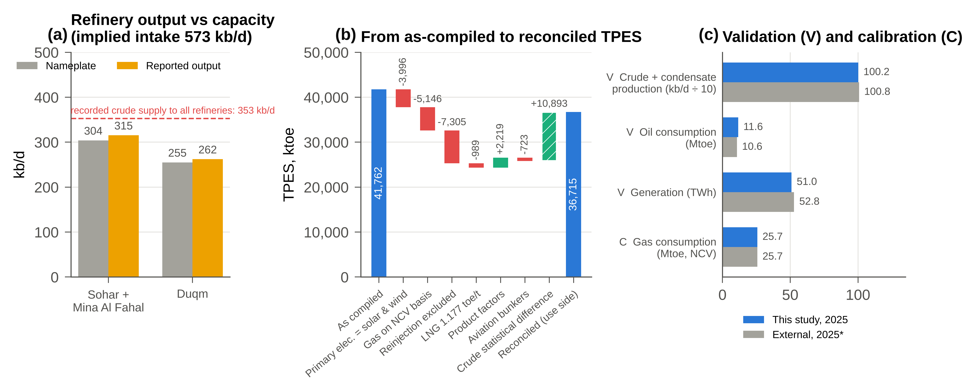
Fig. 3. Diagnostics. (a) Refinery output by plant group against nameplate capacity, and recorded crude supply. (b) Reconciliation of TPES from the as-compiled to the use-side reconciled balance. (c) Validation (V) against data not used in calibration, and the calibration target (C); external values are 2025 or extrapolated to 2025.
Table 6. Diagnostic findings and treatments.
Issue | Test and finding | Treatment | Effect on TPES (ktoe)
Thermal electricity recorded as primary energy | IRES definition | Primary electricity = solar and wind | -3,996
Gas factor on gross basis; NCV emission factors | Calorific consistency | All gas on NCV (0.9 × GCV) | -5,146
Oil-field gas includes reinjection | C: EI gas consumption | 32% combusted (20–75%); rest excluded | -7,305
LNG feed implies η = 96.8% | T2: above plant range | Feed from output, η 88–93% | 0 (allocation)
LNG factor 1.09 toe/t | NCV of LNG | 1.178 toe/t | -989
Single product factor 0.145 ktoe/kbbl | Exceeds crude factor | Product-specific factors | +2,219
Jet fuel counted as domestic | IRES bunker convention | International share to bunkers | -723
Chemical feedstock counted as fuel | Plant capacities | 1,887 ktoe to non-energy use | 0 (allocation)
Refinery intake exceeds crude supply by 219 kb/d | T2 plant-level; V tests; H0–H2 rejected | Explicit crude SD; use-side TPES | +10,893
Power-and-water fleet η = 31.8% | T2: below CCGT range | Desalination and unattributed separated | 0 (allocation)

3.3. Headline indicators and supply structure
Table 7 compares the headline indicators. On the use side, the SSR is 243% (90% CI 230–248%). On the supply side it is 345%, and under the GCP calibration 227%; the as-compiled value was 252.8%. Under every variant, Oman produces more than twice its primary requirement.
Table 7. Headline indicators, 2025 (ktoe, NCV).
Indicator | As compiled | Reconciled, use side (90% CI) | Supply side | GCP calibration
Indigenous production | 105,585.5 | 89,139 (88,483–92,585) | 89,139 | –
TPES | 41,761.7 | 36,715 (35,830–40,250) | 25,822 | 41,168
TFC | 25,481.7 | 21,418 (20,787–21,953) | 21,418 | –
Self-sufficiency ratio (%) | 252.8 | 242.8 (229.6–247.6) | 345.2 | 227.3
Energy intensity (toe/RO million) | 1,040.7 | 915 (893–1,003) | 643 | –
Renewable share of TPES (%) | 0.93 | 1.06 | 1.50 | –
Fuel-combustion CO₂ (Mt) | 91.48 | 78.4 (76.0–87.2) | 78.4 | 88.9

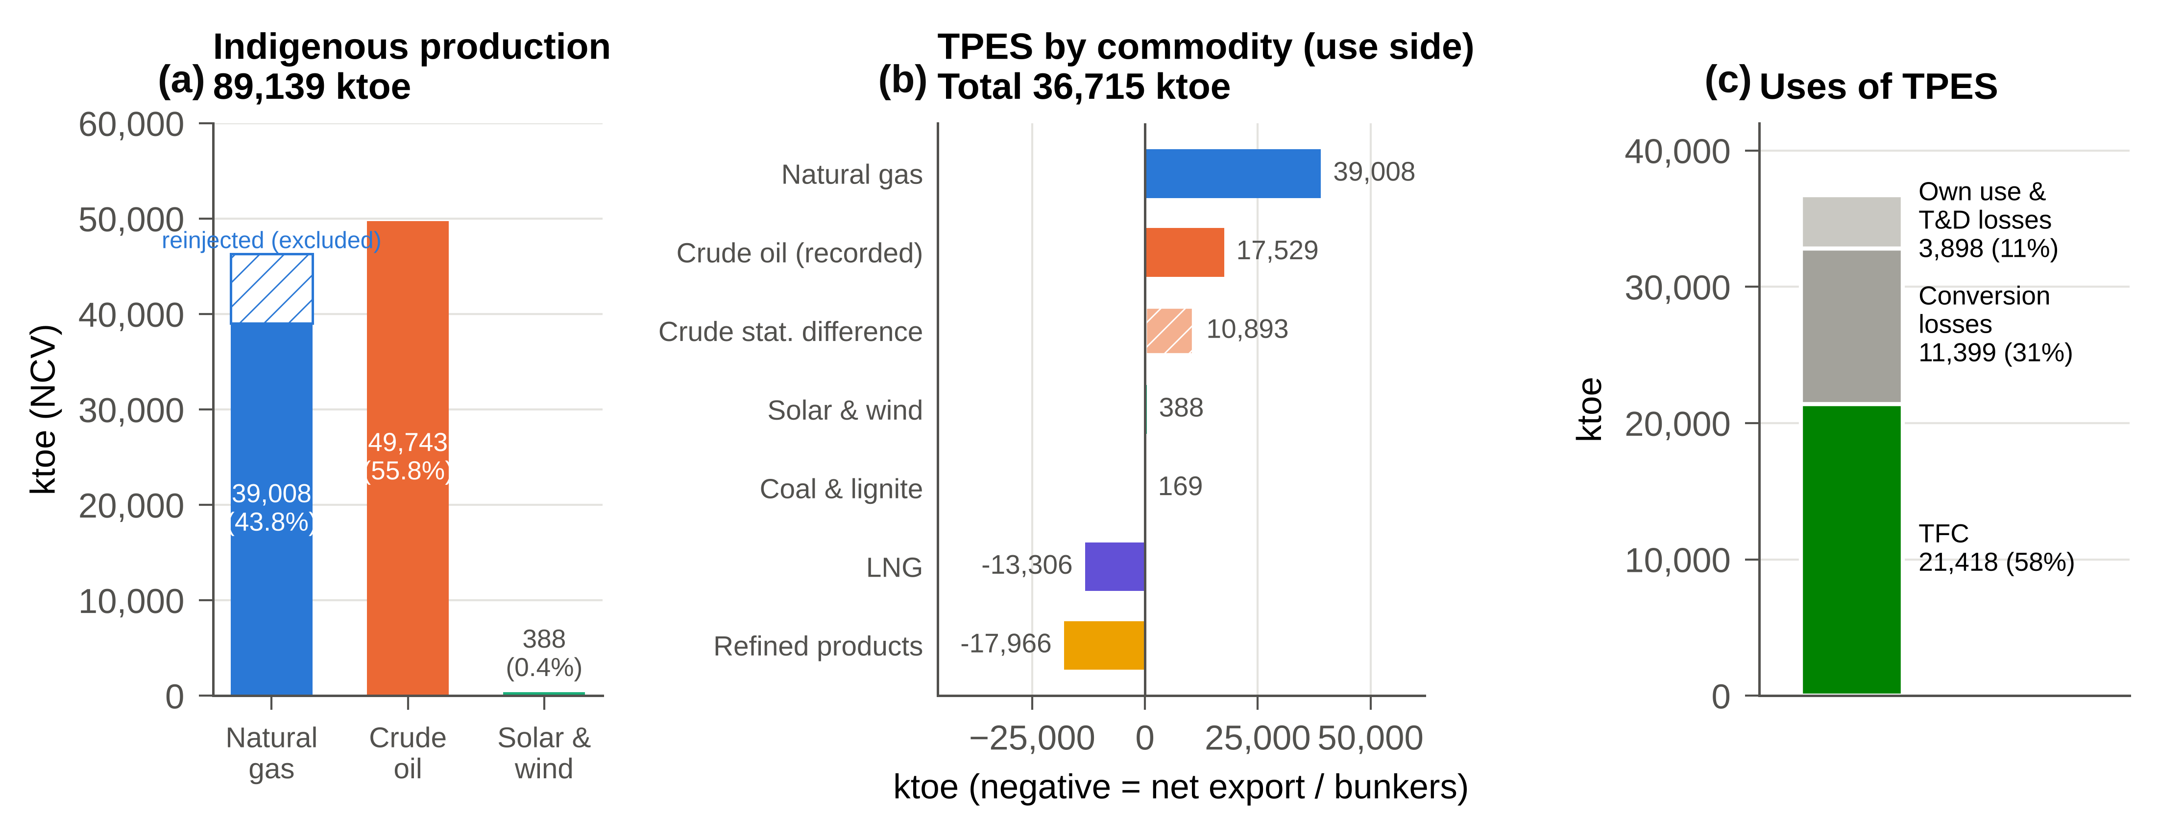
Fig. 4. Supply, 2025. (a) Indigenous production, with reinjected gas excluded. (b) Use-side TPES by commodity, including the crude statistical difference; negative values denote net exports and bunkers. (c) Uses of TPES.
Fig. 5 shows the crude account and the Sohar–Mina Al Fahal product slate, which is dominated by diesel (33%) and naphtha and other products (23%). Of gross gas production on an NCV basis, 31.7% is liquefied, 27.2% goes to power-and-water plants, 13.9% is industrial fuel, 4.1% is chemical feedstock, 7.3% is burnt in upstream operations and 15.8% is reinjected (Fig. 6a). The reconciled LNG feed is 7% above the reported estimate (Fig. 6b).
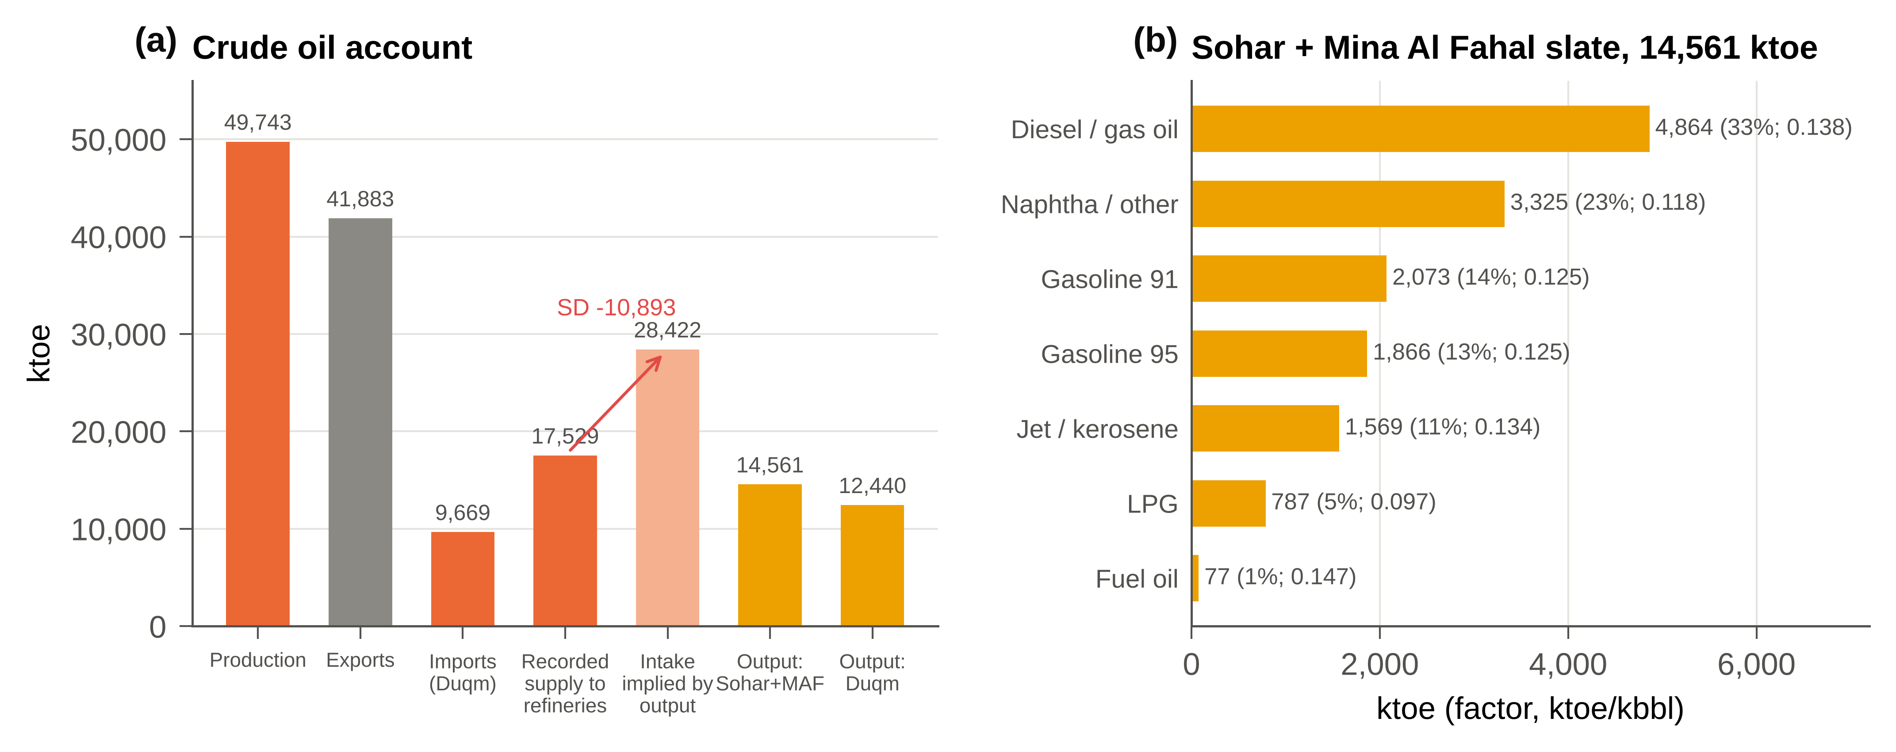
Fig. 5. Oil, 2025. (a) Crude account: recorded supply to refineries, intake implied by output, and refinery output by plant group (ktoe). (b) Sohar–Mina Al Fahal product slate by energy content, with product-specific factors.
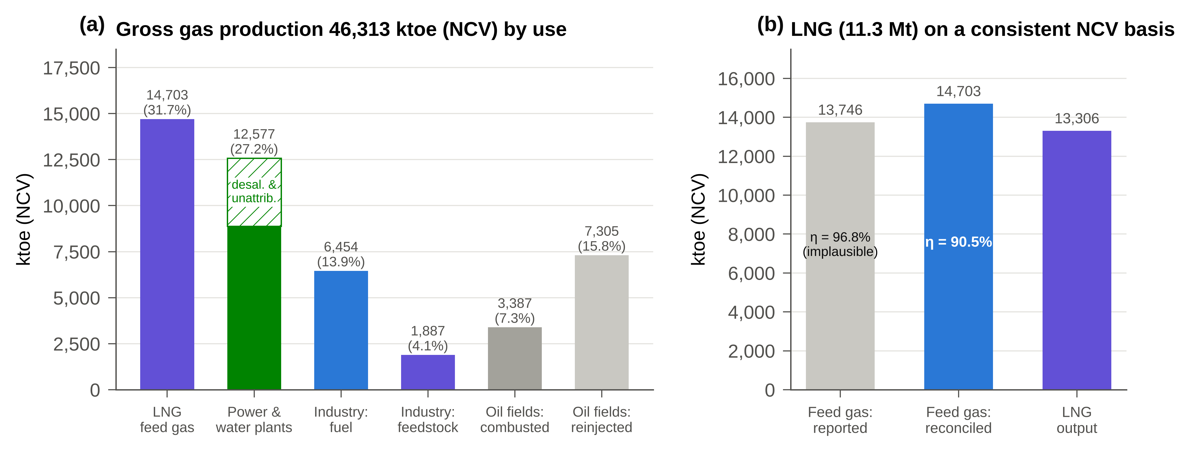
Fig. 6. Natural gas, 2025 (NCV). (a) Gross production by use; the hatched segment is power-and-water plant fuel not attributable to grid electricity. (b) LNG feed gas as reported and as reconciled, with LNG output.

3.4. Final consumption
Table 8 and Fig. 7 present TFC by sector and carrier. Industry is the largest energy user (8,581 ktoe; 40.1%). Non-energy use, comprising chemical feedstock gas and petroleum feedstocks, accounts for 20.8%, transport for 21.3% and buildings for 17.2%. TFC depends on observed refinery output and product exports, not on the crude reconciliation; its 90% interval is 20,787–21,953 ktoe. The largest allocation uncertainty is the split of non-energy use (90% CI 3,654–5,184 ktoe).
Table 8. Total Final Consumption by sector and carrier, 2025 (ktoe, NCV).
Sector | Gas | Petroleum | Electricity | Coal | Total | Share (%)
Industrial | 6,454 | 1,259 | 700 | 169 | 8,581 | 40.1
Transport | – | 4,555 | – | – | 4,555 | 21.3
Non-energy use | 1,887 | 2,577 | – | – | 4,464 | 20.8
Residential | – | 645 | 1,602 | – | 2,246 | 10.5
Commercial | – | – | 1,046 | – | 1,046 | 4.9
Government | – | – | 390 | – | 390 | 1.8
Agriculture & other | – | – | 135 | – | 135 | 0.6
Total | 8,341 | 9,035 | 3,873 | 169 | 21,418 | 100.0

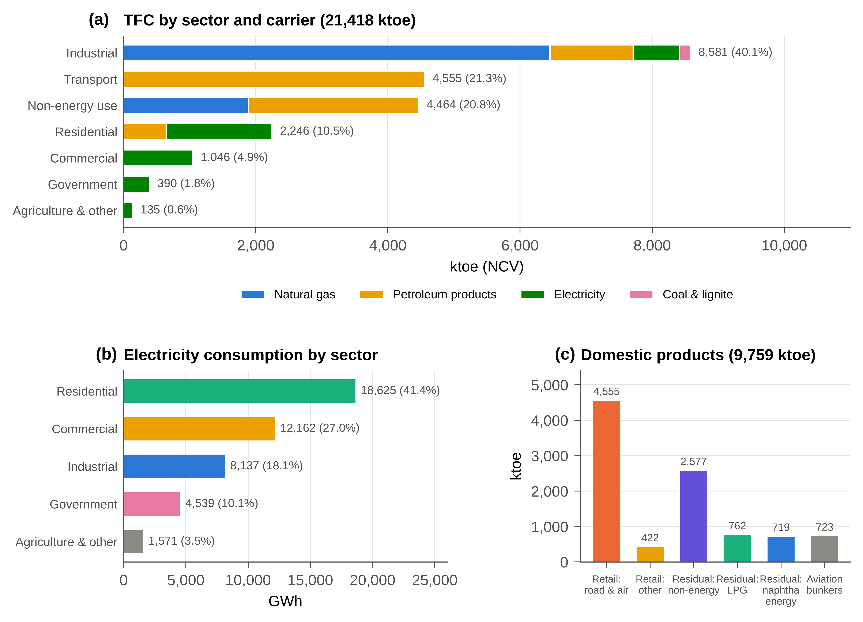
Fig. 7. Final consumption, 2025. (a) TFC by sector and carrier. (b) Electricity consumption by sector. (c) Allocation of domestic petroleum products, including aviation bunkers.
Of the 45,033 GWh of electricity consumed, households use 41.4%, commercial users 27.0%, industry 18.1% and government 10.1% (Fig. 7b). Renewable generation reached 4,509 GWh, or 8.85% of generation, against 4.89% in 2024 (Fig. 8); three photovoltaic plants supplied 97.2% of it. Ember's preliminary 2025 estimate (4.5%) carries forward 2024 solar output and misses new capacity that appears in the plant-level data. Reaching OPWP's 30% target requires a gain of 4.2 percentage points a year to 2030.
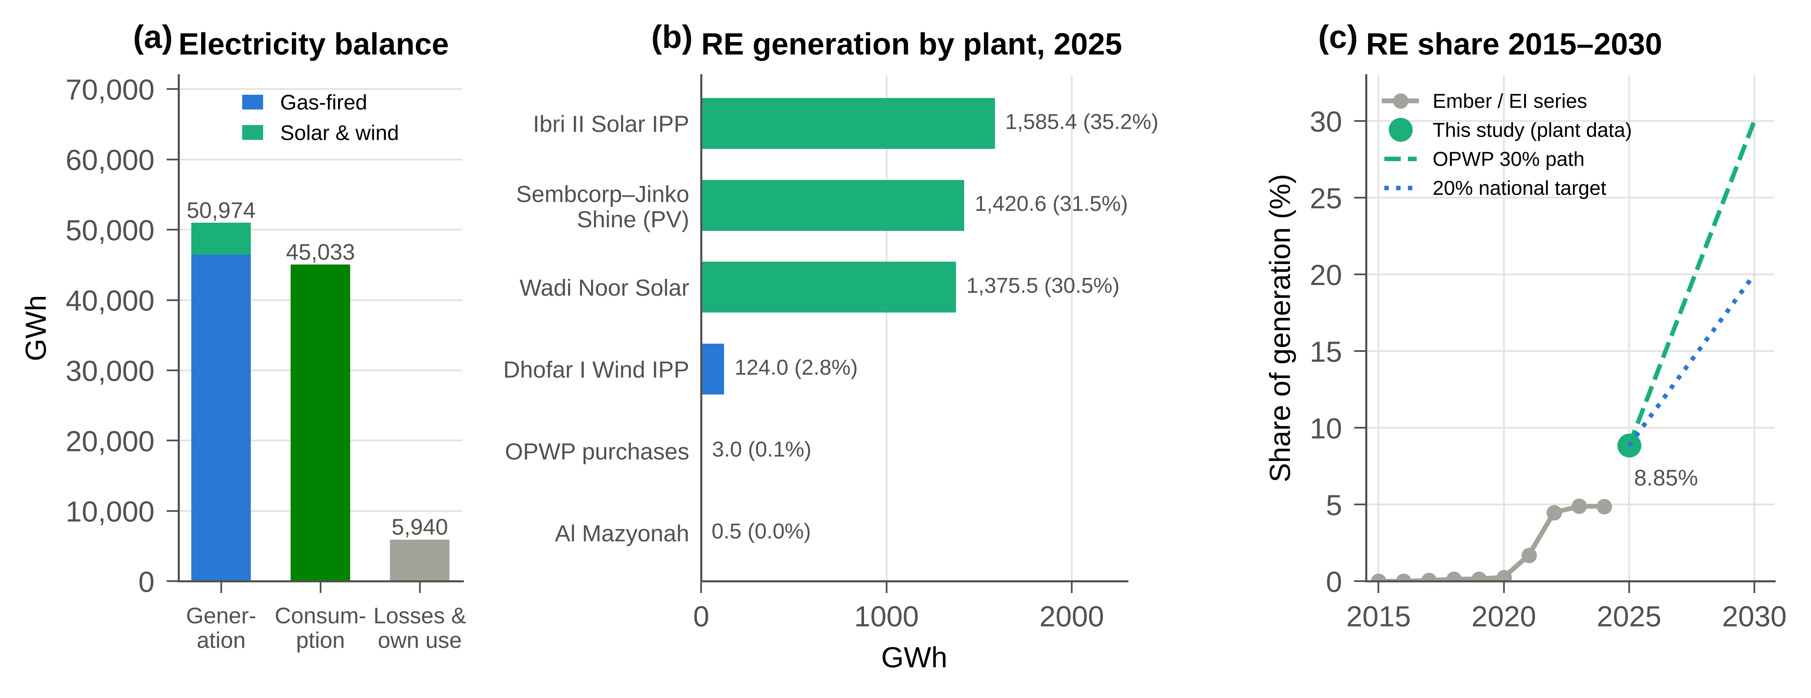
Fig. 8. Electricity, 2025. (a) Electricity balance. (b) Renewable generation by plant. (c) Renewable share of generation, 2015–2025, with the 2030 targets.

3.5. CO₂ emissions
Fuel-combustion CO₂ emissions are 78.4 Mt (90% CI 76.0–87.2; median 80.8), or 14.6 t per capita (Table 9; Fig. 9). The distribution is skewed upwards because higher combusted shares of oil-field gas cannot be excluded; the GCP calibration gives 88.9 Mt. Energy industries (1.A.1) account for 43.5 Mt. Of this, 20.9 Mt comes from grid electricity, 8.7 Mt from desalination and unattributed plant fuel, and 14.0 Mt from refining, liquefaction and upstream fuel, three categories absent from the as-compiled inventory. Manufacturing contributes 19.6 Mt and transport 13.5 Mt; natural gas accounts for 71%. International bunkers add a memo item of 3.6 Mt.
Table 9. CO₂ emissions from fuel combustion by IPCC category, 2025 (Mt).
IPCC category | Reconciled | Share (%) | As compiled
1.A.1.a Electricity (grid) | 20.86 | 26.6 | 32.82*
1.A.1.a Desalination heat & unattributed | 8.68 | 11.1 | *
1.A.1.b Petroleum refining | 3.08 | 3.9 | –
1.A.1.c LNG liquefaction | 2.95 | 3.8 | –
1.A.1.c Oil & gas extraction | 7.96 | 10.1 | –
1.A.2 Manufacturing industries | 19.64 | 25.0 | 27.81
1.A.3 Transport | 13.52 | 17.2 | 13.29
1.A.4 Residential | 1.75 | 2.2 | 0.95
Unallocated petroleum residual | – | – | 16.60
Total | 78.45 | 100.0 | 91.48
Memo: international bunkers | 3.64 |  | –
*All power-and-water plant gas was attributed to electricity in the as-compiled inventory, on a gross calorific basis.
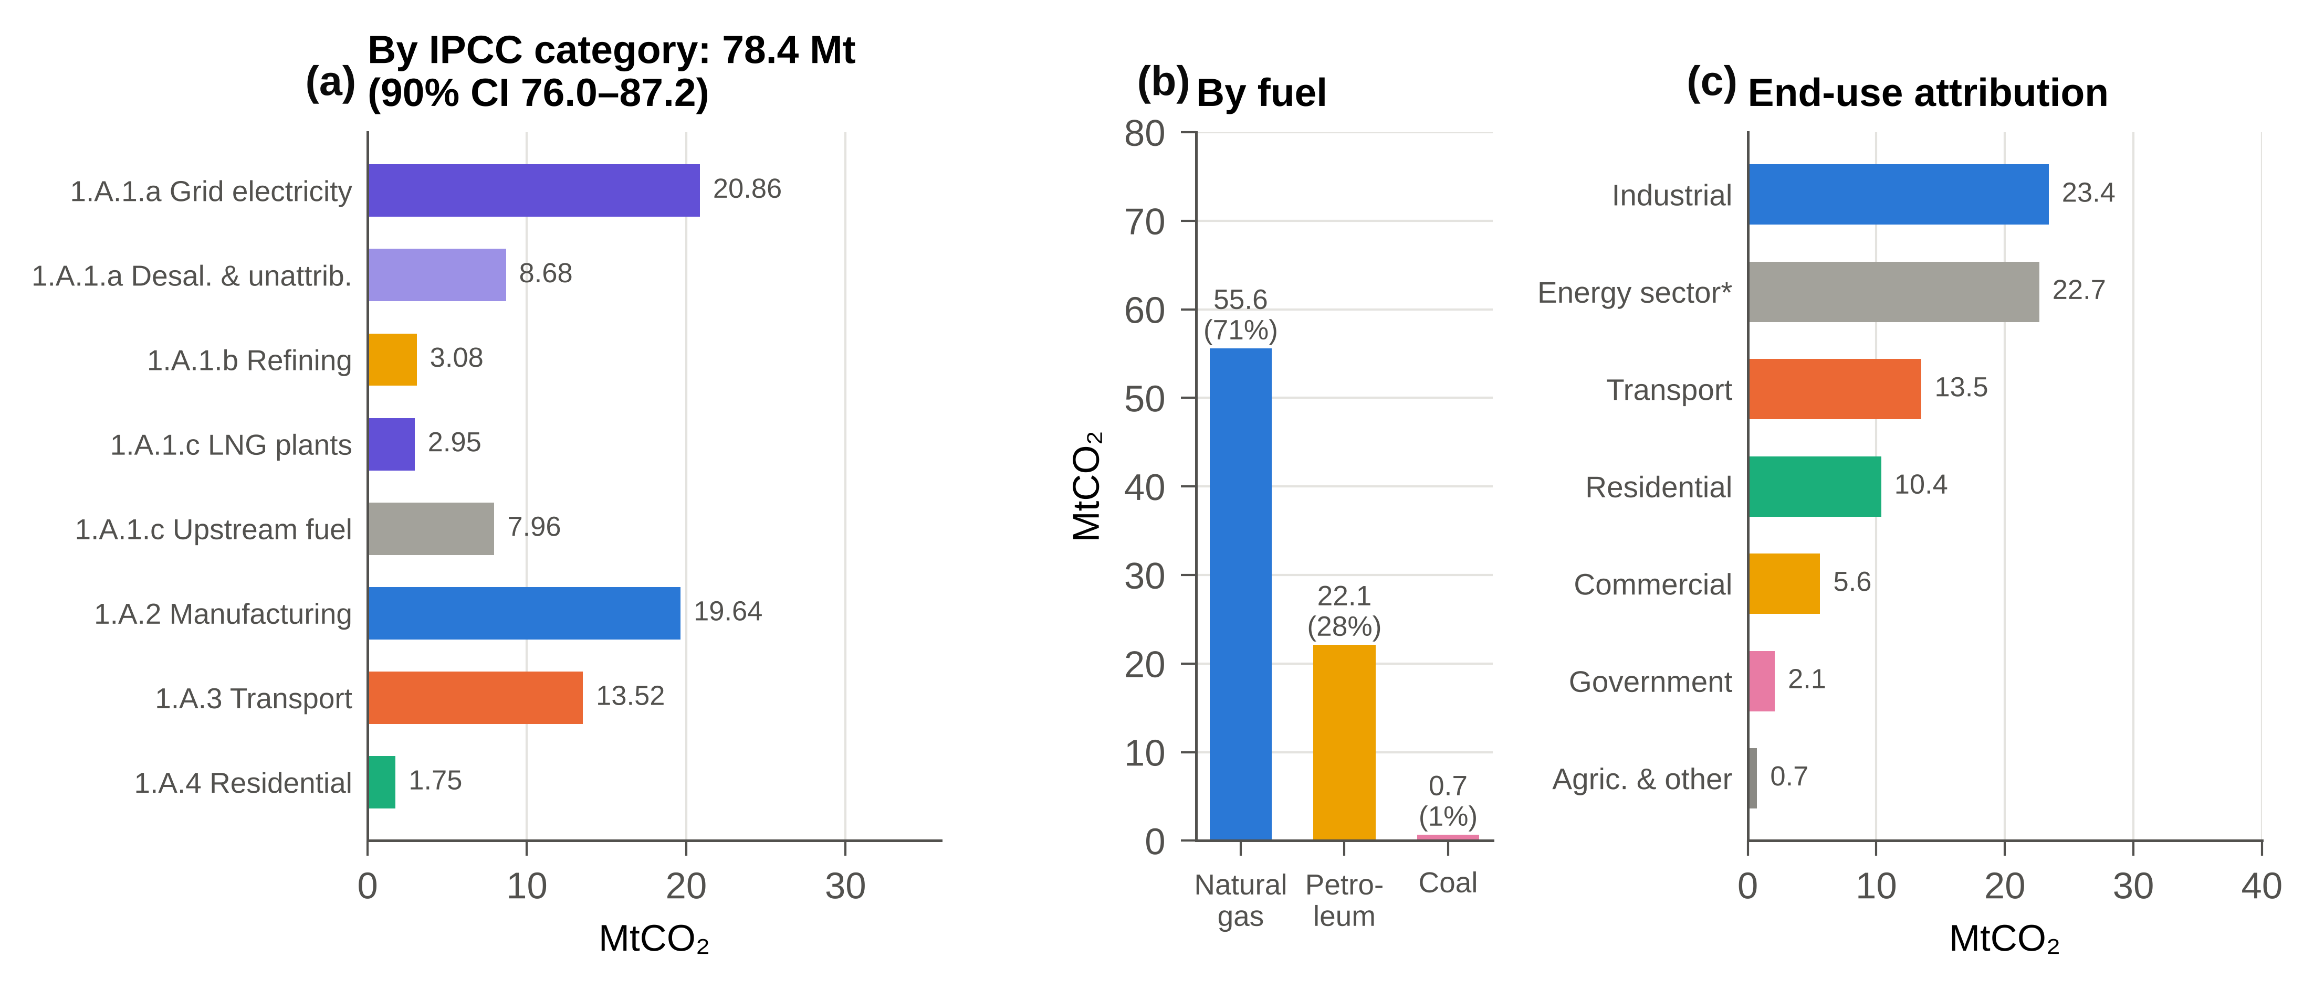
Fig. 9. CO₂ emissions from fuel combustion, 2025. (a) By IPCC category. (b) By fuel. (c) End-use attribution, with grid-electricity emissions allocated by consumption. *Energy sector: upstream, LNG, refining, desalination and unattributed fuel.

3.6. Emission trends and drivers, 2015–2024
CO₂ from fuel combustion and flaring rose from 65.7 Mt in 2015 to 79.8 Mt in 2024 (+14.1 Mt), and the gas share rose from 73% to 80% (Fig. 10a). The LMDI decomposition (Table 10; Fig. 10b) attributes the increase to population growth (+16.9 Mt) and rising energy intensity of GDP (+11.6 Mt). Falling real GDP per capita (-8.1 Mt) and declining carbon intensity (-6.3 Mt) partly offset them. The energy-intensity effect accelerated after 2019 (+8.3 Mt in 2019–2024 against +3.2 Mt in 2015–2019), coinciding with gas-intensive industrial expansion and the commissioning of Duqm. Emissions grew while real GDP per capita fell, so there is no evidence of decoupling (Stern, 2004). The reconciled 2025 inventory excludes flaring and is built from national activity data, so it is not strictly comparable with the series; its central value lies close to the 2024 series level excluding flaring.
Table 10. LMDI decomposition of the change in CO₂ from fuel combustion and flaring (Mt).
Period | Population | GDP per capita | Energy intensity | Carbon intensity | Total
2015-2019 | 6.28 | -2.64 | 3.23 | -2.80 | 4.06
2019-2024 | 10.46 | -5.38 | 8.33 | -3.39 | 10.03
2015-2024 | 16.89 | -8.05 | 11.55 | -6.29 | 14.09

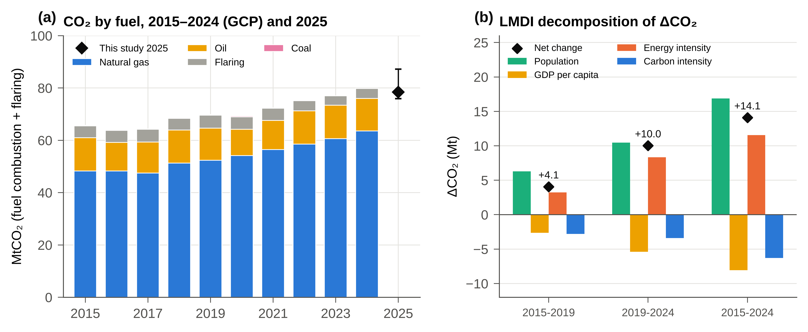
Fig. 10. Emission trends. (a) CO₂ from fuel combustion and flaring by fuel, 2015–2024 (GCP), and the reconciled 2025 inventory with its 90% interval. (b) LMDI decomposition of the change in CO₂.

3.7. Uncertainty
The 90% intervals are 35,830–40,250 ktoe for TPES, 230–248% for the SSR and 76.0–87.2 Mt for CO₂ (Fig. 11). The combusted share of oil-field gas dominates both the SSR (ρ = -0.84) and CO₂ (ρ = +0.87). Refinery efficiency and the non-energy share of naphtha follow. Field-level data on reinjection and fuel gas would remove most of the remaining uncertainty.
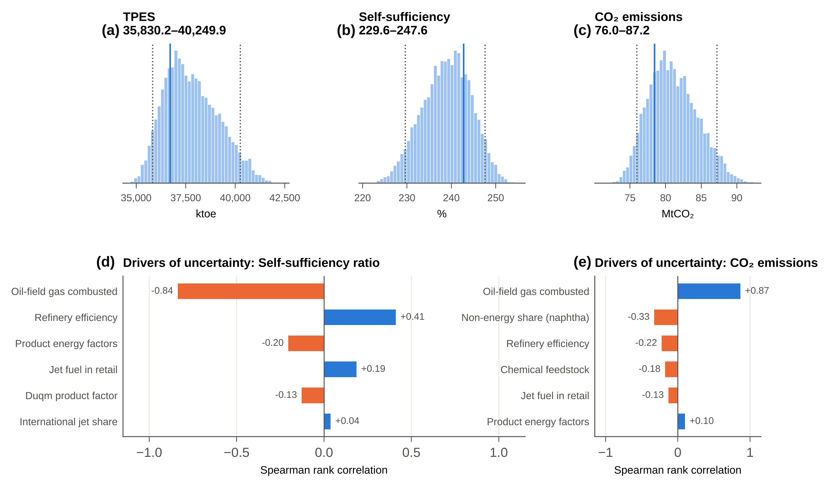
Fig. 11. Monte Carlo uncertainty (10,000 draws). (a–c) Distributions of TPES, the self-sufficiency ratio and CO₂; solid lines mark the central estimate, dotted lines the 90% interval. (d–e) Spearman rank correlations between parameters and outputs.

4. Discussion: the political economy of Oman's transition

4.1. Rent incidence in a gas-based rentier economy
Rentier theory predicts that the state distributes resource rents to sustain political allegiance; in energy exporters much of this distribution occurs off-budget, through energy sold below its opportunity cost (Beblawi and Luciani, 1987; Krane, 2019). The reconciled accounts allow the transfer to be measured. At an LNG price of USD 10/MMBtu, net of liquefaction losses and costs, domestic gas use in 2025 carried an implicit rent of USD 5.4 billion, or 5.2% of GDP (90% CI 1.5–9.4%). Power-and-water plants received 2.8 billion, industry (fuel and feedstock) 1.9 billion and upstream operations 0.8 billion (Fig. 12a). The explicit electricity subsidy in the 2025 budget is RO 520 million, or USD 1.35 billion (Gulf News, 2025). The implicit gas rent is several times larger and reaches consumers mainly through electricity tariffs and industrial gas prices. This makes tariff and gas-price reform politically sensitive, and it is consistent with the argument of Al-Sarihi and Cherni (2023) that renewables are embraced in forms that leave these distributional channels intact.
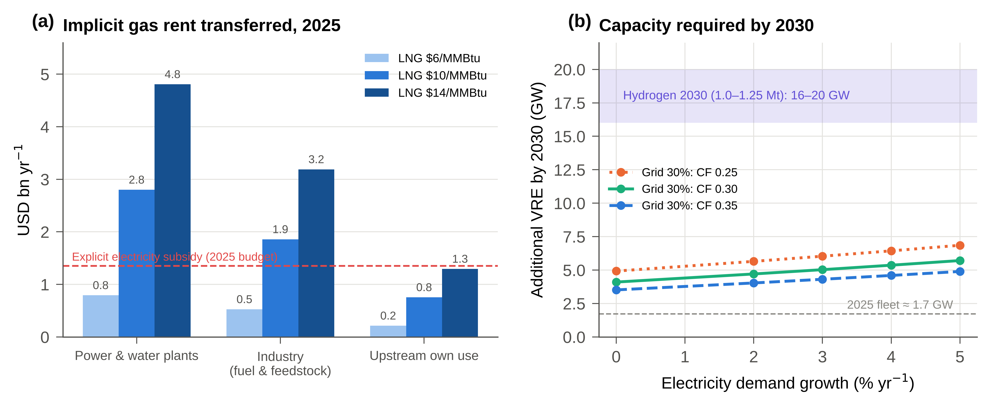
Fig. 12. Rents and scale. (a) Implicit gas rent transferred to domestic users in 2025 at three LNG prices, compared with the explicit electricity subsidy. (b) Additional VRE capacity required for a 30% renewable share by 2030, by demand growth and capacity factor, compared with the capacity required for the 2030 hydrogen target.

4.2. The dual dividend of renewables
In 2025 renewables avoided 2.02 MtCO₂ (90% CI 1.75–2.38) and freed 1.06 bcm of gas, preserving an export rent of USD 0.19 billion (0.05–0.34) (Fig. 13). With 30% renewables at constant generation, avoided emissions would reach 5.6–8.8 Mt and the preserved rent USD 0.18–1.12 billion per year. This dual dividend is specific to exporters, aligning climate policy with the fiscal interests of the rentier state, whereas importers benefit mainly through lower import bills (Al-Maamary et al., 2017b; Szalai et al., 2025). It has two limitations. Gas that is exported or redirected to new industry is still burnt elsewhere, so global emissions fall by less than the territorial saving (Davis et al., 2011; Liu et al., 2026). And the preserved rent is small compared with the implicit rent transferred domestically: renewables protect rents at the margin but do not alter how they are distributed.
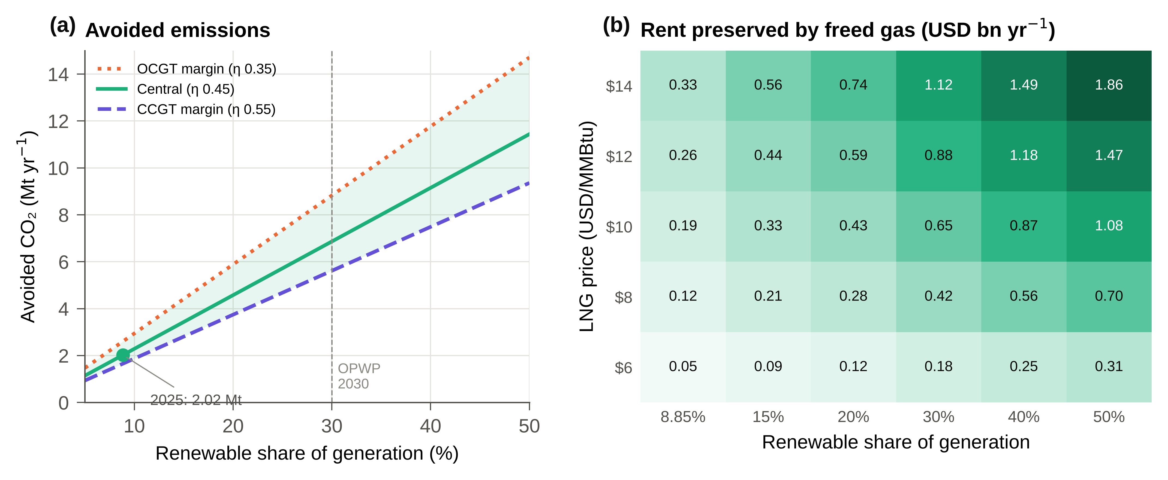
Fig. 13. The dual dividend. (a) Avoided CO₂ as a function of renewable share for the central and bounding displaced-plant efficiencies, with 2025 generation held constant. (b) Export rent preserved by freed gas by renewable share and LNG price (domestic price USD 3/MMBtu; liquefaction cost USD 1/MMBtu).

4.3. Demand-side management and energy efficiency
Rising energy intensity added 11.6 Mt of CO₂ between 2015 and 2024, more than renewables could abate at the 30% target. Energy efficiency has been under-prioritised in the GCC because administered prices weaken the incentive to conserve (Fattouh and El-Katiri, 2013; Almasri and Narayan, 2021). Partial indicators such as energy per unit of GDP conflate structural change with efficiency (Patterson, 1996). Total-factor energy efficiency benchmarking offers a better basis for negotiated agreements with the industrial gas users identified here (Hu and Wang, 2006; Tanaka, 2008). Buildings consume 78.5% of electricity, largely for cooling, and cost-reflective tariffs with targeted household support and building codes are the instruments most directly supported by the evidence. Each additional percentage point of annual demand growth raises the VRE capacity needed for the 30% target by about 0.3 GW (Fig. 12b).

4.4. Hydrogen and additionality
Hydrom's 2030 target of 1.0–1.25 Mt of hydrogen requires about 55–69 TWh of electricity, or 16–20 GW of dedicated capacity at a hybrid capacity factor of 0.40. This compares with an implied 2025 VRE fleet of about 1.7 GW and 3.5–7 GW of grid additions for the 30% target (Fig. 12b; IEA, 2023b; Marzouk, 2024). At this scale, the accounting question becomes central: a reconciled annual balance is needed to verify that electrolytic electricity is additional and does not raise gas burn elsewhere in the system.

4.5. Implications for energy statistics in producer states
Three lessons generalise. First, calorific basis matters: mixing gross gas data with net emission factors and LNG factors overstated gas CO₂ by about 10% and produced an implausible liquefaction efficiency. Second, transformation flows must be checked plant by plant; national aggregates concealed both a feasible refinery output and an infeasible crude supply. Third, parameters calibrated to international series must not be presented as validated by them. Producer states should report refinery intake, reinjection, chemical feedstock and power-and-water fuel splits as metered quantities, and international compilers should request them explicitly (UNSD, 2018; Kuunifaa et al., 2026).

5. Policy implications and limitations

5.1. Policy recommendations
Fig. 14 organises the recommendations, and Table 11 links each instrument to its evidence.
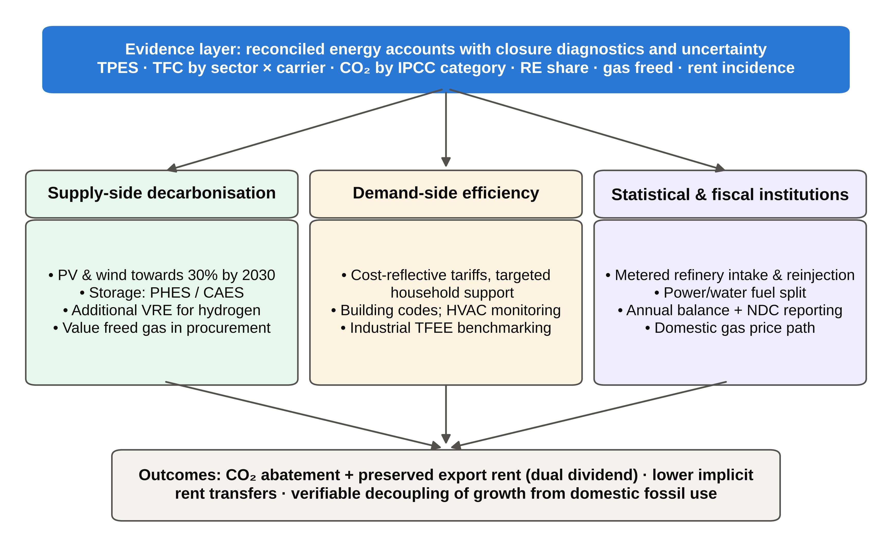
Fig. 14. Policy framework linking the reconciled evidence layer to supply-side, demand-side and institutional instruments.
Table 11. Policy instruments and supporting evidence.
Instrument | Evidence | Lead institutions | Horizon
Meter refinery crude intake, reinjection and plant fuel splits | Crude SD 10.9 Mtoe; oil-field share 20–75%; 3.7 Mtoe unattributed | Ministry of Energy and Minerals; NCSI; operators | Short term
Report all gas on a stated calorific basis | GCV/NCV mixing biased CO₂ by ~10% | NCSI | Short term
Adopt the reconciled balance for NDC reporting | Inventory of 78.4 Mt with 1.A.1 categories previously missing | Environment Authority; NCSI | Short term
Gradual domestic gas price path towards opportunity cost | Implicit rent ≈ 5.2% of GDP | Ministry of Finance; regulator | Medium term
Value freed gas in renewable procurement | 1.06 bcm freed in 2025 | OPWP; Ministry of Finance | Short term
Industrial efficiency benchmarking and fuel switching | Industry 40% of TFC; 19.6 Mt CO₂ | Ministry of Energy and Minerals | Medium term
Additionality rules for hydrogen | 16–20 GW for hydrogen versus 3.5–7 GW for the grid | Hydrom; OPWP | Medium term

5.2. Limitations and future work
Table 12 catalogues the limitations. The most important is the crude statistical difference of 10,893 ktoe (219 kb/d). It is reported, not resolved, and its location (unrecorded imports, stock draws or recording of terminal liftings) can be established only with metered refinery intake by crude origin. The combusted share of oil-field gas is calibrated, not measured, and its range spans a factor of nearly four. The split of power-and-water fuel and the feedstock estimates rest on engineering parameters. The Tier 1 inventory excludes flaring (about 3.8 Mt in 2024 according to the GCP), venting, fugitive methane and process emissions (Elvidge et al., 2018). The 2015–2024 decomposition uses international series whose definitions differ from the national balance. Future work should rebuild a national time series on the reconciled basis and move key categories to Tier 2.
Table 12. Remaining limitations and required data.
Limitation | Effect | Required data
Crude SD (219 kb/d) unattributed | Supply-side and use-side TPES differ by 30% | Refinery intake by crude origin; Ras Markaz stock data
Reinjection not separated from fuel use | Dominant source of CO₂ and SSR uncertainty | Field-level reinjection, EOR steam and fuel gas
Power-and-water fuel split | 3.7 Mtoe not attributed to grid electricity | Plant-level fuel, power and water output
Chemical feedstock and naphtha non-energy use | Non-energy use 3,654–5,184 ktoe | Plant feedstock statistics
Duqm product slate | Product factor 0.125–0.135 | Duqm output by product
Tier 1 scope | Flaring, venting, fugitive and process CO₂ excluded | Tier 2/3 upstream, ammonia and cement inventory

6. Conclusions
Applying standard closure checks plant by plant to Oman's 2025 energy accounts revealed problems that arithmetic closure concealed. Gross and net calorific bases had been mixed. Reinjected gas and chemical feedstock had been counted as fuel. Thermal electricity had been counted as primary energy, and the reported LNG feedstock was implausible. Refinery output is consistent with plant capacities and independent consumption data, but recorded crude supply falls 219 kb/d short of it, a gap reported here as an explicit statistical difference. On a net-calorific basis, Oman produces 89.1 Mtoe against use-side primary supply of 36.7 Mtoe, a self-sufficiency ratio of 243%. Fuel-combustion emissions are 78 MtCO₂ (76–87). Between 2015 and 2024 emissions grew by 14.1 Mt, driven by population and energy intensity, with no evidence of decoupling.
Renewables reached 8.85% of generation in 2025, avoiding about 2 MtCO₂ and freeing about 1 bcm of gas. This dual dividend aligns climate policy with the fiscal interests of a rentier state, but it is small relative to the implicit gas rent of about 5% of GDP transferred to domestic users. Deep decarbonization will therefore depend on reforming the pricing and statistical institutions through which that rent is distributed and measured, and transparent annual energy accounts are a precondition for verifying progress towards Oman Vision 2040 and net zero by 2050.

Data availability
The reconciled balance, Monte Carlo outputs, time series and all scripts needed to reproduce the figures and tables are openly available at https://github.com/AnasGhawanmeh/JB (directory paper/) under a CC BY 4.0 licence; a versioned archive with a Zenodo DOI will be created on acceptance. Confidential company-level source data are not included; the aggregate inputs used are listed in the model code.

Declaration of generative AI and AI-assisted technologies in the writing process
During the preparation of this work the authors used an AI assistant (Claude, Anthropic) for drafting support, figure scripting and language editing. The authors reviewed and edited all content, verified all references against their DOIs or publisher records, and take full responsibility for the publication.

References
Abdel-Gadir, S.E.M. and Mohammed, M.G.A. (2024) ‘Oman’s green horizon: steering towards sustainability through decarbonization and energy transition’, Sustainability, 16(21), 9375. https://doi.org/10.3390/su16219375
Al-Abri, Z.M., Alawasa, K.M., Al-Abri, R.S., Al-Hinai, A.S. and Awad, A.S.A. (2024) ‘Multi-criteria decision-making approach for optimal energy storage system selection and applications in Oman’, Energies, 17(20), 5197. https://doi.org/10.3390/en17205197
Al-Badi, A. and AlMubarak, I. (2019) ‘Growing energy demand in the GCC countries’, Arab Journal of Basic and Applied Sciences, 26(1), pp. 488–496. https://doi.org/10.1080/25765299.2019.1687396
Al-Badi, A.H., Malik, A. and Gastli, A. (2011) ‘Sustainable energy usage in Oman—opportunities and barriers’, Renewable and Sustainable Energy Reviews, 15(8), pp. 3780–3788. https://doi.org/10.1016/j.rser.2011.06.007
Al-Iriani, M.A. (2006) ‘Energy–GDP relationship revisited: an example from GCC countries using panel causality’, Energy Policy, 34(17), pp. 3342–3350.
Al-Maamary, H.M.S., Kazem, H.A. and Chaichan, M.T. (2017a) ‘Climate change: the game changer in the Gulf Cooperation Council region’, Renewable and Sustainable Energy Reviews, 76, pp. 555–576. https://doi.org/10.1016/j.rser.2017.03.048
Al-Maamary, H.M.S., Kazem, H.A. and Chaichan, M.T. (2017b) ‘The impact of oil price fluctuations on common renewable energies in GCC countries’, Renewable and Sustainable Energy Reviews, 75, pp. 989–1007. https://doi.org/10.1016/j.rser.2016.11.079
Almasri, R.A. and Narayan, S. (2021) ‘A recent review of energy efficiency and renewable energy in the Gulf Cooperation Council (GCC) region’, International Journal of Green Energy, 18(14), pp. 1441–1468. https://doi.org/10.1080/15435075.2021.1904941
Al-Sarihi, A. and Cherni, J.A. (2023) ‘Political economy of renewable energy transition in rentier states: the case of Oman’, Environmental Policy and Governance, 33(4), pp. 423–439. https://doi.org/10.1002/eet.2041
Amoatey, P., Al-Hinai, A., Al-Mamun, A. and Said Baawain, M. (2022) ‘A review of recent renewable energy status and potentials in Oman’, Sustainable Energy Technologies and Assessments, 51, 101919. https://doi.org/10.1016/j.seta.2021.101919
Ang, B.W. (2015) ‘LMDI decomposition approach: a guide for implementation’, Energy Policy, 86, pp. 233–238. https://doi.org/10.1016/j.enpol.2015.07.007
Ang, B.W., Choong, W.L. and Ng, T.S. (2015) ‘Energy security: definitions, dimensions and indexes’, Renewable and Sustainable Energy Reviews, 42, pp. 1077–1093. https://doi.org/10.1016/j.rser.2014.10.064
Argus Media (2023) ‘COP: Oman updates NDC with more ambitious 2030 goal’, Argus Media, 30 November.
Argus Media (2025) ‘Oman’s Duqm refinery mulls raising capacity further’, Argus Media.
Beblawi, H. and Luciani, G. (eds) (1987) The Rentier State. London: Croom Helm.
Bekhet, H.A., Matar, A. and Yasmin, T. (2017) ‘CO2 emissions, energy consumption, economic growth, and financial development in GCC countries: dynamic simultaneous equation models’, Renewable and Sustainable Energy Reviews, 70, pp. 117–132. https://doi.org/10.1016/j.rser.2016.11.089
CEIC (2026) Oman Crude Oil: Exports (series based on OPEC data). Available at: https://www.ceicdata.com/en/indicator/oman/crude-oil-exports (accessed 11 October 2026).
Charabi, Y., Al-Awadhi, T. and Choudri, B.S. (2018) ‘Strategic pathways and regulatory choices for effective GHG reduction in hydrocarbon based economy: case of Oman’, Energy Reports, 4, pp. 653–659. https://doi.org/10.1016/j.egyr.2018.10.005
Davis, S.J., Peters, G.P. and Caldeira, K. (2011) ‘The supply chain of CO2 emissions’, Proceedings of the National Academy of Sciences, 108(45), pp. 18554–18559. https://doi.org/10.1073/pnas.1107409108
Denholm, P. and Hand, M. (2011) ‘Grid flexibility and storage required to achieve very high penetration of variable renewable electricity’, Energy Policy, 39(3), pp. 1817–1830. https://doi.org/10.1016/j.enpol.2011.01.019
Elvidge, C.D., Bazilian, M.D., Zhizhin, M., Ghosh, T., Baugh, K. and Hsu, F.C. (2018) ‘The potential role of natural gas flaring in meeting greenhouse gas mitigation targets’, Energy Strategy Reviews, 20, pp. 156–162. https://doi.org/10.1016/j.esr.2017.12.012
Ember (2026) Yearly Electricity Data. London: Ember. Available via the Our World in Data energy dataset (accessed 11 October 2026).
Energy Institute (2025) Statistical Review of World Energy 2025 and Methodology 2025. London: Energy Institute.
Energy Intelligence (2025) Oman: country profile. Available at: https://www.energyintel.com/wcod/country-profile/oman (accessed 11 October 2026).
Eurostat (2021) Energy Balance Guide: Methodology Guide for the Construction of Energy Balances. Luxembourg: European Commission.
Fattouh, B. and El-Katiri, L. (2013) ‘Energy subsidies in the Middle East and North Africa’, Energy Strategy Reviews, 2(1), pp. 108–115. https://doi.org/10.1016/j.esr.2012.11.004
FRED (2025) Crude Oil Exports for Oman (OMNNXGOCMBD), source: International Monetary Fund. Federal Reserve Bank of St. Louis. Available at: https://fred.stlouisfed.org/series/OMNNXGOCMBD (accessed 11 October 2026).
Geels, F.W. (2002) ‘Technological transitions as evolutionary reconfiguration processes: a multi-level perspective and a case-study’, Research Policy, 31(8–9), pp. 1257–1274. https://doi.org/10.1016/S0048-7333(02)00062-8
Gielen, D., Boshell, F., Saygin, D., Bazilian, M.D., Wagner, N. and Gorini, R. (2019) ‘The role of renewable energy in the global energy transformation’, Energy Strategy Reviews, 24, pp. 38–50. https://doi.org/10.1016/j.esr.2019.01.006
Goldthau, A. and Westphal, K. (2019) ‘Why the global energy transition does not mean the end of the petrostate’, Global Policy, 10(2), pp. 279–283. https://doi.org/10.1111/1758-5899.12649
Grossman, G.M. and Krueger, A.B. (1995) ‘Economic growth and the environment’, The Quarterly Journal of Economics, 110(2), pp. 353–377. https://doi.org/10.2307/2118443
Gulf News (2013) ‘Oman to double natural gas prices for some industrial users by 2015’, Gulf News.
Gulf News (2025) ‘Oman allocates $4.1b in 2025 budget to curb inflation, support essential services’, Gulf News.
Hirth, L. (2013) ‘The market value of variable renewables: the effect of solar wind power variability on their relative price’, Energy Economics, 38, pp. 218–236. https://doi.org/10.1016/j.eneco.2013.02.004
Hu, J.-L. and Wang, S.-C. (2006) ‘Total-factor energy efficiency of regions in China’, Energy Policy, 34(17), pp. 3206–3217. https://doi.org/10.1016/j.enpol.2005.06.015
IEA (2021) Ammonia Technology Roadmap: Towards More Sustainable Nitrogen Fertiliser Production. Paris: International Energy Agency.
IEA (2023a) World Energy Balances: Database Documentation. Paris: International Energy Agency.
IEA (2023b) Renewable Hydrogen from Oman: A Producer Economy in Transition. Paris: International Energy Agency.
IMF (2024) ‘Oman: IMF staff concludes staff visit’, Press Release No. 24/154. Washington, DC: International Monetary Fund.
IPCC (2006) 2006 IPCC Guidelines for National Greenhouse Gas Inventories, Volume 2: Energy. Eggleston, H.S., Buendia, L., Miwa, K., Ngara, T. and Tanabe, K. (eds). Hayama: Institute for Global Environmental Strategies.
Kaya, Y. and Yokobori, K. (eds) (1997) Environment, Energy, and Economy: Strategies for Sustainability. Tokyo: United Nations University Press.
Krane, J. (2019) Energy Kingdoms: Oil and Political Survival in the Persian Gulf. New York: Columbia University Press.
Kuunifaa, C.B., Dzamesi, S.K.A., Kabo-Bah, A.T., Domfeh, M.K., Tutu-Benefoh, D. and Sey, N.E.N. (2026) ‘The challenges of greenhouse gas emission reporting in emerging economies: lessons from Ghana’s energy sector’, Energy and Climate Change, 7, 100249. https://doi.org/10.1016/j.egycc.2026.100249
Lahn, G. and Stevens, P. (2011) Burning Oil to Keep Cool: The Hidden Energy Crisis in Saudi Arabia. London: Chatham House.
Leal-Arcas, R., Almashloum, S., Jazzar, R., Bin Saleh, N. and Almunifi, R. (2025) ‘Energy policy of Oman: pursuing decarbonization’, Energies, 18(5), 1270. https://doi.org/10.3390/en18051270
Lee, I., Park, J. and Moon, I. (2018) ‘Key issues and challenges on the liquefied natural gas (LNG) value chain: a review from the process systems engineering point-of-view’, Industrial & Engineering Chemistry Research, 57(17), pp. 5805–5818. https://doi.org/10.1021/acs.iecr.7b03899
Liu, B., Shan, Y., Guan, Y., Davis, S.J., Hang, Y., Jing, L., Ji, X., Wang, W. and Hubacek, K. (2026) ‘Global combustion CO2 accounting neglects the origin of traded fossil fuels’, Environmental Science & Technology, 60(36), pp. 25385–25396. https://doi.org/10.1021/acs.est.6c01630
Marzouk, O.A. (2024) ‘Portrait of the decarbonization and renewables penetration in Oman’s energy mix, motivated by Oman’s national green hydrogen plan’, Energies, 17(19), 4769. https://doi.org/10.3390/en17194769
Ministry of Finance (2025) ‘Oman’s GDP rises 1.7%’. Muscat: Ministry of Finance, Sultanate of Oman.
Mishrif, A. and Khan, A. (2024) ‘Non-industrial solar energy use, barriers, and readiness: case study of Oman’, Energies, 17(16), 3917. https://doi.org/10.3390/en17163917
Mitsubishi Heavy Industries (2009) Chemical Plants Project Records: Sohar International Urea and Chemical Industries ammonia (2,000 t/d) and urea plants. Tokyo: MHI.
Mondal, M.A.H., Hawila, D., Kennedy, S. and Mezher, T. (2016) ‘The GCC countries RE-readiness: strengths and gaps for development of renewable energy technologies’, Renewable and Sustainable Energy Reviews, 54, pp. 1114–1128. https://doi.org/10.1016/j.rser.2015.10.098
Nagovnak, P., Kienberger, T., Baumann, M., Binderbauer, P. and Vouk, T. (2022) ‘Improving the methodology of national energy balances to adapt to the energy transition’, Energy Strategy Reviews, 44, 100994. https://doi.org/10.1016/j.esr.2022.100994
NCSI (2026) Statistical Year Book 2026. Muscat: National Centre for Statistics and Information.
Neelis, M.L. and Pouwelse, J.W. (2008) ‘Towards consistent and reliable Dutch and international energy statistics for the chemical industry’, Energy Policy, 36(7), pp. 2719–2733. https://doi.org/10.1016/j.enpol.2008.03.024
Oman Observer (2026) ‘OMIFCO, IGC to finalise gas deal for expansion’, Oman Observer.
OPWP (2024) OPWP’s 7-Year Statement (2024–2030). Muscat: Oman Power and Water Procurement Company.
Our World in Data (2026) CO₂ and Greenhouse Gas Emissions Dataset and Energy Dataset (compiled from the Global Carbon Project, Energy Institute and Ember). Available at: https://github.com/owid (accessed 11 October 2026).
Oxford Business Group (2019) ‘Refined development: the Duqm refinery project will double downstream throughput’, in The Report: Oman 2019. London: Oxford Business Group.
Patterson, M.G. (1996) ‘What is energy efficiency? Concepts, indicators and methodological issues’, Energy Policy, 24(5), pp. 377–390. https://doi.org/10.1016/0301-4215(96)00017-1
Praveen, R.P., Keloth, V., Abo-Khalil, A.G., Alghamdi, A.S., Eltamaly, A.M. and Tlili, I. (2020) ‘An insight to the energy policy of GCC countries to meet renewable energy targets of 2030’, Energy Policy, 147, 111864. https://doi.org/10.1016/j.enpol.2020.111864
Proman (2024) Oman Methanol Company, Sohar: plant profile. Wollerau: Proman AG.
QCIntel (2025) ‘Oman’s Duqm refinery expands by 10%, reaches 255kbpd: CEO’, QCIntel.
Salahuddin, M. and Gow, J. (2014) ‘Economic growth, energy consumption and CO2 emissions in Gulf Cooperation Council countries’, Energy, 73, pp. 44–58. https://doi.org/10.1016/j.energy.2014.05.054
Sovacool, B.K. (2016) ‘How long will it take? Conceptualizing the temporal dynamics of energy transitions’, Energy Research & Social Science, 13, pp. 202–215. https://doi.org/10.1016/j.erss.2015.12.020
Sovacool, B.K. and Mukherjee, I. (2011) ‘Conceptualizing and measuring energy security: a synthesized approach’, Energy, 36(8), pp. 5343–5355. https://doi.org/10.1016/j.energy.2011.06.043
Stern, D.I. (2004) ‘The rise and fall of the environmental Kuznets curve’, World Development, 32(8), pp. 1419–1439. https://doi.org/10.1016/j.worlddev.2004.03.004
Sultanate of Oman (2020) Oman Vision 2040. Muscat: Oman Vision 2040 Implementation Follow-up Unit.
Sultanate of Oman (2021) Second Nationally Determined Contribution. Bonn: UNFCCC.
Szalai, M., Shamieh, R. and Colombo, M. (2025) Cutting through the Green Hype: The Political Economy of Renewable Energy in the UAE and Oman. The Hague: Clingendael Institute. Available at: https://www.jstor.org/stable/resrep69151
Szklo, A. and Schaeffer, R. (2007) ‘Fuel specification, energy consumption and CO2 emission in oil refineries’, Energy, 32(7), pp. 1075–1092. https://doi.org/10.1016/j.energy.2006.08.008
Tanaka, K. (2008) ‘Assessment of energy efficiency performance measures in industry and their application for policy’, Energy Policy, 36(8), pp. 2887–2902. https://doi.org/10.1016/j.enpol.2008.03.032
UNSD (2018) International Recommendations for Energy Statistics (IRES). Statistical Papers, Series M, No. 93. New York: United Nations.
Venkatachalam, S.D., Al Nadabi, A., Al Shukaili, A.A., Al Hinai, A.S., Al Shuaili, A.S. and Al Shukaili, I.S. (2025) ‘Performance and suitability analysis of rooftop solar PV in Oman: a case study of university branches’, Heliyon, 11, e42578. https://doi.org/10.1016/j.heliyon.2025.e42578

Appendix A. Emission factors
Table A.1. IPCC (2006) default CO₂ emission factors (NCV basis).
Fuel | Carbon content (kg C/GJ) | EF (kg CO₂/TJ) | EF (t CO₂/toe)
Crude oil | 20.0 | 73,300 | 3.0689
Motor gasoline | 18.9 | 69,300 | 2.9015
Jet kerosene | 19.5 | 71,500 | 2.9936
Gas/diesel oil | 20.2 | 74,100 | 3.1024
LPG | 17.2 | 63,100 | 2.6419
Residual fuel oil | 21.1 | 77,400 | 3.2406
Naphtha/other | 20.0 | 73,300 | 3.0689
Refinery gas | 15.7 | 57,600 | 2.4116
Natural gas | 15.3 | 56,100 | 2.3488
Anthracite/bituminous coal | 26.8 | 98,300 | 4.1156
Lignite | 27.6 | 101,000 | 4.2287
Source: IPCC (2006), Volume 2, Chapter 1, Table 1.4.

Appendix B. Product-specific conversion factors
Table B.1. Product-specific conversion factors and the Sohar–Mina Al Fahal product slate.
Product | NCV (GJ/t) | Density (t/m³) | Factor (ktoe/kbbl) | Output (kbbl) | Output (ktoe)
Diesel / gas oil | 43.0 | 0.845 | 0.1380 | 35,254 | 4,864
Naphtha / other | 44.5 | 0.700 | 0.1183 | 28,111 | 3,325
Gasoline 91 | 44.3 | 0.745 | 0.1253 | 16,540 | 2,073
Gasoline 95 | 44.3 | 0.745 | 0.1253 | 14,887 | 1,866
Jet / kerosene | 44.1 | 0.800 | 0.1340 | 11,712 | 1,569
LPG | 47.3 | 0.540 | 0.0970 | 8,112 | 787
Fuel oil | 40.4 | 0.960 | 0.1473 | 524 | 77
Slate (mix-weighted) |  |  | 0.1265 | 115,140 | 14,561
NCV from IPCC (2006); densities are typical values. Factor = density × 0.158987 m³/bbl × NCV / 41.868 GJ/toe. Duqm output (95,693 kbbl) has no product breakdown and is converted at 0.130 ktoe/kbbl (U(0.125, 0.135)).

