Uncovering the ‘Grid Penalty’ and Pollution Swaps in Transport Decarbonization: A Well-to-Wheel Life Cycle Assessment of the Jordanian Fleet

Abstract
Jordan’s transportation sector faces two competing challenges: meeting growing mobility demands while addressing severe environmental degradation. International decarbonization strategies commonly presume that EVs are charged from a power system that has already been largely decarbonized; in developing economies whose electricity generation remains dependent on fossil fuels, this presumption is seldom valid. The present research examines it through the Jordanian case by evaluating the environmental burdens and health impacts of national transport. A Well-to-Wheel Life Cycle Assessment (LCA) of the 2022 vehicle fleet was conducted with the SimaPro simulation tool and the ReCiPe 2016 Endpoint (H) method. Four hypothetical mitigation strategies were then quantified — a 20% share of electric vehicles (EVs), expansion of public bus services, implementation of Euro 6 standards, and complete electrification — and their durability against real-world fluctuations was tested through a stochastic Monte Carlo simulation of 10,000 iterations.
Under the business-as-usual baseline for 2022, the sector generates approximately 2.8 ×10³ Gg CO₂-eq, a health burden of 2,790 Disability-Adjusted Life Years (DALYs), and resource damages valued at nearly 1.62 billion dollars. Converting one fifth of the fleet to EVs lowers emissions overall; however, a considerable part of this gain is absorbed by the fossil-dominated electricity grid used for charging, an effect termed here the “grid penalty.” Transferring commuters to conventional diesel buses provides a similar warning from the opposite direction: aggregate CO₂ declines, yet poorly occupied buses raise localized PM2.5 formation and health risk, producing a “pollution swap.” None of the three incremental pathways (EVs, buses or Euro 6) brings sector emissions below a threshold of approximately 2,400 Gg by itself. Complete electrification is the only option that does so, lowering the carbon footprint under 500 Gg and the health burden to about 449 DALYs. This paper therefore seeks to offer decision makers in developing economies an evidence-based basis for handling these trade-offs: diesel-based “transition” technologies should be bypassed, and EV deployment should be synchronized with renewable grid expansion instead of presuming that the grid will simply follow.

Keywords
Decarbonization of transport; LCA; stochastic Monte Carlo analysis; Well-to-Wheel; battery electric mobility; Short-Lived Climate Pollutants (SLCPs); Disability-Adjusted Life Years (DALY); Jordan

1. Introduction
Transport is one of the most important sectors regarding the foundation of modern society; it creates global economies and promotes social mobility, but it has also become a rapidly expanding source of global greenhouse gas (GHG) emissions (UNFCCC, 2022), and fast mitigation of this sector is essential for meeting international climate targets (IPCC, 2022). According to the IPCC, marginal efficiency gains achieved by modern engines are not sufficient; every mode requires a deep, structural transformation (IPCC, 2022). Consequently, the international community has converged around a hierarchical “Avoid-Shift-Improve” (A-S-I) paradigm (Jarre et al., 2024). Under “Shift,” private car passengers move to high-capacity alternatives such as Bus Rapid Transit (BRT) or electrified rail, lowering congestion and improving urban air quality (WHO, 2023; Bastos et al., 2019). Under “Improve,” vehicles and fuels become more efficient, chiefly through electrification. The International Energy Agency projects continued global growth in battery electric vehicle (BEV) sales (IEA, 2024), mainly because EVs are regarded as an effective tool for cutting both CO₂ and Short-Lived Climate Pollutants (SLCPs) in cities (Shindell et al., 2012).
Such reasoning works in high-income nations whose grids are comparatively clean, yet it becomes problematic in developing economies. The expectation that EVs and mass transit lower net emissions depends entirely on a low-carbon power supply. In countries where population and car ownership increase quickly while generation is still based mainly on fossil fuels, this expectation must be verified rather than assumed. The Middle East and North Africa (MENA) region offers a clear example: decades of reliance on fossil fuels for both mobility and electricity have created barriers to EV adoption across the region (Evensen et al., 2025; Al-Alawi and Al-Alawi, 2022), so that decarbonizing transport there is closely linked to the progress of the overall energy transition.
The Hashemite Kingdom of Jordan represents this challenge well. Lacking domestic oil, Jordan is an energy-importing economy that purchases most of its fuel abroad to sustain a growing population and economy (MEMR, 2022). Transport is responsible for about 16% of national GHG emissions and 49% of final energy consumption, making it a key focus area for mitigation (MoEnv, 2022; Jelti et al., 2021). Energy security has improved — solar and wind provided around 27% of grid capacity in 2022 (NEPCO, 2022) — but baseload electricity is still supplied mostly by fossil sources. Since the carbon footprint of a BEV is governed by the carbon content of its charging electricity (Qiao et al., 2019), the climate value of expanding EV ownership in Jordan is decided as much at the power station as at the exhaust pipe.
Adding EVs to a grid of this kind may produce what this study calls a “grid penalty”: rather than disappearing, emissions are shifted from vehicle exhausts to a limited number of central generating stations. A full life cycle perspective is required to determine whether such a shift still supports the national pledge, made in Jordan’s updated Nationally Determined Contribution, of a 31% GHG reduction by 2030 (Ministry of Environment, 2021).
Traditional transport inventories generally consider only exhaust emissions, known as the Tank-to-Wheel (TTW) perspective. Such an approach can serve urban air-quality monitoring, but it ignores the Well-to-Tank (WTT) emissions associated with the extraction, refining and distribution of fuel. This omission becomes critical when assessing EVs or mass transit, whose energy and material demands occur largely upstream, prior to any operation on the road (Nordelöf et al., 2014; Mashayekh, 2020). Unaccounted upstream burdens are not eliminated; they are transferred to another region or converted into a different kind of environmental damage, a process described here as a “pollution swap” (Requia et al., 2018).
Previous studies have identified a substantial “carbon debt” created by battery production, with manufacturing-stage emissions frequently double those of conventional cars (Lai et al., 2022; IEA, 2021a; Ashraf et al., 2025). Repayment of this debt over the operating life depends almost wholly on how carbon-intensive the charging electricity is. Under a fossil-dominated grid such as Jordan’s, pollution moves from millions of exhaust pipes to a handful of generating sites, representing the most acute form of the grid penalty (Qiao et al., 2019; Buberger et al., 2022; Nanaki and Koroneos, 2016). Evidence from the Global South confirms this pattern: across ten leading EV markets in developing countries, BEV emissions mirror the national generation mix almost exactly; hydro-dominated Brazil already satisfies global climate goals, whereas coal-based systems remain well short of them (Aryan et al., 2025).
Modal shift toward public transport also involves an overlooked danger. Replacing private gasoline trips with heavy-duty diesel buses decreases mean CO₂ per journey, yet it may strongly raise local toxic exposure. Within the transport sector, diesel engines account for approximately 90% of black carbon emissions (Brewer, 2019), and black carbon is considered the second greatest contributor to human-induced warming after CO₂ (Bond et al., 2013). Being part of PM2.5, these particles can penetrate the deepest regions of the lungs and pass into the blood, raising the risk of ischemic heart disease, stroke and lung cancer (Haines et al., 2009; Requia et al., 2018). Diesel buses therefore impose a health cost exactly in the places where the shift is presented as an improvement (Grutter, 2014).
This trade-off forms the core of the present investigation. When a commuter leaves a car for a diesel bus, CO₂ per passenger falls; however, if occupancy is low, local damage in the form of higher fine particulate formation and stratospheric ozone depletion may exceed the climate benefit. Exposure is further amplified in “microenvironments” such as bus stops and busy street canyons, where concentrations exceed the urban background (Morales Betancourt et al., 2017). Consequently, an intervention can perform well in global carbon accounting while harming residents who inhale the polluted air along its corridors.

2. Methodology
Unlike a conventional single-perspective inventory, this study incorporates the upstream energy and supply chains overlooked by exhaust-based accounting, and it follows two particular trade-offs. First, the grid penalty: running EVs on electricity generated mainly from fossil fuels does not remove GHG emissions but transfers them from urban streets to central generating stations (Requia et al., 2018). Second, the Well-to-Wheel perspective shows that the fossil resource scarcity of combustion vehicles is exchanged for mineral resource scarcity arising from lithium-ion battery manufacture (Lai et al., 2022; Qiao et al., 2019). Complete details of the modelling framework, data collection and inventory are provided in Ghawanmeh (2026).
The mathematical basis for the Life Cycle Inventory (LCI) phase is the solution to the linear system represented by Equation (1):
s = A⁻¹ f (1)
Where s denotes the scale-factor vector (the volume of each process necessary), A denotes the technology matrix (representing the input and output of each unit process), and f denotes the final demand vector (the functional unit, i.e., the total annual transportation in Jordan).
During the Life Cycle Impact Assessment (LCIA) phase, characterization factors (Q) transform the inventory results (g, the elementary flows) into impact categories (h), according to Equation (2):
h_{i} = Σ_{j} Q_{ij} × g_{j} (2)
in which hi represents the indicator obtained for impact category i (e.g., Climate Change), Qij represents the characterization factor through which elementary flow j contributes to category i, and gj represents the magnitude of elementary flow j (e.g., the weight of CO₂ released).
Effects are assessed with ReCiPe 2016 at two levels, namely problem-oriented midpoints and damage-oriented endpoints. To maintain result stability and international comparability, Ecoinvent 3.x was chosen as the main source of product life cycle data under the ‘Allocation, cut-off by classification’ system model (Weidema et al., 2013), and the outputs were then transferred into a Microsoft Excel database for analysis. Results can therefore be compared consistently with other assessments at national scale.

2.1 The Four-Stage LCA Framework and SimaPro
LCA is considered a standardized method of scientific evaluation that identifies and quantifies the energy and materials consumed, as well as the waste and environmental releases associated with a product, process or activity (ISO, 2006a; Mashayekh, 2020). In accordance with ISO 14040 and 14044, each assessment in this research comprises four separate phases: definition of goal and scope, inventory analysis (LCI), impact assessment (LCIA), and interpretation (ISO, 2006a; ISO, 2006b; Bare et al., 2002). These phases do not operate as isolated, strictly sequential tasks; interpretation often leads back to revisions of the scope or inventory, as happened while the scenarios of Section 2.4 were being developed.
- Goal and scope: specifies the purpose of the study, the system examined, the functional unit used to express the results, and where the boundary is drawn. Here, the boundary follows the Well-to-Wheel definition in Section 2.2 and encompasses all annual activity of Jordanian road vehicles in 2022.
- LCI: the stage of data acquisition, during which a comprehensive listing of all input energies and materials, together with every associated emission, is compiled for fuel supply, power generation and vehicle use, then arranged in the technology matrix of Equation (1).
- LCIA: converts inventory data, e.g. kilograms of CO₂ or NOx emitted, into environmental and health categories by means of the Equation (2) characterization factors, using the ReCiPe 2016 approach explained in Section 2.3 (Mashayekh, 2020).
- Interpretation: evaluates the LCIA outputs for consistency and completeness and determines which processes or scenarios dominate the outcome; Sections 3 and 4 report this stage.
The framework was applied in SimaPro, the most widely used software for carrying out detailed Life Cycle Assessments, which permits modelling of complex systems with extensive LCI databases such as Ecoinvent (Mashayekh, 2020; Weidema et al., 2013). Tool selection matters. Scenario-based platforms like the Low Emissions Analysis Platform (LEAP) are designed for macro-level policy analysis of energy systems and atmospheric emissions (Heaps, n.d.), while SimaPro offers micro-level, “cradle-to-grave” resolution of the entire footprint of an individual product, process or service. Owing to this granularity, both the grid penalty and the pollution swap can be followed to specific vehicle technologies and fuel chains instead of being observed only for the sector in aggregate (Buberger et al., 2022).

2.2 System Boundaries
Well-to-Wheel (WTW) analysis is the only true basis on which a comparison can be made between conventional and electric drivetrains, because it incorporates both the energy needed to supply each carrier and the energy consumed during driving (Nordelöf et al., 2014; Requia et al., 2018), as presented in Figure 1. The boundary comprises two stages:
- Well-to-Tank (WTT): the fuel cycle — crude extraction, shipping to the Port of Aqaba, processing at the Jordan Petroleum Refinery Company, and distribution within Jordan by tanker trucks, an energy-intensive supply chain (MEMR, 2022; World Bank, 2022). For EVs, the corresponding pathway is the “electricity cycle,” comprising generation, transmission and distribution on a national grid supplied by imported natural gas, domestic oil shale and roughly 27% renewables (NEPCO, 2022). A country-specific procedure based on “market for electricity, medium voltage [JO]” ensured that charging burdens reflect the real carbon content of Jordanian power, independently reported at approximately 391 gCO₂-eq/kWh (Low Carbon Power, 2022). Precise representation of this pathway is essential for quantifying the grid penalty where generation remains predominantly fossil-based (Evensen et al., 2025).
- Tank-to-Wheel (TTW): the operational stage — emissions resulting from fuel combustion inside the engine of conventional vehicles, plus brake and tyre abrasion shared by every vehicle type. EVs have no TTW exhaust, which explains their local air-quality benefit.
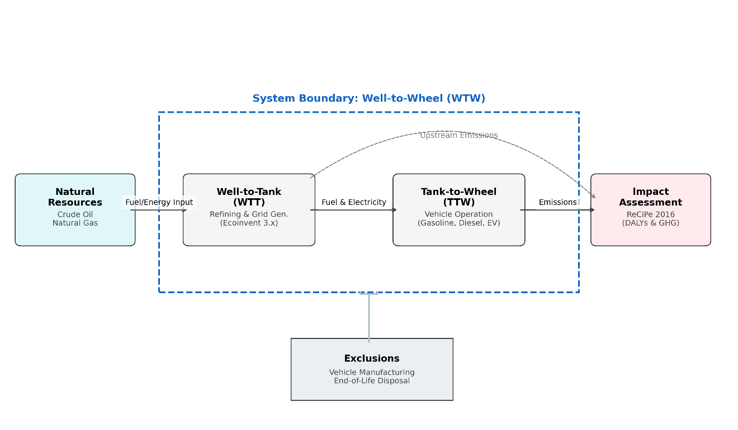
Figure 1: Well-to-Wheel LCA system boundary for the transport sector of Jordan.
Attention is placed on practical energy use during operation; vehicle manufacturing (cradle-to-gate) and final disposal (grave-to-cradle) were strictly excluded from the scope. Such exclusion harmonizes the scope with the national guidelines on emissions inventory reporting and prevents double counting of production burdens that belong to the countries manufacturing the imported bodies and batteries, since Jordan does not currently possess a domestic vehicle manufacturing base. Published evidence confirms that EV production entails greater initial carbon and material loads than conventional manufacturing (IEA, 2024; Qiao et al., 2019); omitting this stage concentrates the analysis on national energy flows and on operational decisions within the control of Jordanian authorities, without repeating burdens already recorded in other nations’ inventories.

2.3 Life Cycle Impact Assessment
Every input was characterized with ReCiPe 2016 Endpoint (H) (Huijbregts et al., 2017). As explained by Bare et al. (2002), the Hierarchist (H) perspective fits national strategic planning, since it represents a widely accepted scientific consensus instead of an extreme optimistic or pessimistic position. It was selected because of its ability to report environmental burdens at two different levels:
- Midpoints (problem-oriented): eighteen categories in total, among which this paper emphasizes GWP100, PM2.5 formation, stratospheric ozone depletion, human non-carcinogenic toxicity and mineral resource scarcity, chosen for their direct relevance to GHGs and SLCPs. They allow the pollution swap to be quantified; transferring car users to diesel buses can lower GWP while raising particulate formation to a degree that creates a genuine local air-quality concern (Fantke et al., 2017).
- Endpoints (damage-oriented): midpoints are aggregated into three areas of protection — human health (DALYs), ecosystem quality (species.yr) and resources (USD). DALYs link environmental engineering with public health, converting exhaust and power-plant emissions into lost years of healthy life. The resource indicator compares fossil depletion with the depletion of battery minerals, showing that the transition changes the type of resource dependence rather than eliminating environmental cost.

2.4 Scenario Design
Guided by the A-S-I framework and by national priorities set in the NDC and the National Climate Change Policy 2022–2050 (Jarre et al., 2024; Ministry of Environment, 2021; MoEnv, 2022), four mitigation scenarios were designed to isolate the real behaviour of the grid penalty and the pollution swap, as summarized in Figure 2. For each case, the baseline configuration was repeated and renamed, and specific parameters were altered to represent the corresponding initiative.
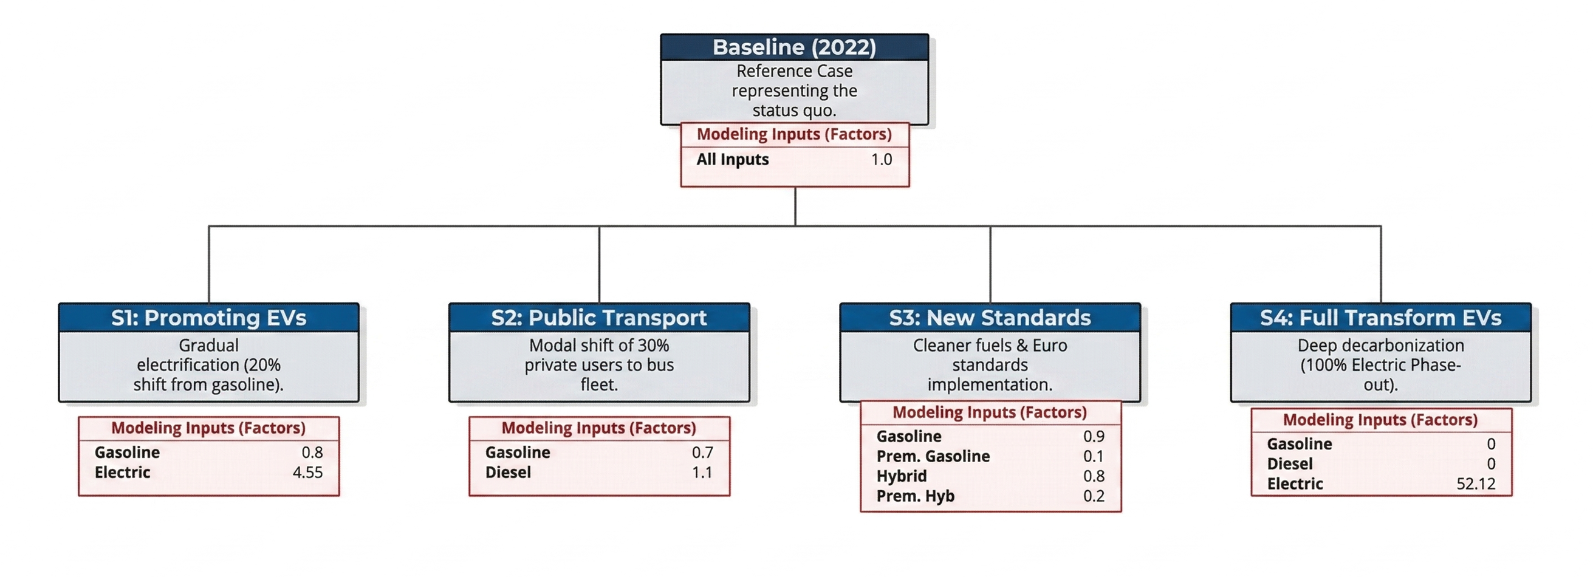
Figure 2: Roadmap of mitigation scenarios and the modelling inputs used in SimaPro.
The following scenarios were evaluated:
- Baseline (Status Quo 2022): the “Business-as-Usual” (BAU) reference, involving no policy actions beyond those in force by 2022. Approximately 1.85 million registered vehicles, mostly gasoline cars and diesel trucks fuelled by imports (Ghawanmeh, 2026), are represented, and EVs draw power from the 2022 generation mix (NEPCO, 2022). Separate process definitions for every vehicle and fuel type were linked into a final national assembly, each scaled to one unit equivalent to the total annual activity of that fleet type. Every alternative is evaluated relative to this reference.
- Scenario 1 — Promoting EVs (technological substitution): one fifth of private gasoline cars are switched to BEVs that continue to charge from today’s fossil-heavy grid. Gasoline consumption was lowered by the same proportion as the displaced conventional vehicles, and the amount reduced was translated into equivalent kWh supplied to the EV process via “market for electricity, medium voltage [JO].” The case examines how far the grid penalty extends, i.e., whether power-sector burdens offset the avoided exhaust (Evensen et al., 2025).
- Scenario 2 — Enhancing Public Transportation (modal shift): private car passenger-kilometres are reassigned to conventional diesel buses, modelled with an Ecoinvent dataset for a modern European bus fleet; the diesel needed to serve the new passenger demand was estimated and entered as an input. This allows direct comparison between avoided gasoline emissions and incurred bus emissions, exposing the pollution swap — the balance between lower total CO₂ and higher local toxic and particulate pollution (Grutter, 2014).
- Scenario 3 — Stricter Emission Standards (end-of-pipe mitigation): Euro 6 engines are introduced, and regular gasoline is partly substituted with premium, low-sulphur fuel. The case examines whether improved combustion by itself can deliver the deep cuts demanded by international climate obligations (UNFCCC, 2022).
- Scenario 4 — Full Transformation (deep decarbonization): the maximum theoretical mitigation, converting one hundred percent of the fleet to electric power; gasoline, hybrid and diesel inputs were intentionally set to zero, and the total energy content of the displaced fuels was converted into the aggregate kWh drawn from the Jordanian grid. It reveals the upper limit of the “Improve” pillar and shows that electrification realizes its complete benefit only in combination with renewable generation (IPCC, 2022).

2.5 Uncertainty Analysis: Monte Carlo Simulation
The traditional deterministic LCA lacks the dynamic information needed to assess the volatility of transport networks in developing economies (Igos et al., 2019; Bisinella et al., 2021). Therefore, a probabilistic uncertainty analysis was performed to test the grid penalty and pollution swap hypotheses against real-world data variation: a Monte Carlo simulation (10,000 trials) was coded in Python following the best practice outlined by Henriksson et al. (2015). Probability distributions were assigned to key inventory parameters, producing a stochastic evaluation on three levels:
- Micro-level vehicle dynamics (grid penalty): probabilistic ranges replaced static averages; Normal distributions simulated the WTW CO₂ footprint of combustion vehicles based on actual driving cycles, traffic congestion and air travel conditions (Cox et al., 2020; Cox et al., 2018). Triangular distributions recalculated the EV footprint dynamically, capturing worst-case peak summer reliance and high battery drain from heavy air-conditioning use in the Middle East (Alotaibi et al., 2022; Koç et al., 2023), where HVAC loads may increase consumption by 20–50% (Alarrouqi et al., 2024). The resulting density curves reveal the point at which the grid penalty ends.
- Micro-level toxicity (pollution swap): bus-related PM2.5 was expressed on a per passenger-kilometre basis. Occupancy, the primary independent variable, followed a broad triangular distribution of 10–60 riders derived from Grutter (2014), superimposed on emission data for various bus types from EMEP/EEA (2019). From this, the ridership threshold beyond which a bus becomes less toxic locally than a private car was determined.
- Macro-level sector scenarios: each of the four pathways was set against the 2022 reference, with triangular distributions applied to total GWP (Gg CO₂-eq) and Human Health (DALYs) derived from ReCiPe 2016 (Huijbregts et al., 2017). The boxplots produced provide statistical confidence intervals and visually separate “incremental traps” — in which Scenarios 1, 2 and 3 overlap and negate policy effectiveness — from structural decarbonization in Scenario 4.

3. Results

3.1 The Baseline Environmental Footprint (2022)
The 2022 operational reference was established within the complete WTW framework, capturing the stress associated with both direct fleet operation and the upstream supply chains of oil and electricity. Findings reveal a sector strongly reliant on imported fossil energy, a reliance that generates two separate problems: climate change and public health.
According to the LCA network analysis (Figure 3), the total carbon footprint base 2022 for the Jordan transport sector is estimated at 2.8 ×10³ Gg CO₂-eq, the aggregate effect of carbon dioxide, methane and nitrous oxide across the fleet. Gasoline vehicles are the largest single emitters, they release 1.27 ×10³ Gg CO₂-eq, almost half of the sector total, which concords with the approximately 60% share of gasoline vehicles in the fleet.
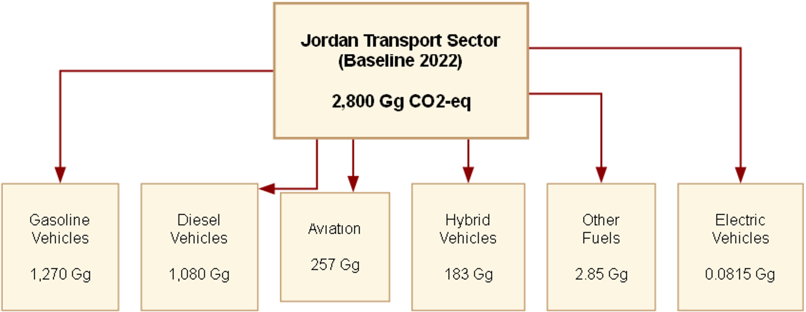
Figure 3: Jordan Transportation sector Baseline 2022 Carbon Footprint.
Table 1 presents the complete midpoint and endpoint findings and demonstrates that judging any fuel solely by GWP overlooks most of its consequences. Long-term climate damage is driven mainly by gasoline, while diesel inflicts a disproportionate share of local harm, reflecting the high SLCP output of heavy-duty diesel engines (Brewer, 2019). The eighteen midpoint categories can be grouped under human health, ecosystem quality and resource scarcity.
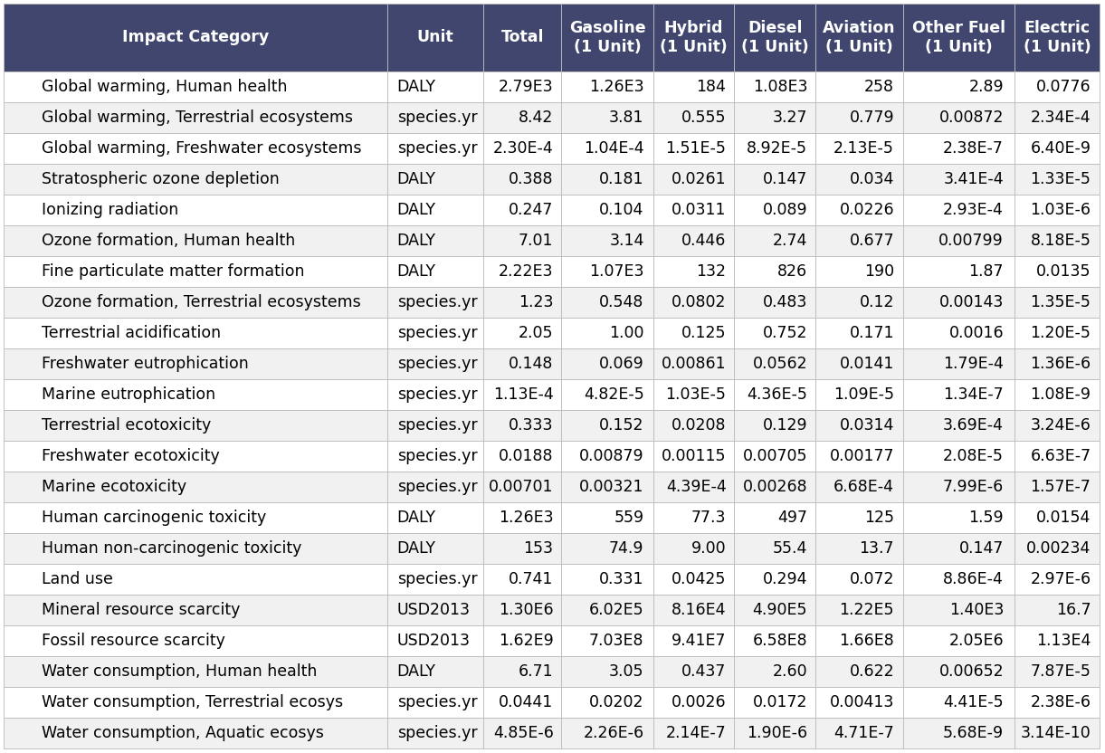
Table 1: Full results at Midpoint characterization for the BAU scenario (2022).
Health damage, measured in DALYs, is considerable. Climate change contributes 2,790 DALYs on its own, while particulate formation contributes another 2,220 DALYs — nearly equal to the warming-related damage, showing that local air quality is as important as long-term climate change in attracting attention and effort.
Among all fuels, diesel exerts the strongest influence on these outcomes, causing 497 DALYs through carcinogenic toxicity and 55.4 DALYs through non-carcinogenic toxicity, plus lesser shares linked to ozone formation (7.01 DALYs) and ionizing radiation (0.247 DALYs). Ground-level ozone, which forms from the reaction between NOx and VOCs, constitutes an additional respiratory threat, and these effects jointly intensify the disease burden of a fossil-reliant transport system.
EVs, in contrast, have a negligible presence across these categories: 0.0776 DALYs for warming-related health effects and 0.0135 DALYs for particulates, several orders of magnitude below gasoline and diesel, which reflects both their limited market share and the efficiency of the electric powertrain.
Biodiversity is also under substantial stress from fuel combustion. Gasoline and diesel are almost exclusively responsible for terrestrial acidification (2.05 species.yr) and ozone-related ecosystem damage (1.23 species.yr), endangering vegetation and soils. Ecotoxic emissions to soil (0.333 species.yr), freshwater (0.0188 species.yr) and the sea (0.00701 species.yr) arise at every step of fuel extraction, processing and use, in addition to land occupation (0.741 species.yr) and eutrophication of freshwater and marine waters. Indicators of water use for humans, terrestrial and aquatic ecosystems point the same way: by nearly any metric, the existing combustion-based fleet consumes resources intensively.
Economically, the “Fossil resource scarcity” category puts the grand total of resource depletion at 1.62 billion dollars for the base year, a huge financial burden of foreign fossil dependence: gasoline vehicles account for 703 million dollars and diesel vehicles for another 658 million dollars. “Mineral resource scarcity” contributes an extra 1.30 million dollars in supply-chain stress.

3.2 Development of Alternative Scenarios
To assess the genuine advantages and drawbacks of transport decarbonization in Jordan, the four mitigation scenarios were each benchmarked against 2022 through the deterministic LCIA and the probabilistic Monte Carlo framework, focusing on any sign of the grid penalty or the pollution swap.
Figure 4 presents a network analysis illustrating how GWP in each scenario is allocated among vehicle technologies.
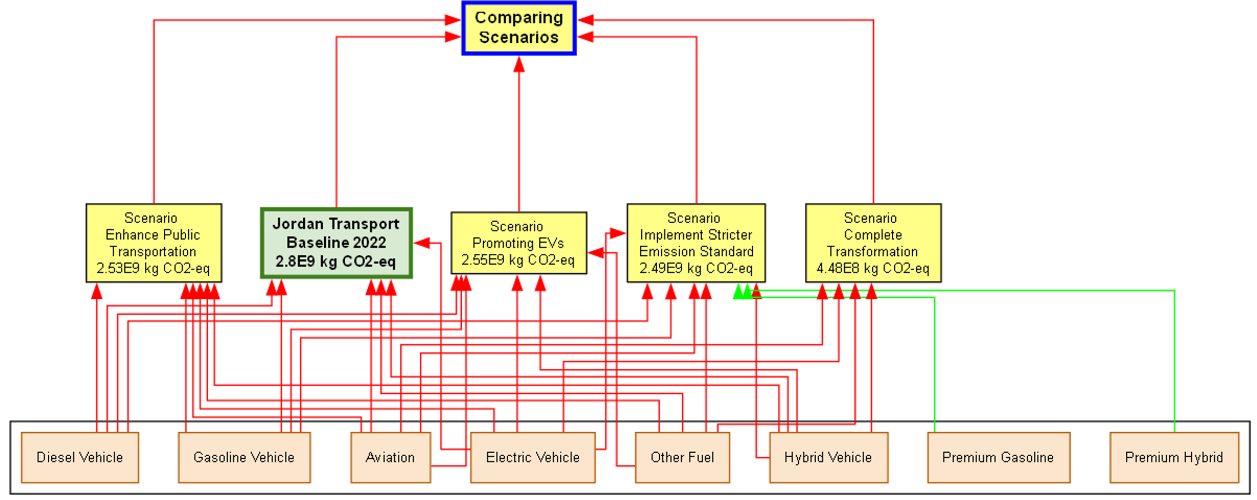
Figure 4: Well-to-Wheel network diagram comparing Global Warming Potential (kg CO₂-eq) across the four mitigation scenarios.
For the reference year, emissions total 2.80×10⁹ kg CO₂-eq. The network diagram immediately exposes the key difficulty: incremental options yield only marginal change.
When one fifth of gasoline vehicles become EVs (Scenario 1), total GWP declines merely to 2.55×10⁹ kg CO₂-eq. Such a small improvement illustrates the grid penalty: with roughly 98% of Jordanian power derived from fossil fuels, the new EVs retain a genuine carbon cost that has been moved from exhaust pipes to a few central generating plants. Even after EVs are introduced, fossil combustion remains the main environmental burden.
Scenario 2 reaches 2.53×10⁹ kg CO₂-eq and Scenario 3 reaches 2.49×10⁹ kg CO₂-eq, so the public transport and Euro 6 options perform similarly. Under Scenario 2, lower private car emissions are partially offset by higher diesel emissions due to bus fleet activity. Improved combustion offers modest gains, yet neither option tackles the structural fossil-fuel dependence of the sector.
Scenario 4 alone departs from this trend. Complete electrification lowers GWP by 84%, reaching 4.48×10⁸ kg CO₂-eq; what remains is mainly the aviation sector, which was not electrified in this model, together with the far smaller upstream burden of charging.
Beyond global climate effects, Figure 5 illustrates how the same interventions influence human health in terms of DALYs.
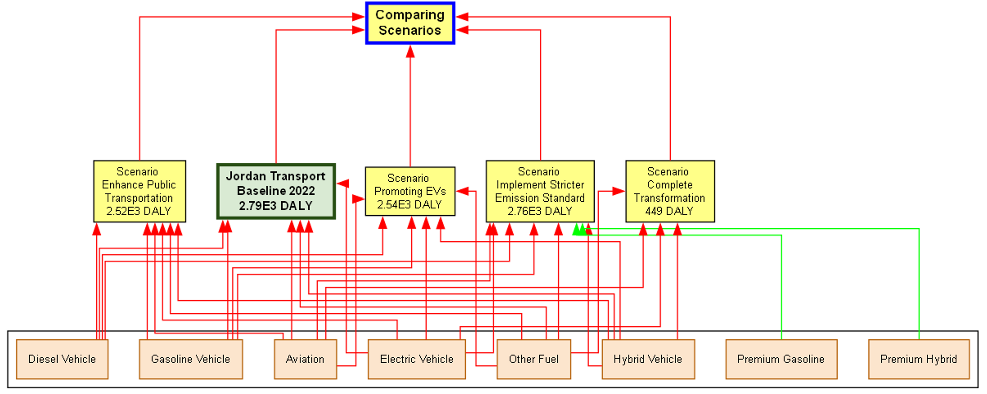
Figure 5: LCA network diagram of human health damage (DALYs) for the four mitigation scenarios.
At baseline, the burden reaches 2.79×10³ DALYs, a high value explained by the prevalence of older gasoline and diesel vehicles within the current fleet. The incremental options reveal an important shortcoming of traditional urban planning:
- Scenario 2 (public transit): substituting heavy-duty diesel buses for car journeys produces only a small decline, from 2.79×10³ to 2.52×10³ DALYs, accompanied by a clear pollution swap. Fewer private trips are counterbalanced by a steep rise in local black carbon and PM2.5 from buses that, even when upgraded, still emit harmful toxins and intensify cardiovascular stress in communities near their routes.
- Scenario 3 (Euro 6): modern particulate filters help somewhat, yet producing low-sulphur fuel requires extraction, shipping and energy-intensive refining, which sustain high background toxicity. At 2.76×10³ DALYs, this option records the smallest improvement among all mitigation pathways, practically identical to the reference.
- Scenario 4 (full transformation): eliminating combustion engines removes the principal urban sources of SLCPs such as black carbon. The burden falls by more than 400 DALYs to 449; remaining damage stems mostly from upstream power generation for the EV fleet and from aviation, which stays non-electric.
As a final synthesis, a single score in Millipoints (MPt) was calculated, expressing the aggregate impact of human health, ecosystem and resource damage as one value directly comparable across alternatives, as presented in Figure 6.
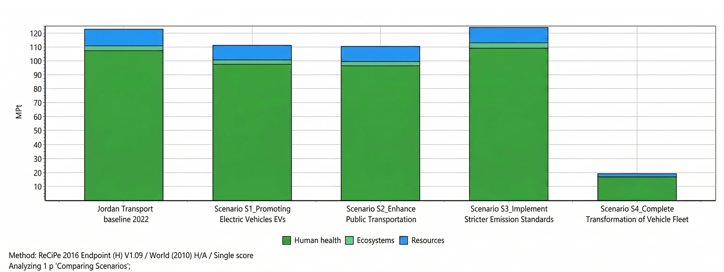
Figure 6: Single-score comparison (MPt) of the mitigation scenarios for human health, ecosystem and resource damage.
This chart illustrates how incremental policy becomes a zero-sum exercise. Totals for the Baseline, S1, S2 and S3 are tightly clustered around 110–125 MPt, since partial EV uptake, diesel bus expansion and Euro 6 regulation merely reallocate damage among categories rather than lowering it. The transition from Baseline to S1 exchanges climate damage for scarcity of minerals such as lithium and cobalt, whereas that from Baseline to S2 exchanges climate damage for harm to local human health.
Under Scenario 4, by contrast, the total score is drastically reduced to about 20 MPt. This separation shows that emission regulations or partial fleet renewal cannot, by themselves, provide developing nations with a truly low-carbon transport system; such an outcome demands full commitment to zero-emission vehicles combined with rapid decarbonization of the grid.

3.3 Probabilistic Uncertainty Analysis (Monte Carlo Simulation)
To determine whether the deterministic SimaPro outputs remain valid under real-world fluctuations, and to test the durability of the suggested pathways at the per-vehicle (micro) and entire-sector (macro) levels, a Monte Carlo simulation of 10,000 iterations was completed, specifically targeting the grid penalty and pollution swap hypotheses.

1. Micro-Level Dynamics: The Grid Penalty
Individual vehicle architectures were assessed first in order to identify baseline limits. Figure 7 depicts the probability density of WTW CO₂-equivalent emissions for five modes of transportation.
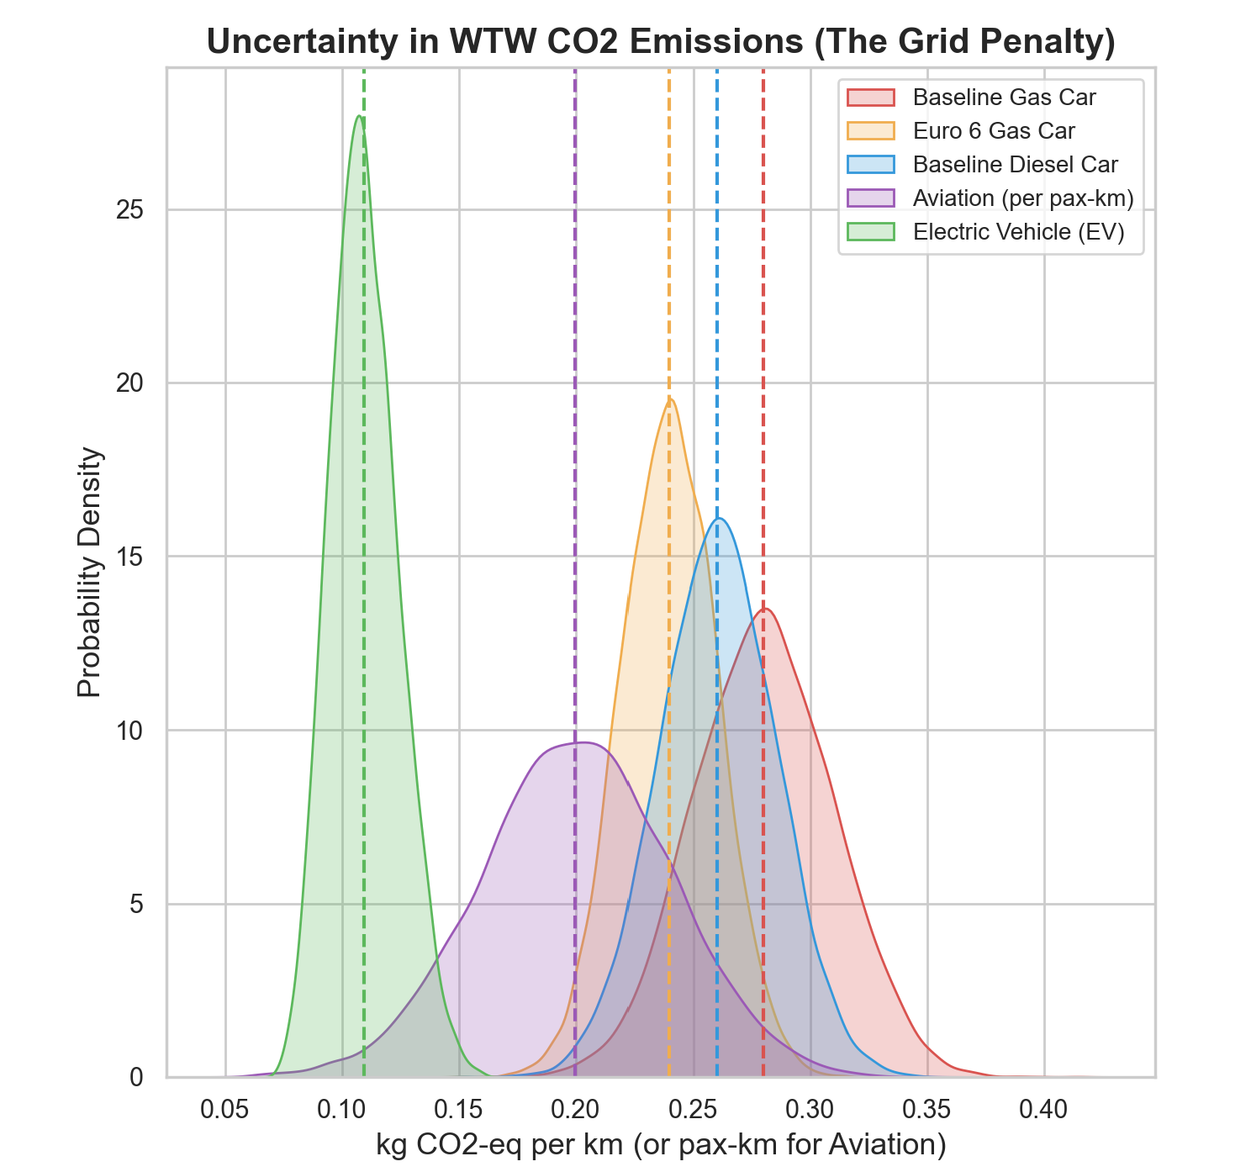
Figure 7: Micro-level probability density of Well-to-Wheel CO₂ emissions.
The grid penalty is a construct used to visualize the share of an EV’s carbon footprint that originates from fossil-based electricity. Results display a distinct gap separating the EV curve from all combustion-vehicle curves; despite the current Jordanian generation mix, EVs hold an inherent climate advantage, and the two distributions show no statistical overlap.
A second result identifies limits to the capabilities of advanced combustion technologies. Euro 6 compliance and modern diesel cars move the distribution only marginally from the baseline and overlap with it to a high degree. Moreover, short-haul domestic aviation, per passenger-kilometre, shows a WTW carbon density equivalent to that of a contemporary diesel car, emphasizing that deep decarbonization will require structural modification of ground transport propulsion rather than exhaust refinements alone.

2. Micro-Level Toxicity: The Pollution Swap
Whereas warming potential is determined largely by upstream energy generation, localized human health impacts are based almost solely on exhaust emissions. To quantify this trade-off, Figure 8 relates local PM2.5 toxicity to transit occupancy.
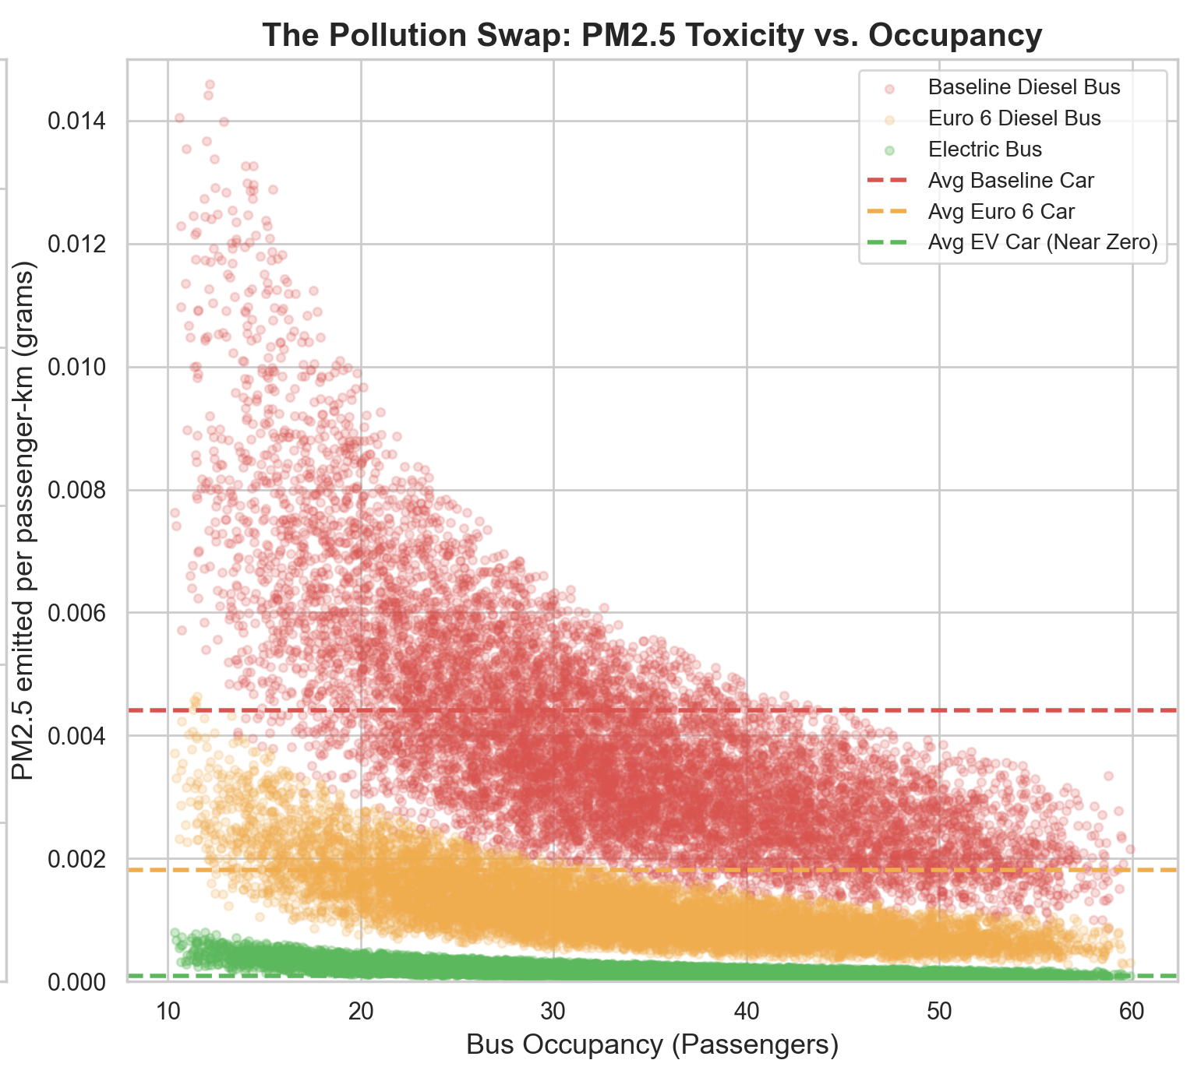
Figure 8: Occupancy threshold of the “pollution swap” for localized PM2.5 toxicity.
This probabilistic scatterplot uncovers a major weakness in traditional mass transit planning. Toxicity per unit of passenger travel is governed by occupancy, and the two share a highly volatile relationship. Below 25–30 riders, a conventional diesel bus releases a greater PM2.5 load for each passenger-kilometre than a typical private gasoline vehicle (shown by the red dashed line), and a Euro 6 diesel bus may likewise cross this threshold when off-peak ridership declines.
Accordingly, imposing a modal switch to diesel transit without guaranteeing that vehicles are well filled may produce a public health crisis at the local level. Electric buses, conversely, lower localized toxicity to nearly nothing, comparable to EV passenger cars, whose only particulate emissions are trace amounts from tyre and brake wear.

3. Macro-Level Sector Trajectories: The Incremental Trap
Next, micro-level vehicle behaviour was upscaled to the sector, and the four alternatives were contrasted with the 2022 baseline. Figure 9 presents the simultaneous stochastic assessment of total GWP (Gg CO₂-eq) and the human health burden (DALYs).
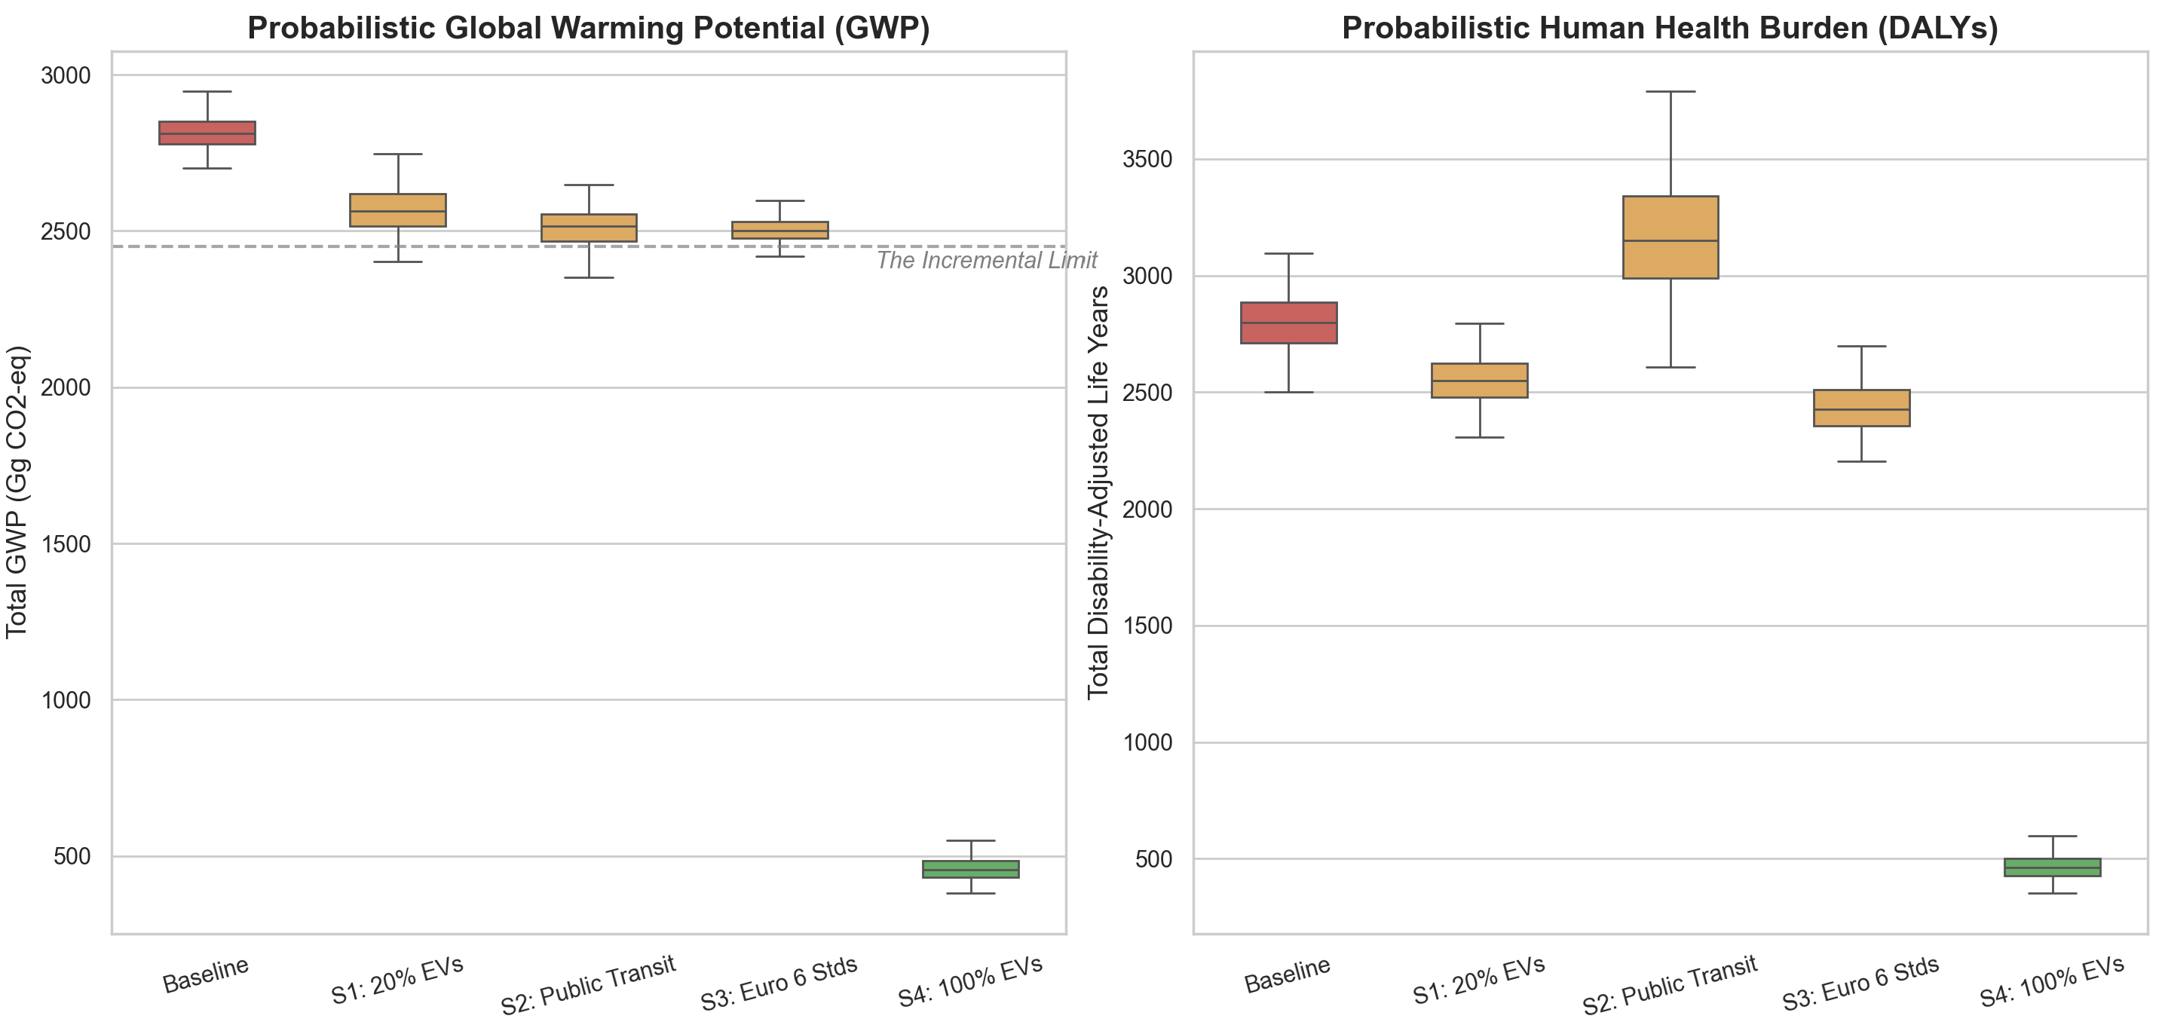
Figure 9: Macro-level probabilistic evaluation of the transport mitigation pathways.
Boxplot analysis indicates that Scenario 1 (20% EVs), Scenario 2 (public transit) and Scenario 3 (Euro 6) display comparable statistical performance, slightly below the base case. After 10,000 iterations, and with traffic congestion and grid intensity accounted for, none of these pathways could lower sector GWP beneath roughly 2,400 Gg.
The DALY distribution under Scenario 2 is an especially important signal: its inter-quartile range is considerably wider than the baseline, with pronounced right-tail risk. Such a pattern implies a high likelihood that diesel-dominated transit expansion would raise national cardiovascular and respiratory illness via the pollution-swap mechanism outlined earlier.
Scenario 4 (total electrification) is completely separated from the incremental cluster. With essentially full statistical confidence, the simulation confirms that only a comprehensive restructuring toward zero-emission technologies can cut sector GHG emissions under 500 Gg and lower health damage beneath the baseline, while effectively eliminating the cumulative uncertainty tied to locally produced exhaust.

4. Discussion
This WTW Life Cycle Assessment identifies the serious problems associated with evaluating transport decarbonization from an operational, end-of-pipe perspective only. Once system boundaries extend to upstream generation and supply chains, it is evident that substituting technologies in a fossil-reliant developing nation does not inherently eliminate environmental burden; frequently it is merely relocated.
Empirical evidence of the grid penalty shows that, although a TTW view lets exhaust emissions vanish from the equation, a WTW view reveals that the carbon footprint is only relocated. In Jordan, regardless of whether the electricity generated comes from imported natural gas or locally produced oil shale, the act of electrifying shifts the footprint further up the chain to the power plant; oil shale is considerably more carbon-intensive than gas, and distinguishing average from marginal emission rates is important for planning (Hawkes, 2010). These results align with the barriers to EV uptake in MENA described by Evensen et al. (2025) and Al-Alawi and Al-Alawi (2022), and they corroborate Liu et al. (2019) and Qiao et al. (2019), who established that fossil-based power can cancel the operational climate gains of EVs. Research on highly decarbonized grids arrives at the reverse result — Buberger et al. (2022) and ICCT (2023) find EVs to be the most sustainable choice throughout their lifecycle — highlighting an unequal global distribution of the “zero-emission” label. Jordan is not an isolated case: a 2026 comparative LCA for Saudi Arabia, whose grid is similarly fossil-based, reported a 25% emission reduction from EVs before any grid improvement, expected to approximately double once declared renewable targets are reached (Alghamdi, 2026), offering a benchmark for how far Jordan’s penalty may narrow as its electricity sector becomes cleaner. Petrauskienė et al. (2021) argue that judging EV effectiveness only by operational emissions may cause systemic lock-in, fixing a permanent decarbonization limit equal to the carbon intensity of national generation.
The first mitigation scenario examined replacing 20% of gasoline cars with BEVs. From a WTW perspective, the critical vulnerability of the EV, namely the grid penalty, becomes more apparent: the burden is merely displaced in geography and technology, not eliminated. Dependence on the Jordanian 2022 grid makes the EV fleet a significant source of upstream emissions (NEPCO, 2022). Where electricity is fossil-dominated, EVs act solely as remote dispersal devices, transferring the carbon load produced by urban traffic to centralized generation locations and thus limiting total decarbonization (Evensen et al., 2025; Al-Alawi and Al-Alawi, 2022). They also drive up “Mineral Resource Scarcity,” as extraction of finite geological fossil fuels gives way to growing mineral extraction for batteries (Lai et al., 2022; IEA, 2021a).
Scenario 2, consistent with the A-S-I approach frequently applied as a demand-side measure for urban decarbonization (Jarre et al., 2024), reveals a hazardous pollution swap: relocating commuters from cars into diesel buses decreases total aggregate GWP but creates a local surge in PM2.5 formation together with ozone depletion at the stratospheric level. Such a result confirms the conclusion of Grutter (2014) that old heavy-duty fleets make an outsized contribution to SLCP emissions. In addition, the ReCiPe endpoint (DALY) calculations support epidemiological work (Anenberg et al., 2012; WHO, 2023; Mills et al., 2007) demonstrating that black carbon from diesel shifts the impact from respiratory nuisance to acute cardiovascular death through ischemic heart disease and stroke. By optimizing a global climate metric (CO₂), local toxicity was inadvertently increased, violating the principle that good policy cannot trade global climate benefits for local health damage (Fantke et al., 2017).
The EV simulation (Scenario 1) also revealed new evidence regarding toxicity in the battery supply chain. Although electrification lowers exhaust emissions, increases are expected in “Human Non-Carcinogenic Toxicity” and “Mineral Resource Scarcity,” both consistent with literature indicating that EV toxicity occurs primarily during mining and manufacturing (Lai et al., 2022; Requia et al., 2018). Electrification further restructures national resource dependence. In Jordan, the baseline internal combustion fleet is already an economic burden, with fossil resource scarcity estimated at $1.62 million (USD2013) (MEMR, 2022). Greater EV proliferation will reduce reliance on fossil fuels, yet rising demand for minerals introduces volatility to resource availability. These observations support the IEA (2021a) caution that the transition to clean energy will demand substantially more mineral resources than has historically been necessary. Essentially, Jordan shifts from relying on imported oil to relying on the minerals used in manufacturing batteries (Lai et al., 2022). Since battery recycling lags in developing countries (Harper et al., 2019), decision makers must recognize that electrification transfers depletion pressure from hydrocarbons to metals, and support for the energy transition will be inadequate without life-cycle circularity, such as required recycling, to minimize the total embedded expense of materials (Ahmadi et al., 2017).
Identifying these trade-offs at an empirical level shows how spatial and geopolitical features will affect the ultimate success of decarbonization. European LCAs strongly favour EVs because their grids are already largely decarbonized, but the fossil nature of the Jordanian grid weakens this benefit, so European conclusions cannot simply be imported into a country without a corresponding energy transition. Local micro-level WTW CO₂ density functions (Figure 7) indicate a grid penalty for Jordan that varies greatly from European-focused LCAs (Cox et al., 2018; Nordelöf et al., 2014). However, the Monte Carlo models ultimately settle the question of EV viability in Jordan: with no statistical overlap between the EV and ICEV distributions, EVs yield a net reduction in global warming even when their upstream generation is fossil-based. Electrification alone, however, will not produce the large reductions needed to achieve deep decarbonization (Qiao et al., 2019).
Critical categories such as stratospheric ozone depletion and human non-carcinogenic toxicity continue to dominate the environmental profile irrespective of exhaust technology, because this ongoing toxicity arises from the WTT phase onward. Consequently, however efficient Euro 6 combustion may be, the upstream processes necessary to manufacture premium fuels (geological extraction, marine transportation, energy-intensive refinery processes for the removal of sulfur) still carry toxicity and deplete resources (EEA, 2019; Al-Saryrah et al., 2021).
This pollution exchange drastically changes the environmental risk. Lower gasoline consumption reduces a worldwide, long-term climate indicator. Diesel, conversely, increases SLCPs in dense urban environments through black carbon and ultrafine particles, which enter the cardiovascular system and cause premature death from ischemic heart disease and stroke as calculated by WHO (2023) and Anenberg et al. (2012). Amman’s topography additionally traps vehicle exhaust within “street canyons,” increasing exposure for residents near major roads (Fantke et al., 2017). Diesel emissions further contribute to ground-level ozone, raising respiratory illness during hot summer months (Grutter, 2014).
The probabilistic visualization lends further support to Chester and Horvath (2009): on a passenger-kilometre basis, a diesel bus with fewer than 25 occupants yields higher localized toxicity than a conventional car, raising doubts about diesel BRT systems unable to assure full ridership at peak times.
In summary, the sector modelling (Figure 3) confirms the IEA Net Zero by 2050 roadmap (IEA, 2021b), which states that late-stage clean-ups of combustion (Scenarios 1–3) can never suffice. DALY assessments show that Euro 6 investment on its own leaves a considerable cardiovascular health cost, as reflected in earlier MENA research (Jelti et al., 2021; Alotaibi et al., 2022; Al-Shetwi et al., 2020; Koç et al., 2023), which collectively indicates that real climate gains depend on decarbonized upstream power production rather than cleaner vehicles alone. To escape the “Incremental Trap,” developing countries should adopt the tailored MENA strategies of Evensen et al. (2025) and Al-Alawi and Al-Alawi (2022), implementing a “leapfrogging” approach that pairs zero-emission vehicles with 100% renewable, decentralized power grids.

5. Policy Implications for Developing Economies
The grid penalty identified in this research supports an uncomfortable yet necessary conclusion for policy: encouraging EVs in isolation, before low-carbon generation has been expanded, is an ineffective route to GHG reduction. EV promotion cannot be pursued independently of the National Energy Strategy.
A coupled energy-transport strategy is needed to dismantle the institutional silos separating these two policy domains. National targets for EVs ought to be tied numerically to fossil power plant retirement and to the speed at which new renewable generation becomes operational (Al-Shetwi et al., 2020). Regional research on distribution networks further shows that high EV penetration could lead to transformer overloading unless the grid is reinforced (Al-Owaifeer et al., 2020).
Across Jordan and MENA, the government should push decentralized “Solar-to-EV” chargers, especially for public transport depots and government fleets. Mandating solar microgrids for new charging depots would effectively establish “zero-emission islands,” where the current fossil intensity of the national grid is completely decoupled from transport, so that newly deployed EVs achieve their entire climate and health benefit immediately (Evensen et al., 2025). Policies must also encourage EV charging during daylight off-peak hours, soaking up peak solar generation instead of adding to evening peaks; this relieves a distribution network already stressed by hot-climate loads and converts EVs from a liability into a stabilizing storage resource (Al-Shetwi et al., 2020; Al-Shetwi et al., 2022).
A second, equally firm lesson follows from the pollution swap: depending on conventional diesel buses for modal shift may degrade, not enhance, local health. Policymakers must explicitly abandon the narrative of “transition technologies” such as Compressed Natural Gas (CNG) or Euro 5/6 diesel, because investment in them creates secondary infrastructure lock-in, binding cities to decades of fossil fuel use and persistent PM2.5 exposure just when net-zero goals demand the reverse (Grutter, 2014). Jelti et al. (2021) arrive at the same finding: alternative fossil fuels fail to yield the environmental return needed by expanding, sustainable cities. A 2022 LCA comparing diesel, diesel-electric and hydrogen fuel cell transit buses strengthens this point, showing that fuel cell buses surpass both diesel options in every environmental indicator once realistic battery degradation and operating cycles are included, which further indicates that transitional diesel options are an unsound long-term investment for public fleets (Ahmadi et al., 2022).
A genuine “leapfrogging” approach is the alternative. Investments in mass transit, notably BRT, should bypass transition technologies and target zero-emission options directly, namely battery electric or hydrogen fuel cell buses. Although electric buses require higher initial capital in hot climates, this difference is recovered rapidly when avoided health expenditure and lower fuel imports are considered; feasibility studies of new projects should therefore explicitly show the ‘avoided health costs’ to justify high upfront capital. By adopting zero-emission mass transit directly, developing nations can lower their share of global warming and, at the same time, improve cardiovascular health in the neighbourhoods these services reach.

6. Conclusion
Through a complete WTW LCA of road transport in Jordan, this paper compared how existing and planned decarbonization measures truly perform once the concealed externalities of a fossil-reliant transition are correctly included.
The findings lead to one principal conclusion: developing nations should change their paradigm from incremental, fragmented regulatory adjustments toward holistic “Energy-Transport-Health” nexus thinking. The grid penalty demonstrates that, in a fossil-dependent country, an EV mandate cannot achieve its intended environmental gains unless legally and structurally bound to renewable power development. Fleet electrification targets should be aligned, sector by sector, with the phase-out of fossil baseload plants and the build-up of grid-connected renewables (Al-Shetwi et al., 2020).
In Jordan and across MENA, the most promising short-term measure is large-scale investment in decentralized “Solar-to-EV” charging. Requiring new depots to rely on local solar microgrids would establish true zero-emission islands, letting EVs leapfrog over the carbon intensity of the national grid and realize their complete climate and health benefits (Evensen et al., 2025). Solar-based charging during off-peak periods would likewise ease the load on a distribution network already burdened by hot-climate demand, converting EVs from a liability into an asset for the grid (Al-Shetwi et al., 2020).
For public transport planning, the pollution swap offers an equally explicit caution: adopting unsafeguarded diesel mass transit may generate a serious local health crisis while simultaneously improving national carbon accounts. Long-term plans in developing nations should formally exclude “transitional” options, namely CNG or Euro 5/6 diesel, since committing funds to them locks in decades of fossil-fuel maintenance and sustained PM2.5 exposure, contradicting net-zero commitments (Grutter, 2014). Jelti et al. (2021) demonstrate that alternative fossil fuels produce too little environmental benefit to support urban growth over the long term.
Transit authorities should consequently adopt zero-emission technologies, electric and hydrogen fuel cell buses, from the beginning rather than postponing them to a future upgrade. The higher capital costs associated with hot climates are recovered fairly rapidly through reduced healthcare spending on respiratory disease and lower reliance on fuel imports. Developing countries thus gain a true leapfrogging opportunity, lessening their share of long-term global warming while directly cutting the immediate burden of cardiovascular disease caused by local pollution.

References
Ahmadi, L., Young, S.B., Fowler, M., Fraser, R.A. and Achachlouei, M.A. (2017) A cascaded life cycle: reuse of electric vehicle lithium-ion battery packs in energy storage systems. The International Journal of Life Cycle Assessment, 22(1), pp. 111-124.
Ahmadi, P., Raeesi, M., Changizian, S., Teimouri, A. and Khoshnevisan, A. (2022) Lifecycle assessment of diesel, diesel-electric and hydrogen fuel cell transit buses with fuel cell degradation and battery aging using machine learning techniques. Energy, 259, 125003.
Al-Alawi, B.M. and Al-Alawi, A. (2022) Electric vehicle adoption in the MENA region: A review of status, challenges, and opportunities. Journal of Cleaner Production, 330, 129929.
Alarrouqi, R.A., Al-Mulla, A. and Al-Kuwari, S. (2024) Electric buses in hot climates: Challenges, technologies, and the road ahead. IEEE Access, 12, pp. 55543-55560.
Alghamdi, A.S. (2026) Comparative life cycle assessment of battery electric and internal combustion engine passenger cars under a fossil-dominated electricity grid: The case of Saudi Arabia. World Electric Vehicle Journal, 17(8), 415.
Alotaibi, S., Omer, S. and Su, Y. (2022) Identification of potential barriers to electric vehicle adoption in oil-producing nations — The case of Saudi Arabia. Electricity, 3(3), pp. 365-395.
Al-Owaifeer, M., Al-Ghamdi, S.G. and Koç, M. (2020) Impact of electric vehicle charging on distribution networks: A case study in Qatar. Energies, 13(20), 5473.
Al-Saryrah, N., Al-Ghandoor, A. and Jaber, J.O. (2021) Assessment of energy and environmental performance of the transport sector in Jordan. Energy Policy, 156, 112456.
Al-Shetwi, A.Q., Hannan, M.A., Jern, K.P., Mansur, M. and Mahlia, T.M.I. (2020) Grid-connected renewable energy sources: Review of the recent integration requirements and control methods. Journal of Cleaner Production, 253, 119831.
Al-Shetwi, A.Q., Hannan, M.A., Jern, K.P., Mansur, M. and Mahlia, T.M.I. (2022) Grid-connected renewable energy sources: Power quality issues and outlook. Energy, 241, 122811.
Anenberg, S.C., Schwartz, J., Shindell, D., Amann, M., Faluvegi, G., Klimont, Z., Janssens-Maenhout, G., Pozzoli, L., Van Dingenen, R., Vignati, E., Emberson, L., Muller, N.Z., West, J.J., Williams, M., Demkine, V., Hicks, W.K., Kuylenstierna, J., Raes, F. and Ramanathan, V. (2012) Global air quality and health co-benefits of mitigating near-term climate change through methane and black carbon emission controls. Environmental Health Perspectives, 120(6), pp. 831-839.
Aryan, Y., C K, A., Dikshit, A.K. and Shinde, A.M. (2025) Comparative life cycle assessment of battery electric vehicles in developing countries under current and future electricity mix scenarios. Discover Sustainability, 6, 675.
Ashraf, F., Equbal, A., Khan, O., Yahya, Z., Alhodaib, A., Parvez, M. and Ahmad, S. (2025) Green Technologies and Sustainability. Green Technologies and Sustainability, 3, 100128.
Bare, J.C., Norris, G.A., Pennington, D.W. and McKone, T.E. (2002) TRACI: The tool for the reduction and assessment of chemical and other environmental impacts. Journal of Industrial Ecology, 6(3-4), pp. 49-78.
Bastos, J., Marques, P., Batterman, S.A. and Freire, F. (2019) Environmental impacts of commuting modes in Lisbon: A life-cycle assessment addressing particulate matter impacts on health. International Journal of Sustainable Transportation, 13(9), pp. 652-663.
Bisinella, V., Christensen, T.H. and Astrup, T.F. (2021) Future scenarios and life cycle assessment: systematic review and recommendations. The International Journal of Life Cycle Assessment, 26, pp. 2143-2170.
Bond, T.C., Doherty, S.J., Fahey, D.W., Forster, P.M., Berntsen, T.K., DeAngelo, B.J., Flanner, M.G., Ghan, S.J., Kärcher, B., Koch, D.M., Kinne, S., Kondo, Y., Quinn, P.K., Sarofim, M.C., Schultz, M.G., Schulz, M., Venkataraman, C., Zhang, H., Zhang, S., Bellouin, N., Guttikunda, S.K., Hopke, P.K., Jacobson, M.Z., Kaiser, J.W., Klimont, Z., Lohmann, U., Schwarz, J.P., Shindell, D.T., Storelvmo, T., Warren, S.G. and Zender, C.S. (2013) Bounding the role of black carbon in the climate system: A scientific assessment. Journal of Geophysical Research: Atmospheres, 118(11), pp. 5380-5552.
Brewer, T.L. (2019) Black carbon emissions and regulatory policies in transportation. Energy Policy, 129, pp. 1390-1399.
Buberger, J., Kersten, A., Kuder, M., Eckerle, R., Weyh, T. and Thiringer, T. (2022) Total CO2-equivalent life-cycle emissions from commercially available passenger cars. Renewable and Sustainable Energy Reviews, 159, 112158.
Chester, M.V. and Horvath, A. (2009) Environmental assessment of passenger transportation should include infrastructure and supply chains. Environmental Research Letters, 4(2), 024008.
Cox, B., Mutel, C.L., Bauer, C., Mendoza Beltran, A. and van Vuuren, D.P. (2018) Uncertain environmental footprint of current and future battery electric vehicles. Environmental Science & Technology, 52(8), pp. 4989-4995.
Cox, B., Bauer, C., Mendoza Beltran, A., van Vuuren, D. P. and Mutel, C. L. (2020) Life cycle environmental and cost comparison of current and future passenger cars under different energy scenarios. Applied Energy, 269, 115021.
Department of Statistics (DoS) (2023) Jordan Statistical Yearbook 2022. Amman: Department of Statistics.
European Environment Agency (EEA) (2019) EMEP/EEA air pollutant emission inventory guidebook 2019: Technical guidance to prepare national emission inventories. Luxembourg: Publications Office of the European Union.
Evensen, D., Uratani, J.M., Sovacool, B.K. and Griffiths, S. (2025) A novel model for barriers to electric vehicle adoption in the Middle East. Transportation Research Part D: Transport and Environment, 142, 104714.
Fantke, P., Jolliet, O., Apte, J.S., Hodas, N., Evans, J., Weschler, C.J., Stylianou, K.S., Jantunen, M.J. and McKone, T.E. (2017) Health effects of fine particulate matter in life cycle assessment: findings from the Basel Guidance Workshop. The International Journal of Life Cycle Assessment, 22(2), pp. 272-283.
Ghawanmeh, A.O.H. (2026) Environmental and Health Impacts of Transportation Sector in Jordan Using Life Cycle Assessment. M.Sc. Thesis, Faculty of Graduate Studies, Jordan University of Science and Technology, Irbid, Jordan.
Grutter, J.M. (2014) Real World Performance of Diesel Buses in Developing Countries. Grutter Consulting.
Haines, A., McMichael, A.J., Smith, K.R., Roberts, I., Woodcock, J., Markandya, A., Armstrong, B.G., Campbell-Lendrum, D., Dangour, A.D., Davies, M., Bruce, N., Tonne, C., Barrett, M. and Wilkinson, P. (2009) Public health benefits of strategies to reduce greenhouse-gas emissions: overview and implications for policy makers. The Lancet, 374(9707), pp. 2104-2114.
Harper, G., Sommerville, R., Kendrick, E., Driscoll, L., Slater, P., Stolstrane, R. and Anderson, P. (2019) Recycling lithium-ion batteries from electric vehicles. Nature, 575(7781), pp. 75-86.
Hawkes, A.D. (2010) Estimating marginal CO2 emissions rates for national electricity systems. Energy Policy, 38(10), pp. 5977-5987.
Heaps, C.G. (n.d.) LEAP: The Low Emissions Analysis Platform. Somerville, MA: Stockholm Environment Institute.
Henriksson, P.J.G., Guinée, J.B., Heijungs, R. and de Snoo, G.R. (2015) A protocol for horizontal averaging of unit process data — including estimates for uncertainty. The International Journal of Life Cycle Assessment, 20(2), pp. 220-229.
Huijbregts, M.A.J., Steinmann, Z.J.N., Elshout, P.M.F., Stam, G., Verones, F., Vieira, M., Zijp, M., Hollander, A. and van Zelm, R. (2017) ReCiPe2016: a harmonised life cycle impact assessment method at midpoint and endpoint level. The International Journal of Life Cycle Assessment, 22(2), pp. 138-147.
IEA (International Energy Agency) (2021a) The Role of Critical Minerals in Clean Energy Transitions. Paris: IEA.
IEA (International Energy Agency) (2021b) Net Zero by 2050: A Roadmap for the Global Energy Sector. Paris: IEA.
IEA (International Energy Agency) (2024) Global EV Outlook 2024: Moving Towards Increased Affordability. Paris: IEA.
Igos, E., Benetto, E., Meyer, R., Baustert, P. and Othoniel, B. (2019) How to treat uncertainties in life cycle assessment studies?. The International Journal of Life Cycle Assessment, 24(4), pp. 794-807.
International Council on Clean Transportation (ICCT) (2023) Comparison of the life-cycle greenhouse gas emissions of combustion engine and electric passenger cars in Europe. ICCT.
International Organization for Standardization (ISO) (2006a) Environmental management — Life cycle assessment — Principles and framework (ISO 14040:2006). Geneva: ISO.
International Organization for Standardization (ISO) (2006b) Environmental management — Life cycle assessment — Requirements and guidelines (ISO 14044:2006). Geneva: ISO.
IPCC (Intergovernmental Panel on Climate Change) (2022) Climate Change 2022: Mitigation of Climate Change. Cambridge University Press.
Jarre, M., Noussan, M. and Campisi, E. (2024) Avoid-Shift-Improve: Are Demand Reduction Strategies Under-Represented in Current Energy Policies?. Energies, 17(19), 4955.
Jelti, F., Allouhi, A., Al-Ghamdi, S.G., Saadani, R., Jamil, A. and Rahmoune, M. (2021) Environmental life cycle assessment of alternative fuels for city buses: A case study in Oujda city, Morocco. International Journal of Hydrogen Energy, 46(49), pp. 25308-25319.
Koç, M., Al-Ghamdi, S.G. and Al-Kuwari, A. (2023) Energy consumption analysis of electric vehicles in hot climates: A case study of Qatar. Transportation Research Part D: Transport and Environment, 118, 103689.
Lai, X., Chen, Q., Tang, X., Zhou, Y., Gao, F., Guo, Y., Bhagat, R. and Zheng, Y. (2022) Critical review of life cycle assessment of lithium-ion batteries for electric vehicles: A lifespan perspective. eTransportation, 12, 100169.
Liu, Y., Chen, J. and Wu, J. (2019) Regional variation of the life cycle environmental benefits of the electric vehicle in China. Journal of Cleaner Production, 233, pp. 1079-1089.
Low Carbon Power (2022) Countries - Jordan. Available at: https://lowcarbonpower.org/region/Jordan.
Mashayekh, S. (2020) Life cycle assessment of electric vehicles: A comprehensive review. Journal of Sustainable Development of Energy, Water and Environment Systems, 8(4), pp. 637-651.
Mills, N.L., Törnqvist, H., Gonzalez, M.C., Vink, E., Robinson, S.D., Söderberg, S., Boon, N.A., Donaldson, K., Sandström, T., Blomberg, A. and Newby, D.E. (2007) Ischemic and thrombotic effects of dilute diesel-exhaust inhalation in men with coronary heart disease. New England Journal of Medicine, 357(11), pp. 1075-1082.
Ministry of Energy and Mineral Resources (MEMR) (2022) Annual Report 2022. Amman: MEMR.
Ministry of Environment (MoEnv) (2021) Jordan's Updated First Nationally Determined Contribution (NDC). Amman: Ministry of Environment.
Ministry of Environment (MoEnv) (2022) The National Climate Change Policy of the Hashemite Kingdom of Jordan 2022–2050. Amman: Ministry of Environment.
Ministry of Environment (MoEnv) / UNFCCC (2025) Jordan's NDC 3.0 Vision. Amman / Bonn: UNFCCC. Reports that renewable electricity generation rose from about 12% (2020) to 28.5% (2024), and EV penetration rose from 1% to 21% of the national fleet over the same period.
Ministry of Transport (MoT) (2023) Annual Report 2022. Amman: Ministry of Transport.
Morales Betancourt, R., Galvis, B., Balachandran, S., Ramos-Bonilla, J.P., Sarmiento, O.L., Gallo-Murcia, S.M. and Contreras, Y. (2017) Exposure to fine particulate, black carbon, and particle number concentration in transportation microenvironments. Atmospheric Environment, 157, pp. 135-145.
Nanaki, E.A. and Koroneos, C.J. (2016) Climate change mitigation and electric vehicles deployment: The case of Greece. Renewable Energy, 91, pp. 252-258.
National Electric Power Company (NEPCO) (2022) Annual Report 2022. Amman: NEPCO.
Nordelöf, A., Messagie, M., Tillman, A.M., Ljunggren Söderman, M. and Van Mierlo, J. (2014) Environmental impacts of hybrid, plug-in hybrid, and battery electric vehicles — what can we learn from life cycle assessment?. The International Journal of Life Cycle Assessment, 19(11), pp. 1866-1890.
Petrauskienė, K., Galinis, A., Kliaugaitė, D. and Dvarionienė, J. (2021) Comparative environmental life cycle and cost assessment of electric, hybrid, and conventional vehicles in Lithuania. Sustainability, 13(2), 957.
Qiao, Q., Zhao, F., Liu, Z., Jiang, S. and Hao, H. (2019) Cradle-to-gate greenhouse gas emissions of battery electric and internal combustion engine vehicles in China. Applied Energy, 254, 113687.
Requia, W.J., Mohamed, M., Higgins, C.D., Arain, A. and Ferguson, M. (2018) How clean are electric vehicles? Evidence-based review of the effects of electric mobility on air pollutants, greenhouse gas emissions and human health. Atmospheric Environment, 185, pp. 64-77.
Shindell, D., Kuylenstierna, J.C.I., Vignati, E., van Dingenen, R., Amann, M., Klimont, Z., Anenberg, S.C., Muller, N., Janssens-Maenhout, G., Raes, F., Schwartz, J., Faluvegi, G., Pozzoli, L., Kupiainen, K., Höglund-Isaksson, L., Emberson, L., Streets, D., Ramanathan, V., Hicks, K., Oanh, N.T.K., Milly, G., Williams, M., Demkine, V. and Fowler, D. (2012) Simultaneously mitigating near-term climate change and improving human health and food security. Science, 335(6065), pp. 183-189.
United Nations Framework Convention on Climate Change (UNFCCC) (2022) Nationally Determined Contributions Registry. UNFCCC.
Weidema, B.P., Bauer, C., Hischier, R., Mutel, C., Nemecek, T., Reinhard, J., Vadenbo, C.O. and Wernet, G. (2013) Overview and methodology: Data quality guideline for the ecoinvent database version 3. St. Gallen: The ecoinvent Centre.
World Bank (2022) Jordan - Country Transport Sector Note. Washington, DC: World Bank.
World Health Organization (WHO) (2023) Ambient (outdoor) air pollution. Geneva: WHO.

