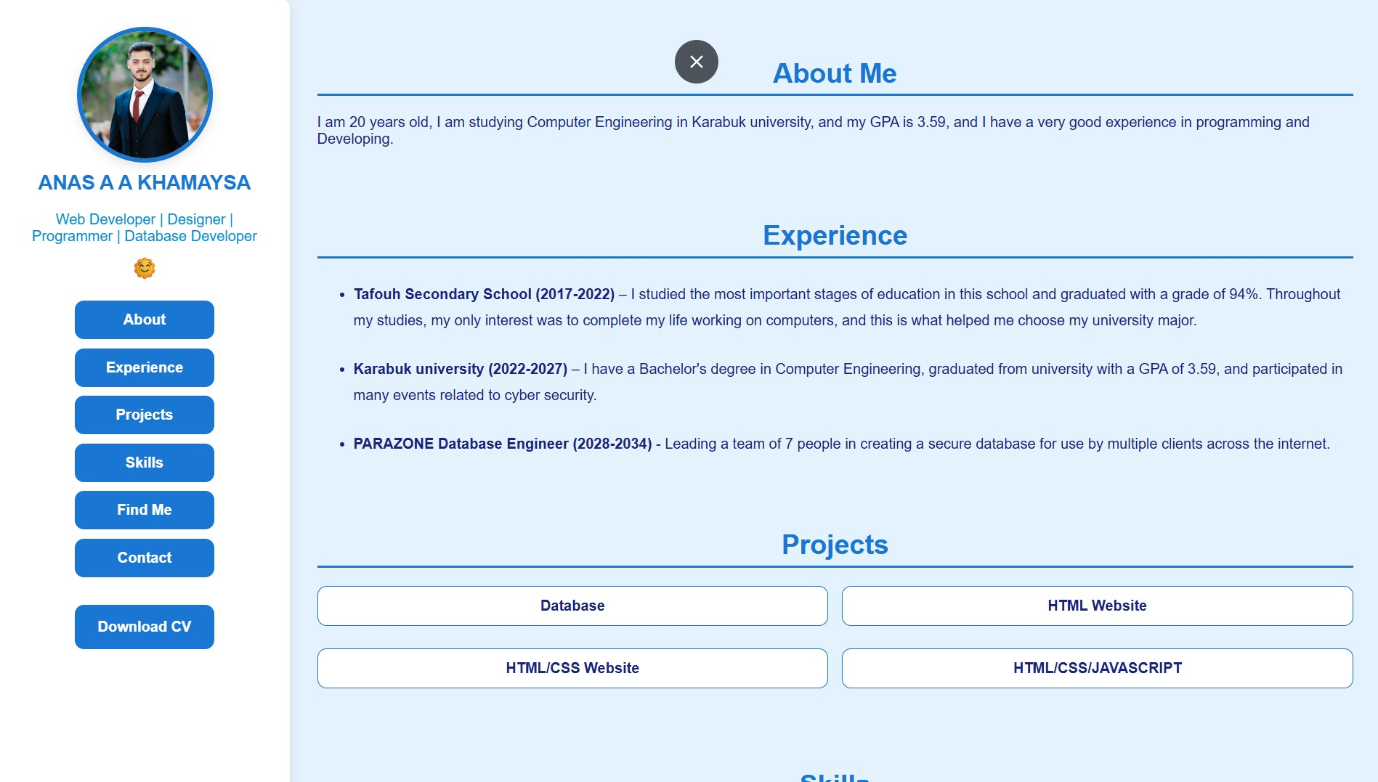

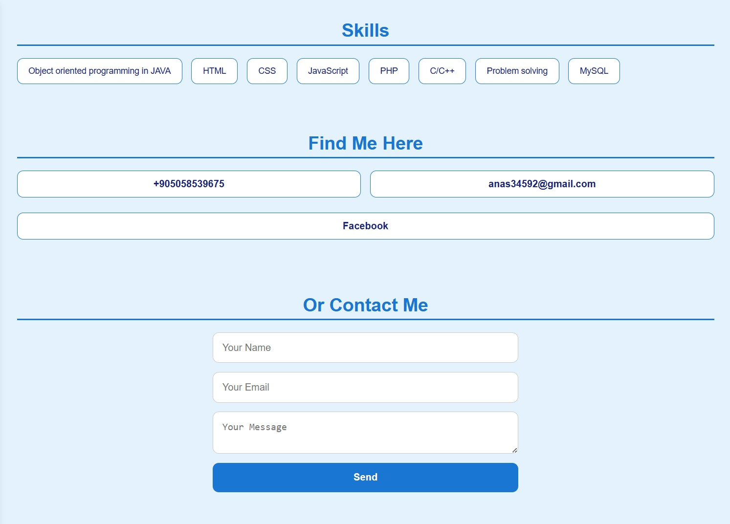

HTML
<!DOCTYPE html>
<html lang="en">
<head>
<meta charset="UTF-8" />
<meta name="description" content="The personalized resume that contains everything you need to know to get hired.">
<title>ANAS A A KHAMAYSA | Resume</title>
<link rel="shortcut icon" href="anas3.ico">
<link rel="stylesheet" href="style.css" />
<script src="script.js" defer></script>
</head>
<body>
<aside class="sidebar">
<div class="profile">
<img src="anas.jpg" alt="Picture for ANAS A A KHAMAYSA">
<h1>ANAS A A KHAMAYSA</h1>
<p>Web Developer | Designer | Programmer | Database Developer</p>
<button id="themeToggle">🌞</button>
</div>
<nav>
<ul>
<li><button data-target="about">About</button></li>
<li><button data-target="experience">Experience</button></li>
<li><button data-target="projects">Projects</button></li>
<li><button data-target="skills">Skills</button></li>
<li><button data-target="Find-Me">Find Me</button></li>
<li><button data-target="contact">Contact</button></li>
</ul>
<button class="btn-download" id="downcv">Download CV</button></li>
</nav>
</aside>

<main class="content">
<section id="about">
<h2>About Me</h2>
<p>I am 20 years old, I am studying Computer Engineering in Karabuk university, and my GPA is 3.59, and I have a very good experience in programming and Developing.</p>
</section>

<section id="experience">
<h2>Experience</h2>
<ul class="experienceList">
<li><strong>Tafouh Secondary School (2017-2022)</strong> – I studied the most important stages of education in this school and graduated with a grade of 94%. Throughout my studies, my only interest was to complete my life working on computers, and this is what helped me choose my university major.</li>
<li><strong>Karabuk university (2022-2027)</strong> – I have a Bachelor's degree in Computer Engineering, graduated from university with a GPA of 3.59, and participated in many events related to cyber security.</li>
<li><strong>PARAZONE Database Engineer (2028-2034)</strong> - Leading a team of 7 people in creating a secure database for use by multiple clients across the internet.</li>
</ul>
</section>

<section id="projects">
<h2>Projects</h2>
<nav class="projectDow">
<ul>
<li><button id="database">Database</button></li>
<li><button id="htmlweb">HTML Website</button></li>
<li><button id="cssweb">HTML/CSS Website</button></li>
<li><button id="jsweb">HTML/CSS/JAVASCRIPT</button></li>
</ul>
</nav>
</section>

<section id="skills">
<h2>Skills</h2>
<div id="skillsContainer" class="skills-box"></div>
</section>

<section id="Find-Me">
<h2>Find Me Here</h2>
<nav class="projectDow">
<ul>
<li><button>+905058539675</button></li>
<li><button>anas34592@gmail.com</button></li>
<li><button id="myfacebook">Facebook</button></li>
</ul>
</nav>
</section>

<section id="contact">
<h2>Or Contact Me</h2>
<form id="contactForm" action="https://2210213581.free.nf/contact.php" method="POST">
<input type="text" name="name" placeholder="Your Name" required />
<input type="email" name="email" placeholder="Your Email" required />
<textarea name="message" placeholder="Your Message" required></textarea>
<button type="submit">Send</button>
<p id="formStatus"></p>
</form>
</section>
</main>
</body>
</html>

CSS
:root {
--bg: #e3f2fd;
--text: #1a237e;
--accent: #1976d2;
--highlight: #0288d1;
--card: #ffffff;
--shadow: 0 4px 12px rgba(0, 0, 0, 0.1);
--radius: 10px;
--font-family: 'Roboto', sans-serif;
}

.dark {
--bg: #212121;
--text: #e0e0e0;
--accent: #90caf9;
--highlight: #64b5f6;
--card: #333;
--shadow: 0 4px 12px rgba(255, 255, 255, 0.2);
}

body {
margin: 0;
font-family: var(--font-family);
background: var(--bg);
color: var(--text);
transition: background 0.4s, color 0.4s;
display: flex;
min-height: 100vh;
}

.sidebar {
position: fixed;
top: 0;
left: 0;
height: 100%;
width: 280px;
background: var(--card);
padding: 30px 20px;
display: flex;
flex-direction: column;
align-items: center;
box-shadow: var(--shadow);
z-index: 1000;
border-top-right-radius: var(--radius);
border-bottom-right-radius: var(--radius);
}

.profile {
display: flex;
flex-direction: column;
align-items: center;
text-align: center;
}

.profile img {
width: 140px;
height: 140px;
border-radius: 50%;
border: 5px solid var(--accent);
box-shadow: var(--shadow);
}

.profile h1 {
margin: 10px;
font-size: 22px;
color: var(--accent);
text-align: center;
}

.profile p {
margin: 8px;
font-size: 16px;
text-align: center;
color: var(--highlight);
}

#themeToggle {
background: none;
border: none;
font-size: 24px;
cursor: pointer;
transition: transform 0.3s;
}

#themeToggle:hover {
transform: rotate(180deg);
}

nav ul {
list-style: none;
padding: 0;
margin-top: 20px;
width: 100%;
}

nav ul li {
margin-bottom: 10px;
}

nav ul li button {
width: 100%;
padding: 12px;
background: var(--accent);
color: white;
border: none;
border-radius: var(--radius);
cursor: pointer;
font-size: 16px;
font-weight: bold;
transition: background 0.3s ease, transform 0.2s;
}

nav ul li button:hover {
background: var(--highlight);
transform: translateX(5px);
}

.btn-download {
background: var(--accent);
color: white;
border: none;
padding: 15px 25px;
border-radius: var(--radius);
cursor: pointer;
font-size: 16px;
font-weight: bold;
margin-top: 15px;
transition: background 0.3s ease, transform 0.2s;
}

.btn-download:hover {
background: var(--highlight);
transform: translateX(5px);
}

.content {
margin-left: 320px;
padding: 40px 30px;
flex: 1;
scroll-behavior: smooth;
}

section {
margin-bottom: 80px;
}

h2 {
font-size: 30px;
color: var(--accent);
margin-bottom: 20px;
text-align: center;
border-bottom: 3px solid var(--accent);
padding-bottom: 5px;
}

.experienceList li {
margin-top: 25px;
line-height: 1.8;
}

.projectDow ul {
display: flex;
flex-wrap: wrap;
gap: 15px;
list-style: none;
padding: 0;
}

.projectDow ul li {
flex: 1 1 45%;
}

.projectDow button {
width: 100%;
padding: 12px;
font-size: 16px;
background-color: var(--card);
color: var(--text);
border: 1px solid var(--accent);
border-radius: var(--radius);
cursor: pointer;
transition: all 0.3s ease;
}

.projectDow button:hover {
background: var(--accent);
color: #fff;
}

.skills-box {
display: flex;
flex-wrap: wrap;
gap: 15px;
}

.skills-box span {
background: var(--card);
padding: 12px 18px;
border-radius: var(--radius);
border: 1px solid var(--accent);
font-size: 14px;
transition: all 0.3s ease;
}

.skills-box span:hover {
background: var(--accent);
color: #fff;
}

form {
display: flex;
flex-direction: column;
gap: 15px;
max-width: 500px;
margin: 0 auto;
}

input, textarea {
padding: 15px;
font-size: 16px;
border: 1px solid #ccc;
border-radius: var(--radius);
background: var(--card);
color: var(--text);
transition: all 0.3s ease;
}

input:focus, textarea:focus {
border-color: var(--accent);
outline: none;
}

button[type="submit"] {
background: var(--accent);
color: white;
padding: 15px;
border: none;
border-radius: var(--radius);
cursor: pointer;
font-size: 16px;
font-weight: bold;
transition: background-color 0.3s ease;
}

button[type="submit"]:hover {
background-color: var(--highlight);
}

#formStatus {
font-size: 14px;
color: var(--highlight);
text-align: center;
}

JAVASCRIPT
document.getElementById("themeToggle").addEventListener("click", () => {
document.body.classList.toggle("dark");
const btn = document.getElementById("themeToggle");
btn.textContent = document.body.classList.contains("dark") ? "🌙" : "🌞";
});

document.querySelectorAll("nav button").forEach(button => {
button.addEventListener("click", () => {
const targetId = button.getAttribute("data-target");
const section = document.getElementById(targetId);
if (section) {
section.scrollIntoView({ behavior: "smooth" });
}
});
});

const skills = ["Object oriented programming in JAVA", "HTML", "CSS", "JavaScript", "PHP", "C/C++", "Problem solving", "MySQL"];
const skillsContainer = document.getElementById("skillsContainer");

skills.forEach(skill => {
const span = document.createElement("span");
span.textContent = skill;
skillsContainer.appendChild(span);
});

window.onload = function() {
document.getElementById("downcv").onclick = downcv;
document.getElementById("myfacebook").onclick = gofacebook;
document.getElementById("database").onclick = downdatabase;
document.getElementById("htmlweb").onclick = downhtml;
document.getElementById("cssweb").onclick = downcss;
document.getElementById("jsweb").onclick = downjs;
document.getElementById("contactForm").onsubmit = submitContactForm;
}

function downcv() {
window.open("ANAS A A KHAMAYSA.pdf");
}

function gofacebook() {
window.open("https://www.facebook.com/profile.php?id=100022263947828&mibextid=wwXIfr&rdid=JMktNa5zLsa2phql&share_url=https%3A%2F%2Fwww.facebook.com%2Fshare%2F1AX5PzZNDa%2F%3Fmibextid%3DwwXIfr#");
}

function downdatabase() {
window.open("Project.pdf");
}

function downhtml() {
window.open("htmlWeb.pdf");
}

function downcss() {
window.open("cssWeb.pdf");
}

function downjs() {
window.open("2210213581.pdf");
}

function submitContactForm(event) {
event.preventDefault();

const form = document.getElementById("contactForm");
const formData = new FormData(form);
const formStatus = document.getElementById("formStatus");

formStatus.textContent = "Sending your message...";

fetch("https://2210213581.free.nf/contact.php", {
method: "POST",
body: formData
})
.then(response => response.text())
.then(data => {
formStatus.textContent = "Message sent successfully!";
form.reset();
})
.catch(error => {
formStatus.textContent = "Error sending message.";
console.error("Error:", error);
});
}

PHP
<?php
header('Content-Type: text/html; charset=UTF-8');

$host = "sql211.infinityfree.com";
$dbname = "if0_38972839_mycontacts";
$username = "if0_38972839";
$password = "2210213581";

$response = [];

if ($_SERVER["REQUEST_METHOD"] == "POST") {

$name = htmlspecialchars(trim($_POST["name"]));
$email = htmlspecialchars(trim($_POST["email"]));
$message = htmlspecialchars(trim($_POST["message"]));

if (empty($name) || empty($email) || empty($message)) {
$response['error'] = "Please fill in all fields.";
} elseif (strlen($name) < 3) {
$response['error'] = "Name must be at least 3 characters long.";
} elseif (!filter_var($email, FILTER_VALIDATE_EMAIL)) {
$response['error'] = "Invalid email format.";
} else {
$conn = new mysqli($host, $username, $password, $dbname);

if ($conn->connect_error) {
$response['error'] = "Connection failed: " . $conn->connect_error;
} else {
$conn->set_charset("utf8mb4");

$stmt = $conn->prepare("INSERT INTO messages (name, email, message) VALUES (?, ?, ?)");
$stmt->bind_param("sss", $name, $email, $message);

if ($stmt->execute()) {
$response['success'] = "Message sent successfully!";
} else {
$response['error'] = "Error: " . $stmt->error;
}

$stmt->close();
$conn->close();
}
}
} else {
$response['error'] = "Invalid request.";
}

echo json_encode($response);
?>

