Artery–Coronary- Anas Khoury , Bshara Naoum
https://github.com/AnasKhoury/GTEx-Artery-Coronary-SMTSISCH.git
Overview of the first section (Labs 1–7)
In the first part of the course we processed GTEx v8 Artery–Coronary gene-expression data and built an analysis-ready expression matrix with matched sample metadata. The pipeline included: loading the GTEx expression matrix, applying a log transformation, filtering low-information genes, quantile normalization, matching expression samples to GTEx sample attributes, applying RNA quality filtering (RIN threshold), exploring global structure using PCA, identifying and removing outliers, and finally performing confounder correction to reduce unwanted technical/biological variation before downstream biological analyses. The output of this section is a cleaned expression matrix (genes × samples) and a corresponding metadata table aligned by sample ID.
Instructor feedback and implemented fixes
After the presentation of the first section, the instructor provided several specific comments. We implemented each correction to ensure the analysis and slides reflect the correct statistical interpretation and clearer methodology:
- Histogram scale before log transformation
The original “before log transformation” histogram used a very wide x-axis range up to 100,000 TPM, which compressed the distribution near zero and made the shape unclear. We updated the visualization to zoom into 0–10,000 TPM (and adjusted bins), producing a clearer distribution view while keeping the same underlying data.
- Top 5 gene selection direction (positive vs negative correlation)
Originally, the “top 5 genes correlated with SMRIN” were selected by absolute correlation |r|, which allowed strongly negative correlations to be selected and led to plots with trends opposite to the intended interpretation. We fixed this by selecting the top 5 genes with the highest positive Pearson correlation (r > 0) with SMRIN, ensuring that the SMRIN-gene scatter plots reflect the expected direction.
- PCA outliers: focus on PC1 and PC2 only
Outlier detection was clarified to rely on the first two principal components. We updated the PCA-based outlier method to flag samples using PC1/PC2 only (z-score threshold on PC1/PC2), aligning with the instructor’s guidance and keeping the method consistent and interpretable.
- Outlier investigation: keep only two clear methods
The presentation originally included three outlier approaches (PCA, hierarchical clustering, and a total-expression IQR/boxplot method), resulting in a larger outlier set and a less clear narrative. We revised the pipeline to use only two complementary methods:
- PCA-based outliers (PC1/PC2)
- Hierarchical clustering outliers (extreme-cut small clusters)
We removed the “total expression boxplot/IQR method” from the final outlier decision to avoid ambiguity and to maintain a clean, explainable outlier definition. After this change, the final outlier list decreased (e.g., from 13 to 4 in the updated run), and all downstream steps were updated accordingly.
- Categorical variables and regression lines in plots (AGE/SEX/DeathType)
Regression lines were previously drawn even for variables that are categorical or binned (e.g., SEX, DeathType, and GTEx AGE bins), which can be misleading. We updated the plotting code so that for AGE/SEX/DeathType the plots show the scatter distribution without a regression line, while continuous traits still include regression lines.
- Batch handling clarity (“batch is not category”)
The instructor noted that batch should not be described or treated as a categorical one-hot feature in the way it was presented. We removed wording implying “batch one-hot encoding / batch categorical” from the slides and ensured the description matches the final approach used in code and analysis.
- Consistency of RIN threshold across code and presentation
To avoid confusion, we ensured that the chosen RIN threshold (e.g., RIN > 5.8 or RIN > 6.0, depending on the final decision) is stated consistently across the scripts, outputs (sample counts), and presentation slides.
Final output of Section 1
After applying these fixes, the final Section 1 deliverables are:
- a cleaned, normalized, and outlier-filtered expression matrix aligned to metadata,
- a clear and consistent documentation of decisions (histogram scaling, gene selection direction, two-method outlier removal, correct handling of categorical/binned traits, and consistent thresholds),
- and corrected presentation text that matches the implemented code and results.
1. Short Introduction
This project investigates whether ischemic time in GTEx Artery–Coronary tissue is associated with systematic transcriptomic changes.
Research variable: SMTSISCH (ischemic time).
Research question: Do samples with high ischemic time show different gene expression and biological pathway activity compared to samples with low ischemic time?

This question matters because ischemic exposure is linked to cellular stress, inflammation, and metabolic disruption, which may appear as coordinated changes in gene expression and enriched biological pathways. Understanding these patterns helps interpret transcriptomic effects associated with tissue ischemia in large reference datasets like GTEx.

2. Data Description, Cleaning, and Data Correction
2.1 Data source and alignment
We used GTEx expression data for Artery–Coronary. Expression and metadata were aligned to ensure sample IDs match across files.
Final aligned inputs:
- expr_final.csv (genes × samples)
- meta_final.csv (sample metadata)
After alignment and filtering:
- Total samples: 209
- Total genes: 17,309
- Files are included in the folder
2.2 Defining LOW vs HIGH ischemic time groups (Q1 vs Q3)
To maximize contrast, we used extreme groups based on SMTSISCH quartiles:
- Q1 = 139
- Q3 = 567
- LOW: SMTSISCH ≤ 139 → n = 53
- HIGH: SMTSISCH ≥ 567 → n = 53
Files:
- smtsisch_thresholds.txt
- meta_groups.csv
- group_stats_table.csv
- Files are included in the folder
2.3 Batch diagnostics and correction strategy
Batch effects can strongly distort expression analyses. Batch diagnostics supported using SMGEBTCH as the batch variable (better than SMNABTCH).
Critical constraint (course/rubric): Batch must NOT be treated as a categorical term in the differential expression (DE) model.
Therefore, batch was handled only using ComBat (Step 4), and the DE model contains no batch term.

3. Methods (3 Course Methods Used)
Method 1 — ComBat Batch Correction (Step 4)
We applied ComBat (empirical Bayes batch correction) to remove unwanted technical variation due to batch while preserving biological/clinical covariates.
Input: expr_final.csv + meta_final.csv
Batch variable: SMGEBTCH
Covariates preserved in the model matrix:
- SMTSISCH + AGE + SEX + DeathType + SMRIN
Outputs:
- expr_combat.csv
- combat_report.txt
Batch diagnostic visualization (PCA):
Goal: PCA after ComBat should show reduced clustering by batch compared to before.
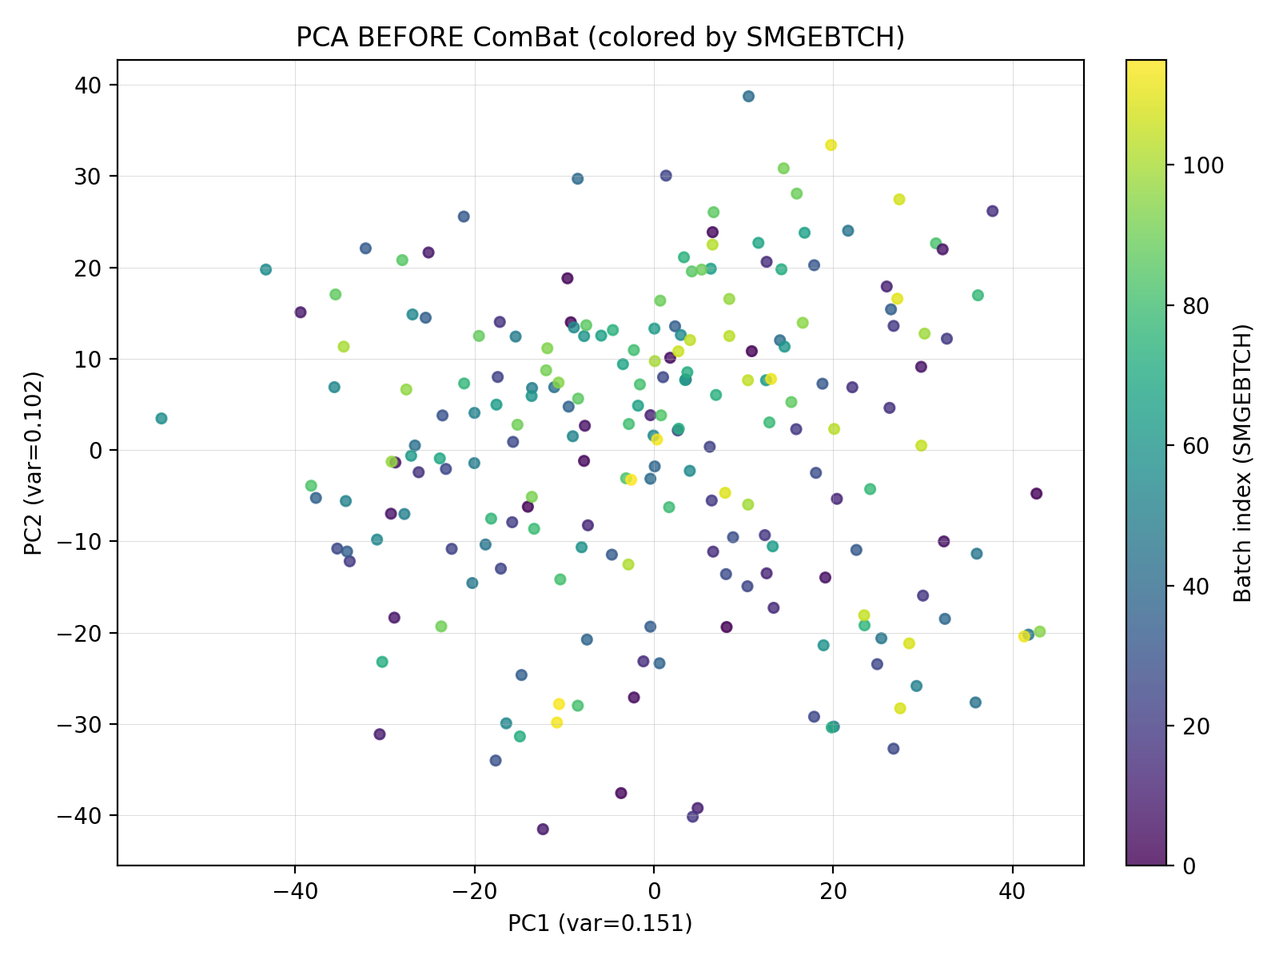
- Figure 1: pca_before_by_batch.png (before ComBat)

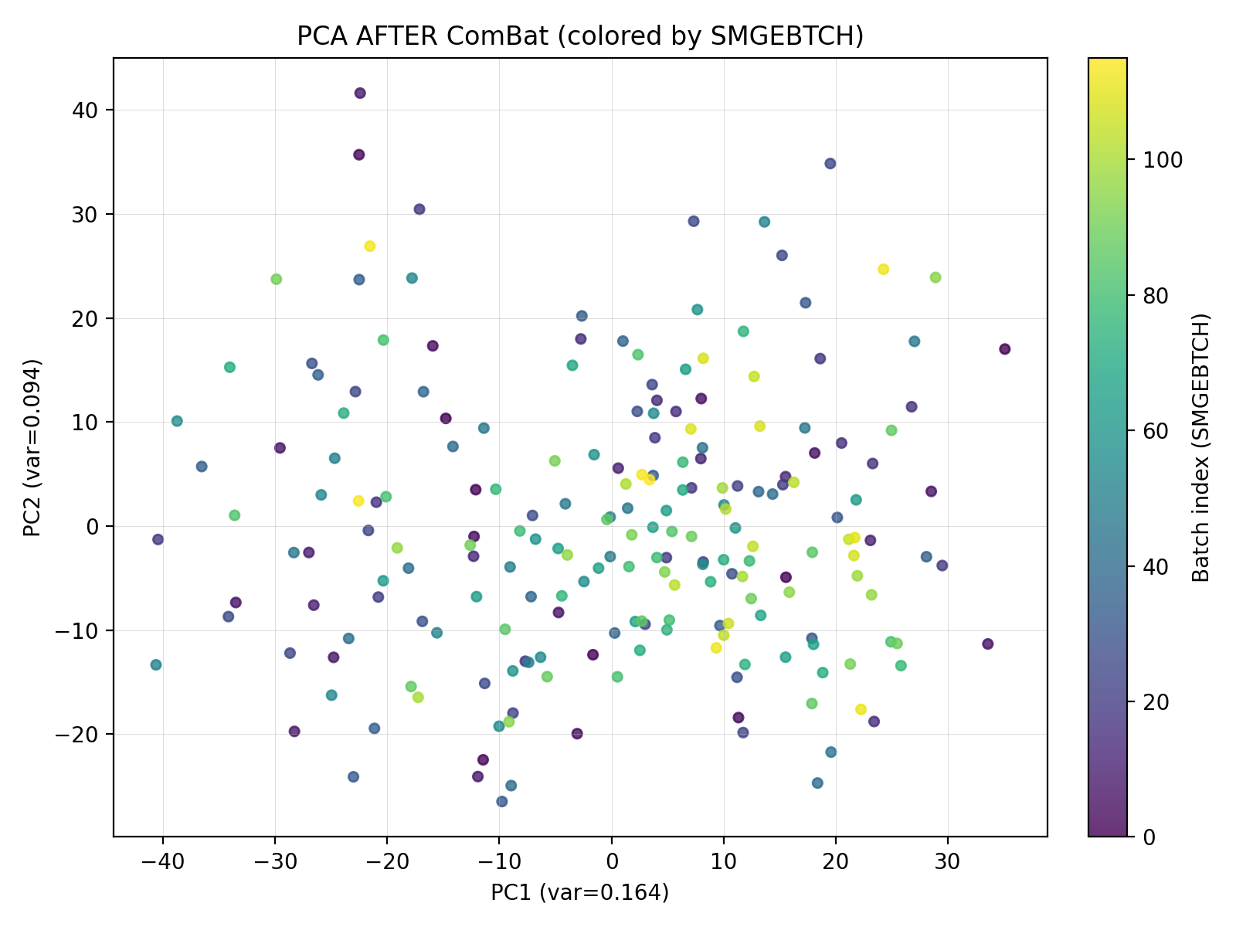
- Figure 2: pca_after_by_batch.png (after ComBat)
Method 2 — Differential Expression with limma (Step 5)
Differential expression was performed using limma with linear modeling and moderated statistics.
Input: expr_combat.csv + meta_groups.csv (only LOW/HIGH extreme groups)
Design (no batch term, per rubric):
~ Group + AGE + SEX + DeathType + SMRIN
Contrast: HIGH − LOW
So positive logFC means higher expression in HIGH ischemic time.
Multiple testing control: Benjamini–Hochberg FDR (adj.P.Val).

Outputs:
- deg_table.csv
- deg_top50.csv
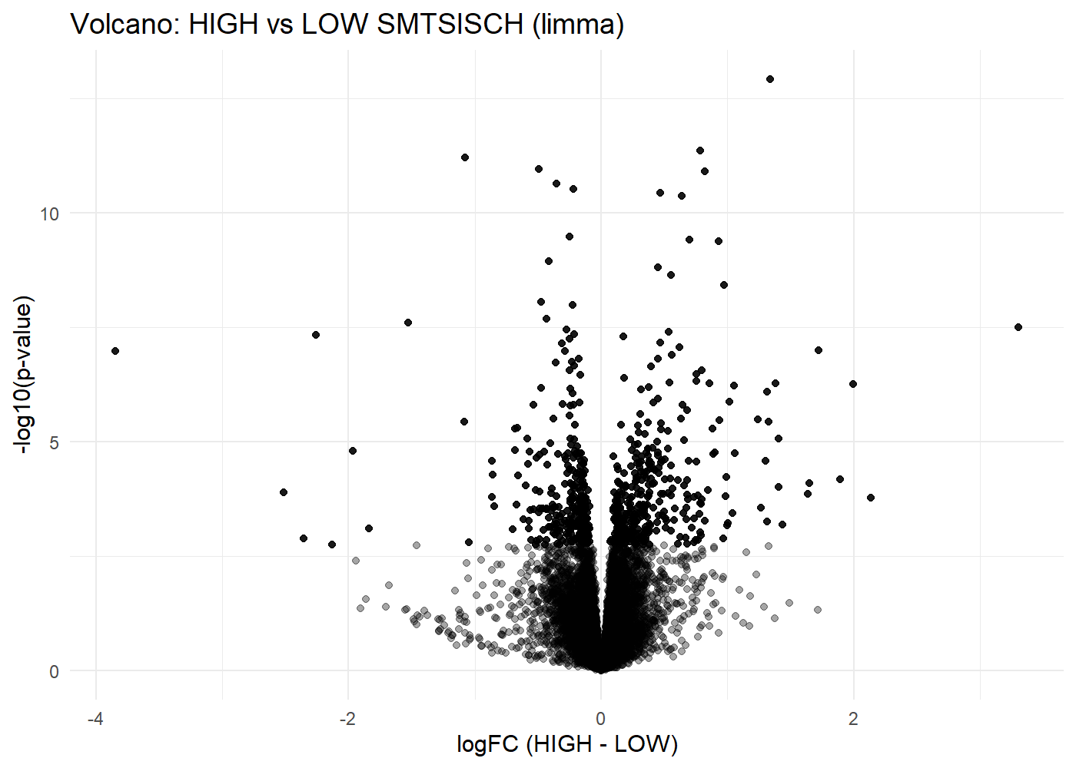
- deg_summary.txt

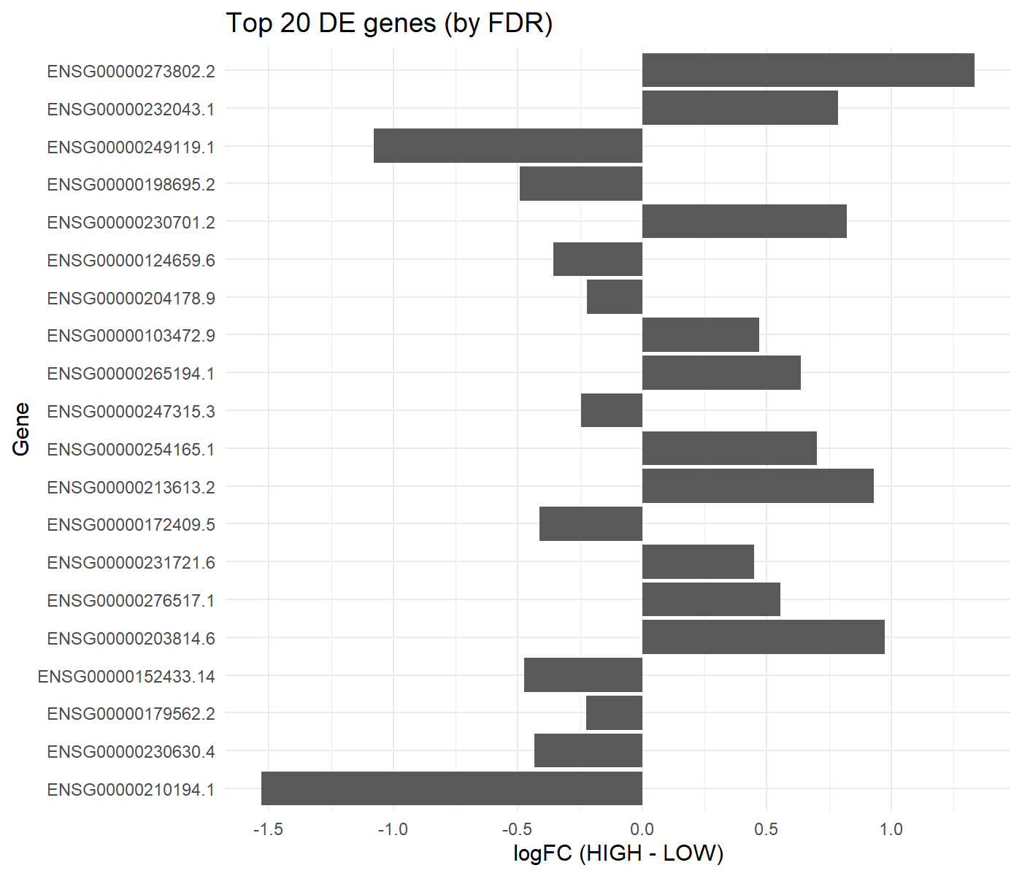
Method 3 — Pre-ranked GSEA
To interpret changes at the pathway level, we performed Gene Set Enrichment Analysis (GSEA) using a pre-ranked gene list.
Ranking statistic: limma t-statistic for HIGH − LOW
Ranked file: gsea_ranked_t_HighVsLow.rnk
Gene set collection: MSigDB Hallmark (H), a curated reduced-redundancy gene set collection.
Outputs:
- gsea_hallmark_full.csv
- gsea_hallmark_top_up.csv
- gsea_hallmark_top_down.csv
- Figure 5: gsea_hallmark_dotplot.png
- Figure 6: gsea_enrichment_HALLMARK_TNFA_SIGNALING_VIA_NFKB.png (HIGH-enriched example)
- Figure 7: gsea_enrichment_HALLMARK_OXIDATIVE_PHOSPHORYLATION.png (LOW-enriched example)
  - All the files and the photos in the gsea folder ( no place to show them here)
Interpretation rule:
- NES > 0 ⇒ enriched in HIGH
- NES < 0 ⇒ enriched in LOW
4. Results (Describe the Analysis Results)
4.1 Batch correction results (ComBat)
PCA before correction showed visible structure consistent with batch effects. After ComBat, PCA clustering by SMGEBTCH was reduced, supporting effective batch correction while preserving covariate structure.
- Figure 1: PCA before ComBat (pca_before_by_batch.png)
- Figure 2: PCA after ComBat (pca_after_by_batch.png)
This supports using corrected expression (expr_combat.csv) for downstream DE and GSEA.
4.2 Differential expression results (limma)
From deg_summary.txt:
- Genes tested: 17,309
- Samples in DE: 106 (LOW n=53, HIGH n=53)
- Significant DEGs:
  - FDR < 0.05: 636
  - FDR < 0.10: 1,034
- Figure 3: Volcano plot (volcano.png)
- Figure 4: Top 20 DE genes (top20_genes_bar.png)
- All the files needed are included in differential expression folder
4.3 GSEA results (Hallmark pre-ranked)
From gsea_hallmark_full.csv:
- 17 out of 50 Hallmark pathways are significant at FDR < 0.05
  - 8 pathways enriched in HIGH (NES>0)
  - 9 pathways enriched in LOW (NES<0)
Top HIGH-enriched pathways (NES>0):
- HALLMARK_MYC_TARGETS_V2 — NES 2.196, FDR 7.9e−05
- HALLMARK_TNFA_SIGNALING_VIA_NFKB — NES 1.855, FDR 7.3e−05
- HALLMARK_EPITHELIAL_MESENCHYMAL_TRANSITION — NES 1.800, FDR 1.68e−04
- HALLMARK_UNFOLDED_PROTEIN_RESPONSE — NES 1.695, FDR 0.00266
- HALLMARK_MYC_TARGETS_V1 — NES 1.540, FDR 0.00585
Top LOW-enriched pathways (NES<0):
- HALLMARK_OXIDATIVE_PHOSPHORYLATION — NES −1.806, FDR 9.0e−05
- HALLMARK_PEROXISOME — NES −1.630, FDR 0.01596
- HALLMARK_ADIPOGENESIS — NES −1.445, FDR 0.02479
- HALLMARK_ALLOGRAFT_REJECTION — NES −1.473, FDR 0.02867
- HALLMARK_HEME_METABOLISM — NES −1.448, FDR 0.02867
- Figure 5: Hallmark dotplot (gsea_hallmark_dotplot.png)
- Figure 6: TNFA/NFKB enrichment (gsea_enrichment_HALLMARK_TNFA_SIGNALING_VIA_NFKB.png)
- Figure 7: OxPhos enrichment (gsea_enrichment_HALLMARK_OXIDATIVE_PHOSPHORYLATION.png)
  - All the photos and the files needed are included in the gsea folder
Overall, the pathway results suggest that HIGH ischemic time is associated with coordinated stress/inflammatory signaling, while LOW ischemic time is associated with stronger metabolic/mitochondrial pathway signatures.
5. Conclusions + What We Learned + Future Improvements
This analysis supports the conclusion that extreme ischemic time differences (SMTSISCH HIGH vs LOW) correspond to measurable transcriptomic differences in GTEx Artery–Coronary tissue:
- Hundreds of DEGs remain significant after covariate adjustment (FDR<0.05: 636).
- Hallmark GSEA identifies multiple significant pathways (17/50 at FDR<0.05), including:
  - HIGH-enriched: TNFα/NF-κB signaling and MYC targets (stress/regulatory activation).
  - LOW-enriched: oxidative phosphorylation and peroxisome (metabolic/mitochondrial programs).
What we can learn
The results suggest ischemic time is linked with broad biological programs rather than isolated gene changes, and pathway-level interpretation strengthens biological interpretability beyond single-gene lists.
Future work / improvements
- Model SMTSISCH as a continuous variable rather than only Q1 vs Q3.
- Add approaches to account for cell-type composition variation across samples.
- Validate the same findings in independent vascular datasets or replicate GTEx subsets.

