BMP & Co. LLP: Statutory Compliance System
Technical Overview
Prepared for | BMP & Co. LLP
Prepared by | CanopusGBS
Date | 21 September 2026
Version | 1.1
Document type | Technical overview for review
Companion document | A detailed engineering roadmap exists separately for the development team.

At a glance
What | A central system of record for BMP’s company-secretarial work, with an AI assistant added on top once the foundation is in place
Pilot | 5 client companies, with the Annual General Meeting as the first activity handled end to end
Phase 1 | System of record
Phase 2 | AI assistant
Phase 3 | Final Rollout
Where data lives | On BMP’s own server. Only the information needed for a specific AI task is sent to the AI provider.
Key safeguard | The AI proposes; a person approves. Nothing is saved or sent without human confirmation.

1. What We Are Building
A central system of record for BMP’s company-secretarial practice. It will:
- Store and organise all statutory data for each client company: directors, shareholders, meetings, filings and more
- Track obligations, the statutory processes your team must complete under the Companies Act 2013
- Break each obligation into tasks with clear steps, deadlines and status
- Attach evidence such as notices, minutes, resolutions and attendance sheets to the relevant records
- Apply the “Don’t Ask Twice” rule, so a person entered once is available everywhere they appear
- Calculate automatically fields such as shareholding percentages, director ages, notice periods and attendance rates, which are never typed by hand
- Work out what is required for each company from its characteristics (capital, turnover, listing status and so on) using a reviewable rules system
- Keep an audit trail of every change: who made it, when, and what it changed from

Once that foundation is in place, an AI assistant is added on top. It can:
- Read uploaded documents and extract the details, for example reading an AGM notice and filling in the date, venue and agenda
- Set up work from a simple instruction, for example “Set up the AGM for Acme Corp” creates all the steps, deadlines and records
- Draft notifications, for example the AGM notice to all directors and shareholders, which your team reviews before it is sent
- Answer questions from your documents, with a reference to the source it relied on

IMPORTANT: The AI never acts on its own. Anything that creates records, changes data or sends a communication requires explicit confirmation from a person before it happens.

2. Why “System of Record First, AI Second”
This was the core decision from the 18 September discussion.
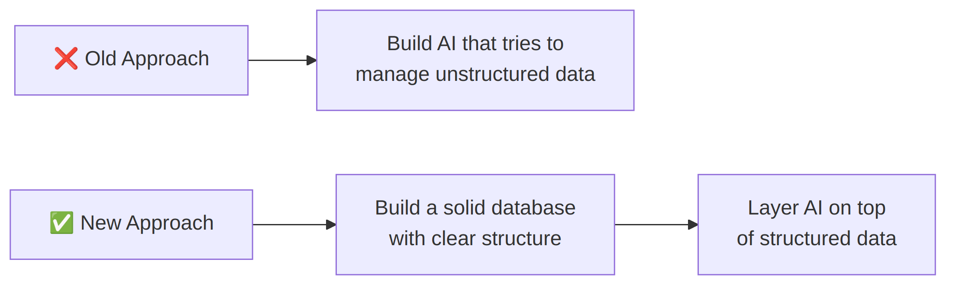
The reasoning:
- AI works best when it has well-organised data to read from and write to
- Without a proper system of record, the AI would be guessing at how information fits together
- A structured database is useful on its own, as a compliance management tool, even without AI
- This approach is more reliable, easier to audit, and easier to defend

3. How the System Is Organised

3.1 Architecture: what runs where
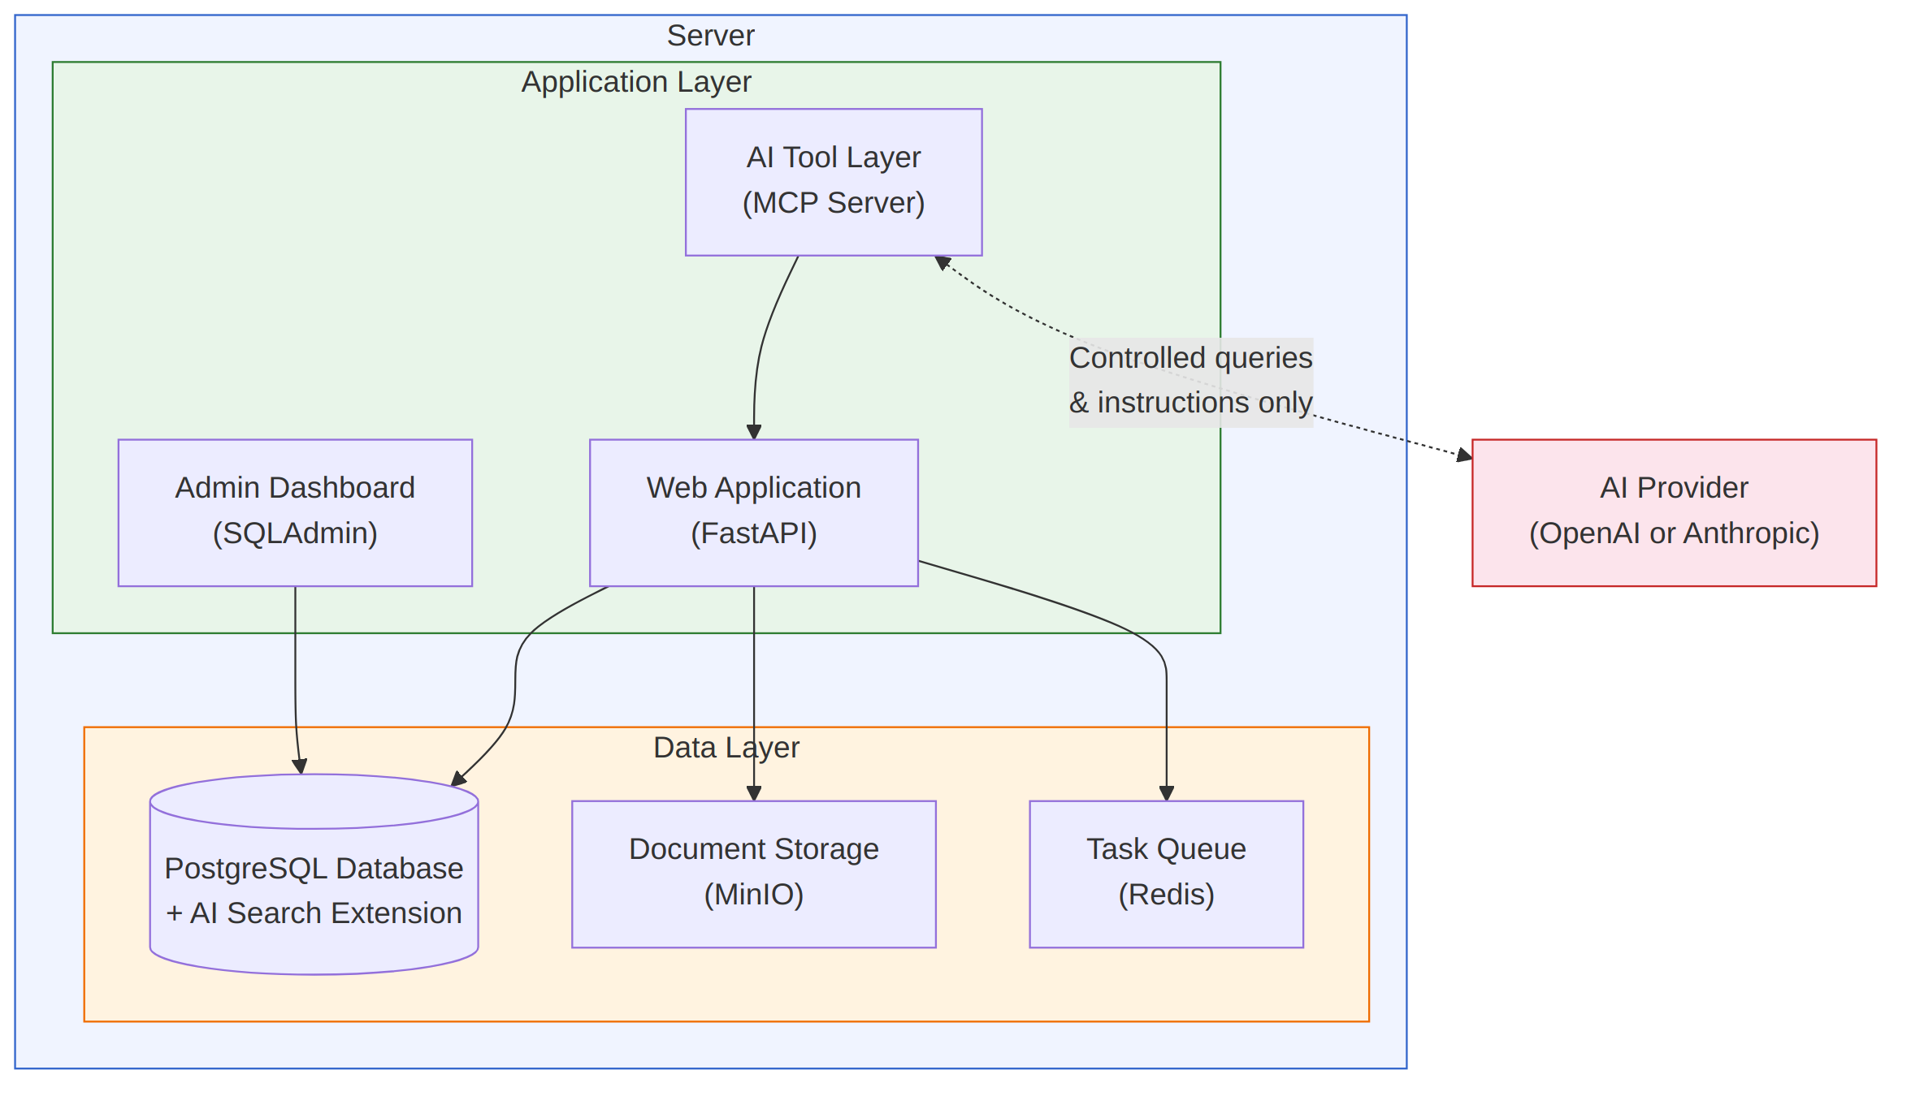
Component | What it does | Where it lives
Web application | The core of the system. Handles all data operations, access and business logic | BMP’s server
Admin interface | A web screen for viewing and managing all records directly: tables, records, filters | BMP’s server
Database | Stores all company data, obligations, tasks, rules and document details. Includes a search extension that lets the AI find relevant documents quickly | BMP’s server
Document storage | Stores all uploaded evidence files: PDFs, images and scanned documents | BMP’s server
Task queue | Runs background work such as sending emails, reading documents and preparing documents for search | BMP’s server
AI tool layer | The controlled gateway between the AI and your data. The AI can only act through pre-defined, permission-controlled tools | BMP’s server
AI provider | The external AI service used to understand documents and instructions and to draft communications | External (cloud). See section 5

NOTE: Everything except the AI provider runs on BMP’s own server, on infrastructure BMP controls. The AI provider receives only the specific information needed for the task in hand.

3.2 How data is organised
The system organises information into clear categories, linked to one another:
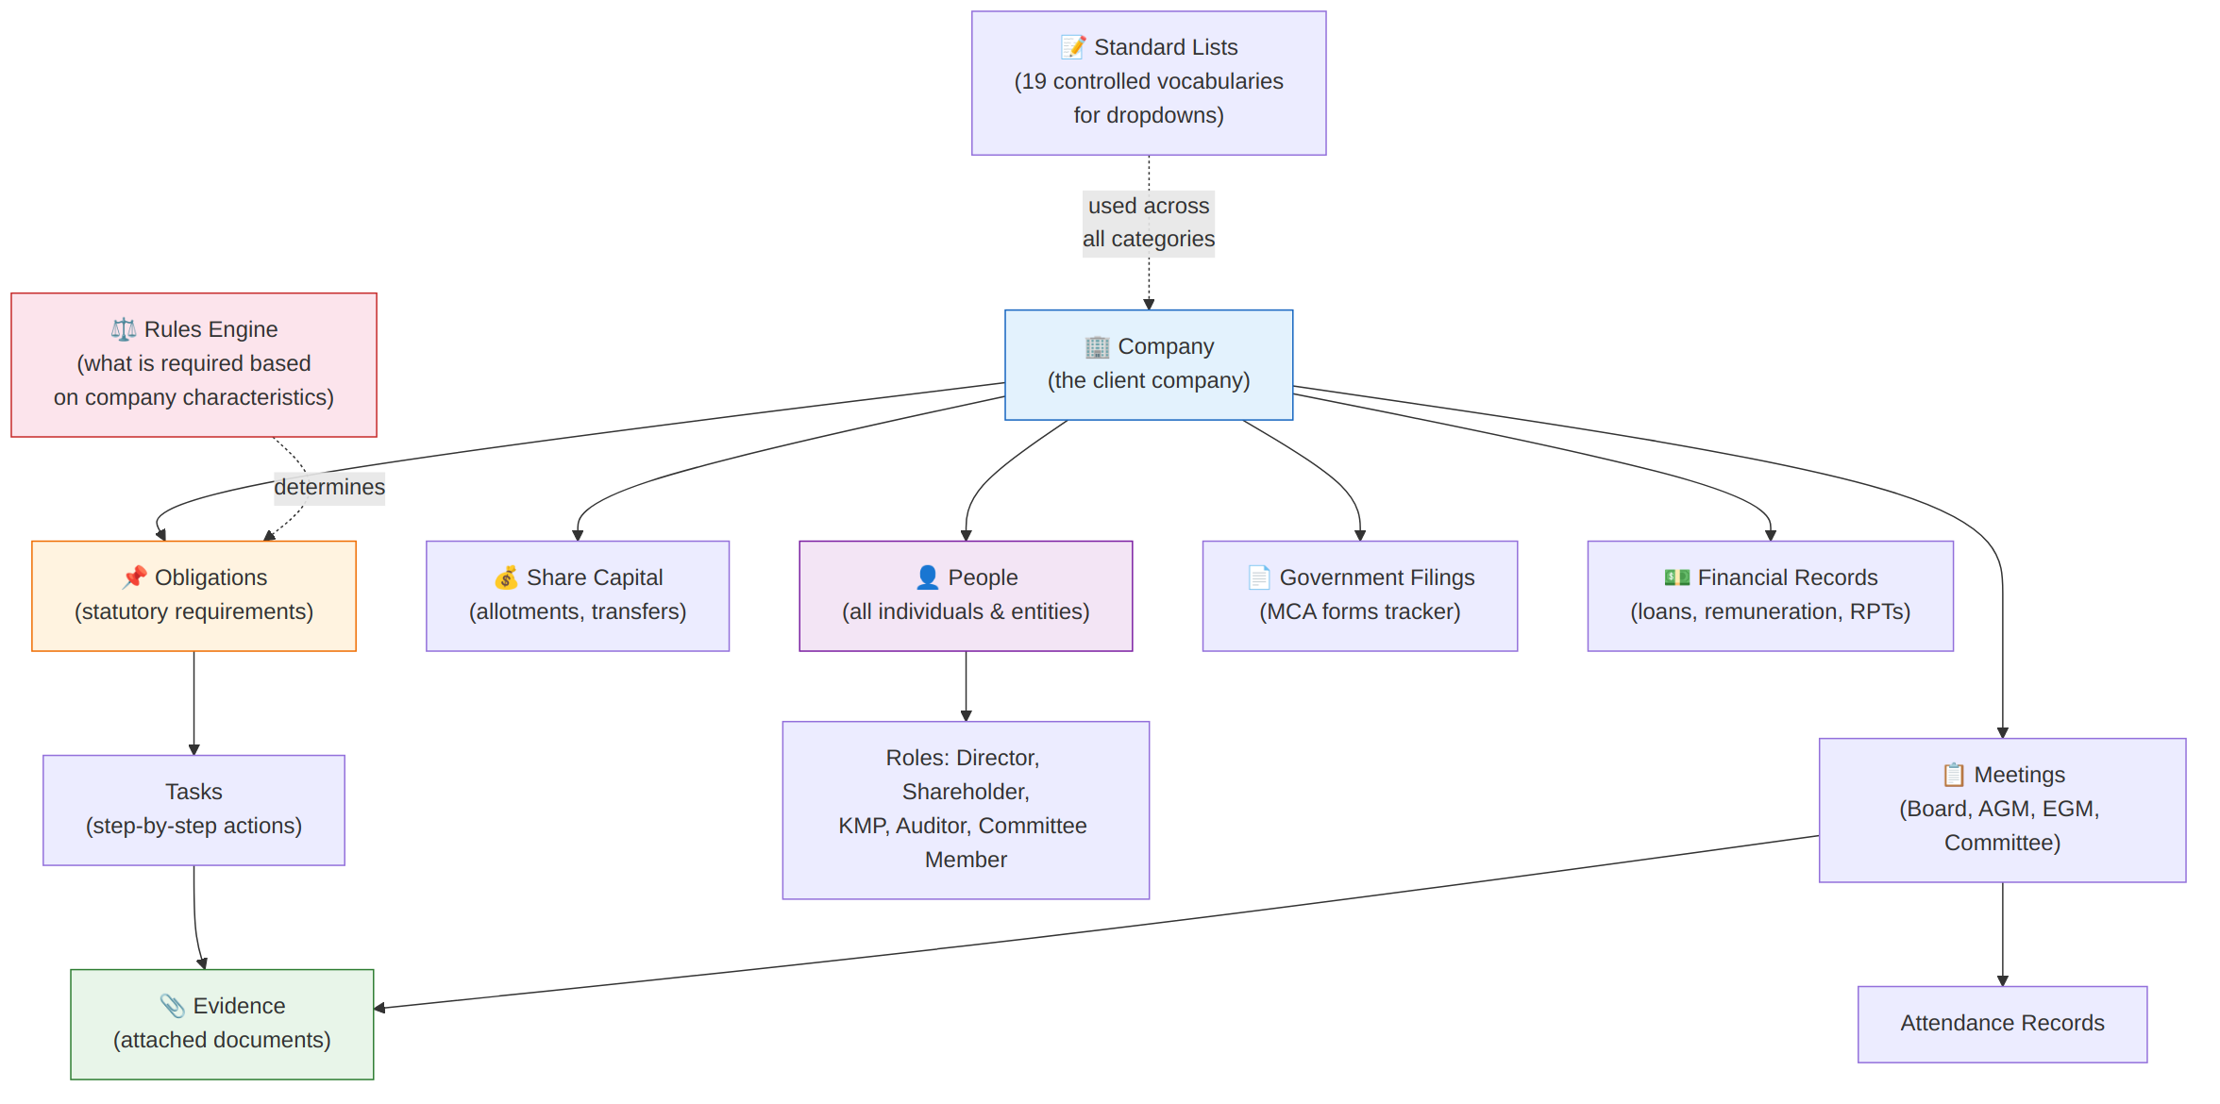
Category | What it stores | Key principle
Company | CIN, incorporation date, registered office, type, capital, turnover, listing status, financial year | One record per client company
People | Name, DIN, PAN, contact details, nationality, date of birth | Entered once, used everywhere
Roles | Director appointments, shareholdings, KMP designations, auditor terms, committee memberships, each linked to the person | Each role has its own start and end dates, so history is kept
Meetings | Board meetings, AGMs, EGMs and committee meetings: notice date, venue, mode, quorum, chairperson, minutes | Attendance tracked per person per meeting
Share capital | Authorised and issued shares by class, allotment history, transfer history | Holdings and percentages are calculated automatically
Obligations | Statutory requirements, such as “Hold the AGM within 6 months of FY end”, broken into step-by-step tasks | Status moves from not started, to in progress, to completed or overdue
Evidence | Notices, agendas, minutes, attendance sheets, financial statements and other documents | Can be attached to meetings, tasks, people or any other record
Government filings | MCA form tracker: form name, due date, filing date, SRN, status | Status is calculated from the dates
Financial records | Remuneration, loans and investments (Sections 185 and 186), related party transactions (Section 188), penalties | Linked to people and companies
Rules engine | 37 rules linking company facts to requirements, for example “paid-up capital above ₹10 crore means an Audit Committee is mandatory” | Reviewable and updatable. See section 3.4
Standard lists | 19 fixed lists used as dropdowns: company types, designations, meeting modes and so on | Keeps data entry consistent
Audit trail | Every change made to any record, and every action proposed by the AI | Cannot be edited or deleted. See section 3.5

NOTE: Portal Access stores only portal names and usernames. As directed by BMP, passwords are never stored in this system.

3.3 The “Don’t Ask Twice” principle
When a person is entered once, they are available for selection everywhere:
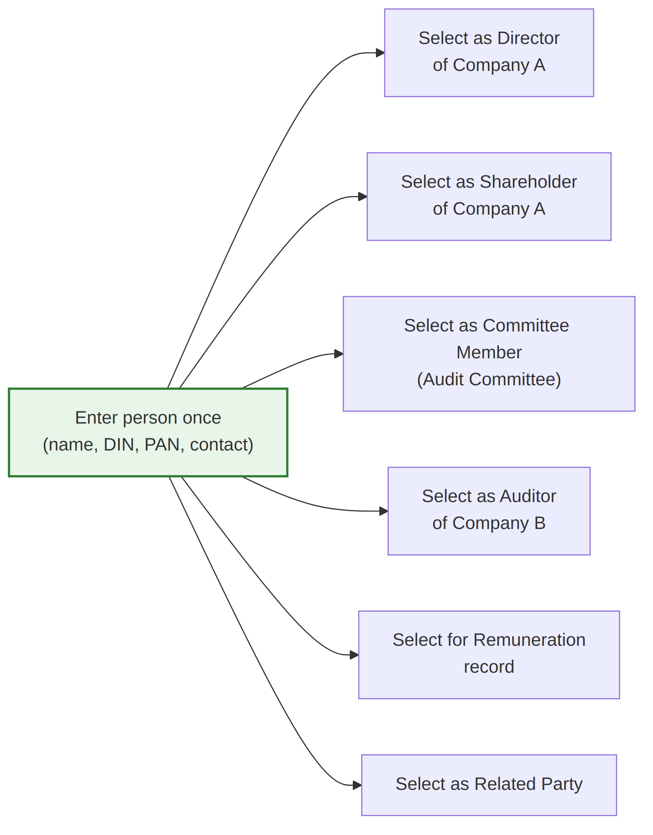
- No re-typing of names, DINs or contact details
- Updating a person’s contact details updates them everywhere that person appears
- The system shows each person’s roles across all companies in one place
- People are matched on DIN or PAN, and companies on CIN, rather than on names. Where a name looks similar to an existing record, such as “ABC Private Limited” and “ABC Pvt Ltd”, the system asks whether it is the same entity rather than creating a duplicate

3.4 The rules engine: “When Something Becomes Required”
Based on BMP’s 37-rule table from the master checklist, the system works out what is required for each company.
Aspect | How it is handled
Source | BMP’s own “When Something Becomes Required” table (37 rows)
How it runs | Fixed logic: the same inputs always give the same answer. The AI is never used to decide this.
Shows its working | Each result shows the figures it used, the threshold applied, and the legal section it comes from
Reviewable | Each rule records when it was last reviewed and by whom
Updatable | Rules can be changed, added or switched off as the law changes, without touching the rest of the system
Review status | Every rule is marked “pending review” until a BMP professional signs it off

WARNING: The rules engine is a decision-support tool, not legal advice. BMP professionals must review and approve each rule before relying on it for an actual filing. The system tracks review status for every rule.

3.5 Audit trail
BMP asked for a full record of changes, which also supports the firm’s obligations under the Digital Personal Data Protection Act. The system records:
- Every change to any record: who made it, when, and the value before and after
- Every action the AI proposed, whether it was approved, edited or rejected, and by whom
- Every notification sent, to whom, and who approved it
The audit trail cannot be edited or deleted by anyone, including administrators.

4. Delivery Roadmap

Phase overview
Delivery is in three phases. Each phase builds on the one before it, and dates will be confirmed once the plan is approved and the decisions in section 9 are in place.

Phase 1: System of Record
Goal: a fully structured, populated and inspectable database, which is the foundation everything else is built on.
What is delivered | Details
Complete database structure | All the data categories in section 3.2
5 client companies fully loaded | Each with directors, shareholders, KMPs, auditors, committees and share capital
AGM fully set up | Current and prior year AGM records per company, with step-by-step tasks and sample evidence attached
Rules engine working | All 37 rules loaded and evaluated per company, showing what is and is not required
19 standard lists | All dropdowns from the master checklist
All calculated fields working | Shareholding percentages, ages, notice periods, attendance, filing status
Admin interface | Password-protected web screen to browse, search and manage all records
Audit trail | Recording every change from day one
Data access layer | Ready for the dashboard and AI to connect to later
Daily backups | From day one, with a copy held on separate storage

What does “done” look like? An authorised person opens the admin interface, selects any of the 5 companies, and moves through all their records: directors, meetings, AGM obligations with task checklists, and attached evidence, with all links intact and every calculated field showing the correct value.
NOTE: Until BMP’s server is ready, Phase 1 is delivered and demonstrated on a secure staging environment. It moves to BMP’s server as soon as the hardware is in place. See decision item 2 in section 9.

Not included in Phase 1:
Not included | Why
AI capabilities | Phase 2
Individual user accounts | Phase 2. Access in Phase 1 is through the password-protected admin interface
Email and notifications | Phase 2
Document reading | Phase 2
Front-end dashboard | After the pilot
ODI compliances and ECB | Out of scope, as agreed

Phase 2: AI Assistant on the AGM Pilot
Goal: AI assistance working end to end on the Annual General Meeting process for the 5 pilot companies.

Why the AGM was chosen as the pilot
Reason | Detail
Involves the most records | Company, directors, shareholders and auditors all take part in an AGM
Clear legal deadlines | Must be held within 6 months of FY end (9 months for the first AGM), and no more than 15 months apart
Largest evidence checklist | 11 document types: a strong test of evidence linking
Clear, testable flow | Fix date, prepare notice, send notice, hold meeting, record attendance, draft minutes, file with ROC

Capability 1: Reading documents
Upload a document, the AI reads it and extracts the details, your team checks them, and the confirmed details are saved.
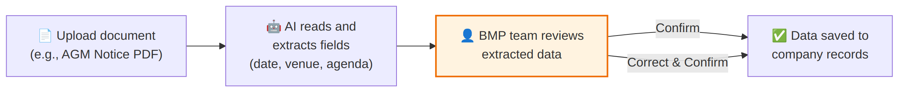
- Works on digital PDFs, Word files and scanned documents
- Where a document disagrees with information already held, such as two different appointment dates, the system shows both values and asks which is correct. It never overwrites silently
- Any detail the AI is unsure of is highlighted for the reviewer rather than filled in with a guess

Capability 2: Setting up work from an instruction
Give a simple instruction, the AI prepares all the steps, deadlines and records, and your team confirms.
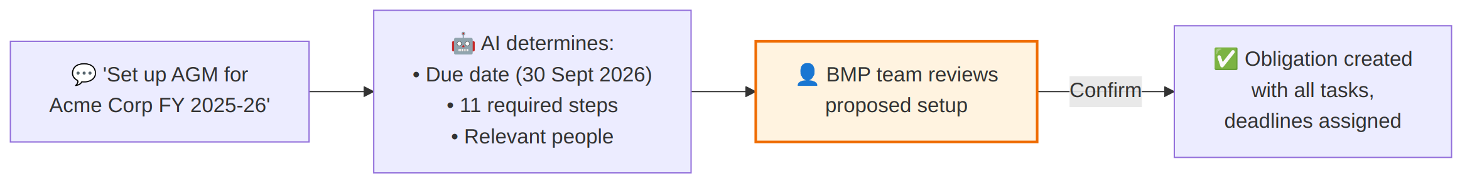

Capability 3: Drafting notifications
Ask the AI to notify people, it drafts the message and shows the recipient list, your team reviews, and the email is sent.
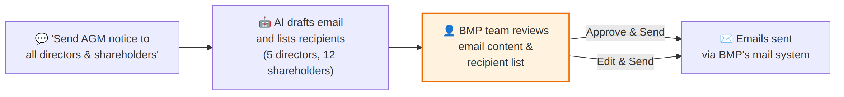

Capability 4: Answering questions from documents
Ask a question, the AI searches the relevant documents, and answers with a reference to its source.
Example: “What does Section 96 say about AGM timing?” The AI finds the relevant paragraphs and answers with citations.
Reference material such as the Companies Act and Secretarial Standards is held in a shared library available to all companies. Client documents stay within their own company and are never searched on behalf of another.

Where human confirmation applies
The AI cannot act on its own for anything that changes data or sends a communication:
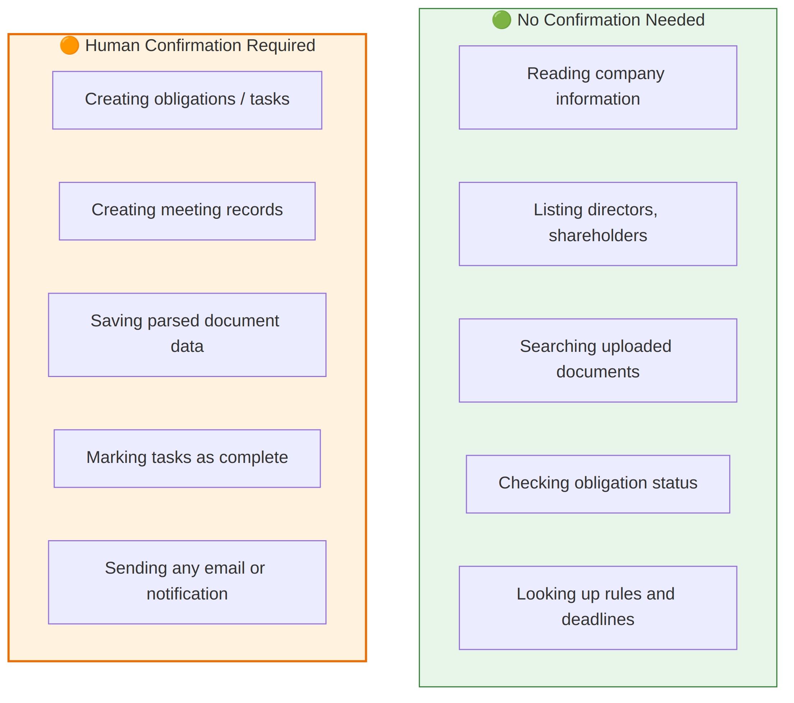
IMPORTANT: The AI proposes. People approve. This is built into the system itself, not an instruction given to the AI that could be ignored. The AI has no way to write to the database or send an email without going through the confirmation step.

Because every approval is recorded against a named person, individual user accounts are introduced in Phase 2 for everyone who will approve AI actions. Full role-based permissions follow in Phase 3.

The AGM flow, end to end
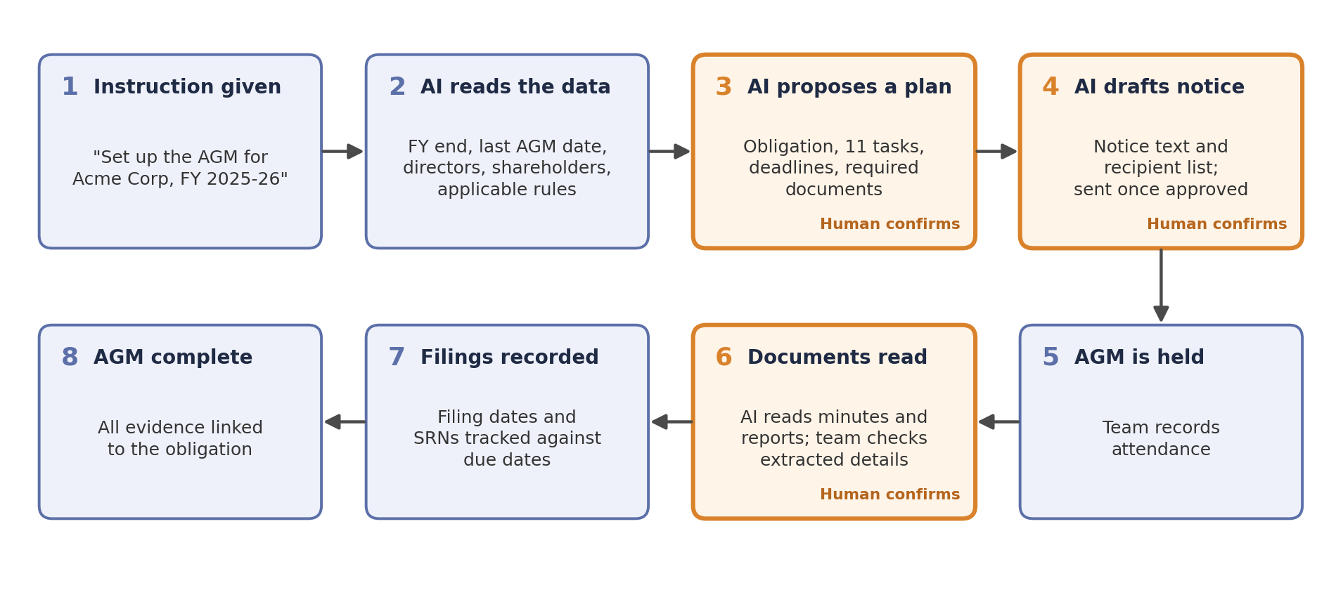

How we will judge the pilot
Measure | What we will check
Reading accuracy | Details extracted from pilot documents, compared against the same details checked by hand
Correction rate | How often reviewers need to change what the AI extracted
Time saved | Time to set up and run an AGM with the system, compared with the current way of working
Safeguards | No data saved and no email sent without approval, confirmed through the audit trail

Results will be shared with BMP at the end of the pilot, before the wider rollout begins.

Phase 3: Full Rollout
Work stream | What it covers
Remaining statutory activities | Board meetings, share allotments and transfers, EGMs, committee meetings and circular resolutions, each given the same treatment as the AGM
Full client portfolio | Onboarding the remaining BMP client companies beyond the first 5
Roles and permissions | Administrator, CS Professional and Viewer roles, with appropriate access for each
Dashboard connection | Connecting the existing BMP dashboard to the live system, replacing any sample data
Additional compliance modules | FC-GPR, FC-TRS, ODI and ECB, when needed
Hosting review | Whether to stay on BMP’s own server or move to cloud hosting

5. Data Security and Privacy

5.1 Where your data lives
Data | Stored where | Controlled by
Company records, people, meetings, obligations, tasks, rules, audit trail | Database on BMP’s server | BMP
Uploaded documents: notices, minutes, financial statements and so on | Document storage on BMP’s server | BMP
Backups | Daily, with a copy on separate storage so that a server failure does not also lose the backups | BMP

5.2 What the AI provider sees
What is sent | When | Why
The text of a document | When a document is uploaded and reading is requested | To extract the details
The specific company details a task needs | When the AI is asked to carry out a task | To understand context, for example who the directors are
The user’s instruction | When a user gives an instruction | To understand what to do

What is never sent | How this is enforced
Data from other client companies | The AI’s tools only reach the company it is working on
Passwords or portal credentials | These are not stored in the system at all
The whole database | The AI reaches data only through controlled tools that return just what is needed
Conversations from other companies | AI conversations are kept separately for each company

5.3 AI provider data retention
IMPORTANT: The AI provider (OpenAI or Anthropic) will be chosen on the basis of acceptable Zero Data Retention terms: a contractual commitment not to store, train on or keep BMP’s data beyond processing each request. Under both providers’ standard business terms, data sent through their API is not used for training. Zero Data Retention goes further and removes the short period for which requests are otherwise kept. It is granted by the provider on application, and is a legal and procurement matter currently in progress.

Both providers process requests outside India. BMP should confirm that this is consistent with its engagement terms with its own clients. See decision item 5 in section 9.

5.4 Keeping each company separate
Every record is tagged with the company it belongs to, and the database itself enforces separation, not just the application:
- A request for Company A’s data cannot return Company B’s records
- The AI working on Company A cannot reach Company B’s documents, people or history
- Because the rule is enforced in the database as well as in the application, a mistake in one layer is caught by the other. This separation is tested explicitly before each release

5.5 Keeping sensitive details to a minimum
- Aadhaar numbers are not stored. No rule or process in the system needs them
- BMP will confirm a list of fields that are never sent to the AI provider. These are withheld automatically. See decision item 6
- Personal details are visible only to users with a need to see them, once roles are introduced in Phase 3

6. How the System Meets BMP’s Key Requirements
BMP requirement | How the system meets it
“Don’t ask twice” | One record per person, used across all their roles. No repeated data entry
No duplicate records | People matched on DIN or PAN, companies on CIN. Similar names prompt a confirmation rather than a new record
Calculated fields | Shareholding percentages, ages, notice periods, attendance and filing status are all calculated, never typed
History retained | Every role carries start and end dates, so past positions and previous years remain visible
Conflicting documents flagged | Where two sources disagree, both values are shown and a person decides
Evidence retention | Each activity has a defined list of required documents, stored securely and linked to the relevant records
Rules reviewable, not hard-coded | 37 rules held as data, with legal references, review dates and reviewer names. Changed without altering the software
Audit trail | Every change and every AI action recorded, and not editable by anyone
Each company kept separate | Enforced in the database as well as the application, including in AI conversations
Continuity of work | AI conversations are saved per company, so later work builds on earlier context
No password storage | Portal access holds portal name and username only. There is no password field
AI does not act alone | Every change and every communication requires human confirmation, built into the system
Freedom to change AI provider | OpenAI and Anthropic can be switched through a configuration setting, with no rebuild

7. Running Costs
Cost | Type | Notes
Server and backup hardware | One-time | Set out in the separate server specification
AI provider usage | Monthly, pay per use | Charged per document read and per request. Measured during the pilot, and an estimate for full rollout will be provided before Phase 3
Email service | Monthly, if applicable | Depends on decision item 4. Using BMP’s existing mail system may carry no extra cost

8. Key Risks
Risk | Effect | How it is managed
Seed data not available | Phase 1 cannot be completed | Decision on real or test data (item 1 in section 9) taken early
AI provider contract takes longer than expected | Phase 2 cannot go live | Development continues against test data; switching providers needs only a configuration change
Server not ready in time | Deployment to BMP is delayed | Staging environment used in the meantime
AI misreads a document | An incorrect detail could be saved | Every extracted detail is checked by a person before saving; accuracy measured during the pilot
Rules not yet signed off | Results cannot be relied on for filings | Each rule is marked pending review until a BMP professional approves it

9. Items Requiring a BMP Decision
# | Decision needed | Effect if delayed
1 | Seed data for the 5 pilot companies. Will BMP provide real data (with sensitive details removed if preferred), or should the team prepare realistic test data? If real data is used, BMP should confirm it may be held on the staging environment until the server is ready | Delays Phase 1
2 | Server. Confirm the hardware and when it will be available | Cannot move the system onto BMP’s premises
3 | AI provider contract. Which provider offers acceptable data-retention terms? | Cannot switch on the AI features
4 | Email. Which system should send notifications: BMP’s own mail server or a cloud email service? | Cannot build notifications
5 | Processing outside India. Confirm that sending document text to a provider outside India is consistent with BMP’s engagement terms with its clients | Cannot switch on the AI features
6 | Fields withheld from the AI. Which fields should never be sent to the AI provider? | Delays AI go-live
7 | Pilot approvers. Who at BMP will approve AI actions during the pilot? Each will need a user account | Delays Phase 2
8 | Roles and permissions. What roles should exist, and what can each do? | Does not affect Phase 1 or 2

10. Glossary
Term | What it means
System of record | The single trusted source for all compliance data, replacing spreadsheets and manual tracking
Obligation | A statutory process required by law, such as holding an AGM or filing an annual return
Task | A single step within an obligation, such as “Prepare notice” or “Record attendance”
Evidence | A document attached to a record as proof of compliance, such as signed minutes or an attendance sheet
Audit trail | A permanent, unalterable record of every change made and who made it
Admin interface | A web screen for viewing and managing records directly
API / data access layer | The way software systems talk to each other, allowing the dashboard and the AI to work with the database
Database (PostgreSQL) | Where all company data is stored: a highly reliable system that many people can use at once
Document storage (MinIO) | A dedicated store for uploaded files, kept separate from the database for security and performance
Staging environment | A secure copy of the system used for building and testing before it goes onto BMP’s server
AI provider | The external service (OpenAI or Anthropic) providing the AI capabilities
MCP (Model Context Protocol) | The controlled gateway between the AI and the system. It defines exactly what the AI can and cannot do, like a set of approved tools
RAG (Retrieval-Augmented Generation) | The AI first finds the relevant passages in your documents, then answers from them, so answers are grounded in real sources
Zero Data Retention (ZDR) | A contractual commitment from the AI provider not to store or use BMP’s data beyond processing each request
Row-Level Security (RLS) | A database feature that keeps each company’s data separate from every other
Docker | A way of packaging the software so it runs the same on any server, and can move to the cloud later

