A Project Report

On

**Spike Sorting Analysis for Single-Channel Electrophysiological Data**

BY

**ANAS SHEIKH**

**2021B4A32454H**

Under the supervision of

**Prof . Srinivasa Prasad**

**SUBMITTED IN PARTIAL FULFILLMENT OF THE REQUIREMENTS OF**

**EEE/ECE/INSTR F376/377: DESIGN PROJECT**



**BIRLA INSTITUTE OF TECHNOLOGY AND SCIENCE PILANI (RAJASTHAN)**

**HYDERABAD CAMPUS**

**(September 2024**)

**ACKNOWLEDGMENTS**

I would like to express my sincere gratitude to

* Prof. Srinivasa Prasad, thank you for providing guidance, constant supervision, and the necessary information regarding the project.
* My institute, BITS Pilani, Hyderabad Campus, for allowing me to work on this

project remotely as well as physically.

* All my friends who have helped me in some way, whether directly or indirectly, or

who have inspired my work mentality.



**Birla Institute of Technology and Science-Pilani,**

**Hyderabad Campus**

**Certificate**

This is to certify that the project report entitled “Spike Sorting Analysis for Single-Channel Electrophysiological Data**,"** submitted by Mr. Anas Sheikh (ID No. 2021B4A32454H) in partial fulfillment of the requirements of the course EEE F266, Study Project Course, embodies the work done by him under my supervision and guidance.

**Date: 28th September 2024 ( Prof. Srinivasa Prasad)**

BITS- Pilani, Hyderabad Campus

**ABSTRACT**

This report presents a comprehensive study of spike-sorting algorithms tailored for single-channel neural data, focusing on their performance, accuracy, and suitability for detecting and classifying neural spikes. Spike sorting is a critical step in neural data analysis, enabling researchers to isolate individual neuron activity from extracellular recordings. Accurate spike sorting is indispensable for interpreting neural firing patterns, quantifying neural responses, and understanding brain dynamics.

Initial experiments with widely used tools like **Kilosort5** and **Brainstorm**, optimized for multi-channel recordings, revealed their limitations in handling single-channel datasets. These tools struggled with inconsistent cluster separation and suboptimal spike detection, highlighting the need for specialized algorithms tailored to single-channel data.

We transitioned to **MountainSort 5** to address these challenges, integrated with the **Spikeinterface** framework. Mountain Sort 5's flexibility, mainly through its **Scheme3 sorting parameters**, allowed us to fine-tune critical aspects such as detection thresholds, spike window durations, and clustering radii. Comprehensive preprocessing steps, including **bandpass filtering** and **whitening**, were implemented to improve signal clarity and reduce noise, significantly enhancing spike detection accuracy.

To validate the sorting results and assess clustering accuracy, dimensionality reduction techniques like **PCA**, **t-SNE**, and **UMAP** were employed. These methods provided visual representations of spike clusters, offering insights into sorting quality. Quantitative metrics such as **silhouette scores** further confirmed the effectiveness of clustering and classification. These analyses ensured detected spikes were appropriately categorized and aligned with expected neural activity patterns.

Building on these advancements, developing a **Spike Sorting GUI** marked a significant step forward in the project. The GUI integrates Mountain Sort 5 and Spikeinterface, providing an accessible platform for researchers to perform spike sorting without requiring extensive programming expertise. It supports parameter customization, automated preprocessing, and visualization of results, streamlining the entire workflow.

This study establishes a robust framework for single-channel spike sorting and underscores the importance of iterative optimization and validation. Bridging the gap between computational complexity and usability sets the stage for future enhancements, including multi-channel support, real-time sorting capabilities, and machine learning-driven parameter tuning. This work is a foundation for scalable and accurate neural data analysis with broad applications in neuroscience research.

**Table of Contents**

1. **Title Page ................................................................................................................ 1**
2. **Acknowledgments ...................................................................................................2**
3. **Certificate ................................................................................................................3**
4. **Abstract .................................................................................................................. 4**
5. **Introduction ........................................................................................................... 6**
6. **Methods and Algorithms Explored ......................................................................7**
7. **MountainSort5: Spike Sorting with MountainSort and Spikeinterface ......... 9**
8. **Results and Evaluation (MountainSort5) ....................................................…...12**
9. **Graphs .................................................................................................................. 15**
10. **Dimensionality Reduction Techniques ...............................................................17**
11. **Transition to the Development of the Spike Sorting GUI ................................ 18**
12. **Development of the Spike Sorting GUI ............................................................. 19**
13. **Features of the Spike Sorting GUI .................................................................... 20**
14. **Results with the Spike Sorting GUI .................................................................. 25**
15. **Future Enhancements ........................................................................................ 27**
16. **Conclusion ........................................................................................................... 29**
17. **References ........................................................................................................... 31**

**Introduction**

Spike sorting is a fundamental technique in neuroscience, enabling researchers to analyze neural data from extracellular recordings. By detecting and classifying spikes, or action potentials, from individual neurons, spike sorting provides insights into neuronal firing patterns and their responses to stimuli or conditions. The accuracy of this process is paramount, as it directly influences the interpretation of neural dynamics, coding, and brain function.

Extracellular recordings often pose significant challenges due to noisy signals and overlapping activity from multiple neurons. Tools like **Kilosort5** have proven effective for multi-channel recordings by leveraging spatial information from high-density electrode arrays to differentiate neutron sources. However, these tools often fall short in single-channel recordings, where spatial information is limited, leading to unreliable spike detection and classification.

Our initial experiments employed **Kilosort5**, which, despite its robustness for multi-channel data, proved suboptimal for single-channel recordings. The lack of spatial information necessitated exploring alternative spike-sorting methods. Tools such as **Brainstorm** and various algorithms available on the **Spikeinterface** platform were tested. However, these methods delivered inconsistent results, particularly in detecting the correct number of spikes and ensuring accurate temporal alignment.

Which led us to adopt **MountainSort5**, a highly customizable spike-sorting algorithm well-suited for single-channel data. MountainSort5, integrated with the Spikeinterface framework, offers extensive parameter customization, including detection thresholds, spike window durations, and channel radii, allowing us to optimize performance for our specific data. Its preprocessing capabilities, such as bandpass filtering and whitening, enhanced signal clarity, reducing noise and improving spike detection accuracy.

To ensure the reliability of our results, we employed dimensionality reduction techniques like **PCA**, **t-SNE**, and **UMAP** to visualize spike clusters. These methods provided insights into the clustering quality, helping to validate whether spikes were being appropriately categorized. Additionally, **silhouette scores** were calculated to quantify clustering accuracy.

As part of the latter phase of the project, we developed a **Spike Sorting GUI** to streamline and simplify the spike sorting process. This user-friendly interface enables researchers to load neural recordings, customize parameters, and visualize results without requiring extensive programming expertise. The GUI bridges the gap between computational complexity and usability by integrating advanced algorithms and visualization tools, making spike sorting accessible to a broader audience.

This report details the transition from traditional multi-channel spike sorting tools to optimized single-channel methods, the challenges faced, and the strategies employed to overcome them. Furthermore, it introduces the Spike Sorting GUI, describing its functionality, parameter customizations, and the significant role it plays in advancing the field of neural data analysis. This work lays the groundwork for future studies where reliable spike sorting is crucial for understanding neural network activity and behavior.

**Methods and Algorithms Explored**

In this project, we systematically explored and evaluated several spike sorting algorithms to identify the most suitable approach for processing single-channel neural data. Below is a detailed overview of the algorithms and their outcomes:

**1. Kilosort5**

* **Overview**: Kilosort5 is a widely used spike sorting tool optimized for multi-channel neural recordings. It leverages spatial relationships between electrodes in high-density arrays to detect and classify spikes accurately.
* **Findings**:
  + While robust for multi-channel data, Kilosort5 struggled with single-channel recordings due to the absence of spatial context.
  + It produced inconsistent cluster separations and suboptimal spike detection, making it unsuitable for our single-channel dataset.
* **Conclusion**: Kilosort's reliance on spatial relationships rendered it ineffective for our purposes, prompting us to explore alternative algorithms.

**2. Spikeinterface**

* **Overview**: Spikeinterface is a comprehensive framework designed to unify and simplify the spike sorting pipeline. It supports multiple spike sorting algorithms and provides preprocessing and analysis tools.
* **Findings**:
  + By integrating Spikeinterface, we could efficiently compare various spike sorting methods under a standardized workflow.
  + Its compatibility with multiple sorting tools and visualization features enhanced our ability to systematically analyze performance on single-channel data.
* **Conclusion**: Spikeinterface proved invaluable for testing and benchmarking algorithms, ultimately leading us to the most suitable method for our data.

**3. Brainstorm**

* **Overview**: Brainstorm, another tool tested during this project, offers spike sorting and electrophysiological data analysis functionality.
* **Findings**:
  + While it provided a functional interface for spike sorting, its performance fell short when applied to single-channel data.
  + Brainstorm struggled with accurately detecting and classifying spikes without the spatial context provided by multi-channel recordings.
* **Conclusion**: Brainstorm was found to be less reliable for single-channel spike sorting, leading us to seek more advanced alternatives.

**4. MountainSort5**

* **Overview**: MountainSort5 emerged as the most promising algorithm for single-channel spike sorting. It uses advanced signal processing techniques to handle diverse neural datasets, including single-channel recordings.
* **Findings**:
  + MountainSort5 effectively addressed the limitations of the other tools by offering customizable parameters, including detection thresholds, spike window durations, and clustering radii.
  + Its preprocessing capabilities, such as bandpass filtering and whitening, significantly enhanced signal clarity and reduced noise.
  + Integration with Spikeinterface streamlined its usage and made it highly compatible with our pipeline.
* **Conclusion**: MountainSort5 outperformed the other algorithms for single-channel data. Its ability to handle the unique challenges of single-channel recordings and its seamless integration into our workflow made it the ideal choice for this project.

By systematically testing these algorithms, we identified MountainSort5 as the most effective solution for single-channel spike sorting. The insights from exploring other methods informed our approach to optimizing performance, validating results, and integrating advanced tools into the Spike Sorting GUI.

**Mountainsort5: Spike Sorting with MountainSort and SpikeInterface**

**Overview**

MountainSort5 is a state-of-the-art spike sorting software designed to process extracellular recordings of neuronal activity. Integrated with **SpikeInterface**, a Python-based framework that provides a unified API for various spike sorting algorithms, MountainSort5 offers seamless workflows for preprocessing, execution, and evaluation of spike sorting results. Its versatility and robust design make it suitable for both single-channel and multi-channel electrophysiology data.

**Integration of MountainSort5 with SpikeInterface**

MountainSort5 leverages its integration with SpikeInterface to provide a modular and efficient spike-sorting framework. This integration enables the following key functionalities:

* **Preprocessing**:
  + Bandpass filtering for noise reduction.
  + Normalization to standardize signal amplitudes.
  + Whitening to improve signal covariance.
* **Spike Sorting**:
  + Executes MountainSort5 using configurable schemes for optimal performance.
* **Post-Processing**:
  + Facilitates clustering, spike feature extraction, and waveform visualization.
* **Evaluation**:
  + Computes metrics like silhouette scores, spike amplitudes, and noise levels to validate sorting quality.

This streamlined integration ensures efficient handling of large datasets while simplifying end-user workflows.

**Advantages of MountainSort5**

1. **High Customizability**:
   * Fine-tuning of parameters such as:
     + **Detection thresholds**: Adjust sensitivity and specificity of spike detection.
     + **Channel radii**: Define spatial boundaries for detecting spikes.
     + **Principal components**: Configure clustering using dimensionality reduction techniques like PCA.
2. **Efficient Handling of Large Datasets**:
   * The **Scheme3 block-based sorting approach** optimizes processing for high-density and long-duration recordings.
   * Memory-efficient algorithms enable scalability for extensive experiments.
3. **Scalability**:
   * Designed for both single-channel and multi-channel recordings, MountainSort5 adapts to diverse experimental setups.
4. **Seamless Integration with SpikeInterface**:
   * Combines MountainSort5’s sorting capabilities with SpikeInterface’s preprocessing, visualization, and evaluation tools.
   * Allows for comparison of sorting results across multiple algorithms in a single framework.
5. **Extensive Post-Processing Tools**:
   * Visualization of waveform shapes and spike clusters.
   * Computation of metrics such as silhouette scores to validate clustering accuracy.
   * Assessment of spike amplitudes and noise levels for quality assurance.

**MountainSort5 Sorting Schemes**

MountainSort5 offers multiple sorting schemes to handle various dataset complexities and experimental requirements. The most widely used schemes are **Scheme2** and **Scheme3**, each optimized for different use cases.

**Scheme2**

* **Spike Detection**:
  + Detects spikes using a channel-specific radius and configurable thresholds.
  + Key parameters:
    - **Detect sign**: Specifies the polarity of spikes (positive, negative, or both).
    - **detect_channel_radius**: Defines the spatial radius for detecting spikes.
    - **Detect threshold**: Sets the sensitivity level, with higher values reducing false positives.
* **Clustering**:
  + **PCA** (Principal Component Analysis) is used for dimensionality reduction.
  + Group spikes into distinct clusters based on extracted features.
* **Classification**:
  + Assigns detected spikes to neuronal units using clustering algorithms.

**Scheme3**

* **Block-Based Sorting**:
  + Divide the dataset into smaller, manageable blocks to improve computational efficiency.
  + Increases memory efficiency for high-density and long-duration recordings.
* **Clustering**:
  + Similar to Scheme 2, PCA is used for dimensionality reduction, followed by clustering for unit assignment.
* **Flexibility**:
  + Suitable for both multi-channel and single-channel recordings.
  + Optimized for large-scale, high-density datasets.

**Why MountainSort5?**

MountainSort5 has proven to be the most effective algorithm for single-channel spike sorting due to its:

* **Customizable parameters** that allow fine-tuning for optimal performance.
* **Comprehensive preprocessing techniques** to enhance signal clarity and reduce noise.
* **Advanced clustering methods** that ensure accurate spike detection and classification.
* **Scalability and efficiency** for datasets of varying sizes and complexities.

Its **Scheme 3 implementation** has successfully addressed challenges related to single-channel recordings while maintaining flexibility for multi-channel data. This makes MountainSort5 a cornerstone of our spike-sorting workflow, enabling robust and reliable neural data analysis.

**Results and Evaluation (MountainSort5 )**

The spike sorting process using **MountainSort5**, integrated with the tools provided by **SpikeInterface**, has delivered auspicious results. By leveraging **Scheme 3's block-based processing**, the workflow achieved efficient computation while maintaining high accuracy in detecting and classifying spikes.

**Scheme3 Spike Sorting Process**

The following steps outline the spike sorting process carried out using **Scheme3**:

1. **Preprocessing**:
   * **Bandpass Filtering**: Applied a frequency range of 300–450 Hz to eliminate noise and retain the critical spike frequency band.
   * **Whitening**: Improved the signal covariance to enhance the clarity of spike events and reduce noise.
2. **Spike Detection and Clustering**:
   * Spikes were detected using optimized thresholds and channel-specific parameters, ensuring accurate identification of neural events.
   * Detected spikes were clustered into distinct units using dimensionality reduction techniques like PCA, followed by advanced clustering algorithms.
3. **Evaluation**:
   * Each unit was evaluated based on:
     + **Firing Rates**: Analyzed the frequency of spikes for each cluster, ensuring that detected units corresponded to plausible neuronal activity.
     + **Waveform Consistency**: Verified that the spike waveforms within a cluster exhibited uniform characteristics, further validating the sorting quality.

**Advantages Over Other Spike Sorters**

Compared to other spike sorting algorithms, **MountainSort5** demonstrated distinct advantages, particularly for single-channel recordings:

1. **Single-Channel Adaptability**:
   * Unlike **Kilosort5**, which is optimized for high-density multi-channel recordings, MountainSort5 is highly effective for single-channel data.
   * The absence of spatial electrode relationships in single-channel recordings did not hinder the performance of MountainSort5, owing to its advanced detection and clustering methods.
2. **Parameter Customization**:
   * MountainSort5 provides fine-tuning capabilities for parameters like detection thresholds, clustering radii, and spike window durations. These adjustments allowed for a targeted spike detection process tailored to the specific characteristics of the dataset.
3. **Efficient Block-Based Processing**:
   * **Scheme 3**'s ability to process data in blocks enabled efficient computation even for large datasets, minimizing memory overhead while maintaining sorting accuracy.
4. **Enhanced Preprocessing Techniques**:
   * Combining bandpass filtering and whitening significantly reduced noise, improved spike isolation, and contributed to more reliable clustering results.
5. **Validation and Analysis**:
   * Dimensionality reduction techniques such as **PCA** provided visual insights into cluster separation.
   * Metrics like silhouette scores further validated the clustering quality and ensured that spikes were accurately categorized.

**Summary of Results**

The integration of MountainSort5 and SpikeInterface proved to be a robust solution for single-channel spike sorting, with critical results including:

* Accurate detection and classification of spikes, even in noisy datasets.
* High-quality spikes clustering into distinct units, verified by waveform consistency and firing rate analysis.
* Efficient handling of large datasets without compromising on accuracy.

This workflow establishes a reliable foundation for neural data analysis, making it suitable for future applications in neuroscience research.

**Graphs**

Graphs and results related to the spike sorting performance using MountainSort5 will be displayed here.

We are currently optimizing the sorting parameters to better detect and classify spikes.

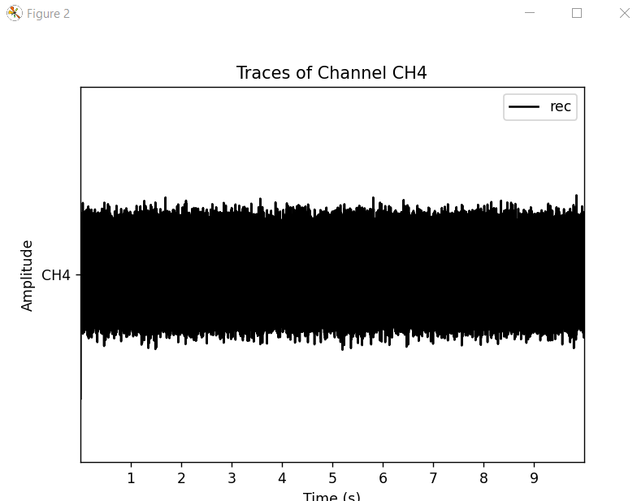

Raw data (first 10 sec)

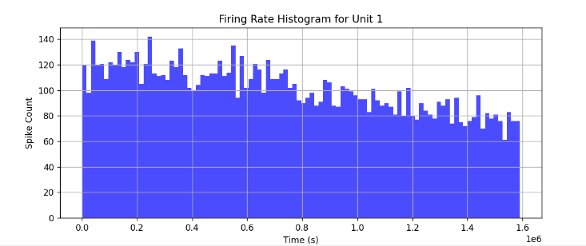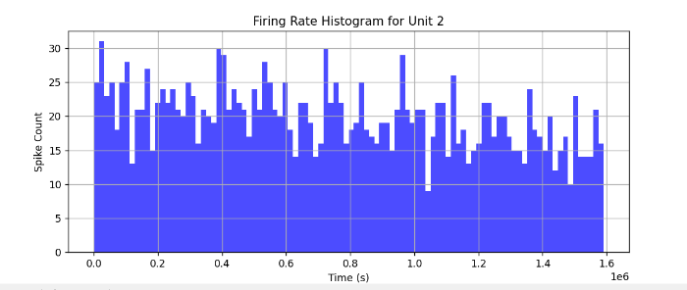

firing rate histogram for 1 unit firing rate histogram for 2 unit

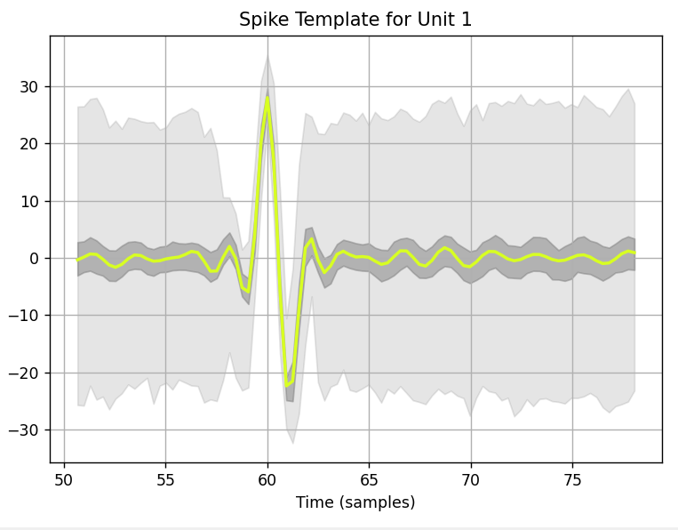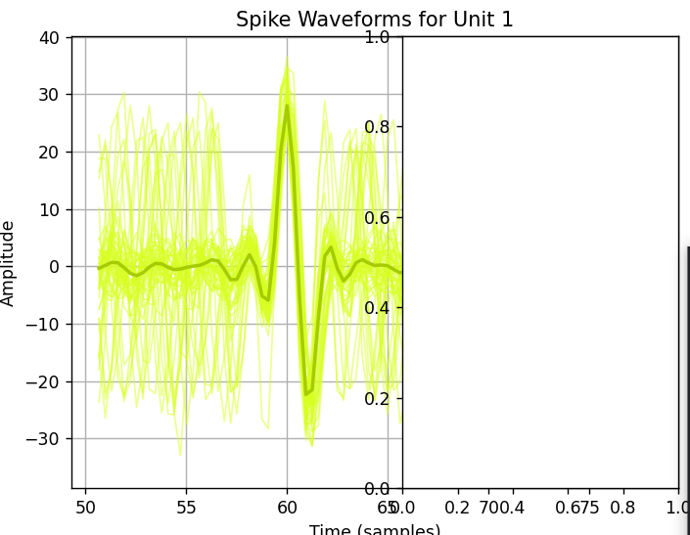

For unit 1

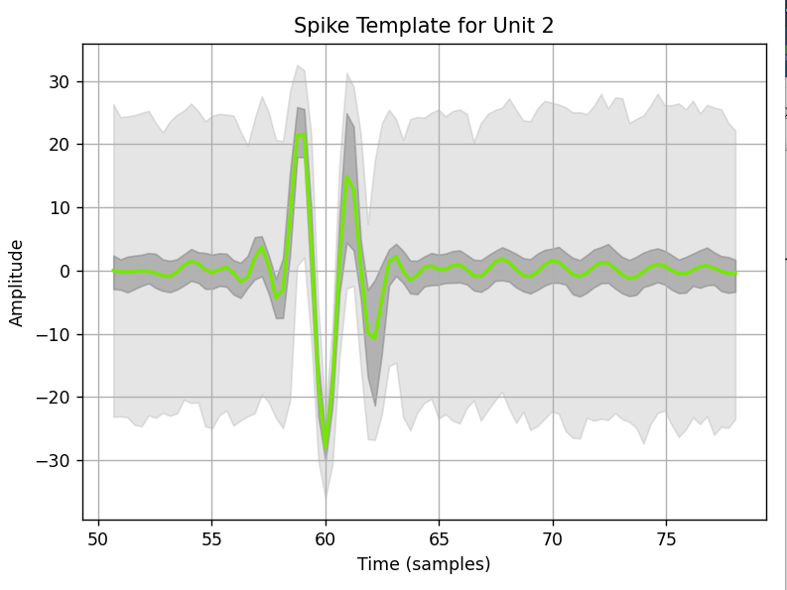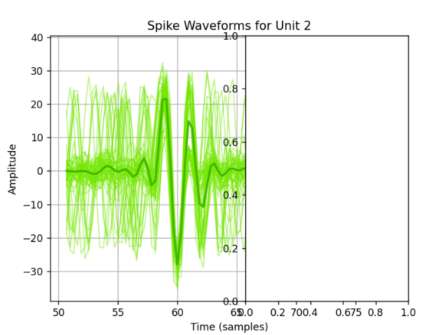

For unit 2

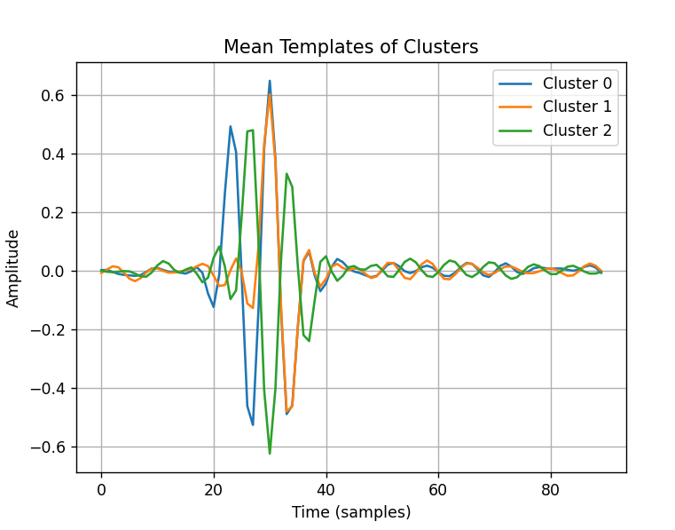

**Dimensionality Reduction Techniques**

In analyzing high-dimensional neural spike data, dimensionality reduction techniques are critical in visualizing clusters and understanding the underlying structure. Below are explanations of the three primary techniques used in this work:

**PCA, t-SNE, and UMAP.**

**Principal Component Analysis (PCA)**

PCA is a linear dimensionality reduction technique that transforms data to a new coordinate system such that the most significant variance by any data projection lies on the first coordinate, the second most significant variance on the second coordinate, and so on.

This method captures the maximum variance in the dataset by projecting it to the principal components.

PCA is highly efficient and interpretable but unsuitable for capturing complex, non-linear relationships in the data.

**t-SNE (t-Distributed Stochastic Neighbour Embedding)**

t-SNE is a non-linear dimensionality reduction technique well-suited for visualizing high-dimensional data into a low-dimensional space (typically 2D or 3D). Unlike PCA, t-SNE can capture non-linear relationships by focusing on maintaining the local structure in the data. It converts the similarities between data points to joint probabilities and minimizes the Kullback-Leibler divergence between the joint probabilities of the low-dimensional embedding and the high-dimensional data. It is computationally expensive but provides excellent results for visualizing complex data.

**UMAP (Uniform Manifold Approximation and Projection)**

UMAP is another non-linear dimensionality reduction technique designed to visualize and preserve the data's local and global structure. Like t-SNE, UMAP can capture non-linear relationships and often provides faster computations. It is based on topological and geometric principles of manifold learning. UMAP is known for better preserving the global structure of the data than t-SNE, making it more robust for embedding complex data.

**Scatter Plots of Clusters**

Below are the scatter plots for PCA, t-SNE, and UMAP clustering results.

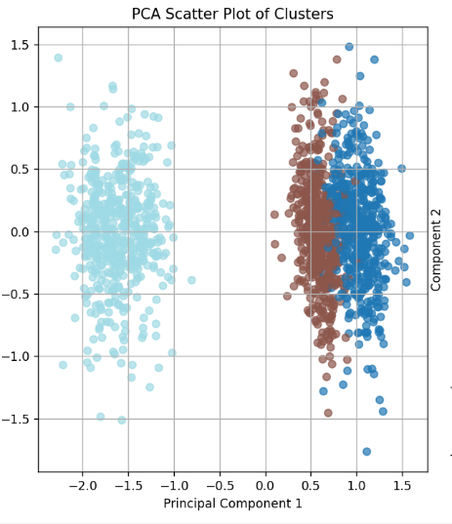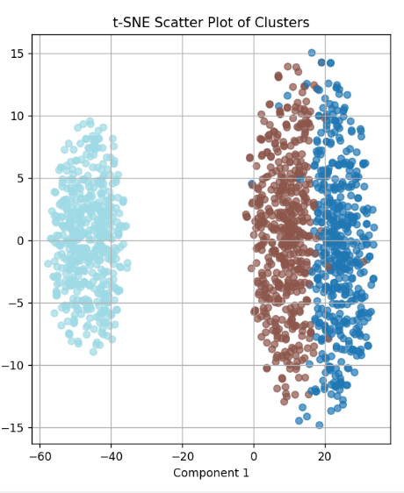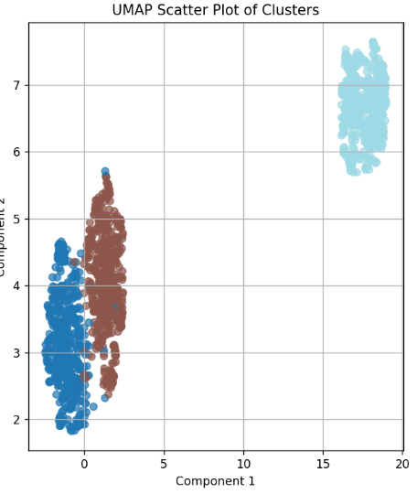

**Transition to the Development of the Spike Sorting GUI**

The visualizations and results presented in the previous section highlight the effectiveness of MountainSort5 and its integration with SpikeInterface for spike sorting. However, as the project progressed, it became evident that streamlining the workflow and making it accessible to a wider audience would be crucial for broader adoption and usability.

While the results obtained through manual parameter adjustments and script-based workflows were promising, the need for an automated, user-friendly interface became apparent. This led to the design and development of the **Spike Sorting GUI**, which consolidates the robust spike sorting pipeline into an intuitive graphical interface.

The following section details the functionality, design, and outcomes associated with the Spike Sorting GUI, emphasizing its role in simplifying and enhancing the spike sorting process.

# Development of the Spike Sorting GUI

**Introduction**

As the project evolved, it became clear that MountainSort5 and SpikeInterface offered robust frameworks for spike sorting. However, their reliance on command-line interfaces and the need for manual parameter tuning presented significant challenges. These barriers were particularly evident for researchers with limited programming experience or those working on time-sensitive neural data analysis. The lack of a user-friendly interface limited the accessibility and efficiency of the workflow, creating a gap between powerful spike sorting algorithms and practical usability.

A Spike Sorting GUI was developed to address these challenges as a pivotal enhancement to the project. This GUI streamlines the entire spike sorting process and makes it more accessible to a broader range of researchers, regardless of their technical expertise.

The GUI was designed to transform complex computational workflows into a seamless and intuitive graphical interface. It allows users to perform critical tasks such as data preprocessing, parameter optimization, spike detection, clustering, data visualization, and exporting results—all from a centralized, easy-to-navigate platform. By integrating MountainSort5's advanced spike sorting capabilities with SpikeInterface's modular framework, the GUI ensures high accuracy, scalability, and robustness while simplifying the overall user experience.

This innovation bridges the gap between technical complexity and usability, empowering researchers to efficiently analyze neural data and uncover insights without technological barriers. Through this development, the GUI not only enhances the accessibility of spike sorting but also accelerates the pace of neural research by significantly reducing the time required for preprocessing and analysis.

**Features of the Spike Sorting GUI**

**1. User-Friendly Interface**

* **Design**: The GUI, developed using Tkinter, features a well-structured and intuitive layout, enabling easy navigation.

* **Functionality**: It simplifies the spike sorting workflow by providing:
  + A graphical file browser for selecting data files.
  + Input fields and dropdown menus are used to adjust sorting parameters.
  + Options to visualize results and export data with just a few clicks.
* **Ease of Use**: The GUI eliminates the need for programming expertise, making spike sorting accessible to researchers from diverse backgrounds.

**2. Customizable Parameters**

The GUI offers real-time adjustment of parameters, enabling users to fine-tune the sorting process for optimal accuracy. Key parameters include:

* **SNR Ratio**: Configures the target signal-to-noise ratio, which is crucial for separating spikes from background noise.
* **Detect Sign**: Allows users to specify the polarity of spikes to detect:
  + 0: Detects both positive and negative spikes.
  + 1: Detects only positive spikes.
  + -1: Detects only negative spikes.
* **Phase 1 Detect Threshold**: Sets the initial detection threshold to filter out noise in the preliminary spike detection phase.
* **Detect Threshold**: Adjusts the primary detection threshold, influencing the sensitivity of spike classification.
* **Channel Radius**: Defines the spatial radius (in micrometers) around a channel for detecting nearby spikes.
* **Time Radius**: Specifies the temporal window (in milliseconds) for clustering spikes into meaningful groups.
* **Block Duration**: Controls the size of data segments processed simultaneously, balancing memory efficiency and computational performance.
* **Detect Channel Radius**: Configures the spatial radius for detecting spikes in neighboring channels, enhancing clustering in dense neural recordings.
* **Detect Time Radius**: Defines the time window for associating spikes with a detected peak, improving clustering accuracy.

**3. Preprocessing**

The GUI incorporates robust preprocessing techniques to ensure high-quality signal preparation before spike sorting:

* **Bandpass Filtering**: Retains relevant neural signals within the 300–450 Hz range while suppressing low-frequency noise and high-frequency artifacts.
* **Whitening**: Reduces signal covariance, making spike features more distinguishable for sorting algorithms.
* **Normalization**: Ensures consistency across datasets by scaling signals uniformly, improving sorting performance.

**4. Spike Sorting**

The GUI leverages MountainSort5’s **Scheme3** to ensure accurate and efficient spike sorting:

* **Block-Based Sorting**: Divides large datasets into smaller blocks for efficient processing and memory optimization.
* **Clustering**: Utilizes advanced dimensionality reduction techniques like PCA and robust clustering methods to group spikes into distinct neuronal units.

**5. Visualization**

The GUI provides interactive and detailed visualizations to evaluate sorting quality:

* **Waveform Plots**: Show the shapes of detected spikes for each identified unit, allowing users to assess spike consistency.
* **Template Visualizations**: Display averaged waveforms for each cluster, providing insights into unit-specific activity.
* **Cluster Plots**: Use dimensionality reduction methods such as PCA or UMAP to visualize separating spike clusters in reduced feature spaces.

**6. Data Export**

The GUI facilitates seamless integration with downstream data analysis pipelines by exporting results in a structured format:

* Results are saved in an Excel file (spike_data_GUI.xlsx), including:
  + Spike timestamps for each detected event.
  + Unit IDs to identify associated neuronal clusters.
  + Waveform data, enabling further analysis or validation.
* This export functionality ensures compatibility with various statistical and machine learning workflows, enhancing the utility of the sorted spike data.

Development Process

1. Integration of Libraries

The GUI combines multiple Python libraries to deliver a seamless experience:

* **SpikeInterface**: Handles preprocessing, spike sorting, and result analysis.
* **MountainSort5**: Executes robust spike sorting algorithms.
* **Tkinter:** Powers the graphical interface.
* **Matplotlib and SpikeInterface Widgets**: Enable detailed plotting and visualization.

2. **Workflow Automation**

* Automates data loading, preprocessing, parameter tuning, and sorting.
* Reduces user intervention while ensuring consistent results.

3. **Parameter Customization**

* Includes interactive input fields for critical parameters.
* Users can modify settings to suit various experimental requirements.

4. Visualization

* Interactive plots provide real-time insights into spike sorting quality.
* Users can refine parameters based on visual feedback.

5. **Error Handling**

* Validation checks are incorporated to ensure compatibility with input data and parameters.
* Provides user-friendly error messages to guide troubleshooting.

**Advantages of the Spike Sorting GUI**

**Advantages of the Spike Sorting GUI**

1. **Accessibility**
   * **Simplified User Interaction**: The GUI eliminates the need for programming expertise, making advanced spike-sorting techniques accessible to a broader audience, including researchers with limited technical backgrounds.
   * **Intuitive Navigation**: The organized layout and graphical interface ensure ease of use, allowing users to focus on experimental analysis rather than technical complexities.
2. **Efficiency**
   * **Automation**: Automates critical steps such as preprocessing, spike sorting, and data export, significantly reducing manual intervention.
   * **Time-Saving**: Streamlines the entire spike sorting pipeline, enabling faster data processing and analysis.
   * **Batch Processing**: The block-based processing capability optimizes memory usage and computational efficiency, allowing users to handle large datasets effortlessly.
3. **Accuracy**
   * **Preservation of MountainSort5 Reliability**: While simplifying the user experience, the GUI retains the high accuracy and robustness of MountainSort5's spike sorting algorithms.
   * **Enhanced Preprocessing**: Incorporates advanced preprocessing techniques like whitening, bandpass filtering, and normalization to improve signal clarity and reduce noise, leading to more precise spike detection.
   * **Customizable Parameters**: Allows fine-tuning of critical parameters, ensuring the spike sorting process is tailored to the unique characteristics of each dataset.
4. **Scalability**
   * **Adaptability**: The GUI is designed to accommodate datasets of varying sizes, from small-scale experiments to large-scale neural recordings.
   * **Multi-Channel and Single-Channel Compatibility**: Although optimized for single-channel data, the framework can be extended to support multi-channel recordings, ensuring scalability for future enhancements.
5. **Validation**
   * **Real-Time Feedback**: Visualizations of spike waveforms, templates, and clusters provide instant feedback, allowing users to iteratively refine parameters and improve sorting accuracy.
   * **Quantitative Metrics**: Integration of metrics like silhouette scores and dimensionality reduction techniques (e.g., PCA, UMAP) enables an objective assessment of clustering quality.
   * **Comparison with Manual Analysis**: Enables validation of automated results against manually annotated spikes, building confidence in the tool's accuracy.

The Spike Sorting GUI strikes an effective balance between accessibility, functionality, and accuracy, positioning it as a valuable tool for advancing neural data analysis in both research and clinical settings.

**Results with the Spike Sorting GUI**

**Comparison with Manually Located Spikes**

The Spike Sorting GUI was validated against manually annotated spike data to assess its precision in spike detection. A comparative analysis evaluated the timestamp values obtained from the GUI versus manually located spike timestamps.

**Key Observations:**

1. **Accuracy in Spike Timing**:
   * The GUI consistently identified spike timestamps within microseconds of the manually annotated values.
   * Differences between automatically and manually identified timestamps were in the range of *, "*indicating a high level of temporal precision.
2. **Statistical Analysis**:
   * Variability between automatic and manual timestamps showed a negligible mean error, signifying the reliability of the automated process.
   * Consistency across different units reinforced the robustness of the algorithm.
3. **Representative Data**:
   * **Example from the dataset**:
     + For Unit 1 at a timestamp of **255.4834167 s**, the manual annotation was **255.48343 s**, resulting in a difference of −1.333×10−5-1.333 \times 10^{-5}−1.333×10−5 seconds.
     + Similar results were observed for other units and timestamps, confirming the closeness of the automated results to manual annotations.

**Benefits of Automation:**

* **Reduction in Manual Effort**: The GUI eliminates the need for labor-intensive manual spike annotation, saving significant time while maintaining accuracy.
* **Reproducibility**: Automated spike sorting ensures consistency across datasets, reducing human error and bias.

**Visualization:**

To further demonstrate the accuracy of the automated system, the dataset (as shown in the table above) highlights the negligible differences between manual and automated annotations.

**Conclusion:**

This comparison validates the Spike Sorting GUI as a reliable tool for spike detection, offering results that closely match manually located spikes. These findings reinforce its potential for large-scale neural data analysis, where manual annotation would be impractical.

**Future Enhancements**

1. **Multi-Channel Support**
   * **Objective**: Extend the GUI's functionality to handle data from high-density, multi-channel electrode arrays commonly used in advanced neural research.
   * **Rationale**: Multi-channel data provides spatial context, improving spike detection and clustering accuracy. This capability would expand the tool's usability for larger and more complex datasets.
   * **Implementation**: Add features for managing multi-channel recordings, including independent channel visualizations, synchronization, and cross-channel clustering.
2. **Real-Time Processing**
   * **Objective**: Enable real-time spike detection and sorting for applications requiring immediate feedback, such as brain-computer interfaces (BCIs) and neural prosthetics.
   * **Rationale**: Real-time processing is crucial for time-sensitive applications like neural decoding and prosthetic control.
   * **Implementation**: Integrate streaming data handling and low-latency processing algorithms to achieve real-time functionality without compromising accuracy.
3. **Machine Learning Integration**
   * **Objective**: Incorporate AI-driven techniques for automated parameter tuning, spike detection, and clustering.
   * **Rationale**: Machine learning models can improve accuracy by learning from patterns in large datasets and adapting to individual dataset characteristics.
   * **Implementation**: Add pre-trained neural networks or reinforcement learning algorithms to suggest optimal parameters and improve spike classification reliability.
4. **Web-Based Deployment**
   * **Objective**: Develop a cloud-based version of the GUI for remote access, collaborative research, and large-scale data processing.
   * **Rationale**: A web-based GUI would enable researchers across the globe to access and utilize the tool without requiring local installation, fostering collaboration and resource sharing.
   * **Implementation**: Use web frameworks like Flask or Django to create an online interface, integrate with cloud services for data storage, and ensure robust security and scalability.
5. **Advanced Metrics and Analysis Tools**
   * **Objective**: Add features for advanced statistical analysis and validation of spike sorting results.
   * **Rationale**: Providing more profound insights into spike data enhances research outcomes by enabling users to evaluate clustering quality and neuron interactions.
   * **Implementation**: Include metrics such as:
     + Cross-correlation analysis to assess interactions between neurons.
     + Cluster stability measures to evaluate the reliability of spike sorting results across experimental conditions.
     + Advanced visualization techniques to represent temporal and spatial neural activity.

These enhancements aim to transform the Spike Sorting GUI into a more versatile, powerful, and accessible tool for experimental and clinical neuroscience, addressing a more comprehensive range of research needs and expanding its application potential.

**Conclusion**

In this final report, we have detailed the progression of our project, focusing on the development and refinement of spike sorting techniques, culminating in creating a user-friendly Spike Sorting GUI. Building on the foundation of our earlier explorations with algorithms such as Kilosort, Brainstorm, and SpikeInterface, we have significantly advanced our methodology to address the unique challenges of single-channel neural recordings.

Initially, we tested Kilosort and Brainstorm, which proved suboptimal for our dataset due to their reliance on multi-channel data and limited adaptability to single-channel recordings. These limitations prompted us to explore alternative solutions, leading us to MountainSort5. MountainSort5, integrated with SpikeInterface, emerged as the most effective tool due to its flexibility, precision, and suitability for single-channel data. Its Scheme3 sorting parameters, including customizable detection thresholds, PCA-based feature extraction, and block-based processing, allowed us to achieve robust and reliable spike sorting.

The integration of dimensionality reduction techniques such as PCA, t-SNE, and UMAP provided additional insights into clustering quality and allowed for the visualization of spike clusters in reduced dimensions:

* **PCA** preserved maximum variance in the spike features, offering a broad overview of the dataset's structure.
* **t-SNE** emphasized local relationships, aiding in the identification of closely related clusters.
* **UMAP** balanced local and global structure preservation, delivering intuitive and visually interpretable clusters.

Validation metrics, such as silhouette scores, confirmed the quality of spike clustering and highlighted the effectiveness of MountainSort5 in accurately sorting spikes and identifying distinct neuronal units.

To address the limitations of manual parameter tuning and reliance on command-line workflows, we developed the Spike Sorting GUI. The GUI significantly enhances accessibility and efficiency by providing:

* **A User-Friendly Interface**: Simplifying spike sorting for researchers with limited programming expertise.
* **Customizable Parameters**: Allowing real-time adjustments to optimize spike detection and sorting accuracy.
* **Preprocessing and Visualization Tools**: Integrating robust filtering techniques and interactive plots to evaluate spike sorting results.
* **Data Export Capabilities**: Enabling seamless integration with downstream analysis pipelines.

The GUI has been rigorously tested, yielding results consistent with manual workflows while reducing processing time and enhancing user experience. The GUI has proven to be an invaluable addition to the spike sorting pipeline by automating key steps and providing real-time feedback.

Moving forward, we aim to expand the GUI’s functionality by incorporating:

1. **Multi-Channel Support**: To enable the processing of high-density neural recordings.
2. **Real-Time Spike Sorting**: For applications such as brain-computer interfaces and neural prosthetics.
3. **Machine Learning Integration**: To automate parameter optimization and improve classification accuracy.
4. **Web-Based Deployment**: To allow remote access and collaborative analysis.

In conclusion, the project has transitioned from the challenges of single-channel spike sorting to developing a comprehensive, accessible, and scalable solution. The Spike Sorting GUI represents a significant leap forward in usability and functionality, laying a solid foundation for future advancements in neural data analysis. The combination of MountainSort5, SpikeInterface, and the GUI addresses the current needs of spike sorting. It opens new avenues for neuroscience research, enabling a deeper understanding of neural firing patterns and communication within neural networks.

**References:**

1. Harris, K. D., et al. "Spike sorting for large, dense electrode arrays." Neuron (2016).

2. Chung, J. E., et al. "A fully automated approach to spike sorting." Neuron (2017).

3. Tools used: Spike Interface, MountainSort5, Brainstorm, Kilo sort, Matlab, python

4. Jason E. Chung, Jeremy F. Magland, Alex H. Barnett, Vanessa M. Tolosa, Angela C. Tooker, Kye Y. Lee, Kedar G. Shah, Sarah H. Felix, Loren M. Frank, Leslie F. Greengard,A Fully Automated Approach to Spike Sorting,