# Mobile App Design and Feature Report

**App/Project Name:** Fitness Planner and Log

**Your Name:** Mohammad Anas Saeed

**Student ID:** 19071709

## Introduction:

My app is designed to be a “Fitness Planner and Log”. It should allow the user to input various types of data into a log and be able to add a description and a photo as evidence for each individual workout.

## Aims and Objectives:

The main aim of my fitness planner and log app is to offer an effective platform to effectively track workouts and progress. In terms of hardware, I would like to incorporate a camera feature to allows users to visually capture their workouts and I would also want to add swiping and haptic feedback capabilities. Furthermore, the app should be able to allow users to save detailed descriptions of their workouts on a dedicated page, enabling reflective analysis of past performances. Key objectives include maintaining user engagement and delivering a user-friendly interface to ensure optimal user support and satisfaction.

## Target Audience:

The target audience for my mobile app is primarily aimed to be gym enthusiasts or anyone who is doing some sort of exercise. They will be able to track their progress using this app and add detailed description for each workout.

## User Experience (UX) Design:

After doing some research on what fitness enthusiasts would want in an app, I found some key features. For example, having a way to view progress is essential and the best way to do this is through the use of images or videos. Other things include tracking nutrition and calories, but I feel like this could be a whole other app. Another important feature fitness users would want would be having the app work on different devices and have a good/balanced display.

I want my app to have a good and uncomplicated design that makes ease of use a priority for the user. In terms of the base design, the user should be able to input all the necessary details in the main page section. So, an input area for the workout, the weight, the date and finally the time. The user should then be able to save the inputs and store them in a displayable area also on the main page. I created a diagram below to show how I want the app to look.

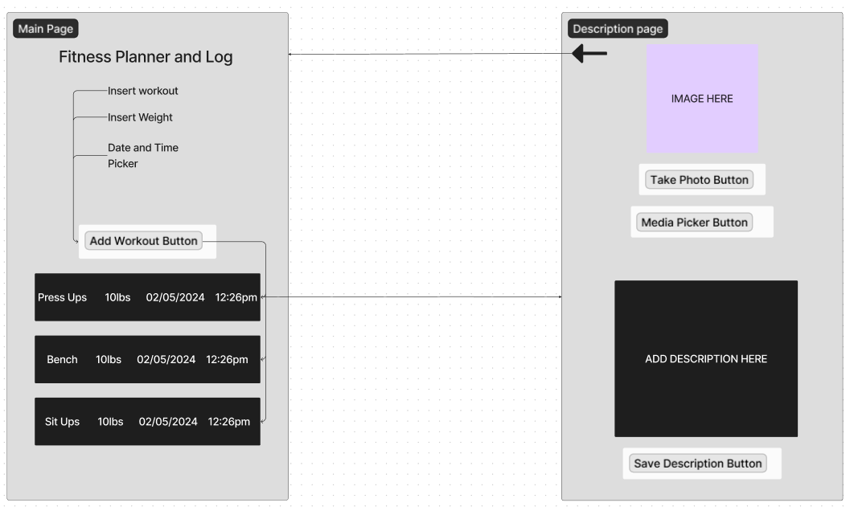

I would also like to add a remove button which appears to the user once they swipe right on their workout log in the grid. There should also be another button that allows the user to add a description by navigating to the description page similar to the diagram below. It would make sense to allow the user also to return to the main page again through the use of a back button or return to menu button.

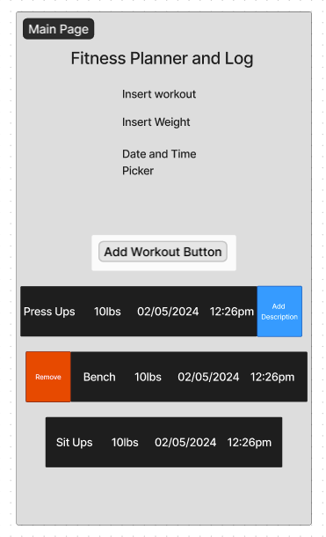

## User Interface (UI) Design:

For my User Interface design, I will most likely keep the colour palette dark with white text as it goes easier on the eyes. In terms of buttons such as ‘Remove’ or ‘Add Details,’ I will probably download SVG images and use those to indicate what the button does. So, a bin for ‘Remove’ to get rid of a log or a plus sign for the description that will navigate to the ‘Add Details’ page when clicked.

In terms of the layout and spacing I think it’s good to have a section at the top of the page that allows the user to input information regarding their workout and then a submit/add button underneath that. I’ll probably have the input fields positioned in the top middle part of the screen and have even spacing between them. I don’t want them to be too spread apart as this would cause the logs to have barley any room on the screen and make it look very cramped.

My ‘Add Details’ page would have a section at the top for adding an image and also an area in the middle to input a description. Below that there would be a save description button as well. I will have the buttons be purple or blue as I this would match the dark design.

I will also add more images next to each input field such as a dumbbell for the weight or a calendar for the date and time sections so that the app looks more visually appealing for the user. Furthermore, the logs should be clearly visible and shouldn’t match the colour of the background. This makes it easier for the user to distinguish between where the input fields end and where the logs begin to appear.

## Validation and Testing:

Elements of your app that will need to show it has been tested and validated. For example, making sure entry text is the correct type if you only want numeric input.

In terms of validation and testing, there would a section of my app where the user must input a weight value. This value must be a number and not a string. If a user does input a string and submit it, this should either create a default int value or display and error message. If they do submit something that is not a number, they should have the option to easily delete this log and make a new one to remedy this mistake.

There were many issues during development mainly when it came to developing the ‘Add Details Page.’ This was in the form of clicking anything in the grid and having it lead to the ‘Add Details Page’.

Furthermore, whenever I implement the date and time input field into my application, I believe the default date and time is set to the 1st of January 1900 and 00:00. This was very impractical and monotonous as it would take time flicking through each value and just feel terrible for the user. So, in order to remedy this problem, I made it so the default value was the current date and current time, making it much easier for the user to input their desired values.

## Feature Implementation:

Due to my app being a planner and a log, I feel it’s necessary that it includes features such as a camera. I would allow the user to add a description for their workout in an ‘Add Details’ page and also provide an image to support their log with evidence if they wish. They could use this to visually track their performance and progress to find areas of improvement. It would be ideal to allow them to use both the front and back cameras and ask them for permission to allow access to the cameras.

After also looking into how the ‘MonkeyFinder App’ was created I wanted to create a similar SQL database. This would allow the user to store their data and have saved in the database so whenever they restart their application it they would still have all of their data. This should save data for the workout, the weight, the date, the time, the image and finally the description. This is essential for a planner and log to function as you’d want to save your details and have reminders of future workouts.

I would also want to add haptic feedback to indicate that the user clicking a button has resulted in a process or something appearing on the screen. I would add this functionally to the add/update button on the main page so if a user had inputted their values in the desired fields and clicked ‘Add/Update’ they would feel some haptic feedback and see that a log has appeared below. Vibration would also be another thing I would want to add, primarily when a log is removed from the grid as removing a row/log is an important event. Both haptic feedback and vibration are very similar as they are both vibrate, but they can each be used for a unique purpose.

Swiping would also be a desirable feature. I would make this available on the logs so if a user chose to swipe right on a log they could choose to remove, or if they chose to swipe left, they could add a description to it instead. This is a key feature I see in almost every app utilise and in my eyes it’s a necessity. Having the swipe function makes doing certain actions much easier and allows.