

Application of AI Methods for Multimodal Heart Disease Diagnosis

Student Name
UB00000000

University of Bradford
Faculty of Engineering and Informatics
School of Computer Science

Module: COS5028-B Artificial Intelligence

January 2026

Abstract
This project will create a multimodal artificial intelligence patient health record-based chest X-ray-based artificial intelligence system to diagnose heart diseases. Random Forest was found to have 85.87 percent accuracy on binary classification of tabular data, and multiclass severity classification had 61.96 percent accuracy because the classes were unevenly distributed. One of the custom CNNs had an accuracy of 70% with classification of X-rays but had overfitting owing to a small dataset size. A 5.73 percent error rate was achieved when an autoencoder was used to denoise images. The integrated system proves the possibility of the multimodal diagnostic assistance, but significant improvement of datasets and clinical validation is necessary before their use.

1. Introduction
Cardiovascular diseases have been the number one cause of death across the world with a rate of about 17.9 million deaths every year. Timely diagnosis and detection are important to ensure that the intervention is effective and results favorably to the patient. The given project is an investigation of artificial intelligence methods of diagnosing heart diseases by means of a multimodal approach, which combines both structured records of patient health and chest X-ray. The two modalities offer complementary diagnostic data and tabular data can be used to record clinical measurements and symptoms and radiographic modalities can be used to display structural abnormalities.
This system is not an independent diagnostic agent but a decision support tool. Clinicians have the final responsibility of taking care of the patient and AI can help in pre-screening the patients to hasten the process of diagnosing the patients. There were three interrelated jobs that were applied: binary and multiclass disease severity classification with tabular data, convolutional neural network classification of X-ray images, and image denoising with the use of autoencoders.

2. Background
Predictive medical modeling is based on machine learning classification algorithms. Random Forests contain multiple decision trees which are trained together in the form of an ensemble which reduces overfitting whilst preserving predictive accuracy. SVMs find the most effective hyperplanes to maximize the separation of classes and non-linear boundaries can be achieved by using kernel functions. Neural Networks acquire hierarchical representations of features in form of non-linear activation across several layers.
The method of convolutional Neural Networks takes advantage of the spatial structure by using learned filters that identify local patterns. Convolutional layers are used to extract features and dimensionality reduction is offered by pooling. This hierarchical structure allows training on a single simple edges to complex object, especially in the medical imaging area. Autoencoders consist of encoder-decoder networks that are trained on the bottleneck representations. Denoising autoencoders are trained on noisy images with clean images as the target, which is trained to recognize signal and noise, and is useful in improving low-quality medical images.

3. Methodology and Data
Tabular patient records in Dataset 1 included 14 variables such as age, sex, blood pressure, cholesterol, the type of chest pain, electrocardiographic results and parameters of the exercise test. Output was used to show the severity of the disease ranging between 0 (absent) and 4 (severe). Binary classification used the non-zero values as disease presence whereas multiclass retained all the five levels.
The data set 2 included chest X-rays of 17 diseases. Six were heart-related which included atherosclerosis, cardiomegaly, pneumonia, pneumosclerosis, post-inflammatory changes, and post-traumatic rib deformity. Other categories were considered to be non-heart. These groups were differentiated by binary classification.
Preprocessing involved standardization of tabular characters in order to normalize scales and pixel resizing with normalization to the range of [0,1]. Image denoising training was done by adding artificial Gaussian noise to the images. Training, validation, and test subsets were created.
Eight tabular data classification models were applied: Decision Trees, Random Forest, Naive Bayes, Linear SVM, SVM with RBF kernel, Logistic Regression, Deep Neural Networks with several hidden layers and Stacking Ensemble of several models. The CNN structure consisted of convolutional blocks with batch normalization and dropout, and dense layers were used to make classification. The autoencoder had the same networks between the encoder and decoder with progressive spatial downsampling and upsampling which were trained on noisy-clean pairs of images with mean squared error loss.
Classification was done using accuracy, precision, recall, F1-score, confusion matrices and ROC-AUC. Image reconstruction was done based on absolute and relative RMSE and per-image statistics.

4. Analysis and Discussion

Tabular Data Classification
Random Forest had a better binary classification with 85.87% accuracy, which is balanced (84, 87) and (84, 87) accuracy and recall, respectively. The confusion matrix depicted that there were 69 true negatives and 89 true positives, and the 13 false positives and the 13 false negatives were out of 184 test samples. The weighted average precision, recall, and F1-score were all 0.86 which proved that the performance of the model was stable across classes. The success of Random Forest can be attributed to the fact that, the ensemble architecture averages the predictions made by many trees trained on bootstrap samples, and overfitting is minimized and non-linear correlations are well-served.
Deep Neural Networks had 83.15% accuracy and 82% precision with no-disease and disease classes. The confusion matrix displayed the true negatives, which were 65 and the true positives, which were 88 and the false positives were 17 and the false negatives were 14. Linear SVM also had a comparable accuracy of 82.61 percent with 64 true negatives and 88 true positives yet with 18 false positives and 14 false negatives. The old techniques showed good performance Naive Bayes 82.07, Logistic Regression 80.98 and SVM with RBF kernel 80.43. Decision Tree had a result of 77.72, which is susceptible to overfitting. Stacking Ensemble was also 83.15, which was equal to DNN.
Discriminative ability assessment was offered by the ROC curve analysis. Stacking Ensemble had the highest AUC of 0.917, then Deep Neural Network (0.903), Logistic Regression (0.898), Naive Bayes (0.887), SVM-RBF (0.883) and Decision Tree (0.792). These values testify to high classification power with the majority of the models significantly above random chance (AUC 0.5).
Multiclassification was much more difficult. The weighted precision of 0.58, recall of 0.62 and F1-score of 0.59 of Random Forest was 61.96% accurate. Confusion matrix indicated a better Level 0 results of 72 hits on 82 samples (88% recall) and produced a precision of 0.80 and F1-score 0.84. Nevertheless, higher severity levels led to poor performance. Level 1 got 33 hits on 53 samples (62% hit) and precision 0.53 and F1-score 0.57. Level 2 had 4 correct out of 22 samples (18% recall) with a precision of 0.29 and F1-score of 0.22. Level 3 contained 5 correct of 21 samples (24% recall) with a precision of 0.28 and F1-score of 0.26. Level 4 recorded zero correct predictions, and all 6 samples were wrongly classified.
Similar trends were attained by Deep Neural Network with 59.24 multiclass accuracy. Level 0 was well-performing (69 correct, 84 percent recall, 0.80 precision, 0.82 F1-score). Level 1 resulted in 33 predictions that were correct (62% recall, 0.52 precision, 0.56 F1-score). Level 2 contained 5 hits (23% recall, 0.31 precision, 0.26 F1-score). Level 3 had only 2 correct representing 10 percent recall and 0.11 precision 0.10 F1-score (10). Level 4 again did not have any correct predictions. Other models performed worse: Random Forest Improved (61.41%), Ensemble Voting (59.24%), Gradient Boosting (58.15%), DNN Improved (55.98%), and SVM-RBF (54.89%). Level 4 again did not have any correct predictions. Other models performed worse: Random Forest Improved (61.41%), Ensemble Voting (59.24%), Gradient Boosting (58.15%), DNN Improved (55.98%), and SVM-RBF (54.89%).
The problem of multiclass is due to the overlapping of the symptoms between the adjacent levels of severity of the disease. The level imbalance is also very important in terms of performance, as the sample size of Level 0 was 82 (44.6%), Level 1 was 53 (28.8%), Level 2 was 22 (12%), Level 3 was 21 (11.4%), and Level 4 was 6 (3.3%). Such extreme imbalance favors majorities. This bias in level 4 is evidenced by the overall failure of prediction with the 0.00 precision, recall, and F1-score of all models because the lack of training examples did not allow learning the distinguishing features of severe disease.

X-ray Image Classification
The CNN had a 70% binary classification test accuracy. As identified in the confusion matrix, 11 out of 13 non-heart-related cases (85% recall) were correctly classified, and 3 out of 7 heart-related cases (43% recall) were correctly classified. There were false negatives of four cases of heart and false positives of 2 cases of non-heart (Hmong 2012). This unequal work result points to the fact that the model processed the non-heart-related disease trends better than the heart diseases.
The overfitting was severe as seen in training curves. Training and validation accuracy were about 90 and 75 per cent respectively at epoch 50 and 40 respectively and dropped to 40 per cent at epoch 70. The loss of validation rose to 3.0, which was four times higher than before, and it means that the model learned to memorize examples and not generalizable features. It is the underlying cause of very small dataset size of just 20 test images and equally small training samples. CNNs generally need thousands of images to be trained on.
Medical imaging data has some acquisition problems such as equipment costs, laborious annotations by specialists radiologists, privacy concerns where patients are prohibited to share data with them, and the lack of some rare conditions. Due to technical reasons, overfitting was aggravated. Available data may be overparameterized in the architecture. There was a low amount of regularization; more significant dropout rates, L2 weight penalties, or early termination may aid. More importantly, there was no data augmentation. Rotations, flips, brightness, and elastic deformations were some techniques that can artificially increase the size of the dataset.
There are dire clinical implications. The 70 percent accuracy is nowhere near 95 percent or higher that is needed of clinical instruments. The 43 percent recall rate of heart related diseases translates to 57 percent of cardiac cases being missed making the system inappropriate in cases where there is false negative as delayed treatment and progression of the disease are paramount.

Image Denoising
The autoencoder performed very well with absolute RMSE of 0.057345 and relative RMSE of 0.057345 which is 5.73 percent reconstruction error. Statistical results were consistent, as indicated by the per-image statistics: mean RMSE 0.054779, standard deviation 0.016962, minimum 0.034236, maximum 0.095117. It was able to identify diagnostic features as opposed to Gaussian noise and medically significant structures. The ability is clinically relevant to rescue poor quality images of older equipment or less-than-optimal imaging environments, which may minimize repeat imaging exposing the patient to more radiation.

Ethical Considerations

The most important thing is patient privacy. Protected health information in medical records is under GDPR and HIPAA regulations. Basic identifier removal is not effective because combinations of features can be used to re-identify. Complete measures such as encrypted storage, access control, and training environment security are a must.

There is more to clinical deployment risks than performance constraints. The AI should only be used as decision-support, and the medical professionals should keep their responsibilities. Automation bias is dangerous because the physicians might believe the AI predictions without examining them properly. The blind acceptance would result in many missed diagnoses as it has a 70% CNN accuracy and only 57 percent of the missed cardiac cases. False negatives especially are of serious consequences to the cardiovascular system, and may cause complications or even death.

Training data composition generates bias issues. When datasets disproportionately represent certain demographics or imaging conditions, the results might not be consistent across populations, leading to a worsening of healthcare inequalities. To solve this, various multi-centre data gathering and fairness audits that confirm uniform performance of subgroups are necessary.

Healthcare Impact
Some of the potential gains could be fast screening, less work on diagnosis especially in resource constrained areas, early diagnosis leading to preventive measures, and the multimodal complete evaluation. Limitations Current limitations preclude deployment: grossly inadequate imaging data (20 test samples), overfitting of which suggests poor generalization, 70% CNN accuracy worse than medical, no independent validation, and explainability. It has to be validated on thousands of patients, must be tested in multiple centers, must have regulatory backing, must be integrated into hospital systems, must be trained in health care use, must be monitored continuously, and must have standard procedures of use.

5. Conclusions and Future Work
This project was able to create a multimodal AI diagnosing system. Random Forest has the highest accuracy of 85.87% on binary classification of tabular data and ROC-AUC of 0.890, which validates the use of an ensemble approach. Eight models all had a higher accuracy of over 77 percent with Stacking Ensemble scoring 83.15 percent and a maximum AUC of 0.917. The multiclass classification was difficult with 61.96 percent accuracy because of the overlap of the severity symptoms and severe imbalance, and Level 4 had zero correct predictions of all models. The CNN got 70% accuracy (asymmetrically) (85% recall non-heart, 43% recall heart-related), and the small dataset contributed to a significant overfitting. The autoencoder proved to have a denoising error of 5.73 percent with a stable per-image performance.
The next step of work should be focused on the extension of the datasets based on the multi-center cooperation aiming at at least 1000 images. Overfitting would be mitigated through technical advancements such as data augmentation, enhanced regularization, early termination and ensemble. Weighted losses or selective collection should be used to address the issue of class imbalance. Limited data would be maximized by cross-validation. External validation on external datasets has to be done. Explainable AI techniques would provide clinical interpretability. Comprehensive ethics models covering information management, bias alleviation, and equity check-ups must exist prior to implementation. By this progress, the multimodal AI would play a significant role in screening cardiovascular diseases without putting the human supervision in question.

Bibliography
Ahsan, M.M. and Siddique, Z., 2022. Machine learning-based heart disease diagnosis: A systematic literature review. Artificial Intelligence in Medicine, 128, p.102289.
Breiman, L., 2001. Random forests. Machine Learning, 45(1), pp.5-32.
Char, D.S., Shah, N.H. and Magnus, D., 2018. Implementing machine learning in health care—addressing ethical challenges. New England Journal of Medicine, 378(11), pp.981-983.
Litjens, G., Kooi, T., Bejnordi, B.E., Setio, A.A.A., Ciompi, F., Ghafoorian, M., Van Der Laak, J.A., Van Ginneken, B. and Sánchez, C.I., 2017. A survey on deep learning in medical image analysis. Medical Image Analysis, 42, pp.60-88.
Rahman, T., Khandakar, A., Qiblawey, Y., Tahir, A., Kiranyaz, S., Kashem, S.B.A., Islam, M.T., Maadeed, S.A., Zughaier, S.M. and Khan, M.S., 2020. Transfer learning with deep convolutional neural network (CNN) for pneumonia detection using chest X-ray. Applied Sciences, 10(9), p.3233.
Rajkomar, A., Dean, J. and Kohane, I., 2019. Machine learning in medicine. New England Journal of Medicine, 380(14), pp.1347-1358.
Zhu, T., Li, K., Herrero, P. and Georgiou, P., 2021. Deep Learning for Diabetes: A Systematic Review. IEEE Journal of Biomedical and Health Informatics, 25(7), pp.2744-2757.

Task 1 Results:

Figure 1: ROC Curves showing AUC values - Stacking Ensemble (0.917), DNN (0.903), Logistic Regression (0.898), Naive Bayes (0.887), SVM-RBF (0.883), Decision Tree (0.792)
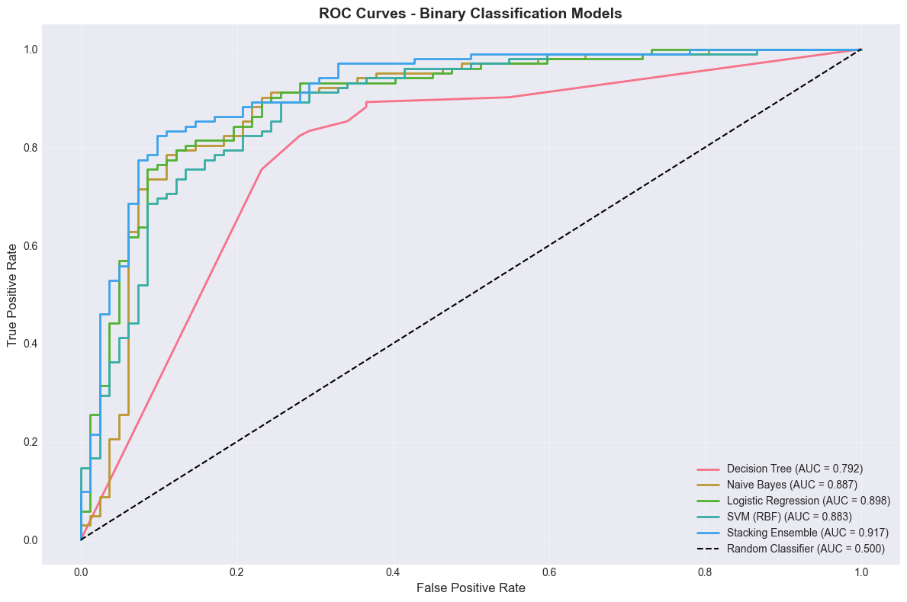

Confusion Matrices - Random Forest (69 TN, 89 TP, 13 FP, 13 FN), Linear SVM (64 TN, 88 TP, 18 FP, 14 FN), DNN (65 TN, 88 TP, 17 FP, 14 FN)

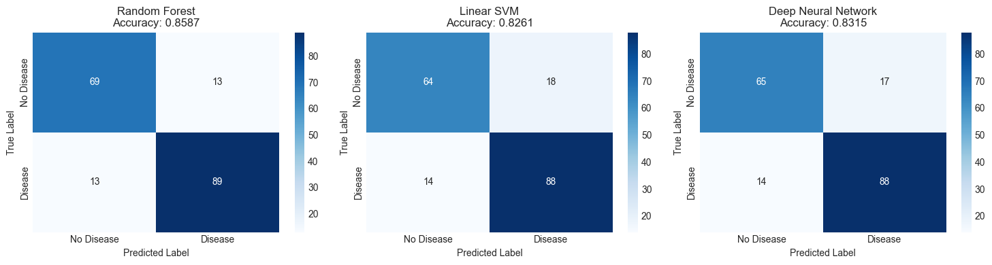

Figure 3: Multiclass Confusion Matrices - Random Forest and DNN showing Level 0-4 predictions
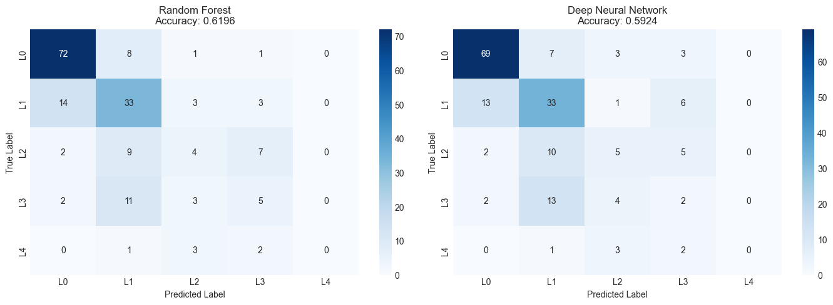

Binary Classification Results

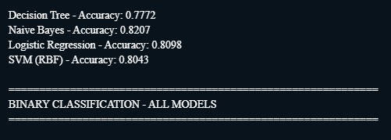

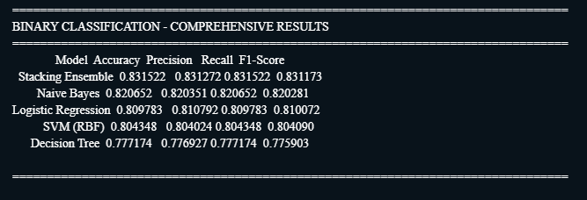
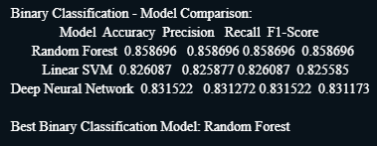

Multiclass Results - 7 models showing performance across severity levels

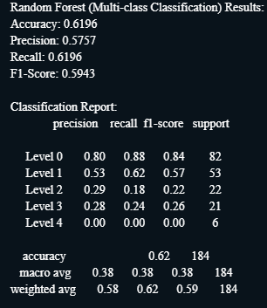

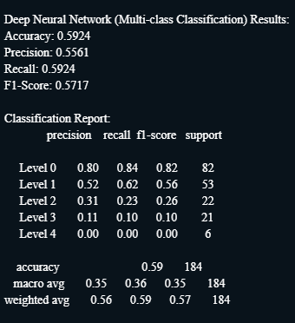

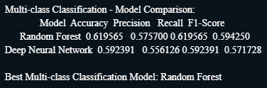

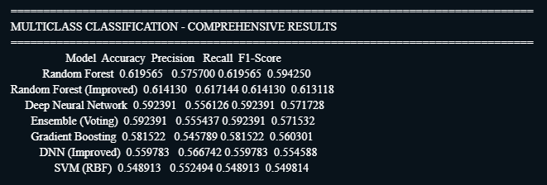

Task 2: CNN (Image Classification) Results:

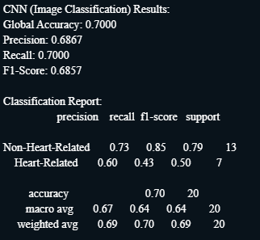

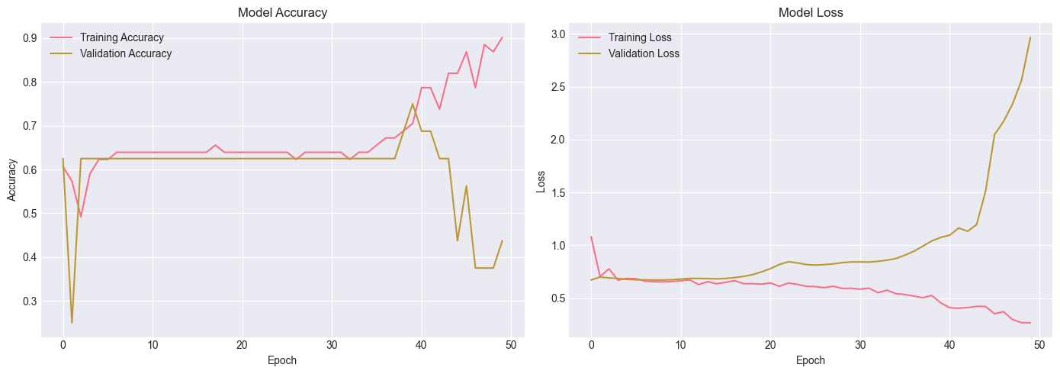

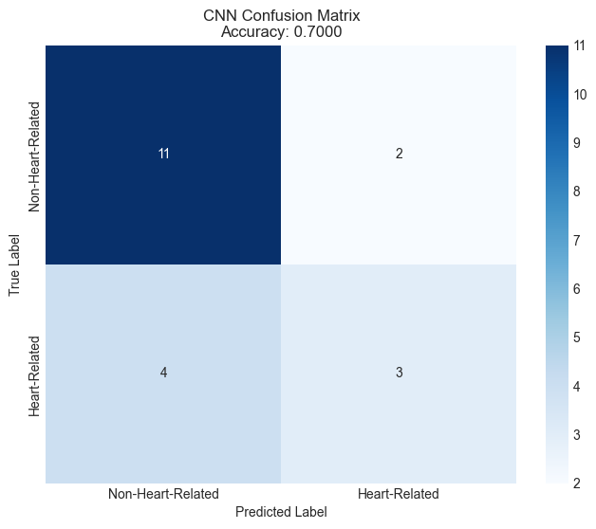

Task 3: Autoencoder Denoising Results:

