The World Islamic Sciences and Education University
جامعة العلوم الاسلامية العالمية
Faculty of Information Technology
كلية تكنولوجيا المعلومات



GRADUATION PROJECT
Title
CORZ Academy WEB Application
Students
Ra’ad Al-Adwan 3200601065 Computer Science
Ezz Dawoud 3200601064 Computer Science
Abdulsamad Hameeda 3210601057 Computer Science
Supervisor
Dr.Raja’ Masa’deh
SEMESTER II
2023/2024

Acknowledgments

وَأَن لَّيۡسَ لِلۡإِنسَٰنِ إِلَّا مَا سَعَىٰ (39) وَأَنَّ سَعۡيَهُۥ سَوۡفَ يُرَىٰ (40) ثُمَّ يُجۡزَىٰهُ ٱلۡجَزَآءَ ٱلۡأَوۡفَىٰ
We thank Allah for giving us the strength to write this documentation so that we stand now proud of ourselves with our heads high and have achieved our ambition and what we aspire to. We would like to offer our sincere thanks to our supervisor Dr. Raja, who has been supporting us from the beginning. Special thanks to all the doctors who prepared us for this project. We dedicate our work to our families and many friends too.

Abstract

CORZ Academy is an innovative educational platform designed to cater to diverse learning needs across various domains of life. The platform serves as a bridge between course providers, course recipients, and administrators, facilitating seamless interactions and empowering users to engage in a Featured learning experience.
At the core of CORZ Academy are three actors: course providers, course recipients, and admins. Course providers are equipped with tools to publish and manage their course content, monitor user feedback, and track course participation and profits. Course recipients, on the other hand, have access to a rich repository of courses, enabling them to search, enroll, and engage in personalized learning journeys. Additionally, course recipients benefit from a structured roadmap feature, guiding them through specialized learning paths tailored to their interests and goals. Meanwhile, admins oversee the platform’s operations, ensuring user management, content moderation, and administrative dashboard functionalities.

Table Contents
GRADUATION PROJECT i
Acknowledgments ii
Abstract iii
Table Contents iv
List of abbreviations vii
CHAPTER 1 1
INTRODUCTION 1
1.1 Overview 2
1.2 Problem statement 3
1.3 Project objectives 3
Sub-objectives 3
1.4 Research Strategy 4
1.5 Scope 4
1.6 Gant chart 5
1.7 Project outline 6
CHAPTER 2 7
LITERATURE REVIEW 7
2.1 Overview 8
2.2 Comparative Study 8
2.3 Related work 9
2.4 Summary 9
CHAPTER 3 10
METHODOLOGY 10
3.1 Overview 11
3.2 Feasibility Study 11
3.3 Requirements 11
3.4 Methodology 14
3.5 Tools 21
3.6 Programming Languages 22
CHAPTER 4 23
DESIGN MODELS 23
4.1 Overview 24
4.2 Context Diagram 24
4.3 Data Flow Diagram 25
4.4 Use case diagram 26
4.7 ER Diagram 27
4.8 Mapping for ER Diagram 28
CHAPTER 5 29
EXPERIMENTS AND RESULT 29
5.1 Overview 30
5.2 Test Design 30
5.3User Acceptance Testing 34
CHAPTER 6 38
CONCLUSION 38
6.1 Overview 39
6.2 Project Summary 39
6.3 Achieved Objectives 39
6.4 Contribution 40
6.5 limitation 40
6. Future Work 40
References 41
Appendix 42

List of Figure
Figure 1 1.1 Gant chart. 5
Figure 2 3.1 : Methodology . 13
Figure 3 4.1 Context Diagram 24
Figure 4 4.2 Data Flow Diagram 25
Figure 5 4.3 Use Case Diagram 26
Figure 6 4.4 ER Diagram 27
Figure 7 4.5 Mapping 28
Figure 8 5.1 User Biography ( Gender ) 35
Figure 9 5.2 User Biography ( year) 36
Figure 10 5.3 User Biography ( College ) 36
Figure 11 5.3 User Biography ( Major ) 37
Figure 12 5.4 Software Usefulness 37
Figure 13 5.5 Ease of Use 38
Figure 14 5.6 user satisfaction 38

List of tables
Table 1 2.1: Comparison between the proposed system and existing systems 9
Table 2 3.1: Technical feasibility 11
Table 3 3.2: Functional Requirements 12
Table 4 3.3: Non-Functional Requirements 13
Table 5 3.4: Sprint planning 14
Table 6 3.5: Development 15
Table 7 3.6: sprint Review 15
Table 8 3.7: Sprint planning 16
Table 9 3.8: Development 17
Table 10 3.9: sprint Review 17
Table 11 3.10: Sprint planning 18
Table 12 3.11: Development 18
Table 13 3.12: sprint Review 19
Table 14 3.13: Sprint planning 20
Table 15 3.14: Development 20
Table 16 3.15: sprint Review 21
. Table 17 3.16: Tools 21
Table 18 3.17: sprint Review 22
Table 19 5.18: Test Cases 31

List of abbreviations
S : Sprint
CR : Criteria
M : Mandatory Requirements
O : Optional Requirements
D : Desirable Requirements
DFD : Data Flow Diagram
ER-D : Entity Relational Diagram
FR : Functional requirements
NFR : Non-Functional requirement

CHAPTER 1

INTRODUCTION

Overview
In the landscape of online education, CORZ Academy emerges as a pioneering web platform crafted to address the multifaceted needs of learners across diverse domains. Harnessing the latest technologies including HTML, CSS, and Angular in the frontend, ASP.NET Core API in the backend, and SQL Server in the database, CORZ Academy offers a comprehensive solution designed to revolutionize the educational experience.
This innovative platform seamlessly integrates a range of features aimed at empowering course providers, course recipients, and administrators alike. Course providers are equipped with tools to publish and manage their course content, monitor user engagement, and analyze profitability, while course recipients benefit from a vast repository of courses, personalized learning pathways, and interactive features for feedback and evaluation.
Administrators maintain the platform's integrity through user management, content moderation, and administrative dashboard functionalities. By combining these elements into a cohesive ecosystem, CORZ Academy strives to redefine online education, fostering collaboration, promoting lifelong learning, and empowering individuals to achieve their educational aspirations with confidence and success.

Problem statement
In today's rapidly evolving educational landscape, students face significant challenges in accessing high-quality learning resources, managing their time effectively, and staying engaged amidst their academic commitments. Traditional methods of education often lack flexibility, personalization, and interactivity, leaving learners feeling overwhelmed and disconnected. Moreover, educators struggle to reach and engage with a diverse audience, limiting their ability to share knowledge and impact lives on a broader scale. Recognizing these pressing issues, there is a critical need for a comprehensive and innovative educational platform that addresses the needs of both learners and educators alike. CORZ Academy seeks to bridge this gap by providing a featured and user-centric online learning environment that empowers learners to explore, engage, and excel in their educational pursuits while enabling educators to share their expertise and inspire learners worldwide.

1.3 Project objectives

Main objective
Developing CORZ Academy, an advanced web application aimed at transforming online education. Our platform provides a streamlined approach for course creators (Clients) to develop and upload lessons. These lessons are then presented to our users (Customer) base in an organized manner, allowing them to select courses based on criteria such as field of study, pricing, and user ratings. Moderators (Admins) have full control over site management, ensuring smooth operations and a high-quality user experience

Sub-objectives
- Develop a user-friendly commenting system where course recipients can leave comments and questions on course content.
- Design an interface for course providers to create and organize course content.
- Aggregate evaluation data to generate course ratings and recommendations for other users.

1.4 Research Strategy
Scrum is an agile software development technique that is built on iterative and incremental processes. Scrum is an Agile framework that is adaptable, rapid, flexible, and effective in delivering value to the client throughout the project’s development. Scrum’s fundamental goal is to meet the needs of the customer through an atmosphere of communication transparency, group responsibility, and continual improvement. The development process begins with a rough understanding of what needs to be produced, followed by the creation of a list of characteristics ordered by priority (product backlog) that the product’s owner desires.

1.5 Scope
This project includes the creation of a complete web application with the goal of deploying a comprehensive educational platform that will revolutionize online learning. The web application's major functionality includes tools for course providers to create and publish material, as well as interactive elements for course receivers such as comments.

1.6 Gant chart
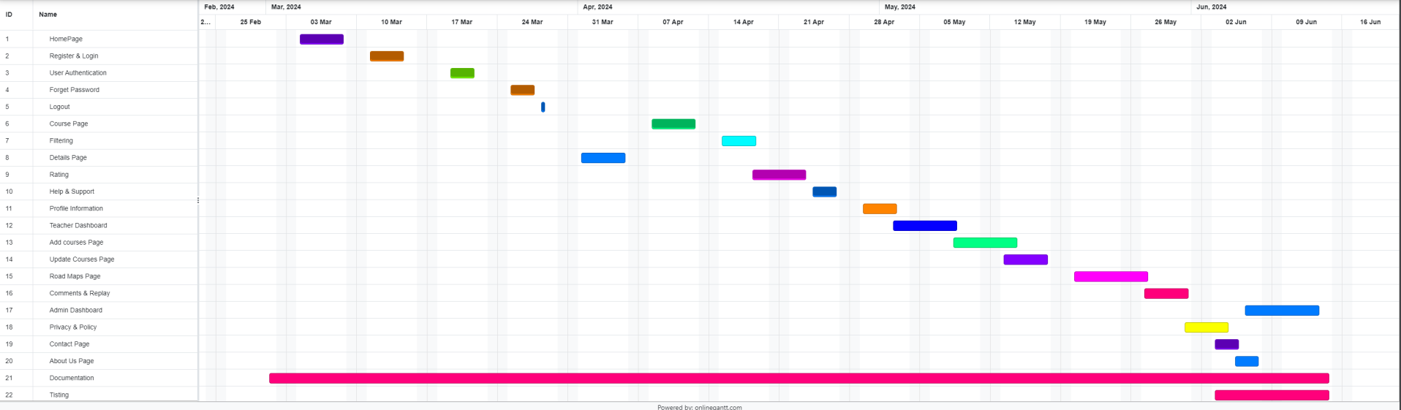

Figure 1 1.1 Gant chart.

1.7 Project outline
Figure SEQ Figure \* ARABIC 3 Gantt chart
Chapter 1 is the introduction chapter that provides a summary of the problem to be solved, the objectives of the project to be built, and the action plan with a clarification of its steps.
Chapter 2 lists the related systems and presents a comparison of the proposed system.
Chapter 3 presents and explains the feasibility study and methodology that used in the project, functional and non-functional requirements.
Chapter 4 Shows how the system works by a set of diagrams most easily and simply and shows how to use the system.
Chapter 5 presents implementation and evaluation with an explanation of each implementation and how it was implemented.
Chapter 6 draws the conclusion of the project and its future work.

CHAPTER 2

LITERATURE REVIEW

2.1 Overview
This chapter includes the definition of comparing the system with other existing systems and reaching its conclusion accordingly the system is built in the best way.

2.2 Comparative Study
In this section, related work is presented.

2.2.1 Coursera
An online learning platform that offers a wide range of courses and specializations taught by instructors from top universities and organizations worldwide.[1]

2.2.2 Udemy
Leading online marketplace for learning and teaching, with a vast catalog of courses covering diverse topics and skills.[2]

2.2.3 edX
Nonprofit online learning platform founded by Harvard University and MIT, offering high-quality courses from leading universities and institutions around the world.[3]

2.3 Related work
Table 2.1 shows a comparison between the suggested system and another existing systems in terms of:
1) Manage contents: Course providers can edit their courses
2) Feedback: Users can rate the course.
3) Roadmap: The website provides a study plan for some specializations.
4) Enrollment in courses: Users can purchase courses.
As shown in Table 2.1, the Corz system is better in terms of roadmap.

 |  |  |   Table 1 2.1: Comparison between the proposed system and existing systems | 
Manage content | ✓ | ✓ | ✓ | ✓
Feedback | ✓ | ✓ | ✓ | ✓
Roadmap | ✗ | ✗ | ✗ | ✓
Enrollment in courses | ✓ | ✓ | ✓ | ✓
Available (✓) Not Available (✗)

2.4 Summary
Based on our search, no system combines these services in one site, it was necessary to create a system to publish and manage educational content, and provide a Roadmap for multiple fields, all of this in one web application.

CHAPTER 3

METHODOLOGY

3.1 Overview
This chapter includes defining the feasibility study, the tools that were used to create the Corz system, the collected requirements (functional and non-functional), and the methodological process by which the project was implemented.

3.2 Feasibility Study
A feasibility study is a critical phase in the development of any project, including the introduced academy courses web application. It serves as a comprehensive assessment that examines the practicality and viability of the project. This study encompasses various dimensions, such as financial, technical, economic, environmental, and legal aspects, to determine whether the project is worth pursuing.

3.2.1 Technical feasibility
CORZ Academy’s technical feasibility is determined by its ability to leverage modern web development technologies and infrastructure to deliver a robust and scalable educational platform.
Table 2 3.1: Technical feasibility
Item | Cost Estimate (JOD)
Hardware and software | 450
Cloud | 30
Courses | 400

3.3 Requirements
Table 3.2 shows the functional requirements and Table 3.3 illustrates the non-functional requirements of the system. x

3.3.1 Functional Requirements
Functional requirements specify what a system should do in terms of its functions, features, and interactions with users or other systems. It defines the basic tasks or actions that the system must be able to perform.

Table 3 3.2: Functional Requirements
Requirement ID | Requirement Description
FR-101 | Manage content
FR-101 | - Course providers can add and delete educational videos.  - Course providers can monitor enrollment numbers and profits.
FR-201 | Feedback
FR-201 | - Course registrants can comment on and rate the course.  - Course providers can respond to comments and see ratings.
FR-301 | Roadmap
FR-301 | - Several stages can be selected.  - You can choose the appropriate course at each stage.
FR-401 | Enrollment
FR-401 | - You can enroll for the appropriate course depending on the price, rating, and provider.

3.3.2 Non-Functional Requirements
Non-functional requirements (NFRs) define the quality attributes and constraints that a system must adhere to, focusing on performance, reliability, security, ease of use, scalability, maintainability, and compliance.

Table 4 3.3: Non-Functional Requirements
Requirement ID | Requirement Description
 | Simplicity and Ease of Use
NFR-101 | - The project prioritizes simplicity for effortless user interaction.
 | Performance
NFR-102 | - Ensures fast and efficient user experience with quick response times.
 | Security
NFR-103 | - Security is paramount, with implemented data encryption protocols.  - Email validation is employed during account creation.  - An email is sent containing a link to verify the validity of the registered email, ensuring the existence and ownership of the email.

3.4 Methodology
As demonstrated in Section 1.4, Scrum is an appropriate methodology for the introduced project's purposes. The requirements were unstable and as well as were not understood in the early study of the project life cycle. Figure 3.1 illustrates ……
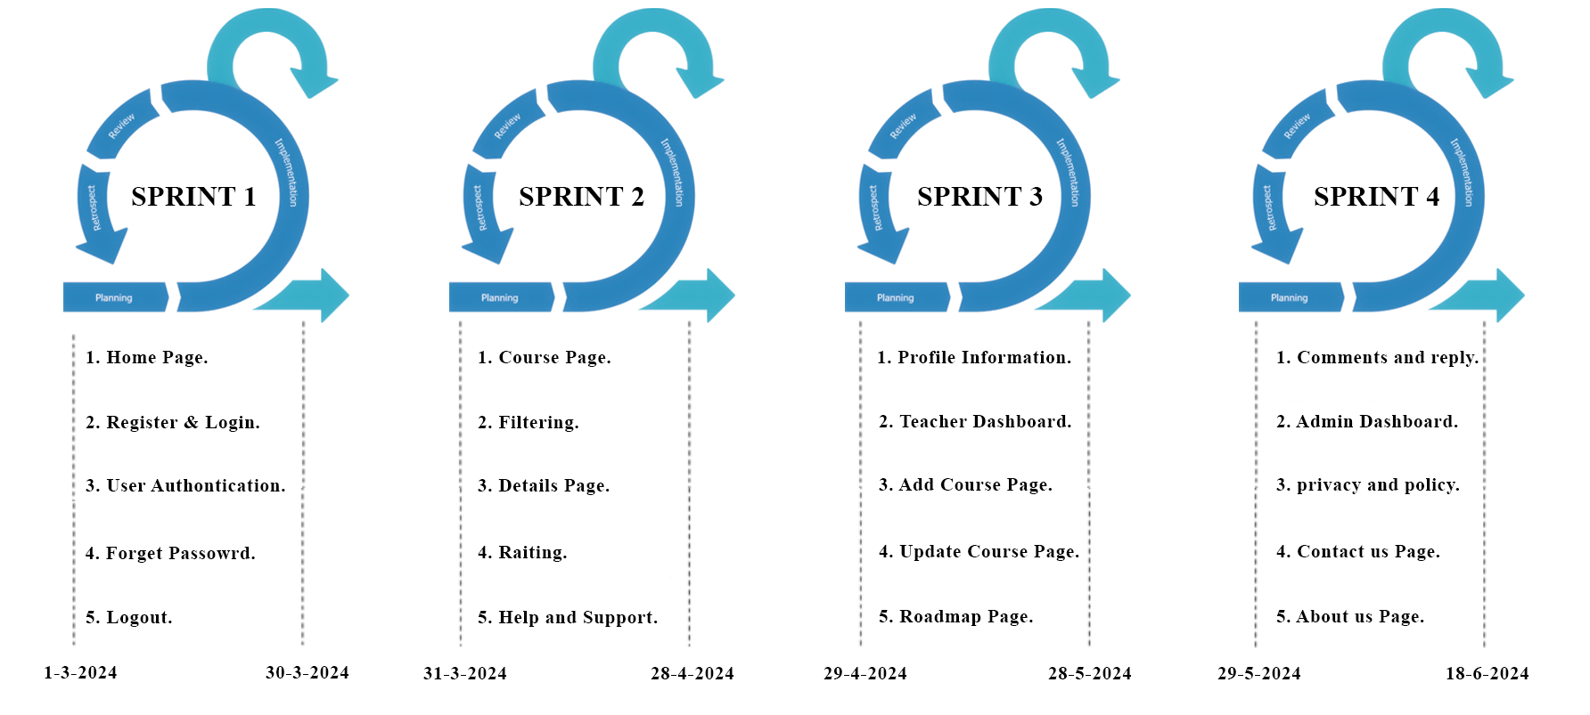
Figure 2 3.1 : Methodology .
Sprint 1
Sprint Planning:
Table 5 3.4: Sprint planning
ID | User story | Description | days
1 | As a user, I want to visit the home page so that I can understand what the site offers. | Development of the initial layout and key sections of the home page. | 5
2 | As a new user, I need a way to register and log in so that I can access personalized features. | Implement registration and login functionalities with basic form validations. | 4
3 | As a user, I need to remain logged in to access my account securely without re-entering credentials. | Set up user authentication mechanisms and session management. | 3
4 | As a user, I want a way to recover my account when I forget my password. | Implement a forget password feature with email verification. | 3

Development:
Table 6 3.5: Development
ID | Tasks
1 | Design home page layout
2 | Develop registration form
3 | Implement login mechanism
4 | Create a forget password feature
5 | Code logout functionality

Sprint Review:
Table 7 3.6: sprint Review
Completed Tasks | Acceptance  Criteria met? | Feedback/Next Steps
Design home page layout | Yes | Enhance the UI based on user feedback.
Develop registration form | Yes | Add more form validations.
Implement login mechanism | Yes | Revisit failed login attempts handling.
Create a forget password feature | Yes | Monitor email delivery success rate.
Code logout functionality | Yes | Test on multiple browsers.

Sprint 2
Sprint Planning:
Table 8 3.7: Sprint planning
ID | User story | Description | days
1 | As a user, I want to browse courses so that I can find one that interests me. | Develop the course page with a list view of available courses. | 5
2 | As a user, I need to filter courses by category so that I can find courses I'm interested in more easily. | Implement filtering functionality on the course page. | 4
3 | As a user, I want to view course details so that I can learn what the course offers before enrolling. | Create a detailed page for each course, including content, prerequisites, and instructor info. | 5
4 | As a user, I want to rate courses so that I can provide feedback on the course quality. | Add a rating system to the course details page. | 4
5 | As a user, I need help and support options so that I can resolve any issues encountered. | Develop a help and support section with FAQs and contact options. | 3

Development:
Table 9 3.8: Development
ID | Tasks
1 | Build course page layout
2 | Implement course filtering
3 | Design course details page
4 | Develop rating functionality
5 | Create a help and support section

Sprint Review:
Table 10 3.9: sprint Review
Completed Tasks | Acceptance  Criteria met? | Feedback/Next Steps
Build course page layout | Yes | Consider adding more interactive elements.
Implement course filtering | Yes | Refine filtering based on user tests.
Design course details page | Yes | Increase page load speed.
Develop rating functionality | Yes | Integrate user feedback for improvements.
Create a help and support section | No | Expand FAQ based on common user questions.

Sprint 3
Sprint Planning:
Table 11 3.10: Sprint planning
ID | User story | Description | days
1 | As a user, I want to manage my profile information so that I can keep my personal details up to date. | Implement a user profile page with editable personal information fields. | 4
2 | As a teacher, I need a dashboard to manage my courses and see an overview of student progress. | Create a teacher dashboard with course management tools and student progress analytics. | 5
3 | As a teacher, I want to add new courses so that I can offer more learning opportunities to students. | Develop an interface for teachers to submit new courses for approval. | 5
4 | As a teacher, I need to update existing courses to keep the content relevant and up-to-date. | Enable course editing functionality for teachers, including multimedia content updates. | 5
5 | As a user, I'm interested in seeing a roadmap of my learning journey to guide my course selections. | Design a roadmap feature that suggests a personalized learning path based on the user's interests and completed courses. | 6
Development:
Table 12 3.11: Development
ID | Tasks
1 | Build a user profile management page
2 | Create teacher dashboard
3 | Implement add course functionality
4 | Develop course update capabilities
5 | Design learning roadmap page

Sprint Review:
Table 13 3.12: sprint Review
Completed Tasks | Acceptance  Criteria met? | Feedback/Next Steps
Build a user profile management page | No | Refine UI based on user feedback.
Create teacher dashboard | Yes | Need to enhance analytics visualization.
Implement add course functionality | Yes | Plan for a moderation queue for submissions.
Develop course update capabilities | No | Integrate a version control system for content.
Design learning roadmap page | No | Improve the algorithm for more personalized paths.

Sprint 4
Sprint Planning:
Table 14 3.13: Sprint planning
ID | User story | Description | days
1 | As a user, I want to comment on courses and reply to comments so that I can engage with the community. | Implement a commenting system under course details with threaded replies. | 5
2 | As an admin, I need a dashboard to manage site content and user feedback to ensure the platform remains high-quality and relevant. | Create an admin dashboard with content moderation, user management, and feedback tools. | 6
3 | As a user, I want to understand the privacy policy to know how my data is used and protected. | Develop a privacy policy page detailing data use, collection, and user rights. | 3
4 | As a potential user, I need a Contact Us page to reach out for more information or support. | Create a Contact Us page with the form and other contact details. | 3
5 | As a visitor, I want to learn more about the platform so that I can decide whether to join. | Design an about us page that shares the mission, vision, and team behind the platform. | 3

Development:
Table 15 3.14: Development
ID | Tasks
1 | Build a commenting and reply system
2 | Create admin dashboard
3 | Draft and publish the privacy policy page
4 | Implement a contact us page
5 | Presentation

Sprint Review:
Table 16 3.15: sprint Review
Completed Tasks | Acceptance  Criteria met? | Feedback/Next Steps
Build a commenting and reply system | No | Monitor for moderation needs.
Create admin dashboard | No | Enhance with more detailed analytics.
Draft and publish the privacy policy page | No | Plan to update frequently as laws change.
Implement a Contact Us page | No | Test responsiveness on various devices.
Design and populate the About Us page | No | Update with new team members quarterly.

3.5 Tools
It’s necessary to point out the Tools that were used in the Journals project these Tools are the Munitions that the project requires to help us in getting our work organized. It is used to manage the projects and tasks in such a way that they achieve success. The below table shows the tools Used in the project.
. Table 17 3.16: Tools
Tools Utilized
Visual Studio
Visual Studio Code
Microsoft Office
Canva
Gantt Chart
Trello
Draw.io
UI Vers.IO

3.6 Programming Languages
This table shows the programming languages that developers used.

Table 18 3.17: sprint Review
Programming Languages
C#
JavaScript
SQL

CHAPTER 4

DESIGN MODELS

4.1 Overview
This chapter will demonstrate the process of designing and linking the system’s components using several diagrams such as the Context Diagram, Use-Case Diagram, and ER Diagram.

4.2 Context Diagram
Context diagrams show the interactions between a system and other actors (external factors) with which the system is designed to interface. System context diagrams can be helpful in understanding the context in which the system will be part. Figure 4.1 shows the context diagram of our system.
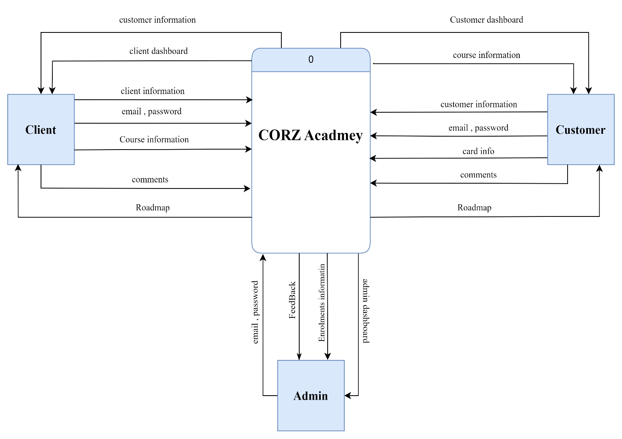
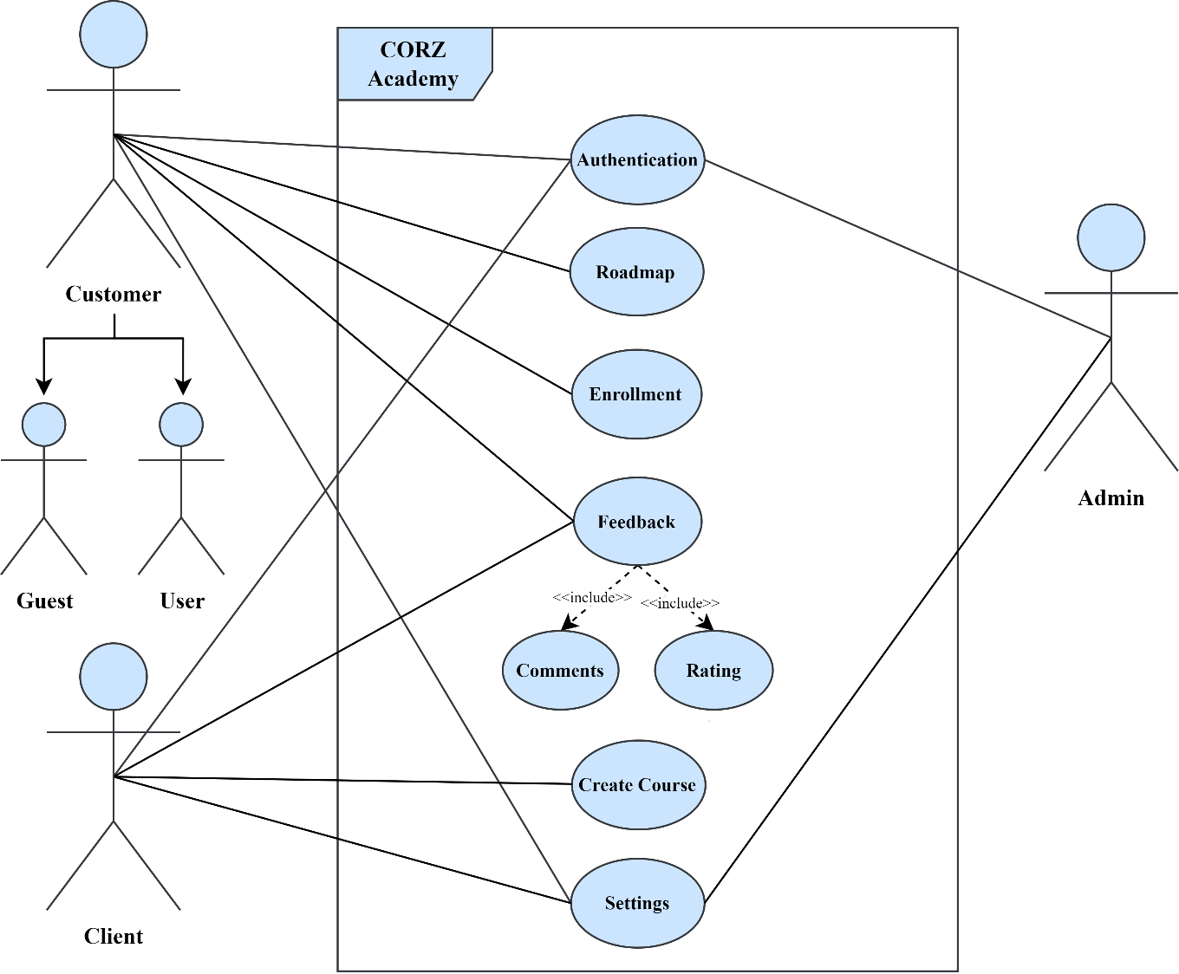

Figure 3 4.1 Context Diagram

4.3 Data Flow Diagram
A data flow diagram (DFD) maps out the flow of information for any process or system. It uses defined symbols like rectangles and arrows, plus short text labels, to show data inputs, outputs, storage points, and the routes between each destination. Figure 4.2 shows the data flow diagram of the system.
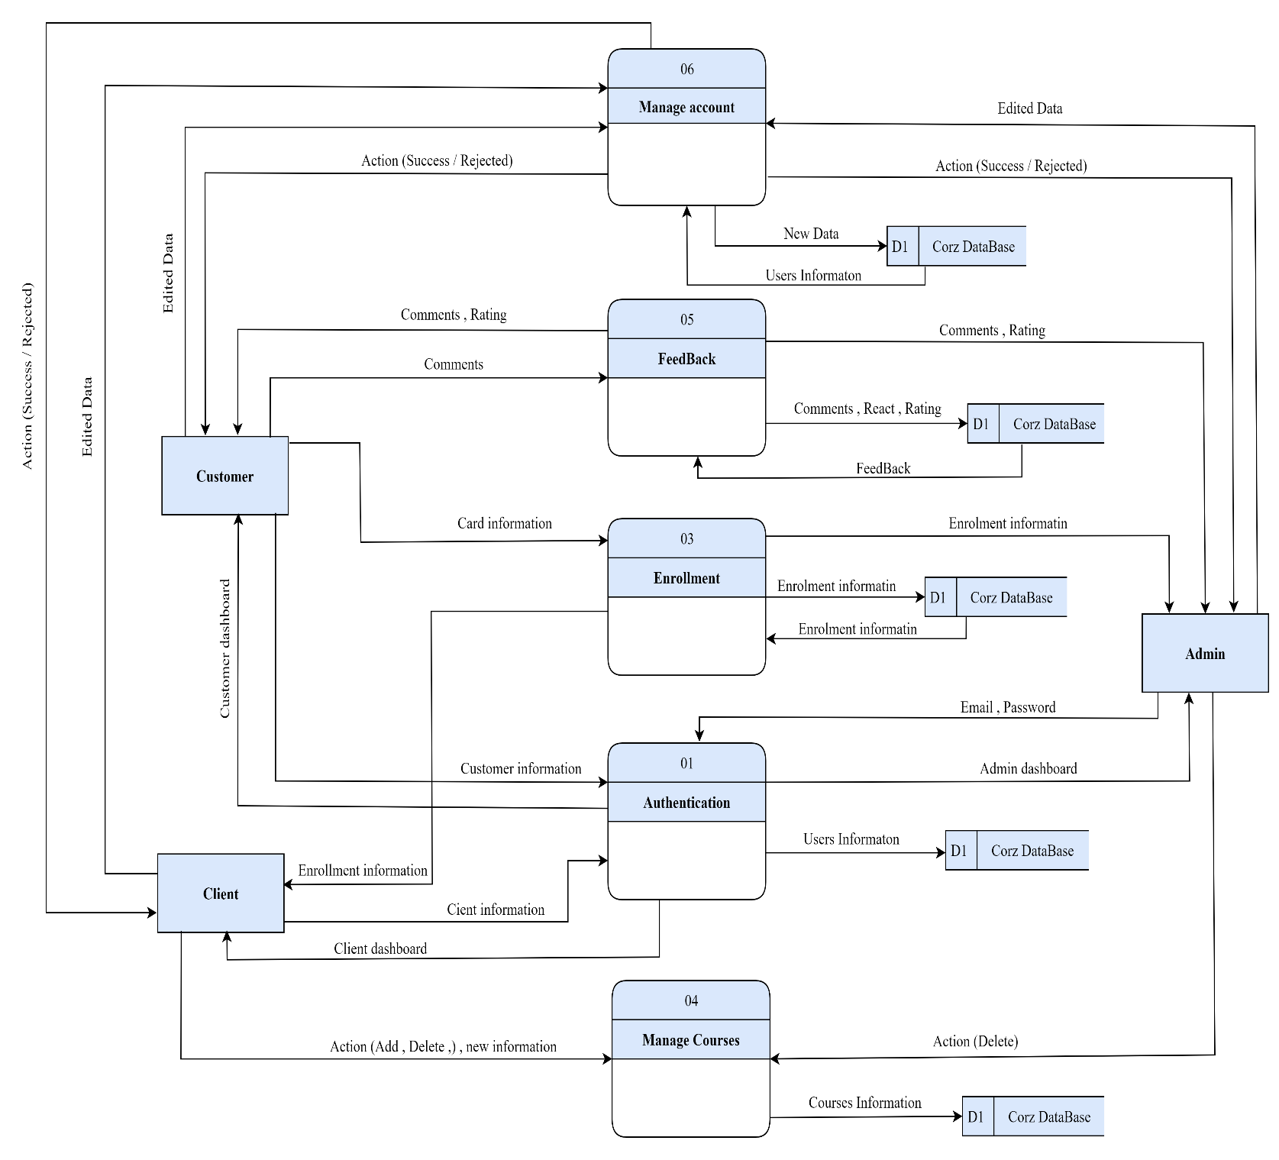

Figure 4 4.2 Data Flow Diagram

4.4 Use case diagram
A use case diagram can summarize the details of the system’s users (also known as actors) and their interactions with the system. To build one, you’ll use a set of specialized symbols and connectors. Figure 4.3 shows a use case diagram of the system.
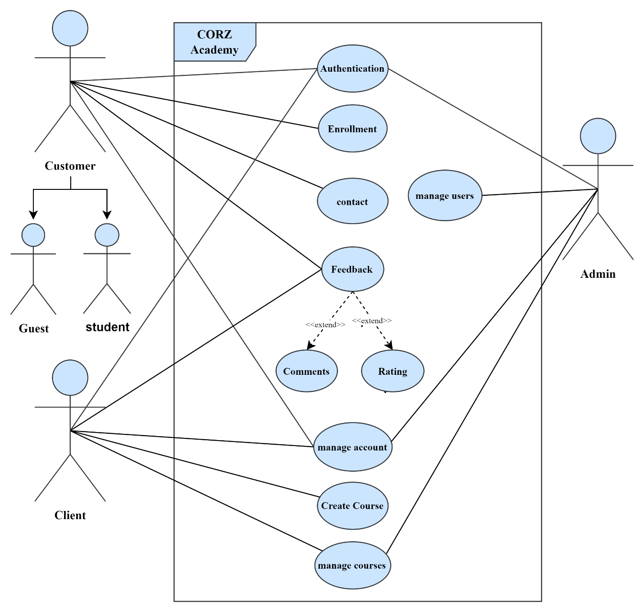

Figure 5 4.3 Use Case Diagram

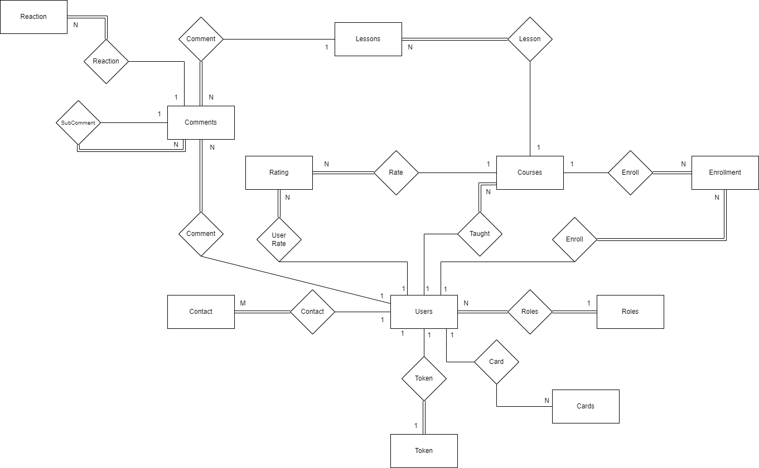
4.7 ER Diagram

Figure 6 4.4 ER Diagram

4.8 Mapping for ER Diagram
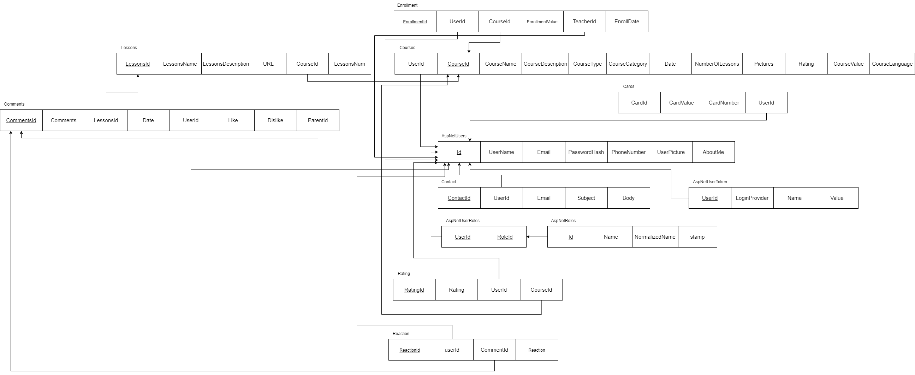

Figure 7 4.5 Mapping

CHAPTER 5

EXPERIMENTS AND RESULT

5.1 Overview
In this chapter, the system undergoes rigorous testing to ensure that each unit fulfills its designated tasks and maintains consistency with the other units within the system. This involves employing various software testing methods and evaluating the system's performance in an environment that closely mirrors the intended operational environment for which it was created.

5.2 Test Design
Test design is a systematic process that outlines how testing should be conducted. It encompasses the identification of testing techniques, formulation of test scenarios, creation of test cases, selection of test data, and specification of expected test results. This comprehensive approach ensures a structured and effective testing methodology.

Table 19 5.18: Test Cases
Test-id | function | Test step | Input data | Expected Results | Actual Results | Execution Status
01 | Create account student | 1- Navigate to web site  2- Click on the register button  3- Enter the full name  4- Enter your password  5- Enter the phone number  6- Choose your role (student)  7- Click on the Create Account button | RaadRaedAl-Adwan  Raad@gmail.com  password:Raad12345@  0795062887  student | Showing the message "Registration successful. Please check your email for confirmation"  And the OK button. When I press it, I will be taken to the login screen | Showing the message "Registration successful. Please check your email for confirmation"  And the OK button. When I press it, I will be taken to the login screen | Passed
02 | Create an accounting student (without a name) | 1- Navigate to the website  2- Click on the register button  3- Enter your email  4- Enter your password  5- Enter the phone number  6- Choose your role (student)  7- Click on the Create Account button | Raad@gmail.com  password:Raad12345@  0795062887  student | The name field is required | The name field is required | Passed
03 | Login by account student invalid email | 1- navigate to web site  2- click on the login button  3- Enter the email  4- Enter your password  5- click on the submit button | Raad%gmail.com  password:Raad12345@ | Enter valid Email 'user@example.com' | Enter valid Email 'user@example.com' | Passed
04 | Login by account student valid email | 1- Navigate to web site  2- Click on the login button  3- Enter the email  4- Enter your password  5- Click on the submit button | Email: user@example.com  pass: User@123 | Go to the home page and there is a button with the user's picture and his name, when you click on it, 3 buttons are displayed Settings, contact, and Logout | Go to the home page and there is a button with the user's picture and his name, when you click on it, 3 buttons are displayed Settings, contact, and Logout | Passed
05 | Forget password with an invalid email | 1- Navigate to web site  2- Click on the login button  3- Click on the Forget button  4- Enter your email  5- Click on the verify button | Email: user&example.com  pass: User@123 | Enter valid Email 'user@example.com' | Enter valid Email 'user@example.com' | Passed
06 | Forget your password with a valid email | 1- Navigate to web site  2- Click on the login button  3- Click on the Forget button  4- Enter your invalid email  5- Click on the verify button | Email: user@example.com | Success  Password change request initiated. Please check your email for confirmation. | Success  Password change request initiated. Please check your email for confirmation. | Passed
07 | Check the filter on the course page | 1- Navigate to web site  2- Login by email and password  3- Navigate to the course page  4- Click on the filter button  5- Choose rating  6- Set the price | Email:Raad@gmail.com  password :password:Raad12345@  rating:5star  price:0-80 | Show all filtered courses | Show all filtered courses | Passed
08 | Check the search field on the Courses page | 1- Navigate to web site  2- Login by email and password  3- Navigate to the course page  4- Fill in the search field | email:Raad@gmail.com  password :password:Raad12345@  search input :”JAVA” | Show all filtered courses | Show all filtered courses | Passed
09 | Check on the RoadMaps page | 1- Navigate to web site  2- Navigate to the RoadMaps page |  | Go to the RoadMaps page which contains button the basics of the computer, button frontend, and backend button | Go to the RoadMaps page which contains button the basics of the computer, button frontend, and backend button | Passed
10 | Check the contact page | 1- Navigate to web site  2- Navigate to the contact page |  | Display the contact page that contains the location, email, phone number, and send message button, and contains the Name, Email, Subject, and Description fields. | Display the contact page that contains the location, email, phone number, and send message button, and contains the Name, Email, Subject, and Description fields. | Passed
11 | Examine the social networking icons located at the foot of the main page. | 1- Navigate to web site  2- Click the button on Facebook & Instagram & Twitter |  | When I press the social media buttons, I am taken to the pages of the site on social media |  | Passed

5.3User Acceptance Testing
User Acceptance Testing (UAT), commonly conducted in many IT projects, is alternatively known as beta testing or end-user testing. It constitutes a crucial phase in software development where the software undergoes testing in the "real world" environment by the intended audience or business representatives. This phase ensures that the software aligns with the users' expectations and requirements before its final deployment.
Users biography:
1-Gender
2-What year are you in (at university)
3-In which college do you study
4-What is your major in college

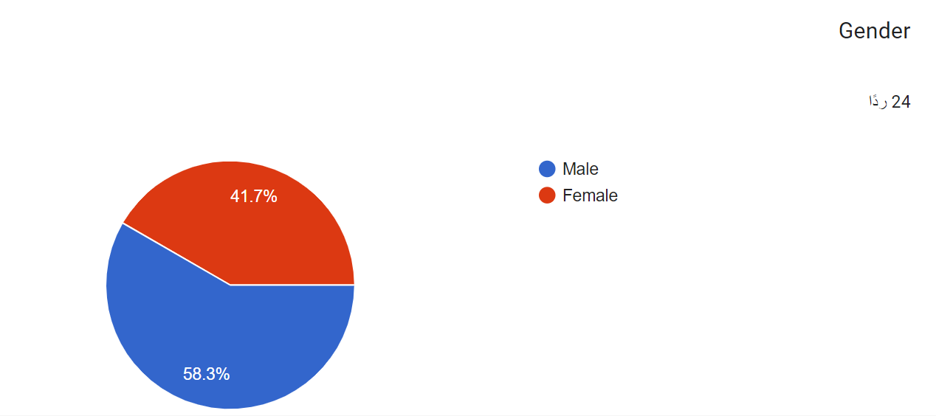

Figure 8 5.1 User Biography ( Gender )

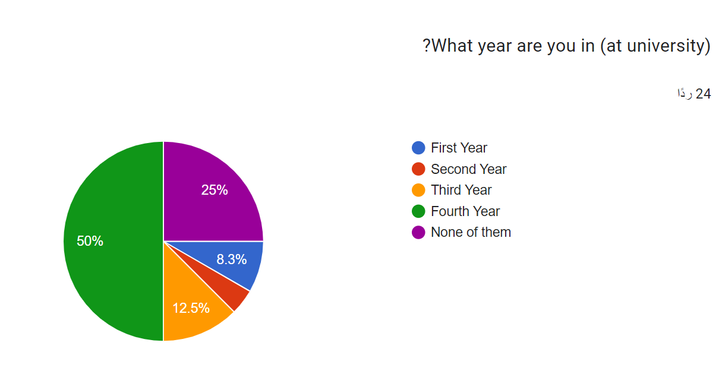
Figure 9 5.2 User Biography ( year)
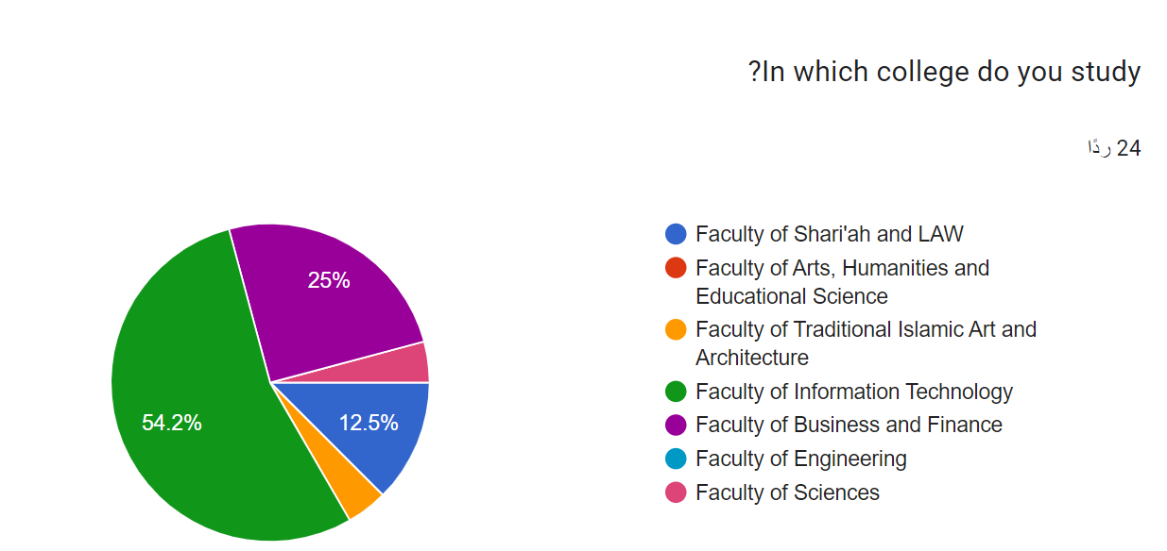
Figure 10 5.3 User Biography ( College )

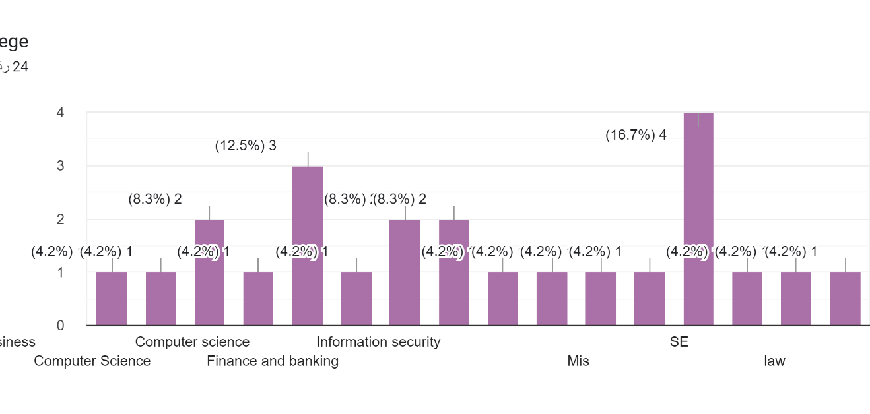

Figure 11 5.3 User Biography ( Major )

Evaluation of Software Usefulness
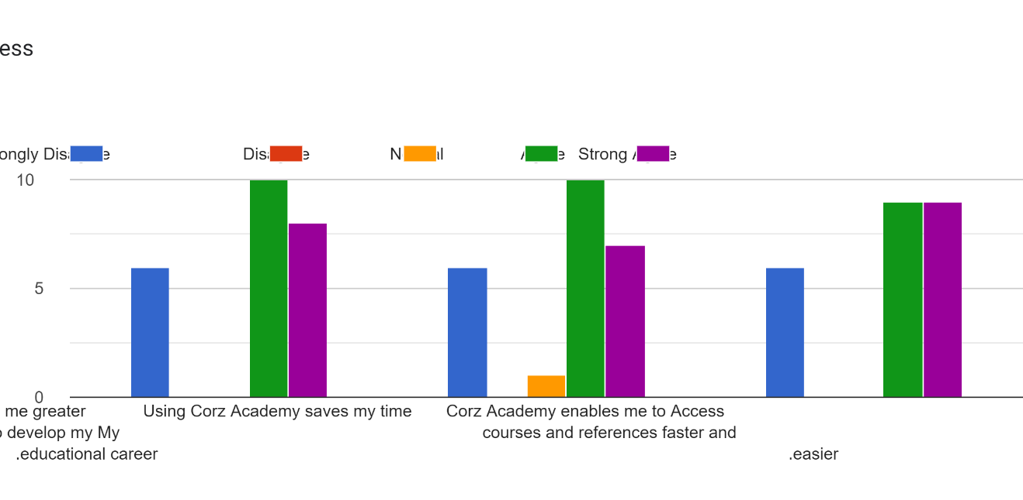

Figure 12 5.4 Software Usefulness

Evaluation of Ease of Use
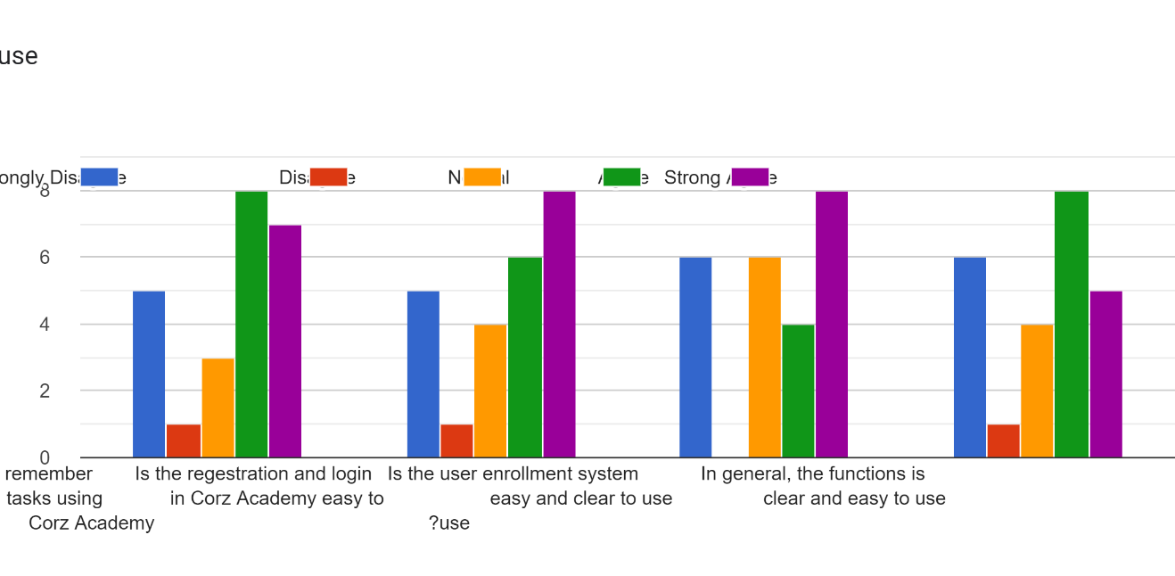
Figure 13 5.5 Ease of Use

Evaluation of User Satisfaction
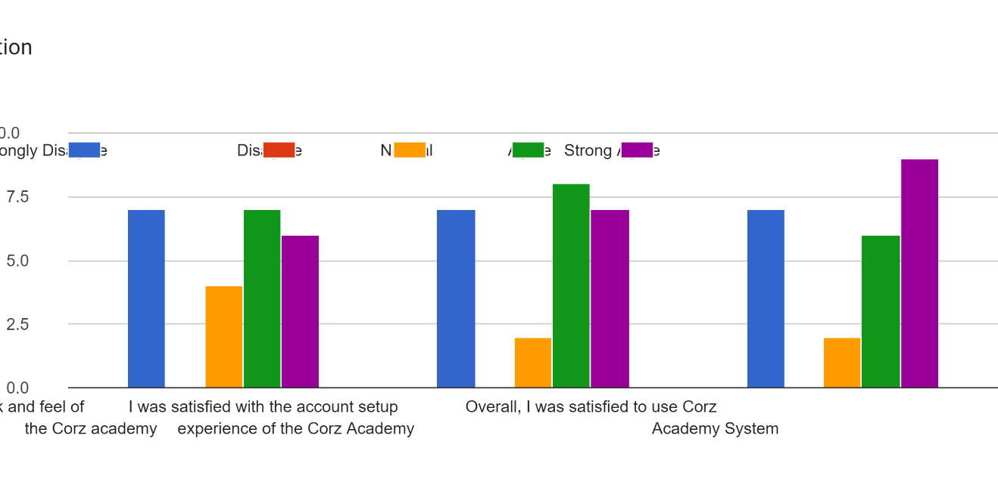

Figure 14 5.6 user satisfaction

CHAPTER 6

CONCLUSION

6.1 Overview
This chapter will present a holistic view of Corz Academy, encompassing a project summary, objectives, contributions, achievements, limitations, and an exploration of future work.

6.2 Project Summary
CORZ Academy is a comprehensive educational platform designed to meet the diverse learning needs of individuals across various fields. It facilitates the connection between course providers and recipients, offering a robust ecosystem for online learning. The platform includes features for publishing and managing content, interactive feedback mechanisms, structured learning pathways (roadmaps), and course enrollment processes. Built using modern technologies like Angular, ASP.NET Core, CORZ Academy aims to revolutionize online education by promoting lifelong learning and skill development.

6.3 Achieved Objectives
Objective 01: Identify and Analyze the Problem
The project began by identifying the challenges faced by learners in accessing high-quality, diverse educational content and the difficulties educators encounter in reaching a broad audience. CORZ Academy was designed to bridge this gap by providing an intuitive and user-friendly platform. Comparative analysis with existing educational platforms was conducted to ensure that CORZ Academy offers superior ease of use and comprehensive functionalities.

Objective 02: Development (Problem Solution)
A structured development approach was adopted, starting with a feasibility analysis and selection of agile project management methodologies. Requirements were meticulously collected through user stories and interviews with potential users, which were then analyzed and translated into detailed user flow diagrams and wireframes. The development involved building a scalable backend, an interactive frontend, and robust database management.

Objective 04: Validate the System
The system underwent rigorous testing, including functional, usability, and performance tests. Multiple users, including course providers and recipients, were involved in the testing phases to ensure the platform's reliability and effectiveness. Feedback was collected and iteratively used to enhance the platform.

6.4 Contribution
CORZ Academy is a valuable resource for learners and educators. The intuitive user interface ensures easy navigation and access to a wide range of courses and educational resources. The platform provides real-time updates on course content and user interactions. Security is a top priority, with measures in place to protect user data and ensure a safe learning environment. CORZ Academy aims to empower users by providing tools for continuous learning and professional development.

6.5 limitation
Despite its achievements, CORZ Academy currently faces some limitations:
L01: Limited availability of course providers in certain specialized fields.
L02: The need for continuous collection and updating of comprehensive course content and user data.
L03: Potential challenges in meeting the diverse needs of all users, especially during peak times or in highly specialized areas.

6. Future Work
1. Create a Section for Student Inquiries:
Develop a feature that allows users to ask questions and seek clarifications.
2. Peer-to-Peer Interaction:
Add a section for users to connect with each other for sharing opinions, providing assistance, and collaborative learning.
3. Roadmaps for all specialties, not just IT.
4. Develop mobile applications.
5. Chatting between teachers and students.

References
[1] Coursera. URL: www.coursera.org
[2] udemy. URL: www.udemy.com
[3] edx. URL: www.edx.org
[4] w3schools. URL: www.w3schools.com
[5] StackOverflow. URL: StackOverflow
[6] Bootstrap. URL: www.getbootstrap.com
[7] Microsoft Visual Studio Documentation. URL : www.docs.microsoft.com/en-us/visualstudio
[8] SQL Server Documentation. URL : www. docs.microsoft.com/en-us/sql/sql-server

Appendix

1) Home page
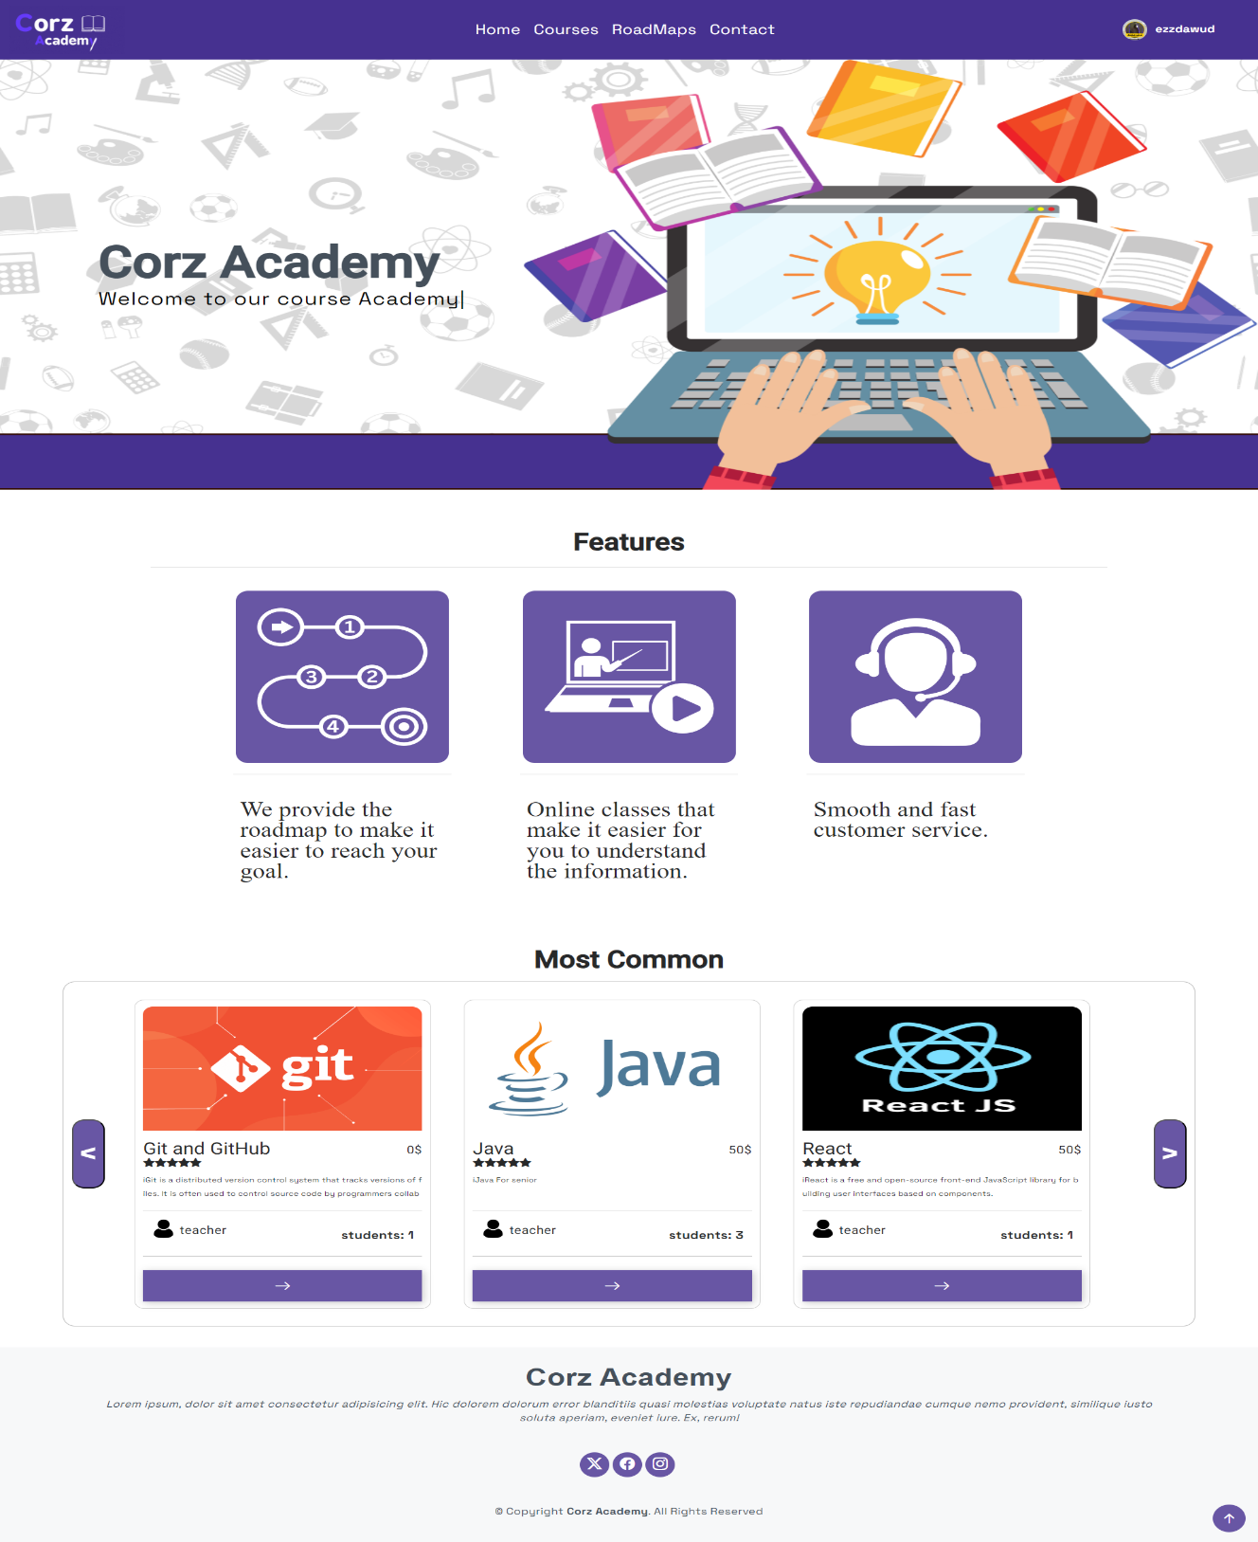

2) Course Page
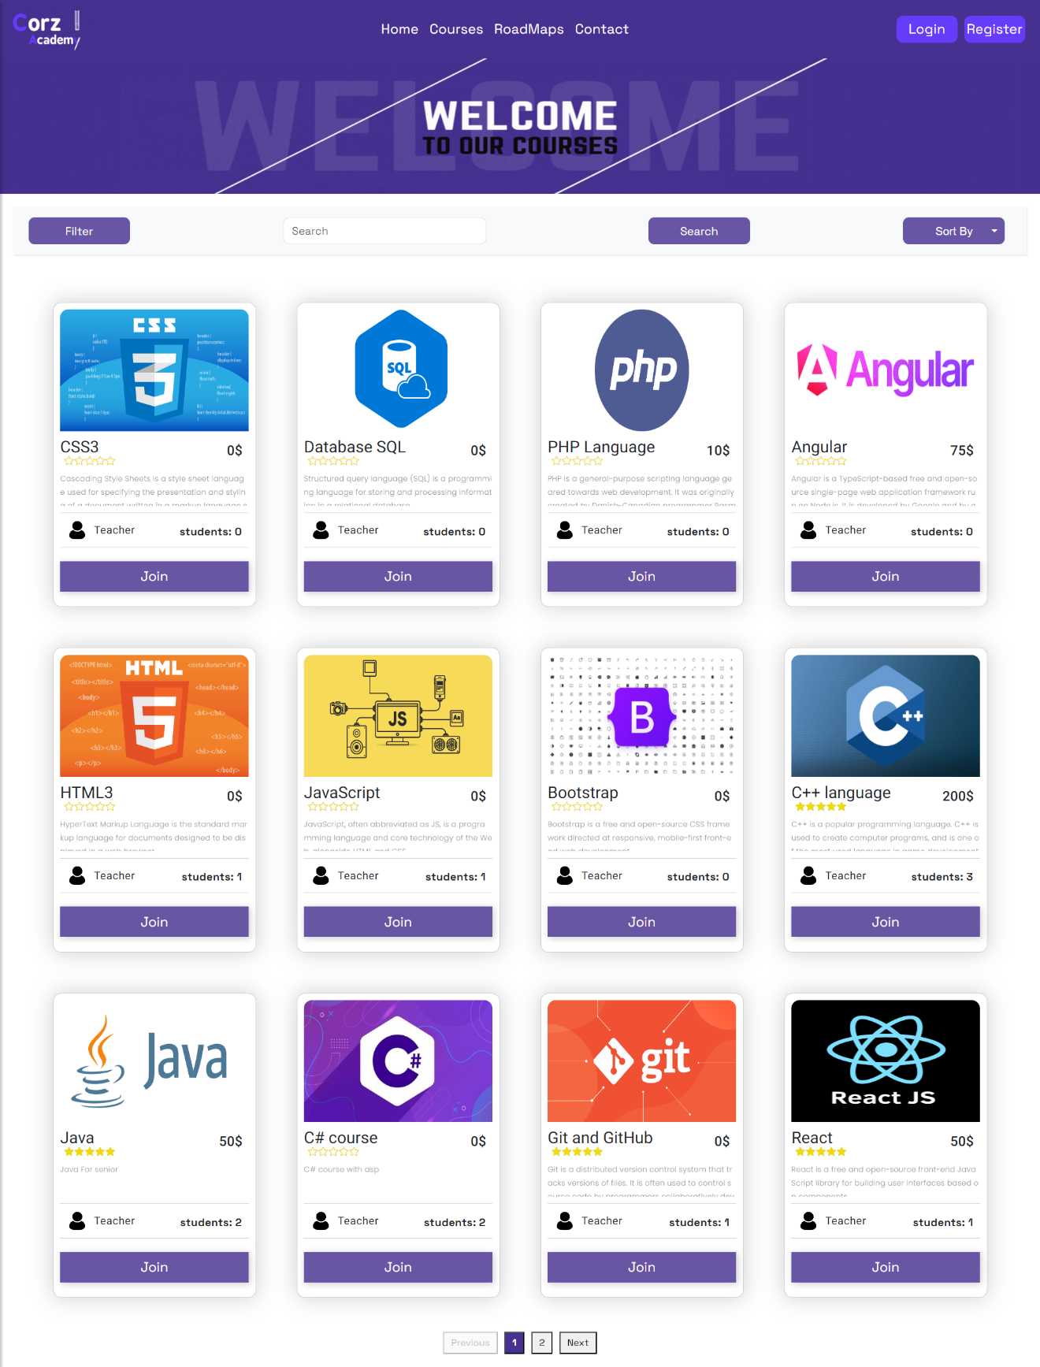

3) Road Maps
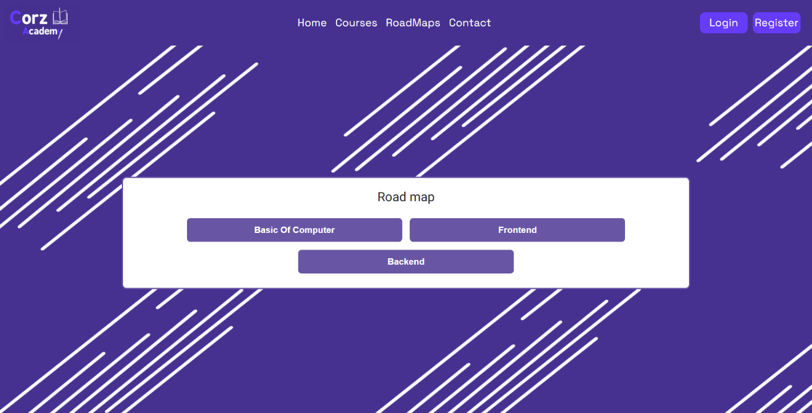
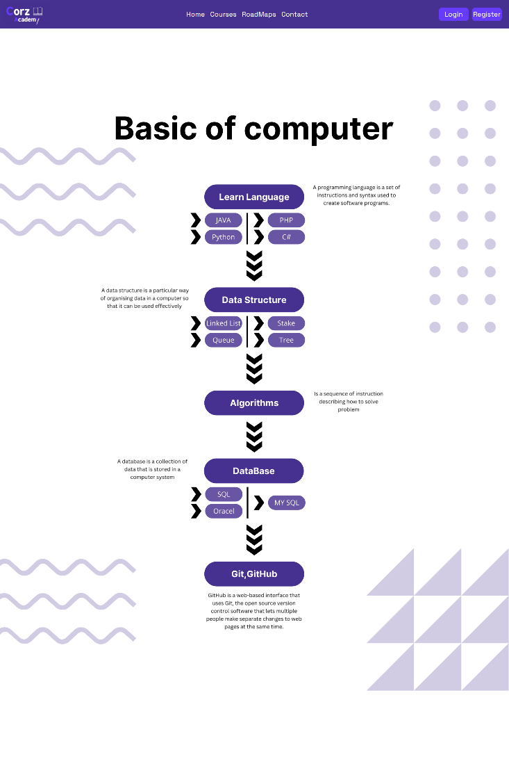

4) Admin dashboard
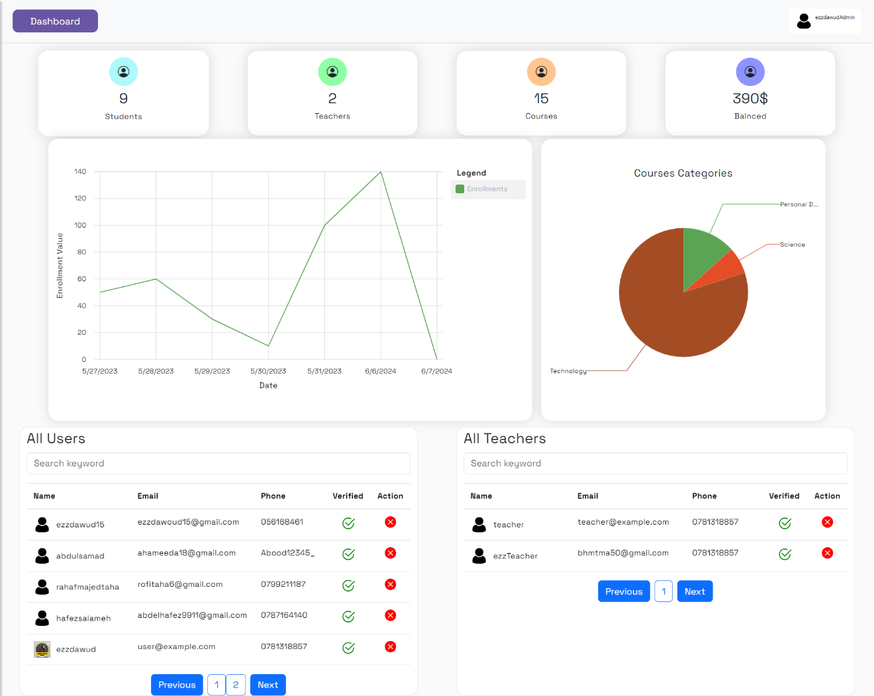

5) Teacher (Client) dashboard
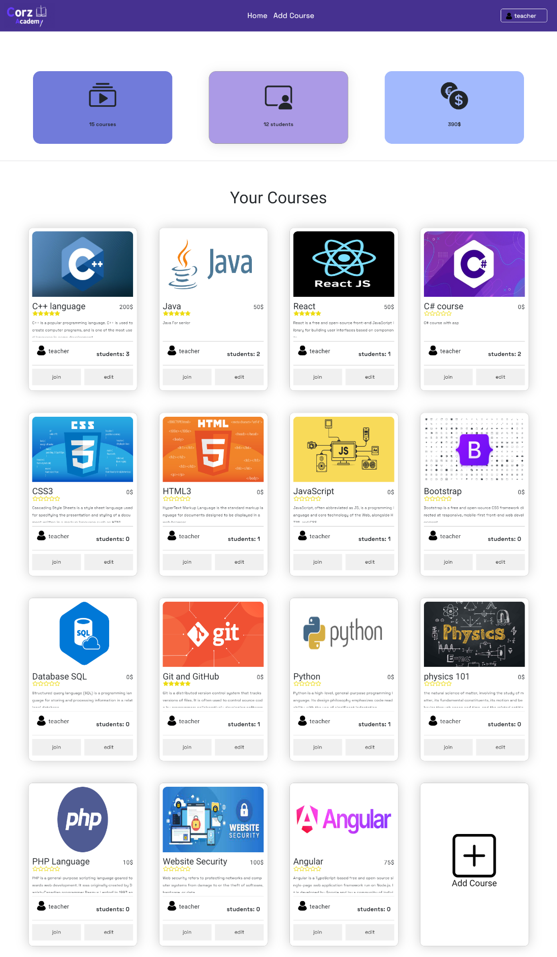

6) Add course

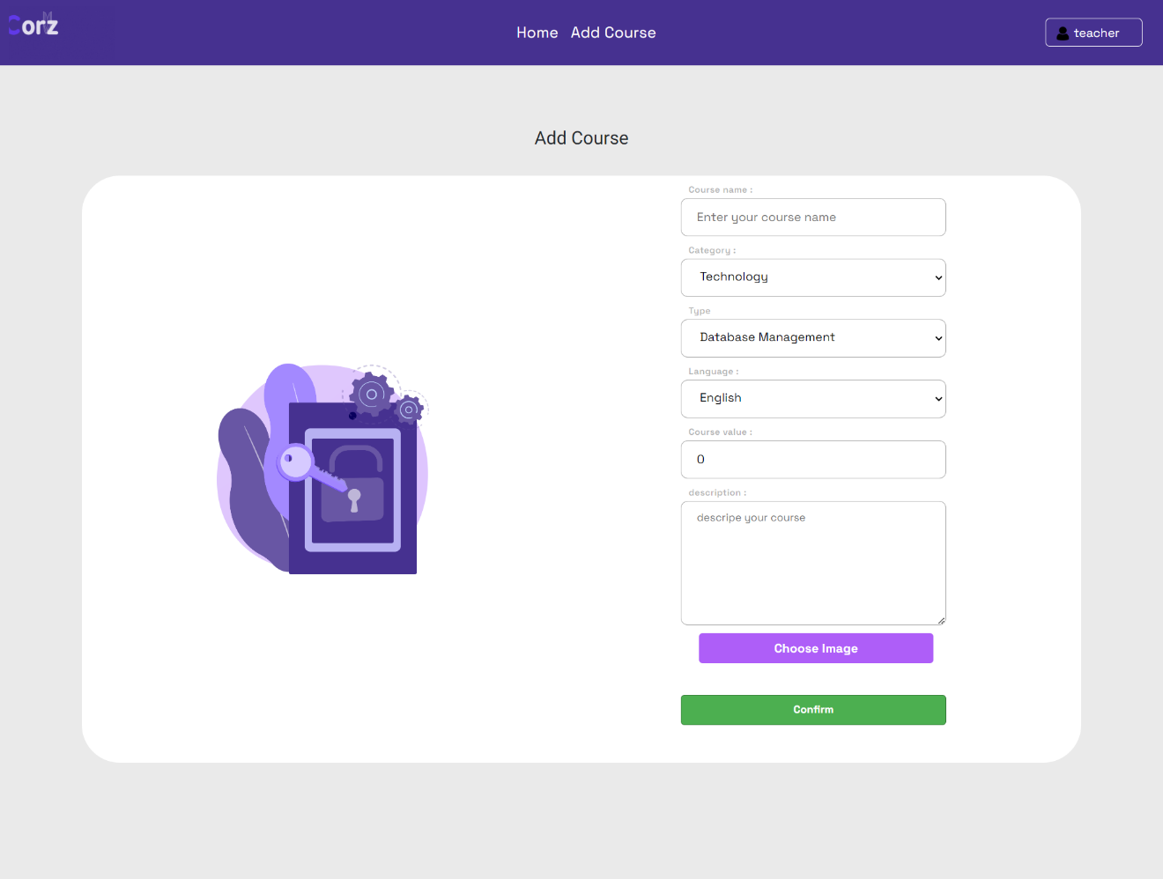

7) Contact Page

