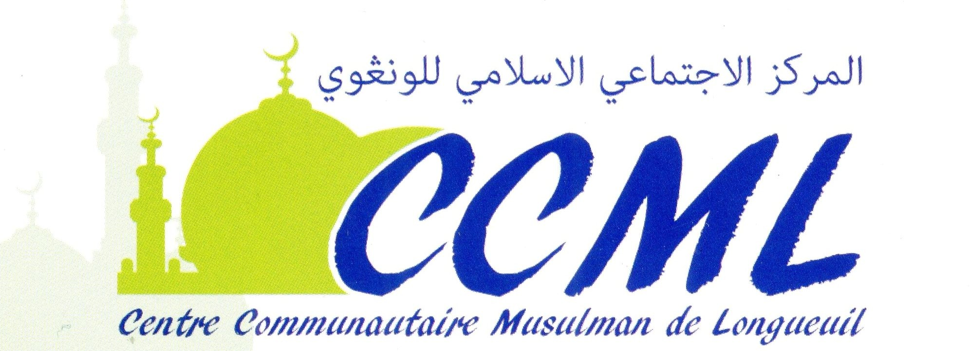

ﺑﺴﻢ ﷲ اﻟﺮﲪﻦ اﻟﺮﺣﻴﻢ
وﺛﻴﻘﺔ ﻋﻘﺪ زواج ﺷﺮﻋﻲ
رﻗﻢ اﻟﻌﻘﺪ: | ﺻﻔﺤﺔ رﻗﻢ: | رﻗﻢ اﻟﺴﺠﻞ:
اﶈﻜﻤﺔ اﳌﺨﺘﺼﺔ | اﳌﻮاﻓﻖ | اﻟﺘﺎرﻳﺦ

ﺑﻴﺎنات اﻟﺰوج
رﻗﻢ اﳍﻮﻳﺔ / اﻟﺒﺎﺳﺒﻮر | ﳏﻞ اﻹﻗﺎﻣﺔ | ﻣﻜﺎن اﳌﻴﻼد | اﳌﻬﻨﺔ | تارﻳﺦ اﳌﻴﻼد | اﳉﻨﺴﻴﺔ | اﻻﺳﻢ
ﺑﻴﺎنات اﻟﺰوﺟﺔ
رﻗﻢ اﳍﻮﻳﺔ / اﻟﺒﺎﺳﺒﻮر | ﳏﻞ اﻹﻗﺎﻣﺔ | ﻣﻜﺎن اﳌﻴﻼد | اﳌﻬﻨﺔ | تارﻳﺦ اﳌﻴﻼد | اﳉﻨﺴﻴﺔ | اﻻﺳﻢ

ﺗﻔﺎﺻﻴﻞ اﻟﺼﺪاق )اﳌﻬﺮ(
 | إﲨﺎﱄ ﻗﻴﻤﺔ اﳌﻬﺮ اﳌﺴﻤﻰ ﺑﲔ اﻟﻄﺮﻓﲔ | اﳌﻬﺮ اﳌﺴﻤﻰ:
 | اﳌﺒﻠﻎ أو اﻟﺬﻫﺐ اﳌﻘﺒﻮض ﻧﻘﺪاً ﻋﻨﺪ اﻟﻌﻘﺪ | اﳌﻌﺠﻞ )اﳌﻘﺪم:(
 | اﳌﺆﺧﺮ اﻟﺜﺎﺑﺖ ﰲ اﻟﺬﻣﺔ ﻷﻗﺮب اﻷﺟﻠﲔ | اﳌﺆﺟﻞ )اﳌﺆﺧﺮ:(
زواﺟﺎً ﺷﺮﻋﻴﺎً ﻋﻠﻰ ﻛﺘﺎب ﷲ وﺳﻨﺔ رﺳﻮﻟﻪ ﳏﻤﺪ ﺻﻠﻰ ﷲ ﻋﻠﻴﻪ وﺳﻠﻢ بإﳚﺎب وﻗﺒﻮل ﺷﺮﻋﻴﲔ ﺻﺎدرﻳﻦ ﻣﻦ اﻟﻄﺮﻓﲔ أو وﻛﻴﻠﻴﻬﻤﺎ )اﻟﻮﱄ( ﺑﻌﺪ ﺗﻌﺮﻳﻔﻬﻤﺎ اﳌﻌﺮﻓﺔ اﻟﺸﺮﻋﻴﺔ واﻟﺘﺤﻘﻖ ﻣﻦ ﺧﻠﻮﳘﺎ ﻣﻦ ﻛﺎﻓﺔ اﳌﻮاﻧﻊ اﻟﺸﺮﻋﻴﺔ واﻟﻘﺎﻧﻮﻧﻴﺔ، وﲝﻀﻮر اﻟﺸﻬﻮد اﳌﺬﻛﻮرﻳﻦ أدناﻩ.

ﺑﻴﺎنات اﻟﻮﱄ واﻟﺸﻬﻮد
اﻟﺘﻮﻗﻴﻊ | ﳏﻞ اﻹﻗﺎﻣﺔ | اﻟﺮﻗﻢ اﻟﺑﻄﺎﻗﺔ | اﻻﺳﻢ باﻟﻜﺎﻣﻞ | اﻟﺼﻔﺔ
 |  |  |  | وﱄ اﻟﺰوﺟﺔ
 |  |  |  | اﻟﺸﺎﻫﺪ اﻷول
 |  |  |  | اﻟﺸﺎﻫﺪ اﻟﺜﺎﱐ
ﺗﻮﻗﻴﻊ اﻟﺰوﺟﺔ )أو وﻟﻴﻬﺎ:(
اﻟﺘﻮﻗﻴﻊ: ...........................................
ﺗﻮﻗﻴﻊ اﻟﺰوج )أو وﻛﻴﻠﻪ:(
اﻟﺘﻮﻗﻴﻊ: ...........................................

اﻋﺘﻤﺎد اﳌﺄذون اﻟﺸﺮﻋﻲ:
اﻻﺳﻢ: .............................................................................................
اﻟﺘﻮﻗﻴﻊ واﳋﺘﻢ: .....................................................................................

CENTRE CULTUREL MUSULMAN DE LONGUEUIL
1398 Chemin de Chambly, Longueuil, Québec, Canada, J4J 3X3
Téléphone: (450) 321-1225 | Courriel: infoccmlongueuil@gmail.com | Site Web: www.ccmlongueuil.ca

