

**APTECH GARDEN CENTER**

**Eproject**

# **EarthScape**

|  |  |
| --- | --- |
|  |  |

APWA Complex, 1st Floor, Agha Khan 3 Rd, Garden East Saddar Town, Karachi Pakistan.

**Designing Phase**

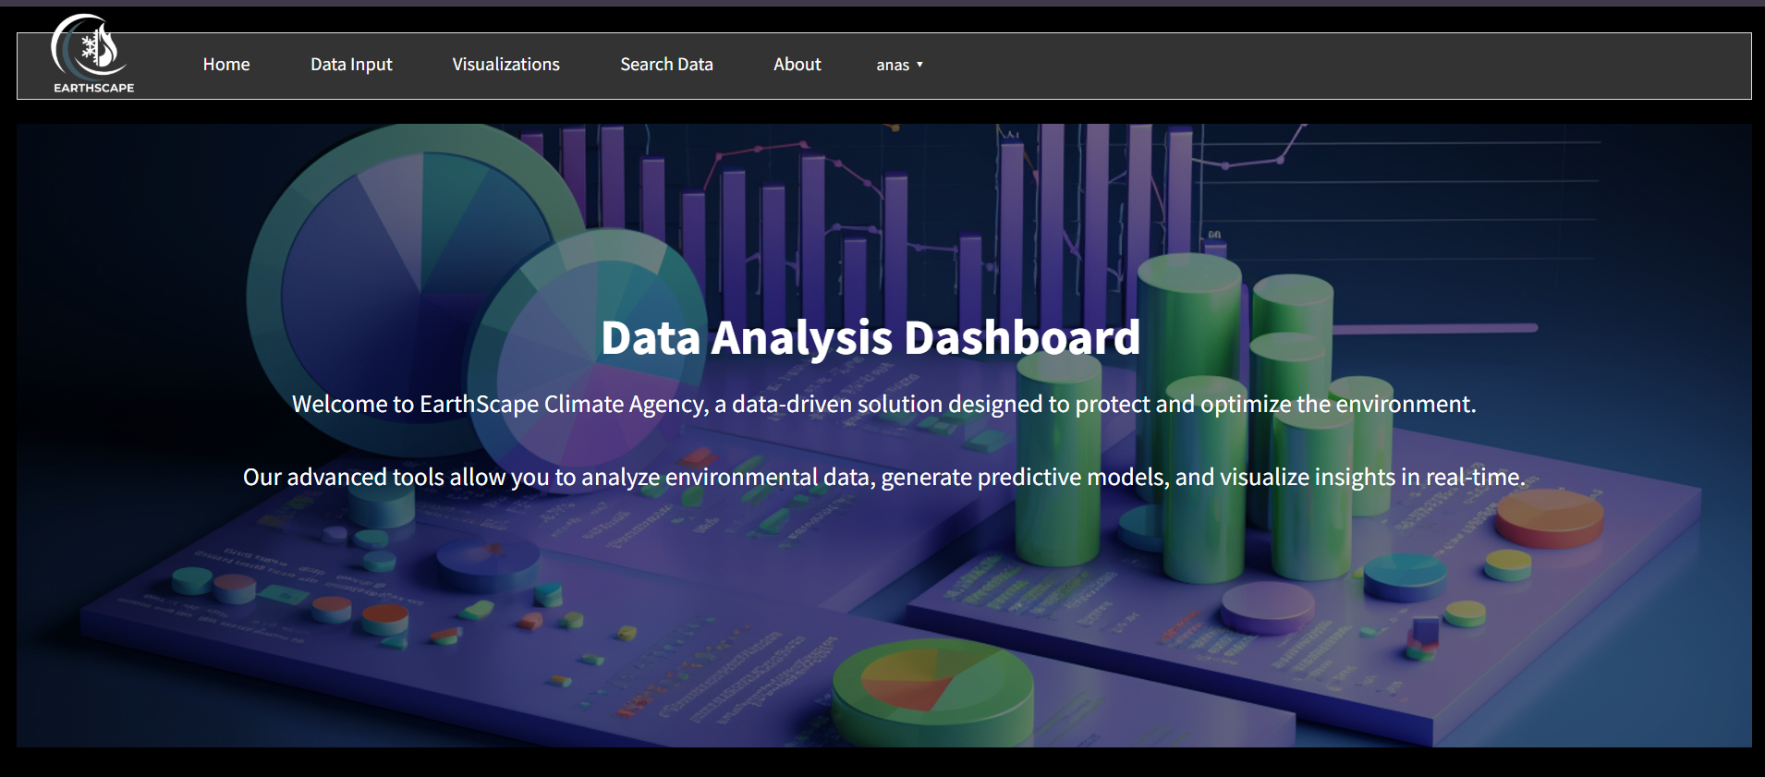

**EarthScape Futuristic Data Analysis Dashboard**

**1. Home Section**

The Home Section serves as the introductory gateway to the EarthScape platform. It welcomes users with an engaging overview, highlighting the mission of the dashboard: to provide a data-driven solution for environmental protection and optimization. The text emphasizes the dashboard's capability to analyse environmental data, generate predictive models, and visualize insights in real-time, making it a powerful tool for users looking to make informed decisions based on data.

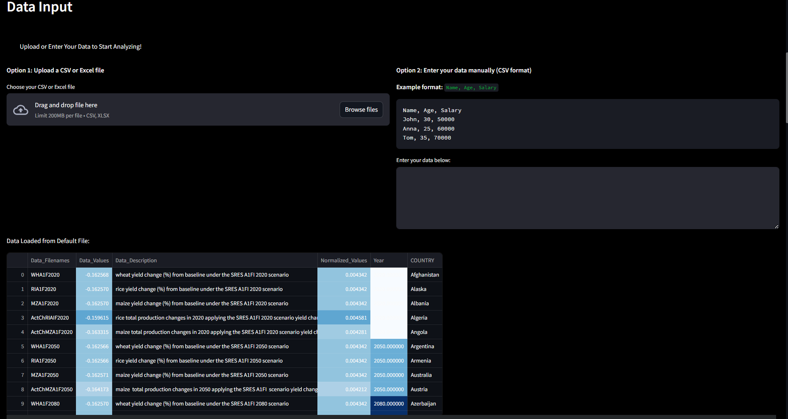

**2. Data Input Section**

In the Data Input Section, users are given two primary options for inputting their data:

* **File Upload:**

Users can easily upload their CSV or Excel files. Once uploaded, the application displays the data in a user-friendly table format, allowing for quick verification and initial analysis. This feature ensures that users can immediately begin analysing their data without cumbersome setup processes.

* **Manual Data Entry:**

For those who prefer to input data directly, this section includes a text area where users can enter data in a specified format (e.g., Name, Age, Salary). An example format is provided to guide users, making it accessible even for those who may not be familiar with data formats.

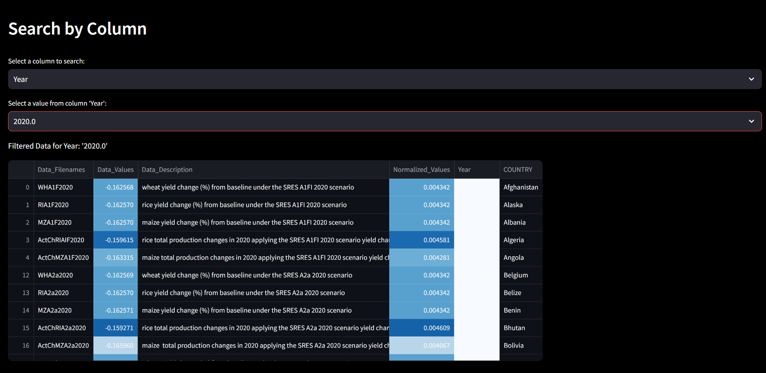

**3. Search Data Section**

The Search Data Section enables users to filter their data dynamically. This feature is particularly useful for analysing large datasets. Users can:

* **Select a Column:**

They choose from the available columns in their dataset, facilitating focused analysis based on specific attributes.

* **Select a Value:**

Once a column is selected, users can pick a specific value from that column to filter the dataset. The filtered results are displayed in a table, allowing users to hone in on specific data points of interest.

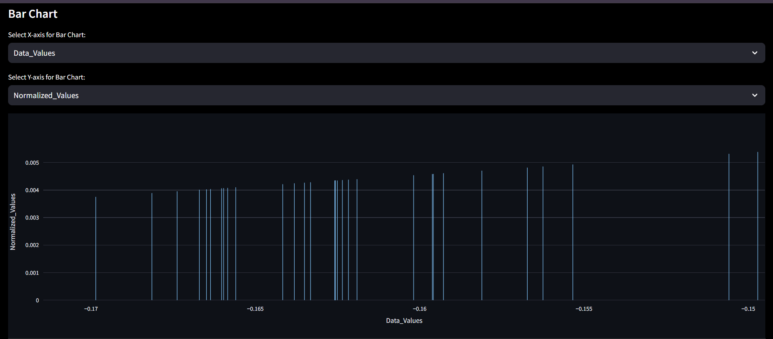

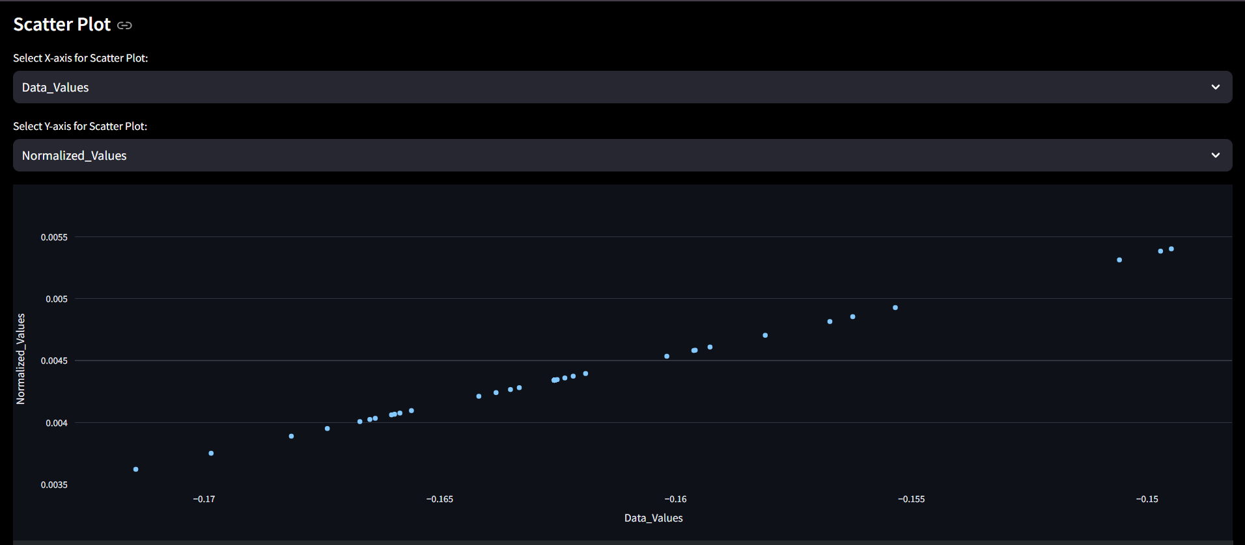

**4. Visualizations Section**

The Visualizations Section provides users with tools to create meaningful graphical representations of their filtered data. This section includes:

* **Pie Chart:**

Users can create pie charts from categorical data, helping visualize the distribution of different categories within their dataset.

* **Bar Chart:**

This feature allows users to select numeric columns for the x and y axes, providing a way to visualize relationships and comparisons between different data points.

* **Scatter Plot:**

Users can create scatter plots to explore correlations between two numeric variables, offering insights into trends and patterns in the data.

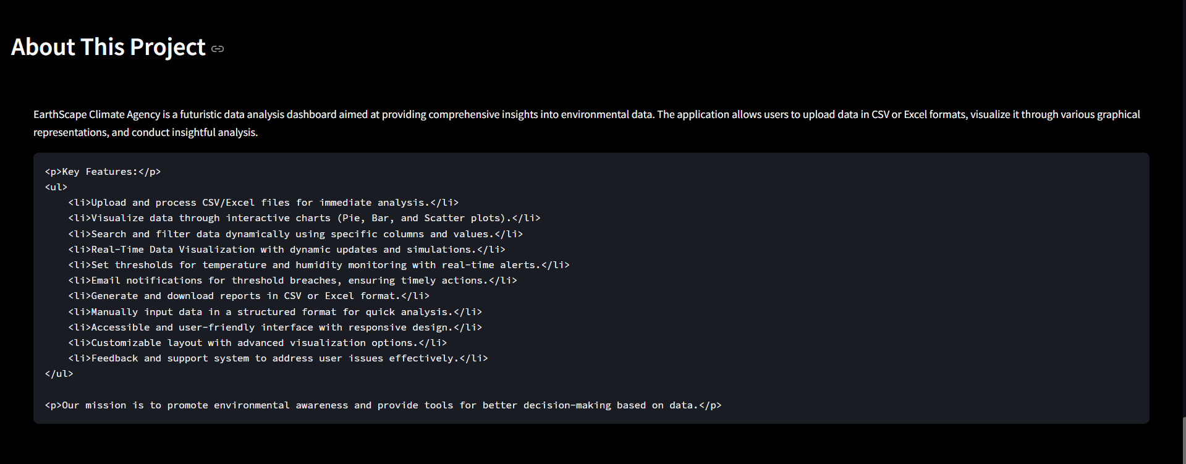

**5. About Section**

The About Section gives users an overview of the EarthScape project, outlining its objectives and significance. It includes:

* **Project Overview:**

A description of the dashboard’s purpose, focusing on its role in promoting environmental awareness and providing essential tools for data analysis.

* **List of Features:**

A summary of key functionalities, such as the ability to upload and process files, visualize data through interactive charts, and perform dynamic searches. This section highlights the user-friendly design and accessibility of the dashboard.

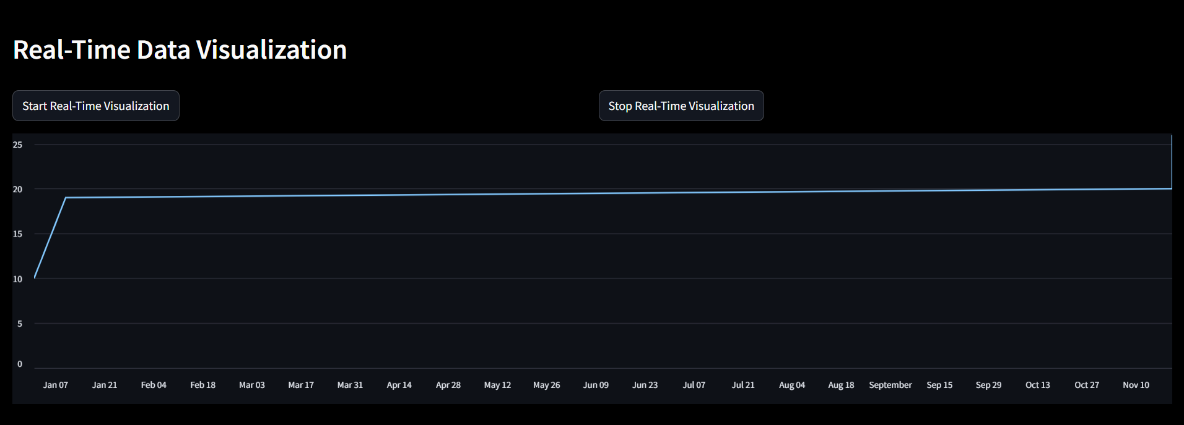

**Real-Time Data Visualization Dashboard**

The image provided represents a dashboard designed for real-time data visualization. This dashboard allows users to monitor and analyze data trends dynamically as they are updated in real-time. It provides an interactive interface for controlling the visualization process and a clean design to make data analysis intuitive and user-friendly. Below is a comprehensive explanation of its components, functionality, and significance.

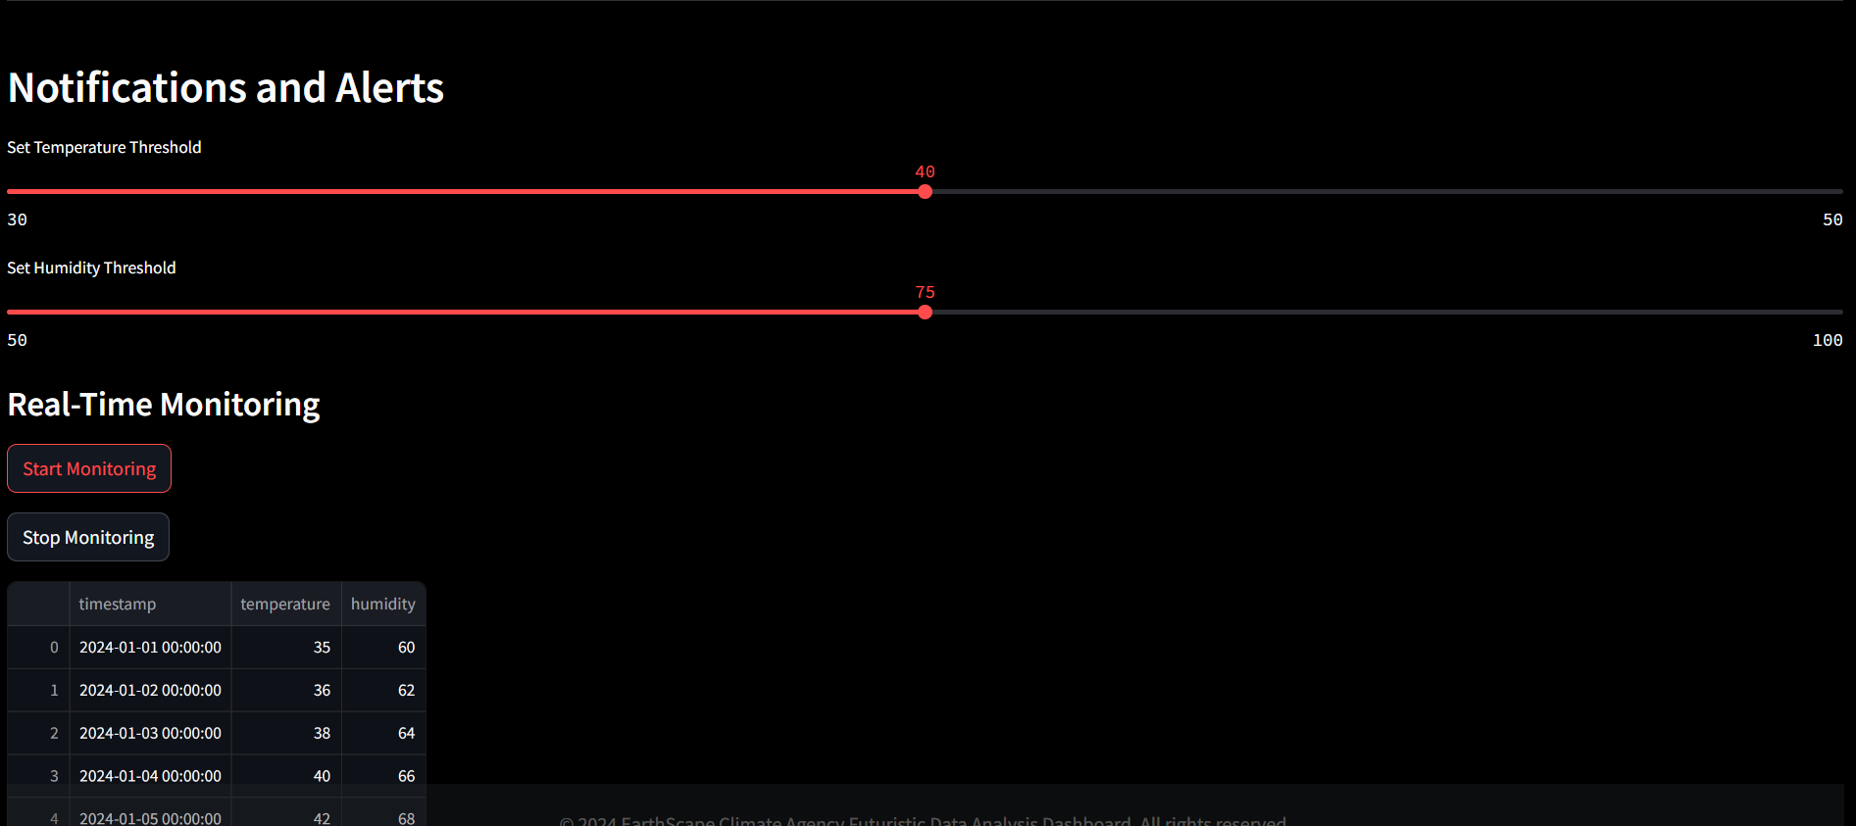

**Dashboard for Notifications and Alerts with Real-Time Monitoring**

The provided dashboard focuses on **real-time monitoring** and dynamic threshold-based notifications. It allows users to set specific thresholds for environmental factors like temperature and humidity while enabling real-time data updates and monitoring. Here's a detailed explanation of its structure, functionality, and significance.

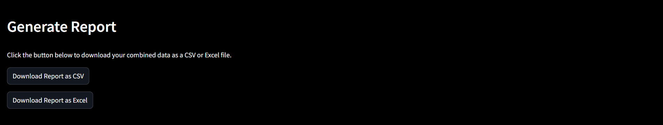

**Report Generation**

In the Generate Report section of the EarthScape Data Analysis Dashboard, users can easily download the filtered data they have processed. This feature allows for seamless exporting of data in both CSV and Excel formats, enhancing the usability of the application.

**Key Features:**

* **Download as CSV**:

Users can click the "Download Report as CSV" button to export the current filtered dataset in CSV format. This is particularly useful for those who prefer working with data in spreadsheet applications or for further analysis.

* **Download as Excel**:

Users have the option to download the data as an Excel file by clicking the "Download Report as Excel" button. This allows for better formatting and the ability to utilize Excel's advanced features.

**Usage:**

1. **Filtered Data Requirement**:

Before generating a report, users must first upload or enter their data and apply any desired filters. The report will be generated based on the currently displayed filtered dataset.

1. **Download Links**:

Once the user clicks on the respective download button, a link will be generated. Clicking this link will initiate the download of the report in the chosen format.

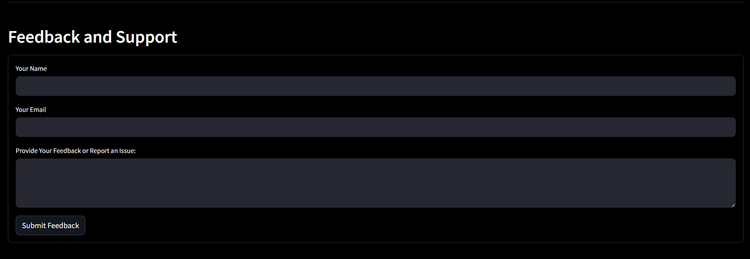

**Feedback and Support Dashboard**

The provided image showcases a **Feedback and Support** interface designed to collect user input for improving the system, addressing user concerns, and resolving issues. Below is a detailed description of the form and its functionalities:

**Compiled Code**

* **Eco Shield Climate Data Tracker**

The Eco Shield Climate Data Tracker is a powerful tool designed to help you monitor and analyze climate-related data for environmental insights and agricultural impact. With features such as generating detailed reports and exporting data, it provides users with a comprehensive view of climate trends and their influence on crop yields. Utilize the search functionality to find specific data sets or trends, making it easier to track patterns over time.

Each data entry offers detailed information, including country or region, crop type, year-wise production trends, climate factors (such as temperature, rainfall, CO2 levels), and other relevant notes. You can edit or delete entries as needed, ensuring your data remains accurate and up-to-date. The pagination feature allows you to seamlessly navigate through your stored data, whether you are reviewing trends from past years or current forecasts.

Whether you're an environmental researcher, agricultural expert, or policymaker, the Eco Shield Climate Data Tracker empowers you to make informed decisions for sustainable development and agricultural planning based on reliable data.



