On Google Chrome

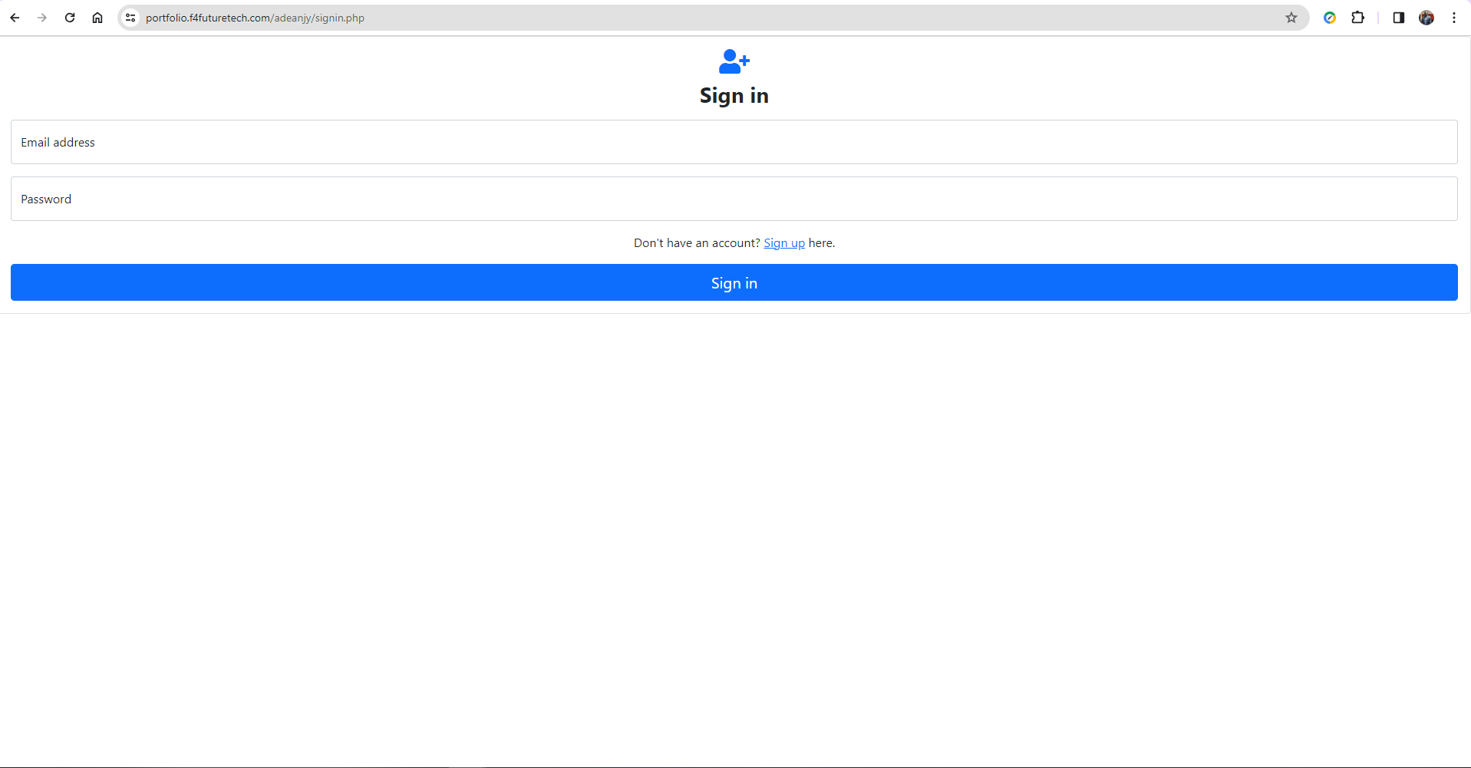

On Microsoft Edge and Mozilla Firefox

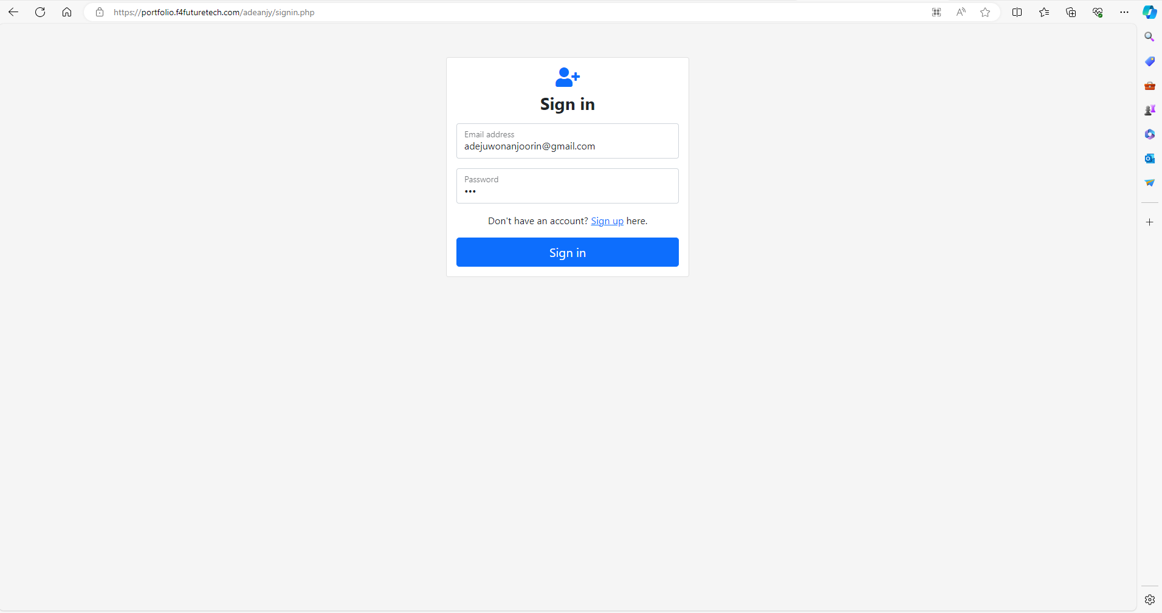

**End User Section Errors:**

1. When user does not attempt all questions, the app throws an error which says “Attempt all questions”. This is good. However, the app does not highlight the questions that were missed out on, so I had to look back and forth several times before I could find the questions that I missed. Please correct this, make the app highlight the missen questions.
2. The “My Assessments” button sticks to the top of the page, directly with the url bar, no space at all. Please make it sit at a reasonable level on the page.

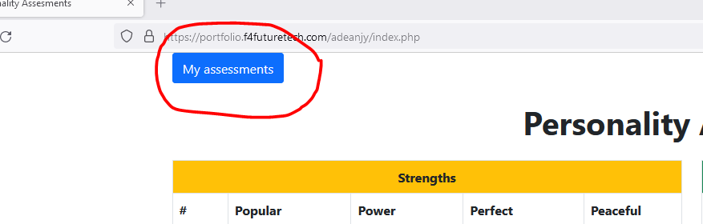

1. Please change the title of the result email from “Assessment Results” to “Your Personality Assessment Results”
2. In the body of the email, add the text above the results, and add a table to cover the results. It will look like this:

Hello “Username”,

Thank you for taking our personality assessment. Your results are here in the table below:

|  |  |  |
| --- | --- | --- |
| Strengths | Adventurous, Considerate, Respectful, Spontaneous, Orderly, Faithful, Cultured, Demonstrative, Thoughtful, Loyal, Chartmaker. | Score - 11 |
| Weaknesses | Undisciplined, Repetitious, Unpredictable, Headstrong, Workaholic, Doubtful, Mumbles, Rash, Critical | Score - 9 |

We will follow up with your with further comments, analysis, and recommendations.

Yours, Admin

(I only used red color here to highlight email text, it should be black in the actual email. “Username” should be the name entered by the user”

1. After the user clicks submits, a pop message should pop up and say:

Thank you, your assessment has been submitted successfully. We will get back to you shortly. You may sign out now.

Then there should be a Sign-Out button so the user can then sign out.

Admin Section Errors:

1. The Dashboard buttons are too large stretched out, they spread all across the screen, they should only be the size of the number inside them. Also, the current scores “54 users” and “34 assessments” are not correct. Please turn on counter to work accurately.

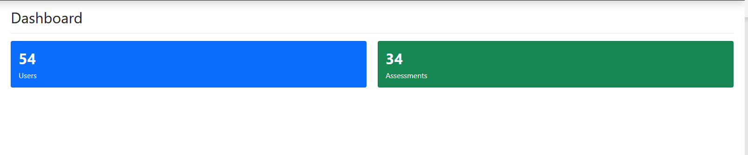

1. In the Users Page, please make it two separate sections. First section on top for Administrators, and second section below for Users. Again, this table is too stretched out. Please wrap it around the content, let it only expand based upon the content. The email column has so much unused space, the Assessments column has only one digit, yet the column stretches so wide, please do the right text padding or so to make the table fit with text. Also, let the lines of the columns show.

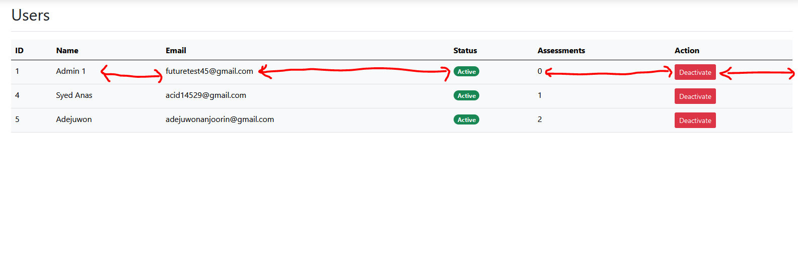

1. What is the difference between “Users” and “Allowed Users”? Table is too stretched out.

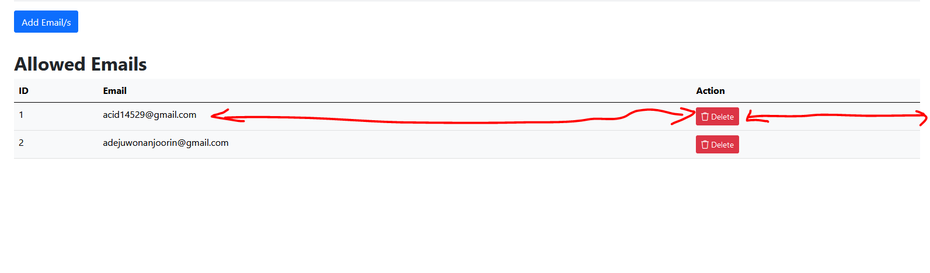

1. Change “Assessments” page, to “Completed Assessments”. Reduce size of columns to wrap around the text inside them.
2. At the log in page, make First Name text box, and Last Name Box Mandatory, so that users have to enter both names for proper identification.