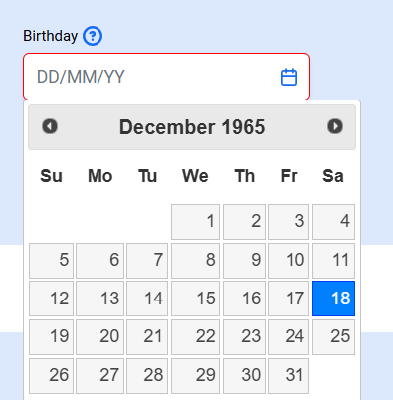

Mask is wrong, it still says DD/MM/YY. But the logic is correct, when I enter it as per the mask it gives me an error.

=====================================================

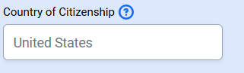

Default mask should be “Mexico.”

====================================================

After I selected Gender error message still persists

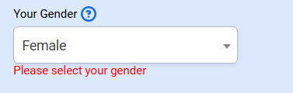

This field is not required

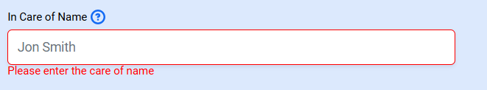

These fields are not required either

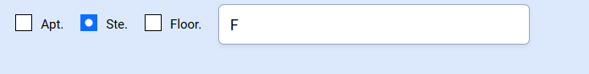

Move on the same line US Address Line 2, but everything will shift down and align, Zip, City, State should be on the same line, and The Name of Your Emergency Contact and Emergency phone # contact should be next to one another, on the desktop on the same line.

=====================================================

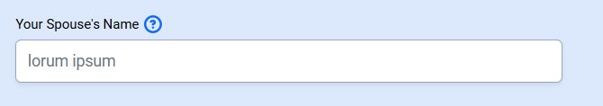

Change this mask to Maria Gonzalez

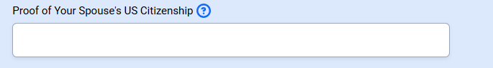

Needs to be a pulldown with these 3 options:

1. US birth certificate
2. US Passport
3. US Naturalization Certificate

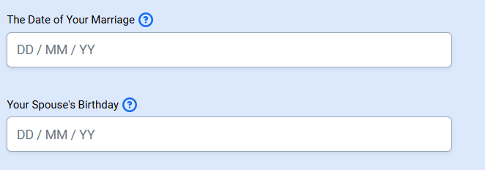

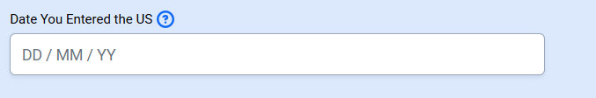

Reminder, ALL date fields’ masks need to be MM/DD/YY

=====================================================

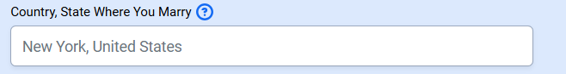

Are the labels data driven? I should be able to change this one to “, State, Country of Marriage Certificate”, yes?

=====================================================

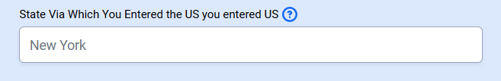

All US State field should have a pulldown option, see data list below.

1. Alabama
2. Alaska
3. Arizona
4. Arkansas
5. California
6. Colorado
7. Connecticut
8. Delaware
9. Florida
10. Georgia
11. Hawaii
12. Idaho
13. Illinois
14. Indiana
15. Iowa
16. Kansas
17. Kentucky
18. Louisiana
19. Maine
20. Maryland
21. Massachusetts
22. Michigan
23. Minnesota
24. Mississippi
25. Missouri
26. Montana
27. Nebraska
28. Nevada
29. New Hampshire
30. New Jersey
31. New Mexico
32. New York
33. North Carolina
34. North Dakota
35. Ohio
36. Oklahoma
37. Oregon
38. Pennsylvania
39. Rhode Island
40. South Carolina
41. South Dakota
42. Tennessee
43. Texas
44. Utah
45. Vermont
46. Virginia
47. Washington
48. West Virginia
49. Wisconsin
50. Wyoming
51. American Samoa
52. Guam
53. Northern Mariana Islands
54. Puerto Rico
55. U.S. Virgin Islands



Anash, can I just go to the database and change these labels?

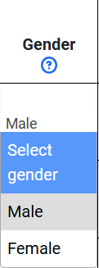

The dropdown only needs the selection, no heading are necessary in any of the dropdowns, just the options.

Law Enforcement Section has two encounters

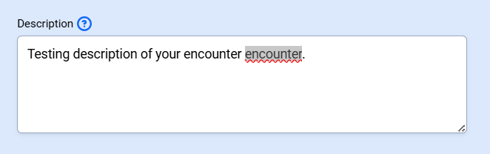

================================

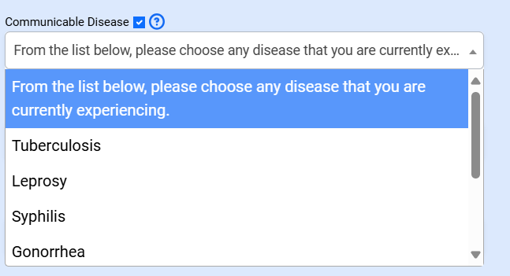

Delete “From the list below, …” For all dropdowns, only show the selections.

==================================================

Content of dropdown for “Are You Missing An US Required Vaccines” see list below:

1. **Measles**
2. **Mumps**
3. **Rubella**
4. **Polio**
5. **Tetanus and Diphtheria Toxoids**
6. **Pertussis**
7. **Haemophilus Influenzae Type B (Hib)**
8. **Hepatitis A**
9. **Hepatitis B**
10. **Rotavirus**
11. **Meningococcal Disease**
12. **Varicella (Chickenpox)**
13. **Pneumococcal Disease**
14. **Seasonal Influenza (Flu)**

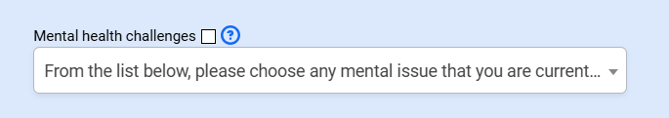Dropdown content to Mental Disorders

1. Schizophrenia

2. Bipolar Disorder

3. Major Depressive Disorder with Psychotic Features

4. Antisocial Personality Disorder

5. Substance Use Disorders

6. Psychotic Disorders

=========================================================================

