**FUNCTIONAL SPECIFICATIONS**

**03/01/2025**

**Version 0.0.1**

| VERSION HISTORY | | | | |
| --- | --- | --- | --- | --- |
| VERSION | APPROVED BY | REVISION DATE | CHANGE DESCRIPTION | AUTHOR |
| 0.0.01 |  | 03/01/2025 | First version | Castle |
|  |  |  |  |  |
|  |  |  |  |  |
|  |  |  |  |  |
|  |  |  |  |  |

# INTRODUCTION

This document describes the functionality required for the development of the bank reconciliation process, using records already stored in the database.

# OVERVIEW

1. **FUNCTIONALITY**
   1. **Tables Used:** The tables that will be used in the process are the following:

|  |  |  |
| --- | --- | --- |
| Table Number | Description | Number of fields |
| Cont_extracto | This table contains the records that were stored from the MT940 files of bank statements, which has the movements of the accounts, this table will be provided with example data | 13 |
| Librodiario | This table contains the records of internal movements in the general ledger accounts, this table will already be provided with example data | 8 |
| Cont_catalogocuentas | Contains the list of accounts to be displayed in the "account" combobox | 3 |

* 1. **Design Required:** it is required to create a screen that contains the base design shown in image 1 below

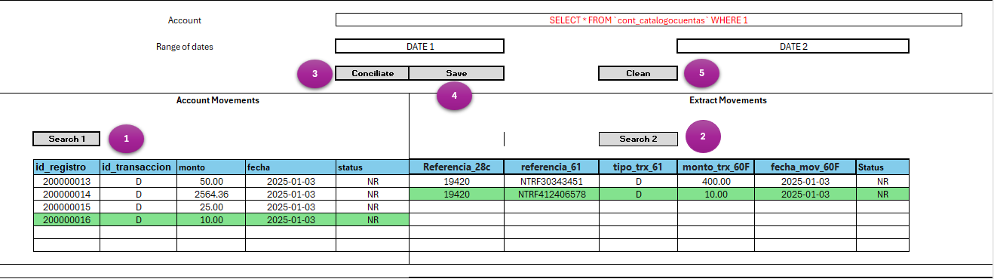

Illustration 1 Design suggested of screen, the records that match are marked in green

* 1. **Form/Display Field Description**

**Board 1 Search Fields**

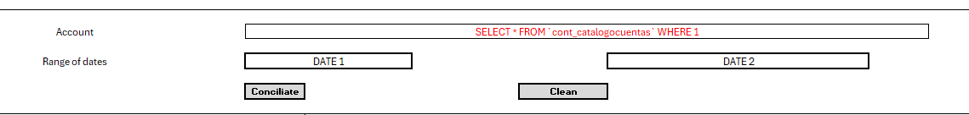

|  |  |  |  |  |
| --- | --- | --- | --- | --- |
| Field | Description | Guy | Origin | Example |
| Account | List of Accounts | ComboBox | SELECT * FROM `cont_catalogocuentas` WHERE 1 | 742398331 |
| Range of dates – date 1 | Start date of the search range | Select/Combo Box date | Calendar | 2025-01-03 |
| Range of dates – date 2 | Search Range End Date | Select/Combo Box date | Calendar | 2025-01-31 |
| Conciliate | This button executes the reconciliation process described below | Button | - | - |
| Clean | This button cleans up the previous search, leaving the entire screen in the initial state | Button | - | - |

* **Boton “Conciliate”:**

1. When you run the reconcile process, you must compare the records in both tables, the equivalent fields and the ones to be compared are, both records must have the status = "NR"
2. If matches are found, the cells of both tables must be marked with another color
3. Use Bootstrap's "progress bar" control to display the click of this button, with a default minimum delay of 3 seconds.

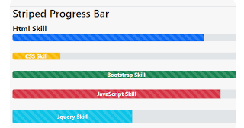

Illustration 2 Bootstrap progress bar control

Board 2 Equivalence to compare both tables in the reconciliation process

|  |  |
| --- | --- |
| "Journalbook" Table Field | Table field "cont_extracto" |
| Id_transaccion | Tipo_trx_61 |
| Amount | Monto_trx_60F |
| Date | fecha_mov_60F |

* **Boton “Save”:**

1. When you run this button, you should update the status of the records that matched to status="R".
2. The information of each table and the colors must remain after clicking on the Save button
3. A message must be displayed to the user on the screen, about the result of the update process, whether it is successful or not.

**Board 3 Fields for Output No.1 Account Movements**

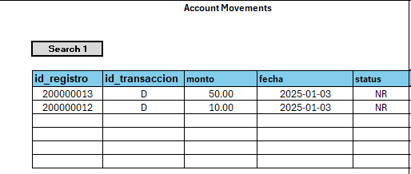

| Field | Description | Data Type | Origin | Example |
| --- | --- | --- | --- | --- |
| Id_registro | Record ID in the table | Whole | Field that comes from the table "journal" field **id_registro** | 200000013 |
| Id_transaccion | Type of transaction, can be D=Debit or C=Credit | Text | Field that comes from the table "journal" field **Id_transaccion** | D |
| Amount | Transaction Amount | Decimal | Field that comes from the "journalbook" table amount field | 40,0 |
| Date | Date of transaction | Date | Field that comes from the "journal" table Date field | 2025-01-03 |
| Status | Record status, can be **"NR"** or **"R",** NR = Not Reconciled R = Reconciled | Text | Field that comes from the "journalbook" table **status field** | NR |

* **"Search 1" button:** this button should search the "journal" table, filtering by the fields selected in the initial filters, the status of the record in the table should be status = NR:

|  |  |
| --- | --- |
| Search filter field | Field of the "journal" table |
| Account | Count |
| Date 1 and Date 2 | date |
|  | Status=NR |

**The query required to fill table 1 is the following:** *SELECT id_registro,id_transaccion,monto,fecha,status FROM `librodiario` WHERE cvecuenta = 'Account selected' and fecha BETWEEN 'date 1' and 'date 2' AND status = 'NR'*

**Board 4 Fields for Output No.2 Extract Movements**

Board

Auto-generated description

* **"Search 2" button:** this button should search the "cont_extracto" table, filtering by the fields selected in the initial filters, the status of the record in the table should be status = NR.

|  |  |
| --- | --- |
| Search filter field | Table field "cont_extracto" |
| Account | **Cta_banco_25** |
| Date 1 and Date 2 | **fecha_mov_60F** |
|  | Status=NR |

**The query required to fill table 2 is the following:** *SELECT `Referencia_28c`,`fecha_mov_60F`, `referencia_61`, `monto_trx_60F`, `tipo_trx_61`,`status` FROM `cont_extracto` WHERE* ***Cta_banco_25*** *= 'Account selected' and fecha_mov_60F BETWEEN 'date 1' and 'date 2' AND status = 'NR'*

| Field | Description | Data Type | Origin | Example |
| --- | --- | --- | --- | --- |
| Referencia_28c | Extract reference number | Text | Field that comes from the table "cont_extracto" field **referencia_28c** | 19420 |
| Referencia_61 | Transaction Reference | Text | Field that comes from the "cont_extracto" table field **referencia_61** | NTRF30343451 |
| Tipo_trx_61 | Type of Movement Debit or Credit | Text | Field that comes from the "cont_extracto" table field **tipo_trx_61** | D |
| Monto_trx_60F | Transaction Amount | Decimal | Field that comes from the "cont_extracto" table, field **monto_trx_60F** | 400,0 |
| fecha_mov_60F | Date of transaction | Date | Field that comes from the "cont_extracto" table field **fecha_mov_60F** | 2025-01-03 |
| Status | Record status, can be **"NR"** or **"R",** NR = Not Reconciled R = Reconciled | Text | Field that comes from the "cont_extracto" table **status field** | NR |

1. **CONSIDERATIONS**

* When you click on the "RECONCILE" button, the "Search 1" and "Search 2" buttons must be disabled.
* When you click on the "SAVE" button, all buttons except "Clean" should be disabled.
* For this development, the structure and content of the tables will be provided.
* Ajax or Bootstrap 5.0 minimum must be used
* Use Jquery or ajax

1. **Script**

