**Requirements**

**INBOX.HTML**

* Front-end
* 1:1 real time chat. The logged in user can only DM Northeast Xpress Inc. which will be accessible to the owner of the business. This includes timestamps and message history. No ‘read’ functionality needed.   
  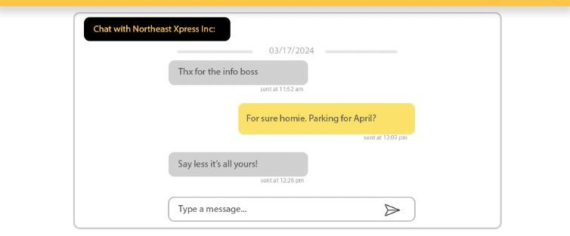

**PROFILE.HTML**

* Store user information and allow for updating the database when the user edits it.

**VEHICLE.HTML**

* Add vehicle information based from the submitted forms to the database, and allow removing entries.
* Anytime a vehicle is added, send an automatic DM from the logged in user to Northeast Xpress Inc. with a request to get a spot for that vehicle in the parking lot (will provide the message format).
* Fix Truck form sends a DM to Northeast Xpress Inc from the user.

**SIGNUP.HTML**

* Store information in the database to allow users to sign up.

**LOGIN.HTML**

* Retrieve information from the database to allow users to log in.

**INDEX.HTML**

* Contact form at the bottom of this page should send emails to [dryvan@live.com](mailto:dryvan@live.com) when submitted.

**Add security measures if possible.**