Lab 2 Solution
Objectives/Tested Concepts
- Device Powering + Connecting Interfaces (Cabling)
- VLAN Access Port Configuration
- VLAN Trunk Configuration
- Switch Configuration
  - Hostname
  - Secret Password
  - Banner MOTD
  - Console + VTY Line Settings
    - Exec Timeout
    - Login / Login Local
    - Accepting SSH vs. Telnet Connections
    - ACL Configuration for Inbound Connections
  - SSHv2 Configuration
    - Username + Password
    - Cryptographic Key Generation
    - Management IP + Default Gateway
  - Descriptions
- Inter-VLAN Routing via ROAS
  - Configuring Sub-interfaces
- Subnetting Networks with the /24, /26, /27, /29, and /30 Masks
- Determining and Configuring IP Addressing / Subnets / Default Gateways
- OSPF Configuration
  - Hello / Dead Timers
  - Passive Interfaces
  - Router ID
  - Propagate Default Route
- Standard / Default / Floating Static Route Configuration Using Next Hop / Link
- Configuring and Applying Static NAT / Dynamic NAT / PAT (NAT Overload)
  - 1 to 1 Mapping
  - Standard ACL + NAT Pool Creation
  - Applying ACL and/or NAT Pool on an Interface
- Named + Numbered Extended ACL Configuration
The Lab
Power Devices
Switches are powered on by default, so only examine the PCs, servers, and routers. Click the red button or on/off switch to power them on.
For PCs, a powered on device should look like this with a green bar:
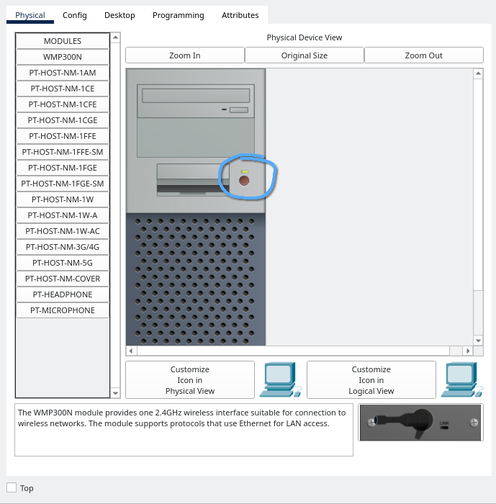
The same goes with servers:
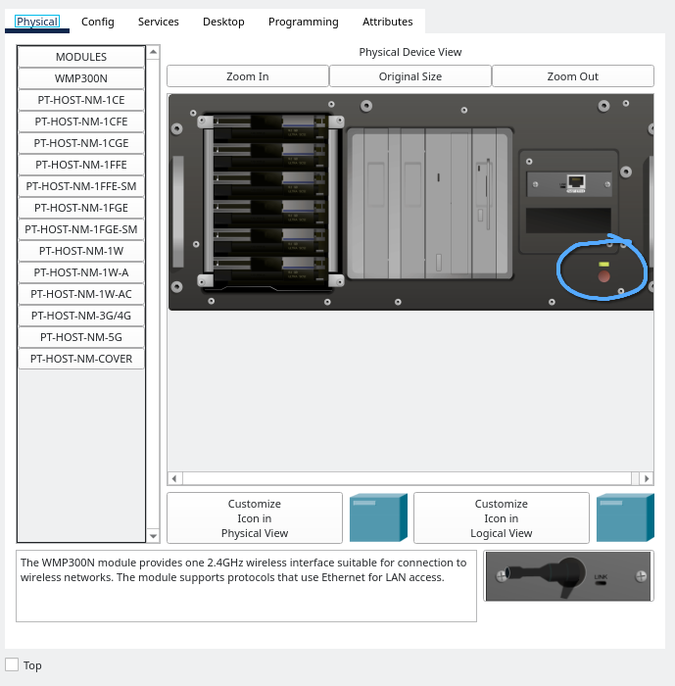

The routers have an on/off switch for toggling power. A powered on router should look like this with a green bar:
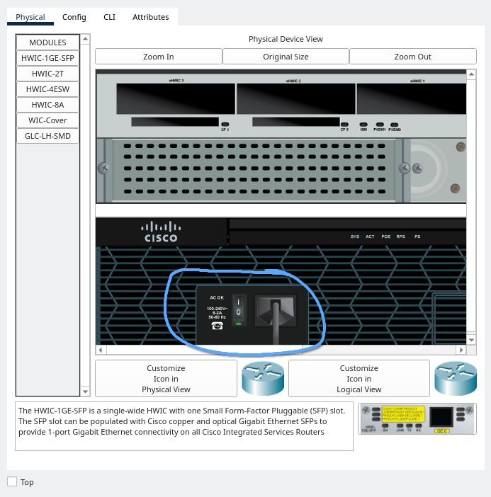
* I pressed the “Zoom In” button at the top because the default zoom makes it a bit difficult to see whether the router is on or not

As you go through each device, you should see that Server 2, Worker 1, Worker 2, Boss PC, R1, R3, Edge Router, and Diamond Bar Router are powered off. Make sure to turn these on first.
Part 1: Connect All of the Devices in the Internal Network
Use either the copper straight-through or copper cross-over wires to connect all of the devices as listed in the internal network (aqua/cyan zone). You can find the cabling on the bottom left of Packet Tracer by clicking on the orange lightning bolt and hovering over each wire.
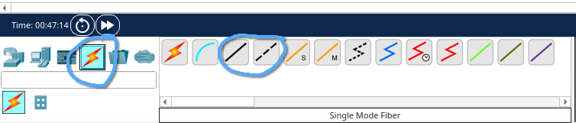
End devices (hosts) like PCs and servers only have one interface, which is FastEthernet0, so connect to that interface when connecting hosts to the switches.

Typically, “Fa” means “FastEthernet” while “G”, “Gi”, “Gig”, “GbE”, or “GigE” means “GigabitEthernet”. I use “Fa” and “G” usually.

In the router section, when it says “The G0/2 interfaces of R1 and R2 connect to each other”, it means to connect G0/2 on R1 to G0/2 on R2. Also, when it says “The G0/0 of R1-3 will connect to the MLS's G1/0/router#”, it means to connect G0/0 on R1 to G1/0/1 on the MLS, G0/0 on R2 to G1/0/2 on the MLS, and G0/0 on R3 to G1/0/3 on the MLS. This type of instruction will show up later, and this is so that you get used to more generic/variable instructions which may show up in competition rounds or in real life for the sake of organization.
Part 2: Assign IP Addressing for End Hosts in the Internal Network
This should be pretty self explanatory if you’ve assigned IP addressing on host devices before and are familiar with CIDR notation for subnetting. Default gateways will be assigned later.

If you’re not aware with subnetting or CIDR (/) notation, I strongly recommend that you learn it because it is an extremely important fundamental concept in networking. It will take some time.

If you’re not aware how to assign IP addressing to devices, press the device, click “Desktop” on the top bar, and then click “IP Configuration”, then click “Static” under “IP Configuration”:
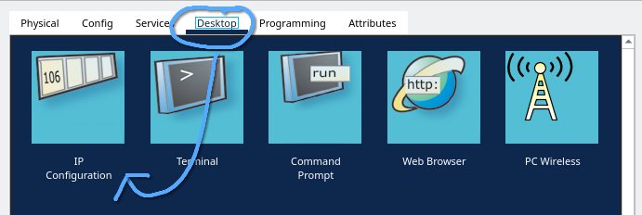
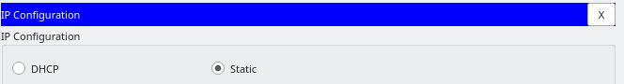
Note that the subnet mask must be filled in dotted-decimal notation instead of CIDR for IPv4 addresses.

Once again, there are three generic instructions.
1. “Servers: Use 10.0.3.x00/24 where x is the number of the server”
This means that Server 1 will use 10.0.3.100/24 and Server 2 will use 10.0.3.200/24.

2. “Money Manager: Use the second available host address in 10.0.12.0/26”
The network address is 10.0.12.0, so 10.0.12.1 is the first available host address and 10.0.12.2 is the second available host address, which is what the Money Manager will use for its IP address. Make sure you use 255.255.255.192 for the subnet mask since the network uses a /26 subnet mask instead of /24.

3. “Workers: Use 10.0.12.10x/26 where x is the number of the worker”
Same thing with the servers. This means Worker 1 will use 10.0.12.101/26 and Worker 2 will use 10.0.12.102/26. Again, make sure the subnet mask you use for both devices is 255.255.255.192.
Part 3: Assign IP Addressing and Hostnames for Routers in the Internal Network

