**COAL ASSIGNMENT 3**

**23k-0575 BCS-3D**

Questions:  
Question 1.

Write a recursive procedure in x86 assembly language that divides a number by another number and stops when dividend is less than or equal to 5h. Consider dividend = D4A4h and divisor = Ah. The Intel IA 32version of this program is required.

Questions 2

Write a recursive procedure to find a value in a large integer array. Ask the user to enter an integer value in the main program. You should pass user supplied value as parameter to the recursive function using the INVOKE directive. Also, draw labeled diagrams to show stack values at each iteration of this recursive

function.

Question 3

Write an assembly language program to copy the characters of a string to a target string. The characters are stored in such a way that only a single instance of any character in the string is stored. Initialize a source string to: &quot;This is the source string&quot;.

Question 4

Write an assembly language program to read a string of characters from the user and prints/store the vowel count. For each vowel, the count includes both uppercase and lowercase letters.

Question 5

Write a procedure named DifferentInputs that returns EAX = 1 if the values of its three input parameters are all different; otherwise, return with EAX = 0. Use the PROC directive with a parameter list when declaring the procedure. Create a PROTO declaration for your procedure, and call it five times from a test program that passes different inputs.

Question 6

Create a variant of the Str_trim procedure that lets the caller remove all instances of a leading character from a string. For example, if you were to call it with a pointer to the string “###ABC” and pass it the # character, the resulting string would be “ABC”.

**Q1**

Code:

INCLUDE Irvine32.inc

.data

.code

main PROC

mov eax , 0D4A4h

mov edx , 0

call Divide

call Writehex

exit

Divide PROC

cmp eax , 5h

jle done

mov ecx , 0Ah

div ecx

call Divide

done:

ret

Divide ENDP

main ENDP

END main



**Q2**

INCLUDE Irvine32.inc

.data

str1 BYTE "Enter the integer value: " , 0

arr DWORD 12 , 13 , 14 , 20 , 21 , 22, 25 , 26 ; arr to be searched for

value DWORD ?

size1 DWORD ?

str2 BYTE "Value found" , 0

str3 BYTE "Value not found" , 0

.code

findvalue PROTO Searchvalue:DWORD , pArray: PTR DWORD , size1:DWORD

main PROC

mov edx , offset str1

call Writestring

call Readint

mov value , eax

mov size1 , LENGTHOF arr

INVOKE findvalue , value , ADDR arr , size1

exit

main ENDP

findvalue PROC,

Searchvalue:DWORD , pArray:PTR DWORD , size2:DWORD ; func recieves the value and the address of the array

push ebp

mov ebp, esp

cmp size2 , 0

je not_found

mov eax , [pArray]

cmp Searchvalue , eax

je found

add pArray , 4

sub size2 , 1

INVOKE findvalue , Searchvalue , pArray , size2

jmp end_proc

not_found:

mov edx , offset str3

call Writestring

;ret

jmp end_proc

found:

mov edx , offset str2

call Writestring

;ret

end_proc:

pop ebp

ret

findvalue ENDP

END main

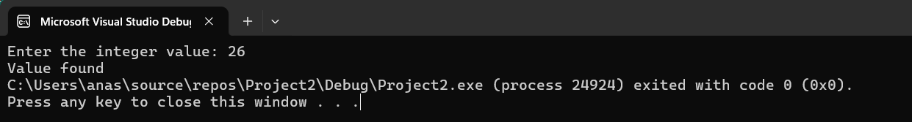

**Q3**

INCLUDE Irvine32.inc

.data

str1 BYTE "This is the source string" , 0

target BYTE 40 DUP(?)

.code

Str_length PROTO ,

pString:PTR BYTE

Str_copy PROTO ,

source : PTR BYTE ,

target : PTR BYTE

main PROC

INVOKE Str_copy , ADDR str1 , ADDR target

;print the original string

mov edx , offset str1

call Writestring

call crlf

;print the copied string

mov edx , offset target

call Writestring

call crlf

exit

main ENDP

Str_length PROC USES edi,

pString:PTR BYTE ; pointer to string

mov edi,pString

mov eax,0 ; character count

L1:

cmp byte ptr [edi],0 ; end of string?

je L2 ; yes: quit

inc edi ; no: point to next

inc eax ; add 1 to count

jmp L1

L2:

ret

Str_length ENDP

Str_copy PROC ,

source:PTR BYTE,

target1:PTR BYTE

INVOKE Str_length , source

mov ecx , eax ; move the length into ecx

inc ecx ; add 1 for the null byte

mov esi , source

mov edi , target1

cld

rep movsb ; copy the string

ret

Str_copy ENDP

END main

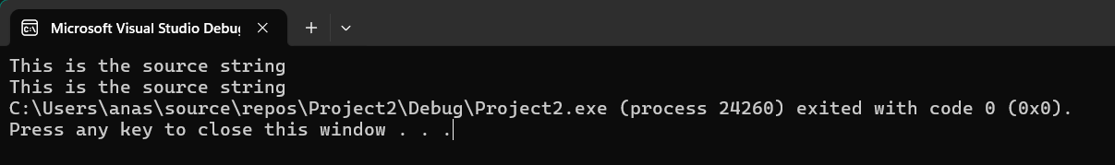

**Q4**

INCLUDE Irvine32.inc

.data

Sentence BYTE "Advanced Programming in UNIX Environment" , 0

countA DWORD ?

countE DWORD ?

countI DWORD ?

countO DWORD ?

countU DWORD ?

str1 BYTE "a or A = " , 0

str2 BYTE "e or E = " , 0

str3 BYTE "i or I = " , 0

str4 BYTE "o or O = " , 0

str5 BYTE "u or U = " , 0

.code

main PROC

mov eax , 0

mov countA , 0

mov countE , 0

mov countI , 0

mov countO , 0

mov countU , 0

mov edi , offset Sentence

mov al , 'A'

mov ecx , LENGTHOF Sentence

cld ; direction = forward

L1:

SCASB

jz foundA

loop L1

jmp for_a

foundA:

add countA , 1 ;

loop L1

;for 'a'

for_a:

mov edi , offset Sentence

mov al , 'a'

mov ecx , LENGTHOF Sentence

cld ; direction = forward

L2:

SCASB

jz found_a

loop L2

jmp forE

found_a:

add countA , 1 ;

loop L2

;Now for E or e

forE:

mov edi , offset Sentence

mov al , 'E'

mov ecx , LENGTHOF Sentence

cld ; direction = forward

L3:

SCASB

jz found_E

loop L3

jmp for_e

found_E:

add countE , 1 ;

loop L3

for_e:

mov edi , offset Sentence

mov al , 'e'

mov ecx , LENGTHOF Sentence

cld ; direction = forward

L4:

SCASB

jz founde

loop L4

jmp forI ;

founde:

add countE , 1 ;

loop L4

;NOW FOR I or i

forI:

mov edi , offset Sentence

mov al , 'I'

mov ecx , LENGTHOF Sentence

cld ; direction = forward

L5:

SCASB

jz foundI

loop L5

jmp for_i ;

foundI:

add countI , 1 ;

loop L5

for_i:

mov edi , offset Sentence

mov al , 'i'

mov ecx , LENGTHOF Sentence

cld ; direction = forward

L6:

SCASB

jz found_i

loop L6

jmp forO

found_i:

add countI , 1 ;

loop L6

;NOW FOR O or o

forO:

mov edi , offset Sentence

mov al , 'O'

mov ecx , LENGTHOF Sentence

cld ; direction = forward

L7:

SCASB

jz foundO

loop L7

jmp for_o ;

foundO:

add countO , 1 ;

loop L7

for_o:

mov edi , offset Sentence

mov al , 'o'

mov ecx , LENGTHOF Sentence

cld ; direction = forward

L8:

SCASB

jz found_o

loop L8

jmp forU ;

found_o:

add countO , 1 ;

loop L8

;NOW FOR U or u

forU:

mov edi , offset Sentence

mov al , 'U'

mov ecx , LENGTHOF Sentence

cld ; direction = forward

L9:

SCASB

jz foundU

loop L9

jmp for_u ;

foundU:

add countU , 1 ;

loop L9

for_u:

mov edi , offset Sentence

mov al , 'u'

mov ecx , LENGTHOF Sentence

cld ; direction = forward

L10:

SCASB

jz found_u

loop L10

jmp done ; as the sentence ends , jump to done to print results

found_u:

add countU , 1 ;

loop L10

;printing all counts

done:

mov edx , offset str1

call Writestring

mov eax , countA

call Writeint

call crlf

mov edx , offset str2

call Writestring

mov eax , countE

call Writeint

call crlf

mov edx , offset str3

call Writestring

mov eax , countI

call Writeint

call crlf

mov edx , offset str4

call Writestring

mov eax , countO

call Writeint

call crlf

mov edx , offset str5

call Writestring

mov eax , countU

call Writeint

call crlf

exit

main ENDP

END main

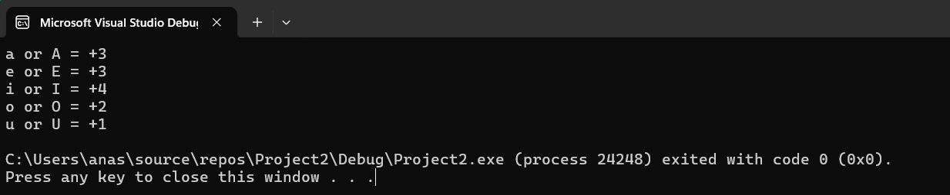

**Q5**

INCLUDE Irvine32.inc

.data

.code

DifferentInputs PROTO value1:DWORD , value2:DWORD , value3:DWORD

main PROC

mov eax , 0

mov ebx , 0

mov ecx , 0

INVOKE DifferentInputs , 3 , 3 , 3

call Writeint

call crlf

INVOKE DifferentInputs , 3 , 2 , 3

call Writeint

call crlf

INVOKE DifferentInputs , 1 , 1 , 1

call Writeint

call crlf

INVOKE DifferentInputs , 12 , 0 , 2

call Writeint

call crlf

INVOKE DifferentInputs , 4 , 3 , 5

call Writeint

exit

main ENDP

DifferentInputs PROC ,

value1:DWORD , value2:DWORD , value3:DWORD

mov eax , value1

mov ebx , value2

mov ecx , value3

cmp eax , ebx

jne check2

mov eax , 0

jmp quit

check2:

cmp eax , ecx

jne notequal

mov eax , 0

jmp quit

notequal:

mov eax , 1

quit:

ret

DifferentInputs ENDP

END main

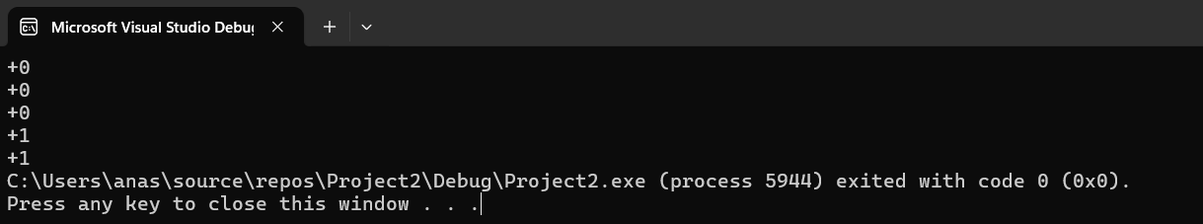

**Q6**

INCLUDE Irvine32.inc

.data

myString BYTE "###ABC",0

.code

main PROC

;original string

mov edx , offset myString

call Writestring

INVOKE Str_trim, ADDR myString, '#'

;after trimming

Mov edx , offset myString

Call Writestring

exit

main ENDP

Str_length PROC USES edi,

pString:PTR BYTE ; pointer to string

mov edi,pString

mov eax,0 ; character count

L1:

cmp byte ptr [edi],0 ; end of string?

je L2 ; yes: quit

inc edi ; no: point to next

inc eax ; add 1 to count

jmp L1

L2:

ret

Str_length ENDP

Str_trim PROC ,

pString:PTR BYTE, char1:BYTE

mov edi,pString

INVOKE Str_length,edi

;mov eax , value1 ; returns length in EAX

cmp eax,0 ; zero-length string?

je L2 ; yes: exit

mov ecx,eax ; no: counter = string length

dec eax

add edi,eax ; EDI points to last char

mov al,char1 ; char to trim

std ; direction = reverse

repe scasb ; skip past trim character

jne L1 ; removed first character?

dec edi ; adjust EDI: ZF=1 && ECX=0

L1:

mov BYTE PTR [edi+2],0 ; insert null byte

L2:

ret

Str_trim ENDP

END main

