**COAL LAB 4**

Questions:

1. What errors are present in the following?

• MOV AX 3d

• MOV 23, AX

• MOV CX, CH

• MOVE AX, 1h

• ADD 2, CX

• ADD 3, 6

• INC AX, 2

2. Store the ASCII codes for starting three letters of your name in a register.

3. Use following array declarations:

varB BYTE +10

varW WORD -150

varD DWORD 600

Now move every element to EAX,EBX and ECX.

6. Write a program which declares a symbolic constant named SecondsInDay using the equal-sign

directive and assign it an arithmetic expression that calculates the number of seconds in a 24-

hour period.

7. Let A = 0FF10 h and B = 0E10B h, you need to write an assembly language code to swap the

contents.

8. Use this data for the following questions:

i. Write an instruction that increments val2.

ii. Write an instruction that subtracts val3 from EAX.

iii. Write instructions that subtract val4 from val2.

Q1

1. Comma is missing; correct code: MOV AX, 3d
2. We cannot move register into variable; correct code: MOV AX , 23
3. We cannot move 8 bit register into 16 bit register with MOV instruction.
4. Incorrect spelling of the MOV instruction.
5. We cannot store register into constant. Correct code: ADD CX , 2
6. A constant cannot be stored in a constant.
7. Syntax is wrong since we cannot increment register by any value other than 1.

Correct code: INC AX

Q2

Code:

INCLUDE Irvine32.inc

.data

.code

main PROC

mov ax , 65

mov cx , 110

mov bx , 97

call Dumpregs

exit

main ENDP

END main

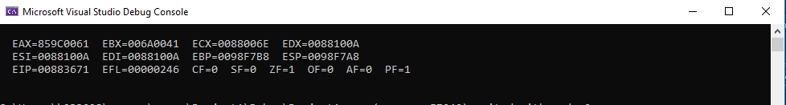

Q3

Code:

INCLUDE Irvine32.inc

.data

varB BYTE +10

varW WORD -150

varD DWORD 600

.code

main PROC

MOVSX EAX , varB

MOVSX EBX , varW

MOVZX ECX , varD

call Dumpregs

exit

main ENDP

END main

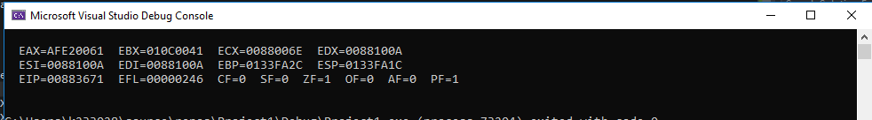

Q4

Equation 1

Code:

INCLUDE Irvine32.inc

.data

.code

main PROC

MOV EAX , 0

MOV EAX , 89 ; eax = 89

ADD EAX , 75Fh

ADD EAX , 1101b

SUB EAX , 46o

SUB EAX , 28

call Writeint

exit

main ENDP

END main



Equation 2

Code:

INCLUDE Irvine32.inc

.data

Val1 DWORD 25h

Val2 BYTE 36o

Val3 WORD 20d

.code

main PROC

MOV EAX , 0

MOV EAX , Val1

MOVZX EBX , Val2

MOVZX ECX , Val3

ADD EAX , EBX

ADD EAX , ECX

SUB EAX , 654h

call Writeint

exit

main ENDP

END main



Q5

INCLUDE Irvine32.inc

.data

SecondsInDay = 24*60*60

.code

main PROC

MOV EAX , SecondsInDay

call Writeint

exit

main ENDP

END main



Q7

Code:

INCLUDE Irvine32.inc

.data

A DWORD 0FF10h

B DWORD 0E10Bh

.code

main PROC

MOV EAX , A

MOV EBX , B

XCHG EAX , EBX

call Dumpregs

exit

main ENDP

END main

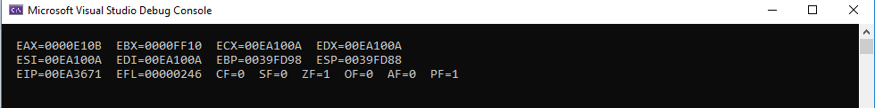

Q8

INCLUDE Irvine32.inc

.data

Val1 BYTE 10h

val2 WORD 8000h

val3 DWORD 0FFFFh

val4 WORD 7FFFh

.code

main PROC

MOVZX EAX , val2

INC EAX

call Dumpregs

exit

main ENDP

END main

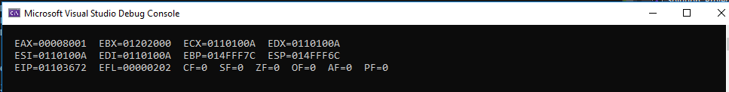

ii)

Code:

INCLUDE Irvine32.inc

.data

vail BYTE 10h

val2 WORD 8000h

val3 DWORD 0FFFFh

val4 WORD 7FFFh

.code

main PROC

MOV EAX , 0

MOVZX EAX , val2

INC EAX

MOV EBX , val3

SUB EAX , EBX

call Dumpregs

exit

main ENDP

END main

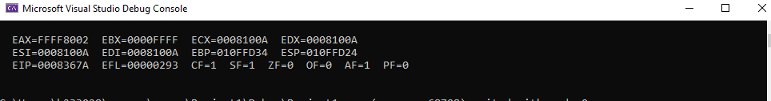

iii)

Code:

INCLUDE Irvine32.inc

.data

val1 BYTE 10h

val2 WORD 8000h

val3 DWORD 0FFFFh

val4 WORD 7FFFh

.code

main PROC

MOV EAX , 0

MOVZX EAX , val2

INC EAX

MOV EBX , val3

SUB EAX , EBX

MOVZX ECX , val4

SUB EAX , ECX

call Dumpregs

exit

main ENDP

END main

