COAL LAB 2

Questions:

1. Implement all of these equations in assembly language.

• 47 + 39 + 60 + 85 + 64+54o-0Ah

• 30- 9 + 186 – 150

• 101110 + 50Ah + 6710d + 1010001 + F

• 10001101 – D83h + 385+10 + 1111101 – E+F

2. Write a program in assembly language that implements following expression:

• edx = eax + 1 + ebx– ecx + 0Ah-65o+73d

• eax = 5ADh – ebx + 65o + 65d – 11110111 + 150

• ebx = 5ADh – eax + 65d + 73o – 11100101 + 7Bh

• ecx = 110010101101b + 45h-73o + ebx -ecx + 1

Exercise 1

1)47 + 39 + 60 + 85 + 64+54o-0Ah

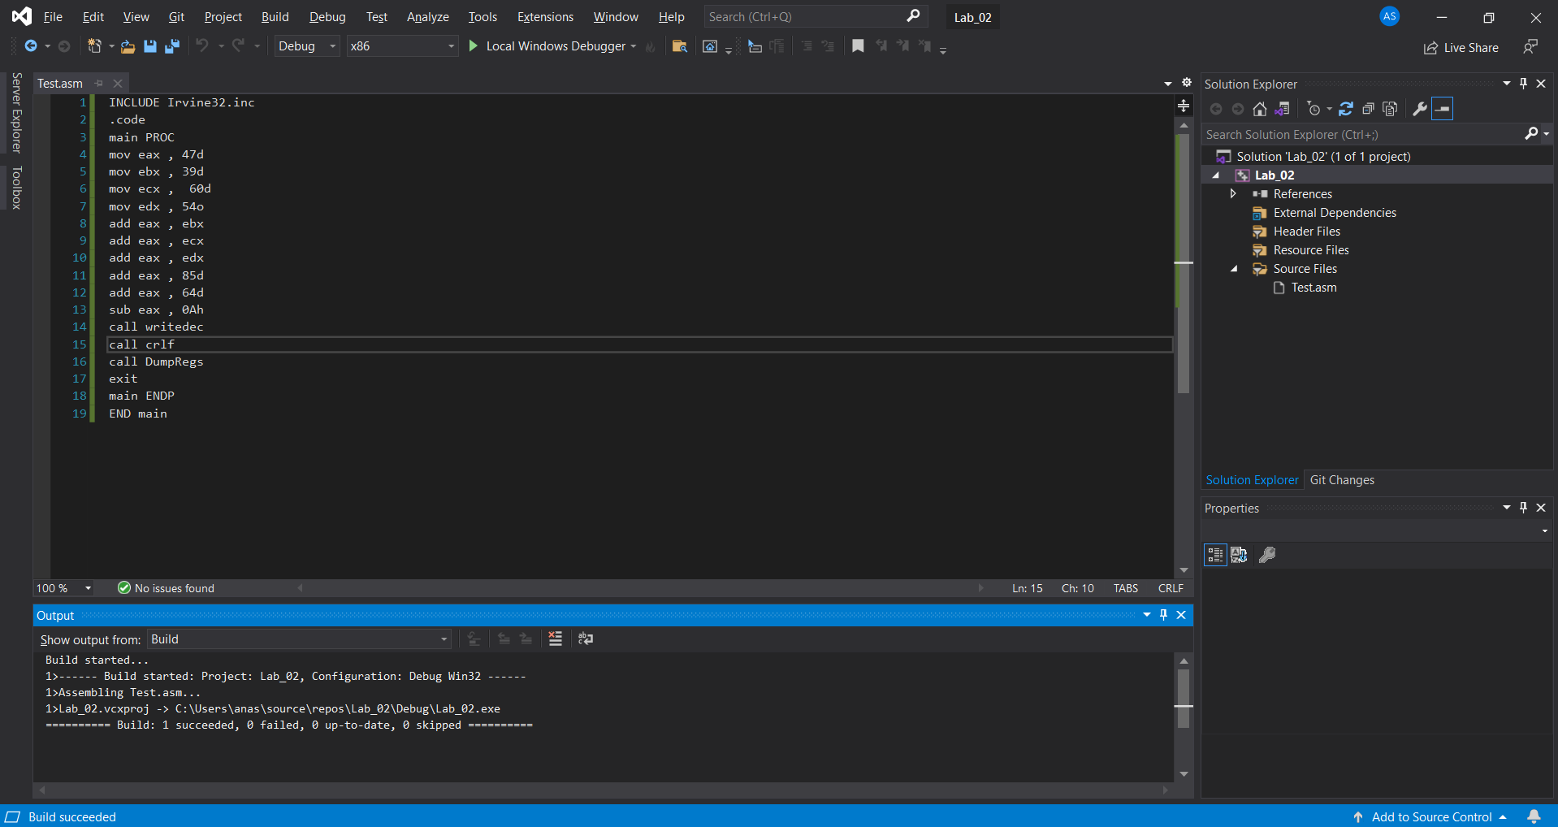

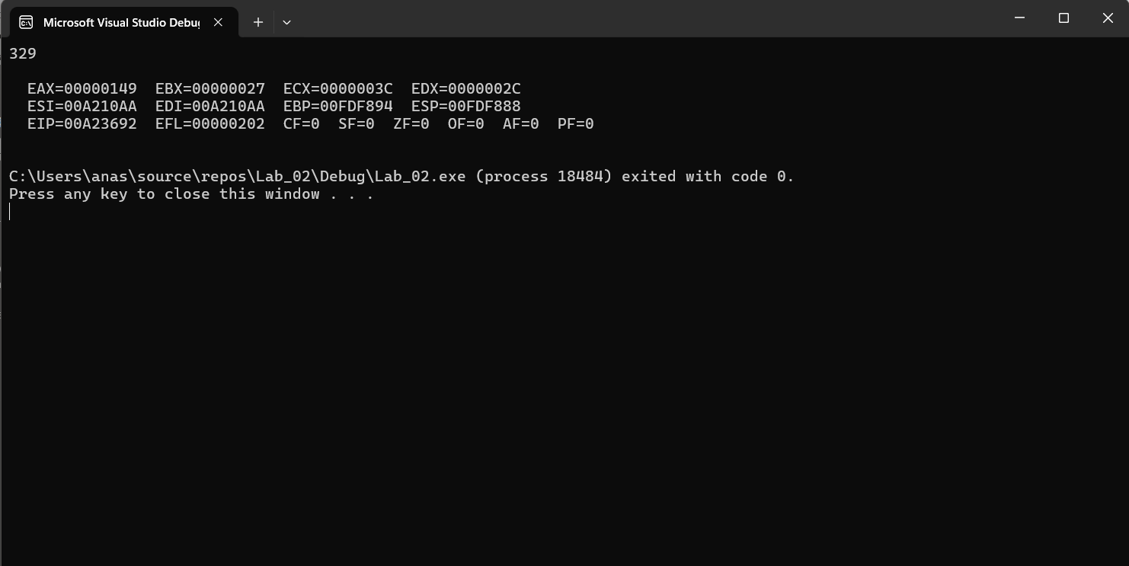

Code:

INCLUDE Irvine32.inc

.code

main PROC

mov eax , 47d

mov ebx , 39d

mov ecx , 60d

mov edx , 54o

add eax , ebx

add eax , ecx

add eax , edx

add eax , 85d

add eax , 64d

sub eax , 0Ah

call writedec

call crlf

call DumpRegs

exit

main ENDP

END main

2) 30- 9 + 186 – 150

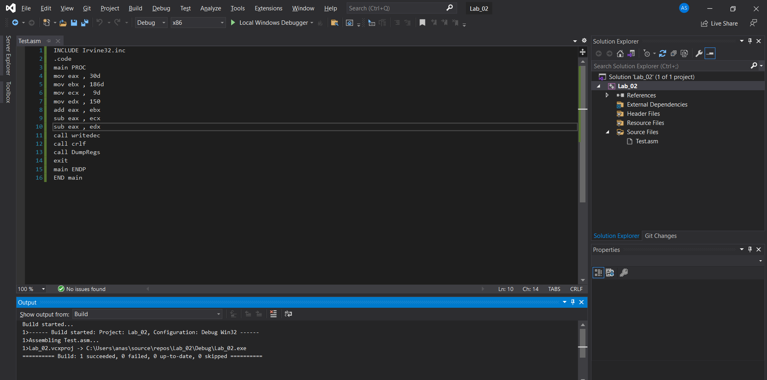

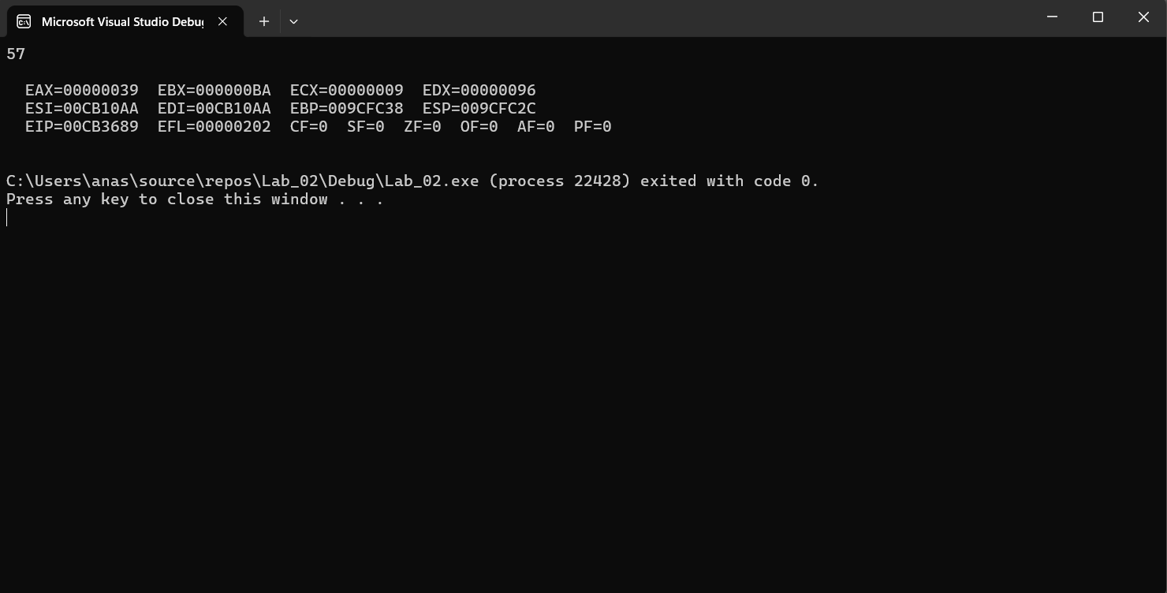

Code:

INCLUDE Irvine32.inc

.code

main PROC

mov eax , 30d

mov ebx , 186d

mov ecx , 9d

mov edx , 150

add eax , ebx

sub eax , ecx

sub eax , edx

call writedec

call crlf

call DumpRegs

exit

main ENDP

END main

3)101110 + 50Ah + 6710d + 1010001 + F

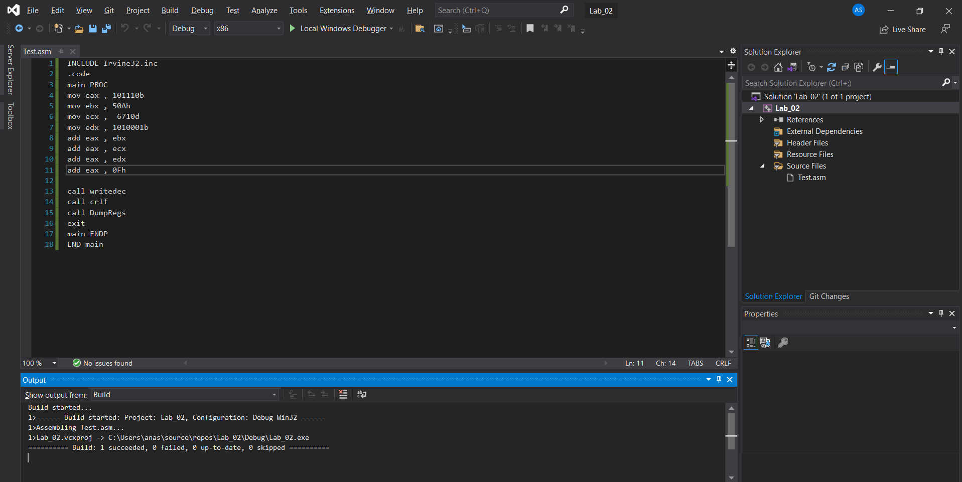

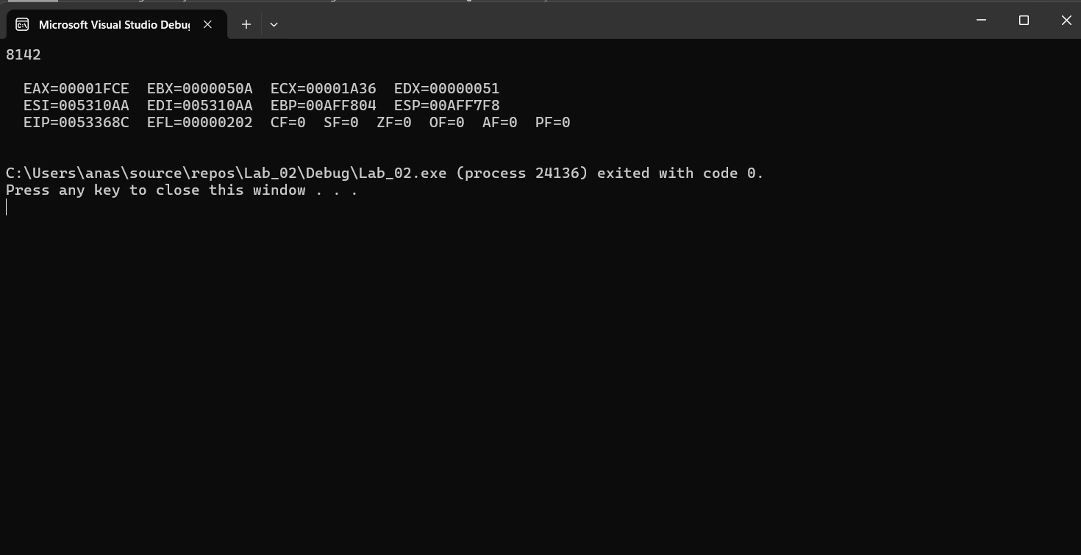

Code:

INCLUDE Irvine32.inc

.code

main PROC

mov eax , 101110b

mov ebx , 50Ah

mov ecx , 6710d

mov edx , 1010001b

add eax , ebx

add eax , ecx

add eax , edx

add eax , 0Fh

call writedec

call crlf

call DumpRegs

exit

main ENDP

END main

4)10001101 – D83h + 385+10 + 1111101 – E+F

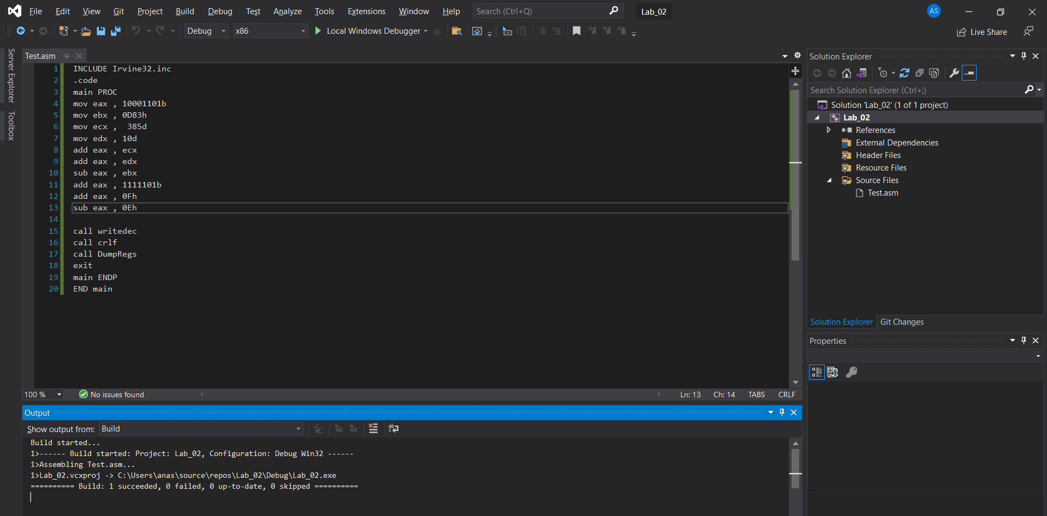

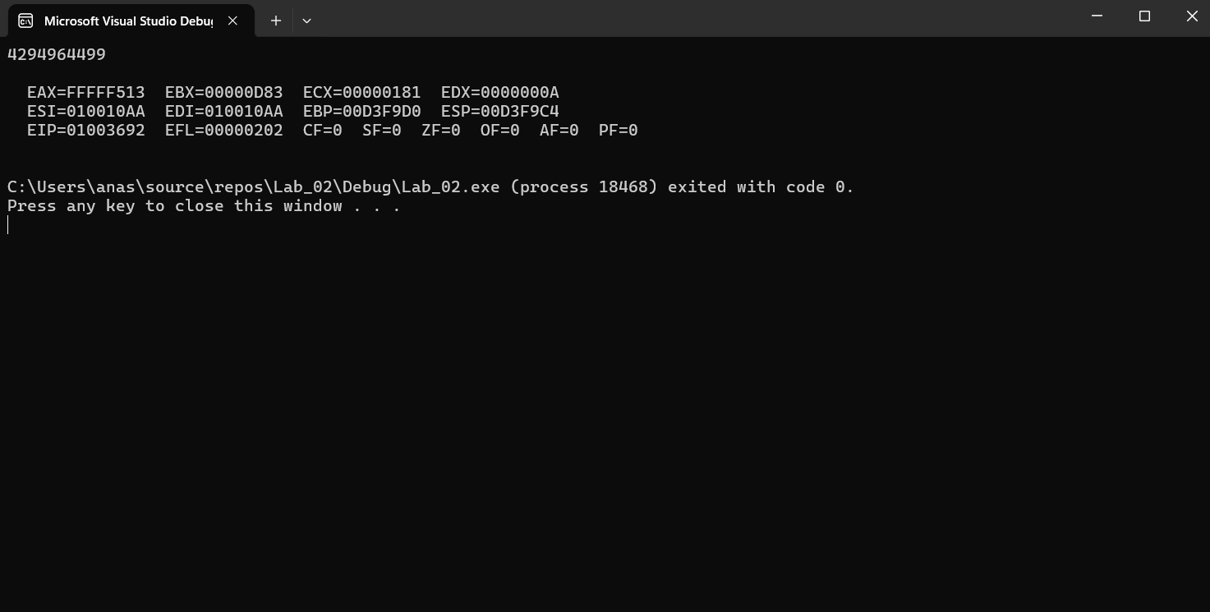

Code:

INCLUDE Irvine32.inc

.code

main PROC

mov eax , 10001101b

mov ebx , 0D83h

mov ecx , 385d

mov edx , 10d

add eax , ecx

add eax , edx

sub eax , ebx

add eax , 1111101b

add eax , 0Fh

sub eax , 0Eh

call writedec

call crlf

call DumpRegs

exit

main ENDP

END main

Exercise 2

1)edx = eax + 1 + ebx– ecx + 0Ah-65o+73d

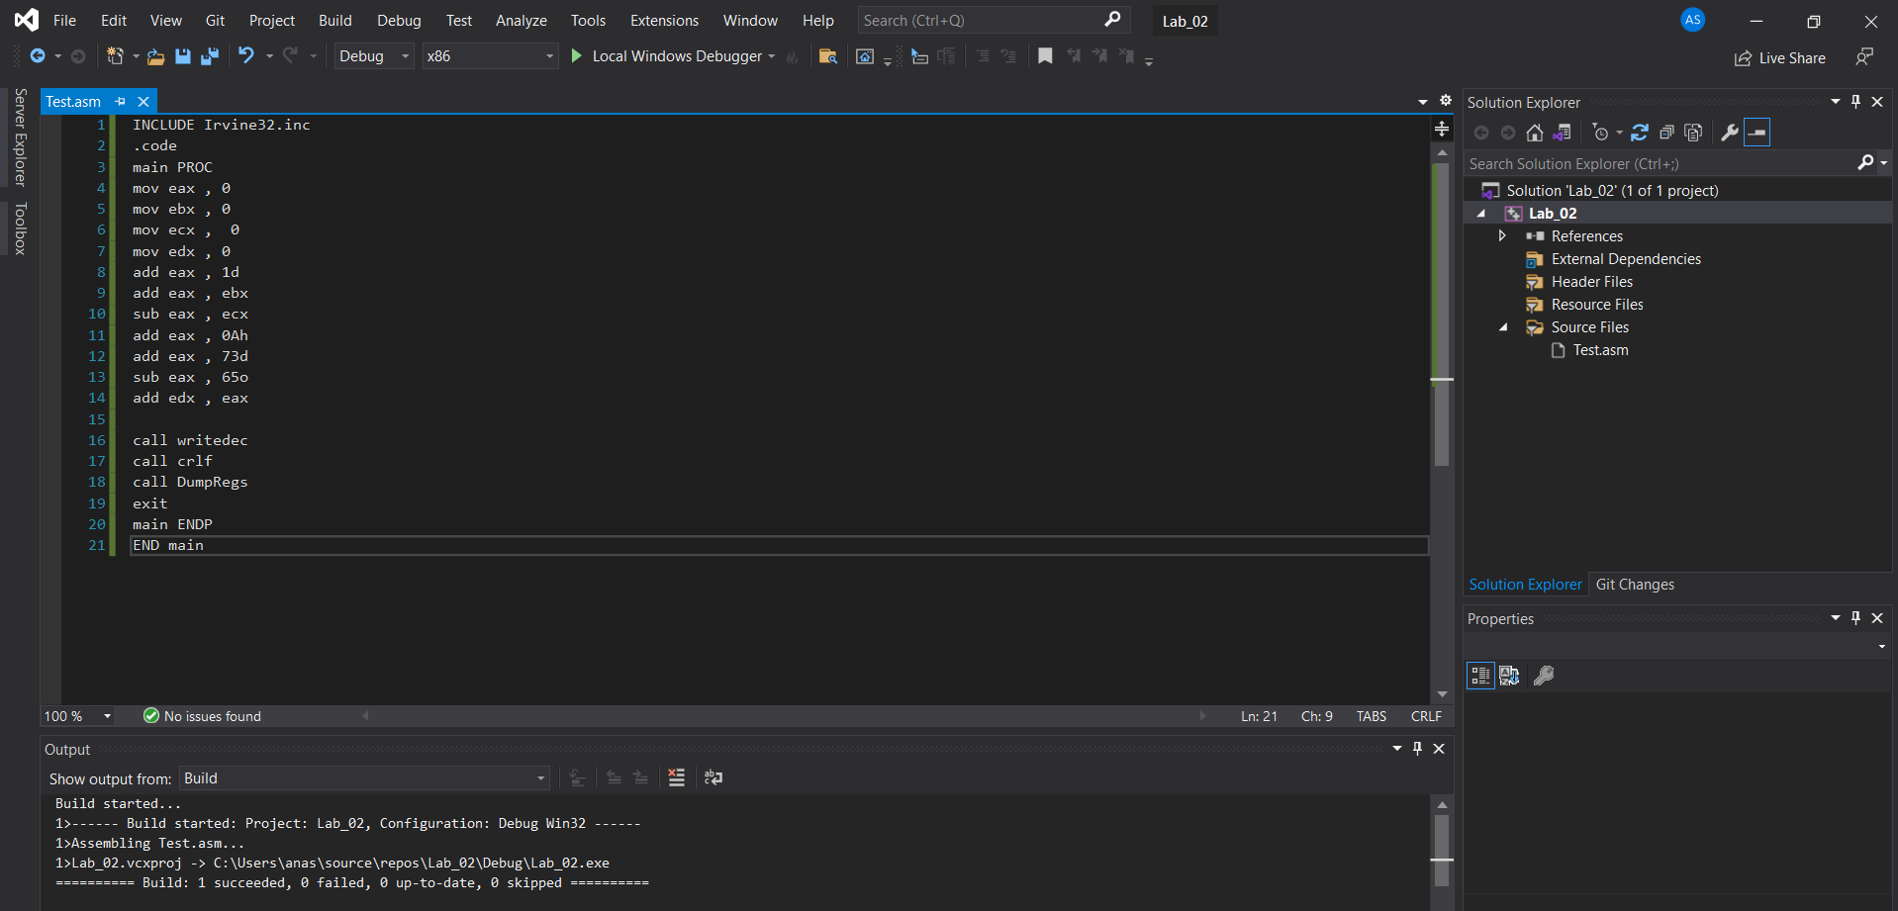

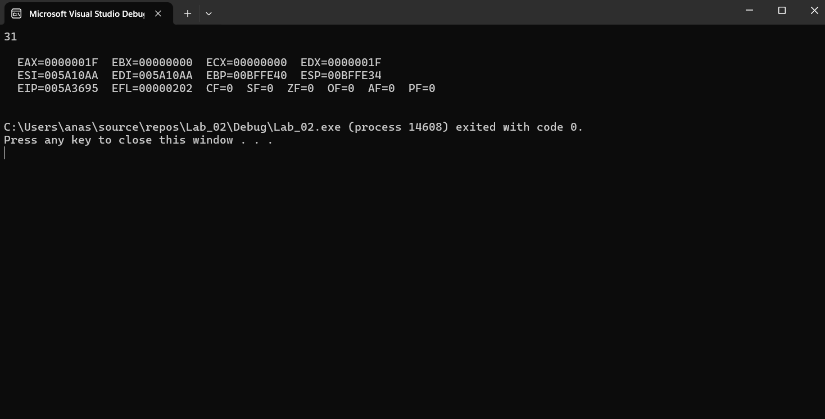

Code:

INCLUDE Irvine32.inc

.code

main PROC

mov eax , 0

mov ebx , 0

mov ecx , 0

mov edx , 0

add eax , 1d

add eax , ebx

sub eax , ecx

add eax , 0Ah

add eax , 73d

sub eax , 65o

add edx , eax

call writedec

call crlf

call DumpRegs

exit

main ENDP

END main

2)eax = 5ADh – ebx + 65o + 65d – 11110111 + 150

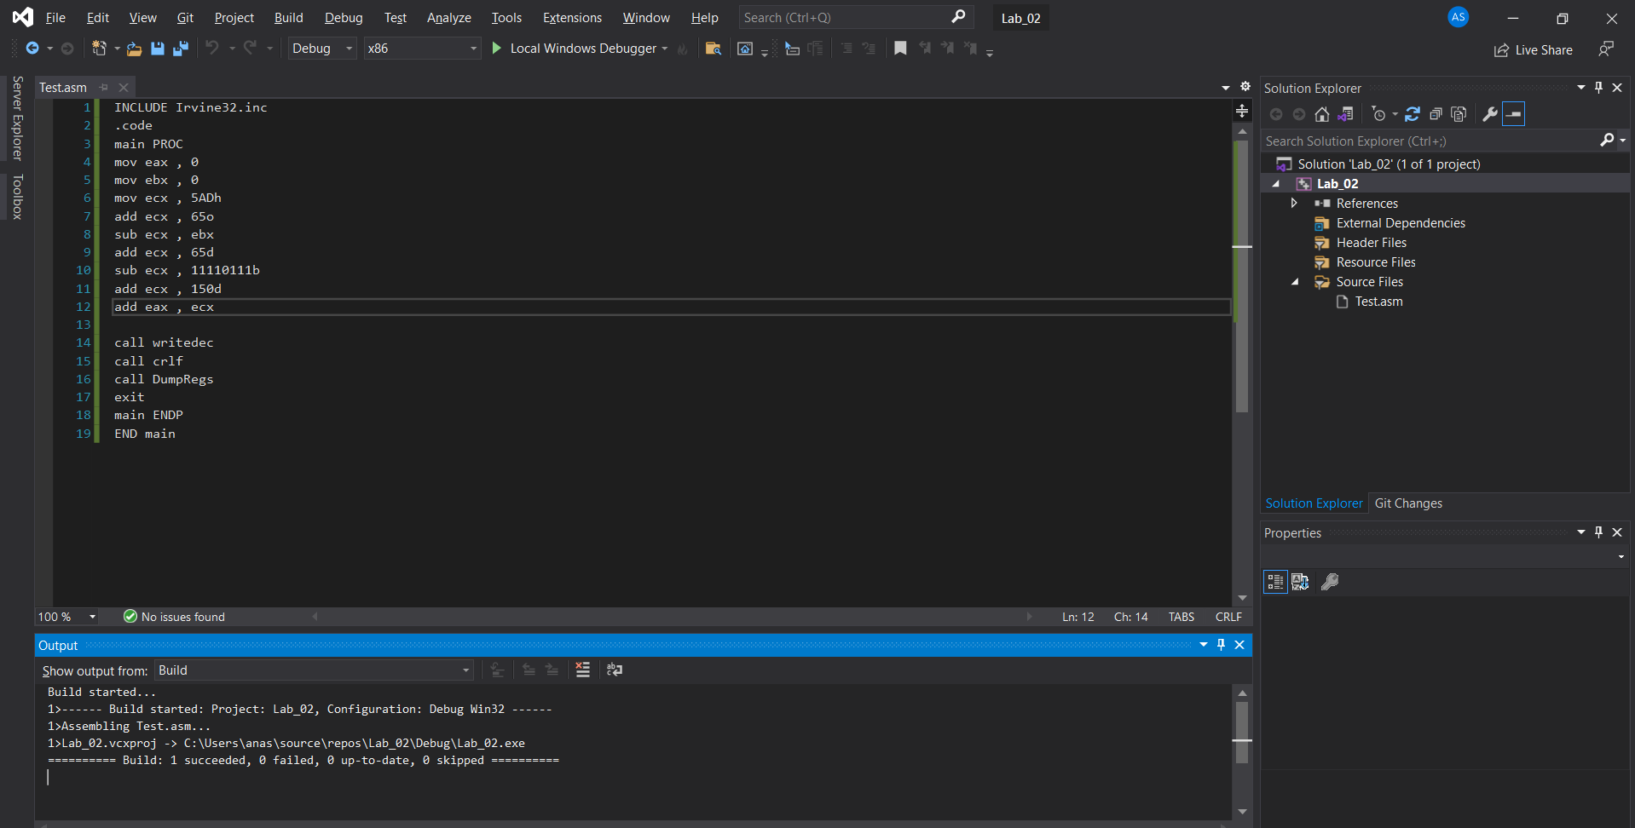

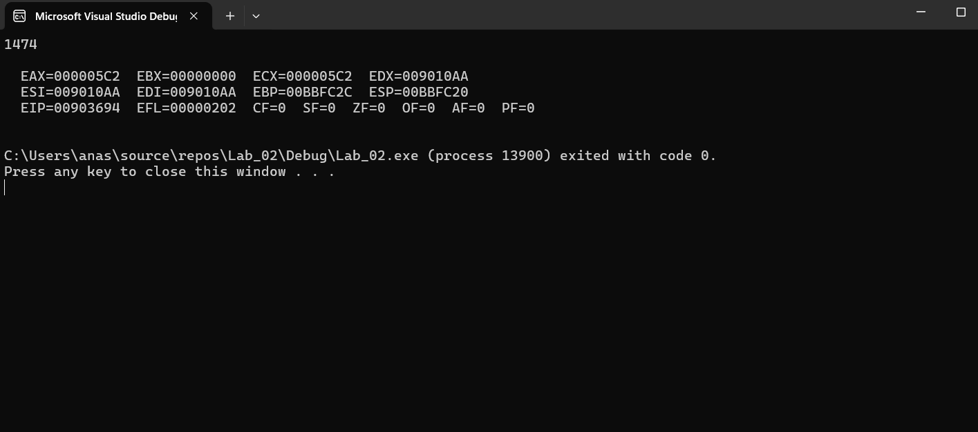

Code:

INCLUDE Irvine32.inc

.code

main PROC

mov eax , 0

mov ebx , 0

mov ecx , 5ADh

add ecx , 65o

sub ecx , ebx

add ecx , 65d

sub ecx , 11110111b

add ecx , 150d

add eax , ecx

call writedec

call crlf

call DumpRegs

exit

main ENDP

END main

3)ebx = 5ADh – eax + 65d + 73o – 11100101 + 7Bh

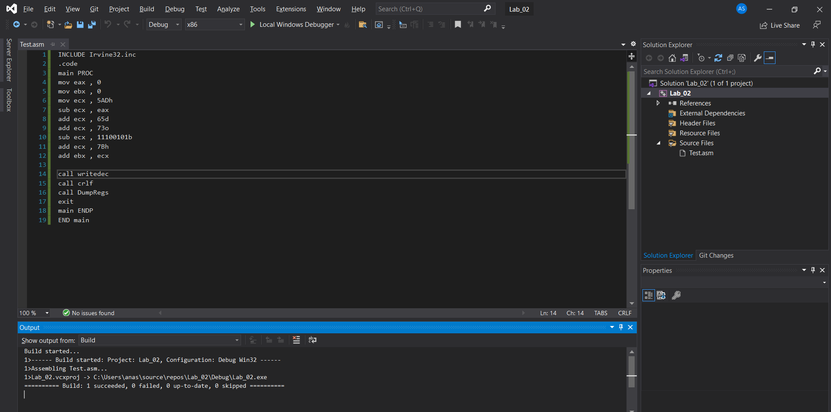

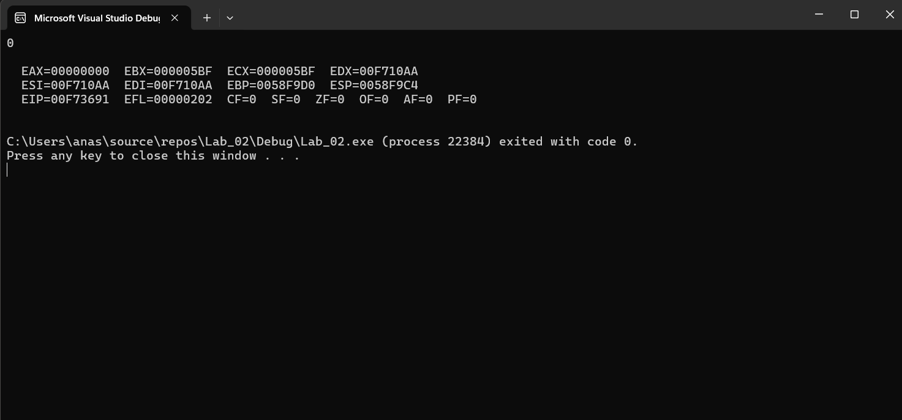

Code:

INCLUDE Irvine32.inc

.code

main PROC

mov eax , 0

mov ebx , 0

mov ecx , 5ADh

sub ecx , eax

add ecx , 65d

add ecx , 73o

sub ecx , 11100101b

add ecx , 7Bh

add ebx , ecx

call writedec

call crlf

call DumpRegs

exit

main ENDP

END main

4)ecx = 110010101101b + 45h-73o + ebx -ecx + 1

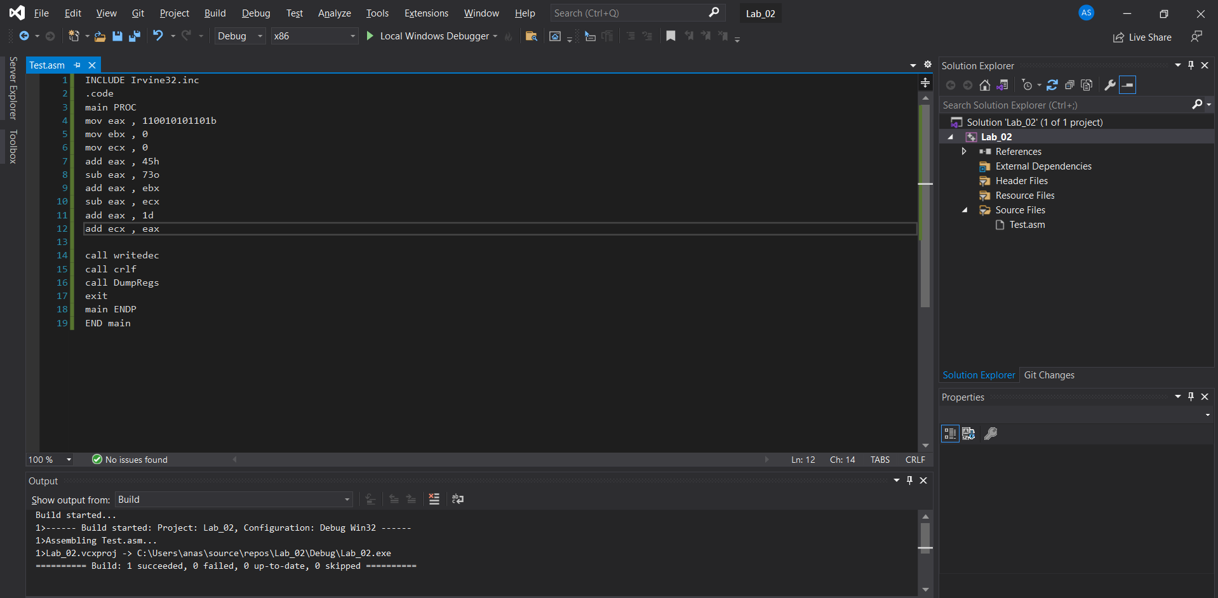

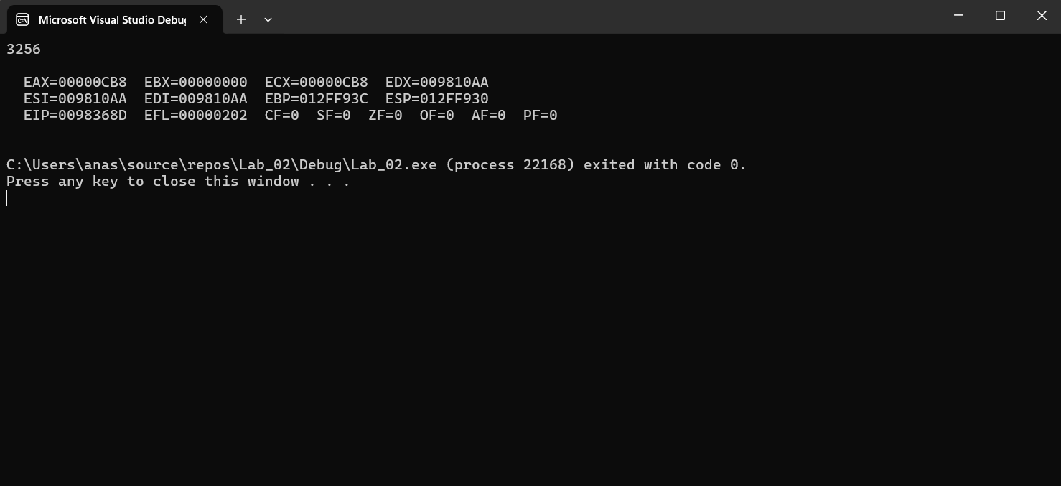

Code:

INCLUDE Irvine32.inc

.code

main PROC

mov eax , 110010101101b

mov ebx , 0

mov ecx , 0

add eax , 45h

sub eax , 73o

add eax , ebx

sub eax , ecx

add eax , 1d

add ecx , eax

call writedec

call crlf

call DumpRegs

exit

main ENDP

END main