Questions

1. Write an uninitialized data declaration for a16-bit signed integer val1

1010Declare a string variable containing the word “TEST” repeated 500 times.

Initializers

4. Declare a string variable containing the name of your favorite color. Initialize

Ini

Declare a 32

negative decimal value.

3. Declare an unsigned 16-bit integer variable named that uses three

tialize 8-bit signed integer val2 with -11. 2-bit signed integer val3 and initialize it with the smallest possible

6. Convert the given values of a,b,c,d into binary and then use in 8-bit data definition

and implement in the equation.

7. Declare an unsigned 16-bit integer variable named wArray that uses three

initializers.

8. Declare an uninitialized array of 50 unsigned doublewords named dArray.

9. Declare a string variable containing the word “TEST” repeated 500 times.

10.Declare an array of 20 unsigned bytes named bArray and initialize all elements

Q1

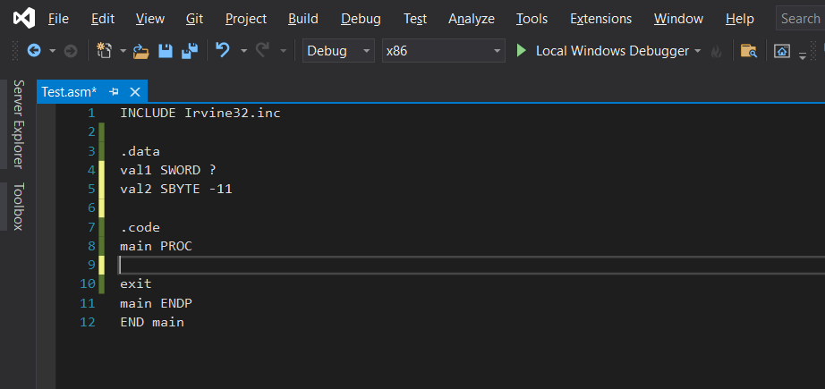

Code:

INCLUDE Irvine32.inc

.data

val1 SWORD ?

val2 SBYTE -11

.code

main PROC

exit

main ENDP

END main

Q2

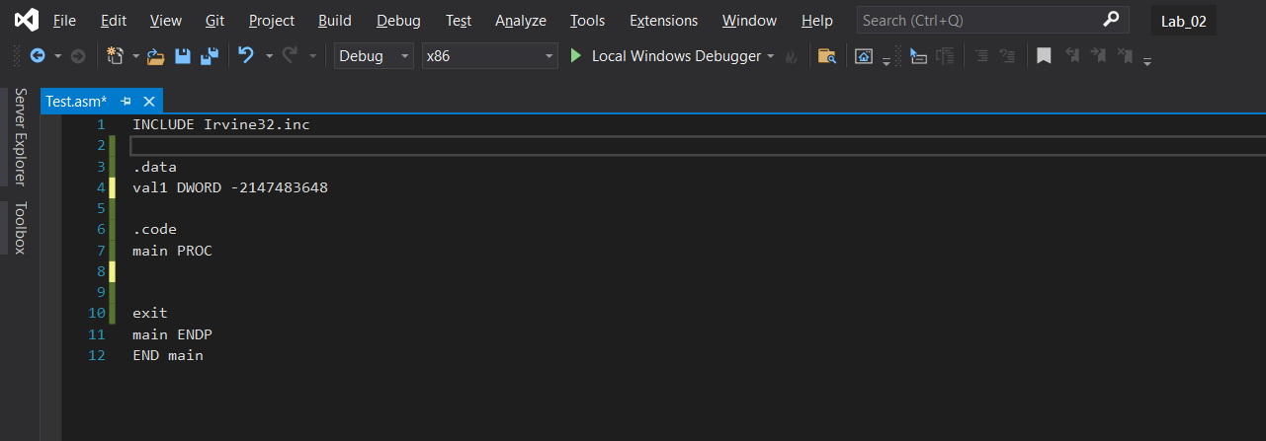

Code:

INCLUDE Irvine32.inc

.data

val1 DWORD -2147483648

.code

main PROC

exit

main ENDP

END main

Q3

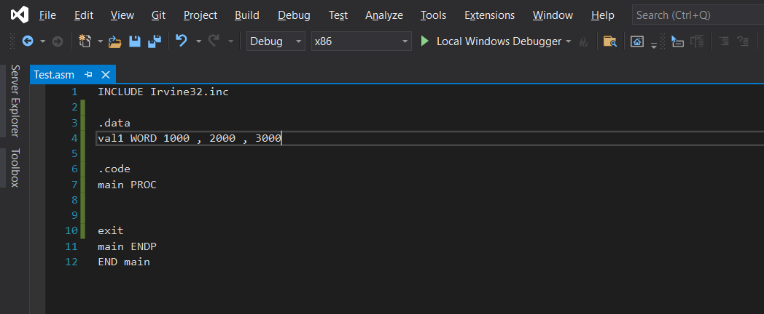

Code:

INCLUDE Irvine32.inc

.data

val1 WORD 1000 , 2000 , 3000

.code

main PROC

exit

main ENDP

END main

Q4

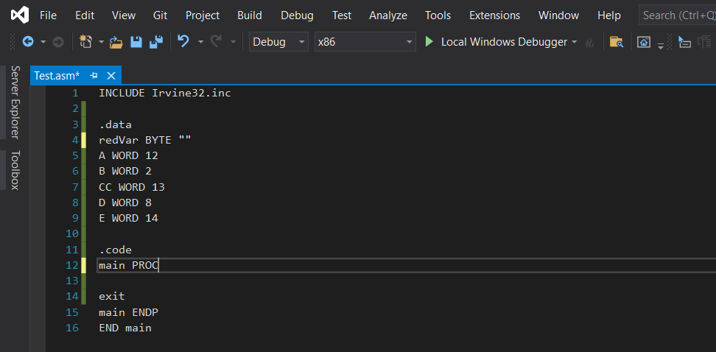

Code:

INCLUDE Irvine32.inc

.data

redVar BYTE ""

A WORD 12

B WORD 2

CC WORD 13

D WORD 8

E WORD 14

.code

main PROC

exit

main ENDP

END main

Q5

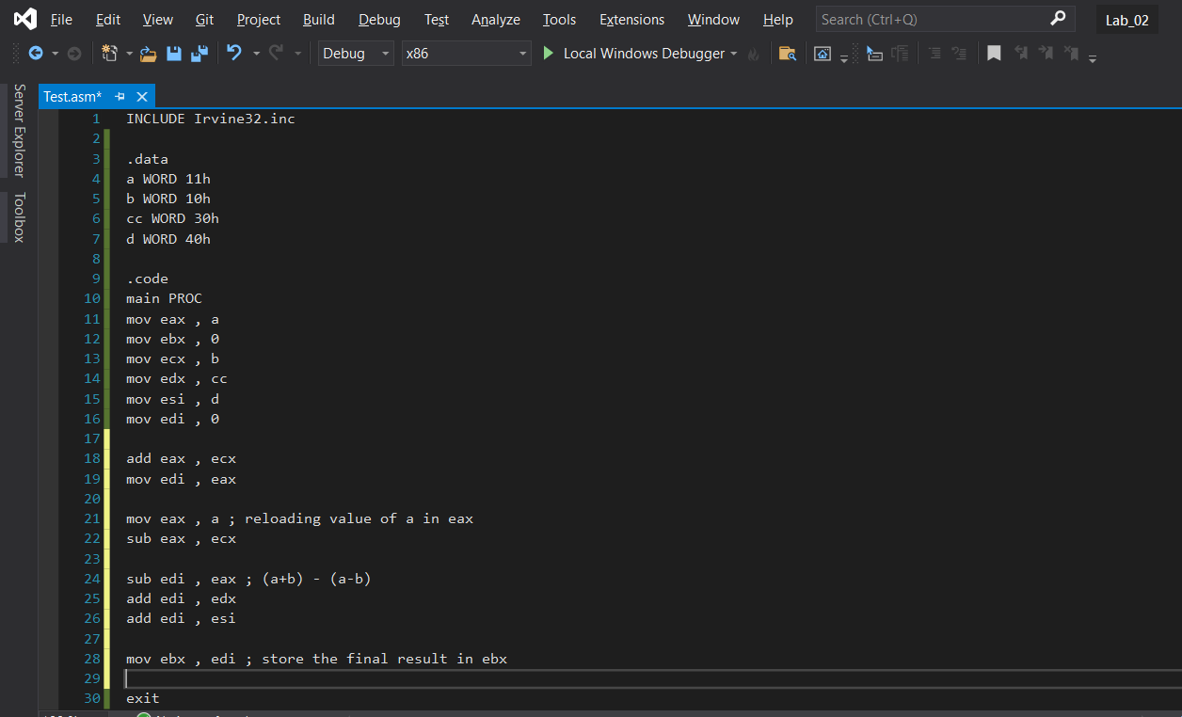

Code:

INCLUDE Irvine32.inc

.data

a WORD 11h

b WORD 10h

cc WORD 30h

d WORD 40h

.code

main PROC

mov eax , a

mov ebx , 0

mov ecx , b

mov edx , cc

mov esi , d

mov edi , 0

add eax , ecx

mov edi , eax

mov eax , a ; reloading value of a in eax

sub eax , ecx

sub edi , eax ; (a+b) - (a-b)

add edi , edx

add edi , esi

mov ebx , edi ; store the final result in ebx

exit

main ENDP

END main

Q6

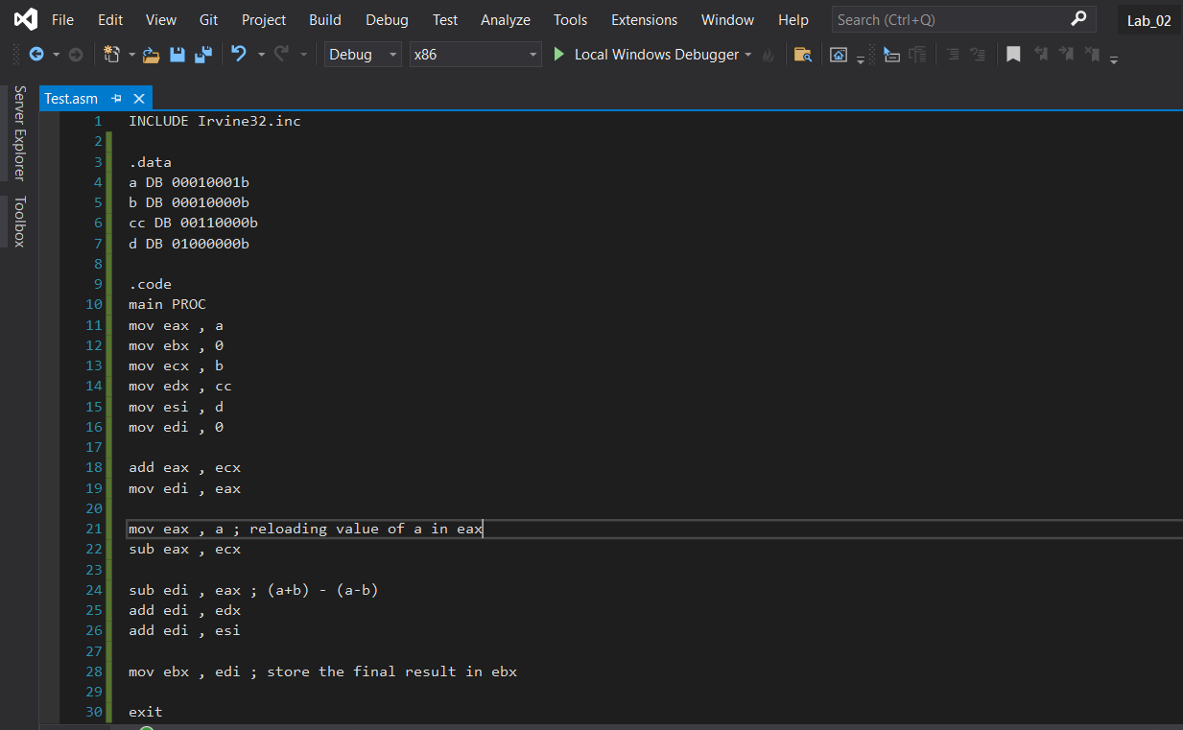

Code :

INCLUDE Irvine32.inc

.data

a DB 00010001b ; 8 bit data defining to store binary number

b DB 00010000b

cc DB 00110000b

d DB 01000000b

.code

main PROC

mov eax , a

mov ebx , 0

mov ecx , b

mov edx , cc

mov esi , d

mov edi , 0

add eax , ecx

mov edi , eax

mov eax , a ; reloading value of a in eax

sub eax , ecx

sub edi , eax ; (a+b) - (a-b)

add edi , edx

add edi , esi

mov ebx , edi ; store the final result in ebx

exit

main ENDP

END main

Q7

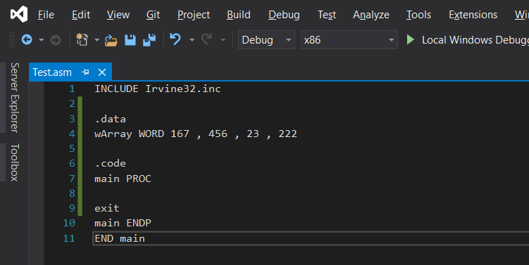

Code:

INCLUDE Irvine32.inc

.data

wArray WORD 167 , 456 , 23 , 222

.code

main PROC

exit

main ENDP

END main

Q8

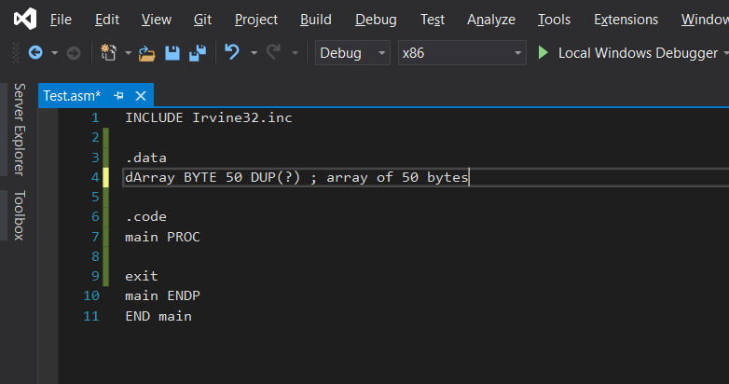

Code:

INCLUDE Irvine32.inc

.data

dArray BYTE 50 DUP(?) ; array of 50 bytes

dArray DB 50 DUP(?) ; directive to define an array of 50 bytes

.code

main PROC

exit

main ENDP

END main

Q9

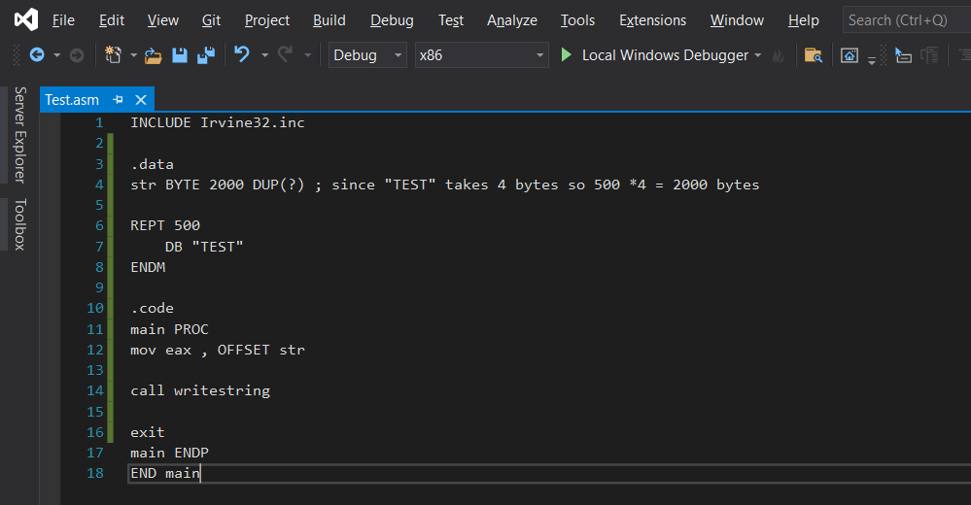

Code:

INCLUDE Irvine32.inc

.data

str BYTE 2000 DUP(?) ; Since “TEST” takes 4 bytes so 500\*4 = 2000 bytes

REPT 500

DB "TEST"

ENDM

.code

main PROC

mov eax, OFFSET str

call WriteString

exit

main ENDP

END main

Q10

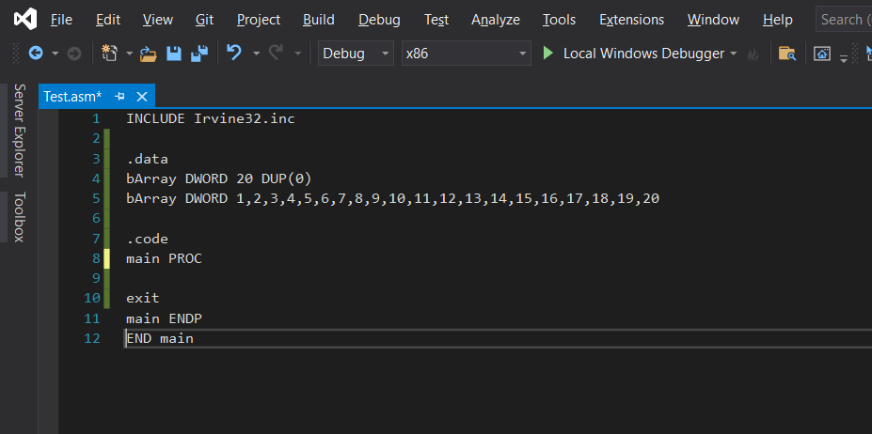

Code:

INCLUDE Irvine32.inc

.data

bArray DWORD 20 DUP(0)

bArray DWORD 1,2,3,4,5,6,7,8,9,10,11,12,13,14,15,16,17,18,19,20

.code

main PROC

exit

main ENDP

END main