Revision History

|  |  |  |  |
| --- | --- | --- | --- |
| **Date** | **Version** | **Description** | **Author** |
| 29/10/2014 | v1.00 | User Requirements Added | Yunus Yılmaz |
| 30/10/2014 | v1.01 | User Requirements Updated | Yunus Yılmaz |
| 30/10/2014 | v2.00 | Conventions Added, System Requirements Added | Vidal Hara |
| 30/10/2014 | v2.01 | Requirements Organized | Yunus Yılmaz, Vidal Hara |
| 30/10/2014 | v2.02 | Requirements Updated | Yunus Yılmaz, Vidal Hara |
| 31/10/2014 | v2.03 | Charts and Introduction part added | Ömer Aslan, Burak Atalay |
| 31/10/2014 | v2.04 | Conventions updated, requirements reviewed | Bahadır Kırdan |
| 31/10/2014 | v2.05 | Non-functional requirements added | Yunus Yılmaz, Vidal Hara |
| 31/10/2014 | v2.06 | System overview added, typos fixed | Ömer Aslan, Burak Atalay |

**TABLE OF CONTENTS**

Revision History 1

1 INTRODUCTION 3

1.1 Document overview 3

1.2 System overview 3

1.3 Abbreviations 3

1.4 References 3

1.5 Conventions 3

2 REQUIREMENTS 5

2.1 User Requirements Specification 5

2.2 System Architecture 8

2.3 Use Cases and Usage Scenarios 10

2.4 System Requirements Specification 10

# INTRODUCTION

## Document overview

This Software Requirements Specification document contains the following information about Ozyegin University Course Scheduler Project:

* *User Requirement Specifications:* Describes the services provided for the user, both functional and non-functional requirements are included.
* *System Architecture:* Presents a high-level overview of the anticipated system architecture, showing the distribution of functions across system modules.
* *Use Case and Usage Scenarios:* relevant UML use case diagrams and sequence diagrams that depict the usage scenarios of the system.
* *User Requirement Specifications:* Describes the functional and nonfunctional requirements in more detail.

## System overview

Ozyegin University Course Scheduler is an all-in-one interface where users get help to organize and decide on which courses to select, their course schedule and more. Ozyegin University Course Scheduler works as a standalone system by allowing users to fill in their required information and it adjusts itself accordingly.

## Abbreviations

OZUSCH: Twitter Desktop Streamer

SRS: Software Requirements Specifications

ID: Identification Key

## References

|  |  |  |
| --- | --- | --- |
| # | Document Identifier | Document Title |
| 1 | Doc #1 | Software Development Plan |

## Conventions

User requirements listed in this document are constructed according to the following structure:

User Requirement Id

User Requirement title

User Requirement description

User Requirement version

Example:

SRS-OZUSCH-000

Title of XXX-000 requirement

Description of XXX-000 requirement

Version of XXX-000

Every system requirement id includes the id of the corresponding user requirement as a prefix.

System requirements listed in this document are constructed according to the following structure:

System Requirement Id

System Requirement title

System Requirement function

System Requirement description

System Requirement inputs

System Requirement source

System Requirement outputs

System Requirement version

Example:

SRS-OZUSCH-000.1

*Title of OZUSCH-000.1 system requirement, which is related to the user requirement OZUSCH-000*

**Function:**

**Description:**

**Inputs:**

**Source:**

**Outputs:**

*VX.X*

# REQUIREMENTS

## User Requirements Specification

SRS-OzuSch-001

*OZUSCH Sign up*

OZUSCH will provide a procedure to Ozu Students will create their own user account.

V1.0

SRS-OZUSCH-002

*OZUSCH Captcha Check*

OZUSCH will control that visitors are human or not with captcha check.

V1.0

SRS-OZUSCH-003

*OZUSCH E-Mail*

OZUSCH will provide students that when they signed up to OzuSch, it will send an automatic e-mail to the student.

V1.0

SRS-OZUSCH-004

*OZUSCH Login*

OZUSCH will allow to login the OzuSch with their created accounts.

V1.0

SRS-OZUSCH-005

*OZUSCH Eliminate the Lessons*

OZUSCH will want to students’ past pass courses then will eliminate them from the offered courses.

V1.0

SRS-OZUSCH-006

*OZUSCH Show Courses*

OZUSCH will show the possible can be taken courses according to student’s background information.

V1.0

SRS-OZUSCH-007

*OZUSCH Choose Courses*

OZUSCH will allow choosing courses which are wanted to take by the student.

V1.0

SRS-OZUSCH-08

*OZUSCH Restricted Courses*

OZUSCH will show student which course are not eligible for his/her background information.

V1.0

SRS-OZUSCH-09

*OZUSCH Non-Optional Courses*

OZUSCH will tell the student which courses have one section and it will not have an extra option to take it.

V1.0

SRS-OZUSCH-010

*OZUSCH Schedule Rest Courses*

OZUSCH will list the courses which have many sections to take.

V1.0

SRS-OZUSCH-011

*OZUSCH Load Profile*

OZUSCH will provide to load a profile for students.

V1.0

SRS-OZUSCH-012

*OZUSCH Profile Settings*

OZUSCH will allow to change his or her course background information..

V1.0

**Non-Functional Requirements:**

SRS-OZUSCH-013

*Student overload*

OZUSCH should be able to work when it is in overload by the students.

V1.0

SRS-OZUSCH-014

*Up-to-date*

OzuSch should be up-to-date all semester and when the course condition change it should be changed automatically or manually.

V1.0

SRS-OZUSCH-015

*Credits Limit*

Maximum number of credit should be under control according to student’s GPA

V1.0

SRS-OZUSCH-016

Offered Courses Data *Time*

OzuSch must be taken offered courses before the starting time of the course registration.

V1.0

SRS-OZUSCH-017

*Wait time for Wrong Captcha*

OZUSCH will wait 2 minutes for the user when he/she tried 5 times wrong captcha.

V1.0

## System Architecture

Figure 1: System Architecture

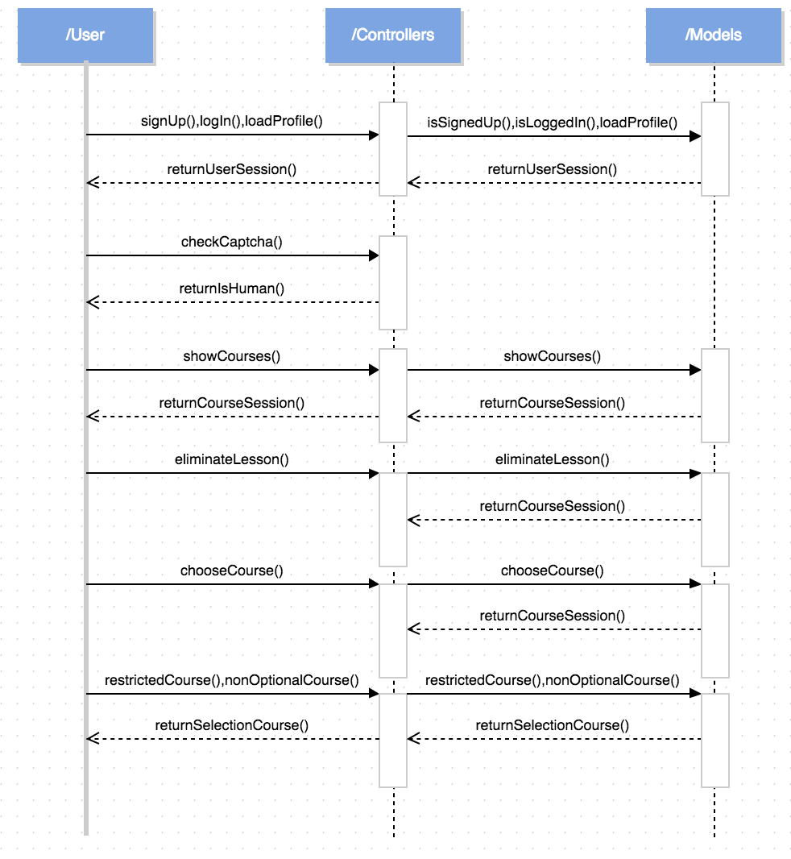

Figure 2: Sequence Diagram

## Use Cases and Usage Scenarios

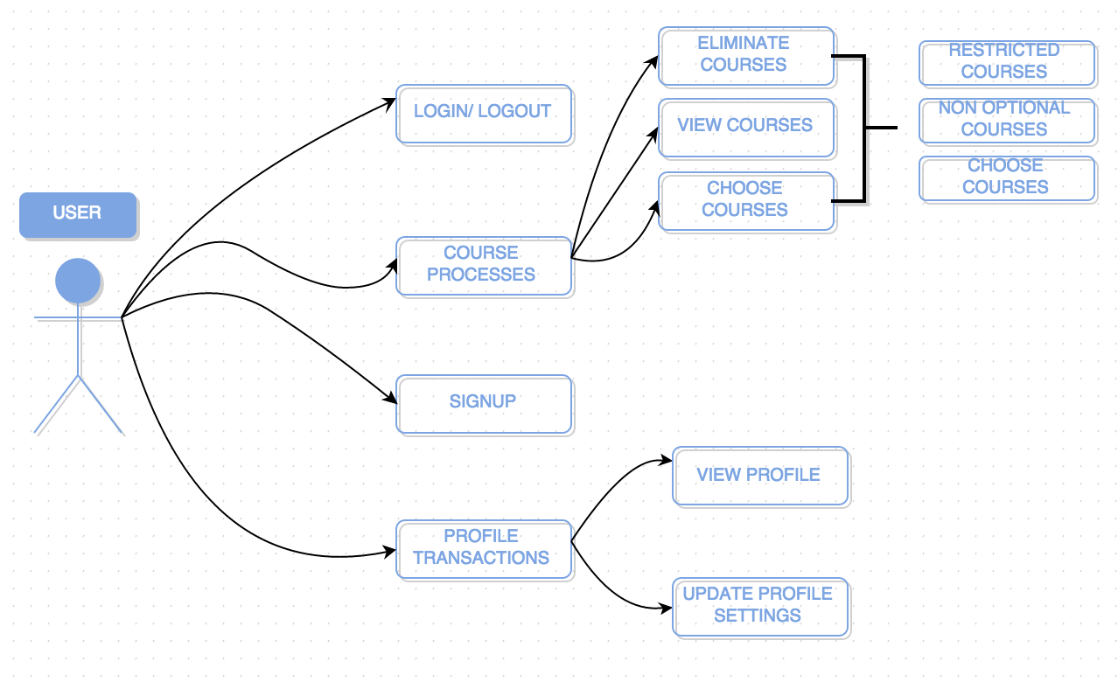

Figure 3: Use Case Diagram

## System Requirements Specification

SRS-OzuSch-001.1

*Sign up*

**Function:** Wait for key

**Description:** Getting user’s name, student number, unused log in name and password

**Inputs:** User Key, User Secret

**Source:** User

**Outputs:** None

*V2.0*

SRS- OzuSch-001.2

*Name Check*

**Function:** Checks used user names

**Description:** Checks the current database for the possible login name conflicts

**Inputs:** Login name

**Source:** Sign up’s log in name label

**Outputs:** Check sign near by the entered login name in sign up page if there is no conflict otherwise cross sign

*V2.0*

SRS- OzuSch-002.1

*Captcha Check*

**Function:** Checking Captcha

**Description:** Checking the Captcha matches with the user text

**Inputs:** User text

**Source:** Captcha

**Outputs:** None

*V2.0*

SRS- OzuSch-003.1

*Send E-mail*

**Function:** Sending an e-mail

**Description:** Sending an e-mail to the new user which contains his/her login name and key

**Inputs:** E-mail of the new user, login name and key

**Source:** Related sign up field

**Outputs:** Creates an email

*V2.0*

SRS- OzuSch-004.1

*Log in*

**Function:** Wait for key

**Description:** Wait for the proper login name and key

**Inputs:** Consumer Key

**Source:** User

**Outputs:** None

*V2.0*

SRS- OzuSch-005.1

*Get Lessons*

**Function:** Gets possible lessons

**Description:** Getting possible lessons from dump related with users Faculty

**Inputs:** User Faculty

**Source:** Dump file

**Outputs:** None

*V2.0*

SRS- OzuSch-005.2

*Eliminated Lessons*

**Function:** Eliminating the lessons

**Description:** Remove the passed lessons list from the whole lesson list

**Inputs:** User Passed Lesson List

**Source:** PossibleLesson List

**Outputs:** Eliminated Lesson List

*V2.0*

SRS- OzuSch-006.1

Show Courses

**Function:** Showing Possible Courses

**Description:** Shows the possible courses according to student’s background information.

**Inputs:** User passed Course List

**Source:** All Possible Lesson List

**Outputs:** Possible Courses

*V2.0*

SRS- OzuSch-007.1

Choose *Courses*

**Function:** Choosing Courses

**Description:** User chooses the lessons that is wanted to be scheduled by the system

**Inputs:** User choice

**Source:** Possible Lesson List

**Outputs:** None

*V2.0*

SRS- OzuSch-008.1

Choose *Restrictions*

**Function:** Choosing Restrictions

**Description:** User choose restrictions for his/her schedule

**Inputs:** User choice

**Source:** Restriction List

**Outputs:** None

*V2.0*

SRS- OzuSch-009.1

*Schedule Non optional Lessons*

**Function:** Scheduling lessons

**Description:** Scheduling lessons, which are only one section

**Inputs:** User Choice List, lesson’s sections and time slots

**Source:** Dump document, User restriction list

**Outputs:** None

*V2.0*

SRS- OzuSch-010.1

*Schedule Rest Lessons*

**Function:** Scheduling Lessons

**Description:** Scheduling lessons, which have multiple sections

**Inputs:** User Choice List, lesson’s sections and time slots

**Source:** Dump document, User restriction list

**Outputs:** Possible Schedules

*V2.0*

SRS- OzuSch-011.1

*Display Profile*

**Function:** Load Profile

**Description:** Loading user profile

**Inputs:** User profile

**Source:** Database

**Outputs:** User’s profile

*V2.0*

SRS- OzuSch-012.1

*Profile Settings*

**Function:** Changing profile information of the user

**Description:** Lessons will be chosen by the User, which are already passed by the user

**Inputs:** User choices, String

**Source:** Database or User

**Outputs:** User’s profile

*V2.0*