Synopsys Interviews Questions (09/04/2026)

- Introduce yourself.
- Explain the project you worked on in your previous company. What was your role? Provide details.
- What is an op-amp?
- Write an SV-RNM code for an op-amp based on the given specifications.
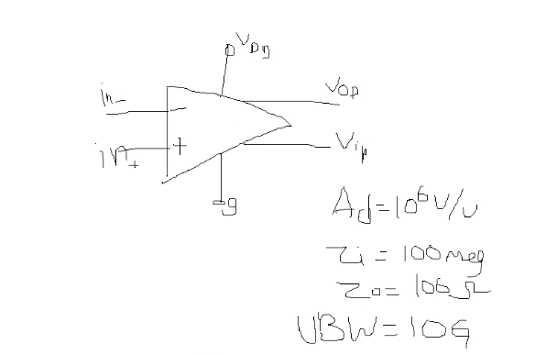
- What is the UBW parameter?
- What is the internal architecture of an op-amp?
- What are Zi and Zo?
- What will be the output voltage in the following cases:
  - Zi = ∞ and Zo = finite
  - Zi = finite and Zo = ∞
- What internal behavior explains the above cases when Zi and Zo are finite or infinite?
- Draw the characteristic graph (voltage vs. current) based on the above cases.
- Draw the V–I curve for the given values of Zi and Zo.
- What is an ideal voltage source? Draw its V–I curve.
- If a 5V source is applied and an additional 1Ω resistor is connected in series in the network, draw the V–I curve.
- Design a NAND gate using CMOS inverter structures (schematic level).
- Derive the output voltage (Vout) for the given figure.
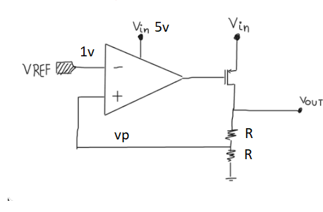

- Explain the UVM-AMS / UVM-MS architecture from scratch.
- Write code for the complete architecture, including all components and sequences.
- Write a sequence that sets the enable signal to 1.
- Write sequences to pass parameters such as Zo, Zi, UBW, and A0.
- If enable = 1, generate waveforms (such as sine, step, etc.) based on user input.
- What is a sequencer?
- Explain all UVM components and their working in detail.
- Explain the role of the sequencer and why it is used (based on the driver–sequencer handshaking mechanism).
- What are a virtual sequence and a virtual sequencer? What is their significance?
- How can we use the virtual sequence concept in our model environment?

