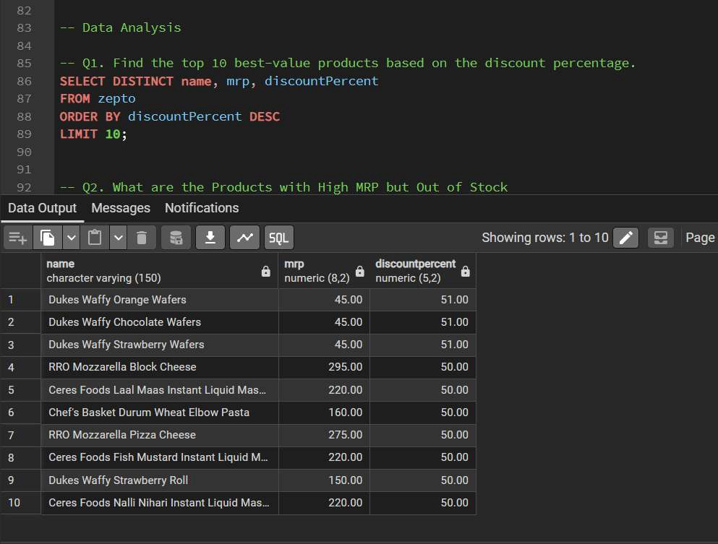

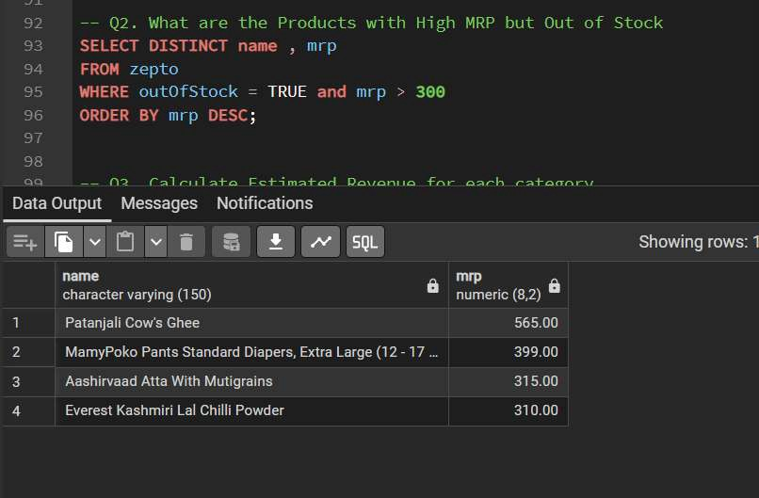

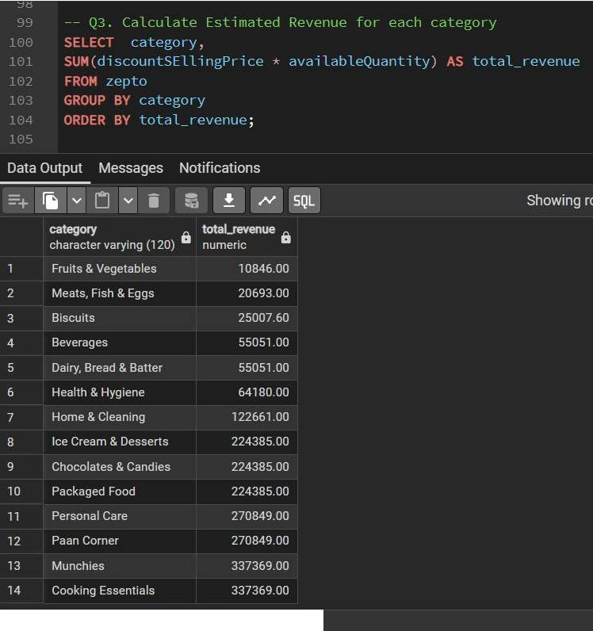
Total rows: 14 Query complete 00:00·00.162

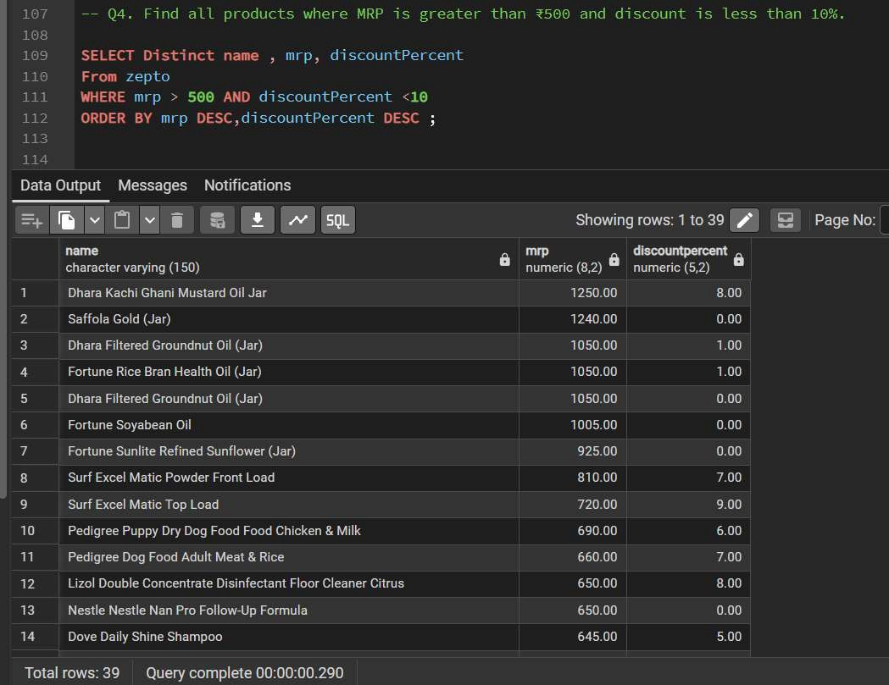

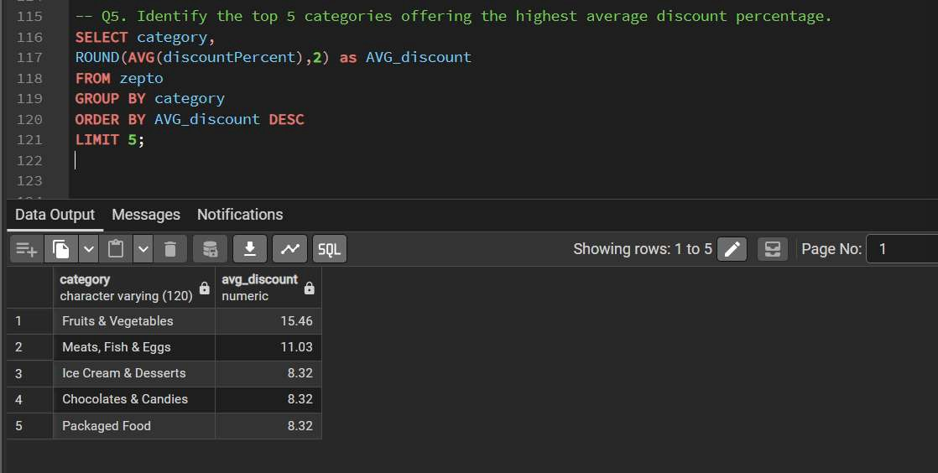

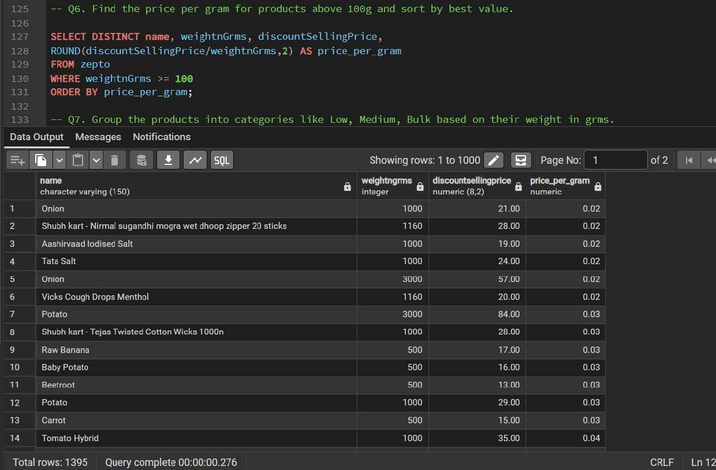

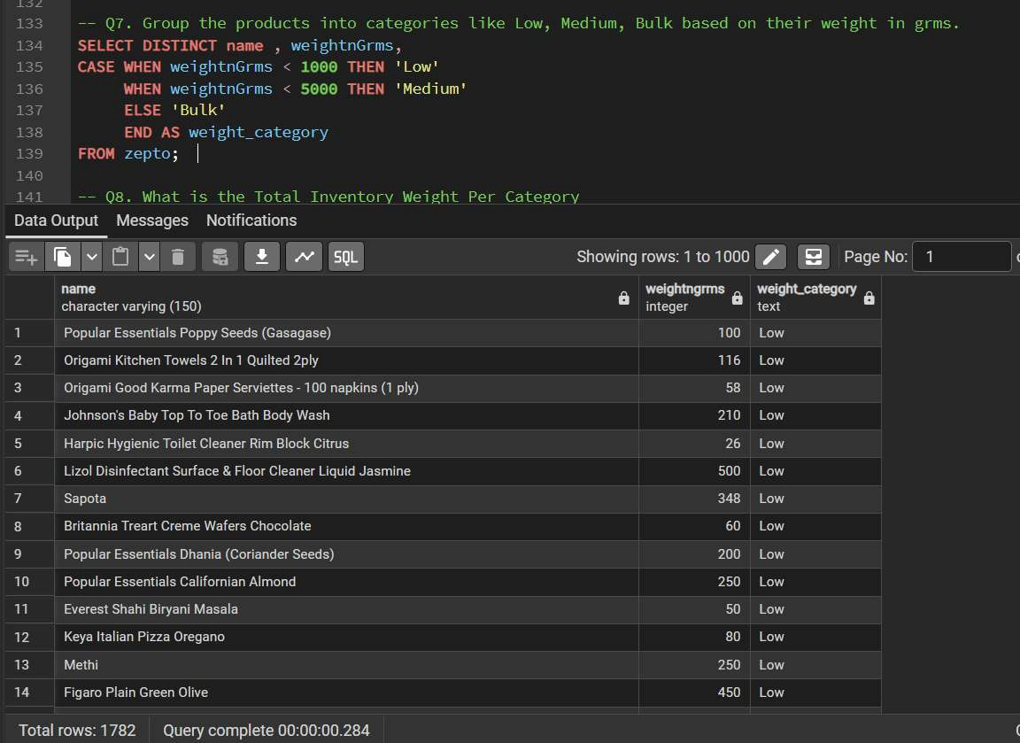

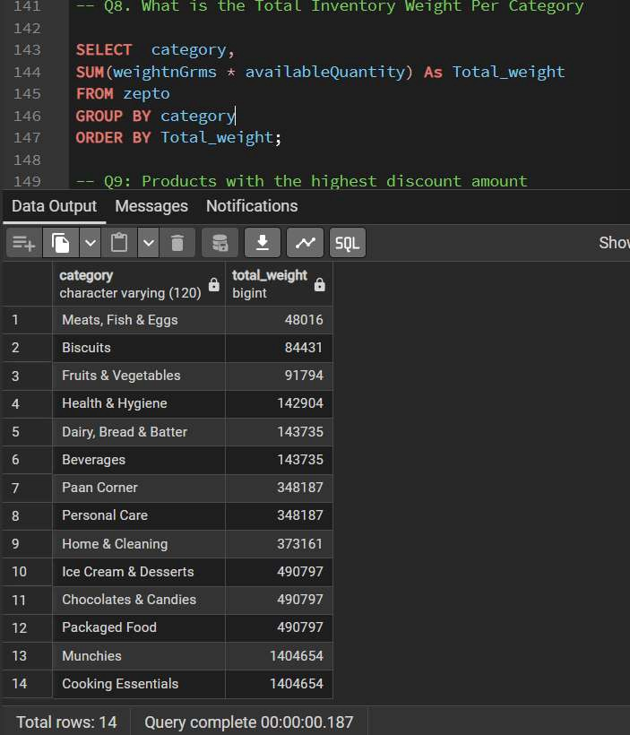

- -- Q9: Products with the highest discount amount
- SELECT
- name,
- category,
- mrp,
- discountSellingPrice,
- ROUND(mrp - discountSellingPrice, 2) AS discount_amount
- FROM zepto
- WHERE mrp > 6
- AND discountSellingPrice > 0
- ORDER BY discount_amount DESC
- LIMIT 10;
Data Output Messages Notifications
i::rnoo
�Lli1iE.□ mrm� Showing rows:1 to10 r/.J I::I Page No:I 1 ' of1
name category m'l> discQuntselllngprice Ii diacou.nt.emount II
6
character varying (150) character varying (120) Ii numeric (8,2) II numeric (8,2) numeric
Borges Extra Light Olive Oil Bottle Cooking Essentials 2600.00 1399.00 1201.00
2 Borges Elctra Light Olive Oil Bottle Munchies 2600.00 1399.00 1201.00
3 Paan Comer 1549.00 849.00 700.00
Pampers Pants | - Large
Pampers Pants | - Large

4 Personal Care 1549.00 849.00 700.00
Kelloggs Chocos - |  | Moons & Stars
Kelloggs Chocos - |  | Moons & Stars
Ke | loggs Chocos - | Moons & Stars

5 Packaged Food 660.00 396.00 264.00
6 Chocolates & Candies 660.00 396.00 264.00
7 l Ice Cream & Desserts 660.00 396.00 264.00
- Pampers Active Baby Diapers New Born Elctra Sm... Paan Corner 1099.00 849.00 250.00
- Pampers Active Baby Diapers New Born Elctra Sm... Personal Care 1099.00 849.00 250.00
- Popular Essentials Californian Almond Cooking Essentials 695.00 470.00 225.00

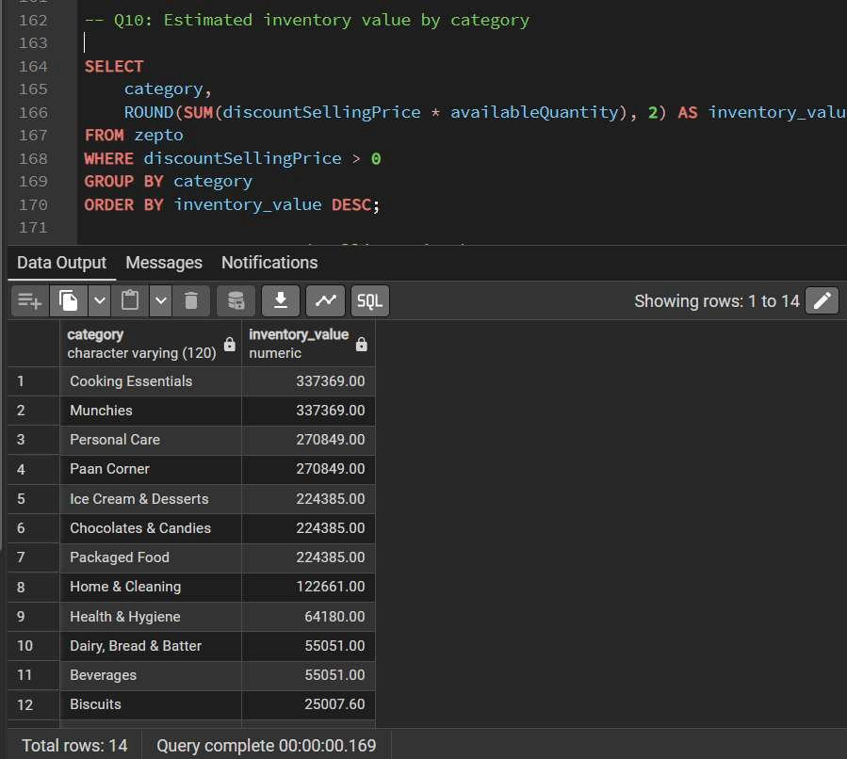

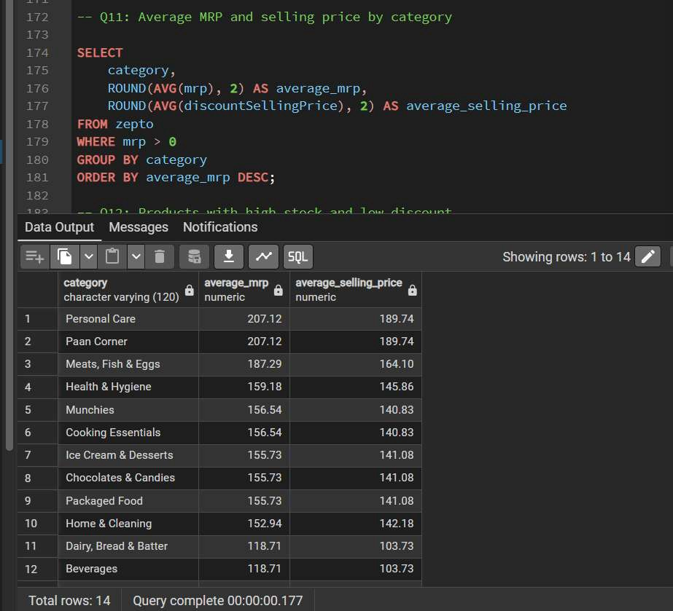

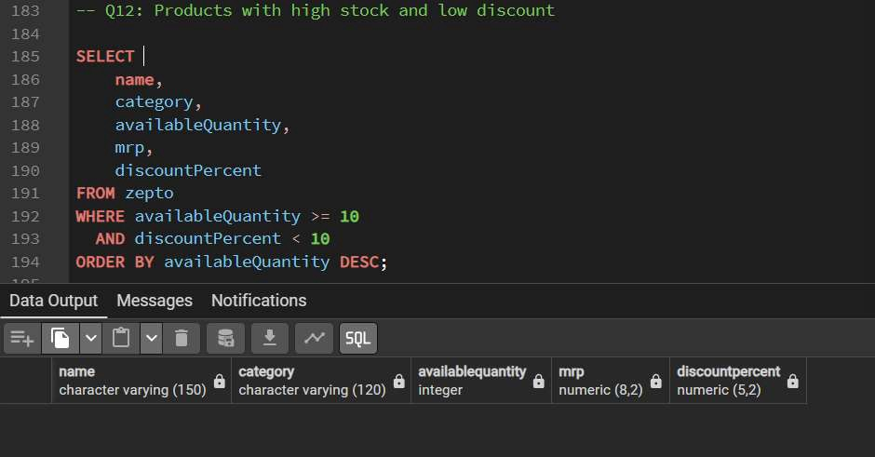

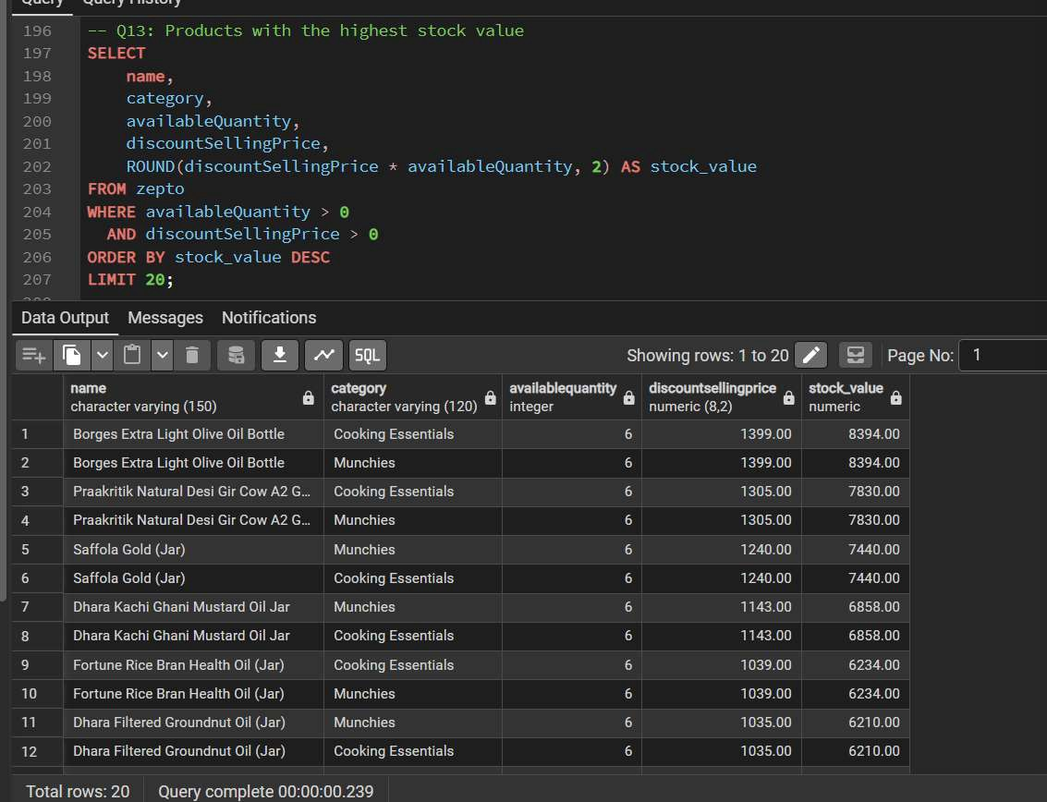

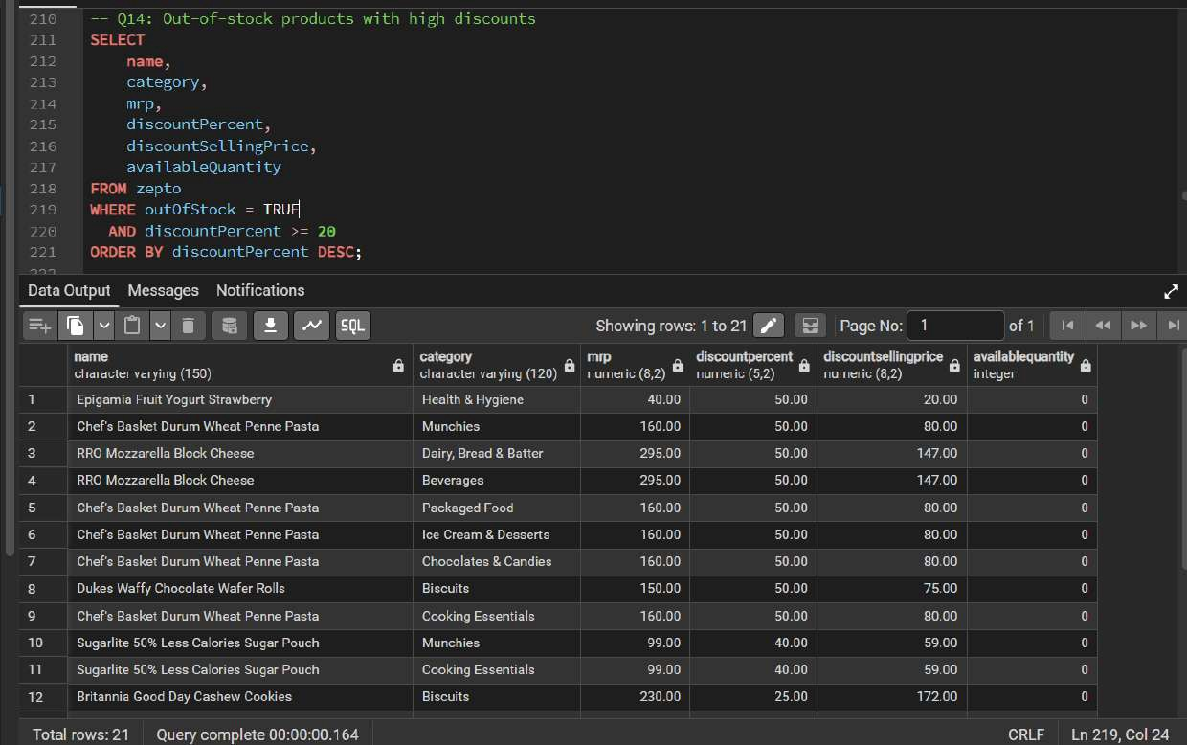

- -- QlS: Out-of-stock rate by category
- SELECT

225

226
227
228
229
230
231
category,
COUNT(*) AS total_products,
SUM(CASE WHEN outOfStock = TRUE THEN l ELSE 0 END) AS out_of_stock_products, ROUND(
1ee.e * SUM(CASE WHEN outOfStock = TRUE THEN l ELSE e END) / COUNT(*),
,1
) AS out of_stock_rate

- FROM zepto
- GROUP BY category
- ORDER BY out_of_stock rate DESC;
Data Output Messages Notifications
m
"'t1[1ii1:2:;□lG;l[i] (.$1 G � Showing rows: 1101•� I:: I Page No:I 1

category
totalproducts
character varying (120) Ii bigint
  - Biscuits
  - Beverages
  - Dairy, Bread & Batter
  - Meats, Fish & Eggs
  - Health & Hygiene Munchies
'
- Cooking Essentials
- Ice Cream & Desserts
- Chocolates & Candies
- Packaged Food
- Home & Cleaning Fruits & Vegetables
12
Ii out_of_stock..producta Ii ouLof�stoclullte Ii
bigint numeric
42 28.57
147
129
129
21.71
28
28
12
21.71
19.05
63
13 13.40
97
12.45
514
64
64 12.45
514
388
388
388
193
93
11.60
45
45
45
19
6
11.60
11.60
9.84
6.45

