National University of Computer and Emerging Sciences

SOFTWARE ENGINEERING
SOFTWARE REQUIREMENTS SPECIFICATION
THREXIA
Group Members:
Name | Roll Number | Sub-section
Anas Naveed Butt | 23L-0764 | 6-D
Muhammad Usman Saboor | 23L-0813 | 6-D
Ibrahim Rashid | 23L-0741 | 6-D
Mohib Ali Khattak | 23L-0763 | 6-D

Department of Computer Science
FAST-NU, Lahore, Pakistan
- Functional Requirements
- Functional Requirement 1: User Registration
The system allow administrators to create user accounts for security analysts and other authorized personnel.

- Functional Requirement 2: User Authentication
The system shall authenticate users through secure login credentials to prevent unauthorized access.

- Functional Requirement 3: Role-Based Access Control
The system shall restrict access to modules and data based on the authenticated user's assigned role.

- Functional Requirement 4: Log File Upload
The system shall allow administrators to upload system log files in supported formats (CSV, JSON) for analysis.

- Functional Requirement 5: Log Preprocessing
The system shall automatically preprocess uploaded log data by cleaning, normalizing, and extracting relevant features prior to analysis.

- Functional Requirement 6: AI-Based Threat Detection
The system shall detect anomalous and potentially malicious activities within log data using trained machine learning models.

- Functional Requirement 7: Risk Score Generation
The system shall evaluate detected anomalies and assign a numerical risk score to quantify the severity of each potential threat.

- Functional Requirement 8: Threat Alert Notification
The system shall generate and display real-time notifications to security analysts when high-risk threats are detected.

- Functional Requirement 9: Dashboard Visualization
The system shall provide an interactive visual dashboard displaying real-time and historical threat analytics through charts and graphs.

- Functional Requirement 10: Report Generation
The system allows users to generate comprehensive threat analysis reports exportable in PDF or CSV format.

1.1 Use Case for Each Functional Requirement
Functional Requirement 1: User Registration
Use Case Name | Create User Account
Actor(s) | Administrator
Precondition | The Administrator is authenticated and logged into the system.
Postcondition | A new user account is created, stored in the system, and the user is notified of their credentials.
Main Flow | 1. Administrator navigates the User Management module.  2. Administrator selects 'Create New User' and fills in the required details (full name, email, role).  3. System validates all input fields for completeness and correct format.  4. System verifies that the username and email address do not already exist.  5. System creates the account, assigns the specified role, and saves the record to the database.  6. System displays a confirmation message along with the new user's credentials.
Alternative Flow | If input validation fails (Step 3) or a duplicate account is detected (Step 4), the system highlights the erroneous fields and prompts the Administrator to correct them before proceeding.

Functional Requirement 2: User Authentication
Use Case Name | User Login
Actor(s) | Administrator, Security Analyst
Precondition | The user has a registered and active account in the system.
Postcondition | The user is authenticated and redirected to their role-specific dashboard.
Main Flow | 1. User navigates to the system login page.  2. User enters their username and password.  3. System validates the credentials against stored records.  4. System generates a secure session token upon successful validation.  5. User is granted access and redirected to the appropriate dashboard.
Alternative Flow | If credentials are invalid (Step 3), the system displays an error message. After three consecutive failed attempts, the account is temporarily locked and the user is notified.

Functional Requirement 3: Role-Based Access Control
Use Case Name | Access System Modules
Actor(s) | Administrator, Security Analyst
Precondition | The user is successfully authenticated and has an assigned role in the system.
Postcondition | The user can only view and interact with modules and features permitted by their role.
Main Flow | 1. User successfully logs into the system.  2. System retrieves the user's assigned role from the database.  3. System evaluates role permissions against all available modules.  4. System renders only the modules and features permitted for that specific role.  5. User interacts with the permitted features of the system.
Alternative Flow | If a user attempts to access a restricted module via a direct URL, the system intercepts the request and returns an 'Access Denied' page.

Functional Requirement 4: Log File Upload
Use Case Name | Upload Log File
Actor(s) | Administrator
Precondition | The Administrator is logged in and has a valid log file available for upload.
Postcondition | The log file is validated, stored in the database, and queued for preprocessing.
Main Flow | 1. Administrator navigates to the Log Management module.  2. Administrator clicks 'Upload Logs' and selects a log file from their local system.  3. System validates the file format (CSV or JSON) and checks that it does not exceed the size limit.  4. System parses and stores the raw log data in the database.  5. System displays a success notification and queues the file for preprocessing.
Alternative Flow | If the file format is unsupported or the file is corrupt (Step 3), the system rejects the upload and informs the Administrator of the specific error reason.

Functional Requirement 5: Log Preprocessing
Use Case Name | Preprocess Log Data
Actor(s) | System (Automated Process)
Precondition | A raw log file has been successfully uploaded and stored in the database.
Postcondition | Log data is cleaned, normalized, and feature-extracted, then stored as a processed dataset ready for analysis.
Main Flow | 1. System detects a new log file in the upload queue.  2. System reads the raw log data from the database.  3. System removes duplicate entries, null values, and malformed records.  4. System normalizes data formats including timestamps, IP addresses, and event codes.  5. System extracts relevant features required by the machine learning model.  6. System stores the processed dataset and marks it as ready for threat detection.
Alternative Flow | If the log file is empty or all records are malformed, the system logs the error, marks the file as 'Preprocessing Failed', and sends a notification to the Administrator.

Functional Requirement 6: AI-Based Threat Detection
Use Case Name | Detect Threats
Actor(s) | System (Automated Process)
Precondition | Preprocessed log data is available, and a trained machine learning model is loaded in the system.
Postcondition | Anomalies are identified, flagged as potential threats, and stored with corresponding threat indicators.
Main Flow | 1. System loads the trained machine learning model into memory.  2. System retrieves the preprocessed log dataset.  3. System feeds the log data through the model for pattern analysis.  4. Model identifies entries that deviate significantly from established baselines.  5. System flags anomalous entries and generates threat indicators including type, timestamp, and source.  6. System stores the detected threats and triggers the risk scoring process.
Alternative Flow | If the machine learning model fails to load or returns an error, the system logs the failure, halts the analysis, and sends a system alert to the Administrator.

Functional Requirement 7: Risk Score Generation
Use Case Name | Generate Risk Score
Actor(s) | System (Automated Process)
Precondition | Threats have been detected and stored by the threat detection module.
Postcondition | Each detected threat is assigned a numerical risk score and a corresponding severity level (Low, Medium, High, or Critical).
Main Flow | 1. System retrieves all newly detected threat records.  2. System evaluates each threat based on factors such as frequency, source, potential impact, and anomaly type.  3. System applies the risk scoring algorithm to compute a numerical score ranging from 0 to 100.  4. System maps the score to a severity level: Low (0-25), Medium (26-50), High (51-75), Critical (76-100).  5. System stores the risk score and severity level alongside the corresponding threat record.
Alternative Flow | If insufficient data is available to compute a reliable score, the system assigns an 'Undetermined' severity and flags the threat for manual review by a Security Analyst.

Functional Requirement 8: Threat Alert Notification
Use Case Name | View and Manage Alerts
Actor(s) | Security Analyst
Precondition | The Security Analyst is logged in, and threat alerts have been generated by the detection module.
Postcondition | The Security Analyst has reviewed the alert and recorded an appropriate action.
Main Flow | 1. System detects a High or Critical severity threat and triggers a notification.  2. Security Analyst opens the Alert Management panel from the dashboard.  3. System retrieves and displays all active alerts sorted by severity and timestamp.  4. Security Analyst selects an alert to view detailed information including log source, threat type, and risk score.  5. Security Analyst marks the alert as 'Reviewed', 'Escalated', or 'False Positive'.
Alternative Flow | If no alerts are present, the Alert panel displays a 'No Active Threats Detected' message to confirm the system is operating normally.

Functional Requirement 9: Dashboard Visualization
Use Case Name | View Threat Analytics Dashboard
Actor(s) | Administrator, Security Analyst
Precondition | The user is logged in, and threat data has been processed and stored in the system.
Postcondition | The user has viewed the current threat landscape through interactive visual analytics.
Main Flow | 1. User navigates to the main Dashboard module.  2. System retrieves the latest threat analytics data from the database.  3. System renders visualizations including threat frequency trends, risk score distributions, top threat sources, and severity breakdowns.  4. User applies filters such as time range, threat type, or severity level.  5. Dashboard dynamically updates all visualizations based on the applied filters.
Alternative Flow | If no threat data is available for the selected period, the dashboard displays placeholder charts with a 'No Data Available' message.

Functional Requirement 10: Report Generation
Use Case Name | Generate Security Report
Actor(s) | Security Analyst
Precondition | The Security Analyst is logged in and threat data is available in the system.
Postcondition | A formatted security report is generated and made available for download.
Main Flow | 1. Security Analyst navigates to the Report Generation module.  2. Security Analyst selects the report type (e.g., Daily Summary, Incident Report, Threat Trend Analysis).  3. Security Analyst specifies parameters such as date range, severity filter, and export format (PDF or CSV).  4. System compiles and formats the relevant threat data based on the specified parameters.  5. System generates the report file and presents a download link to the Security Analyst.  6. Security Analyst downloads the report for distribution or further reference.
Alternative Flow | If no data matches the selected parameters, the system notifies the Security Analyst and suggests broadening the filter criteria.

2 Non-Functional Requirement

1. Non-Functional Requirement for User Registration
Related Functional Requirement: User Registration
The system must ensure that all data entered during account creation is validated and sanitized before being stored. User registration communication shall occur over secure encrypted channels to protect sensitive information.

2. Non-Functional Requirement for User Authentication
Related Functional Requirement: User Authentication
User credentials must be stored using secure password hashing mechanisms rather than plain text. The login process should verify credentials quickly and efficiently to provide smooth user experience.

3. Non-Functional Requirement for Role-Based Access Control
Related Functional Requirement: Role-Based Access Control
The system must enforce strict authorization rules so that users only interact with resources permitted by their assigned roles. Each request made by a user should be validated against the permission model before granting access. Any unauthorized access attempt must be recorded for security monitoring purposes.

4. Non-Functional Requirement for Log File Upload
Related Functional Requirement: Log File Upload
The system must support reliable uploading of structured log files without data loss. Uploaded files must be checked to confirm they match supported file formats before processing. The upload process should maintain system stability even when large files are submitted.

5. Non-Functional Requirement for Log Preprocessing
Related Functional Requirement: Log Preprocessing
Data preprocessing operations should be performed efficiently so that log analysis can begin without significant delay. The system must preserve data consistency while cleaning and transforming log records.

6. Non-Functional Requirement for AI-Based Threat Detection
Related Functional Requirement: AI-Based Threat Detection
The anomaly detection component must provide reliable analytical results with a high level of detection accuracy. Threat analysis should be completed within a reasonable processing time for uploaded log datasets. The machine learning models should be designed to support periodic updates and retraining when new data becomes available.

7. Non-Functional Requirement for Risk Score Generation
Related Functional Requirement: Risk Score Generation
The system should apply a consistent evaluation method when calculating risk scores for detected anomalies. Risk evaluation should occur immediately after anomaly detection to maintain real-time analysis capabilities. Risk levels must be presented in a clear and understandable severity classification.

8. Non-Functional Requirement for Threat Alert Notification
Related Functional Requirement: Threat Alert Notification
Security alerts must be generated promptly after suspicious activity is identified. Notification delivery should occur with minimal delay so analysts can respond quickly. All generated alerts must be stored for later review and auditing.

9. Non-Functional Requirement for Dashboard Visualization
Related Functional Requirement: Dashboard Visualization
The dashboard interface should be responsive and easy to navigate for users. Graphs and visual indicators must present security insights in a clear and understandable manner. The system should support efficient loading of analytical data without degrading performance.

10. Non-Functional Requirement for Report Generation
Related Functional Requirement: Report Generation
The system should allow reports to be produced in commonly used export formats. Report generation must maintain accurate representation of analyzed threat data. The reporting feature should operate efficiently so that users receive generated reports without long waiting times.

3. CLASS DIAGRAM

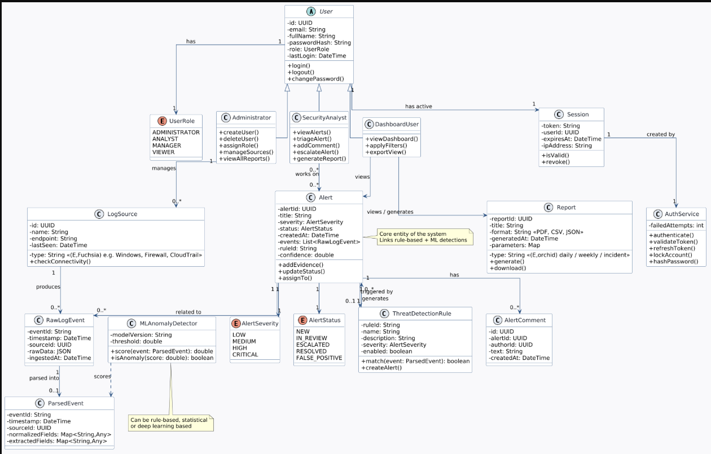

5. USE CASE DIAGRAM

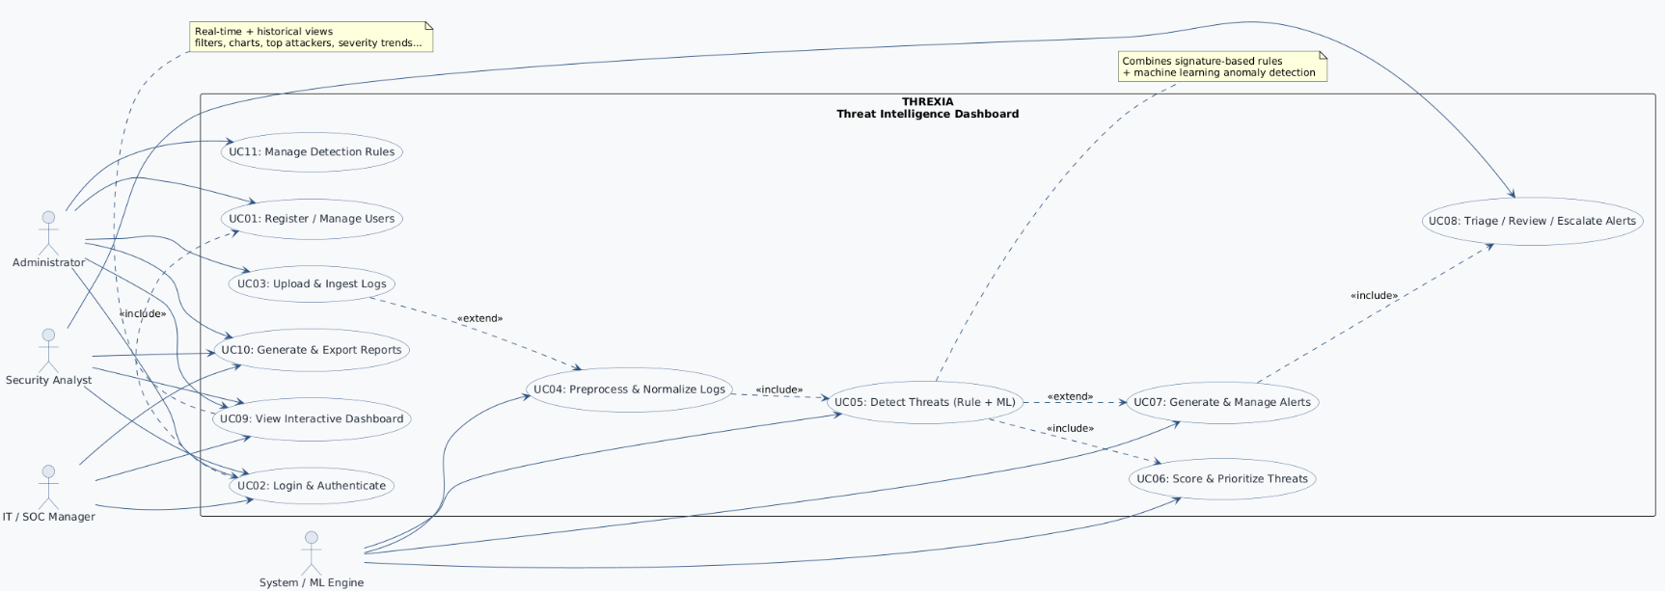

4. 1 DFD LEVEL 0

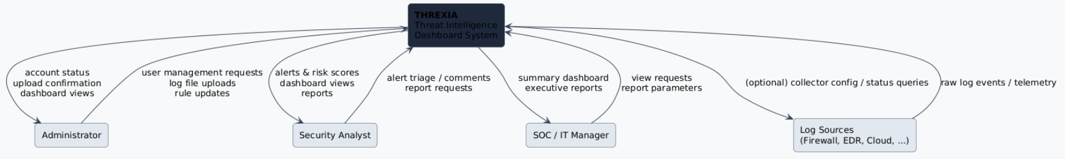

4.2 DFD LEVEL 1

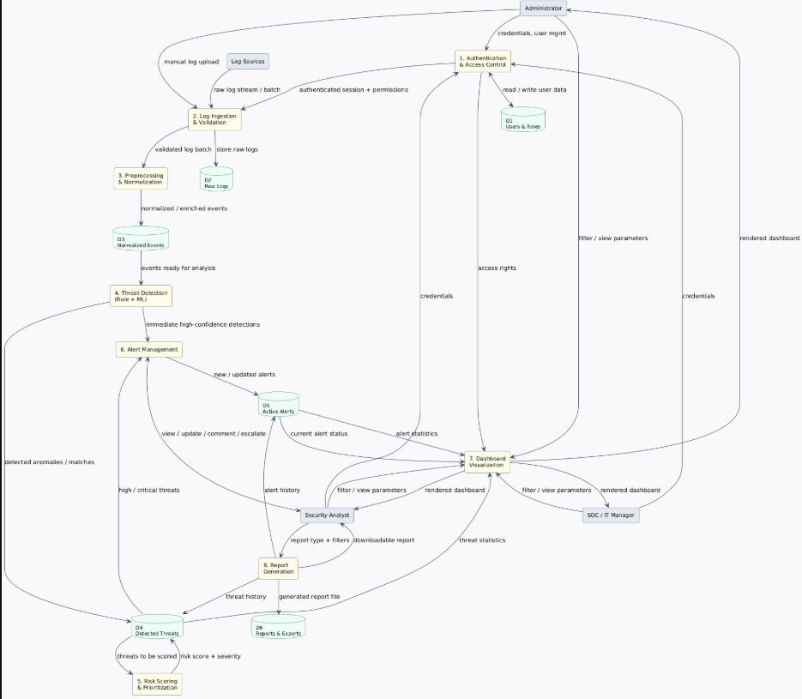

4.3 DFD LEVEL 2

