*QUESTIONS :*

Adding user command :

* CREATE [USER](http://localhost/phpmyadmin/phpMyAdmin-5.0.2-all-languages/url.php?url=https://dev.mysql.com/doc/refman/5.5/en/information-functions.html#function_user) 'anassifi'@'localhost' IDENTIFIED WITH mysql_native_password AS '***';GRANT ALL PRIVILEGES ON *.* TO 'anassifi'@'localhost' REQUIRE NONE WITH GRANT OPTION MAX_QUERIES_PER_HOUR 0 MAX_CONNECTIONS_PER_HOUR 0 MAX_UPDATES_PER_HOUR 0 MAX_USER_CONNECTIONS 0;

*# Step 1 :*

*#1 In the table ‘products’ add a new column called with this description :*

***Product_origin varchar(50)* .**

[ALTER](http://localhost/phpmyadmin/phpMyAdmin-5.0.2-all-languages/url.php?url=https://dev.mysql.com/doc/refman/5.5/en/alter-table.html) [TABLE](http://localhost/phpmyadmin/phpMyAdmin-5.0.2-all-languages/url.php?url=https://dev.mysql.com/doc/refman/5.5/en/alter-table.html) product ADD Product_origin [varchar](http://localhost/phpmyadmin/phpMyAdmin-5.0.2-all-languages/url.php?url=https://dev.mysql.com/doc/refman/5.5/en/string-types.html)(50);

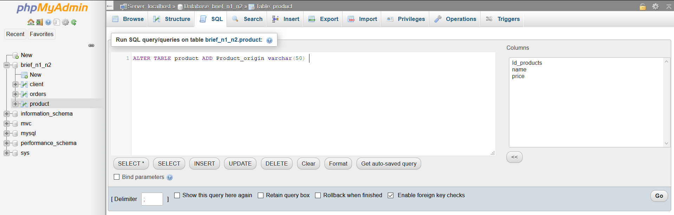

#2 what’s the SQL query that allow us to delete a column in a table

ALTER TABLE “table_name” DROP COLUMN “name”;

#3 Pour aller plus loin dans la définition des donnée (LDD) ; on utilise un mot clé commun appelé **‘Truncat’** ? expliquez en quelques ligne le fonctionnement de cette commande et donner un exemple explicatif ?

Supprime toutes les lignes d'une table ou des partitions spécifiées d'une table, sans enregistrer les suppressions de lignes individuelles. TRUNCATE TABLE est similaire à l'instruction DELETE sans clause WHERE; cependant, TRUNCATE TABLE est plus rapide et utilise moins de ressources système et de journal des transactions.

#4 Add a unique constraint to the ‘first_name’ and ‘last_name’ column in clients table ? what’s UNIQUE constraint ?

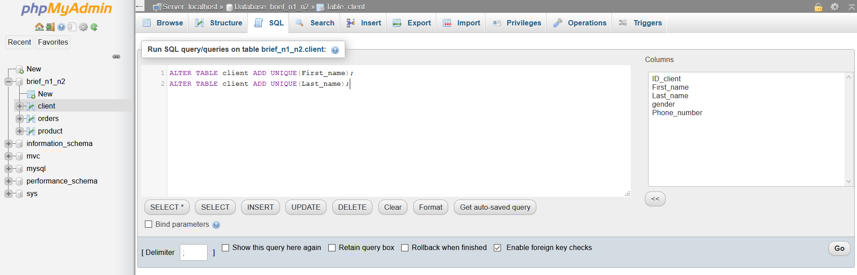

La contrainte UNIQUE garantit que toutes les valeurs d'une colonne sont différentes.

ALTER TABLE client ADD UNIQUE(First_name);

ALTER TABLE client ADD UNIQUE(Last_name);

#5 change the column name ‘order_tim’e to ’Date_order’ in the table ‘command’ and change the type to ‘DATETIME’

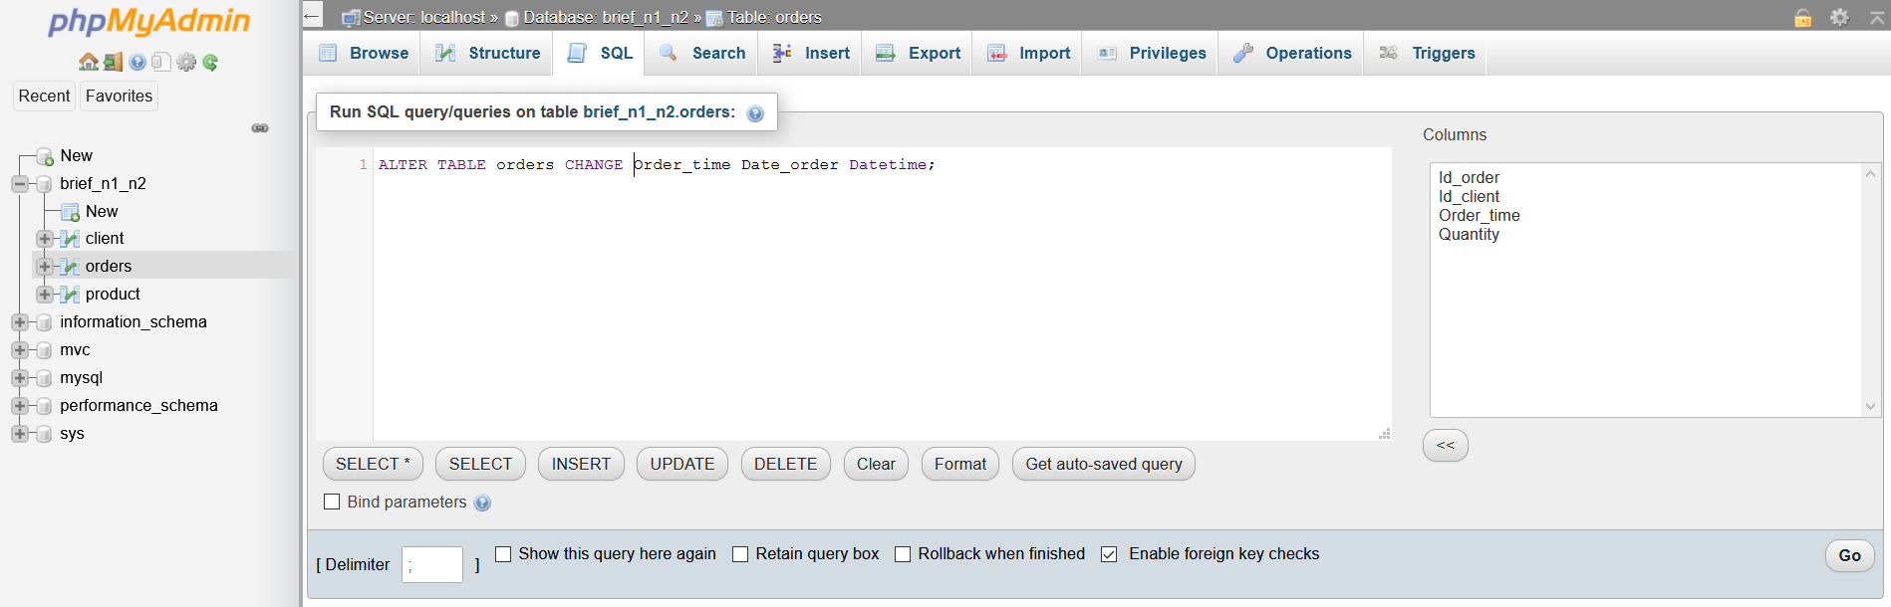

[ALTER](http://localhost/phpmyadmin/phpMyAdmin-5.0.2-all-languages/url.php?url=https://dev.mysql.com/doc/refman/5.5/en/alter-table.html) [TABLE](http://localhost/phpmyadmin/phpMyAdmin-5.0.2-all-languages/url.php?url=https://dev.mysql.com/doc/refman/5.5/en/alter-table.html) orders CHANGE Order_time Date_order [Datetime](http://localhost/phpmyadmin/phpMyAdmin-5.0.2-all-languages/url.php?url=https://dev.mysql.com/doc/refman/5.5/en/date-and-time-types.html)

#6 delete the column ‘quantity’ from the table ‘command’

[ALTER](http://localhost/phpmyadmin/phpMyAdmin-5.0.2-all-languages/url.php?url=https://dev.mysql.com/doc/refman/5.5/en/alter-table.html) [TABLE](http://localhost/phpmyadmin/phpMyAdmin-5.0.2-all-languages/url.php?url=https://dev.mysql.com/doc/refman/5.5/en/alter-table.html) orders DROP COLUMN Quantity

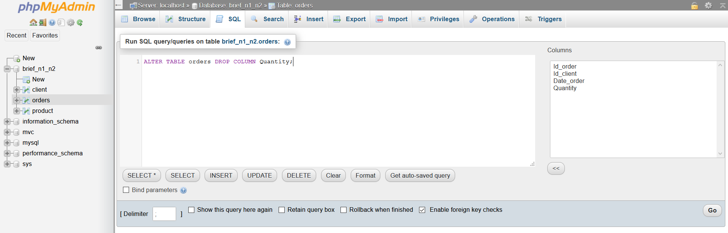

#Establish the foreign key Constraints in order to tie all the tables

(Products, clients, command)

ALTER TABLE order_details ADD FOREIGN KEY(Id_order) REFERENCES orders(Id_order)

ALTER TABLE order_details ADD FOREIGN KEY(Id_products) REFERENCES product(Id_products)

ALTER TABLE products ADD CHECK (price>0)

*# Step 2 :*

*Insert those Data in the table Clients:*

('Chris','Martin','M','01123147789'),

('Emma','Law','F','01123439899'),

('Mark','Watkins','M','01174592013'),

('Daniel','Williams','M',NULL),

('Sarah','Taylor','F','01176348290'),

('Katie','Armstrong','F','01145787353'),

('Michael','Bluth','M','01980289282'),

('Kat','Nash','F','01176987789'),

('Buster','Bluth','M','01173456782'),

('Charlie',NULL,'F','01139287883'),

('Lindsay','Bluth','F','01176923804'),

('Harry','Johnson','M',NULL),

('John','Smith','M','01174987221'),

('John','Taylor','M',NULL),

('Emma','Smith','F','01176984116'),

('Gob','Bluth','M','01176985498'),

('George','Bluth','M','01176984303'),

('Lucille','Bluth','F','01198773214'),

('George','Evans','M','01174502933'),

('Emily','Simmonds','F','01899284352'),

('John','Smith','M','01144473330'),

('Jennifer',NULL,'F',NULL),

('Toby','West','M','01176009822'),

('Paul','Edmonds','M','0196694711

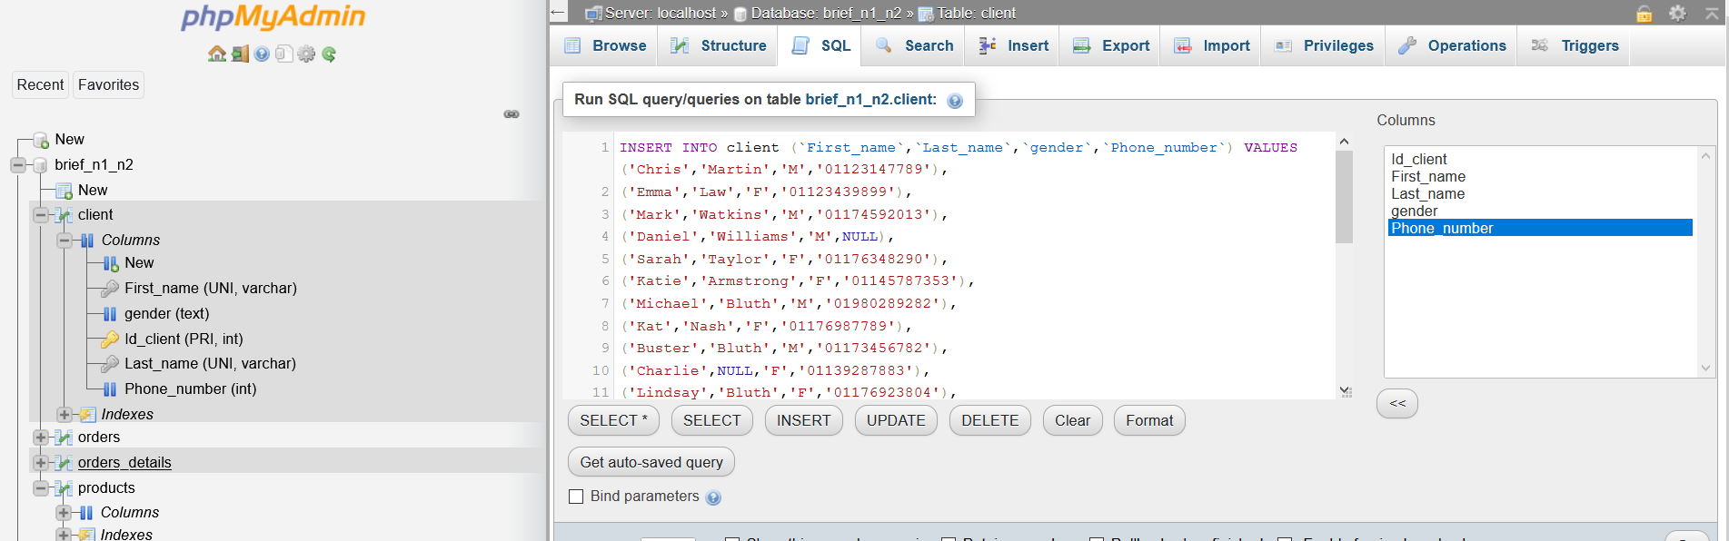

*Insert those Data in the table command:*

(1,1,'2017-01-01 08-02-11'),

(1,2,'2017-01-01 08-05-16'),

(5,12,'2017-01-01 08-44-34'),

(3,4,'2017-01-01 09-20-02'),

(1,9,'2017-01-01 11-51-56'),

(6,22,'2017-01-01 13-07-10'),

(1,1,'2017-01-02 08-03-41'),

(3,10,'2017-01-02 09-15-22'),

(2,2,'2017-01-02 10-10-10'),

(3,13,'2017-01-02 12-07-23'),

(1,1,'2017-01-03 08-13-50'),

(7,16,'2017-01-03 08-47-09'),

(6,21,'2017-01-03 09-12-11'),

(5,22,'2017-01-03 11-05-33'),

(4,3,'2017-01-03 11-08-55'),

(3,11,'2017-01-03 12-02-14'),

(2,23,'2017-01-03 13-41-22'),

(1,1,'2017-01-04 08-08-56'),

(3,10,'2017-01-04 11-23-43'),

(4,12,'2017-01-05 08-30-09'),

(7,1,'2017-01-06 09-02-47'),

(3,18,'2017-01-06 13-23-34'),

(2,16,'2017-01-07 09-12-39'),

(2,14,'2017-01-07 11-24-15'),

(4,5,'2017-01-08 08-54-11'),

(1,1,'2017-01-09 08-03-11'),

(6,20,'2017-01-10 10-34-12'),

(3,3,'2017-01-10 11-02-11'),

(4,24,'2017-01-11 08-39-11'),

(4,8,'2017-01-12 13-20-13'),

(1,1,'2017-01-14 08-27-10'),

(4,15,'2017-01-15 08-30-56'),

(1,7,'2017-01-16 10-02-11');

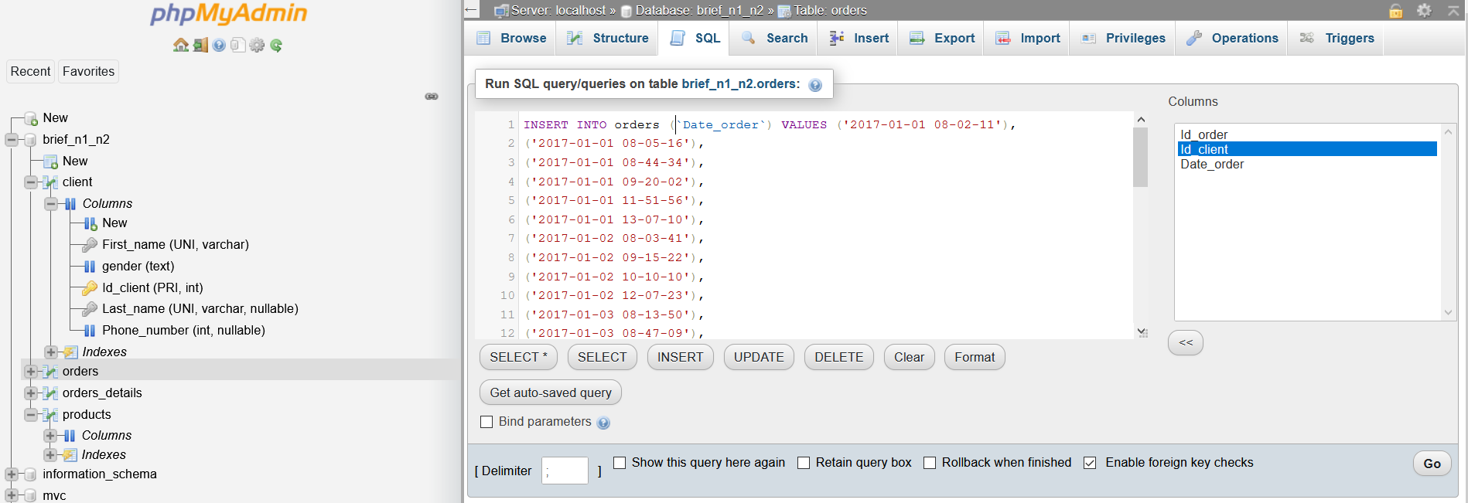

*Insert those Data in the table Products:*

(1,’special coffee’, 7.5,’Brazil’)

(2,’coffee family’, 8,’Cuba’)

(13,’coffee 2.0’, 8.5,’Ethopia’)

(3, ‘animal coffee’,25,’Indonesia’)

(22,’coffe plus’, 15.5,’Italy’)

(14,’coffee ++’,30.00,’Maroc’)

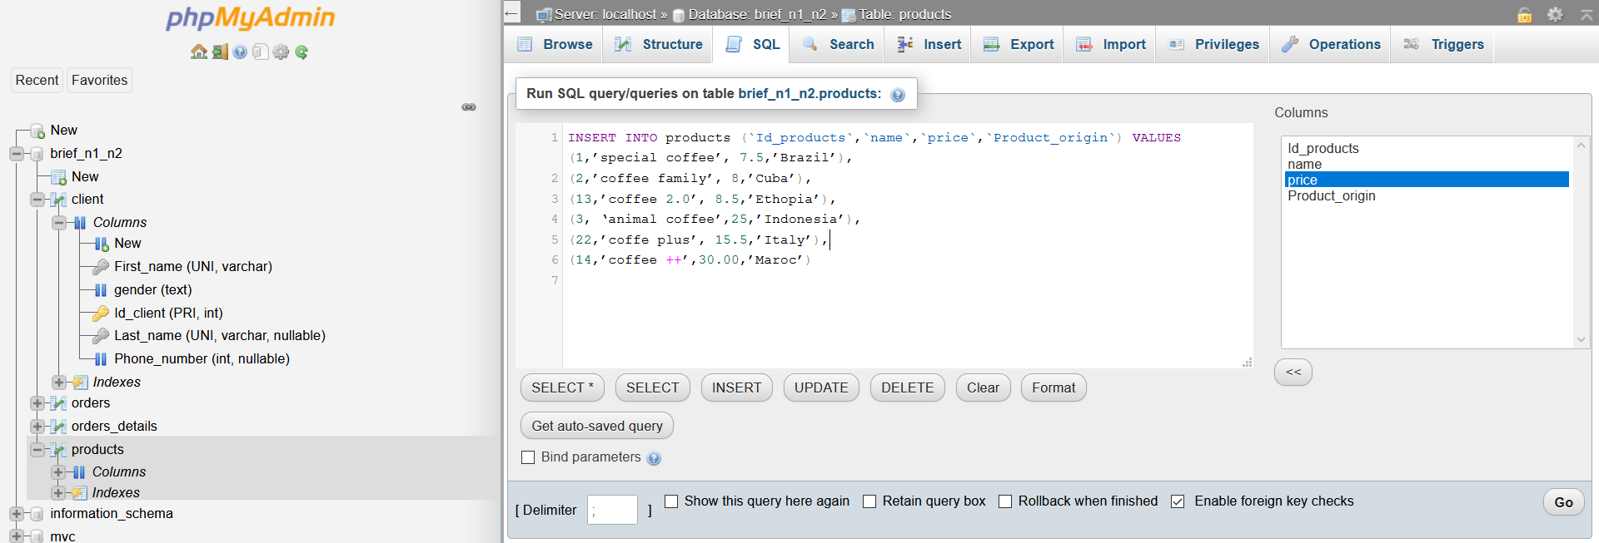

* Doesn’t work until you change the quotes

*#Step 3:*

#1 update in the table products the following statement :

* Price * 5 condition (product_name = special coffee)
* Coffee_orgin = EST Europe where id_product = 22

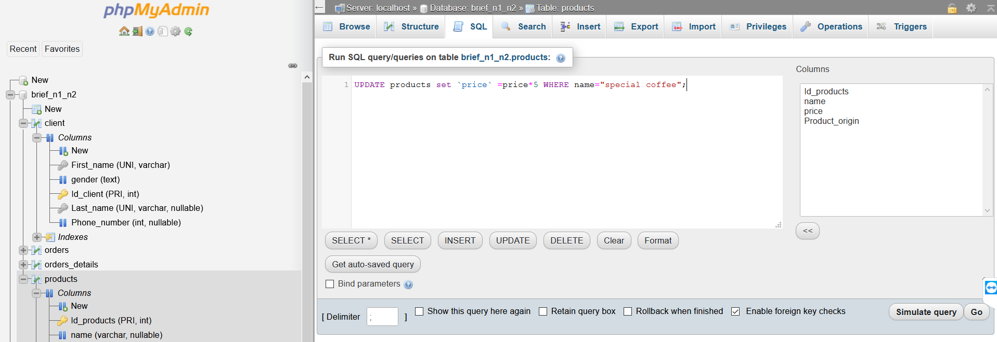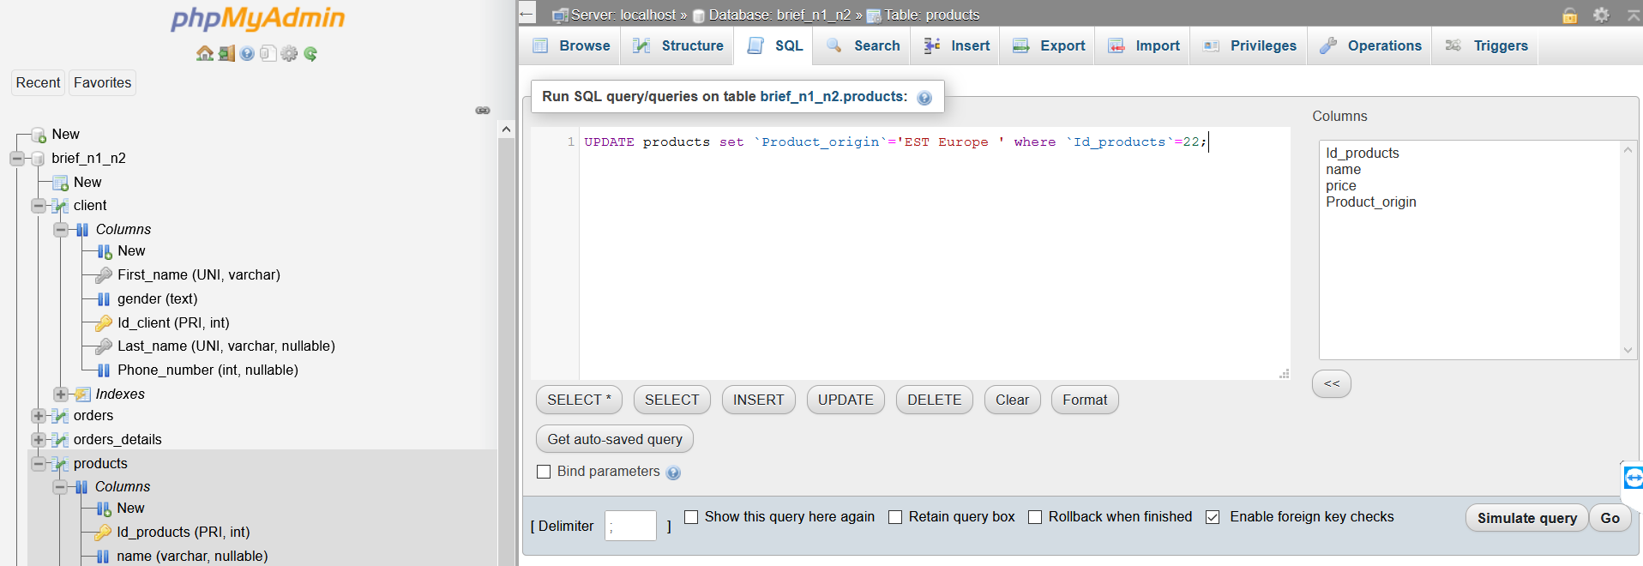

#2 in the table command, Print the recent command ordered

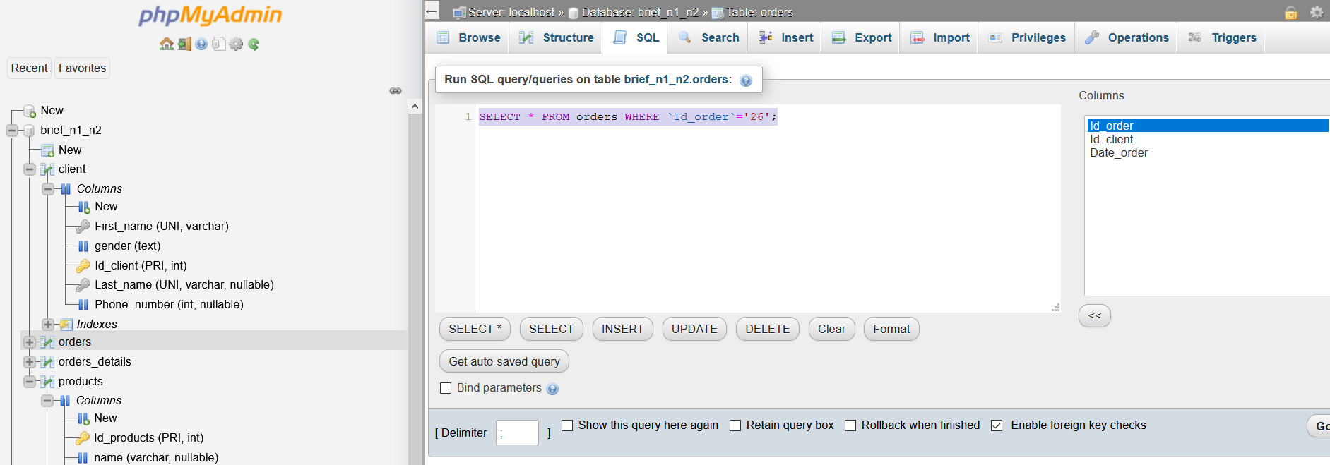

#3 the customer who made the maximum of command

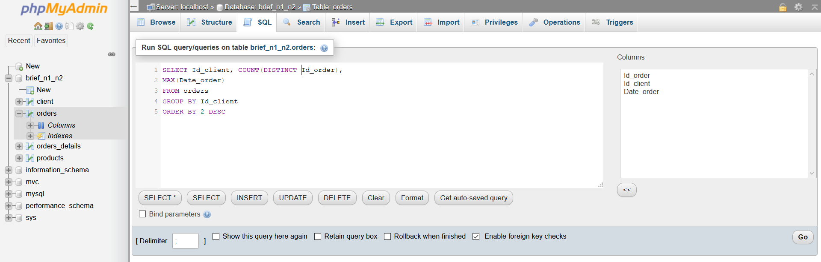

#4 in the table clients print how many man and woman we have

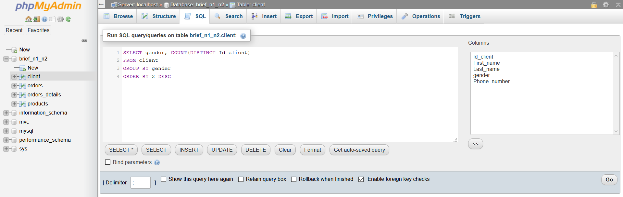

*#Step 4:*

*Selecting:*

#1 Select from the products Table the following:

* All the products which have the price above 15

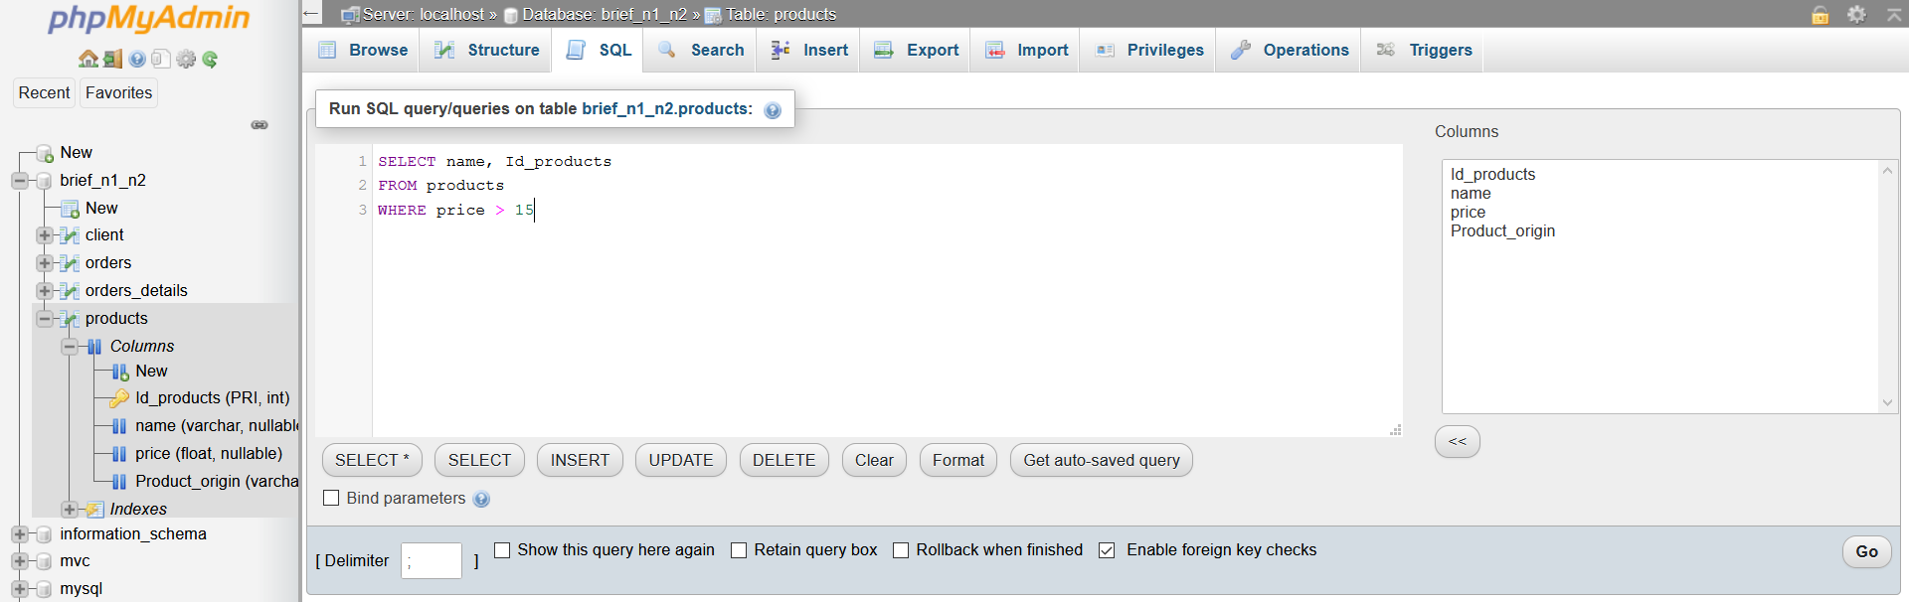

* The product name and the price which contains the sentence ‘special’

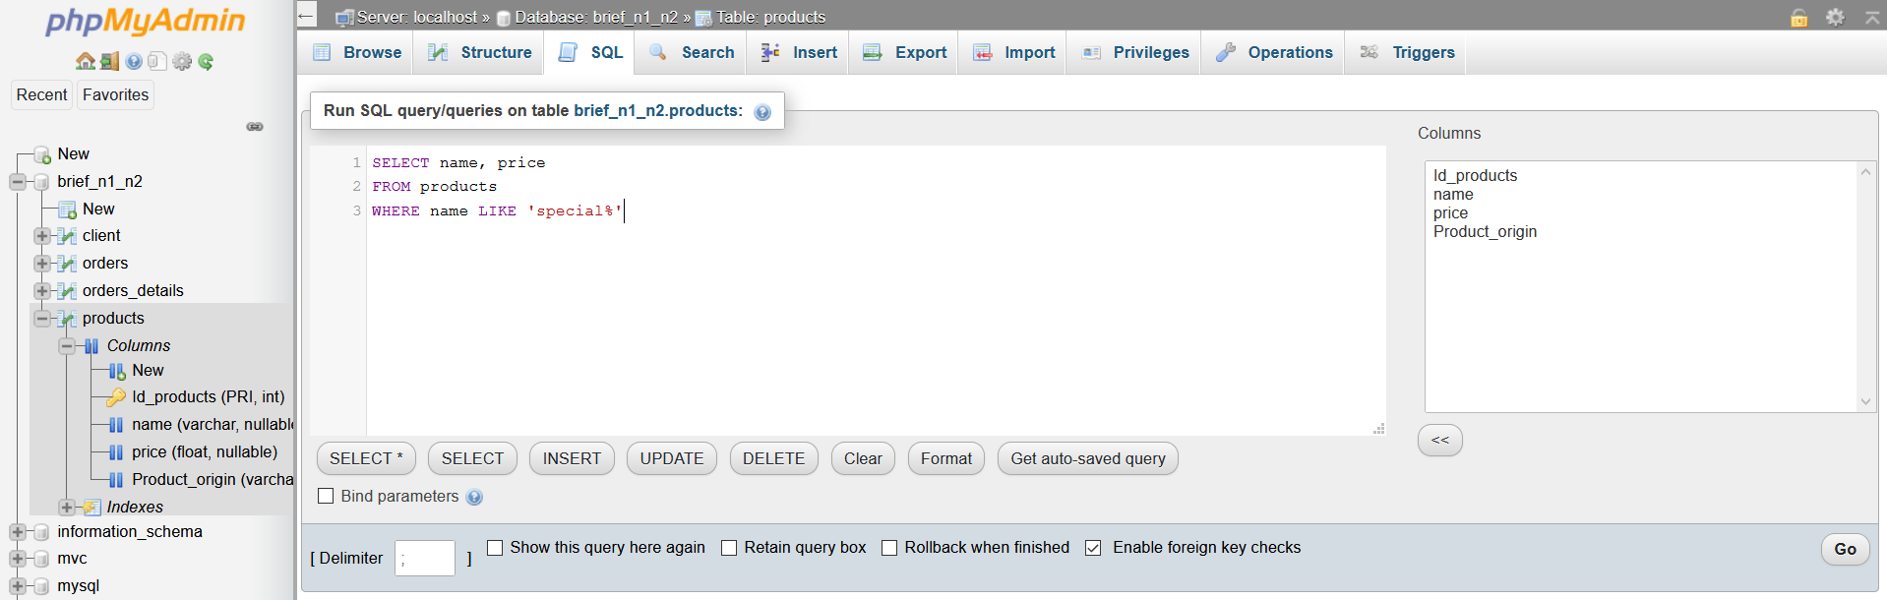

* Product name which price != 8.5

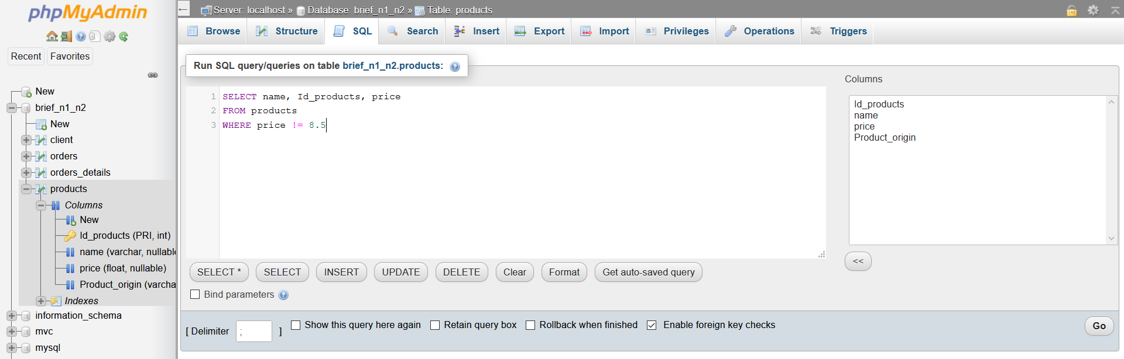

* the name and price of all products with a coffee origin

Equal to Cuba or Indonesia. Ordered by name from A-Z.

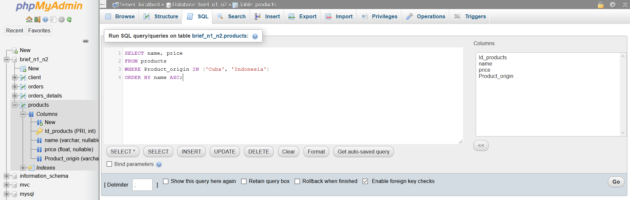

* the name, price and coffee origin but rename the price to

retail_price in the results set.

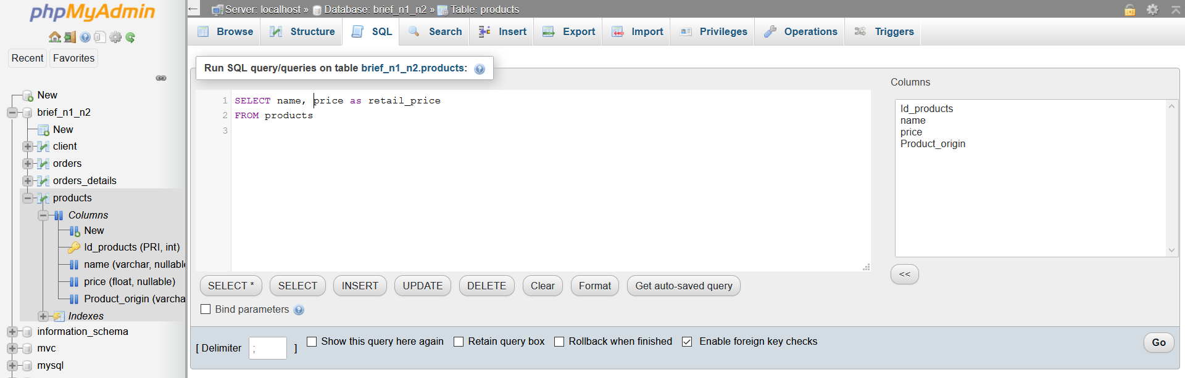

#2 Select from the table clients the following:

* the first name and phone number of all the females who have a last name of Bluth.

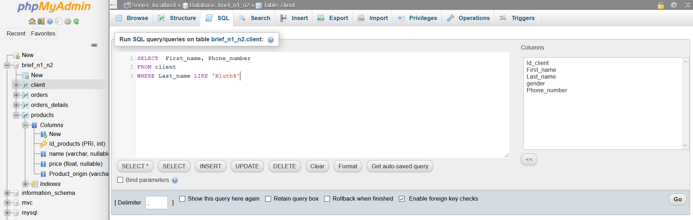

* How many male customers don’t have a phone number entered into the customers table?

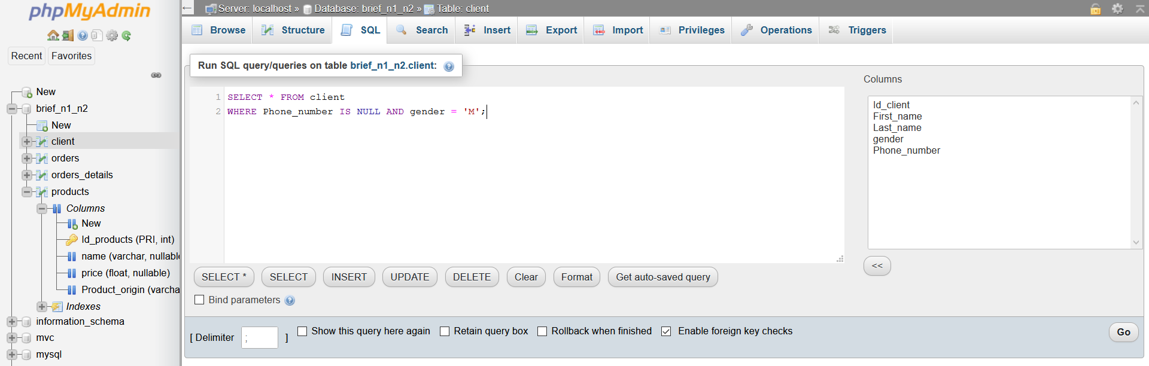

* the first name and phone number of all customers who’s last name contains the pattern ‘ar’.

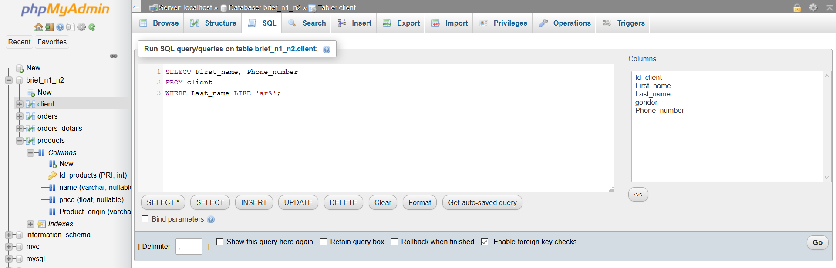

* select distinct last names and order alphabetically from A-Z.

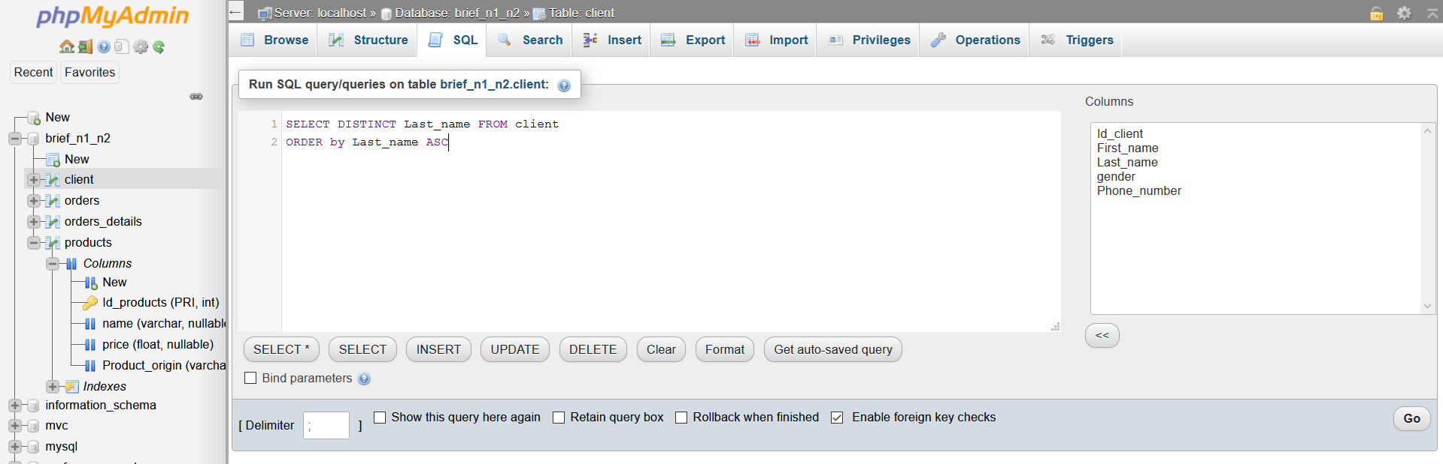

#2 Select from the table command the following :

* all the orders from February 2017 for customers with id’s of 2, 4, 6 or 8.

There isn’t any orders made in February 2017

* the first 3 orders placed by customer with id 1, in january 2017.

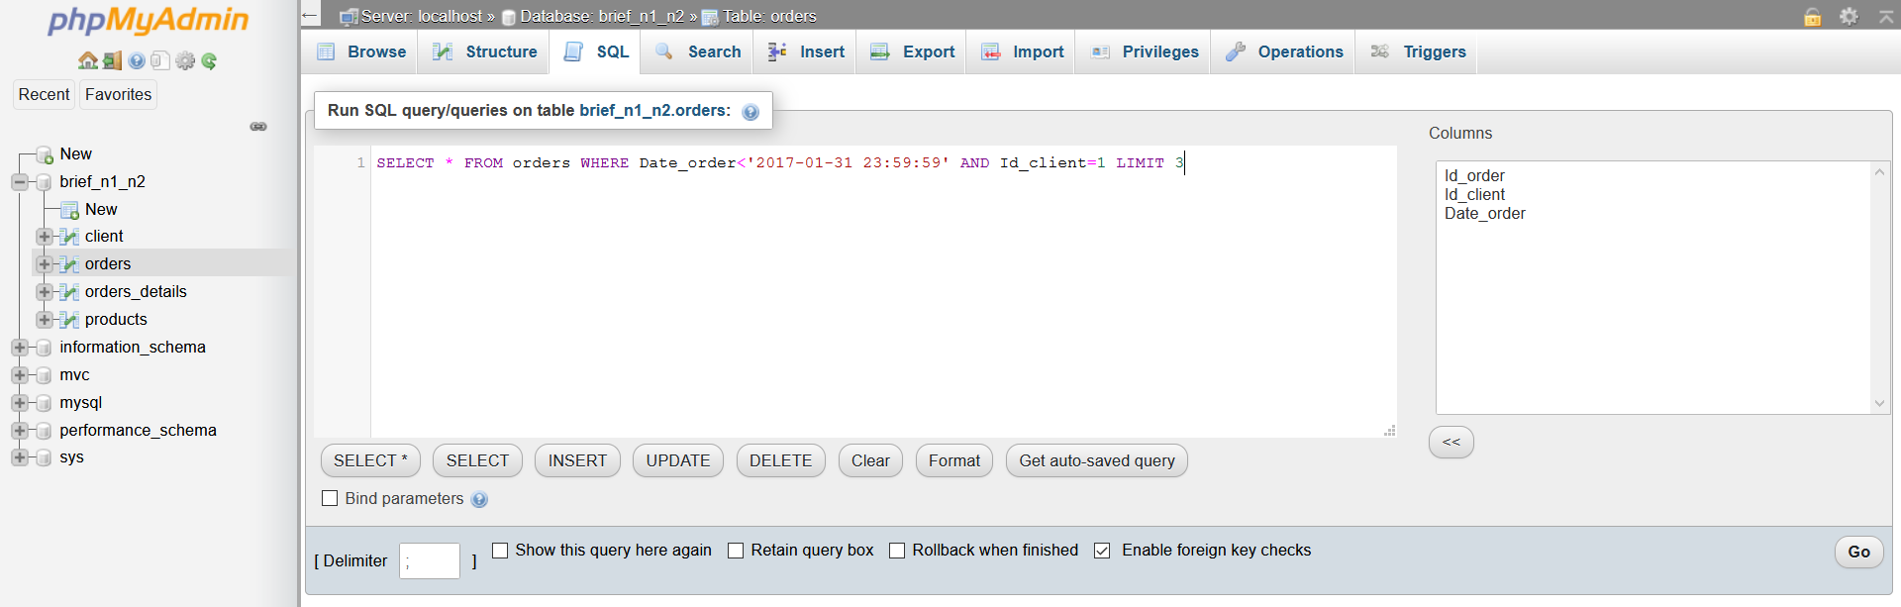

*#Step 5:*

*Multiple Selection using Joins:*

* Select the order id and clients phone number for all orders of product id 4.

There isn’t a product with the id 4

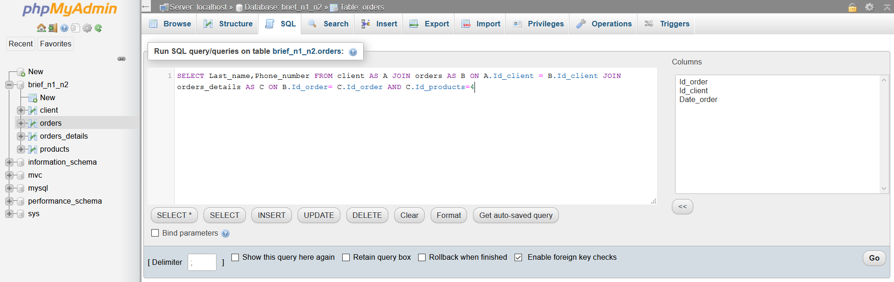

* Select the product name and order time for filter coffees sold between January 15th 2017 and February 14th 2017.

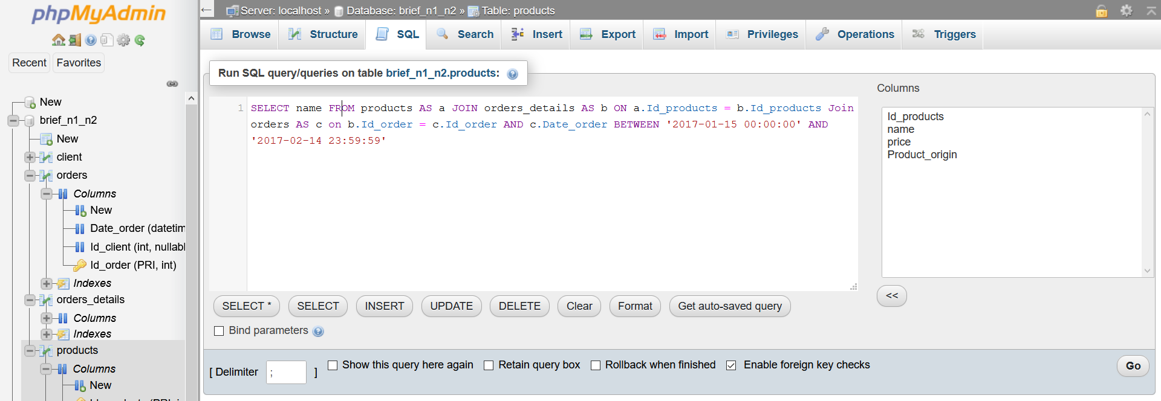

* Select the product name and price and order time for all orders from females in January 2017.

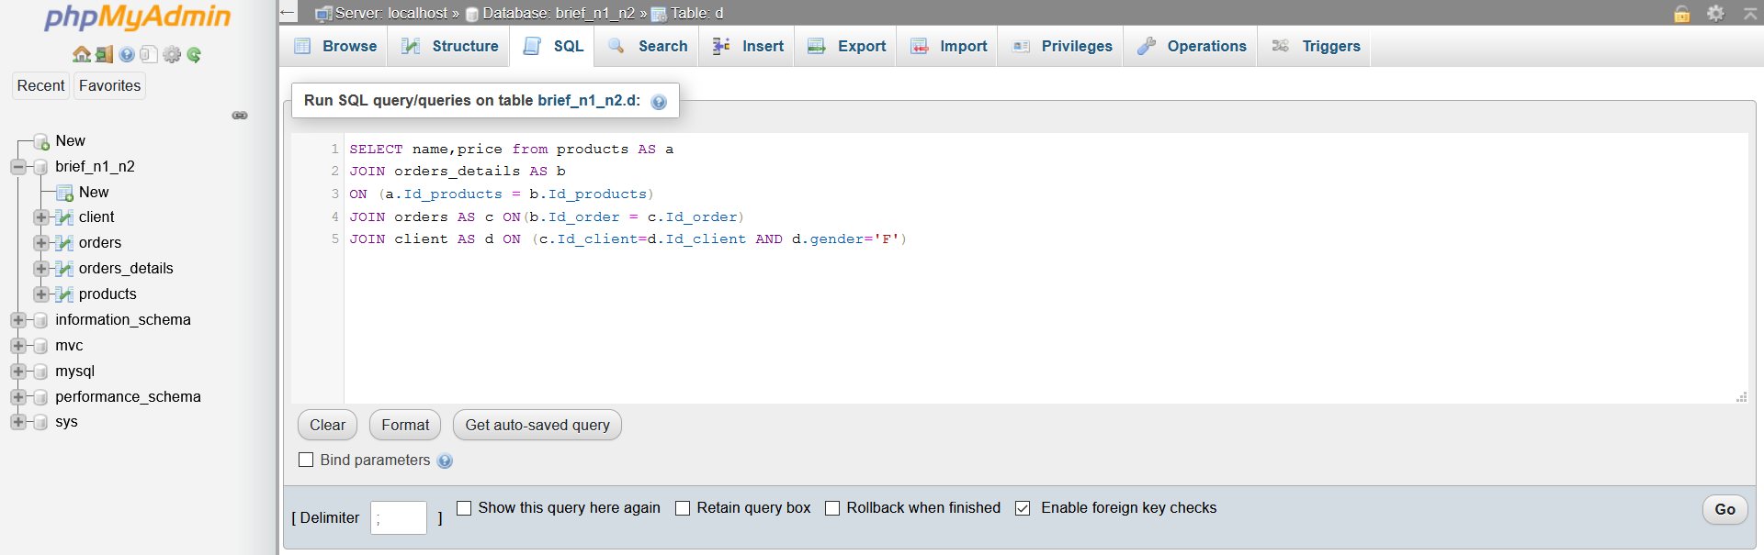

*FIN*