UML and System Design

Campus Service Request Management System
Student: [Student Name] – [Student ID]
All diagrams below were drawn from the final submitted code. The editable sources are in docs/uml/ (.mmd files are Mermaid, use_case_diagram.py draws the use case diagram).

1. Use Case Diagram
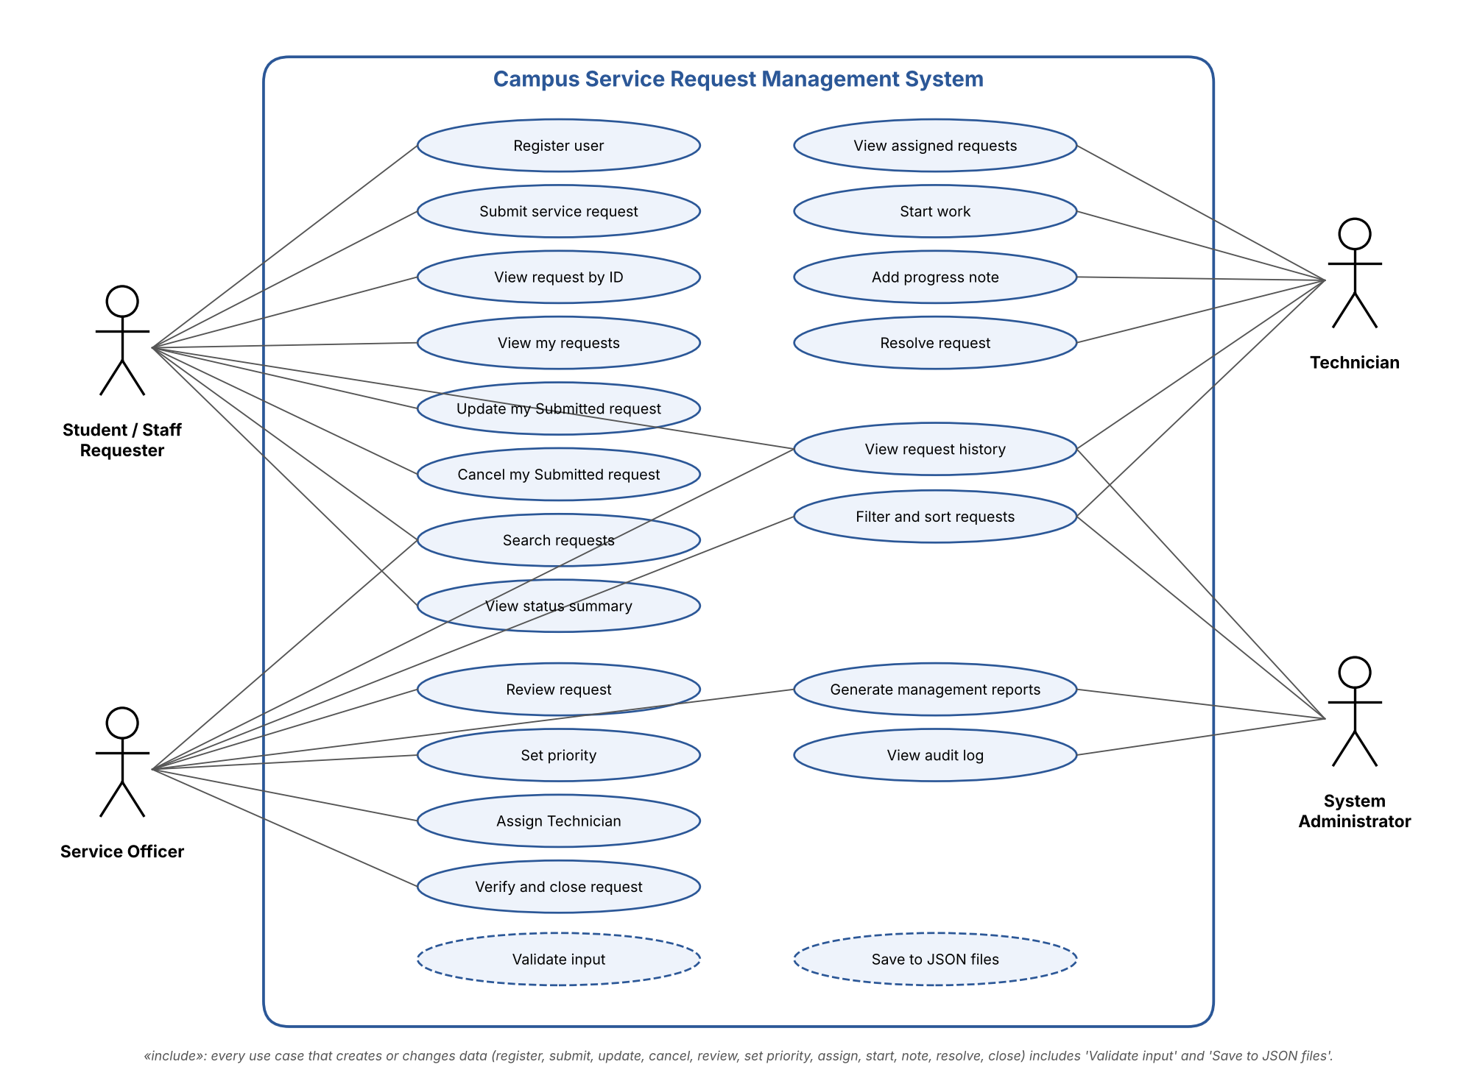
Use case diagram
Four actors use the system. Requesters (students and staff) create and follow their own requests. The Service Officer controls the middle of the workflow: review, priority, assignment and closure. The Technician does the work. The System Administrator only reads: history, audit log and reports. Every use case that creates or changes data includes input validation and saving to the JSON files.

2. Class Diagram
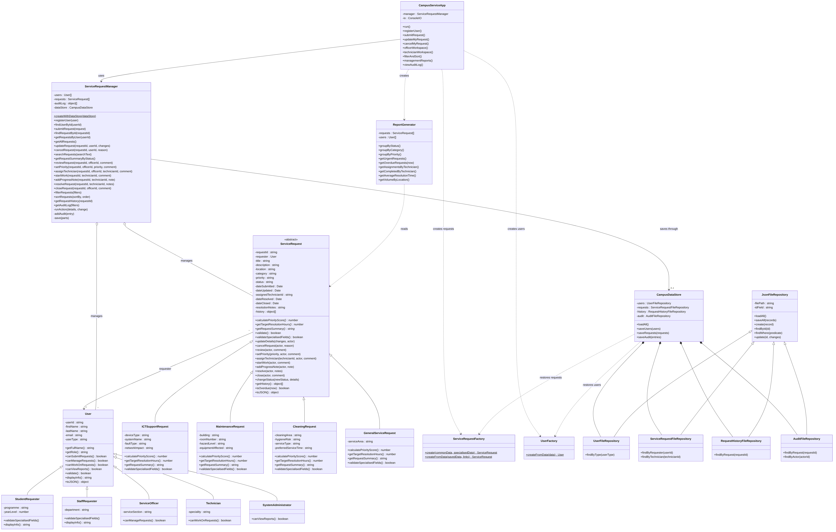
Class diagram
The full-resolution image is docs/uml/class_diagram.png (zoom in to read every member).
Notation: - private field (JavaScript # field), + public method, italic (*) abstract-style method, underlined ($) static method. Hollow triangle = inheritance, filled diamond = composition, hollow diamond = aggregation, dashed arrow = dependency (“creates” or “uses”).

3. Sequence Diagram – Submitting a Request
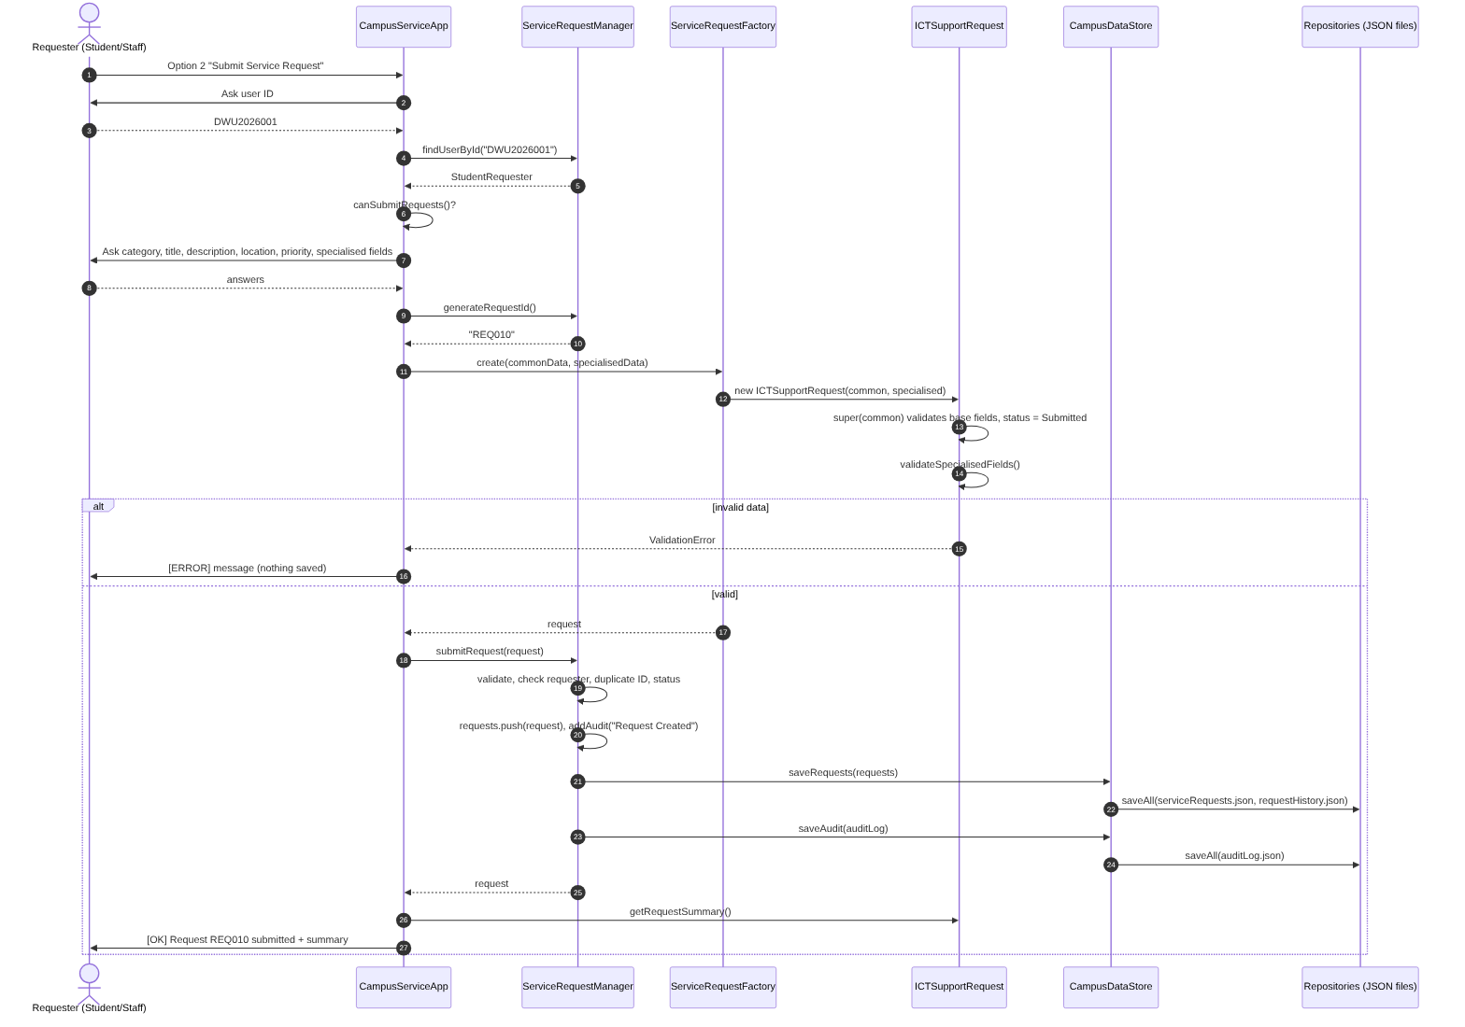
Submit request sequence

4. Sequence Diagram – Assigning a Technician
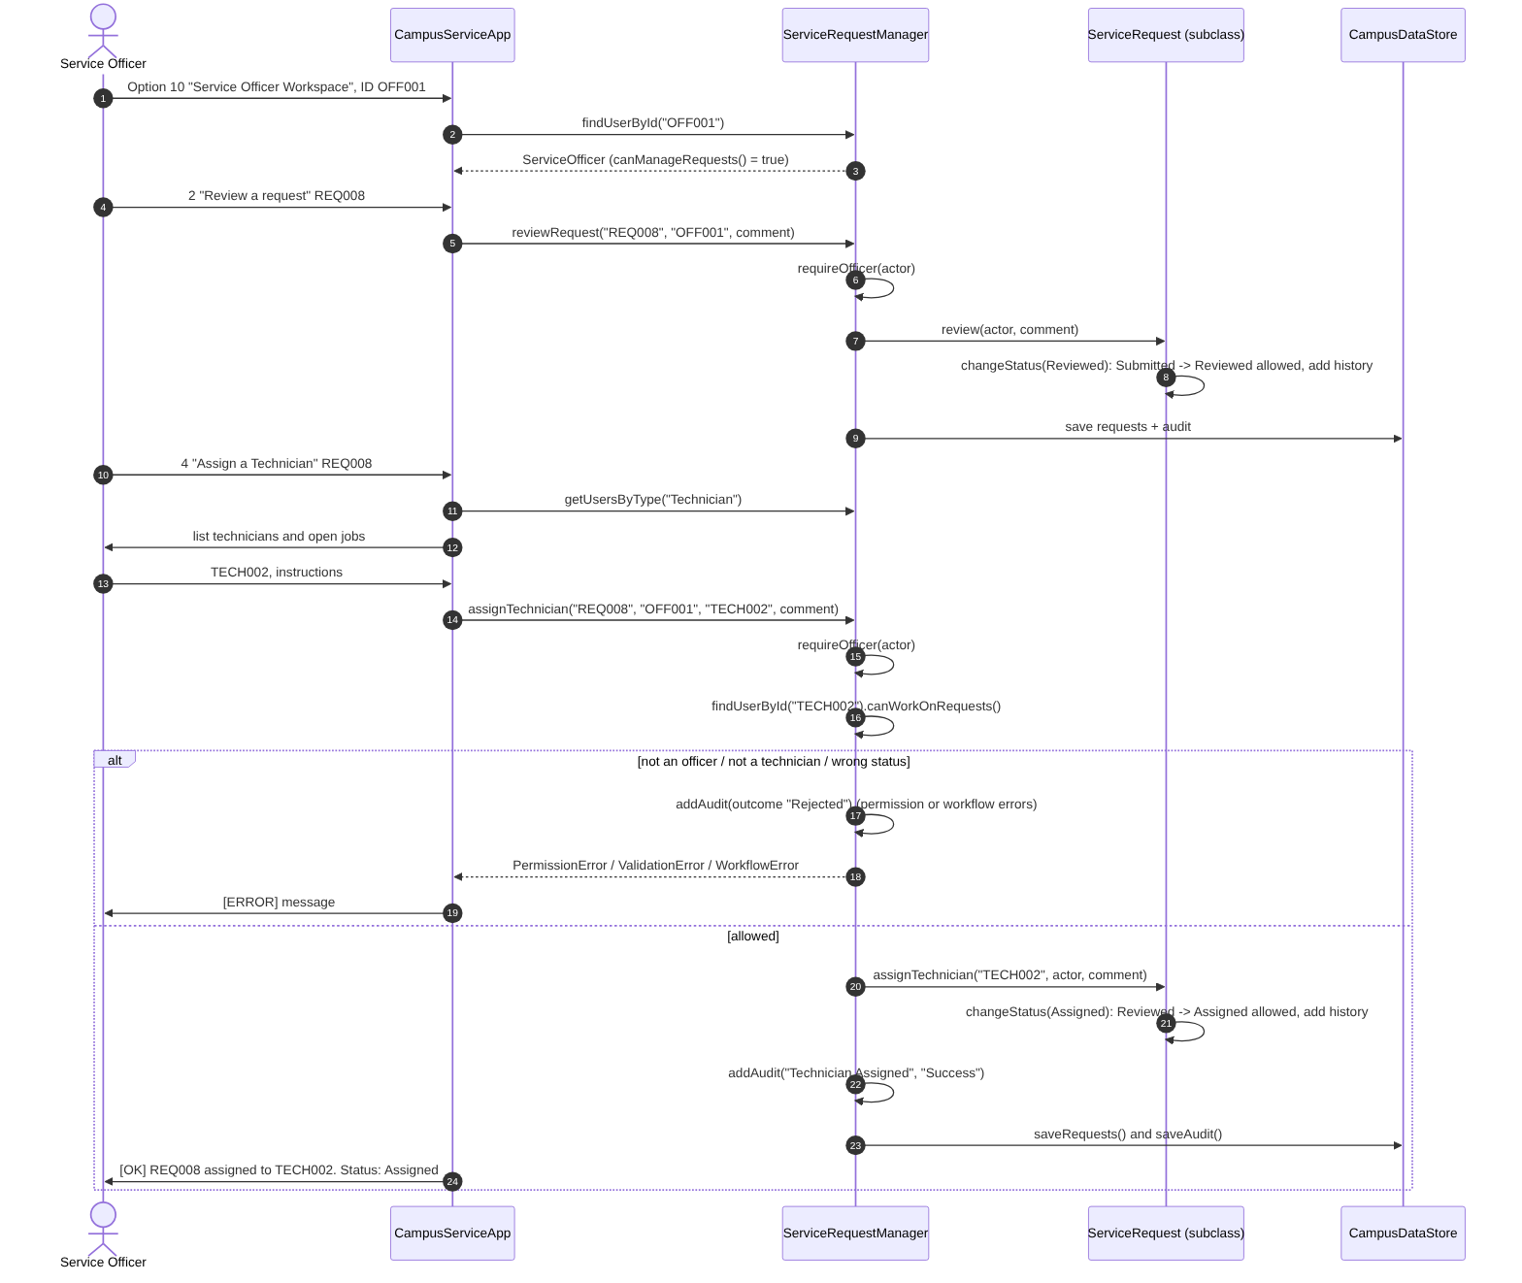
Assign Technician sequence

5. Sequence Diagram – Resolving and Closing a Request
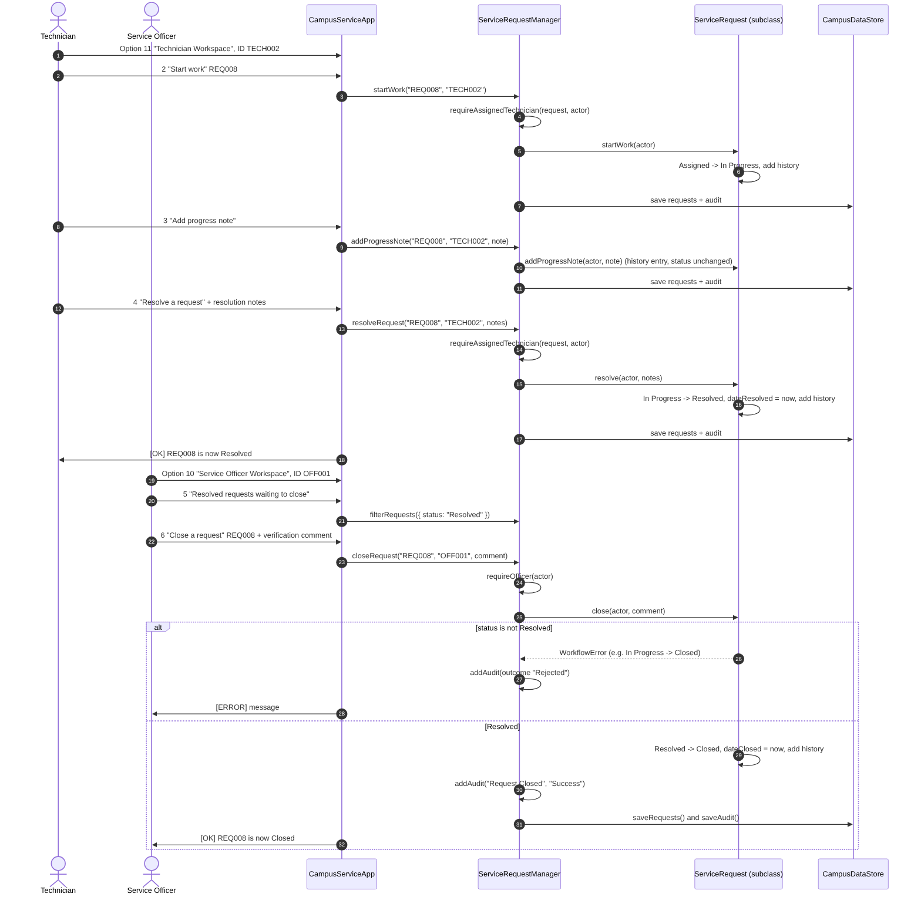
Resolve and close sequence

6. Explanation of the Class Relationships
Inheritance (is-a).
- User is the base class for StudentRequester, StaffRequester, ServiceOfficer, Technician and SystemAdministrator. Each subclass calls super() and adds its own field (programme and year level, department, service section, speciality). They override canSubmitRequests(), canManageRequests(), canWorkOnRequests() and canViewReports(), so the manager asks the object what it is allowed to do instead of checking type names.
- ServiceRequest is an abstract-style base class for ICTSupportRequest, MaintenanceRequest, CleaningRequest and GeneralServiceRequest. It cannot be created directly. Each subclass calls super(commonRequestData) and overrides calculatePriorityScore(), getTargetResolutionHours(), getRequestSummary() and validateSpecialisedFields().
- JsonFileRepository is the base class for the four file repositories. It holds the shared loadAll, saveAll, create, findById and update logic; subclasses add finders such as findByRequester() and findByTechnician().
Association. Each ServiceRequest holds a reference to exactly one User object as its requester (many requests to one user). The assigned Technician is stored as an ID, because the Technician may change role data independently and the ID is what gets saved to JSON.
Aggregation. ServiceRequestManager keeps arrays of User and ServiceRequest objects. The objects can exist without the manager (they are created by the factories and tested on their own), so this is aggregation rather than composition.
Composition. CampusDataStore creates and owns its four repositories; they are not shared and exist only inside it. Each ServiceRequest also owns its history array, which is only reachable through getHistory() (a copy).
Dependency.
- CampusServiceApp uses the manager for every action, and uses UserFactory, ServiceRequestFactory and ReportGenerator. It never touches the repositories or files.
- CampusDataStore uses UserFactory and ServiceRequestFactory to turn plain JSON records back into real objects.
- ReportGenerator reads requests and users to produce reports.
Layers. The design keeps four layers apart:
Layer | Classes | Knows about
Presentation | CampusServiceApp, ConsoleIO | Manager, factories, reports
Application / control | ServiceRequestManager, ReportGenerator | Domain objects, data store interface
Domain | User + subclasses, ServiceRequest + subclasses | Constants and errors only
Persistence | CampusDataStore, repositories, factories | Domain objects, fs/promises

7. Request Status State Model
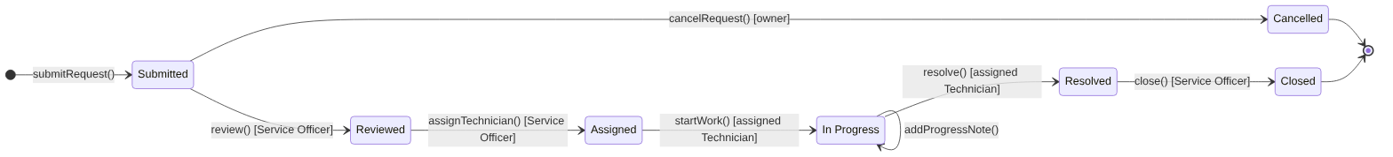
Status state diagram
The allowed moves are stored in one table, ALLOWED_TRANSITIONS in src/constants.js, and checked in one method, ServiceRequest.changeStatus(). Who may trigger each move is checked by ServiceRequestManager before the request method is called.

