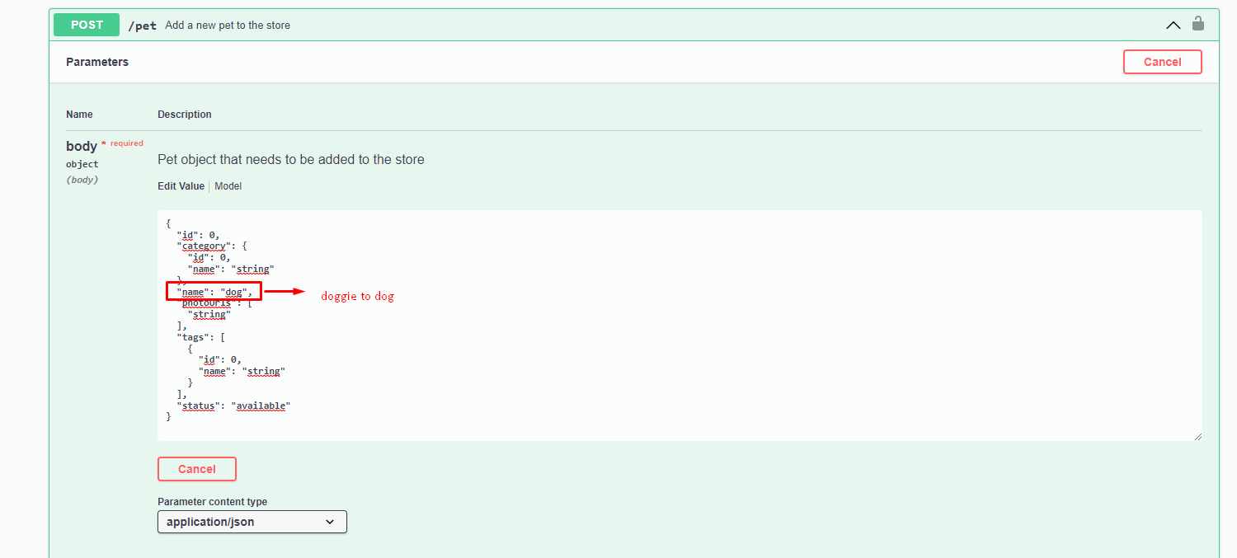
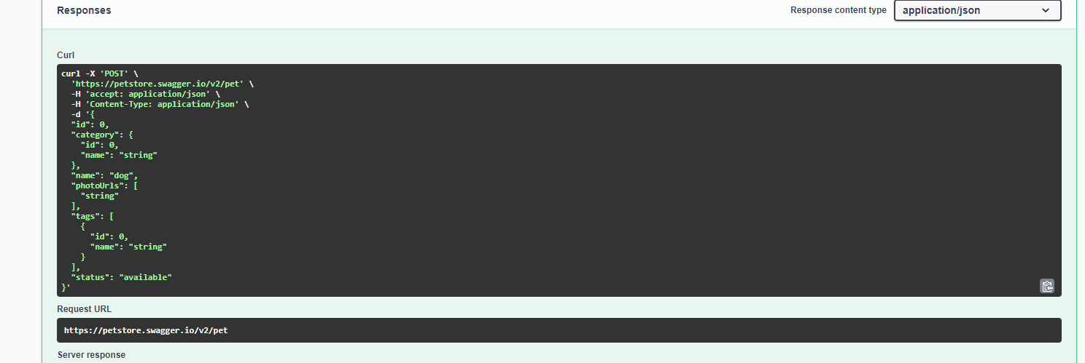
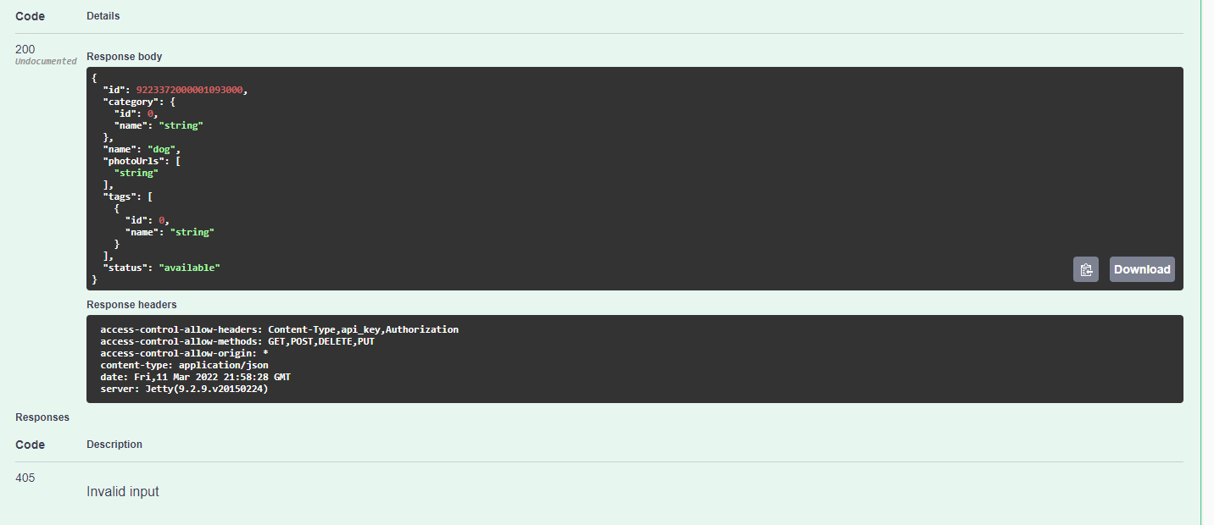
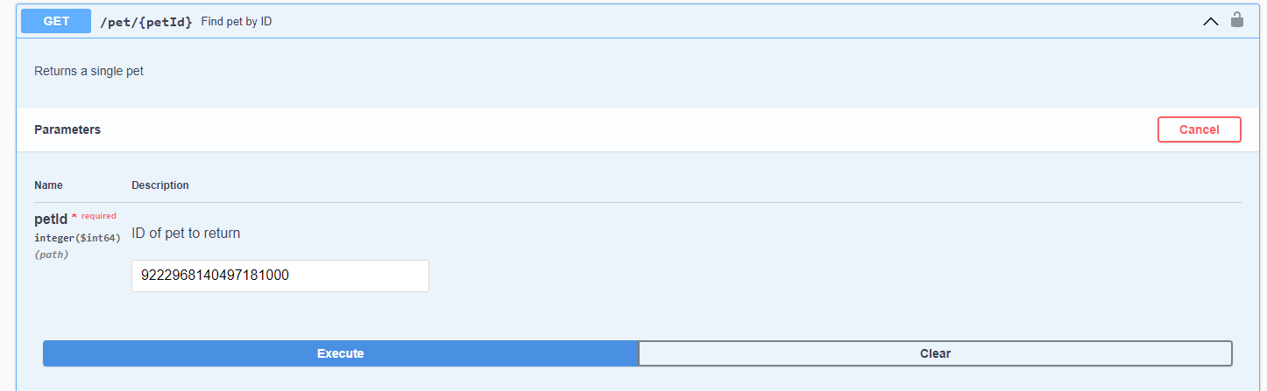
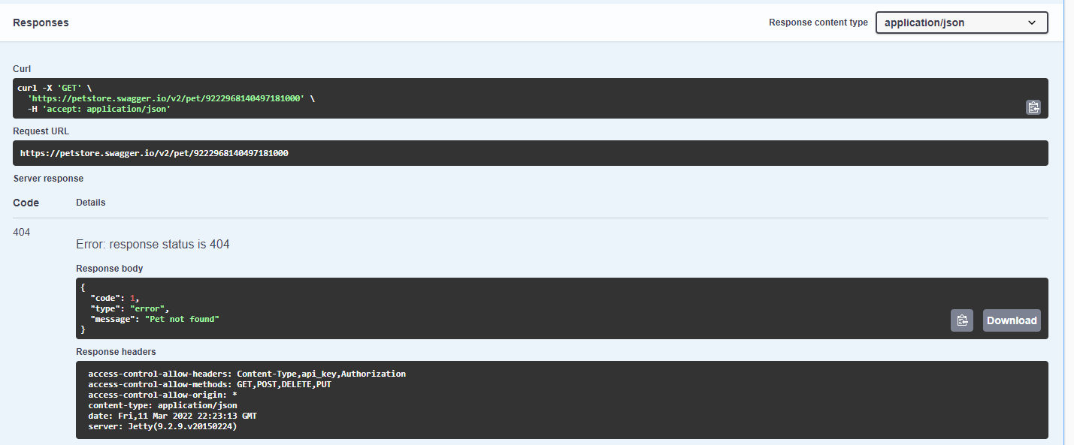
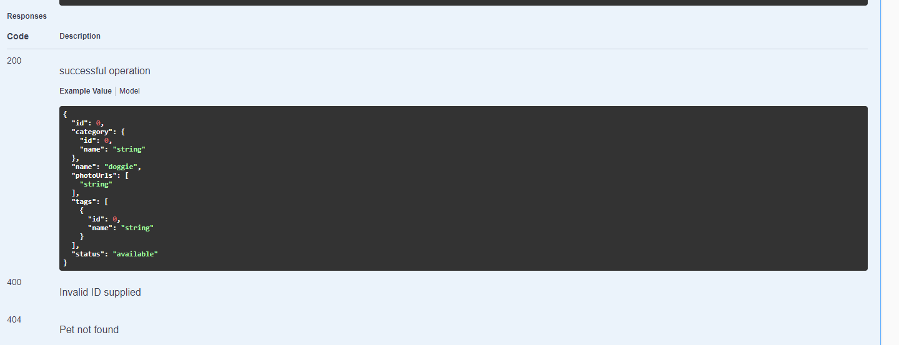
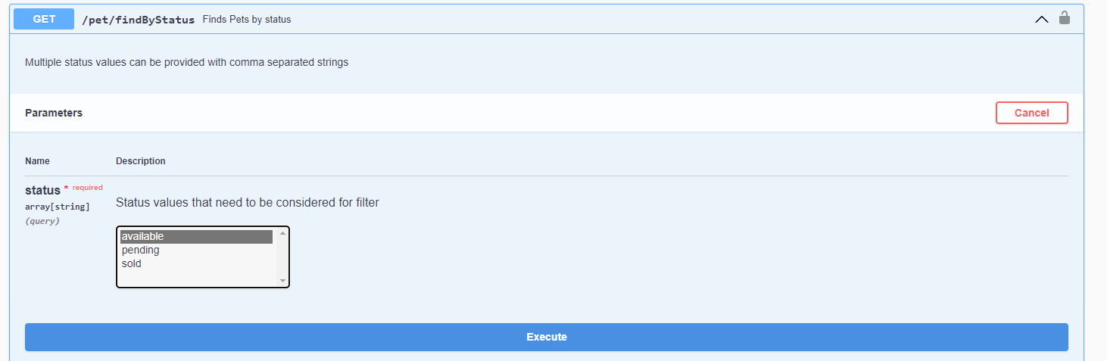
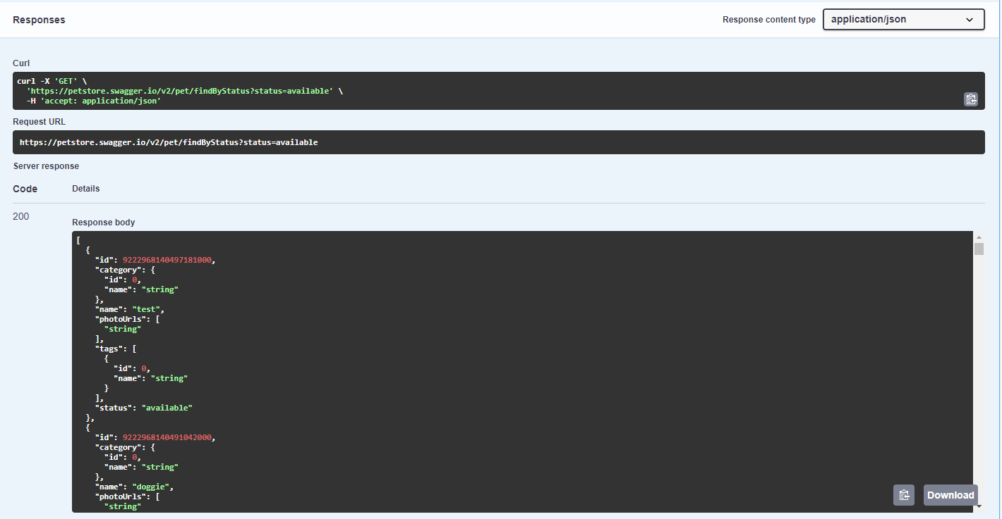
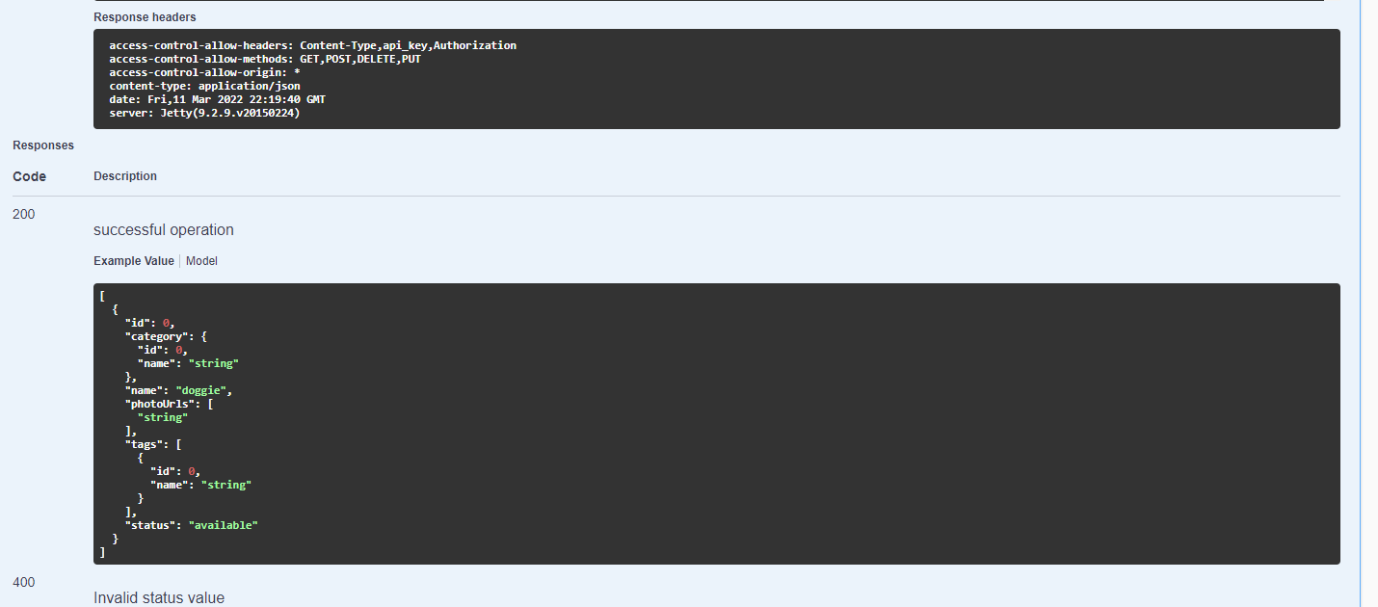
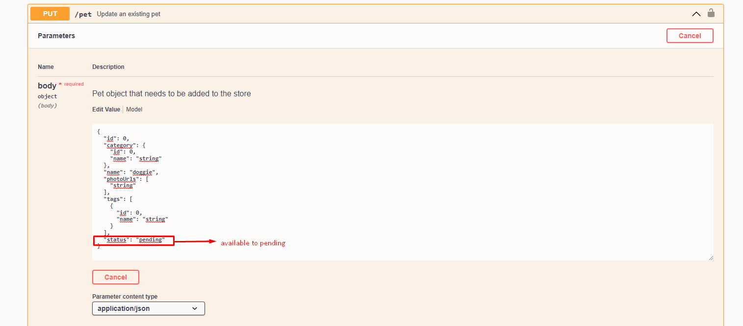
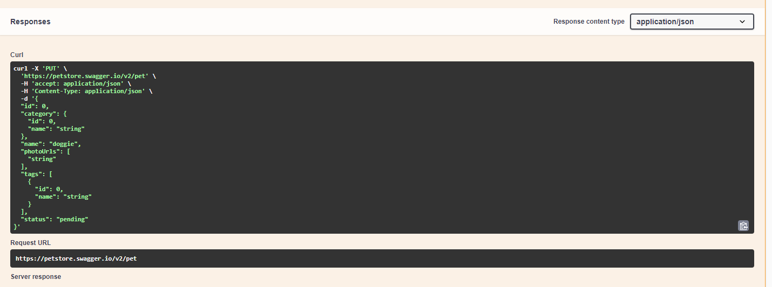
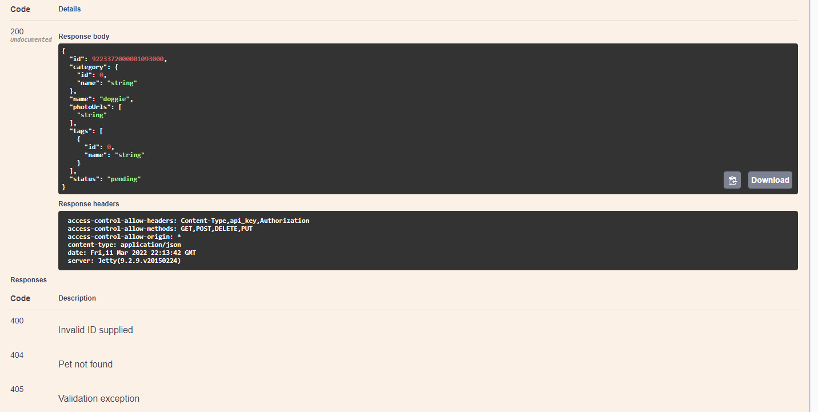
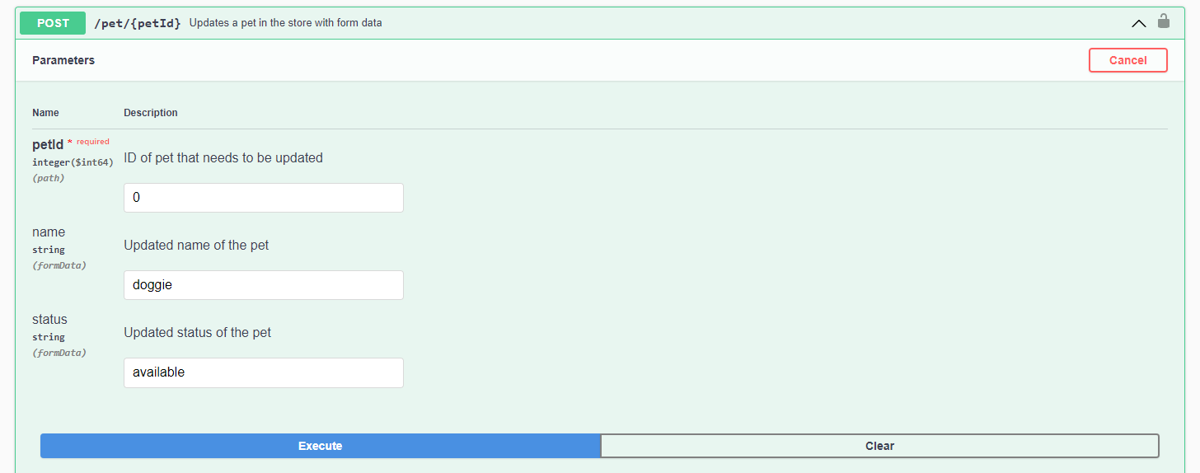
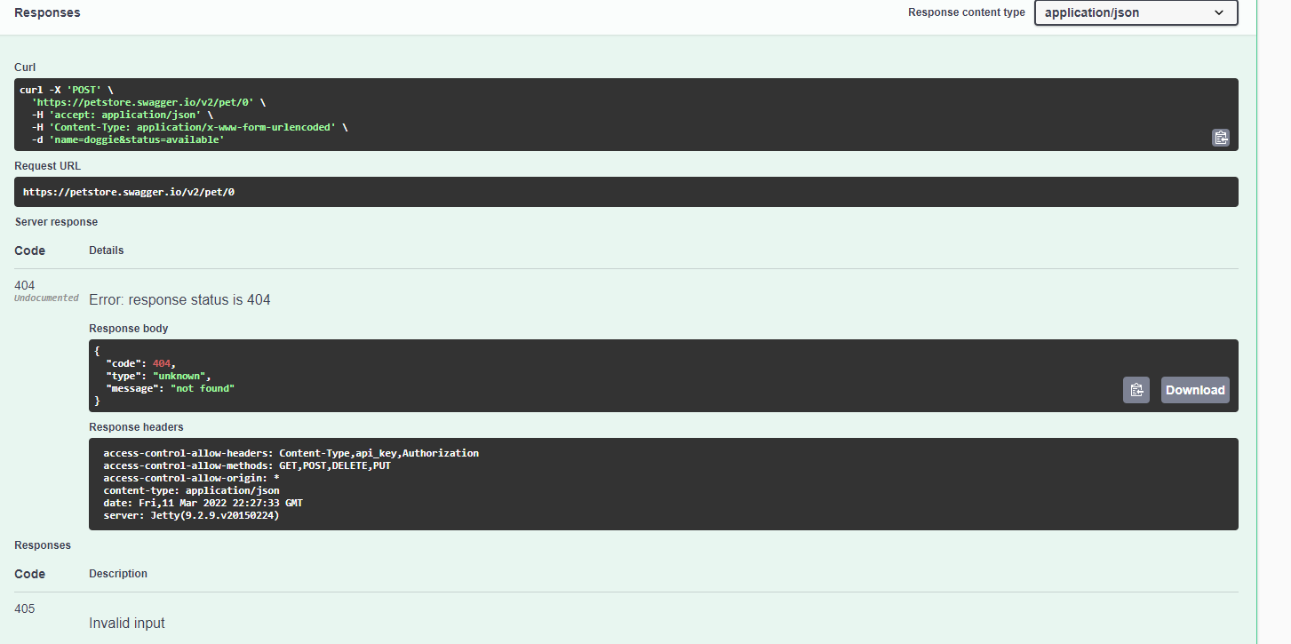
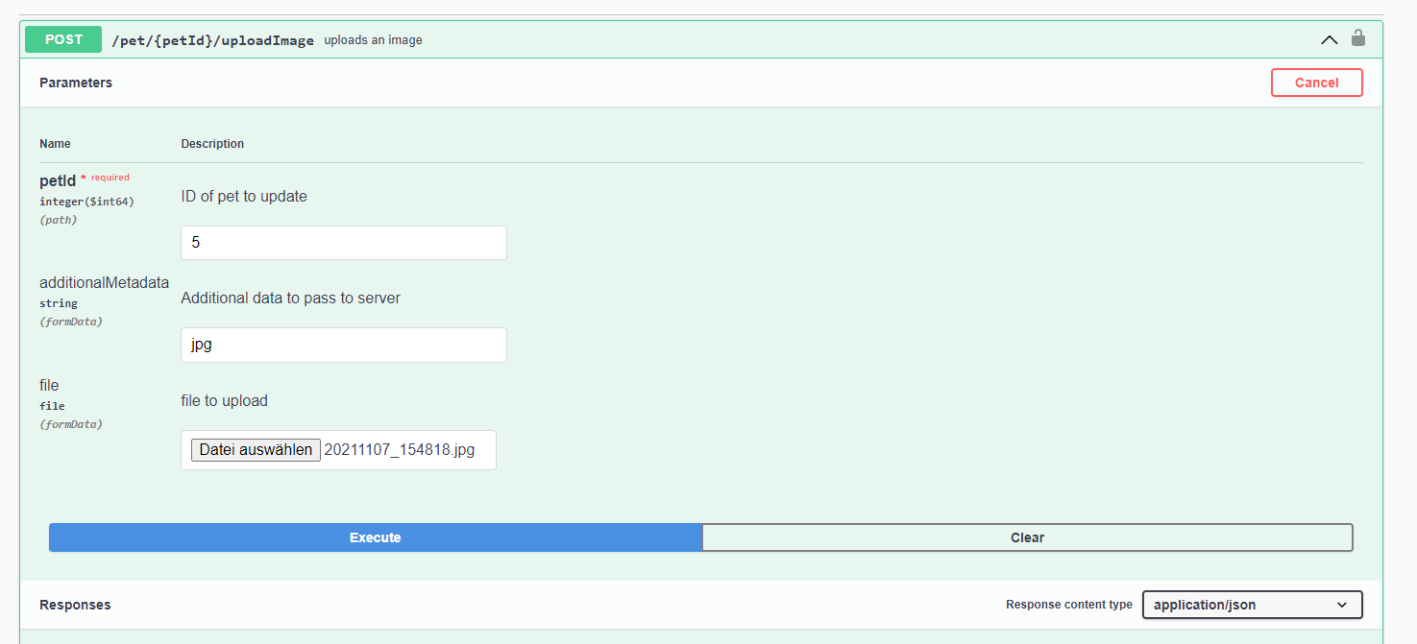
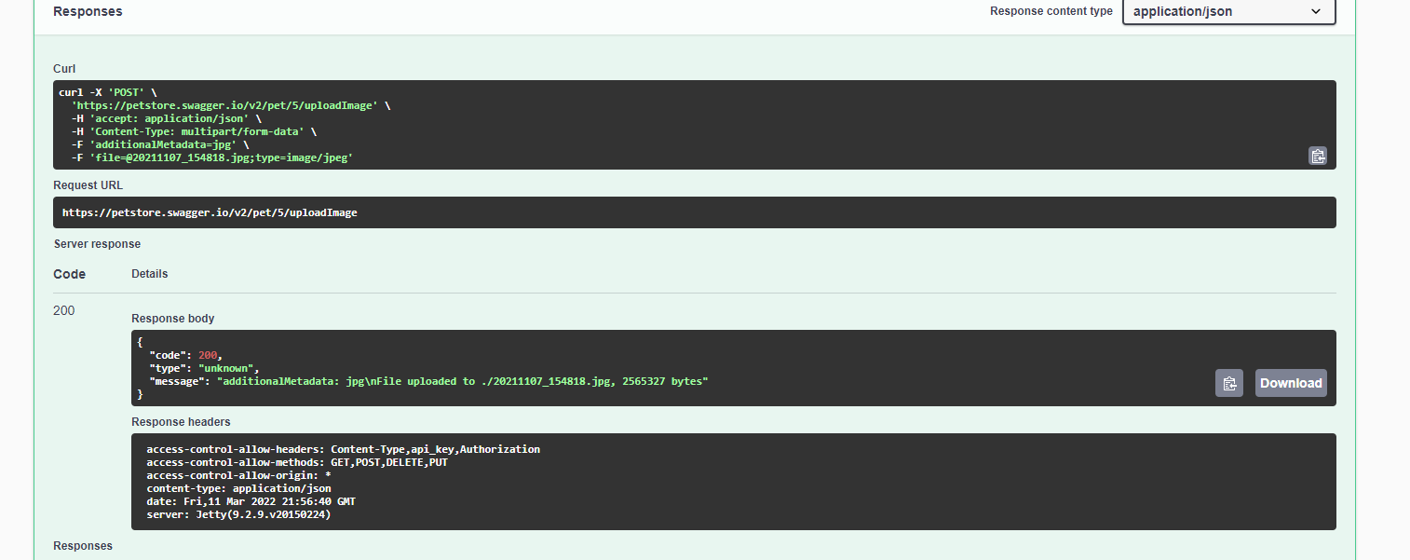
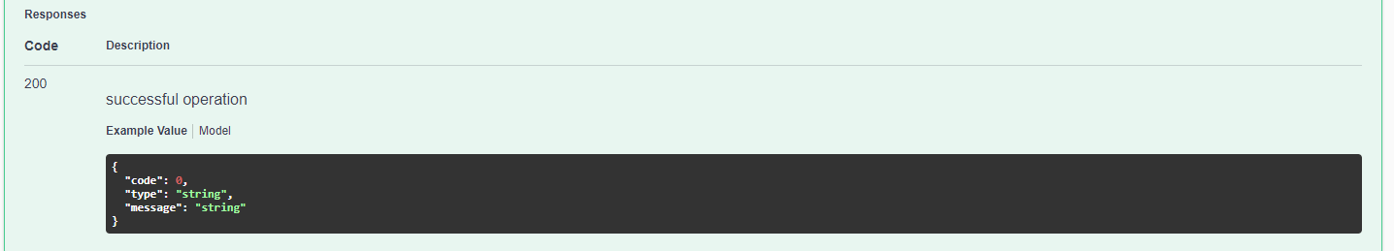
Id | Priority | Summary | Preconditions | Steps | Test data | Expected result | Status | Links | Postconditions
1 | 1 | Check search field on the start page | The german website “bonprix.de” is opened | 1.Hover the point of mouse to the search field.  2.Click on the search field.  3.Enter request | Request: “Damen Blusen” | Woman´s blouses appear. | Passed |  | Click on logo “Bon Prix it´s me” to open start page
2 | 2 | Check that chosen sortiment in the block on the left is displayed | The german website “bonprix.de” is opened. Request “Blusen” is made | 1.Hover the point of mouse to the block on the left.  2.Choose option “Damen” in the checkbox of “Sortimente” |  | Woman´s blouses appear | Passed |  | Click on logo “Bon Prix it´s me” to open start page
3 | 2 | Check that chosen size in the block on the left is displayed | The german website “bonprix.de” is opened. Request “Blusen” is made | 1.Hover the point of mouse to the block on the left.  2.Choose option “34” in the checkbox of “Größe” |  | Woman´s blouses with size “34” appear | Passed |  | Click on logo “Bon Prix it´s me” to open start page
4 | 2 | Check that color in the block on the left is displayed | The german website “bonprix.de” is opened. Request “Blusen” is made. | 1.Hover the point of mouse to the block on the left.  2.Choose yellow color in the “Color” |  | Woman´s yellow blouses appear | Failed |  | Click on logo “Bon Prix it´s me” to open start page
5 | 1 | Check that submenu is displayed by hovering on the one of the option in menu | The start page of website “bonprix.de” is opened. | 1.Hover the point of mouse to the “Kinder” in menu under search field. |  | The submenu is displayed | Passed
6 | 1 | Check that user can see clothes via menu | The start page of website “bonprix.de” is opened. | 1.Hover the point of mouse to the “Kinder” in menu under search field.  2.Hover the point of mouse to the “Schuhe” in submenu.  3.Click on the “Alle Schuhe” in segment “Mädchen” |  | The assortment of shoes for girls is displayed | Passed |  | Click  on logo “Bon Prix it´s me” to open start page
7 | 1 | Check that user can return to start page from any page | The assortment of shoes for girls in website “bonprix.de” is displayed. | 1.Click on the logo “Bon Prix it´s me”. |  | The start page is opened | Passed
8 | 1 | Check that user can add item to the shopping cart | The assortment of shoes for girls in website “bonprix.de” is displayed. | 1.Click on the item “Ballerina”.  2.Choose size 38 and color “schwarz”.  3.Click on the button “In die Einkaufstasche”.  4.Click on the “Zur Einkaufstasche” in the modal window. |  | The page with suggestion to pay is opened. | Passed |  | Click  on logo “Bon Prix it´s me” to open start page
9 | 1 | Check that user can add more than one item to the shopping cart. | The assortment of shoes for girls in website “bonprix.de” is displayed. | 1.Click on the item “Ballerina” for 13,99E.  2.Choose size 38 and color “schwarz”.  3.Click on the button “In die Einkaufstasche”.  4.Click on the “Weitershoppen” in the modal window.  5.Click on the “Alle schuhe”.  6.Click on the “Slipper”.  7.Choose size 37 and color “weiß”.  8.Click on the button “In die Einkaufstasche”.  9.Click on the “Zur Einkaufstasche” in the modal window. |  | The modal window disappears after executing fourth step. The page with suggestion to pay is opened after executing ninth step. | Passed |  | Click  on logo “Bon Prix it´s me” to open start page
10 | 1 | Check that user can pay for selected items | Items “Ballerina” for 13,99E with size 37 and color white and “Slipper” with size 37 and color white from assortment of girls´shoes are added to the shopping cart. The page with suggestion to pay is opened.  User should be signed in. | 1.Click on “Zur Kasse”.  2.Enter login and password in section “Anmeldung”.  3.Choose “Lieferung an Rechnungsadresse” in section “Lieferung”  4.Click on “Weiter” in section “Lieferung”.  5.Click on “Weiter” in section “Zahlung”.  6.Click on “Jetzt zum genannten Preis bestellen” in section “Prüfen & Bestellen”. |  | Page with message “Vielen Dank” is opened | Passed |  | Click  on logo “Bon Prix it´s me” to open start page
11 | 2 | Check that user can return to start page by clicking “Startseite” in footer | The assortment of shoes for girls in website “bonprix.de” is displayed. | 1.Click on the “Startseite” in footer |  | Start page is opened | Passed

